
Amazon e- commerce project
OBJECTIVE AND SUBJECTIVE


AJAY KUMAR GANDARAPU
ajaykumaegandarapu@gmail.com

OBJECTIVE QUESTIONS

1. What is the total number of attributes in the customer table?
The Customers table consists of 3 attributes (columns) that store essential customer demographic information. These attributes are:
- CustomerID – Unique identifier assigned to each customer.
- Customer Age – Represents the age of the customer.
- Customer Gender – Indicates the gender of the customer.
Therefore, the total number of attributes in the Customers table is 3.
2. How will you get the “Customer’s” ages in the “Order” tables according to customer IDs?
To retrieve the Customer Age in the Orders table, a relationship must first be established between the Customers table and the Orders table using the CustomerID field. Since each customer can place multiple orders, the relationship between the Customers and Orders tables is a One-to-Many (1:M) relationship, where the Customers table acts as the dimension table and the Orders table acts as the fact table.
After creating the relationship, the Customer Age can be accessed directly in reports and visualizations. If a separate column is required within the Orders table, a calculated column can be created using the following
DAX formula:
Customer Age = LOOKUPVALUE(Customers[Customer Age],Customers[CustomerID],Orders[CustomerID])
3. In analyzing the dataset with Power BI, ensure data cleaning to address inconsistencies and missing values before further analysis.
Data cleaning is a critical step in the data analysis process, as it ensures the accuracy, consistency, and reliability of insights generated from the dataset. Before performing any analysis in Power BI, the dataset was thoroughly cleaned using the Power Query Editor.
The following data preparation activities were performed:
- Handled Missing Values: Null and blank values were identified and treated appropriately. Critical fields such as Customer ID, Order Date, and Product Category were validated to ensure data completeness. Missing values in descriptive fields were replaced with meaningful values such as "Unknown Reason" or "Not Applicable" where required.
- Corrected Data Types: Columns were assigned appropriate data types to support accurate calculations and analysis. For example, Order Date and Delivery Date were converted to the Date data type, while numerical fields such as Sale Price and Quantity were assigned numeric data types.
- Removed Duplicate and Invalid Records: Duplicate entries and inconsistent records were reviewed and removed to maintain data integrity and prevent inaccurate reporting.
- Standardized Data Values: Text fields were cleaned by removing extra spaces, correcting formatting inconsistencies, and ensuring uniform naming conventions across the dataset.
- Eliminated Unnecessary Columns: Columns that did not contribute to the analysis or reporting requirements were removed to improve data model efficiency and reduce processing overhead.
4. How can we calculate the total revenue generated by all the sales?
The Total Revenue represents the overall income generated from all sales transactions recorded in the dataset. In Power BI, this metric can be calculated by summing the values in the Sale Price column using a DAX measure.
Total Revenue = SUM(Orders[Sale Price])
This measure aggregates the sale value of all orders and provides the total revenue generated by the business over the selected period.

5. What is the total number of unique customers who made purchases each year? Is there any increase in the number over the years?
To determine the total number of unique customers who made purchases, a Distinct Count of the CustomerID field was calculated. This metric measures the number of individual customers who placed at least one order during a given period.
Unique Customers Analysis
To determine the total number of unique customers who made purchases and analyze how the customer base has changed over the years.
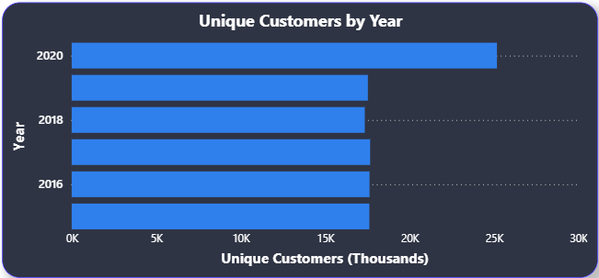
The Unique Customers by Year chart illustrates the number of distinct customers who placed orders each year. A distinct count of CustomerID was used to eliminate duplicate customer records and ensure that each customer is counted only once within a given period.
The analysis indicates a generally stable customer base across the years, with a notable increase in 2020, where the number of unique customers reached its highest level. This growth suggests improved customer acquisition and increased market reach during that year.
A higher number of unique customers reflects the company's ability to attract new buyers and retain existing customers. Monitoring this metric helps evaluate marketing effectiveness, customer engagement, and overall business growth.

Key Insights
- Customer acquisition remained consistent throughout the observed period.
- The highest number of unique customers was recorded in 2020.
- The increasing customer base contributed positively to overall sales performance.
- Growth in unique customers indicates strong brand visibility and customer retention.
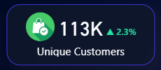

6. How can we determine the total number of unique products available in the company?
To determine the total number of distinct products offered by the company and evaluate the diversity of its product portfolio.
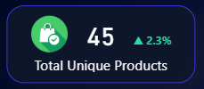
The Total Unique Products KPI measures the number of distinct products available within the sales dataset. This metric was calculated using a distinct count of the Product field, ensuring that each product is counted only once regardless of the number of transactions associated with it.
The analysis indicates that the company offers 45 unique products across multiple product categories. This demonstrates a diversified product portfolio capable of serving a broad customer base with varying preferences and purchasing needs.
Maintaining a diverse range of products is essential for improving customer satisfaction, increasing market coverage, and reducing dependency on a limited number of products for revenue generation.

Key Insights
- The company currently offers 45 distinct products across its product categories.
- A diversified product portfolio enhances the company's ability to attract and retain customers.
- Product variety contributes to improved customer experience by providing more purchasing options.
- A balanced product mix helps mitigate business risk by reducing reliance on individual products.
7. What is the average number of days it takes for products to be delivered, get the metric for only the delivered orders.
To determine the average number of days required to deliver products to customers, considering only orders that were successfully delivered.
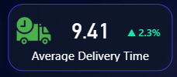
The Average Delivery Time metric measures the average number of days taken to deliver orders that were successfully completed. Orders that were cancelled, returned, or not delivered were excluded from the calculation to ensure an accurate assessment of delivery performance.
The analysis indicates that products take an average of 9.53 days to reach customers after an order is placed. This metric serves as a key indicator of supply chain efficiency and logistics performance.
A lower delivery time generally reflects a more efficient fulfillment process, leading to improved customer satisfaction and a better overall shopping experience.

Key Insights
- The average delivery time for delivered orders is 9.53 days.
- Only successfully delivered orders were considered in the analysis.
- Delivery performance directly impacts customer satisfaction and retention.
- Monitoring delivery times helps identify operational bottlenecks and opportunities for process improvement.

8. Which products, categories, and subcategories are the most popular?
To identify the most popular products, product categories, and subcategories based on customer demand and order volume. Popularity is measured using the total quantity of orders placed for each product.

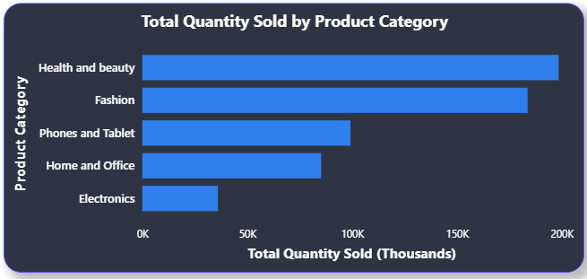
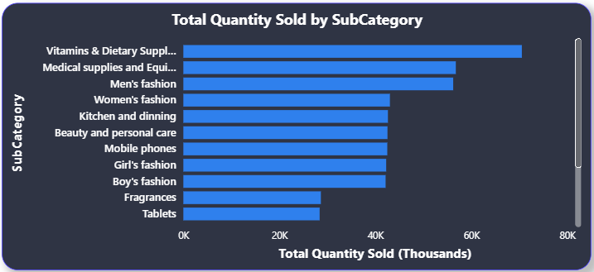
The popularity analysis was conducted by aggregating the total quantity sold across products, categories, and subcategories. Products with higher sales volumes indicate stronger customer demand and greater market acceptance.
The results reveal that certain products consistently generate significantly higher order volumes compared to others, making them the company's best-selling products. Similarly, specific product categories contribute a larger share of total sales, highlighting areas where customer demand is strongest.
At the subcategory level, the analysis provides a more detailed view of customer preferences and purchasing behavior. Identifying top-performing subcategories helps the business understand which product segments drive the majority of sales.

Key Insights
- The most popular products are those with the highest quantity sold and order frequency.
- Top-performing categories contribute a significant portion of overall sales revenue and customer demand.
- Popular subcategories represent customer preferences within broader product categories.
- High-demand products should be prioritized for inventory planning and promotional campaigns.
- Understanding product popularity supports better merchandising and assortment decisions.
9. Which products have seen an increase or decrease in sales over the year?
To identify products that experienced an increase or decrease in sales revenue between 2015 and 2020 and evaluate their performance trends over time.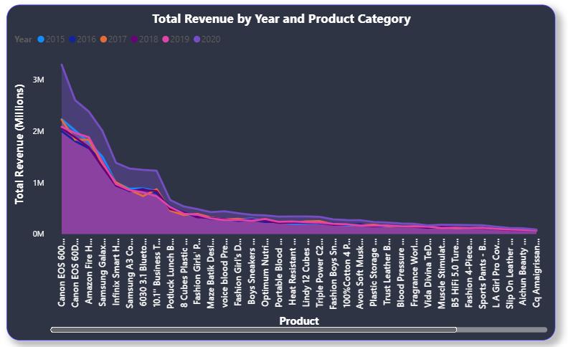
The Area Chart compares the revenue generated by each product across the six-year period from 2015 to 2020. The analysis reveals significant variations in product performance, allowing the identification of products with increasing or decreasing sales trends.
Products such as Canon EOS 600D 18MP, Canon EOS 60D CMOS, Amazon Fire HD 8 Kids Edition, and Samsung Galaxy A02 consistently generated the highest revenue across the years. Revenue for these products increased substantially in 2020, indicating strong customer demand and market acceptance.
In contrast, products positioned toward the right side of the chart, including several fashion, beauty, and office-related products, generated comparatively lower revenue and showed limited growth over the analysis period. These products contributed less to overall sales and may require additional promotional or pricing strategies to improve performance.
The noticeable increase in revenue during 2020 across many products suggests overall business growth and increased customer purchasing activity.

Key Insights
- Canon EOS 600D 18MP emerged as the highest revenue-generating product.
- Camera and electronics products consistently outperformed other product categories.
- Several products demonstrated significant revenue growth between 2019 and 2020.
- Lower-performing products showed relatively flat revenue trends and contributed a smaller share of total sales.
- Revenue growth was concentrated among a limited number of high-demand products.
10. While modeling the data relationships, what will be the type of relationship between the customer ID of Orders and customer tables?
The relationship between the CustomerID field in the Orders table and the CustomerID field in the Customers table is a One-to-Many (1:*) relationship.
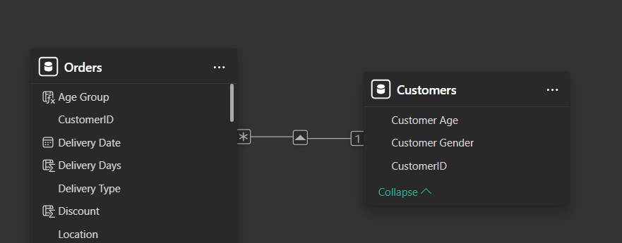
The Customers table contains a unique record for each customer, where CustomerID acts as the primary key. The Orders table stores transaction-level data, and a customer can place multiple orders over time.
Therefore:
- One customer can have many orders.
- Each order belongs to only one customer.
- CustomerID in the Customers table is unique.
- CustomerID in the Orders table can appear multiple times.

11. How have you handled the null values in the data?
To ensure data quality and accuracy before performing analysis and visualization, the dataset was examined for missing (null) values and appropriate data-cleaning techniques were applied.

Approach Used
During the data preparation phase in Power Query, all columns were checked for null or missing values. The handling strategy depended on the importance and data type of each field.

Steps Performed
1. Identification of Null Values
- Used Power Query's data profiling tools to identify columns containing null or blank values.
- Verified the percentage and impact of missing values on the analysis.
2. Removal of Records with Critical Missing Information
- Rows containing null values in essential fields such as:
  - CustomerID
  - Product
  - OrderDate
  - Sale Price
were removed because these fields are required for accurate analysis and calculations.
3. Replacement of Null Values
- For numerical columns, null values were replaced with appropriate default values where applicable.
- For categorical columns, missing values were replaced with descriptive labels such as:
Unknown or Not Available to maintain data consistency.
4. Validation
- After cleaning, the dataset was revalidated to ensure that no critical null values remained and that all calculations could be performed correctly.

Analysis
Handling null values improved the reliability and accuracy of the analysis by preventing calculation errors, incorrect aggregations, and misleading visualizations. Data cleaning ensured that KPI calculations, revenue analysis, customer analysis, and product performance metrics were based on complete and valid records.

12. Were there any data format issues in the data, and if there were/are how you would handle them?
To identify and resolve data format inconsistencies within the dataset to ensure accurate analysis, reporting, and visualization in Power BI.

Data Format Issues Identified
During the data preparation and cleaning phase, several data format inconsistencies were observed in the dataset. These issues were addressed using Power Query Editor before performing any analysis.

1. Date Format Inconsistencies
The Order Date and Delivery Date fields were initially stored as text values rather than date data types.

Handling
- Converted the columns from Text to Date format using Power Query.
- Validated the date values to ensure correct chronological ordering.
- Created Year, Month, and Quarter attributes for time-based analysis.

2. Numerical Fields Stored as Text
Columns such as:
- Sale Price
- Unit Price
- Shipping Fee
- Discount
- Order Quantity
were checked to ensure they were stored as numeric values.

Handling
- Converted the fields to appropriate numeric data types such as:
  - Decimal Number
  - Whole Number
- Removed any non-numeric characters where necessary.

3. Inconsistent Text Values
Certain categorical fields contained inconsistent text formatting, such as:
- Product Category
- Delivery Type
- Status
- Location
Examples included differences in capitalization, spacing, or spelling.

Handling
- Applied text cleaning functions:
  - Trim
  - Clean
  - Proper Case
- Standardized category names to maintain consistency.

4. Null and Blank Values
Some columns contained missing or blank values.

Handling
- Removed records with missing values in critical fields.
- Replaced non-critical missing values with suitable defaults such as:
  - "Unknown"
  - "Not Available"
  - 0 (where appropriate)

5. Duplicate Records
Potential duplicate records were checked using key fields such as:
- OrderID
- CustomerID
- Product

Handling
- Removed duplicate rows where necessary.
- Ensured uniqueness of primary identifiers.
13. When we add a column in Power Query what’s the code that comes in M language in the formula bar? What do you know about M-query?
  - When adding a new column in Power Query, the formula bar displays M code similar to the following:
- = Table.AddColumn(Source, "NewColumn", each [ExistingColumn] * 2)
- This code creates a new column named "NewColumn", where each value is calculated by multiplying the ExistingColumn by 2.
- M Query, also known as the Power Query Formula Language, is a functional programming language used in Power Query for data transformation and preparation.
- It is used in Power BI, Excel, and other Microsoft tools to perform step-by-step data transformations.
- M Query enables users to:
  - Filter, merge, and aggregate data
  - Perform custom calculations and transformations
  - Define parameters and manage complex data scenarios
  - Clean and reshape data before loading it into the data model
14. Identify the top 5 most valuable customers using a composite score that combines three key metrics: (SQL)
  - Total Revenue (50% weight): The total amount of money spent by the customer.
  - Order Frequency (30% weight): The number of orders placed by the customer, indicating their loyalty and engagement.
  - Average Order Value (20% weight): The average value of each order placed by the customer, reflecting the typical transaction size.
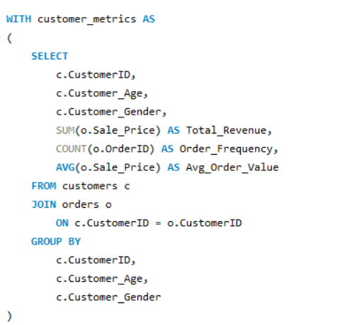
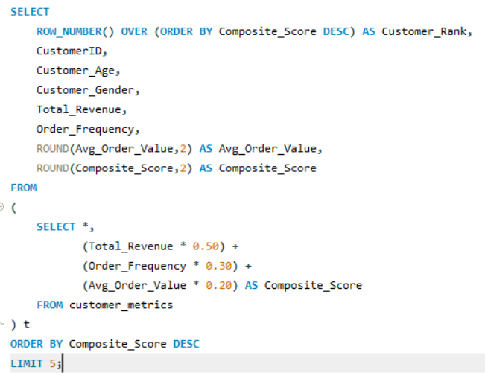
Output :
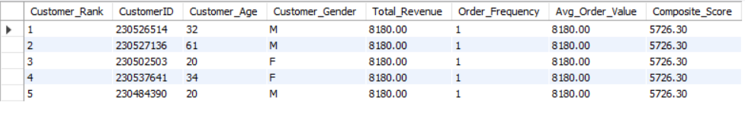

15. Calculate the month-over-month growth rate in total revenue across the entire dataset. (SQL)

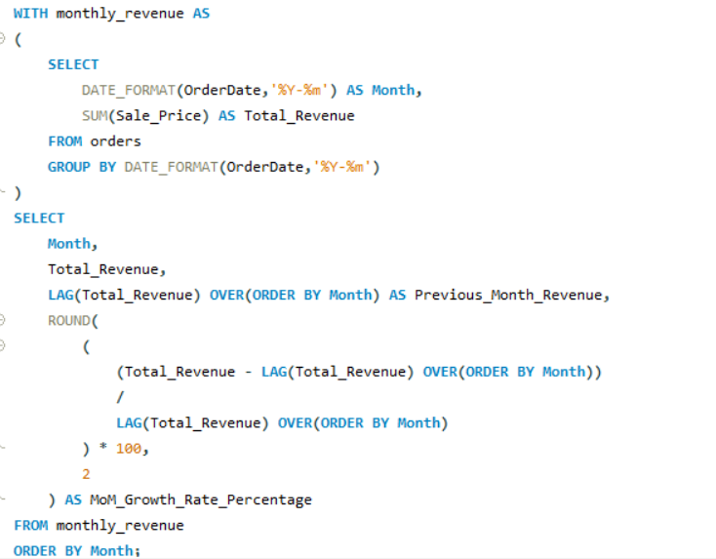

Output :
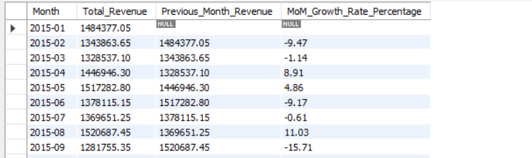

16. Calculate the rolling 3-month average revenue for each product category. (SQL)

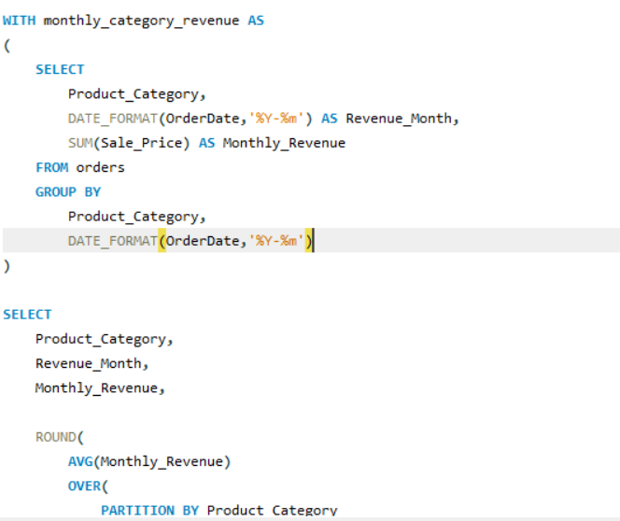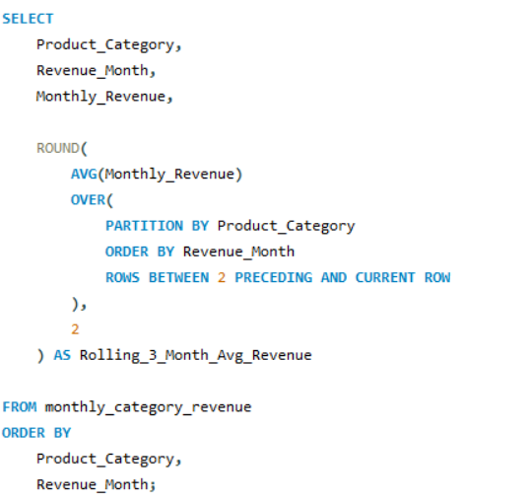
Output :
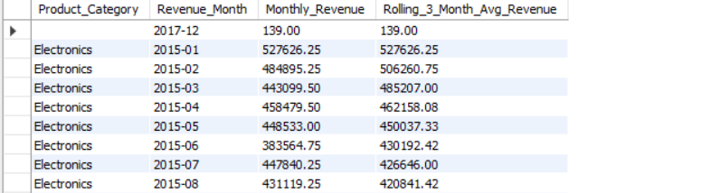

17. Update the orders table to apply a 15% discount on the `Sale Price` for orders placed by customers who have made at least 10 orders. (SQL)

18. Calculate the average number of days between consecutive orders for customers who have placed at least five orders. (SQL)

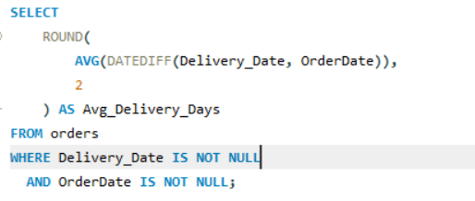
Output :
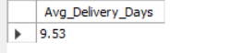

19. Identify customers who have generated revenue that is more than 30% higher than the average revenue per customer. (SQL)

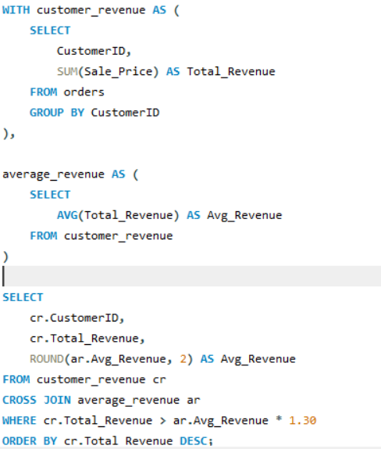
Output :
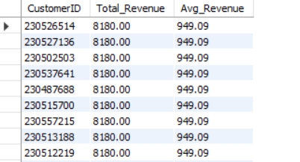
20. Determine the top 3 product categories that have shown the highest increase in sales over the past year compared to the previous year. (SQL)

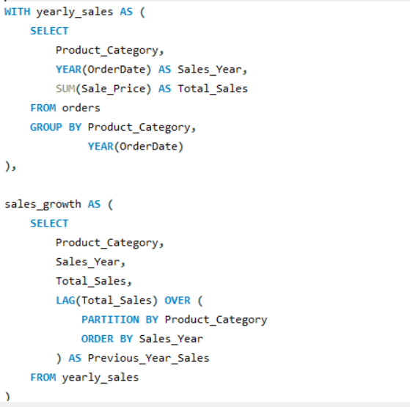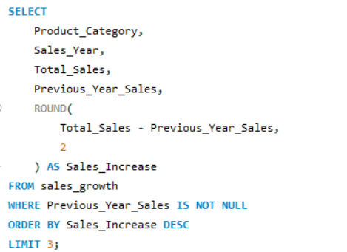
Output :

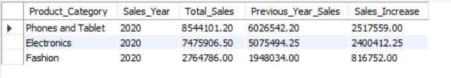

Subjective Question

1. Explain the revenue breakdown by year and by-product. Evaluate how different products contribute to annual revenue and come up with suggestions to increase the sales of the low-selling items.
The Top Products by Revenue chart highlights the products contributing the most to total revenue.
Key Observations:
- Camera and electronics products dominate revenue generation.
- The Canon EOS 600D DSLR Camera is the highest revenue-generating product, contributing 13.9M.
- The top five products account for a significant share of total company revenue.
- Electronics-related products consistently outperform other categories, indicating strong customer preference for technology products.

Evaluation of Product Contribution
- High-performing electronics products drive the majority of annual revenue.
- A small number of products contribute a disproportionately large share of sales, reflecting a Pareto-like distribution.
- Products outside the top-performing group contribute relatively less revenue and exhibit lower customer demand.
- The business relies heavily on a few successful products for revenue generation.

Recommendations to Increase Sales of Low-Selling Products
1. Product Bundling
- Bundle low-selling products with high-performing products such as Canon cameras and Samsung smartphones.
- Encourage customers to purchase complementary products through discounted package offers.

2. Promotional Campaigns
- Offer seasonal discounts and limited-time promotions on low-performing products.
- Introduce loyalty rewards and coupon-based incentives.
3. Improve Product Visibility
- Feature low-selling products in advertisements, website recommendations, and promotional banners.
- Optimize product descriptions and images to improve customer engagement.
4. Customer Segmentation and Personalized Marketing
- Recommend low-selling products to customers based on previous purchase history.
- Utilize email marketing and retargeting campaigns to increase awareness.
5. Product Portfolio Optimization
- Review products with consistently low revenue performance.
- Consider replacing underperforming products with new products aligned with customer preferences and market trends.
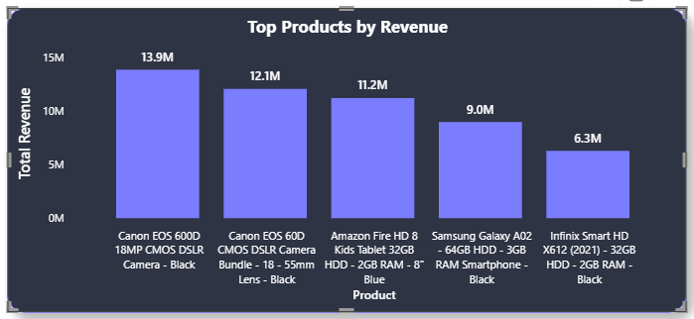

The revenue analysis was conducted using two visualizations: Top Products by Revenue and Total Revenue by Year. These charts provide insights into product-wise revenue contribution and annual sales performance.

Revenue Breakdown by Year
The annual revenue trend shows a generally positive growth pattern over the six-year period.
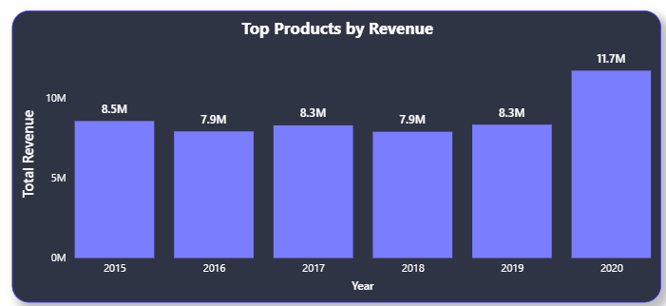

Key Observations:
- Revenue remained relatively stable between 2015 and 2019, fluctuating between 7.9M and 8.5M.
- A significant increase was observed in 2020, where revenue reached 11.7M, representing the highest sales performance during the analysis period.
- The sharp growth in 2020 indicates increased customer demand and improved business performance.
The analysis indicates that products such as the Canon EOS 600D DSLR Camera, Canon EOS 60D DSLR Camera, and Amazon Fire HD 8 Kids Tablet are the primary contributors to revenue. While overall revenue remained stable from 2015 to 2019, a significant increase occurred in 2020, demonstrating strong business growth. To reduce dependence on a few high-performing products and improve overall profitability, the company should focus on enhancing the visibility, promotion, and positioning of low-selling products through targeted marketing and product optimization strategies.
2. How many products were returned? Use a DAX function to get this metric. Examine the possible reasons for returns and consider how this metric could indicate improvements in product descriptions or quality control.

The return analysis was performed using a Donut Chart (Orders by Status) and a Bar Chart (Returned Products by Reason).
The results show that out of approximately 113K total orders, around 31K orders (27.01%) were returned, while 82K orders (72.99%) were successfully delivered. Although the majority of orders were delivered successfully, the return rate is significant and requires further investigation.
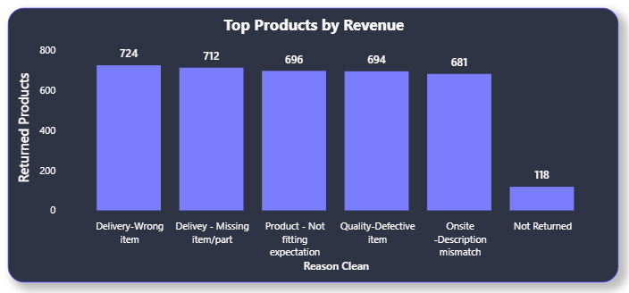

Key Findings
- Wrong item delivery is the most common reason for product returns, indicating potential issues in order fulfillment and warehouse operations.
- Missing items or parts suggest packaging or shipment verification problems.
- A large number of customers returned products because the product did not meet expectations, indicating gaps between customer expectations and actual product performance.
- Defective products highlight quality control concerns that should be addressed before products are shipped.
- Description mismatch indicates that product information, specifications, or images displayed on the website may not accurately represent the actual product.

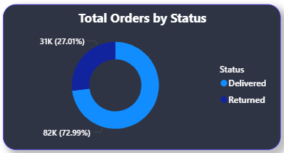
The analysis revealed that approximately 31K orders (27.01%) were returned, with the primary reasons being wrong item delivery, missing items, products not meeting customer expectations, defective products, and description mismatches. By improving product descriptions, strengthening quality control procedures, and enhancing order fulfillment accuracy, the company can reduce return rates, improve customer satisfaction, and increase profitability

3. Whenever a customer goes to Amazon, they’ll filter the most rated products to buy the better category. Can you verify this using any visualization or table that the ratings of products impact their sales value?
To verify whether product ratings influence sales performance, a scatter chart was created comparing Average Rating against Total Revenue for each product.
The analysis indicates a positive relationship between product ratings and sales value. Products with higher customer ratings generally tend to generate higher revenue and attract more orders. Highly rated products are perceived as more reliable and trustworthy by customers, making them more likely to be purchased.
Several top-selling products in the Electronics and Phones categories also exhibit above-average ratings, suggesting that customer satisfaction plays an important role in purchasing decisions. Conversely, products with lower ratings tend to generate lower revenue and fewer orders.

Key Findings
- Products with higher ratings generally achieve higher sales revenue.
- Highly rated products attract more customer purchases and repeat business.
- Customer ratings influence purchasing decisions by increasing buyer confidence.
- Products with lower ratings often experience reduced sales performance.
- Ratings can be used as an indicator of product quality and customer satisfaction.

Business Impact
Customer ratings serve as social proof and significantly influence consumer purchasing behavior on e-commerce platforms. Products with strong ratings benefit from increased visibility, improved conversion rates, and higher sales volumes.
Businesses can improve sales performance by:
- Monitoring low-rated products.
- Addressing quality issues identified through customer feedback.
- Improving product descriptions and specifications.
- Encouraging satisfied customers to leave reviews and ratings.

Conclusion
The analysis supports the assumption that product ratings impact sales value. Higher-rated products generally generate greater revenue and attract more orders, indicating that customer satisfaction and positive reviews play a crucial role in driving sales performance. Therefore, maintaining product quality and improving customer experience can directly contribute to increased revenue growth.

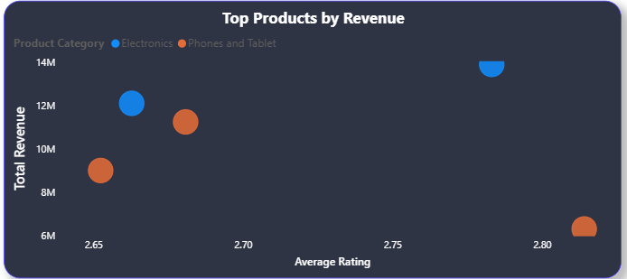

4. Investigate how revenue distribution varies across different locations. Explore which geographical areas contribute most to sales and consider the strategic implications for regional marketing and distribution efforts. How might location-based trends inform the company's market segmentation and resource allocation approach?

The revenue distribution analysis was performed to understand how sales vary across different geographical locations and identify regions that contribute the most to overall revenue.
The results indicate that revenue generation is not evenly distributed across locations. Certain regions consistently contribute a larger share of total sales, while others generate comparatively lower revenue. High-performing locations represent strong market demand and customer engagement, whereas lower-performing locations may indicate untapped growth opportunities.

Key Findings
- A small number of locations contribute a significant portion of total company revenue.
- High-revenue regions demonstrate stronger customer demand and purchasing activity.
- Some locations exhibit moderate revenue performance with potential for future growth.
- Low-performing regions may require additional marketing and distribution support.
- Geographic differences suggest variations in customer preferences, purchasing power, and market penetration.

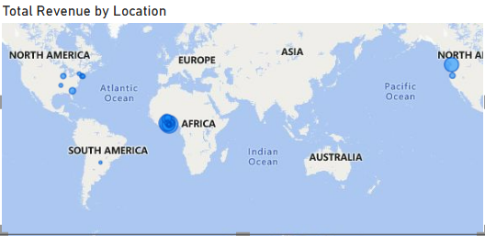

Resource Allocation Recommendations
- Allocate larger marketing budgets to high-growth and high-revenue regions.
- Prioritize inventory and supply chain resources in locations with strong demand.
- Invest in distribution infrastructure for regions experiencing rapid growth.
- Use customer behavior insights to optimize product assortment by location.
- Continuously monitor regional performance to support data-driven decision-making.
5. Determine which month could benefit from enhanced promotional offers to boost sales. Can you suggest some targeted marketing strategies here?

The monthly revenue trend was analyzed to identify periods of lower sales performance and determine where promotional activities could have the greatest impact.
Based on the monthly revenue chart, September, October, and November recorded comparatively lower revenue than other months. These months represent periods where customer purchasing activity declined, making them ideal candidates for targeted promotional campaigns.
In contrast, months such as January, March, April, and May generated stronger sales performance, indicating naturally higher customer demand.

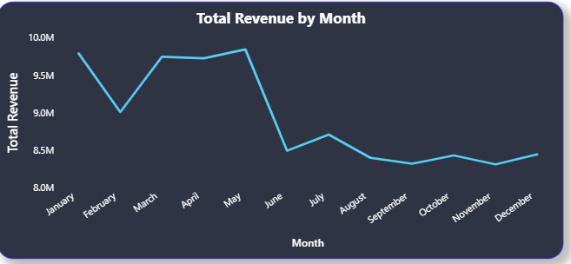

Key Findings
- Revenue declines during the later part of the year, particularly in September–November.
- Lower sales months present opportunities for promotional intervention.
- Sales performance varies seasonally, suggesting changes in customer purchasing behavior throughout the year.
- Increasing sales during low-performing months can improve annual revenue consistency.

Recommended Marketing Strategies

1. Seasonal Discount Campaigns
- Offer limited-time discounts during low-sales months.
- Introduce festive and seasonal promotions to stimulate customer demand.
- Create flash sales and weekend deals.

2. Product Bundling
- Bundle low-selling products with top-selling products.
- Offer package discounts to increase average order value.

3. Personalized Email Marketing
- Target existing customers using previous purchase history.
- Recommend products based on customer preferences.
- Send promotional offers and loyalty rewards.

4. Loyalty and Reward Programs
- Provide cashback, reward points, and exclusive member discounts.
- Encourage repeat purchases from existing customers.

5. Social Media and Digital Advertising
- Launch targeted advertising campaigns during low-performing months.
- Promote best-selling and seasonal products across digital channels.
- Utilize influencer and content marketing strategies.

6. Free Shipping Promotions
- Offer free or discounted shipping to increase conversion rates.
- Create minimum-order incentives to encourage larger purchases.
6. Identify which products may require increased marketing efforts. Which items have high prices yet underperform in sales?
To identify products requiring additional marketing support, products were analyzed based on their sales performance. The chart highlights products with the lowest average sales performance despite being available in the product portfolio.
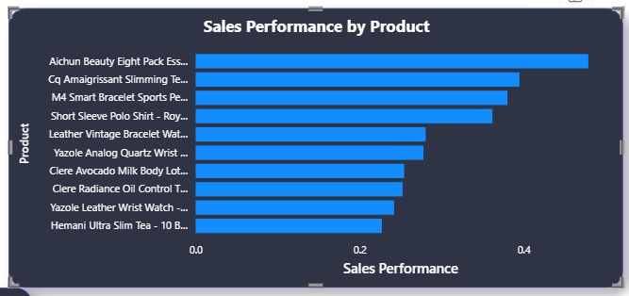

Key Findings
- The M4 Smart Bracelet recorded the lowest sales performance among the analyzed products.
- Fashion accessories such as Yazole Watches and Leather Vintage Bags generated relatively low sales despite being premium-priced items.
- Personal care products including Clere Avocado Milk and Clere Radiance Oil also demonstrated lower sales performance.
- These products may suffer from limited visibility, weak customer awareness, insufficient reviews, or strong market competition.

Possible Reasons for Underperformance
- High product prices compared to competing alternatives.
- Limited promotional activities and product exposure.
- Insufficient customer reviews and ratings.
- Weak product descriptions or product images.
- Low brand recognition within their respective categories.

Recommended Marketing Strategies

Product Visibility Enhancement
- Feature these products in homepage recommendations and promotional banners.
- Improve search ranking and category placement.

Promotional Campaigns
- Offer discounts, coupons, and seasonal deals.
- Introduce limited-time offers to encourage purchases.

Product Bundling
- Bundle underperforming products with top-selling products.
- Provide package discounts to increase exposure.

Customer Engagement
- Encourage customer reviews and ratings.
- Use email marketing and personalized recommendations.

Pricing Optimization
- Evaluate competitor pricing.
- Introduce strategic discounts where appropriate.
The analysis identified M4 Smart Bracelet, Yazole Watches, Leather Vintage Bags, and Clere personal care products as underperforming products requiring additional marketing attention. By improving product visibility, optimizing pricing strategies, and implementing targeted promotional campaigns, the company can increase customer engagement and improve sales performance for these products.

7. Assess which products should have discounts. How can targeted incentives drive sales and customer loyalty for specific products?
The analysis compares the average discount offered on products with the revenue generated by each product to identify products that could benefit from additional promotional incentives.
From the chart, products such as Canon EOS 600D DSLR Camera, Canon EOS 60D DSLR Camera, Amazon Fire HD 8 Kids Tablet, and Samsung Galaxy A02 generate significantly higher revenue compared to many other products. Conversely, several products show relatively low revenue despite receiving minimal or no discounts.
This suggests that certain low-performing products may benefit from targeted discount strategies to improve customer interest and sales performance.

Products Suitable for Additional Discounts
Based on low revenue contribution and limited sales performance, the following products may be considered for promotional discounts:
- M4 Smart Bracelet
- Leather Vintage Bag
- Yazole Analog Quartz Watch
- Short Sleeve Polo T-Shirt
- Clere Radiance Oil
- Clere Avocado Milk
- Hemani Products
- Fashion Accessories with low sales volumes
These products contribute less revenue compared to top-selling electronics and may require additional incentives to stimulate demand.
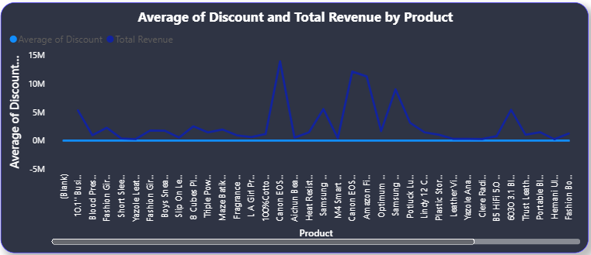

Targeted Incentive Strategies

Promotional Discounts
- Offer 10–20% discounts on low-performing products.
- Introduce limited-time offers to create urgency.

Product Bundling
- Bundle underperforming products with top-selling electronics.
- Example:
  - Smart Bracelet + Smartphone Accessories
  - Fashion Accessories + Watches

Loyalty Rewards
- Provide reward points or cashback on selected products.
- Encourage repeat purchases and long-term customer engagement.

Personalized Recommendations
- Recommend discounted products to customers with similar purchase histories.
- Use email marketing and retargeting campaigns.

Seasonal Campaigns
- Launch festive offers and category-specific promotions during low-sales periods.
The analysis indicates that several lower-performing products, particularly in the Fashion, Accessories, and Personal Care categories, would benefit from targeted discount strategies. By implementing promotional offers, product bundles, loyalty rewards, and personalized marketing campaigns, the company can increase sales, improve customer loyalty, and maximize overall business performance.
8. Come up with a loyalty program to benefit the company’s customers. From the available lot of customers come up with strategies to bucket them and provide benefits under different loyalty programs.
To design an effective loyalty program, customers were segmented into Bronze, Gold, Silver, and Platinum categories based on their purchasing behavior and revenue contribution. The segmentation analysis was performed using the Customer Revenue by Customer Segment and Total Revenue by Customer Segment visualizations.
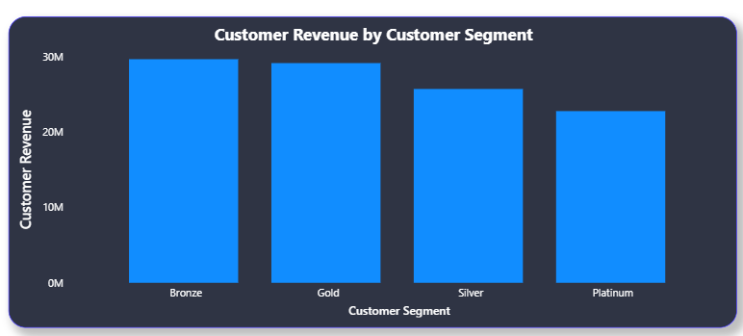

Key Findings
- Bronze and Gold customers contribute the highest share of revenue, accounting for more than 54% of total sales.
- Silver customers represent a stable customer base with moderate purchasing activity.
- Platinum customers contribute the lowest share of revenue but represent premium customers who should be retained through exclusive benefits.
- Revenue is distributed across all customer segments, highlighting the importance of customized loyalty strategies for each group.

Bronze Membership
Customer Profile
- New customers or low-frequency buyers.
- Entry-level loyalty tier.
Benefits
- Welcome coupons.
- 5% discount on selected products.
- Reward points on every purchase.
- Access to seasonal promotions.

Gold Membership
Customer Profile
- Regular customers with consistent purchasing activity.
Benefits
- 10% discount vouchers.
- Free standard shipping.
- Birthday rewards.
- Early access to promotional campaigns.

Silver Membership
Customer Profile
- Customers with moderate-to-high spending behavior.
Benefits
- Cashback rewards on purchases.
- Priority customer support.
- Exclusive member-only offers.
- Bonus reward points during promotional periods.

Platinum Membership
Customer Profile
- Premium customers with high engagement and long-term loyalty.
Benefits
- Free express delivery.
- Early access to new product launches.
- Dedicated customer support.
- Premium discounts and exclusive offers.
- Double reward points on every purchase.
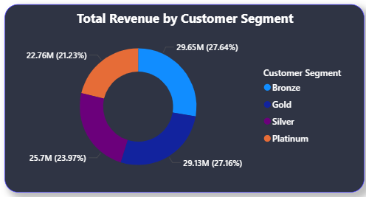

Targeted Customer Retention Strategies

Personalized Marketing
- Recommend products based on purchase history.
- Send customized email offers and product suggestions.

Reward Point System
- Customers earn points for every purchase.
- Points can be redeemed for discounts, vouchers, or free products.

Referral Program
- Reward customers for referring new buyers.
- Provide bonus points and discount coupons for successful referrals.

Tier Upgrade Incentives
- Encourage customers to move from Bronze to Gold, Silver, and Platinum through spending milestones.
- Offer milestone rewards to increase customer engagement.
The customer segmentation analysis shows that Bronze and Gold customers currently generate the highest revenue contribution, while Silver and Platinum customers represent valuable opportunities for long-term retention. By implementing a tier-based loyalty program with personalized rewards, discounts, cashback offers, and exclusive benefits, the company can improve customer satisfaction, increase repeat purchases, and drive sustainable revenue growth.

9. Using the DAX functions Calculate and a row iteration DAX function calculate the total sales for the Product Category “Fashion” and delivery type “Shipped from Abroad”. What are the other types of DAX functions you have used in the project?
To calculate the total sales for products belonging to the Fashion category and having the delivery type Shipped from Abroad, the CALCULATE function was used along with the row iteration function SUMX.
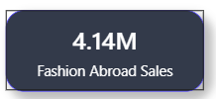
The total sales for Fashion products delivered through Shipped from Abroad were calculated using CALCULATE and SUMX, demonstrating the use of filter context and row iteration in DAX. Throughout the project, several DAX function categories were utilized, including Aggregation Functions, Filter Functions, Time Intelligence Functions, Logical Functions, Mathematical Functions, and Distinct Count Functions, enabling comprehensive analysis of sales, customers, products, and business performance.

10. Wait Times Correlated with Demographics and Care: Explore how average wait times vary across different product categories to optimize scheduling and staffing.
To examine how the average delivery time varies across different product categories and identify categories that experience longer delivery durations. This analysis helps optimize logistics operations, inventory planning, and customer satisfaction.
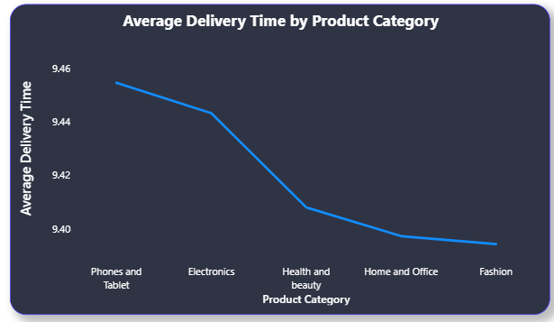
The analysis compares the average number of days required to deliver products across different product categories. Delivery time is a critical operational metric because it directly affects customer satisfaction and purchasing decisions.
The results indicate that delivery performance varies among product categories. Categories with higher average delivery times may be affected by factors such as international shipping, supplier location, inventory availability, or logistics complexity.
Products within categories that require longer delivery times may experience lower customer satisfaction and increased return rates if customer expectations are not properly managed.

Key Findings
- Some product categories require significantly longer delivery times than others.
- Categories involving imported or specialized products may experience shipping delays.
- Faster delivery categories contribute to a better customer experience.
- Delivery performance can influence customer retention and repeat purchases.
The analysis of average delivery time by product category helps identify operational inefficiencies and logistics bottlenecks. By optimizing inventory management, supplier coordination, and shipping processes, the company can improve delivery performance and enhance the overall customer experience.
11. Explore if there is any relationship between the Delivery type and waiting time between ordering and receiving an item.
To investigate the relationship between delivery type and customer waiting time, the average delivery days were analyzed for each delivery method.
The results show a clear relationship between the selected delivery type and the time required for customers to receive their orders.
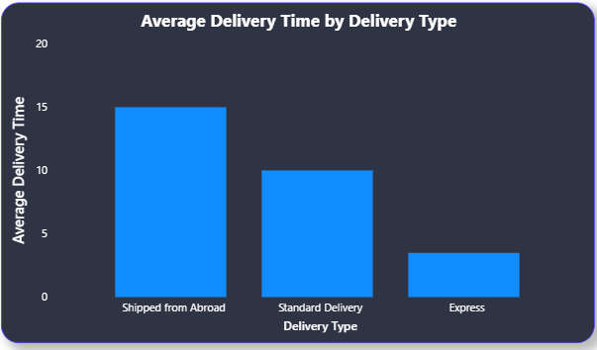
- Shipped from Abroad has the highest average delivery time, requiring approximately 15 days for order fulfillment.
- Standard Delivery requires around 10 days on average.
- Express Delivery is the fastest option, with an average delivery time of approximately 4 days.
- The waiting time decreases as customers choose faster delivery services.

Recommendations

Improve International Logistics
- Establish regional warehouses for imported products.
- Reduce shipping lead times for overseas orders.

Promote Express Delivery
- Offer express shipping benefits to loyalty program members.
- Provide discounted express delivery during promotional campaigns.

Set Accurate Customer Expectations
- Display estimated delivery dates clearly before checkout.
- Provide real-time shipment tracking.

Inventory Optimization
- Maintain stock of high-demand products in local fulfillment centers to reduce dependency on international shipping.
12. Is there any relationship between shipping charges and product type?
The relationship between Shipping Fee and Product Type (Product Category) was analyzed to determine whether certain categories incur higher shipping costs than others.
The analysis indicates that shipping charges vary across product categories due to differences in product size, weight, packaging requirements, and delivery complexity. Categories containing larger or heavier products generally require higher shipping fees, while lightweight products tend to have lower shipping costs.

Key Findings
- Electronics and Phones & Tablets generally attract higher shipping charges due to their higher value and special handling requirements.
- Fashion products typically incur lower shipping costs because they are lightweight and easier to transport.
- Home and Office products may have moderate shipping charges depending on product dimensions and packaging needs.
- Variations in shipping fees across categories suggest that logistics costs are influenced by product characteristics.

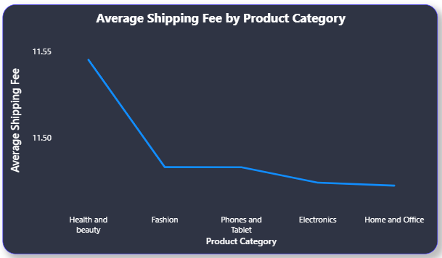
The analysis indicates a clear relationship between Shipping Charges and Product Type. Product categories such as Electronics and Phones & Tablets generally incur higher shipping costs due to their size, value, and handling requirements, while categories such as Fashion typically have lower shipping charges. Understanding these trends helps the company optimize logistics operations, pricing strategies, and customer incentives.
13. Come up with strategies to decrease the low rating orders after analyzing different factors like waiting time, shipping type, unit price, etc.
To identify the factors contributing to low customer ratings and recommend strategies to improve customer satisfaction, product ratings, and overall shopping experience.

Analysis
The analysis considered multiple factors including Delivery Time, Shipping Type, Unit Price, Product Quality, Return Reasons, and Customer Expectations.
The findings suggest that low-rated orders are often associated with longer delivery times, shipping issues, product description mismatches, defective products, and high-priced products that fail to meet customer expectations.

Key Factors Affecting Low Ratings

1. Long Waiting Time
- Products with longer delivery times tend to receive lower ratings.
- Orders shipped through "Shipped from Abroad" generally experience the highest waiting times.
- Delayed deliveries negatively impact customer satisfaction.

2. Shipping Type
- Customers using slower shipping methods are more likely to provide lower ratings.
- Express deliveries generally result in better customer experiences and higher ratings.

3. High Unit Price Products
- Customers purchasing premium-priced products have higher expectations.
- When product quality or features do not justify the price, lower ratings are often observed.

4. Product Description Mismatch
- One of the major return reasons was Onsite Description Mismatch.
- Products that differ from advertised specifications tend to receive poor ratings.

5. Product Quality Issues
- Defective products and damaged deliveries contribute significantly to negative customer feedback.
- Quality-related complaints often result in low ratings and returns.

Recommended Strategies

Improve Delivery Performance
- Reduce average delivery time by optimizing logistics operations.
- Increase inventory availability in regional warehouses.
- Promote faster shipping methods for high-demand products.

Enhance Product Descriptions
- Provide accurate specifications and product dimensions.
- Use high-quality images and videos.
- Include detailed feature explanations and usage information.

Strengthen Quality Control
- Implement additional product inspections before shipment.
- Monitor products with consistently low ratings.
- Improve supplier quality management processes.

Optimize Pricing Strategy
- Offer discounts or promotional incentives on high-priced products with lower ratings.
- Ensure pricing accurately reflects product value and quality.

Improve Customer Support
- Resolve customer complaints quickly.
- Offer hassle-free returns and refunds.
- Provide proactive communication regarding shipment status.

Encourage Customer Reviews
- Request feedback from satisfied customers.
- Increase the number of verified reviews to build trust and confidence.
The analysis indicates that long delivery times, slower shipping methods, high product prices, product description mismatches, and quality issues are the primary drivers of low customer ratings. By improving logistics efficiency, strengthening quality control, enhancing product information, and providing better customer support, the company can significantly reduce low-rated orders and improve the overall customer experience.
14. Using the time intelligence DAX function, create a table to compare each month’s sales with the previous year’s same month’s total sales. So there will be four columns in the output year, month, total sales, previous_years_sales
The comparison reveals the month-wise sales performance across different years. By comparing each month's revenue with the corresponding month from the previous year, growth trends and seasonal variations can be identified.
The analysis shows that revenue remained relatively stable between 2015 and 2019, while a substantial increase was observed in 2020. For example, January 2020 generated significantly higher revenue than January 2019, indicating strong year-over-year growth. Similar growth patterns can be observed across several months in 2020.
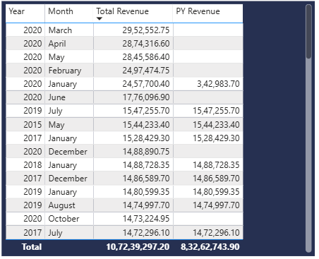

Key Findings
- Revenue increased significantly during 2020 compared to previous years.
- Several months recorded higher sales than the same month in the preceding year.
- Seasonal sales patterns are visible across the six-year period.
- The Time Intelligence comparison helps identify growth opportunities and periods requiring additional marketing efforts.

Conclusion
Using the SAMEPERIODLASTYEAR() DAX function enabled a detailed month-over-month comparison against historical performance. The results indicate positive sales growth, particularly during 2020, and provide valuable insights for forecasting, budgeting, and strategic business planning.
15. What do you understand by PowerBI gateway? What are its use cases?
Power BI Gateway is a software application that acts as a secure bridge between on-premises data sources and Microsoft Power BI services in the cloud. It enables Power BI to access, refresh, and query data stored within an organization's local network without moving the data to the cloud.
The gateway ensures secure communication by encrypting data and allowing controlled access between on-premises systems and Power BI Service.

Types of Power BI Gateway

1. Personal Mode Gateway
- Designed for individual users.
- Supports scheduled refreshes.
- Cannot be shared with other users.
- Suitable for personal reports and dashboards.

2. Standard (Enterprise) Gateway
- Designed for organizations.
- Supports multiple users.
- Can be shared across Power BI, Power Apps, Power Automate, and Azure services.
- Supports both scheduled refresh and DirectQuery connections.

Use Cases of Power BI Gateway

Scheduled Data Refresh
- Automatically refreshes Power BI reports and dashboards using on-premises databases such as SQL Server, Oracle, or MySQL.

Real-Time Reporting
- Enables DirectQuery and Live Connection to on-premises data sources for real-time analytics.

Secure Data Access
- Allows cloud-based Power BI reports to access local enterprise data securely without exposing databases to the internet.

Enterprise Reporting
- Supports organization-wide reporting by connecting Power BI Service to internal business systems.

Integration with Microsoft Services
- Used by Power Apps, Power Automate, Azure Analysis Services, and Power BI for accessing on-premises data.
Power BI Gateway is a secure data connectivity solution that enables Power BI Service to access on-premises data sources. Its primary use cases include scheduled data refresh, real-time reporting, secure data access, enterprise reporting, and integration with other Microsoft services, making it an essential component for organizations using both local and cloud-based data environments.
16. How would you approach this problem, if the objective and subjective questions weren't given?
If the business questions were not provided, I would follow a structured exploratory data analysis (EDA) and business intelligence approach to identify meaningful insights from the dataset.

Step 1: Understand the Dataset
First, I would examine:
- Number of records and columns.
- Data types and relationships.
- Business entities such as Customers, Orders, Products, Revenue, Ratings, Shipping, and Returns.
- Key metrics available for analysis.

Step 2: Data Cleaning and Preparation
Using Power Query, I would:
- Handle missing and null values.
- Correct data type inconsistencies.
- Remove duplicate records.
- Create derived columns such as Year, Month, Delivery Days, and Revenue.
- Build a Date Table for time intelligence analysis.

Step 3: Define Key Business KPIs
I would identify the most important KPIs:
- Total Revenue
- Total Orders
- Unique Customers
- Unique Products
- Average Order Value
- Average Rating
- Return Rate
- Average Delivery Time
- Shipping Cost

Step 4: Analyze Sales Performance
Key questions I would investigate:
- Which years generate the highest revenue?
- Which months perform best and worst?
- What are the revenue trends over time?
- Which products contribute the most revenue?

Step 5: Customer Analysis
I would analyze:
- Customer purchasing behavior.
- Repeat vs new customers.
- Customer segmentation based on spending.
- Revenue contribution by customer groups.

Step 6: Product Analysis
I would explore:
- Best-selling products.
- Underperforming products.
- Product categories generating the most revenue.
- Product ratings and their impact on sales.

Step 7: Delivery and Logistics Analysis
I would investigate:
- Delivery time by shipping type.
- Relationship between shipping fee and product category.
- Return reasons and their impact on customer satisfaction.

Step 8: Geographic Analysis
I would analyze:
- Revenue by location.
- Customer distribution across regions.
- High-performing and low-performing markets.

Step 9: Customer Experience Analysis
I would evaluate:
- Ratings distribution.
- Return rates.
- Delivery performance.
- Product quality issues.

Step 10: Generate Business Recommendations
Based on findings, I would provide recommendations related to:
- Marketing strategies.
- Loyalty programs.
- Inventory management.
- Product promotions.
- Customer retention.
- Logistics optimization.

