|  |  |  |  |  |  |
| --- | --- | --- | --- | --- | --- |
| **People from different education backgrounds appearing for MBA entrance test** | | | | | |
|
| Engg | Commerce | Arts |  |  |  |
| 78 | 66 | 77 |  |  |  |
| 68 | 41 | 43 |  |  |  |
| 55 | 52 | 82 |  |  |  |
| 92 | 62 | 91 |  |  |  |
| 84 | 71 | 54 |  |  |  |
| 40 |  | 33 |  |  |  |
|  |  | 40 |  |  |  |

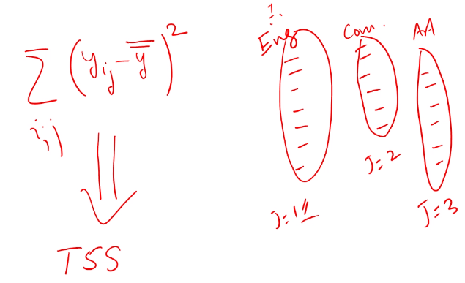

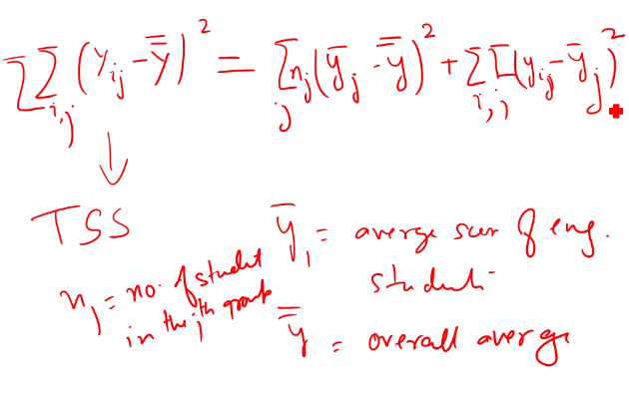

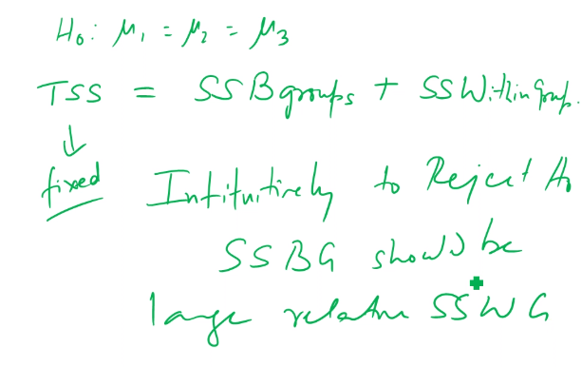

Degrees of freedom – when I use any information from sample the variability of the remaining values is the degrees of Freedom

MSBG = SSBG/df

MSWG = SSWG/df