Day 2 – Terraform Infrastructure Automation and ECS Setup ()
- Infrastructure as Code Concepts
- Manual console setup vs declarative provisioning.
- Version-controlled, repeatable deployments.
- Terraform Workflow Overview
- init → plan → apply → destroy cycle.
- What Terraform means by “desired state.”
- Terraform Files & Structure
- Terraform Variables (Theory)
- Purpose of variables (reusability & customization).
- Types: string, number, bool, map, list.
- Variable precedence (defaults > tfvars > CLI > env).
- Create the AWS Resource using KMS using Terraform Code

Day 2 – Terraform Infrastructure Automation & ECS Setup
Learning Outcome (Senior-Level)
By end of Day 2, participants will:
- Understand Infrastructure as Code from enterprise architecture perspective
- Compare manual vs declarative provisioning (governance impact)
- Master Terraform workflow (init → plan → apply → destroy)
- Understand desired state model deeply
- Implement reusable Terraform structure
- Use variables professionally
- Create AWS KMS key via Terraform
- Provision ECS cluster using Terraform

PART 1 – Infrastructure as Code (Enterprise Thinking)
Professional Explanation
Infrastructure as Code (IaC) means:
Infrastructure defined as version-controlled code.
Traditional model:
Engineer → Console → Click → Resource created
Enterprise Problem:
- No tracking
- No reproducibility
- Human error
- No audit
Terraform model:
Git Repo → Terraform Code → Plan → Apply → Infrastructure
Enterprise Advantage:
- Version control
- Peer review
- Repeatable environments
- Disaster recovery ready

Professional Demo 1: Manual Console vs Terraform
Scenario
Company needs 3 environments:
- Dev
- QA
- Prod
Manual Console Issues:
- Different configurations
- Missed tags
- Wrong security group
Terraform Solution:
Single codebase with variable-based environments.

PART 2 – Terraform Workflow Deep Dive
Terraform Lifecycle
terraform init
terraform plan
terraform apply
terraform destroy

Professional Demo 2 – Basic Terraform Workflow
Step 1: Install Terraform
Verify:
terraform -version

Step 2: Create Project Structure
aws-terraform-project/
├── main.tf
├── variables.tf
├── terraform.tfvars
├── outputs.tf

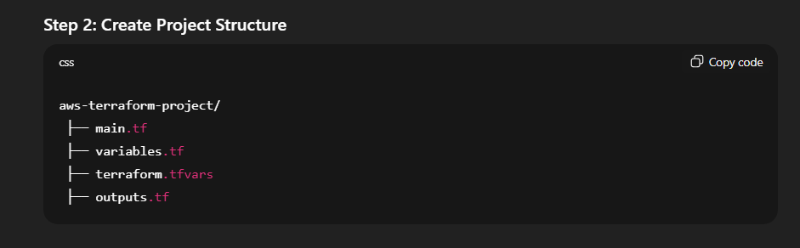

Lab 1 – First Terraform Resource (S3 Example)
main.tf
provider "aws" {
region = "ap-south-1"
}

resource "aws_s3_bucket" "company_bucket" {
bucket = "company-dev-bucket-unique-12345"

tags = {
Environment = "Dev"
Owner = "PlatformTeam"
}
}
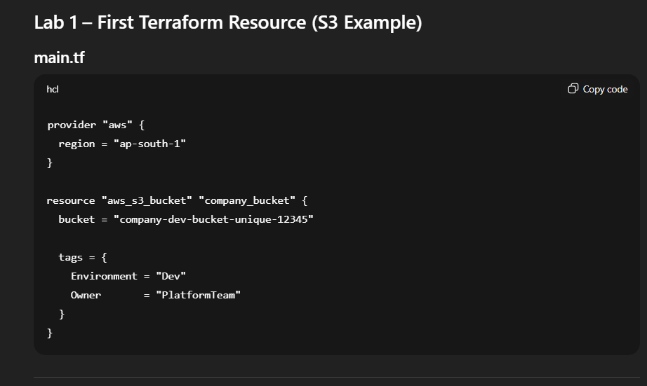

Step 3: Run Workflow
Initialize
terraform init
See Execution Plan
terraform plan
Explain:
Terraform compares:
- Current state
- Desired state (code)
Shows delta.

Apply
terraform apply
Confirm: yes

Destroy
terraform destroy
Enterprise Use Case:
Environment teardown after testing.

PART 3 – Desired State Model (Deep Understanding)
Terraform does NOT say:
"Create bucket"
It says:
"This is what infrastructure should look like."
Terraform then:
- Compares real world
- Makes changes to match desired state
Enterprise Example:
If bucket deleted manually,
Next terraform apply → Recreates bucket.
This ensures compliance.

PART 4 – Terraform File Structure (Professional Standard)
Enterprise Structure:
project/
├── main.tf
├── variables.tf
├── outputs.tf
├── terraform.tfvars
├── backend.tf
├── modules/
├── ecs/
├── kms/
├── vpc/
Why modular?
- Reusability
- Team collaboration
- Governance

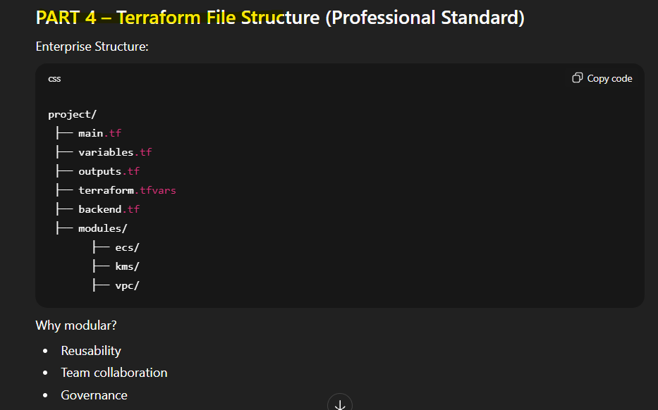

PART 5 – Terraform Variables (Professional Usage)
Why Variables?
Avoid hardcoding:
Bad:
region = "ap-south-1"
Good:
region = var.aws_region

variables.tf
variable "aws_region" {
type = string
description = "AWS Region"
}

variable "environment" {
type = string
default = "dev"
}

variable "enable_deletion" {
type = bool
default = false
}
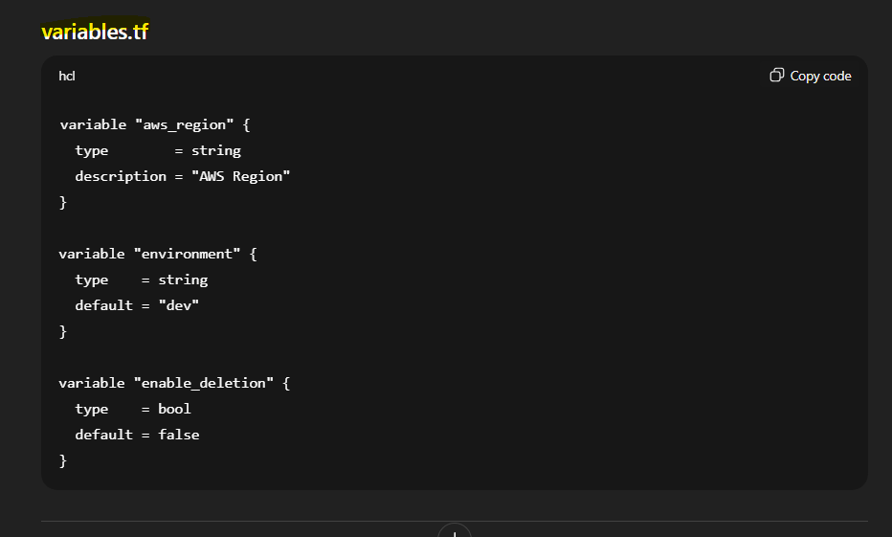

terraform.tfvars
aws_region = "ap-south-1"
environment = "dev"
enable_deletion = true

Variable Precedence (Enterprise Exam Concept)
Lowest → Highest:
- Default in variable block
- terraform.tfvars
- CLI -var
- Environment variables
Enterprise Scenario:
CI/CD pipeline overrides region via CLI.

PART 6 – Create AWS KMS Key Using Terraform
Enterprise Scenario
Finance application needs encryption.
Requirement:
- Centralized KMS key
- Rotation enabled
- Tagged properly

Lab 2 – Create KMS Key
main.tf
provider "aws" {
region = var.aws_region
}

resource "aws_kms_key" "company_kms" {
description = "Enterprise KMS Key"
deletion_window_in_days = 7
enable_key_rotation = true

tags = {
Environment = var.environment
Owner = "SecurityTeam"
}
}
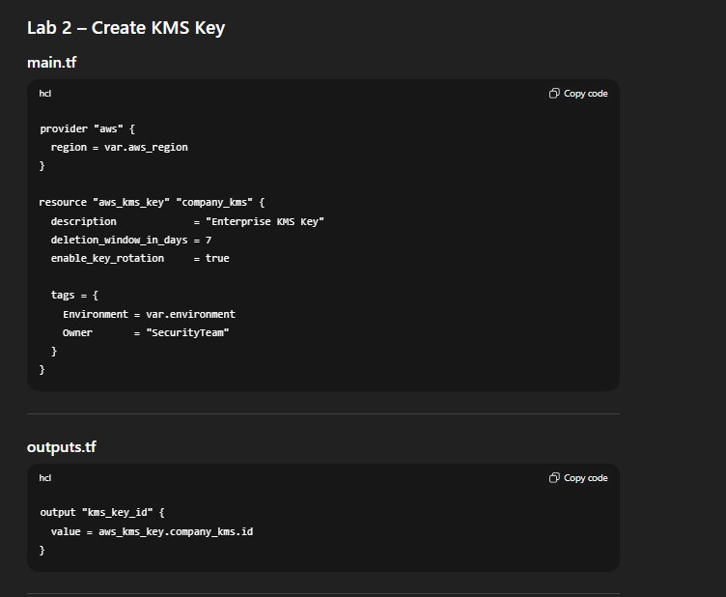

outputs.tf
output "kms_key_id" {
value = aws_kms_key.company_kms.id
}

Run:
terraform init
terraform plan
terraform apply
Verify in AWS Console → KMS → Keys
Enterprise Discussion:
Why enable rotation?
Compliance + audit requirements.

PART 7 – ECS Setup Using Terraform
Enterprise Scenario
Company wants containerized microservice platform.
Architecture:
ECS Cluster
↓
Task Definition
↓
Service
↓
Load Balancer

Lab 3 – Create ECS Cluster
main.tf
resource "aws_ecs_cluster" "company_cluster" {
name = "company-ecs-cluster"
}
Apply:
terraform apply
Verify in ECS Console.

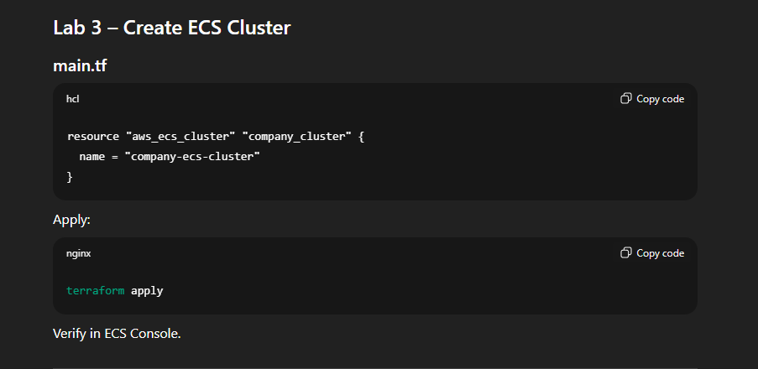

Professional Scenario – Real Enterprise Deployment
Company runs:
- 10 microservices
- 3 environments
- Central encryption via KMS
- ECS-based architecture
Terraform Flow:
GitHub
↓
Pull Request
↓
Terraform Plan
↓
Approval
↓
Terraform Apply
↓
Production Infrastructure

PART 8 – End-to-End Professional Lab
Objective:
Provision:
- KMS key
- ECS cluster
- S3 bucket (logs)

Lab Steps Summary
- Create folder structure
- Create variables.tf
- Create main.tf
- Add KMS resource
- Add ECS cluster resource
- Run:
- terraform init
- terraform plan
- terraform apply

Troubleshooting Demo (Important for Seniors)
Error:
Error: No valid credential sources found
Fix:
Configure AWS CLI first.

Error:
BucketAlreadyExists
Fix:
Use unique name.

Enterprise Best Practices (Very Important)
- Use remote backend (S3 + DynamoDB)
- Use state locking
- Never commit secrets
- Use modules
- Tag everything
- Use separate workspaces per environment

Architecture Summary – Day 2
Terraform Code
↓
Terraform State
↓
AWS API
↓
Infrastructure (KMS, ECS, S3)

Day 2 Professional Capstone
Build:
- Secure container platform
- Encrypted infrastructure
- Version-controlled IaC

