Day 3 – AWS CLI & SDK (Node.js or Python)
- CLI Scripting for EC2, RDS, IAM
- SDK Authentication and API Calls
Hands-on: Script EC2/RDS creation and test SDK query
- Why use the AWS CLI?
– Repeatable automation, faster testing, integration with shell scripts.
- CLI Configuration Concepts
– Access Key ID, Secret Key, Region, Output Format.
– Profiles (default vs custom).
- Command Structure Pattern– How to find help and documentation.
- CLI vs Console vs SDK
– When to choose each for automation.
Security Considerations
– IAM least-privilege roles, avoiding hard-coded keys, using SSO and environment variables.

Day 3 – AWS CLI & SDK Automation (Enterprise-Level)
Learning Outcome
By end of Day 3, participants will:
- Automate infrastructure using AWS CLI scripts
- Understand CLI command structure deeply
- Use profiles and secure authentication methods
- Automate EC2, RDS, IAM using CLI
- Integrate SDK into enterprise applications
- Implement secure SDK authentication
- Understand CLI vs SDK vs Console usage in production

PART 1 – Why Enterprise Uses AWS CLI
Enterprise Scenario
Developer needs to create:
- 10 EC2 servers
- Multiple environments (Dev, QA, Prod)
Manual Console → Slow and error-prone
CLI → Automated and repeatable
Enterprise Automation Flow:
Shell Script
↓
AWS CLI
↓
AWS API
↓
Infrastructure Created

Professional Demo 1 – AWS CLI Configuration (Enterprise Way)
Step 1: Configure CLI
Run:
aws configure
Enter:
Access Key ID
Secret Access Key
Region: ap-south-1
Output: json

Step 2: Verify Access
aws sts get-caller-identity
Expected Output:
{
"UserId": "...",
"Account": "...",
"Arn": "arn:aws:iam::xxxx:user/dev-user"
}
Enterprise Use Case:
Verify identity before running automation scripts.

PART 2 – CLI Profiles (Enterprise Multi-Account Setup)
Enterprise Scenario:
Company has:
- Dev Account
- QA Account
- Prod Account
Create profile:
aws configure --profile dev
Use profile:
aws s3 ls --profile dev
Enterprise Advantage:
Supports multi-account automation.

PART 3 – CLI Command Structure Pattern
Standard Structure:
aws <service> <operation> <parameters>
Examples:
List EC2 instances:
aws ec2 describe-instances
List IAM users:
aws iam list-users

Professional Demo 2 – Finding Help
Command help:
aws ec2 help
Specific help:
aws ec2 run-instances help
Enterprise Use Case:
Developers explore APIs quickly.

PART 4 – Automate EC2 Creation Using CLI
Enterprise Scenario
Auto-create server for application deployment.

Lab 1 – Create EC2 via CLI
Step 1: Create Security Group
aws ec2 create-security-group \
--group-name dev-sg \
--description "Dev Security Group"

Step 2: Launch EC2 Instance
aws ec2 run-instances \
--image-id ami-0f58b397bc5c1f2e8 \
--count 1 \
--instance-type t2.micro

Step 3: Verify Instance
aws ec2 describe-instances
Enterprise Automation Scenario:
DevOps pipeline auto-creates servers.

PART 5 – Automate IAM Using CLI
Lab 2 – Create IAM User via CLI
aws iam create-user --user-name automation-user
Attach policy:
aws iam attach-user-policy \
--user-name automation-user \
--policy-arn arn:aws:iam::aws:policy/AmazonEC2FullAccess
Enterprise Scenario:
Automated onboarding system.

PART 6 – Automate RDS Creation Using CLI
Enterprise Scenario
Application requires database automatically during deployment.

Lab 3 – Create RDS Instance
aws rds create-db-instance \
--db-instance-identifier dev-db \
--db-instance-class db.t3.micro \
--engine mysql \
--master-username admin \
--master-user-password Password123 \
--allocated-storage 20
Enterprise Use Case:
Automated database provisioning.

PART 7 – CLI Automation Script (Professional Demo)
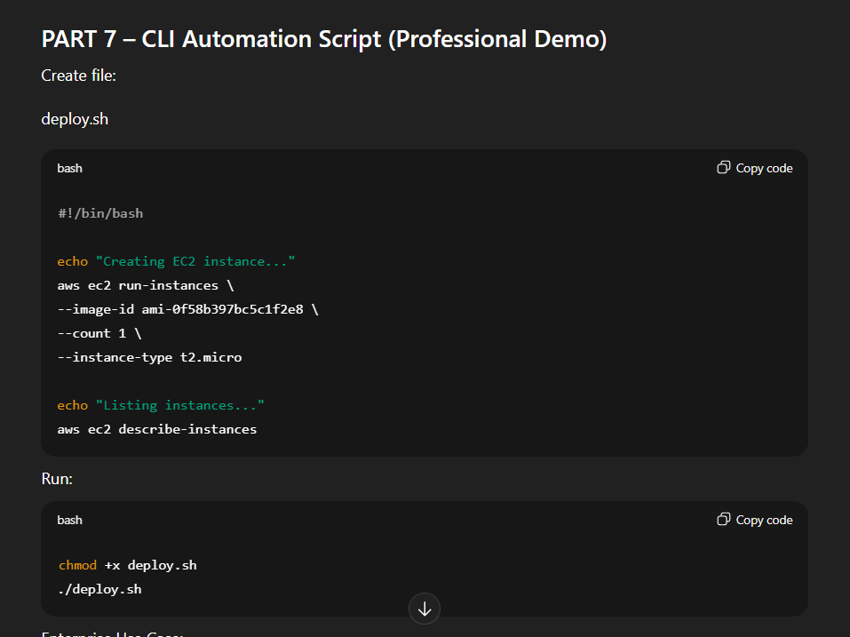
Create file:
deploy.sh
#!/bin/bash
echo "Creating EC2 instance..."
aws ec2 run-instances \
--image-id ami-0f58b397bc5c1f2e8 \
--count 1 \
--instance-type t2.micro

echo "Listing instances..."
aws ec2 describe-instances
Run:
chmod +x deploy.sh
./deploy.sh
Enterprise Use Case:
CI/CD automation.

PART 8 – SDK Authentication and API Calls
SDK is used inside applications.
Enterprise Architecture:
Enterprise Application
↓
AWS SDK
↓
AWS API

Professional Demo 3 – SDK Setup (Python)
Install:
pip install boto3

Lab 4 – SDK Query EC2 Instances
Python code:
import boto3

ec2 = boto3.client('ec2')

response = ec2.describe_instances()

for reservation in response['Reservations']:
for instance in reservation['Instances']:
print(instance['InstanceId'])
Enterprise Use Case:
Application monitors infrastructure.
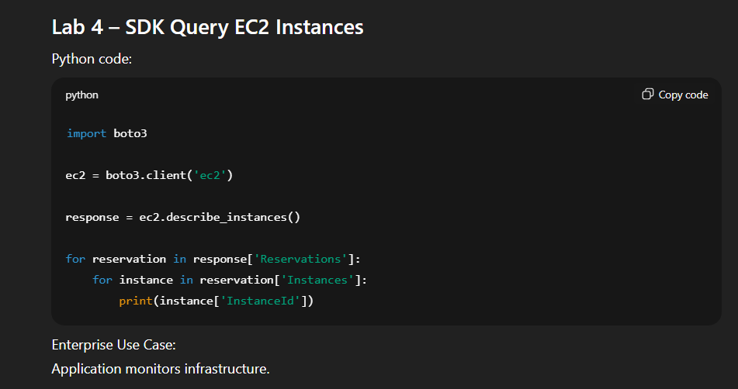

Professional Demo 4 – Create EC2 Using SDK
import boto3
ec2 = boto3.resource('ec2')
instance = ec2.create_instances(
ImageId='ami-0f58b397bc5c1f2e8',
MinCount=1,
MaxCount=1,
InstanceType='t2.micro'
)

print("Instance created:", instance[0].id)
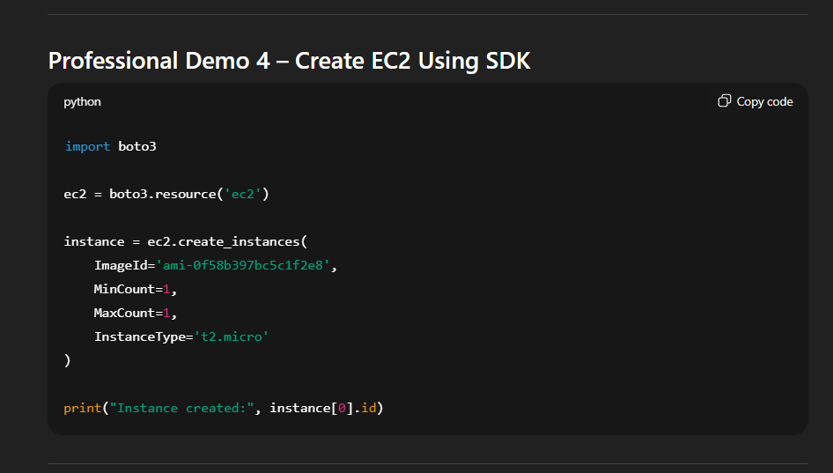

PART 9 – CLI vs Console vs SDK (Enterprise Comparison)
Tool | Use Case
Console | Manual troubleshooting
CLI | Automation scripts
SDK | Application integration
Enterprise Flow:
Application → SDK → AWS
DevOps → CLI → AWS
Admin → Console → AWS
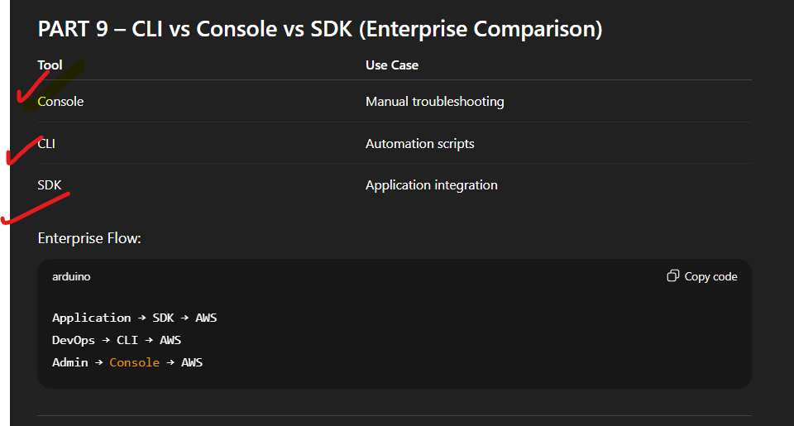

PART 10 – Security Best Practices (Critical Enterprise Topic)
Never hardcode keys like:
aws_access_key_id="ABC"
Use:
CLI configured credentials
OR environment variables:
export AWS_ACCESS_KEY_ID=xxx
export AWS_SECRET_ACCESS_KEY=xxx
OR IAM roles (best practice)

Professional Demo 5 – Using Environment Variables
Linux:
export AWS_ACCESS_KEY_ID=your_key
export AWS_SECRET_ACCESS_KEY=your_secret
Verify:
aws sts get-caller-identity

Enterprise Scenario – Production Application
Application running on EC2 uses IAM role:
EC2 Instance
↓
IAM Role
↓
AWS SDK
↓
S3 Access
No keys stored.
Secure architecture.

End-to-End Professional Lab
Participants will:
Step 1:
Configure CLI
Step 2:
Create EC2 using CLI
Step 3:
Create IAM user using CLI
Step 4:
Create RDS using CLI
Step 5:
Run SDK script to query EC2

Enterprise Architecture Summary
Shell Script
↓
AWS CLI
↓
AWS API
↓
Infrastructure

Application
↓
AWS SDK
↓
AWS API

Professional Troubleshooting Demo
Error:
Unable to locate credentials
Fix:
Run:
aws configure

Error:
AccessDenied
Fix:
Attach proper IAM policy.

Professional Capstone Lab – Enterprise Automation
Create script that:
- Creates EC2
- Creates IAM user
- Queries using SDK
Fully automated deployment.

