Day 4 – Amazon S3 Deep Dive
Introduction to Object Storage
- Difference between block, file, and object storage.
- Why S3 is a backbone for data storage in AWS.
Key S3 Concepts
- Buckets, Objects, and Regions.
- Object structure (key, value, metadata, version ID).
Storage Classes & Use Cases
- Standard, Intelligent-Tiering, Glacier, Deep Archive.
- Real-time example: Storing app logs vs archived backups.
S3 Features Overview
- Versioning, Lifecycle Management, Encryption (SSE-S3, SSE-KMS).
- Access Control: Bucket Policy, ACL, IAM Roles.
Cost Optimization Basics
- Data transfer cost, storage class transitions.

Day 4 – Amazon S3 Deep Dive (Enterprise-Level)
Learning Outcomes
By end of Day 4, participants will:
- Understand storage architecture types (block, file, object)
- Design enterprise storage using S3
- Implement versioning, encryption, lifecycle policies
- Secure S3 using IAM roles and bucket policies
- Optimize storage costs using storage classes
- Automate S3 using CLI and SDK

PART 1 – Storage Types Architecture
Enterprise Storage Comparison
Storage Type | Example | AWS Service | Use Case
Block Storage | Hard disk | EBS | Databases
File Storage | Network drive | EFS | Shared folders
Object Storage | Cloud storage | S3 | Logs, backups, media

Professional Architecture Example
Enterprise Application Storage Model:
Application Server (EC2)
↓
EBS → Database storage

Application
↓
EFS → Shared files

Application
↓
S3 → Logs, backups, media files

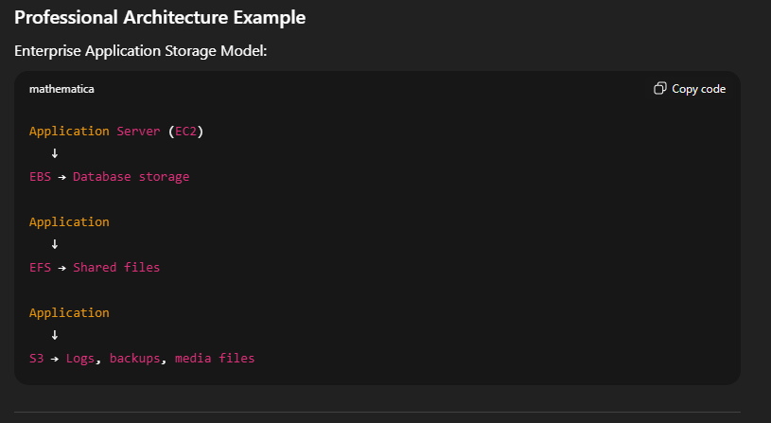

Professional Demo 1 – Why S3 is Backbone
Enterprise systems use S3 for:
- Application logs
- Backups
- Data lakes
- Machine learning datasets
- Static websites
Example Architecture:
Web Application
↓
Uploads files
↓
Amazon S3
↓
Analytics / Backup / Archive

PART 2 – S3 Key Concepts
Core Components
Bucket → Container
Object → File
Key → File path/name
Metadata → File info
Version ID → File version
Example Object Structure:
Bucket: company-data

Object Key:
logs/2026/app.log

Metadata:
Created date
Owner
Version ID

Lab 1 – Create S3 Bucket (Enterprise Standard)
Using CLI
aws s3 mb s3://company-prod-storage-unique123
Verify:
aws s3 ls

Upload Object
aws s3 cp test.txt s3://company-prod-storage-unique123/logs/test.txt
Verify:
aws s3 ls s3://company-prod-storage-unique123/logs/

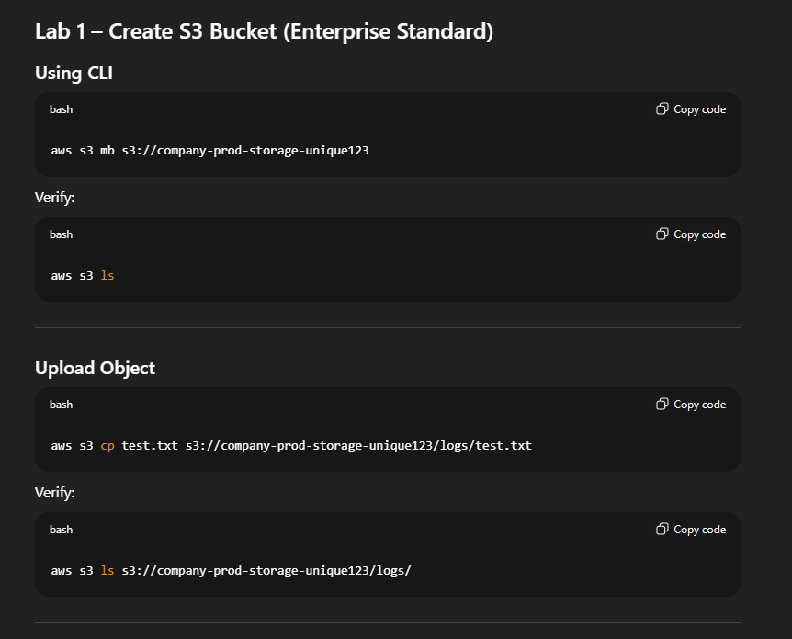

Enterprise Scenario
Application uploads logs automatically.

PART 3 – Storage Classes and Enterprise Use Cases
Storage Class Comparison
Storage Class | Use Case
Standard | Active application data
Intelligent-Tiering | Unknown access patterns
Glacier | Backup storage
Deep Archive | Long-term archive

Enterprise Example
Application logs lifecycle:
Day 0–30 → Standard
Day 30–90 → Intelligent-Tiering
Day 90–365 → Glacier
After 365 → Deep Archive
Cost reduction up to 90%.

Professional Demo 2 – Upload with Storage Class
aws s3 cp test.txt s3://company-prod-storage-unique123 \
--storage-class STANDARD_IA
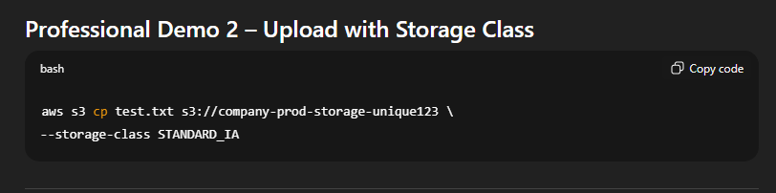

PART 4 – Versioning (Critical Enterprise Feature)
Why Versioning?
Protects against:
- Accidental deletion
- Overwrites
- Ransomware

Lab 2 – Enable Versioning
aws s3api put-bucket-versioning \
--bucket company-prod-storage-unique123 \
--versioning-configuration Status=Enabled

Test Versioning
Upload file:
aws s3 cp test.txt s3://company-prod-storage-unique123
Modify file and upload again.
List versions:
aws s3api list-object-versions \
--bucket company-prod-storage-unique123
Enterprise Benefit:
Recover any version.
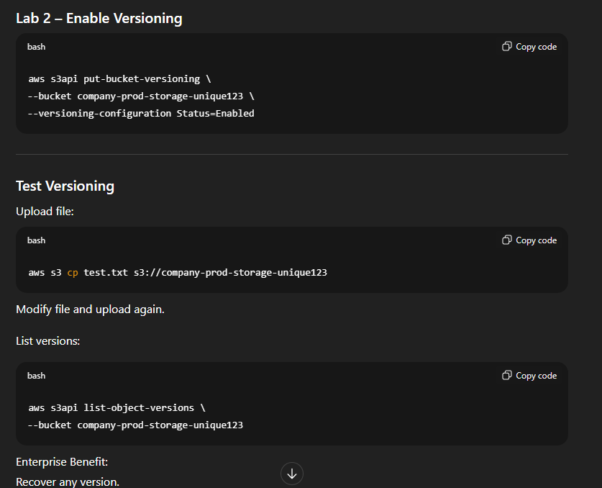

PART 5 – Lifecycle Management (Cost Optimization)
Enterprise Scenario:
Move old files automatically to Glacier.

Lab 3 – Lifecycle Policy
Create file lifecycle.json
{
"Rules": [
{
"ID": "ArchiveRule",
"Prefix": "",
"Status": "Enabled",
"Transitions": [
{
"Days": 30,
"StorageClass": "GLACIER"
}
]
}
]
}
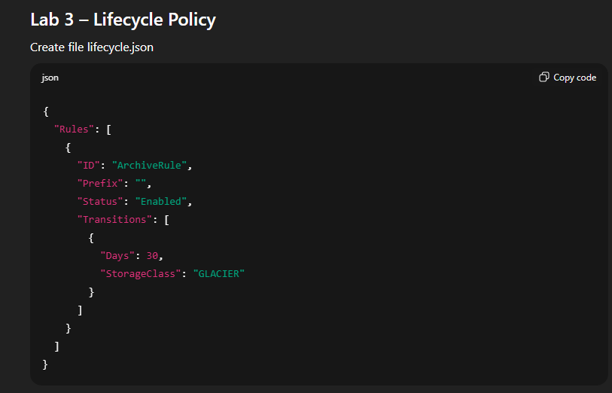
Apply policy:
aws s3api put-bucket-lifecycle-configuration \
--bucket company-prod-storage-unique123 \
--lifecycle-configuration file://lifecycle.json
Enterprise Benefit:
Fully automated cost optimization.
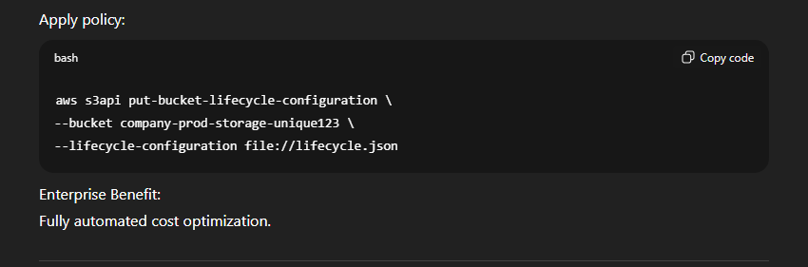

PART 6 – Encryption (Enterprise Security)
Encryption Types:
Encryption | Description
SSE-S3 | AWS managed
SSE-KMS | Enterprise-grade
Client-side | Application encrypts

Lab 4 – Enable Encryption (KMS)
aws s3api put-bucket-encryption \
--bucket company-prod-storage-unique123 \
--server-side-encryption-configuration '{
"Rules":[{
"ApplyServerSideEncryptionByDefault":{
"SSEAlgorithm":"AES256"
}
}]
}'
Enterprise Scenario:
Finance data protection.
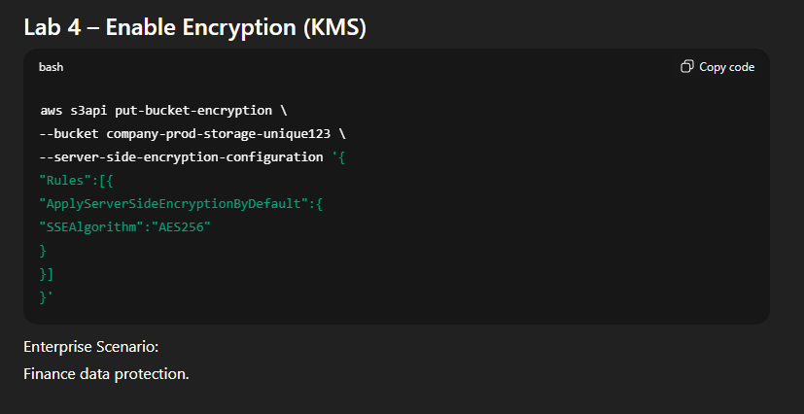

PART 7 – Access Control (Enterprise Security Model)
Access Methods:
- IAM Policies
- Bucket Policies
- IAM Roles
Enterprise Model:
Application
↓
IAM Role
↓
S3 Access

Professional Demo 3 – Bucket Policy Example
Allow EC2 access:
policy.json
{
"Version":"2012-10-17",
"Statement":[
{
"Effect":"Allow",
"Principal":"*",
"Action":"s3:GetObject",
"Resource":"arn:aws:s3:::company-prod-storage-unique123/*"
}
]
}
Apply:
aws s3api put-bucket-policy \
--bucket company-prod-storage-unique123 \
--policy file://policy.json
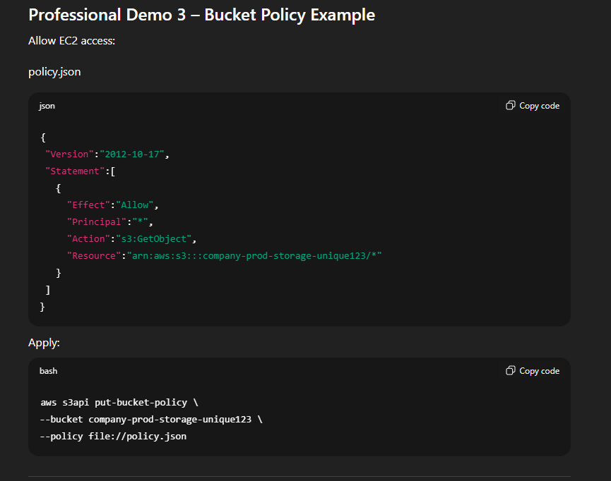

PART 8 – SDK Integration with S3
Lab 5 – Upload using Python SDK
import boto3

s3 = boto3.client('s3')

s3.upload_file(
'test.txt',
'company-prod-storage-unique123',
'logs/test.txt'
)
Enterprise Use Case:
Application uploads logs automatically.
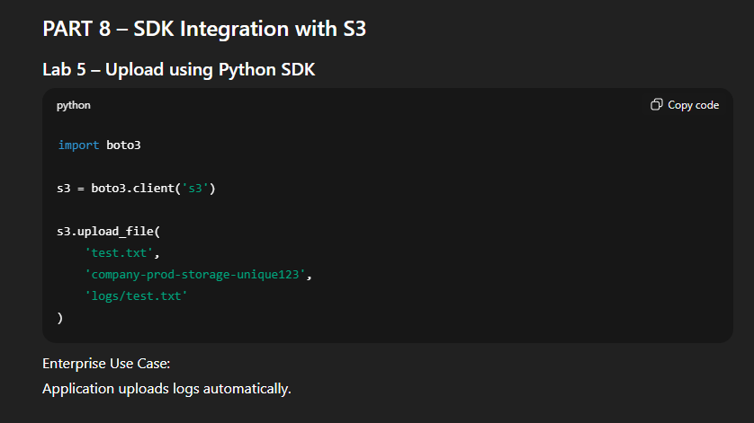

PART 9 – Enterprise Architecture Scenario
Production Application Architecture:
Application Server (EC2)
↓
IAM Role
↓
Amazon S3
↓
Lifecycle → Glacier
↓
Backup Storage
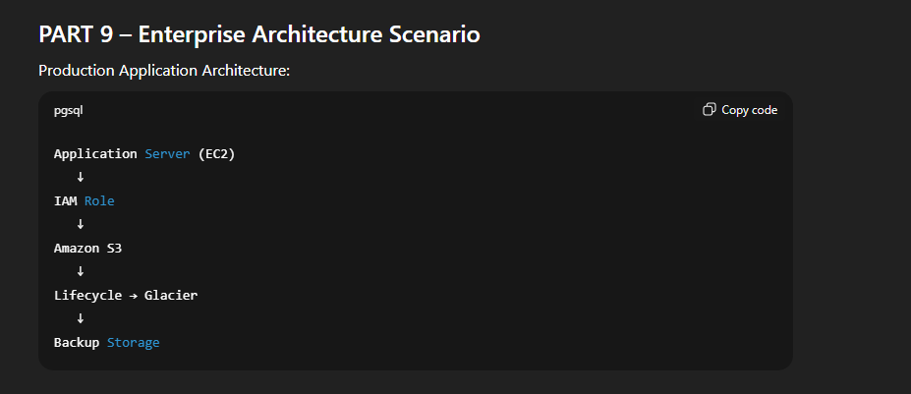

PART 10 – Cost Optimization Best Practices
Key Cost Factors:
- Storage class
- Data transfer
- Number of requests
Enterprise Strategy:
Use:
- Intelligent Tiering
- Lifecycle policies
- Compression

Professional Demo 4 – Analyze Storage
aws s3 ls s3://company-prod-storage-unique123 --recursive --human-readable --summarize

End-to-End Enterprise Lab
Participants will:
Step 1
Create S3 bucket
Step 2
Upload files
Step 3
Enable versioning
Step 4
Enable encryption
Step 5
Apply lifecycle policy
Step 6
Upload via SDK
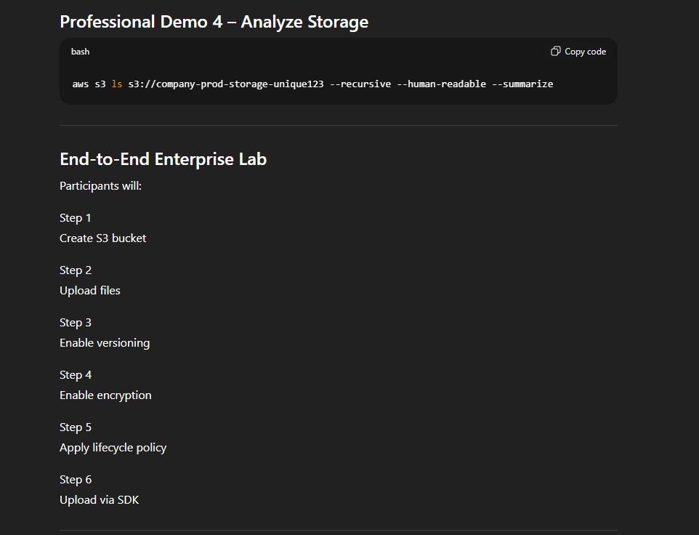

Professional Troubleshooting
Error:
AccessDenied
Fix:
Check IAM permissions.

Error:
BucketAlreadyExists
Fix:
Use globally unique name.
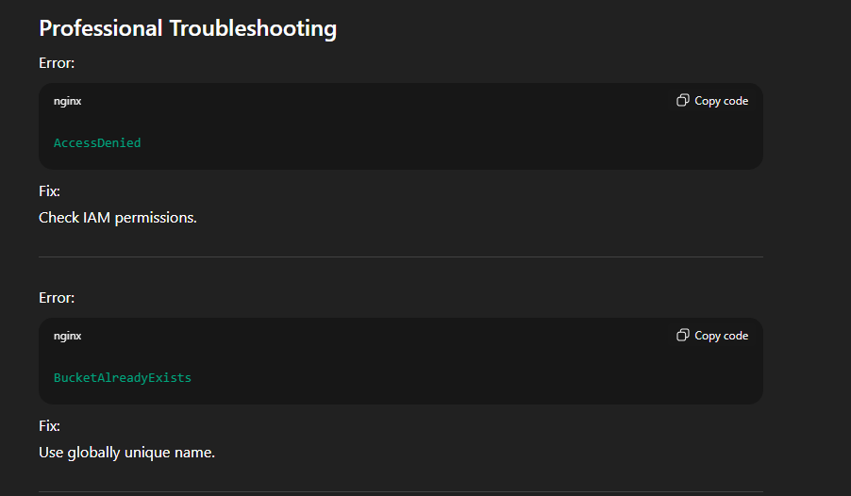

Enterprise Best Practices
Always:
- Enable versioning
- Enable encryption
- Use lifecycle policies
- Use IAM roles (not keys)
- Use storage classes wisely

Enterprise Architecture Summary
Application
↓
IAM Role
↓
S3 Bucket
↓
Versioning + Encryption
↓
Lifecycle → Archive

Professional Capstone Lab (Enterprise Scenario)
Build enterprise log storage system:
- Secure storage
- Version protection
- Cost optimization
- Automated lifecycle

