Day 5 – Lambda (Part 1) – Functions & Triggers
Lambda Introduction and Use Cases
- What is serverless computing?
- When to choose Lambda vs ECS/EKS.
Lambda Execution Model
- Function invocation flow, event sources, cold starts.
- Memory allocation and timeout configuration.
IAM Role & Permissions
- Execution role vs invocation permissions.
- How to grant Lambda access to Aurora RDS resources.
Networking Basics for Lambda (VPC Access)
- Public vs private Lambda configuration.
- Subnets, Security Groups, and NAT Gateway impact.
Environment Variables & Secrets
- Managing DB credentials via SSM Parameter Store or Secrets Manager.
- Encrypting environment variables with KMS.

Day 5 – AWS Lambda (Part 1) – Functions & Triggers (Enterprise-Level)
Learning Outcomes
By end of Day 5, participants will:
- Understand serverless architecture deeply
- Know when to use Lambda vs ECS/EKS
- Create Lambda functions with proper IAM roles
- Integrate Lambda with S3, API, and RDS
- Configure Lambda inside VPC securely
- Manage secrets using Parameter Store / Secrets Manager
- Implement enterprise-grade security model

PART 1 – Serverless Computing (Enterprise Perspective)
What is Serverless?
Serverless means:
You manage code, AWS manages infrastructure.
Traditional model:
Developer
↓
Provision EC2
↓
Install software
↓
Maintain server
Serverless model:
Developer
↓
Upload code
↓
AWS runs automatically
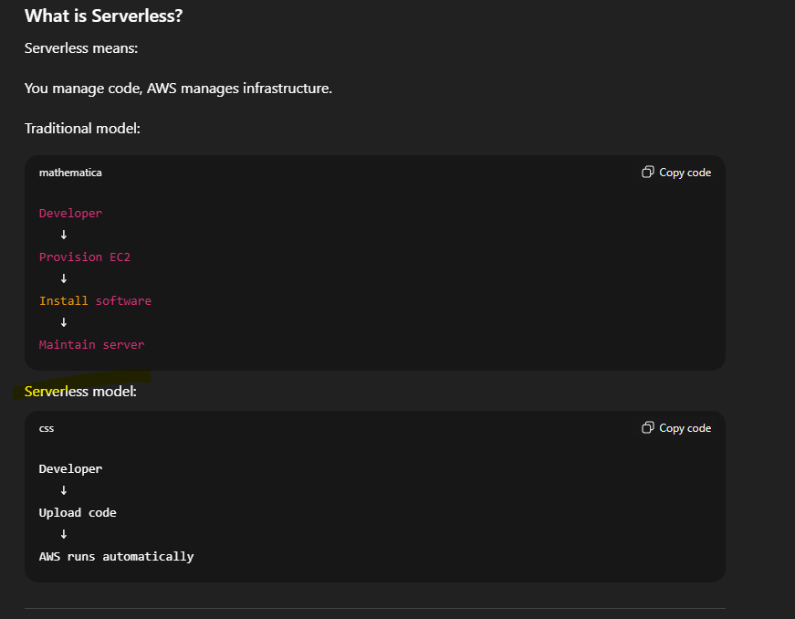

Enterprise Architecture Example
Traditional:
Application
↓
EC2 Server (always running)
Serverless:
Application Event
↓
Lambda Function
↓
Runs on demand
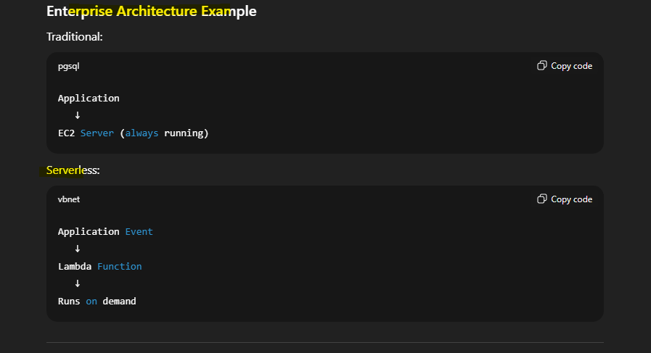

Enterprise Use Cases
Lambda used for:
- File processing
- API backend
- Event-driven automation
- Log processing
- Database triggers

Lambda vs ECS vs EKS (Enterprise Decision Matrix)
Use Case | Lambda | ECS | EKS
Short tasks | Yes | No | No
Long-running services | No | Yes | Yes
Microservices | Yes | Yes | Yes
Containers | No | Yes | Yes
Kubernetes required | No | No | Yes

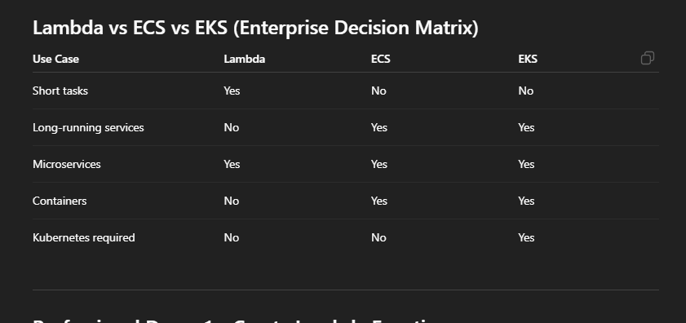

Professional Demo 1 – Create Lambda Function
Scenario
Application uploads file → Lambda processes file automatically.

Lab 1 – Create Lambda Function
Step 1: Go to AWS Console → Lambda
Click:
Create Function
Choose:
Author from scratch
Enter:
Function name: process-file-function
Runtime: Python 3.11
Choose:
Create new IAM role
Click Create.
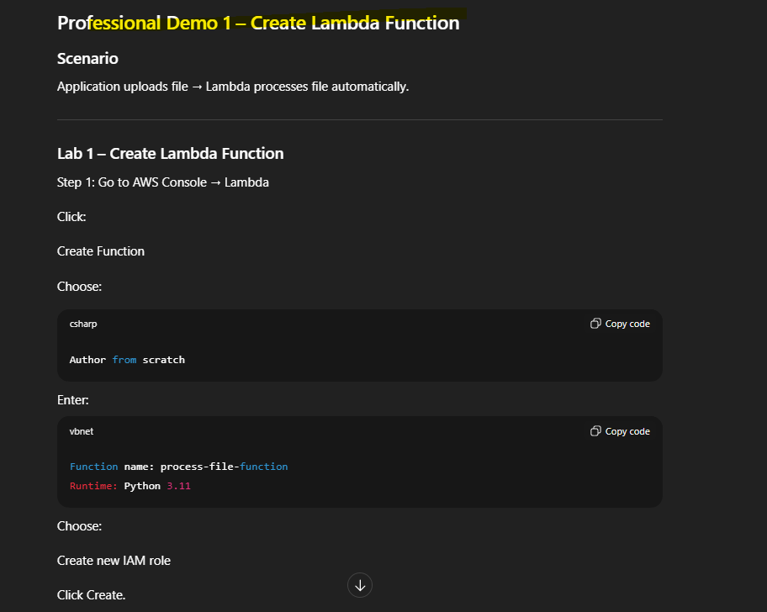

PART 2 – Lambda Execution Model
Invocation Flow Architecture
Event Source (S3/API/EventBridge)
↓
Lambda Service
↓
Execution Environment
↓
Function Runs
↓
Returns response
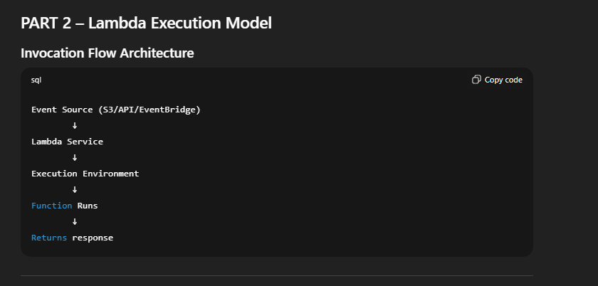

Professional Demo 2 – Lambda Execution Example
Code:
def lambda_handler(event, context):
print("Event received:", event)

return {
'statusCode': 200,
'body': 'Lambda executed successfully'
}
Click:
Deploy
Click:
Test
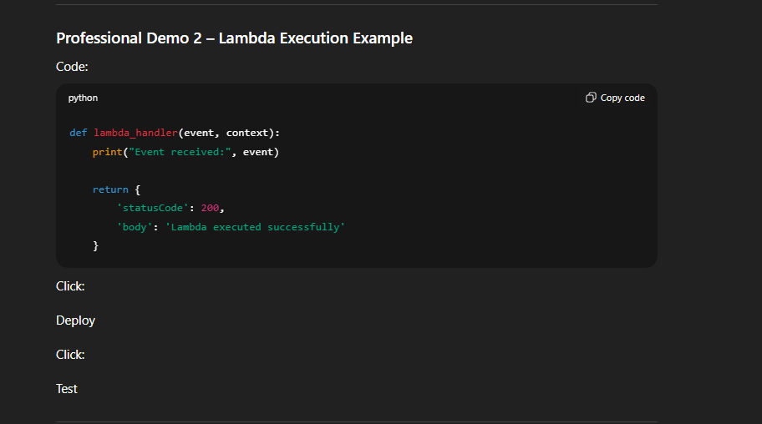

Explain Cold Start (Enterprise Concept)
Cold start occurs when:
Lambda starts new execution environment.
Impacts latency slightly.
Enterprise mitigation:
- Provisioned concurrency
- Proper memory configuration

PART 3 – Memory and Timeout Configuration
Enterprise tuning improves performance.
Example settings:
Memory: 512 MB
Timeout: 30 seconds
More memory → More CPU → Faster execution

Lab 2 – Configure Memory and Timeout
Go to:
Configuration → General Configuration
Edit:
Memory: 512 MB
Timeout: 30 sec
Save.

PART 4 – IAM Role & Permissions
Lambda uses execution role to access resources.
Architecture:
Lambda Function
↓
IAM Execution Role
↓
Access S3 / RDS / DynamoDB

Professional Demo 3 – Add S3 Access Permission
Go to:
Lambda → Configuration → Permissions
Click:
Execution Role → Add policy
Attach:
AmazonS3FullAccess

PART 5 – Lambda Access to Aurora RDS (Enterprise Scenario)
Architecture:
Lambda Function
↓
IAM Role
↓
Aurora RDS
Requirements:
- IAM Role permission
- VPC access
- Security group access

PART 6 – Lambda Networking (VPC Access)
Enterprise Database is inside private VPC.
Lambda must connect securely.
Architecture:
Lambda Function
↓
Private Subnet
↓
Security Group
↓
Aurora RDS

Lab 3 – Configure Lambda VPC Access
Go to:
Lambda → Configuration → VPC
Select:
- Your VPC
- Private subnet
- Security group
Save.

Enterprise Impact:
Lambda can now access database.

PART 7 – Environment Variables & Secrets
Never hardcode credentials.
Bad:
password = "admin123"
Enterprise Solution:
Use:
- Secrets Manager
- Parameter Store

Lab 4 – Add Environment Variable
Go to:
Lambda → Configuration → Environment Variables
Add:
DB_HOST = database-url
DB_USER = admin
Save.

PART 8 – Using Parameter Store (Enterprise Secure Method)
Store secret:
Go to:
SSM → Parameter Store → Create Parameter
Name:
db-password
Type:
SecureString

Professional Demo 4 – Access Parameter Store via Lambda
Code:
import boto3
ssm = boto3.client('ssm')
def lambda_handler(event, context):
response = ssm.get_parameter(
Name='db-password',
WithDecryption=True
)

password = response['Parameter']['Value']
print(password)
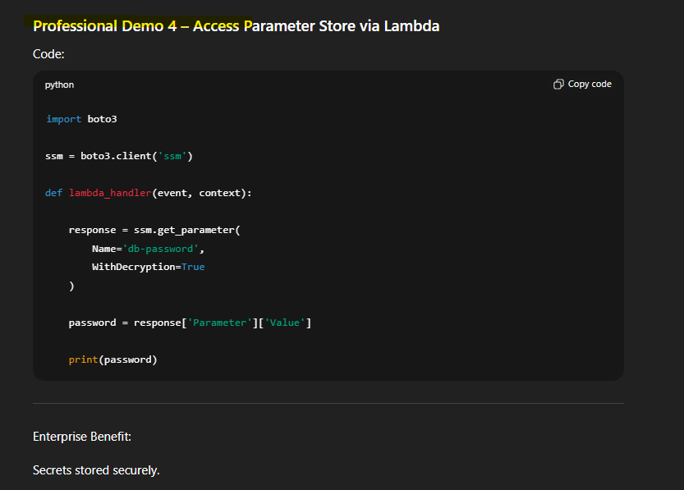

Enterprise Benefit:
Secrets stored securely.

PART 9 – Lambda Trigger Example (S3 Trigger)
Enterprise Scenario:
File upload triggers Lambda.
Architecture:
User uploads file
↓
S3 Bucket
↓
Lambda Triggered
↓
Process file

Lab 5 – Create S3 Trigger
Go to:
Lambda → Configuration → Triggers
Add trigger:
Select:
S3
Choose bucket.
Save.
Test by uploading file.
Lambda executes automatically.

PART 10 – Encryption using KMS
Enterprise uses KMS to encrypt secrets.
Architecture:
Secrets Manager
↓
KMS Encryption
↓
Lambda Access

Professional Demo 5 – Enable KMS Encryption
Go to:
Lambda → Configuration → Environment Variables
Enable encryption using KMS key.

Enterprise End-to-End Architecture Scenario
User uploads file
↓
S3 Bucket
↓
Lambda Function
↓
Fetch secret from Parameter Store
↓
Connect to Aurora RDS
↓
Store processed data
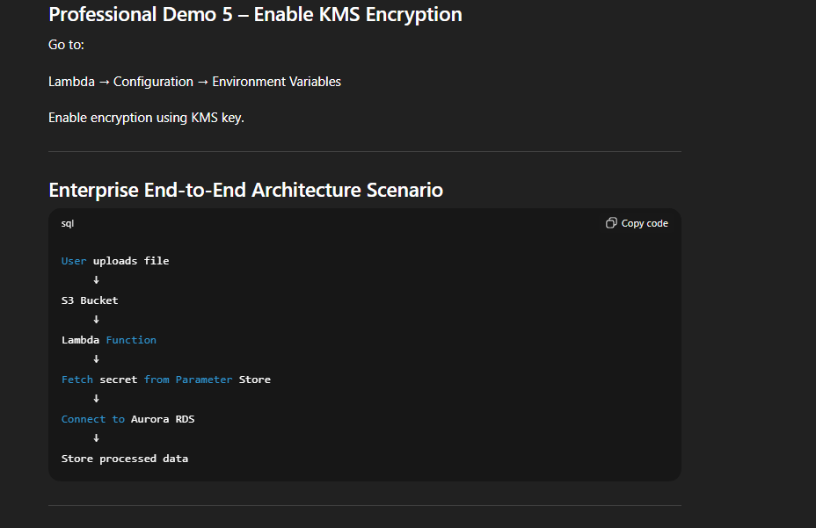

End-to-End Professional Lab
Participants will:
Step 1
Create Lambda function
Step 2
Configure IAM role
Step 3
Configure environment variables
Step 4
Store secrets in Parameter Store
Step 5
Configure VPC access
Step 6
Add S3 trigger
Step 7
Test Lambda execution

Professional Troubleshooting
Error:
AccessDeniedException
Fix:
Add proper IAM permissions.

Error:
Timeout error
Fix:
Increase timeout or fix networking.

Error:
Cannot connect to database
Fix:
Check security group rules.

Enterprise Best Practices
Always:
- Use IAM roles
- Use Parameter Store or Secrets Manager
- Use private VPC for database access
- Use KMS encryption
- Use environment variables

Enterprise Architecture Summary
S3 Event
↓
Lambda Function
↓
IAM Role
↓
Secrets Manager
↓
Aurora RDS

Professional Capstone Lab
Build secure serverless file processing system.

