Day 6 – KMS (Key Management Service) & RDS Integration ()
Why Encryption Matters
- Data at rest vs data in transit.
- Compliance (GDPR, HIPAA, PCI DSS) use cases.
- Shared responsibility for data protection.
Introduction to AWS KMS
- What is AWS Key Management Service?
- Types of Keys:
  - AWS Managed Keys (e.g., aws/rds)
  - Customer Managed Keys (CMK)
  - AWS Owned Keys
- Key components: Key ID, Key Policy, Grants, Aliases, Rotation.
KMS Key Management Concepts
- Envelope encryption concept.
- Key hierarchy (CMK → DEK → Resource Encryption).
- Automatic key rotation.
- Logging with CloudTrail for audit visibility.
Access Control in KMS
- How IAM and Key Policies work together.
- Least privilege for KMS usage (separate encrypt/decrypt roles).

Day 6 – AWS KMS & RDS Integration (Enterprise-Level)
Learning Outcomes
By end of Day 6, participants will:
- Understand enterprise encryption architecture
- Understand KMS key types and usage
- Implement encryption for RDS using KMS
- Implement secure key policies and IAM access
- Understand envelope encryption deeply
- Enable audit logging using CloudTrail
- Implement least privilege access model

PART 1 – Why Encryption Matters (Enterprise Security Foundation)
Enterprise Threat Model
Without encryption:
Database → Data stored in plain text
If attacker gains access → Data exposed.
With encryption:
Database
↓
Encrypted using KMS key
↓
Unreadable without key

Data at Rest vs Data in Transit
Type | Description | Example
Data at rest | Stored data encryption | RDS, S3
Data in transit | Network encryption | HTTPS, TLS
Enterprise Example:
Application → HTTPS → RDS (encrypted at rest)

Compliance Requirements (Enterprise)
Encryption required for:
- GDPR → User data protection
- HIPAA → Healthcare data
- PCI DSS → Payment data
Enterprise Example:
Payment database MUST use encryption.

PART 2 – AWS Shared Responsibility Model (Encryption Perspective)
AWS responsible for:
- Infrastructure security
Customer responsible for:
- Data encryption
- Key management
- Access control

PART 3 – AWS KMS Introduction
What is AWS KMS?
AWS KMS is key management service.
Used to:
- Create encryption keys
- Encrypt resources
- Control access to encryption keys
Architecture:
Resource (RDS, S3, Lambda)
↓
Data Encryption Key (DEK)
↓
Encrypted using CMK (in KMS)

PART 4 – Types of KMS Keys
1. AWS Managed Keys
Example:
aws/rds
aws/s3
Fully managed by AWS.
Limited control.

2. Customer Managed Keys (CMK) – Enterprise Recommended
Full control:
- Rotation
- Permissions
- Policies

3. AWS Owned Keys
Used internally by AWS.
Not visible to customer.

Professional Demo 1 – Create Customer Managed Key
Lab 1 – Create CMK
Go to:
AWS Console → KMS → Create Key
Select:
Symmetric
Choose:
Encrypt and decrypt
Enter:
Alias:
company-rds-key
Click Create.

PART 5 – Key Components
Component | Purpose
Key ID | Unique identifier
Alias | Human readable name
Key Policy | Defines access
Grants | Temporary access
Rotation | Automatic key change

PART 6 – Envelope Encryption (Critical Enterprise Concept)
Enterprise encryption uses 2-layer encryption.
Architecture:
Data
↓
Encrypted using DEK (Data Encryption Key)
↓
DEK encrypted using CMK
↓
Stored securely
Why?
Performance + security.

PART 7 – Key Hierarchy Architecture
Customer Managed Key (CMK)
↓
Data Encryption Key (DEK)
↓
Encrypt Resource
↓
RDS Database

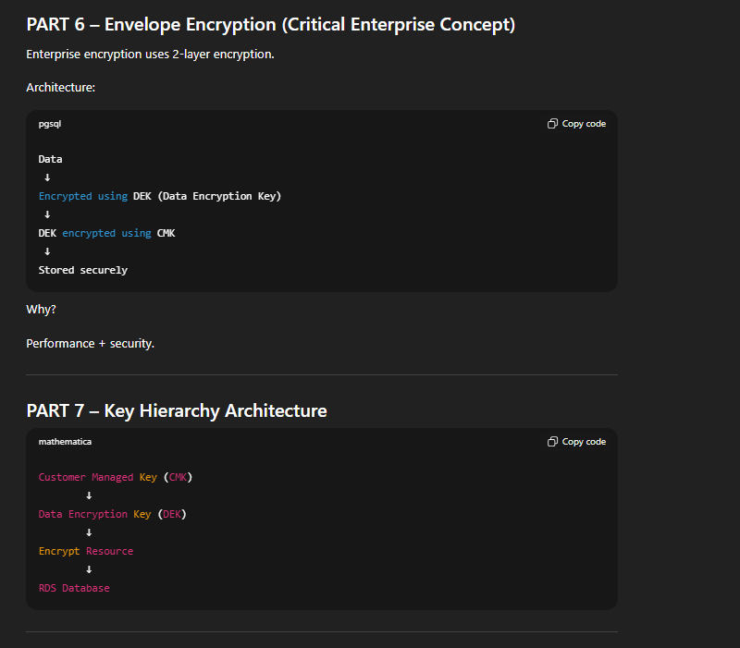

PART 8 – Enable Key Rotation
Enterprise security best practice.

Lab 2 – Enable Rotation
Go to:
KMS → Select key → Key rotation
Enable:
Automatic rotation
Rotation happens yearly.

PART 9 – Audit Logging using CloudTrail
Enterprise compliance requires audit.
CloudTrail logs:
- Who used key
- When used
- Which resource used
Architecture:
User
↓
KMS Key Usage
↓
CloudTrail logs event

Professional Demo 2 – View KMS Logs
Go to:
CloudTrail → Event History
Filter:
Event Source: kms.amazonaws.com
View logs.

PART 10 – Access Control in KMS
Access controlled by:
- IAM policies
- Key policies
Both must allow access.
Architecture:
IAM Role
↓
Key Policy
↓
KMS Key

Professional Demo 3 – IAM Policy for KMS
Example Policy:
{
"Effect": "Allow",
"Action": [
"kms:Encrypt",
"kms:Decrypt"
],
"Resource": "*"
}
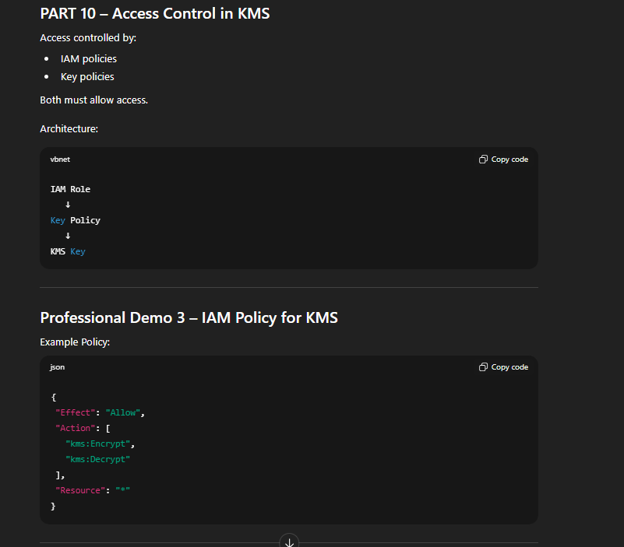

PART 11 – RDS Encryption using KMS (Enterprise Scenario)
Enterprise Architecture:
Application
↓
RDS Database
↓
Encrypted using KMS CMK

Lab 3 – Create Encrypted RDS Database
Go to:
RDS → Create database
Select:
Engine: MySQL
Enable:
Encryption
Choose:
company-rds-key
Create database.

Verify Encryption
Go to:
RDS → Database → Configuration
Check:
Encryption: Enabled
KMS key: company-rds-key

PART 12 – Lambda Access to Encrypted RDS
Enterprise architecture:
Lambda Function
↓
IAM Role
↓
KMS Key access
↓
Encrypted RDS

Lab 4 – Add Lambda Access to KMS
Attach policy to Lambda role:
{
"Effect": "Allow",
"Action": [
"kms:Decrypt"
],
"Resource": "*"
}

PART 13 – CLI Demo for KMS
Create key using CLI:
aws kms create-key \
--description "Enterprise encryption key"
List keys:
aws kms list-keys
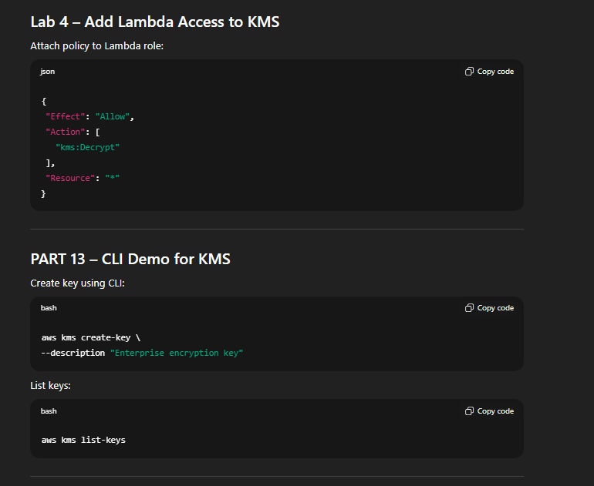

PART 14 – SDK Demo using Python
Encrypt data:
import boto3

kms = boto3.client('kms')

response = kms.encrypt(
KeyId='alias/company-rds-key',
Plaintext='Sensitive Data'.encode()
)

print(response['CiphertextBlob'])

Enterprise Scenario – Banking Application
Architecture:
Banking Application
↓
Lambda
↓
Encrypted RDS
↓
KMS Key
↓
CloudTrail Audit
Compliance satisfied.
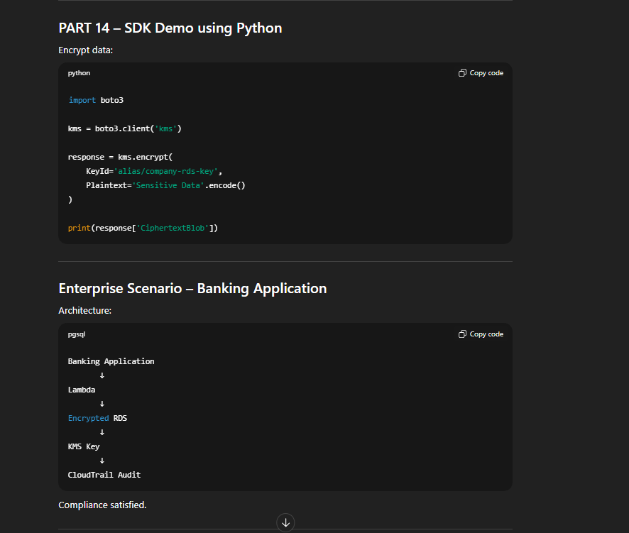

End-to-End Enterprise Lab
Participants will:
Step 1
Create CMK
Step 2
Enable key rotation
Step 3
Create encrypted RDS
Step 4
Grant IAM access
Step 5
Test encryption using SDK
Step 6
View audit logs

Professional Troubleshooting
Error:
AccessDeniedException (KMS)
Fix:
Add IAM permission and key policy.

Error:
Cannot access encrypted database
Fix:
Grant role access to KMS.

Enterprise Best Practices
Always:
- Use Customer Managed Keys
- Enable rotation
- Enable CloudTrail logging
- Use least privilege access
- Separate encrypt and decrypt roles

Enterprise Architecture Summary
Application
↓
IAM Role
↓
KMS CMK
↓
Encrypt DEK
↓
Encrypt RDS Data

Professional Capstone Lab
Build secure encrypted database architecture using KMS and RDS.

