WEEK 1 DATA SCIENCE PROJECT
Data Acquisition, Cleaning and Exploratory Data Analysis
Project Title: Wine Classification Dataset – Exploratory Data Analysis
Domain: Data Science | Tools: Python, Pandas, NumPy, Matplotlib, Scikit-learn

1. Introduction
This project demonstrates a standard data preparation workflow: obtaining a public dataset, inspecting its structure, checking data quality, preparing it for analysis, and using descriptive statistics and visualizations to identify patterns.
The selected Wine dataset contains chemical measurements of wine samples from three cultivars in the same Italian region. The task is to explore how measured properties vary across the three wine classes. This is an exploratory exercise, not a claim that chemistry alone explains every aspect of wine quality or origin.

2. Dataset Acquisition
Source: UCI Machine Learning Repository – Wine dataset (Dataset ID 109). The dataset contains 178 instances and 13 numeric chemical features, with a class label identifying one of three cultivars. The dataset is publicly available under the Creative Commons Attribution 4.0 license.
For this reproducible report, the dataset was loaded using scikit-learn's bundled copy of the UCI Wine dataset. The code below also shows how to fetch the repository version directly using the ucimlrepo package.
Dataset reference: Aeberhard, S. & Forina, M. (1992). Wine [Dataset]. UCI Machine Learning Repository. https://doi.org/10.24432/C5PC7J.

3. Tools and Libraries
Python; Pandas for tabular data; NumPy for numerical operations; Matplotlib for charts; Scikit-learn for loading the public sample dataset. Install with: pip install pandas numpy matplotlib scikit-learn ucimlrepo

4. Data Inspection
The dataset contains 178 rows and 14 original columns (13 measured features plus target). All feature columns are numeric. The target is an integer class code; a readable class_name column was added for analysis.
Missing values detected before cleaning: 0. Duplicate rows detected: 0.
Inspection code:
from sklearn.datasets import load_wine
import pandas as pd
wine = load_wine(as_frame=True)
df = wine.frame.copy()
df['class_name'] = df['target'].map(dict(enumerate(wine.target_names)))
print(df.head())
print(df.shape)
print(df.info())
print(df.isnull().sum())
print(df.describe())

5. Data Cleaning and Preprocessing
Missing values: the inspection found 0 missing cells. No imputation was necessary. Duplicates: 0 duplicate rows were detected and removed using drop_duplicates(). The cleaned dataset therefore contains 178 rows. Data types: the 13 chemical measurements are numeric and the target is an integer class code; these types were retained. A class_name label was added for readable charts.
Rationale: missing-value treatment should depend on the amount and meaning of missing data. Since none were detected, filling values would add unnecessary assumptions. Duplicate removal avoids counting identical records more than once. Numeric measurements should remain numeric for statistics and correlation analysis.
Cleaning code:
# Check missing values and duplicates
print(df.isnull().sum())
print("Duplicate rows:", df.duplicated().sum())
# Remove exact duplicate records
df_clean = df.drop_duplicates().copy()
# Check data types and confirm the cleaned result
print(df_clean.dtypes)
print(df_clean.isnull().sum().sum())

6. Exploratory Data Analysis
Summary statistics were calculated to understand the range, central tendency and spread of each numeric feature. Grouped means were used to compare selected measurements across the three classes.
Mean values by class for selected features:
Class | Alcohol | Flavanoids | Color intensity | Proline
class_0 | 13.74 | 2.98 | 5.53 | 1115.71
class_1 | 12.28 | 2.08 | 3.09 | 519.51
class_2 | 13.15 | 0.78 | 7.4 | 629.9

7. Visualizations
Figure 1. Sample distribution across the three classes. The chart helps identify whether class counts are balanced.
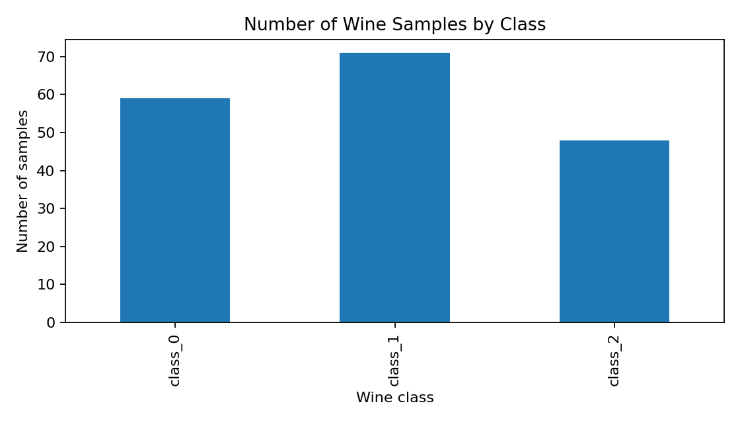
Figure 2. Alcohol distribution by class. Overlapping histograms show the distribution and spread of alcohol measurements in each class.
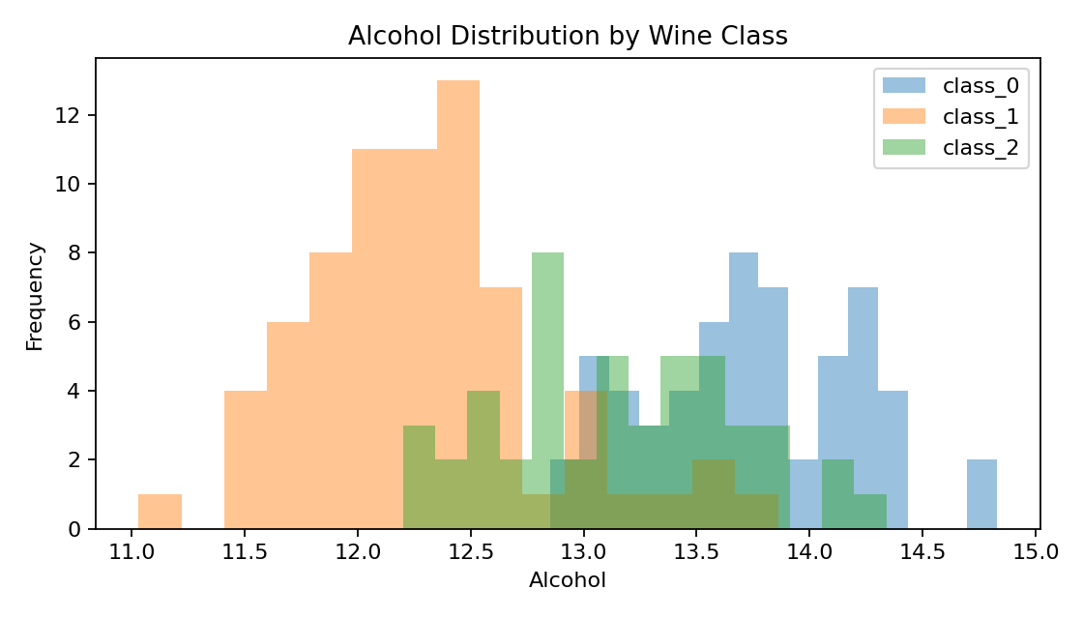
Figure 3. Correlation heatmap. Correlation values range from -1 to +1. Positive values indicate that two measurements tend to increase together; negative values indicate an inverse linear relationship. Correlation does not establish causation.
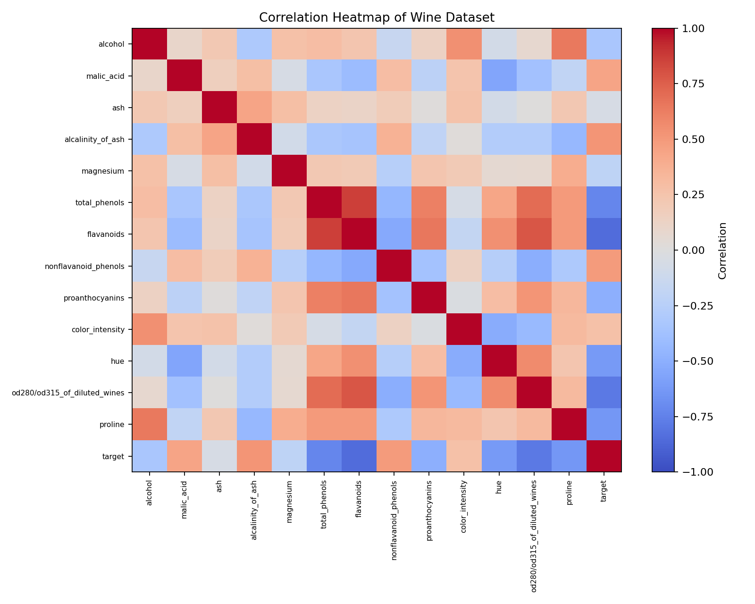

8. Key Insights
• The dataset contains three wine classes, and the class-distribution chart shows the number of samples in each class.
• Alcohol measurements show class-wise distribution differences, although the histograms may overlap. This suggests alcohol alone should not be treated as a perfect class separator.
• The correlation heatmap highlights groups of chemical features that move together. Such relationships can inform feature selection and further statistical testing.
• The Pearson correlation between alcohol and color intensity in this dataset is 0.546. This is a descriptive linear association only; it does not imply that one variable causes the other.

9. Further Analysis
Future work could include standardized feature comparisons, outlier investigation using box plots, hypothesis testing, and a train/test classification experiment. Any predictive model should be evaluated on held-out data and compared with a simple baseline.

10. Conclusion
This Week 1 task completed the main stages of a data science preparation workflow: public dataset selection, loading, structural inspection, missing-value and duplicate checks, type validation, descriptive statistics and visual EDA. The visualizations provide an initial understanding of class distribution and relationships among chemical measurements.

Appendix A – Direct UCI acquisition code
# Optional: fetch the same public dataset directly from UCI
# pip install ucimlrepo
from ucimlrepo import fetch_ucirepo
wine_uci = fetch_ucirepo(id=109)
X = wine_uci.data.features
y = wine_uci.data.targets
df_uci = pd.concat([X, y], axis=1)
print(df_uci.head())
print(df_uci.shape)

References
UCI Machine Learning Repository. Wine dataset (ID 109). https://archive.ics.uci.edu/dataset/109/wine
Aeberhard, S. & Forina, M. (1992). Wine [Dataset]. UCI Machine Learning Repository. https://doi.org/10.24432/C5PC7J
Scikit-learn documentation: load_wine. https://scikit-learn.org/stable/modules/generated/sklearn.datasets.load_wine.html
Note: This report uses the UCI Wine dataset (178 samples, 13 chemical features, 3 classes), not the separate UCI Wine Quality dataset (4,898 combined red/white samples).

