Week 3 Project – Statistical Analysis and Hypothesis Testing in Python
Public Wine Dataset | One-Way ANOVA, Welch t-tests, confidence intervals, and diagnostics

1. Introduction
This project applies statistical analysis and hypothesis testing in Python to a real scientific classification problem. The publicly available Wine dataset from the UCI Machine Learning Repository and distributed through scikit-learn contains 178 observations from three wine classes and 13 measured chemical characteristics. The analysis focuses on alcohol content because it is a continuous variable that can be compared across the three independent groups.
The practical question is whether the observed differences in average alcohol content between wine classes are large enough to be considered statistically significant rather than being explained by random sampling variation. The analysis combines descriptive statistics, visualization, a one-way ANOVA test, follow-up pairwise Welch t-tests, confidence intervals, effect size, and assumption diagnostics.

2. Research Question and Hypotheses
Research question: Do the three wine classes have the same mean alcohol content?
Null hypothesis (H₀): μ₁ = μ₂ = μ₃. The population mean alcohol content is equal across all three wine classes.
Alternative hypothesis (H₁): At least one class has a different population mean alcohol content.
Significance level: α = 0.05.
Decision rule: reject H₀ when the ANOVA p-value is below 0.05; otherwise, fail to reject H₀. A p-value does not measure the probability that H₀ is true. It measures how incompatible the observed data are with H₀ under the assumptions of the test.

3. Dataset and Data Preparation
The dataset contains 178 observations, 13 chemical features, and 3 target classes. The three classes contain class_0: 59, class_1: 71, class_2: 48 observations.
The dataset is already structured for analysis. For this hypothesis test, the target identifies the independent groups and alcohol is the continuous response variable. No missing values are present in the selected columns. The observations are treated as independent groups for the purpose of the analysis.

4. Methodology

4.1 Descriptive statistics
Group-wise count, mean, standard deviation, median, minimum, and maximum were calculated to understand the distribution before formal testing.

4.2 One-way ANOVA
A one-way analysis of variance (ANOVA) tests whether three or more independent groups have the same mean. It compares between-group variation with within-group variation. The F statistic is the ratio of these sources of variation. A statistically significant result indicates that at least one group mean differs, but ANOVA alone does not identify which pairs differ.

4.3 Follow-up Welch t-tests
When ANOVA is significant, pairwise Welch independent-samples t-tests are used as exploratory follow-up comparisons. Welch's version is less dependent on equal-variance assumptions. Because three pairwise comparisons are performed, Bonferroni-adjusted p-values are also reported to reduce the family-wise error rate.

4.4 Confidence intervals and effect size
A 95% confidence interval is calculated for each class mean. Eta-squared (η²) is reported as an effect-size measure for ANOVA, representing the proportion of total variance in alcohol explained by wine class in this sample.

4.5 Assumption diagnostics
Normality within each group is checked using the Shapiro-Wilk test, and equality of group variances is checked with Levene's test. These tests are diagnostics rather than automatic substitutes for subject-matter judgment.

5. Visual Analysis
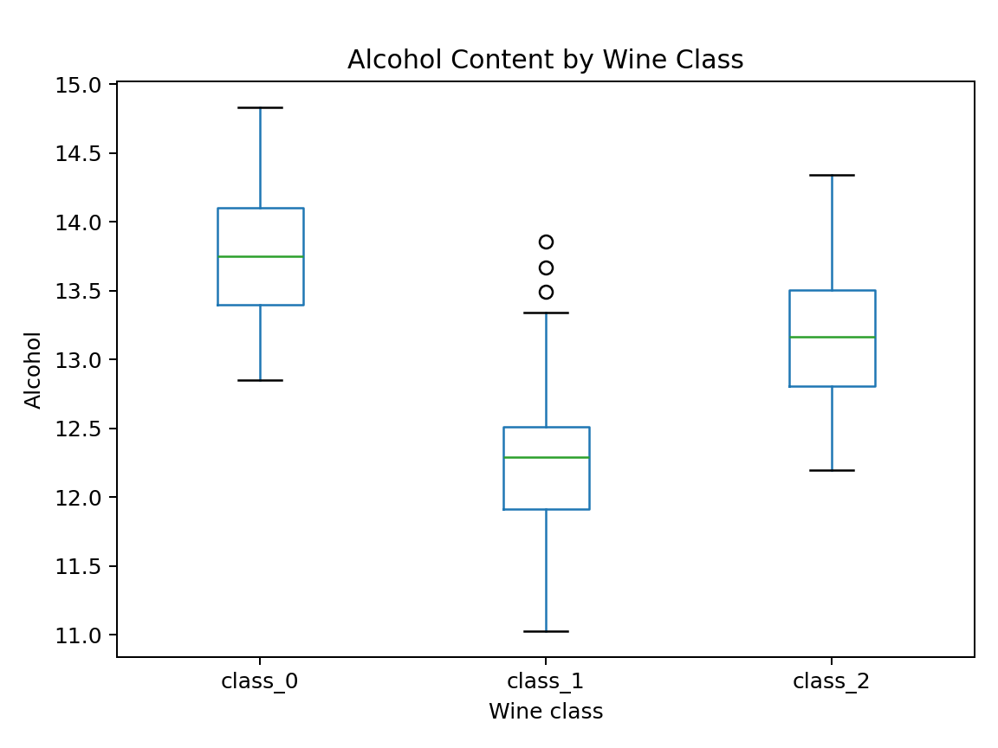
Figure 1. Boxplot of alcohol content by wine class.
The boxplot compares center, spread, and potential outliers across groups. It is useful before ANOVA because it makes differences in group location and variability immediately visible.
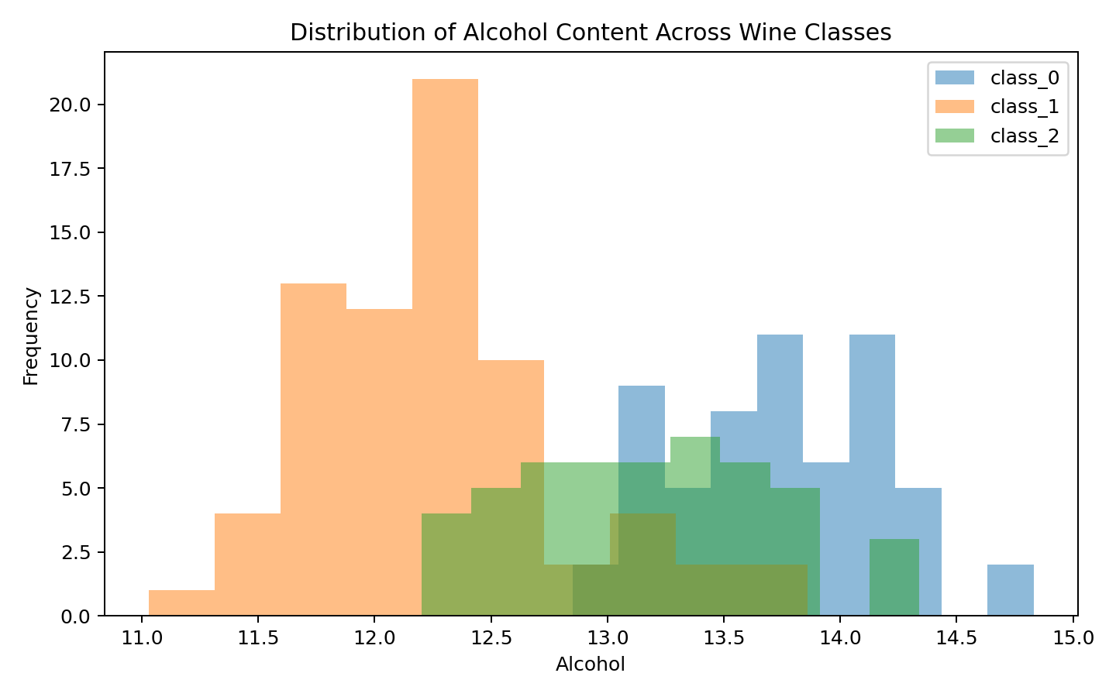
Figure 2. Overlaid histograms of alcohol content by wine class.
The histograms show the shape and overlap of the distributions. They help assess whether group differences are broad shifts or driven by a small number of observations.
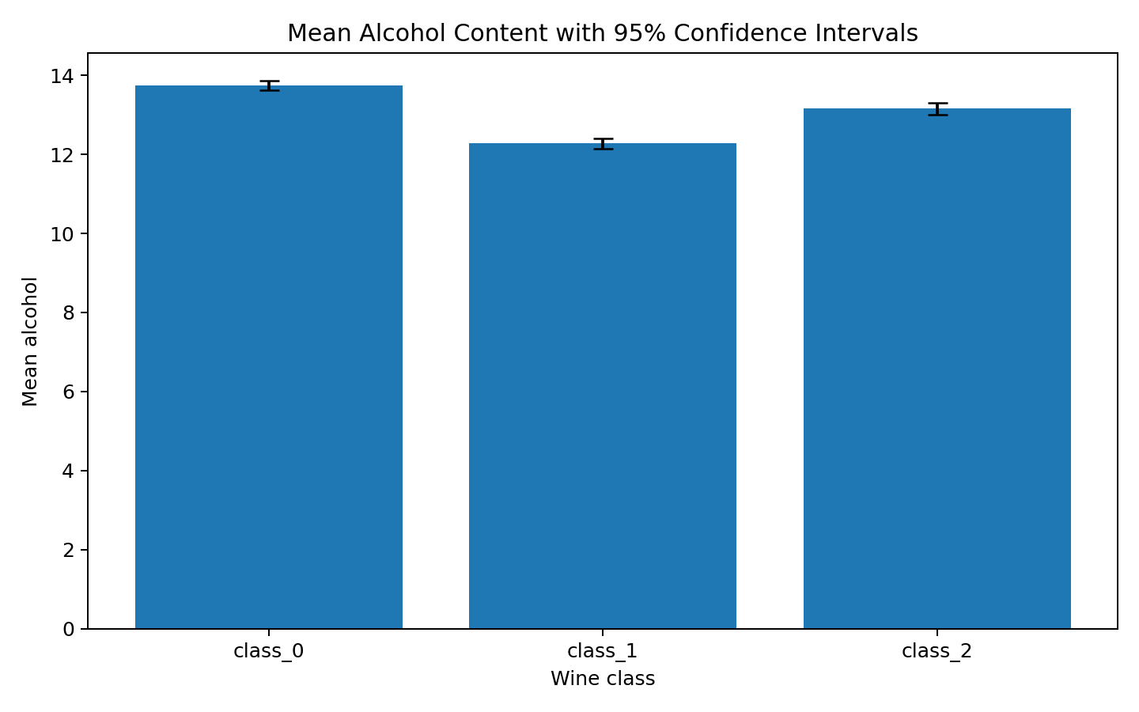
Figure 3. Mean alcohol content with 95% confidence intervals.
The mean-and-confidence-interval chart directly communicates estimated group means and uncertainty, making the inferential result easier for a non-technical reader to interpret.

6. Statistical Results
One-way ANOVA: F = 135.0776, p = 3.3195e-36.
Eta-squared effect size: η² = 0.6069.
Levene's test: statistic = 0.5998, p = 0.550052.
Shapiro-Wilk normality diagnostics:
Class | W statistic | p-value
class_0 | 0.9809 | 0.479068
class_1 | 0.9721 | 0.113961
class_2 | 0.9815 | 0.640839
Descriptive statistics for alcohol:
Class | n | Mean | Std. dev. | Median | Range
class_0 | 59 | 13.745 | 0.462 | 13.750 | 12.850–14.830
class_1 | 71 | 12.279 | 0.538 | 12.290 | 11.030–13.860
class_2 | 48 | 13.154 | 0.530 | 13.165 | 12.200–14.340
95% confidence intervals for the group means:
Class | n | Mean | 95% CI
class_0 | 59 | 13.745 | [13.624, 13.865]
class_1 | 71 | 12.279 | [12.151, 12.406]
class_2 | 48 | 13.154 | [13.000, 13.308]

7. Pairwise Follow-up Tests
Comparison | Welch t | Raw p | Bonferroni p
class_0 vs class_1 | 16.7113 | 5.92641e-34 | 1.77792e-33
class_0 vs class_2 | 6.0708 | 2.67199e-08 | 8.01597e-08
class_1 vs class_2 | -8.7794 | 4.05084e-14 | 1.21525e-13
The pairwise tests should be interpreted together with the Bonferroni-adjusted p-values. A comparison is considered statistically significant at the 0.05 level only when its adjusted p-value is below 0.05.

8. Interpretation and Hypothesis Decision
The ANOVA p-value (3.3195e-36) is below the 0.05 significance level. Therefore, the null hypothesis of equal mean alcohol content across the three wine classes is rejected. The evidence supports the conclusion that at least one wine class has a different mean alcohol content.
The estimated eta-squared value of 0.6069 indicates that wine class accounts for approximately 60.7% of the observed variation in alcohol content in this dataset. This is an association within the analyzed sample, not evidence that wine class causes alcohol differences.

9. Scientific and Business Implications
From a scientific perspective, the result demonstrates how a measured chemical attribute can be evaluated across predefined groups using formal inference rather than relying only on visual differences. In a laboratory or quality-control setting, statistically supported differences can guide feature selection for later classification models and motivate further investigation of related chemical properties.
From a business perspective, a reliable relationship between alcohol content and class membership could be useful as one component of a wine classification or decision-support workflow. However, alcohol alone should not be treated as a complete quality measure. Operational decisions would require validation on new samples, additional chemical variables, and consideration of measurement and sampling processes.

10. Limitations
The analysis uses one public dataset with a relatively small sample and predefined classes. Statistical significance does not establish causation or guarantee performance on a new population. ANOVA also relies on assumptions related to independence, distributional behavior, and variance structure. The analysis therefore should be treated as an inferential demonstration and a starting point for deeper statistical or machine-learning work.

11. Python Code Used
import pandas as pd
from scipy import stats
from sklearn.datasets import load_wine

wine = load_wine(as_frame=True)
df = wine.frame.copy()

# Descriptive statistics
print(df.groupby("target")["alcohol"].describe())

# One-way ANOVA
groups = [g["alcohol"].values for _, g in df.groupby("target")]
F, p = stats.f_oneway(*groups)
print("ANOVA F =", F, "p =", p)

# Welch pairwise t-tests
for i in range(3):
for j in range(i + 1, 3):
a = df.loc[df["target"] == i, "alcohol"]
b = df.loc[df["target"] == j, "alcohol"]
t, p = stats.ttest_ind(a, b, equal_var=False)
print(i, j, t, p)

# 95% confidence interval for a mean
x = df.loc[df["target"] == 0, "alcohol"]
mean = x.mean()
sem = stats.sem(x)
ci = stats.t.interval(0.95, len(x)-1, loc=mean, scale=sem)
print("95% CI:", ci)

# Diagnostics
print(stats.levene(*groups, center="median"))
for x in groups:
print(stats.shapiro(x))

12. Conclusion
This project followed a complete hypothesis-testing workflow: a clear research question was defined, a null and alternative hypothesis were formulated, the public dataset was prepared, descriptive and visual analysis was performed, assumptions were examined, a one-way ANOVA was conducted, pairwise Welch tests were used for follow-up comparisons, confidence intervals and effect size were calculated, and the statistical evidence was interpreted in practical terms. The workflow demonstrates how Python can turn a business/scientific question into a reproducible statistical decision while clearly separating statistical evidence from causal claims.

13. References
1. UCI Machine Learning Repository / Wine dataset.
2. scikit-learn documentation – load_wine dataset.
3. SciPy documentation – scipy.stats statistical tests.
4. Pandas documentation – grouping and descriptive statistics.
5. Matplotlib documentation – statistical visualization.
Workload note: The assignment specifies a 30–35 hour workload. The report is structured to support that scope through dataset research, hypothesis design, statistical testing, diagnostics, visualization, interpretation, documentation, code verification, and reproducibility. It does not claim that a specific number of hours was personally spent unless independently recorded.

