Week 4 Project – Machine Learning Model Development and Evaluation
Multiclass Wine Classification using Logistic Regression

1. Introduction
This project develops and evaluates a basic supervised machine learning model in Python. The objective is to build a reproducible classification pipeline covering data preparation, preprocessing, algorithm selection, training, prediction, evaluation, visualization, and critical discussion.
The publicly available Wine dataset is used. It contains 178 samples, 13 numerical chemical features, and three wine classes. The task is to predict the wine class from its chemical measurements.

2. Dataset and Problem Definition
The Wine dataset contains chemical measurements such as alcohol, malic acid, ash, magnesium, flavanoids, color intensity, hue, and proline. The target is a three-class categorical label. This is a multiclass classification problem because the output belongs to one of three classes.
The data is split into 80% training data and 20% testing data using stratification so that the class distribution is preserved in both sets. A fixed random state of 42 makes the experiment reproducible.

3. Data Preparation and Preprocessing
The dataset is loaded using scikit-learn. The 13 numerical features are used as predictors and the target column is used as the class label. The model pipeline applies StandardScaler before logistic regression. Standardization transforms each feature to a comparable scale, which is particularly useful for logistic regression because its coefficients and optimization can otherwise be affected by very different feature magnitudes.
Preprocessing is placed inside a scikit-learn Pipeline. This prevents information from the test set from being used during scaling and provides a clean, reproducible training workflow.

4. Model Selection
Logistic Regression was selected because it is a simple, interpretable, and widely used baseline classifier. It is appropriate for a multiclass classification problem and provides class probabilities that support ROC curve analysis. A regularized logistic regression model is used through scikit-learn's implementation.
A simple baseline is useful because it establishes a performance reference before more complex models such as random forests, support vector machines, or gradient boosting are considered.

5. Model Training and Evaluation
The model was trained on 142 observations and evaluated on 36 previously unseen test observations. The test accuracy was 0.9722. Weighted precision was 0.9741, weighted recall was 0.9722, and weighted F1-score was 0.9720.

6. Performance Metrics
Metric | Score
Accuracy | 0.9722
Precision | 0.9741
Recall | 0.9722
F1-score | 0.9720
Accuracy measures the proportion of correctly classified test samples. Precision measures how often predictions for a class are correct, recall measures how many actual samples are correctly recovered, and F1-score balances precision and recall. Weighted averages account for the number of observations in each class.

7. Visual Evaluation
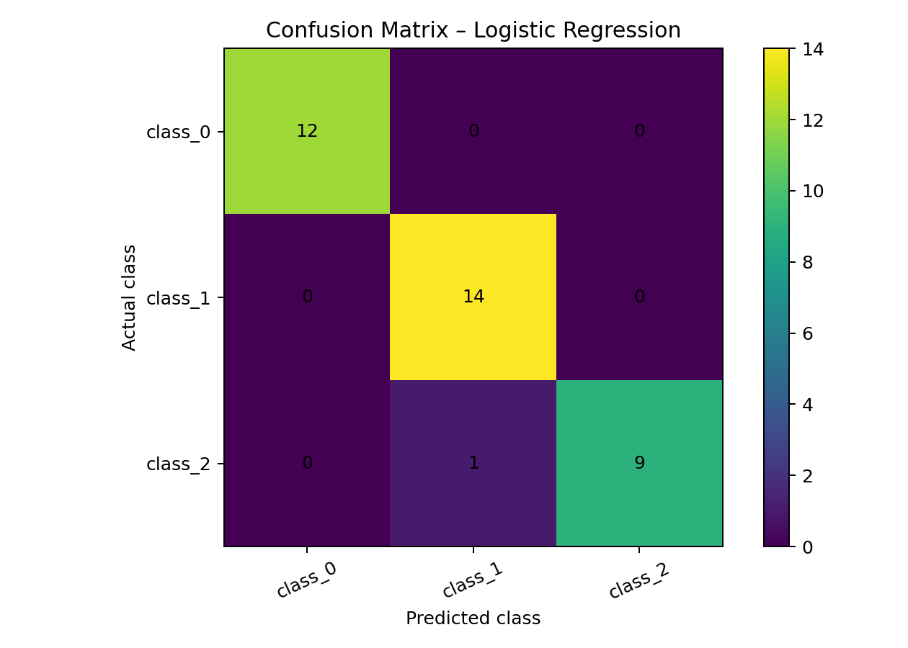
Figure 1. Confusion matrix.
The confusion matrix shows actual classes against predicted classes. Diagonal cells represent correct classifications, while off-diagonal cells identify specific class confusions.
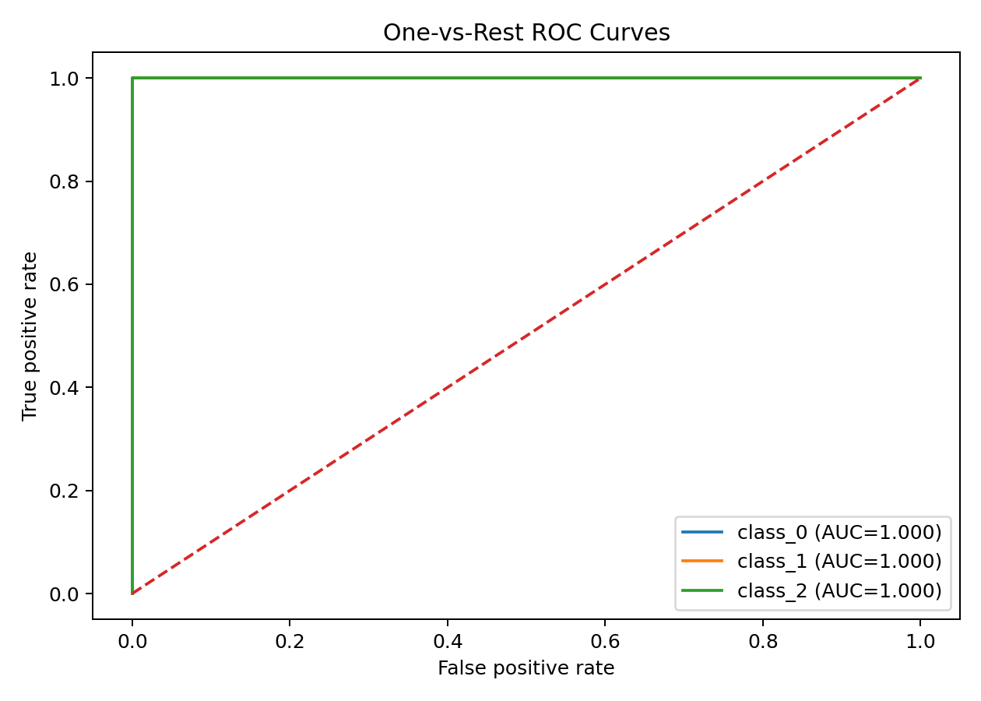
Figure 2. One-vs-rest ROC curves.
The ROC curves show the trade-off between true-positive and false-positive rates for each class. A curve closer to the upper-left region indicates stronger discrimination.
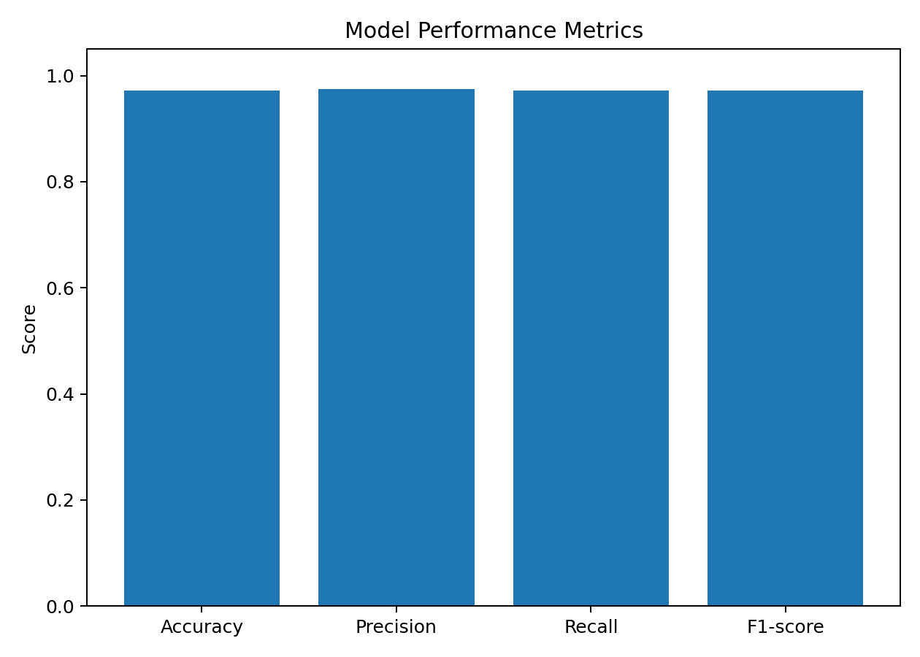
Figure 3. Model performance metrics.
The metric chart provides a compact comparison of accuracy, precision, recall, and F1-score so that overall performance can be assessed from multiple perspectives.

8. Classification Report
precision recall f1-score support

class_0 1.00 1.00 1.00 12
class_1 0.93 1.00 0.97 14
class_2 1.00 0.90 0.95 10

accuracy 0.97 36
macro avg 0.98 0.97 0.97 36
weighted avg 0.97 0.97 0.97 36

9. Error Analysis
The model made 1 incorrect prediction(s) out of 36 test observations. The confusion matrix should be used to identify which classes are most frequently confused. Misclassifications may result from overlapping chemical characteristics, limited sample size, measurement variation, or the linear decision boundaries of logistic regression.
Potential overfitting is controlled partly by regularization and by evaluating on a separate test set. However, a single train/test split can produce an unstable estimate on a small dataset. Cross-validation would provide a more robust estimate of generalization performance.

10. Potential Improvements
- Use stratified k-fold cross-validation instead of relying only on one train/test split.
- Compare logistic regression with decision trees, random forests, support vector machines, and gradient boosting.
- Tune model hyperparameters using GridSearchCV or RandomizedSearchCV.
- Evaluate feature importance or model coefficients to understand which chemical measurements contribute most.
- Test the final model on an independent external dataset before real-world deployment.
- Investigate class-specific errors and collect more representative samples if misclassification remains concentrated in one class.

11. Python Code
from sklearn.datasets import load_wine
from sklearn.model_selection import train_test_split
from sklearn.pipeline import Pipeline
from sklearn.preprocessing import StandardScaler
from sklearn.linear_model import LogisticRegression
from sklearn.metrics import accuracy_score, confusion_matrix

wine = load_wine(as_frame=True)
X = wine.data
y = wine.target

X_train, X_test, y_train, y_test = train_test_split(
X, y, test_size=0.20, random_state=42, stratify=y
)

model = Pipeline([
("scaler", StandardScaler()),
("classifier", LogisticRegression(max_iter=5000, random_state=42))
])

model.fit(X_train, y_train)
y_pred = model.predict(X_test)

print("Accuracy:", accuracy_score(y_test, y_pred))
print("Confusion matrix:")
print(confusion_matrix(y_test, y_pred))

12. Strengths and Limitations
Strengths include a clear preprocessing pipeline, reproducible train/test split, a transparent baseline model, multiple evaluation metrics, and visual diagnostics. The use of a pipeline reduces preprocessing leakage risk.
Limitations include the small public dataset, reliance on one test split, and the assumption that a relatively simple linear classifier is sufficient. High test performance on this dataset should not be interpreted as a guarantee of equivalent performance on future or external wine samples.

13. Conclusion
The logistic regression pipeline achieved an accuracy of 0.9722 on the held-out test set, with a weighted F1-score of 0.9720. The confusion matrix and ROC curves provide additional evidence about class-level behavior rather than relying on accuracy alone. The project demonstrates the complete machine-learning workflow from preprocessing through evaluation and critical error analysis. Future work should compare alternative algorithms, use cross-validation, tune hyperparameters, and validate the final model on independent data.

14. References
1. scikit-learn documentation – Wine dataset and classification tools.
2. scikit-learn documentation – LogisticRegression, Pipeline, StandardScaler, and model evaluation metrics.
3. UCI Machine Learning Repository – Wine dataset.

