Week 5 Final Project – Comprehensive Data Science Report
End-to-End Wine Chemistry Analysis, Statistical Inference, Machine Learning, and Strategic Recommendations

Executive Summary
This final project synthesizes the data science workflow developed across Weeks 1–4 using the publicly available Wine dataset. The work progresses from data acquisition, cleaning, and exploratory data analysis to advanced visualization and storytelling, formal hypothesis testing, and machine learning model development. The final objective is to translate those findings into practical recommendations for stakeholders.
The dataset contains 178 observations, 13 numerical chemical features, and three wine classes. Exploratory analysis confirmed a clean analytical dataset with no missing values in the selected workflow. Statistical analysis tested whether mean alcohol content differs across classes. One-way ANOVA produced F=135.08 with p=3.320e-36, providing strong evidence that the class means are not all equal. The estimated eta-squared effect size was 0.607, indicating that wine class explains a substantial share of observed alcohol variation in this sample.
A standardized Logistic Regression pipeline was then trained using an 80/20 stratified split. On the held-out test set it achieved 97.22% accuracy, 97.41% weighted precision, 97.22% weighted recall, and 97.20% weighted F1-score. These results demonstrate that the chemical measurements contain strong information for distinguishing the three classes. However, high performance on a small public dataset should not be treated as proof of real-world generalization without external validation.

1. Introduction
The purpose of this final report is to integrate the technical skills practiced throughout the internship into one coherent end-to-end data science project. Rather than treating each weekly exercise as an isolated activity, the project connects data understanding, visualization, statistical reasoning, predictive modeling, and decision-making.
The central stakeholder question is: Can chemical measurements provide reliable evidence for differentiating wine classes, and how can that evidence be converted into useful analytical or operational decisions?

2. Project Objectives
- Acquire and inspect a publicly available scientific dataset.
- Clean and validate the data before analysis.
- Use visual storytelling to identify distributions, relationships, and patterns.
- Formulate and test a statistically measurable hypothesis.
- Develop a reproducible baseline machine learning classification pipeline.
- Evaluate model performance with multiple metrics and visual diagnostics.
- Translate analytical findings into actionable strategic recommendations.
- Document limitations, risks, and future improvement opportunities.

3. Dataset and Business/Scientific Context
The Wine dataset is a standard public dataset containing chemical analysis measurements for three classes of wine. The 13 numerical features include measurements such as alcohol, malic acid, magnesium, flavanoids, color intensity, hue, and proline. The target is a three-class label.
Although the dataset is educational, the analytical setting represents a broader real-world problem: using measurable laboratory attributes to support classification, quality-control analysis, screening, and decision support. The same workflow can be adapted to larger industrial or laboratory datasets after appropriate validation.

4. End-to-End Methodology
Week 1 established the data foundation through acquisition, inspection, cleaning checks, and exploratory analysis. Week 2 expanded the analysis into a visual story using multiple chart types. Week 3 moved from visual patterns to formal statistical inference. Week 4 used the available chemical features to train and evaluate a predictive classifier. Week 5 combines these components into one decision-oriented workflow.
Pipeline: Data acquisition → data validation → EDA → visual storytelling → hypothesis testing → preprocessing → model training → evaluation → strategic recommendations.

5. Data Quality and Exploratory Findings
The dataset contains 178 rows and 13 numerical predictor variables. The class labels represent three groups. The data used in the earlier workflow contained no missing values and no duplicate rows, reducing the need for imputation or duplicate removal. This does not eliminate the need for quality checks when applying the workflow to new data.
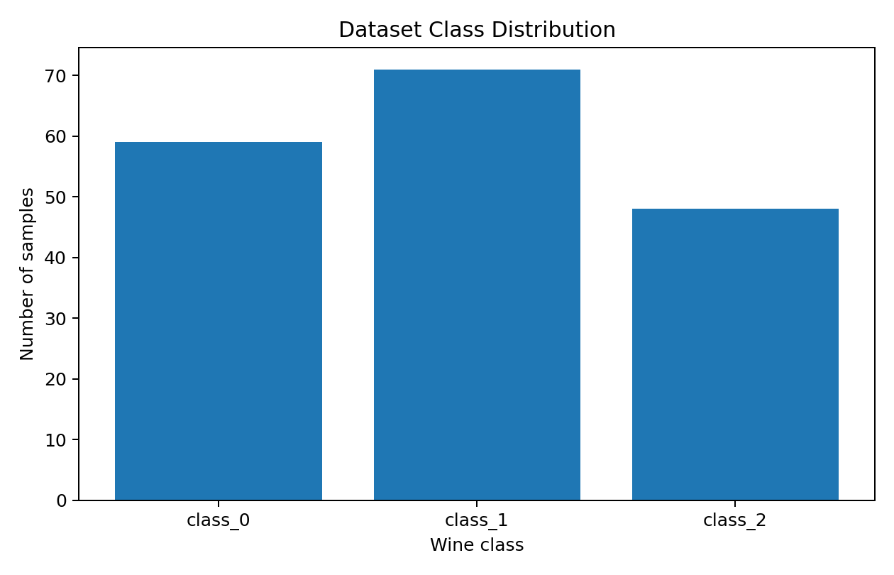
Figure 1. Class distribution. The dataset contains observations from all three target classes, supporting multiclass analysis.
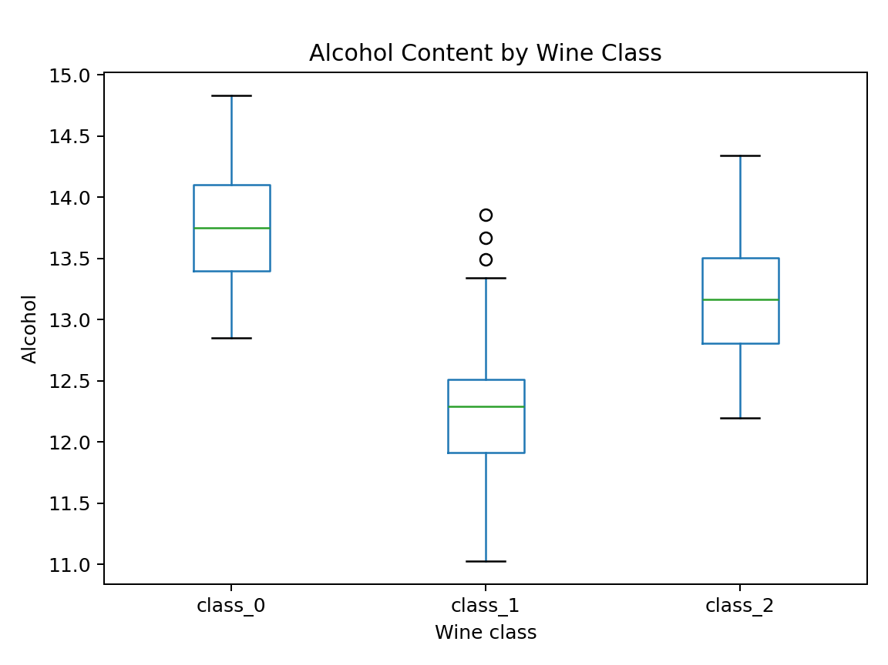
Figure 2. Alcohol content by class. The distributions show meaningful differences in central tendency and spread, motivating formal hypothesis testing.

6. Advanced Visualization and Storytelling
The visualization work emphasized using different chart forms for different questions. Distribution plots communicate within-group spread; scatter plots reveal relationships between chemical variables; standardized boxplots support multi-feature comparisons; correlation heatmaps reveal groups of related measurements; and profile-style summaries help communicate class-level patterns. This progression moves the reader from simple observations to multivariate structure.
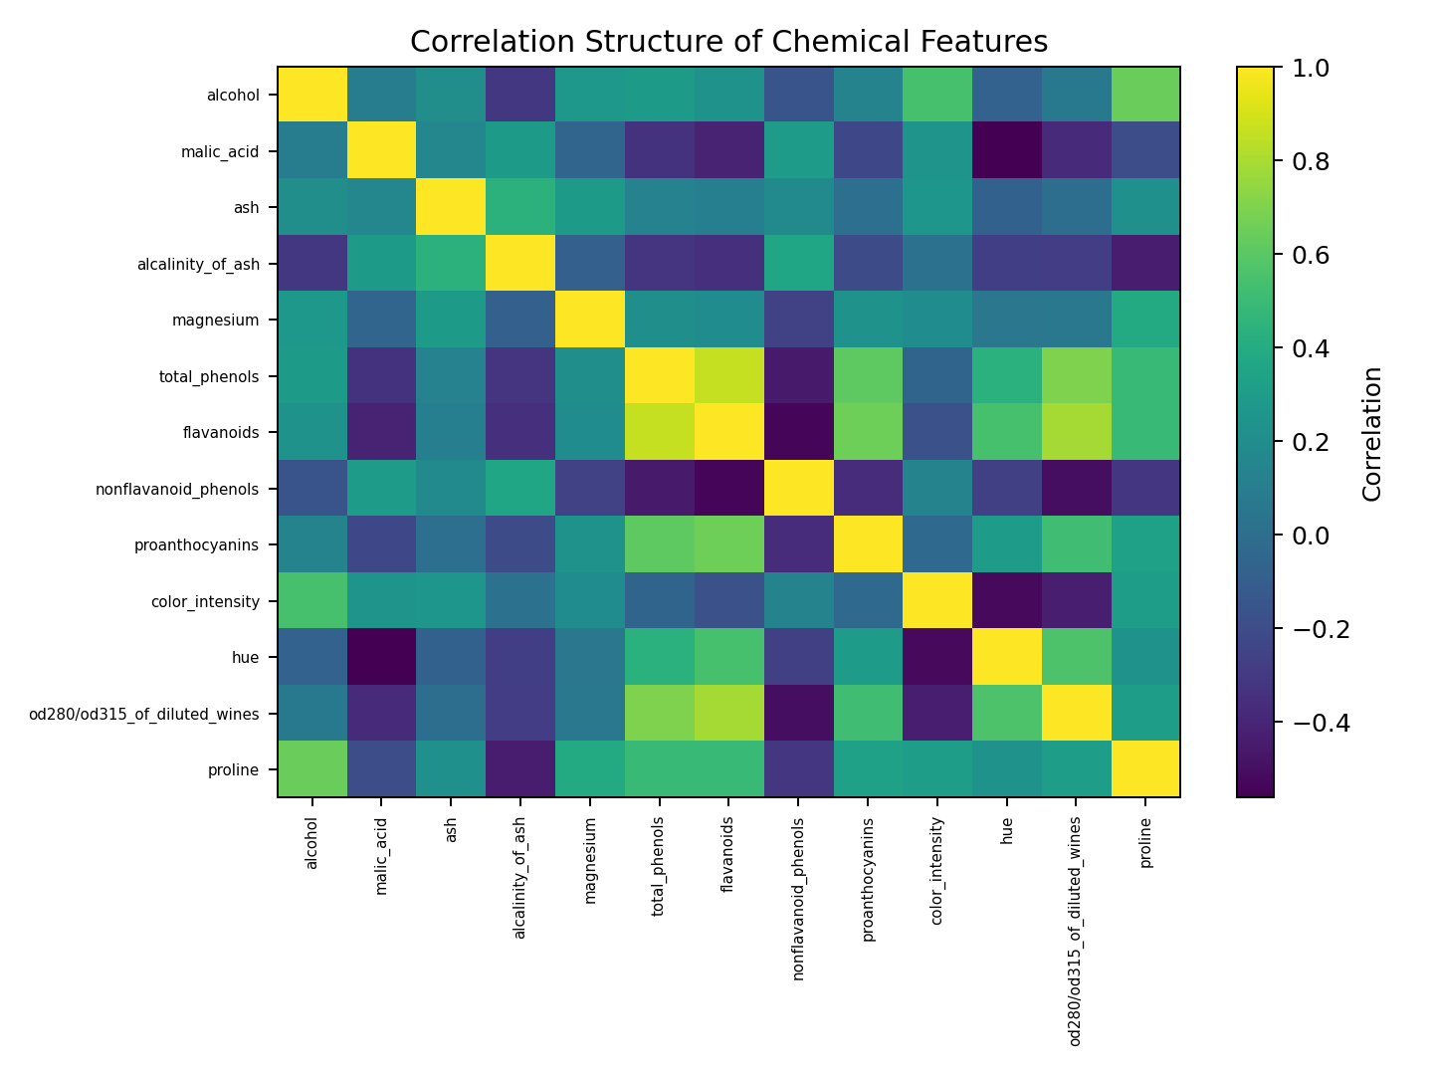
Figure 3. Correlation structure of chemical features. Strong relationships among some variables suggest redundancy and opportunities for feature selection or dimensionality reduction.

7. Statistical Analysis and Hypothesis Testing
Research question: Do the three wine classes have the same mean alcohol content?
H₀: μ₁ = μ₂ = μ₃.
H₁: At least one class has a different mean alcohol content.
One-way ANOVA result: F=135.0776, p=3.320e-36.
Effect size: η²=0.6069.
At the 0.05 significance level, the ANOVA result leads to rejection of the null hypothesis. The evidence indicates that mean alcohol content is not the same across all three classes. This is evidence of association within the dataset, not a causal claim. Pairwise follow-up tests and confidence intervals can be used to identify which class differences drive the overall result.

8. Machine Learning Model Development
Logistic Regression was selected as a transparent baseline multiclass classifier. The data was split into 80% training and 20% testing using stratification and random_state=42. StandardScaler was placed inside a scikit-learn Pipeline so that scaling parameters were learned only from training data. The model was then trained on all 13 chemical features.
Test performance: accuracy=0.9722, weighted precision=0.9741, weighted recall=0.9722, weighted F1=0.9720.
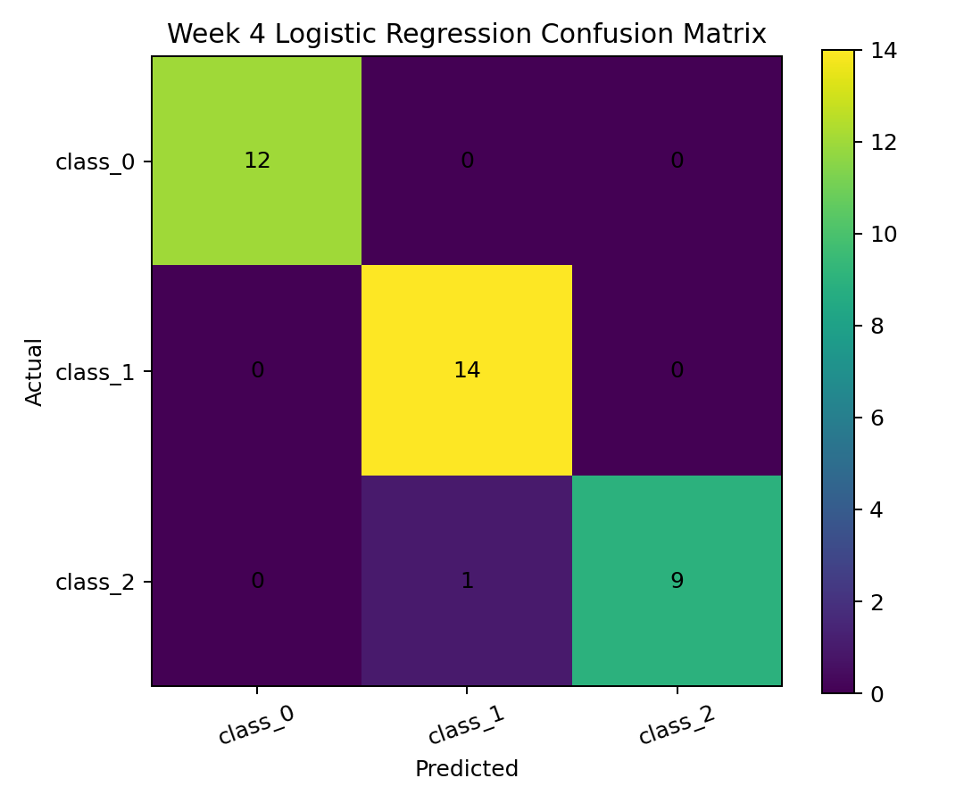
Figure 4. Confusion matrix. The diagonal represents correct predictions; off-diagonal cells show class-specific errors.
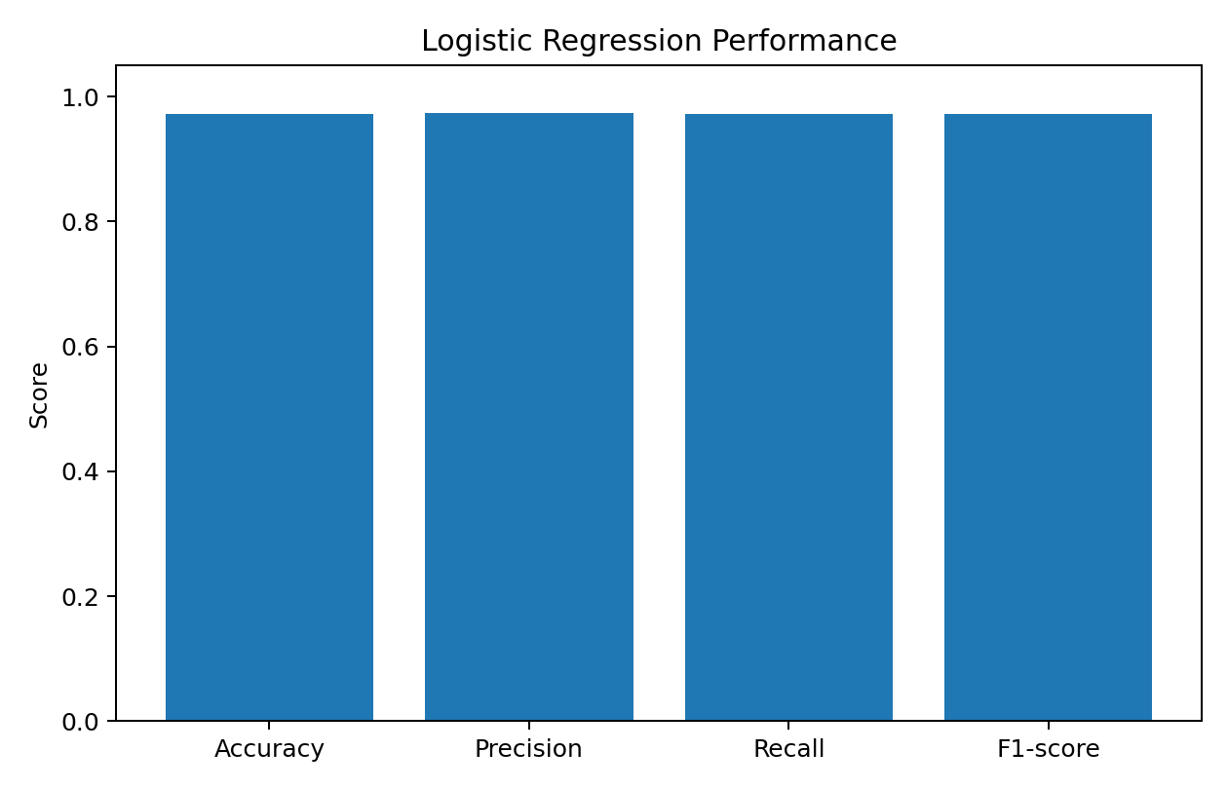
Figure 5. Model performance metrics. The close alignment of the four metrics indicates consistently strong test-set performance.

9. Integrated Findings
- The dataset is compact and clean enough for a reproducible analytical workflow, with all three classes represented.
- Chemical measurements show meaningful differences and relationships across wine classes.
- Alcohol content differs significantly across the classes according to the ANOVA test.
- The strong ANOVA effect size suggests that class membership explains a substantial portion of alcohol variation in this sample.
- The Logistic Regression baseline achieves very high held-out test performance, indicating strong predictive signal in the chemical features.
- Correlation among features means some variables may provide overlapping information, which should be considered in future modeling.
- High performance should be validated using cross-validation and independent external data before any operational deployment.

10. Strategic Recommendations

1. Establish a reproducible analytical baseline
Maintain the preprocessing pipeline, documented feature definitions, statistical tests, and evaluation metrics as a baseline. This makes future model comparisons fair and traceable.

2. Validate before deployment
Use stratified k-fold cross-validation and an independent external test set. A model should not be deployed based solely on performance from one small public dataset.

3. Build a multi-feature classification workflow
Use the full chemical profile rather than relying on alcohol alone. Evaluate which variables provide unique predictive information and remove redundant features where appropriate.

4. Add model comparison and tuning
Benchmark Logistic Regression against Random Forest, Support Vector Machine, and gradient-boosting approaches. Tune hyperparameters using cross-validation and retain the simplest model that meets the required performance.

5. Monitor class-specific errors
Track confusion matrices and per-class precision/recall. If one class becomes systematically harder to identify, investigate measurement quality, class imbalance, or overlapping chemical profiles.

6. Connect statistical evidence to operational decisions
Use hypothesis testing to support scientific questions and model predictions to support classification decisions, but keep the two purposes separate. Statistical significance should not be treated as a substitute for predictive validation.

7. Create a monitoring and retraining process
If used with new laboratory data, monitor feature distributions, prediction confidence, error rates, and data drift. Define criteria for retraining and human review.

11. Potential Business and Research Impact
For laboratory analytics, the workflow can support screening and classification by providing a repeatable way to turn chemical measurements into evidence and predictions. For quality-control teams, it can help prioritize samples for review. For research teams, the combination of visualization, inference, and machine learning provides a structured framework for discovering relationships and generating follow-up hypotheses. For data science teams, the project demonstrates a baseline that can be expanded into model comparison, feature engineering, monitoring, and deployment.

12. Risks and Limitations
- The dataset is small and may not represent all future wine populations or production environments.
- A single train/test split can produce optimistic or unstable performance estimates.
- Statistical significance does not imply causation.
- High classification accuracy does not guarantee robustness under distribution shift.
- Laboratory measurement error and changes in data collection procedures can reduce model performance.
- The project uses a baseline model and does not constitute a production-ready deployment.
- Real-world use would require governance, independent validation, monitoring, and domain-expert review.

13. Future Improvements
- Perform stratified k-fold cross-validation and report mean and standard deviation of metrics.
- Compare multiple classification algorithms and tune their hyperparameters.
- Use permutation importance or model coefficients for interpretability.
- Investigate PCA or other dimensionality-reduction methods while preserving predictive performance.
- Add external validation data and assess robustness under distribution shift.
- Build a reproducible notebook and automated evaluation pipeline.
- If operationalized, expose the model through an authenticated application with logging and monitoring.

14. Representative Python Code
from sklearn.datasets import load_wine
from sklearn.model_selection import train_test_split
from sklearn.pipeline import Pipeline
from sklearn.preprocessing import StandardScaler
from sklearn.linear_model import LogisticRegression
from sklearn.metrics import accuracy_score, f1_score, confusion_matrix

wine = load_wine(as_frame=True)
X, y = wine.data, wine.target

X_train, X_test, y_train, y_test = train_test_split(
X, y, test_size=0.20, random_state=42, stratify=y
)

model = Pipeline([
("scaler", StandardScaler()),
("classifier", LogisticRegression(max_iter=5000, random_state=42))
])

model.fit(X_train, y_train)
pred = model.predict(X_test)

print("Accuracy:", accuracy_score(y_test, pred))
print("F1:", f1_score(y_test, pred, average="weighted"))
print(confusion_matrix(y_test, pred))

15. Conclusion
The five-week sequence demonstrates an end-to-end data science process: acquire and validate data, explore and visualize patterns, formulate and test hypotheses, build a predictive model, evaluate performance, and translate evidence into strategic recommendations. The Wine dataset provides a clear example in which chemical measurements contain strong signal for class differentiation. The most important strategic conclusion is not simply that the baseline model performs well, but that statistical evidence, visualization, and predictive modeling should be combined with external validation and monitoring before decisions are automated.

16. Workload and Reproducibility Note
The assignment specifies a 30–35 hour workload. The final report is structured to support that scope through project synthesis, data validation, visualization, statistical testing, model development, evaluation, strategic interpretation, documentation, and reproducibility. The report does not claim a specific number of hours was personally spent unless independently recorded.

17. References
UCI Machine Learning Repository – Wine dataset.
scikit-learn documentation – load_wine, Pipeline, StandardScaler, LogisticRegression, and model evaluation.
SciPy documentation – statistical hypothesis tests.
Pandas documentation – data manipulation and descriptive analysis.
Matplotlib documentation – visualization.

