Software Requirements Specification Template

<Project Name>

Software Requirements Specification

<Version>

<Date>

Sl.No | Name | USN#

Guide:

Revision History

Date | Description | Author | Approver | Comments
<date> | <Version 1> | <Your Name> | <Approver’s Name> | <First Revision>

Document Approval

The following Software Requirements Specification has been accepted and approved by the following:
Signature | Printed Name | Title | Date
 | <Your Name>

Table of Contents

Revision History i
Document Approval i
1. Introduction 1
1.1 Purpose 1
1.2 Scope 1
1.3 Definitions, Acronyms, and Abbreviations 1
1.4 References 1
2. General Description 2
2.1 Product Perspective 2
2.2 User Characteristics 2
2.3 General Constraints 2
2.4 Assumptions and Dependencies 2
3. Specific Requirements 2
3.1 External Interface Requirements 3
3.1.1 User Interfaces 3
3.1.2 Hardware and Software in terms of how they would interact or how they would be executed 3
3.2 Functional Requirements 3
3.2.1 <Functional Requirement or Feature #1> 3
3.2.2 <Functional Requirement or Feature #2> 3
3.3 Non-Functional Requirements 3
3.4 Other Requirements 3

1. Introduction
The introduction to the Software Requirement Specification (SRS) document should provide an overview of the complete SRS document. While writing this document please remember that this document should contain all of the information needed by a software engineer to adequately design and implement the software product described by the requirements listed in this document. (Note: the following subsection annotates are largely taken from the IEEE Guide to SRS).

1.1 Purpose
What is the purpose of this SRS and the (intended) audience for which it is written?

1.2 Scope
This subsection should:
(1) Identify the software product(s) to be produced by name; for example, Host DBMS, Report Generator, etc
(2) Explain what the software product(s) will, and, if necessary, will not do
(3) Describe the application of the software being specified. As a portion of this, it should:

Eg. TimeSheetManager is a web-based application that will allow users to manage their timesheets and leave through an intuitive, easy-to-use interface. The system will also allow reports on that data to be easily generated, printed or exported.
This will not have support for running on a Mobile (Android/ios devices)

1.3 Definitions, Acronyms, and Abbreviations
This subsection should provide the definitions of all terms, acronyms, and abbreviations required to properly interpret the SRS. This information may be provided by reference to one or more appendixes in the SRS or by reference to other documents.

Eg. TSM – Time Sheet Manager

2. General Description
This section of the SRS should describe the general factors that affect 'the product and its requirements. It should be made clear that this section does not state specific requirements; it only makes those requirements easier to understand.

2.1 Product Perspective
This subsection of the SRS puts the product into perspective with other related products or
Projects. This also provides big picture diagram of the product keeping both the structure and the high level (mostly but not limited to external) interactions.

Eg.
TSM is a new system that replaces the current system hosted on Strictly Business servers for managing timesheets and leave time. The context diagram in Figure 1 illustrates the external entities and system interfaces. The system is expected to evolve over at least three releases, ultimately allowing for complete streamlining of the payroll process, mobile phone support

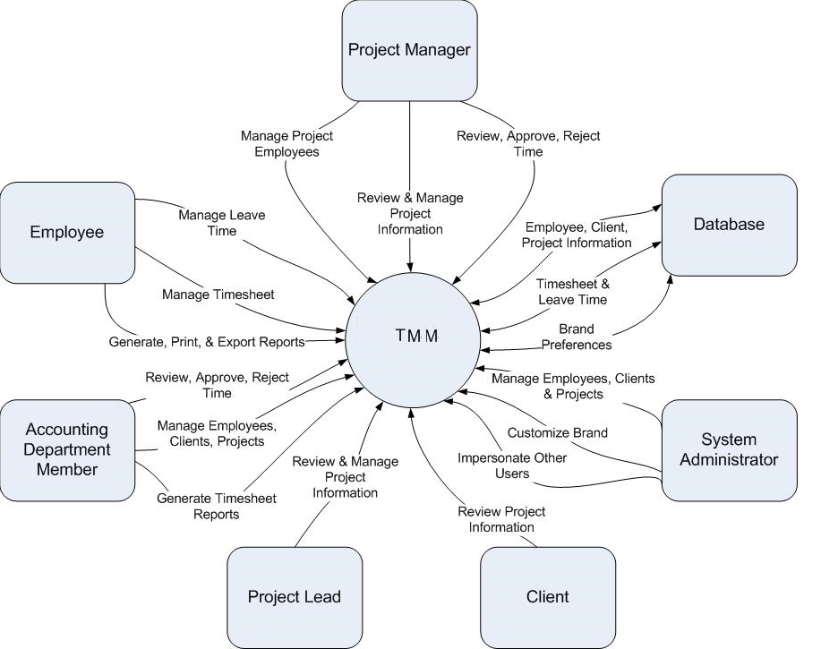

Figure 1

Context diagram for TMM.
Note: Project Manager, Project Lead, and Accounting Department Member are all specialized forms of Employee and have access to all Employee actions in addition to their own specialized actions. System Administrators have access to all actions within the system in addition to their own specialized actions.

2.2 Product Features
Eg.

FE-1: Data and application hosting on Google Apps
FE-2: Log and submit time spent on projects and clients
FE-3: Manage leave time
FE-4: Generate, print and export reports
FE-5: Employee management
FE-6: Time approval and rejection with notification
FE-7: Integration of Google Calendar, Mail and Talk
FE-8: Brand customization
FE-9: Time management through Android application
FE-10: Impersonate other users
FE-11: Project/Client Management

See Figure 2 for the relationship between these features. Please note that this document covers all features.

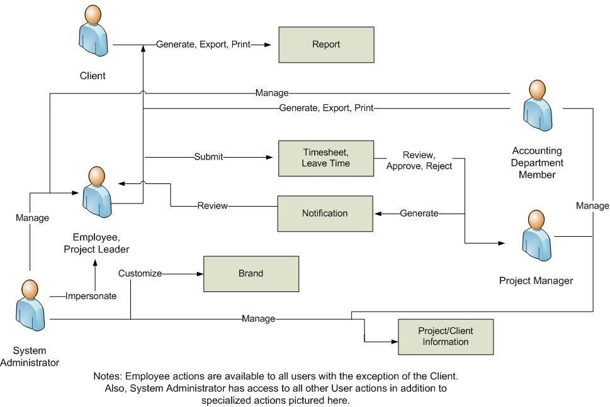
Figure 1
Major features and how they relate.

2.3 User Characteristics
This subsection of the SRS should describe those general characteristics of the eventual users of the product that will affect the specific requirements in other words this describes the characteristics of whoever is going to use this product/result of the project.

Eg:
Employee (favored) | The Employee is the person or people who work for the business using TMM and need to log time spent on clients/projects and manage leave. They will also use the new system to manage company email, schedule business meetings in the calendar, and communicate with other employees through instant messenger. Some might have to be trained to use the new system. Employees will have the ability to generate reports associated with their own work only.
Project Manager (favored) | A Project Manager is a special employee or group of employees which are in charge of managing a particular project. Project Managers will use the new system in the same way as a regular user, but will also need the ability to view project status and approve/reject timesheets. Project Managers will also need the ability to manage employees associated with their projects as well. Project Managers will have the ability to generate reports associated with their own work as well as the projects which they manage.
Project Lead | A Project Lead is a special employee or group of employees who are the lead on a particular project or projects. They will have the ability to approve/reject time in the event that the Project Manager is unable to do so. Project Leads, like Project Managers, will have the ability to generate reports associated with their own work as well as the projects which they are leading.
System Administrator | The Administrator is the person or people who will have any and all the privileges of all other user types. They will be able to impersonate other employees within the system. They will also have the authority to edit the branding and manage/generate reports regarding all projects/employees.
Accounting Department Member | The Accounting Department Member is the person or group of people that will be in charge of all payroll activities. They will need to have the ability to generate timesheet reports.
Client | The client is the person or people who are employing the talents of the business using TMM. They will use the new system to view the remaining time and status reports associated with all their current project(s).

2.4 Operating Environment
OE-1: | System is not dependent on geographical areas.
OE-2: | System shall operate in newest versions of all web browsers.
OE-3: | There should be no constraint on users being able to access the system at a given time.
OE-4: | Data is generated by online forms and stored in the Google App Engine database.
OE-5: | Continuous service is preferred, but as long as there is no data loss, minor service interruptions can be tolerated.
OE-6: | Personal data will be stored in the database, so the Google App Engine database must be secure.
OE-7: | jQuery javascript library will be needed to create the user interface for the system.

2.5 General Constraints
This subsection of the SRS should provide a general description of any other items that will
limit the developer’s options for designing the system.

2.6 Assumptions and Dependencies
This subsection of the SRS should list each of the factors that affect the requirements stated in the SRS. These factors are not design constraints on the software but are, rather, any changes to them that can affect the requirements in the SRS.
Eg an assumption might be that a specific operating system will be available on the hardware designated for the software product. If, in fact, the operating system is not available, the SRS would then have to change accordingly.

2.7 Documentation
Eg. No user documentation information at this time.

3. Specific Requirements
This will be the largest and most important section of the SRS. The customer requirements will be embodied within Section 2, but this section will give the D-requirements that are used to guide the project’s software design, implementation, and testing.

Each requirement in this section should be:
- Correct
- Traceable (both forward and backward to prior/future artifacts)
- Unambiguous
- Verifiable (i.e., testable)
- Prioritized (with respect to importance and/or stability)
- Complete
- Consistent
- Uniquely identifiable (usually via numbering like 3.4.5.6)

Attention should be paid to the carefully organize the requirements presented in this section so that they may easily accessed and understood. Furthermore, this SRS is not the software design document, therefore one should avoid the tendency to over-constrain (and therefore design) the software project within this SRS.
All requirement will need to have an unique Identifier which will need to be traced through Architecture, Design, Implementation & Testing (Supporting Requirement Traceability Matrix)

Eg.

3.1 Functional Requirements
FR1 | Time Review | The system shall allow a user who is logged in to review their time.
FR2 | Time Review Log | The system shall allow a user who is logged in to log time.
FR3 | Time Review Submit | The system shall allow a user who is logged in to submit time.
FR4 | Time Submit Incomplete | The system shall check to see if all required information is present, and prompt the user to fill out missing data and resubmit.
FR5 | Time Submit Duplicate | The system shall copy selected time submission to new day(s).

3.2 Non-Functional Requirements
Non-functional requirements may exist for the following attributes. Often these requirements must be achieved at a system-wide level rather than at a unit level. State the requirements in the following sections in measurable terms (e.g., 95% of transaction shall be processed in less than a second, system downtime may not exceed 1 minute per day, > 30 day MTBF value, etc) if they are relavent.
NF1
NF2… as above
These could be Performance, Reliability, Availability, Security, Maintainability, Portability ..

3.3 External Interface Requirements

3.3.1 User Interfaces
UI1 - Website - This interface is primarily for the doctors to interact with our Service. It allows for doctors to type out detailed answers in the forums etc. It is more feasible for doctors to use the website as they are usually based out if a clinic/hospital and have visiting hours.
UI2- Mobile Application- This is the user end interface that allows for booking appointments on the move. It also provides a smart selection of the right specialist based on specialization and reviews. Also integrated is the Google Maps API which will provide easy directions to the users.

3.3.2 Hardware and Software in terms of how they would interact or how they would be executed
The website will be available for all to access, but only doctors are given accounts for which they will be charged a nominal amount.
The mobile app will be free to download and use on an Android smart phone.
The phone will need minimum hardware requirements such as mobile internet(GPRS) and GPS.
The Android device will frequently query a cloud based server for required details based on the algorithms formulated by our team.

3.3.3 Software Interfaces
Eg.
SI-1: Time Management System
SI-1.1: The time management system shall transmit data to be stored on Google App Engine.
SI-1.2: Upon completion, system will display notification to user of result of data transmission.
SI-1.3: If applicable, system will then generate notification to be displayed.

SI-2: Database - The system shall communicate with a database through a programmatic interface for the following operations:
SI-2.1: To manage employee, client, and project data.
SI-2.2: To allow a user to submit timesheets/leave time.
SI-2.3: To allow an administrator/project manager to approve/reject time.
SI-2.4: To store brand and theme preferences.

4 Appendix A: Glossary
No glossary terms available at this time.

