AI Assisted Coding
Assignment 12.5
Name: V.Ajay Kumar
Hall ticket no: 2303A51268
Batch no: 19

Task 1: Sorting – Merge Sort Implementation Prompt:
Generate a Python function merge_sort(arr) that sorts a list in ascending order using the Merge Sort algorithm.
Include time complexity and space complexity in the function docstring.
Code & Output:
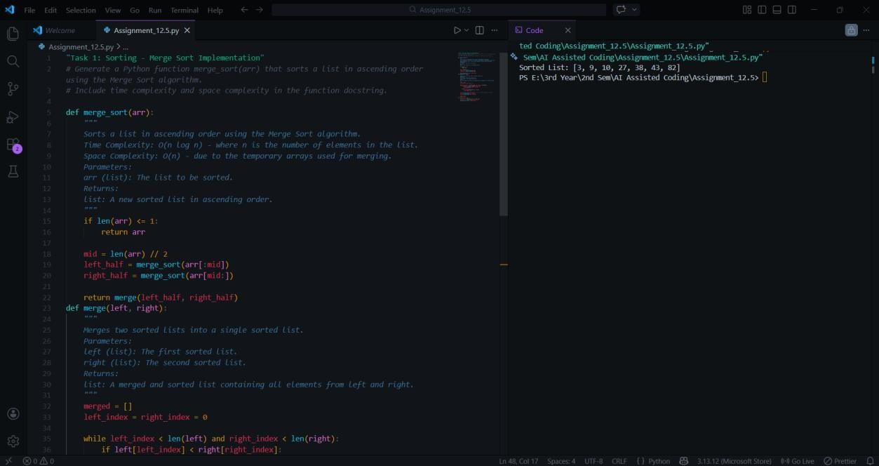
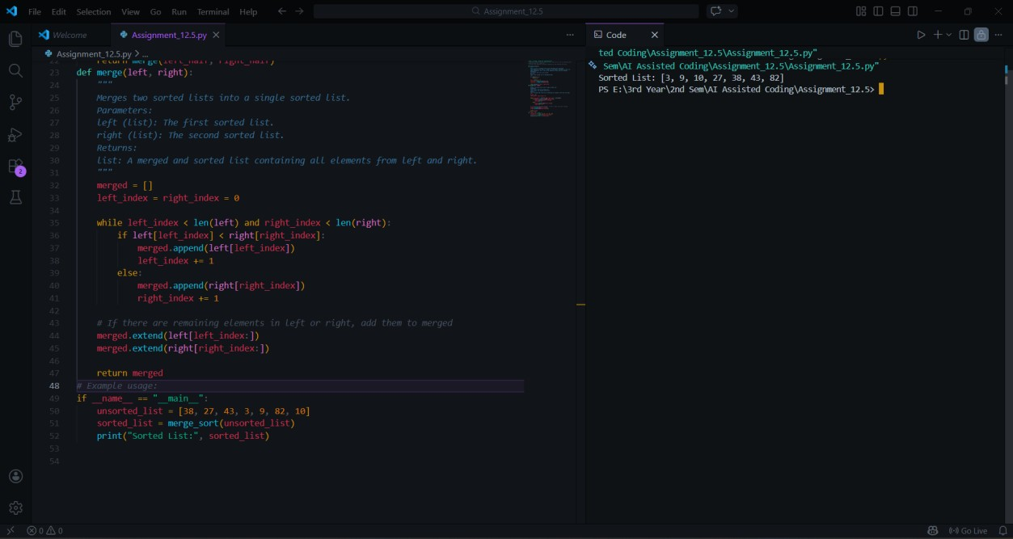
Explanation:
Merge Sort divides the list into smaller halves recursively and then merges them in sorted order. It guarantees O(n log n) time complexity in all cases, making it efficient for large datasets. The algorithm requires additional memory for merging, resulting in O(n) space complexity. AI assistance helped generate structured recursive logic with proper documentation.

Task 2: Searching – Binary Search Prompt:
Generate a Python function binary_search(arr, target) that returns the index of the target element in a sorted list or -1 if not found. Include complexity explanation in the docstring.
Code & Output:
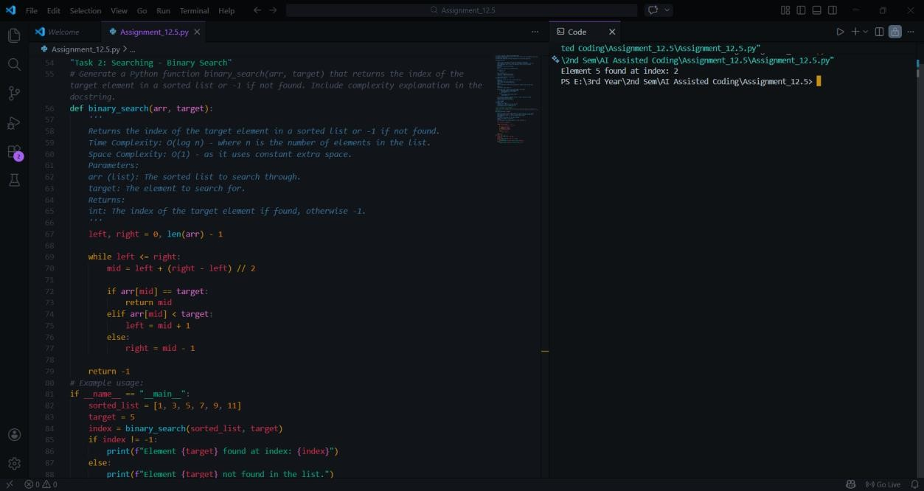
Explanation:
Binary Search works by repeatedly dividing the sorted list into halves. It significantly reduces the search space, resulting in logarithmic time complexity. It is efficient compared to linear search for large sorted datasets. AI assistance helped structure the iterative logic and complexity documentation clearly.

Task 3: Smart Healthcare Appointment Scheduling Prompt:
Recommend suitable searching and sorting algorithms for appointment management and implement them in Python.
Code & Output:
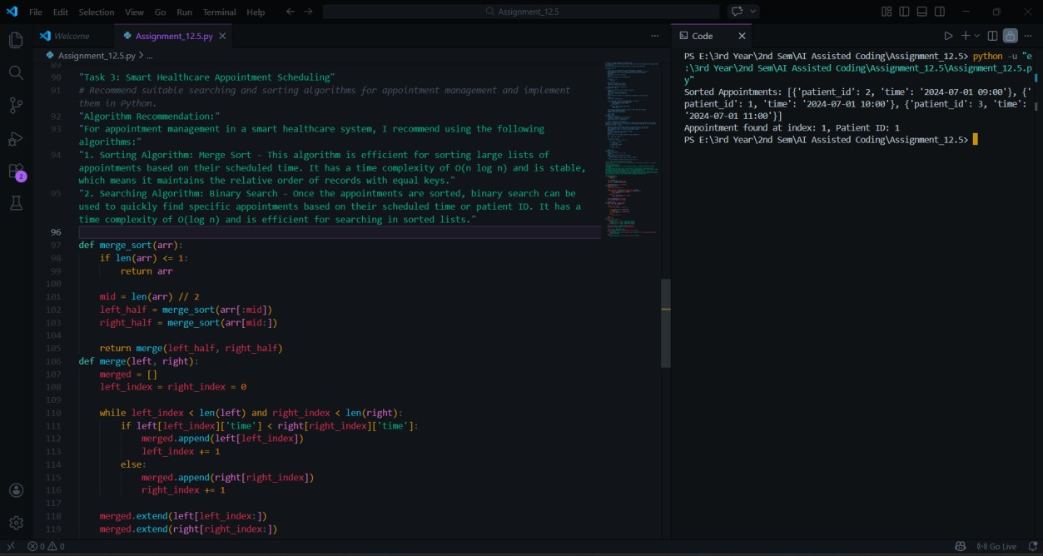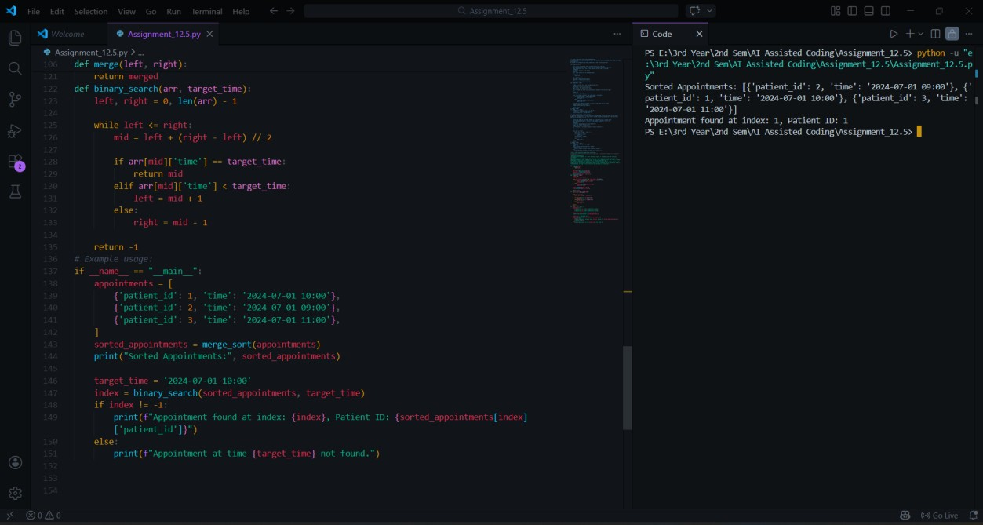
Explanation:
Binary Search is efficient for searching appointment IDs when records are sorted. Merge Sort ensures stable and efficient sorting by time or fee. These algorithms provide optimal performance for medium to large datasets. AI-assisted reasoning supported algorithm selection based on efficiency requirements.

Task 4: Railway Ticket Reservation System Prompt:
Generate Python code for a Railway Ticket Reservation System that stores booking details including ticket ID, passenger name, train number, seat number, and travel date.
The system must:
- Search tickets using ticket ID.
- Sort bookings based on travel date.
- Sort bookings based on seat number.
First, recommend suitable searching and sorting algorithms with justification.
Then implement the selected algorithms in Python with proper function definitions and brief docstrings explaining time complexity.
Code & Output:
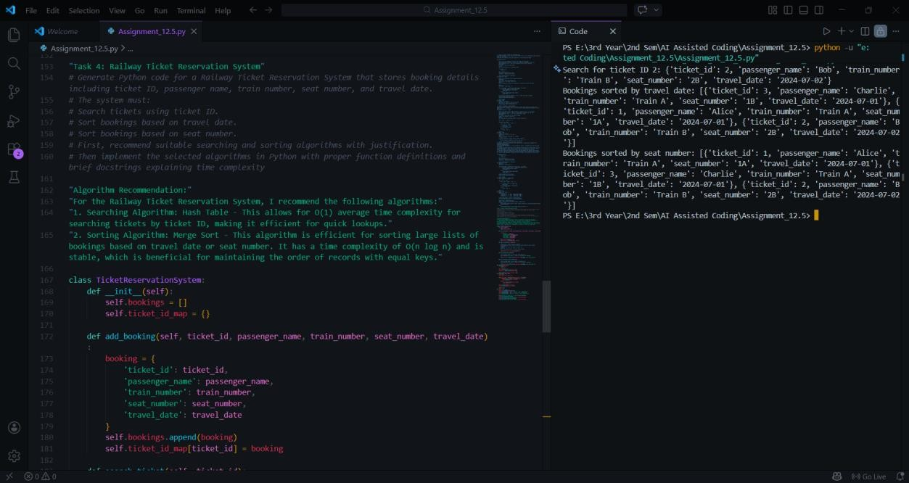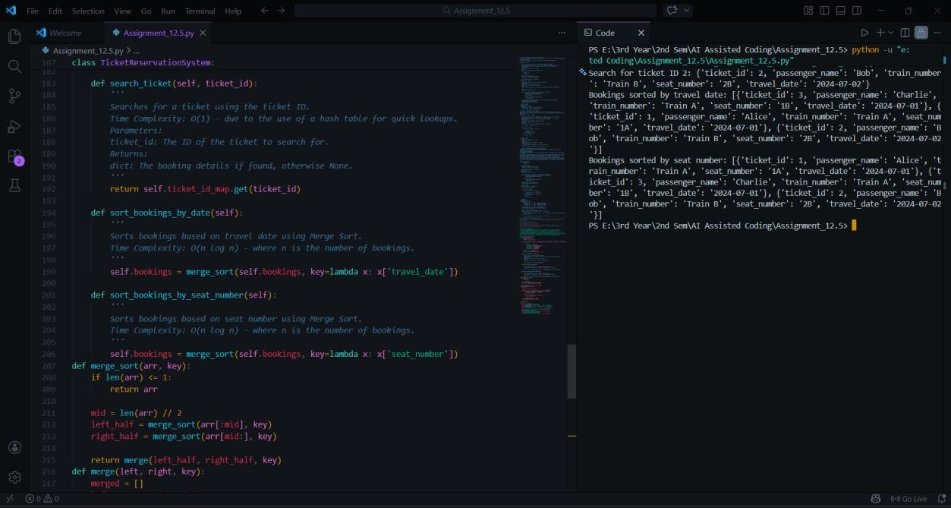
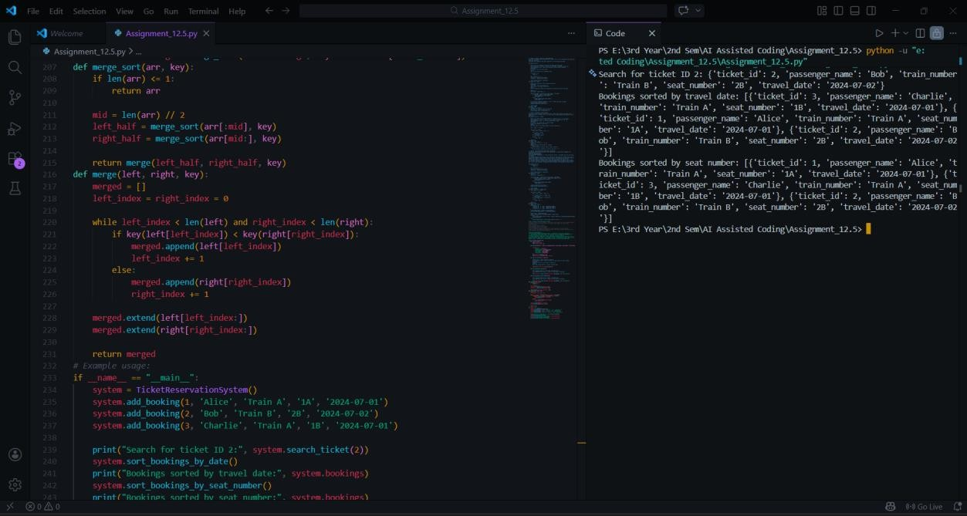
Explanation:
Binary Search is chosen for efficient ticket lookup when records are sorted by ticket ID, reducing search time to O(log n). Sorting is done using a stable sorting method (similar to Merge Sort Behaviour) to organize bookings by date or seat number. This ensures structured record management. AI assistance helped select efficient algorithms and implement clean functions.

Task 5: Smart Hostel Room Allocation System Prompt:
Generate Python code for a Smart Hostel Room Allocation System storing student_id, room_number, floor, and allocation_date.
The system must:
- Search allocation details using student_id
- Sort records based on room_number
- Sort records based on allocation_date
Recommend suitable algorithms and implement them with brief complexity documentation.
Code & Output:
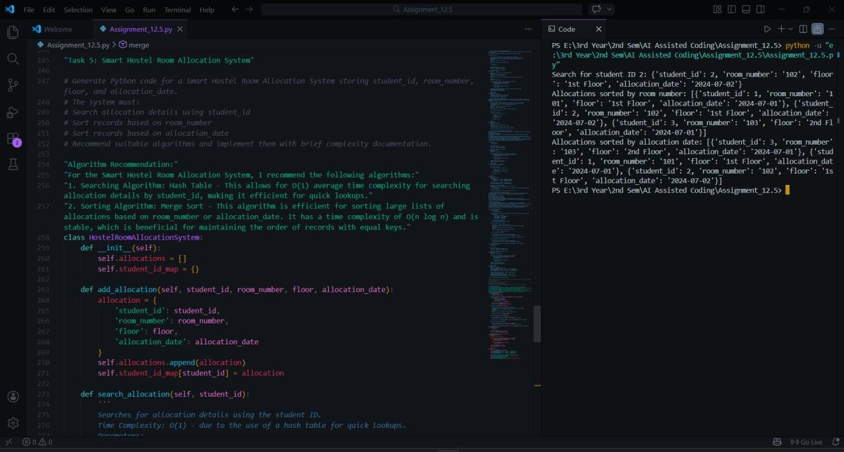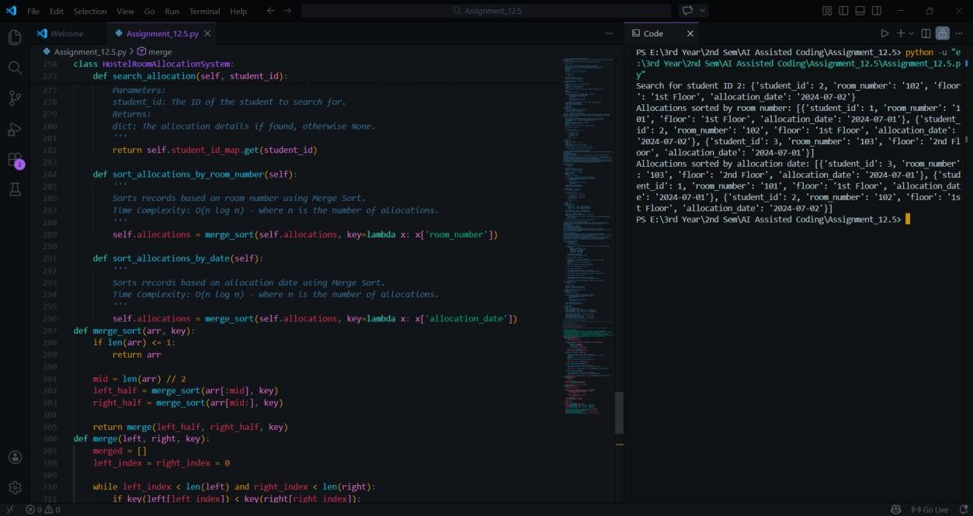

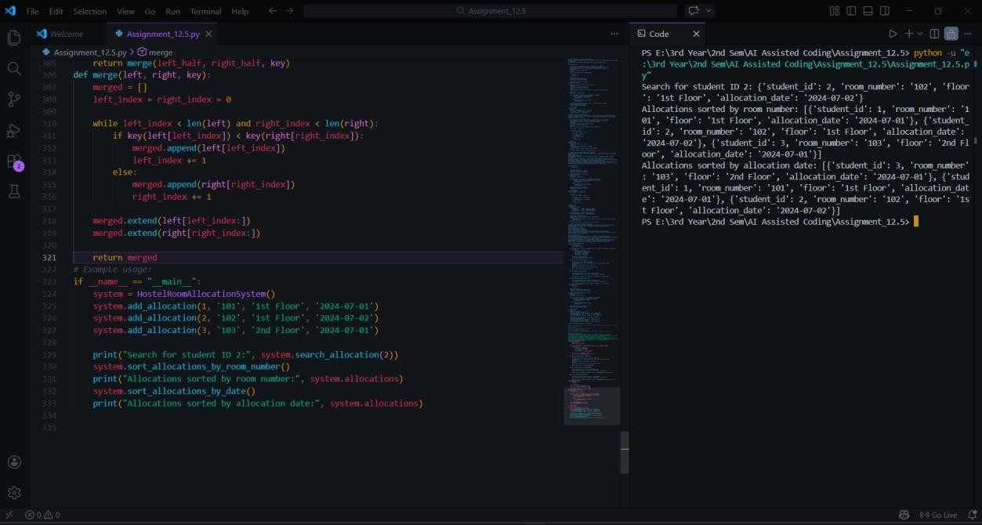
Explanation:
Binary Search allows fast lookup of student allocation records when sorted by student ID. Sorting by room number or allocation date organizes hostel data efficiently. These algorithms ensure scalability for large datasets. AI guidance supported correct structure and optimized implementation.

Task 6: Online Movie Streaming Platform Prompt:
Generate Python code for a Movie Streaming Platform storing movie_id, title, genre, rating, and release_year. The system must:
- Search movies by movie_id
- Sort movies based on rating
- Sort movies based on release_year
Recommend suitable algorithms and implement them.
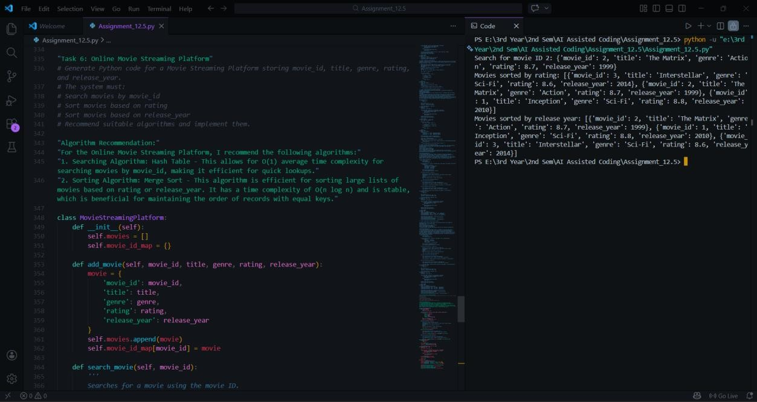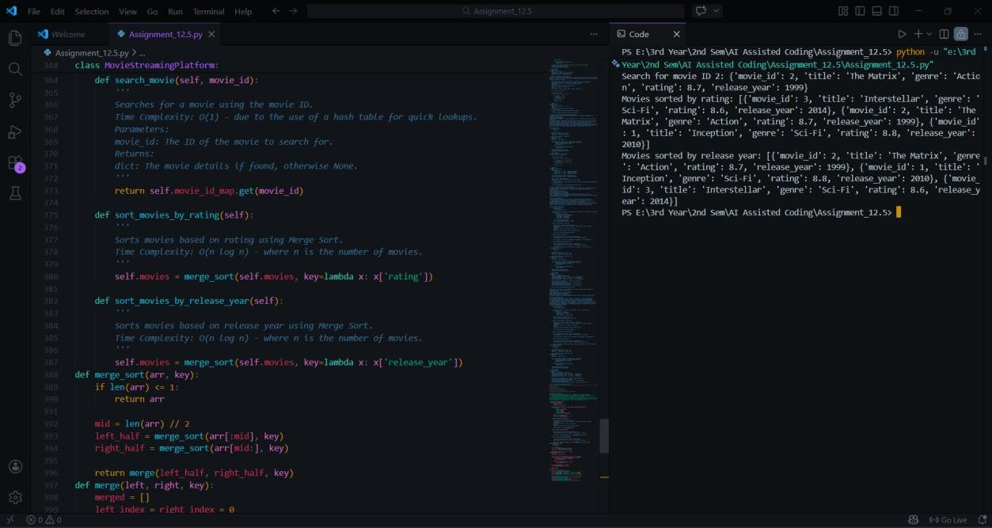
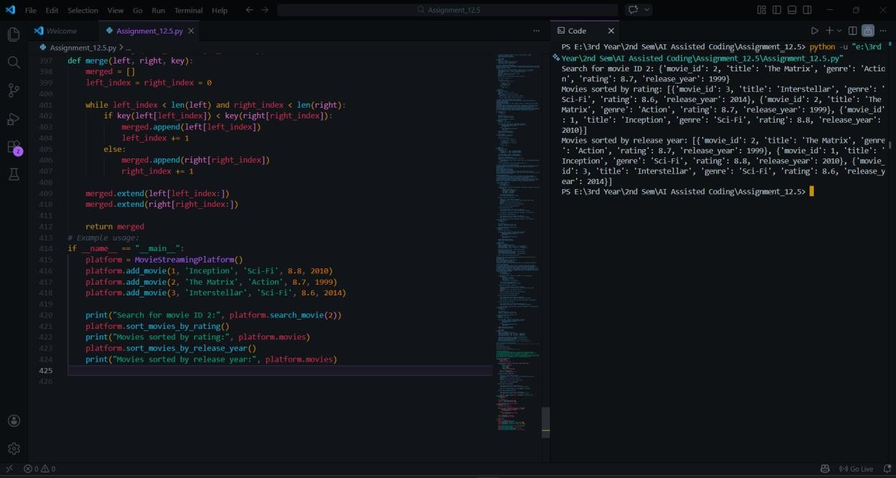
Explanation:
Binary Search is suitable for quick movie lookup when sorted by movie ID. Sorting by rating helps rank movies, while sorting by release year organizes content chronologically. These algorithms ensure efficient data management for streaming platforms. AI assistance improved modularity and clarity.

Task 7: Smart Agriculture Crop Monitoring System Prompt:
Generate Python code for a Crop Monitoring System storing crop_id, crop_name, soil_moisture_level, temperature, and yield_estimate.
The system must:
- Search crop details using crop_id
- Sort crops based on soil_moisture_level
- Sort crops based on yield_estimate
Recommend suitable algorithms and implement them.
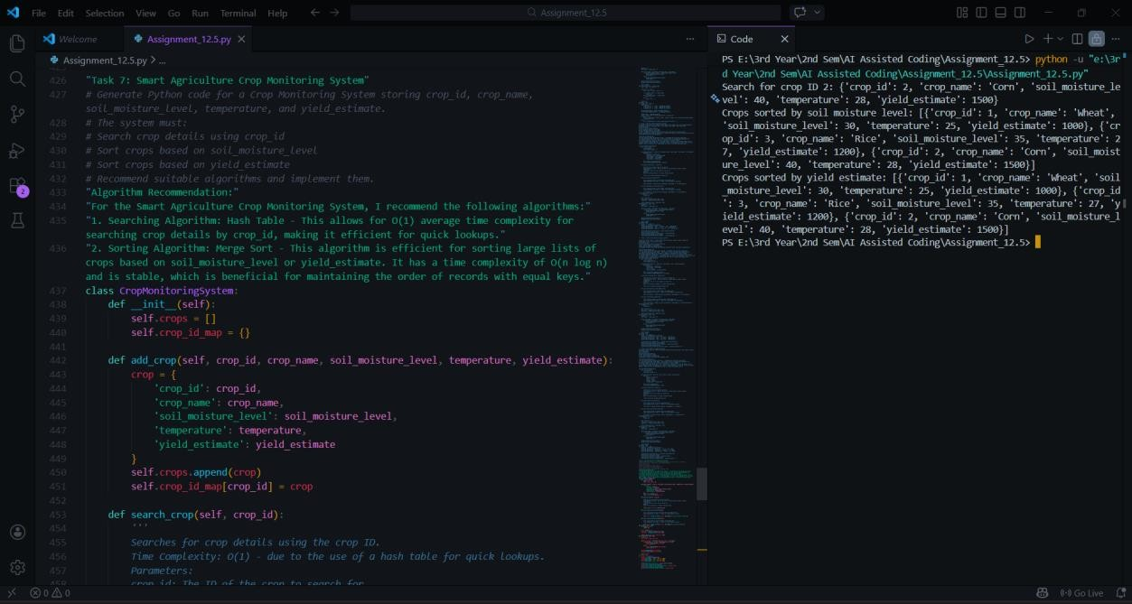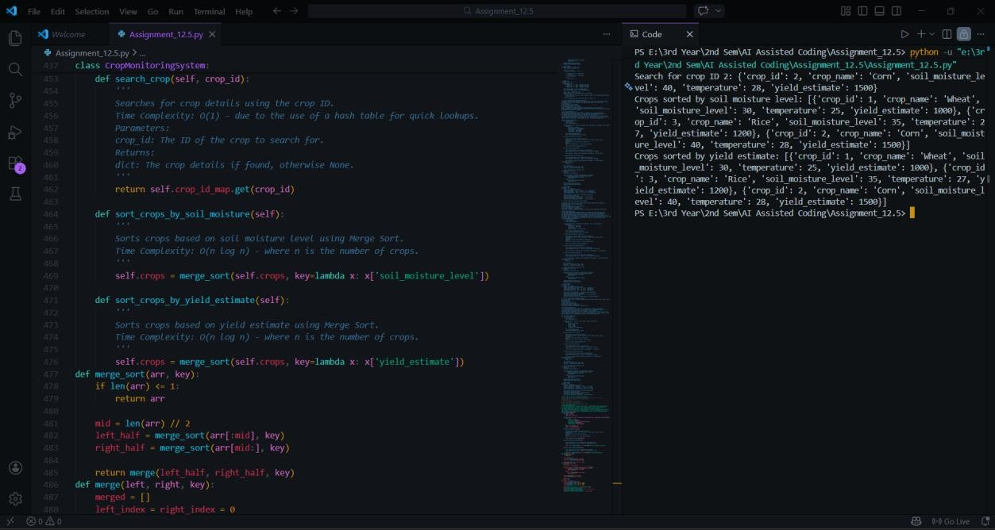
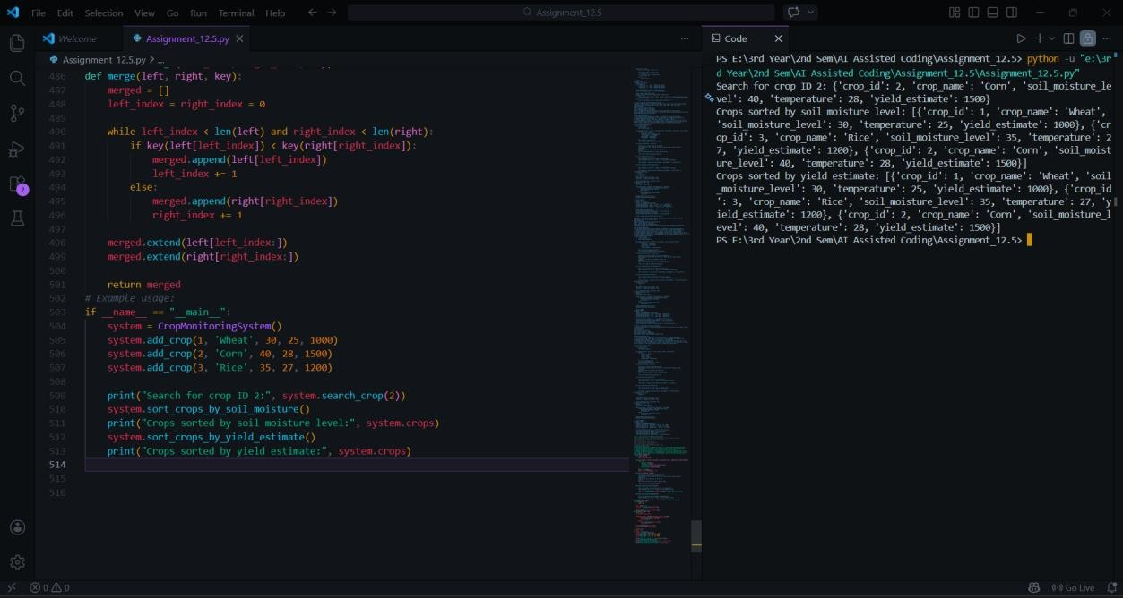
Explanation:
Binary Search enables efficient crop lookup after sorting by crop ID. Sorting by moisture or yield estimate helps farmers analyze data effectively. These algorithms ensure optimized performance for agricultural monitoring systems. AI-supported reasoning guided appropriate algorithm selection.

Task 8: Airport Flight Management System Prompt:
Generate Python code for an Airport Flight Management System storing flight_id, airline_name, departure_time, arrival_time, and status.
The system must:
- Search flight details using flight_id
- Sort flights based on departure_time
- Sort flights based on arrival_time
Recommend suitable algorithms and implement them.
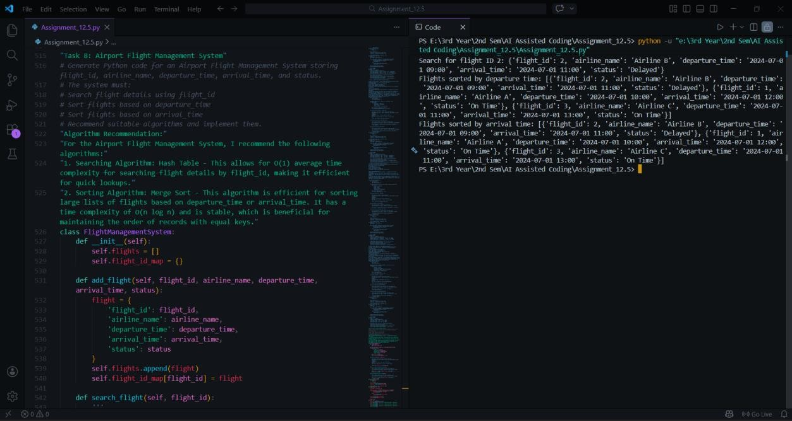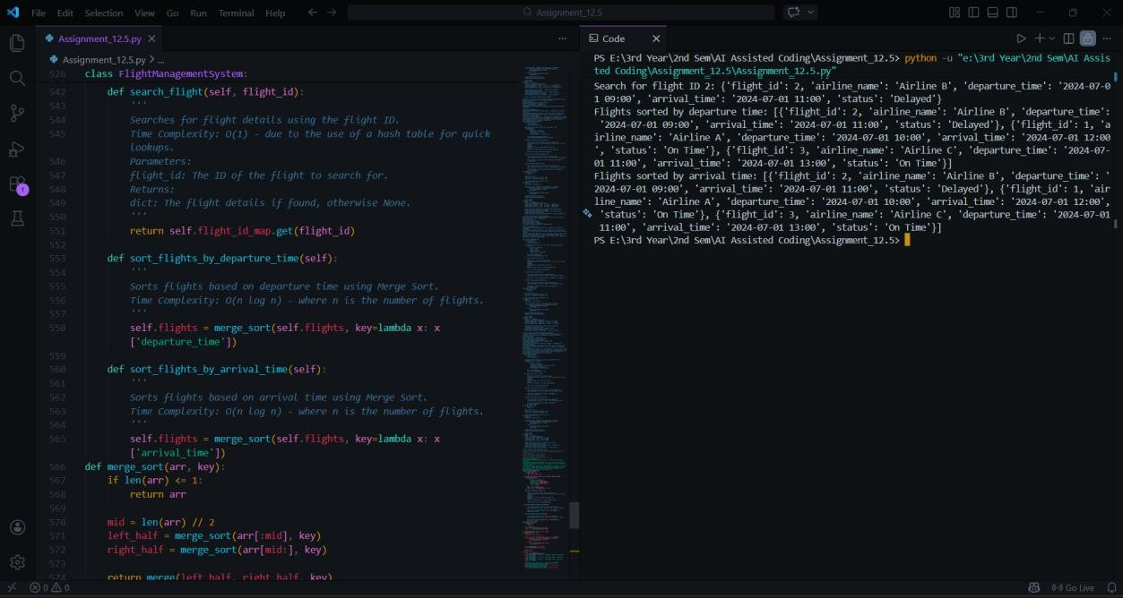

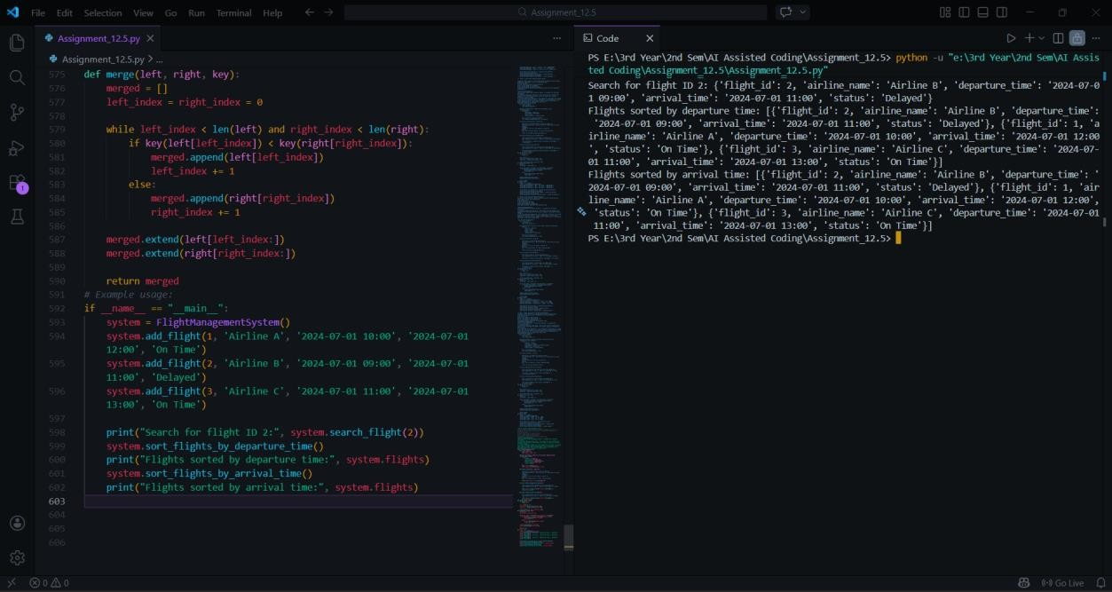
Explanation:
Binary Search ensures fast flight lookup when sorted by flight ID. Sorting by departure or arrival time organizes airport schedules effectively. These algorithms provide efficient record management. AI assistance supported correct algorithm implementation and modular function design.

Final Conclusion:
This lab demonstrated the implementation of sorting and searching algorithms using AI assistance across multiple real-world scenarios. Binary Search was selected for efficient searching due to its logarithmic time complexity, while Merge Sort was chosen for stable and reliable sorting performance. AI tools supported algorithm recommendation, code generation, and optimization. However, understanding algorithm efficiency and selecting appropriate techniques remain the developer’s responsibility to ensure correct and scalable solutions.

