AI Assisted Coding
Assignment 6.3
Name: Ajay kumar
Hall ticket no: 2303A51268
Batch no: 19

Task 1: Classes (Student Class) Prompt:
#Write the code for developing a simple student information management module using classes
#Student attributes:name,rollno,branch
#display_details method to display student information Code & Output:
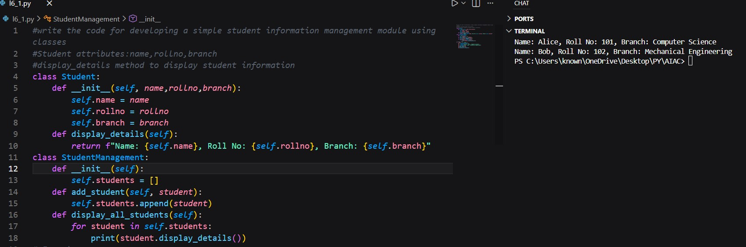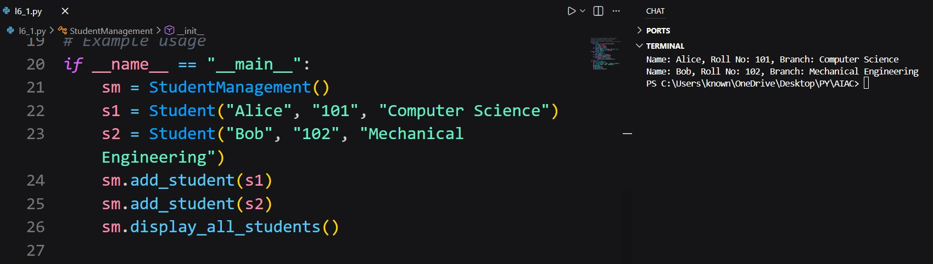
Explanation:
The AI-generated code correctly defines a Student class using object-oriented principles. The constructor initializes student attributes, and the display_details() method prints them clearly. The class structure is simple, readable, and functions correctly when an object is created and executed.

Task 2: Loops (Multiples of a Number) Prompt:
Generate a function that prints first 10 multiples of a given number n Code & Output:
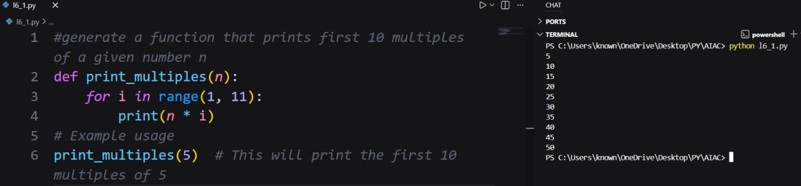
Explanation:
The AI-generated function uses a for loop to iterate from 1 to 10 and prints the multiples of the given number. In each iteration, the loop variable is multiplied by the input number. The loop boundaries are correctly defined, and the logic produces accurate results. This implementation is efficient and readable, making it ideal for tasks with a fixed number of iterations.

Prompt (Alternative Loop):
Generate a function that prints first 10 multiples of a given number n using while loop Code & Output:
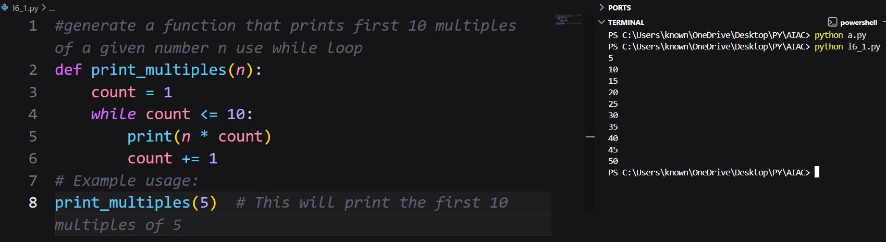
Explanation:
The while-loop version produces the same output as the for-loop version. While loops require manual control of the counter variable, making the for loop slightly cleaner and more readable for fixed iterations.

Task 3: Conditional Statements (Age Classification) Prompt:
Generate nested conditional statements to classify age groups.
Code & Output:
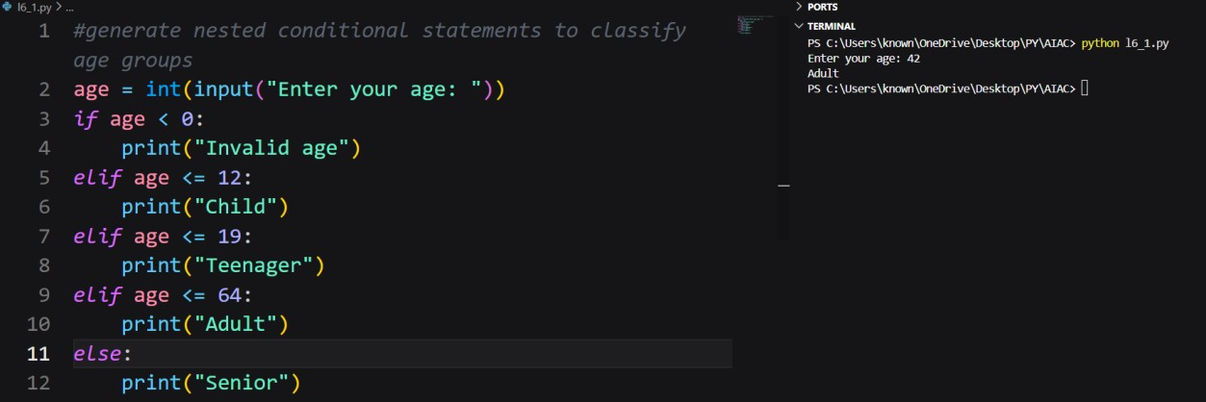
Explanation:
The AI-generated function uses nested if-elif-else conditions to classify age groups. Each condition checks a specific age range in increasing order. The structure ensures that only one category is returned for a given age. The logic is clear, correct, and easy to verify, making the code understandable for beginners and suitable for real-world classification tasks.

Prompt (Alternative Logic):
Generate a program to classify age groups using alternative if-elif-else statements Code & Output:
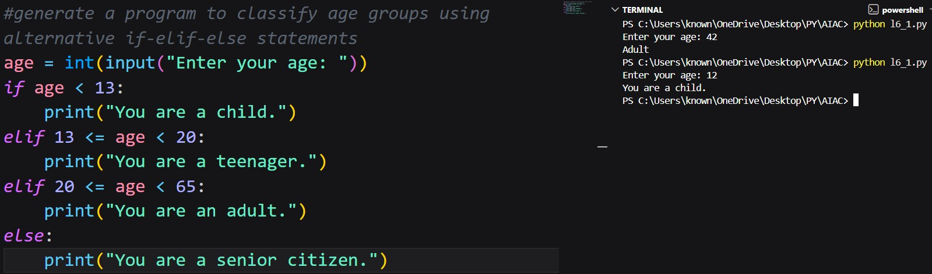

Explanation:
This alternative approach uses a dictionary and a loop to determine the age group. While this method is flexible and scalable, it is more complex than the if-elif-else approach. For simple classification problems, the original conditional structure is more readable and easier to maintain.

Task 4: For and While Loops (Sum of First n Numbers) Prompt:
Generate a Python function to calculate the sum of first n natural numbers using a for loop.
Code & Output:
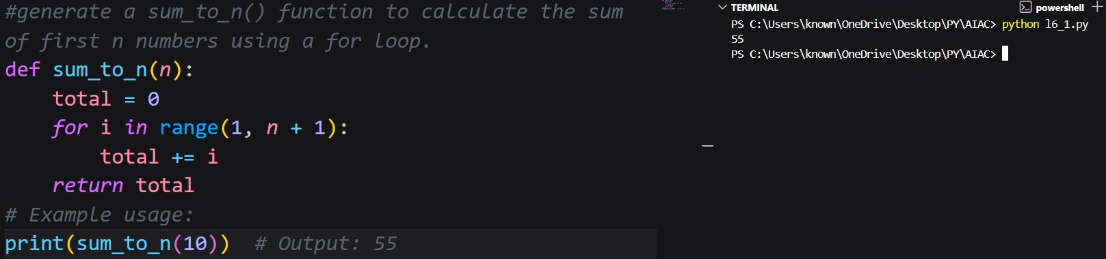
Explanation:
The AI-generated function calculates the sum by iterating through numbers from 1 to n and adding them to a total variable. The loop logic is correct and produces accurate results. This approach is easy to understand and works efficiently for small to moderate values of n.

Prompt (Alternative Loop):
Generate a sum_to_n() function to calculate the sum of first n numbers using a while loop Code & Output:
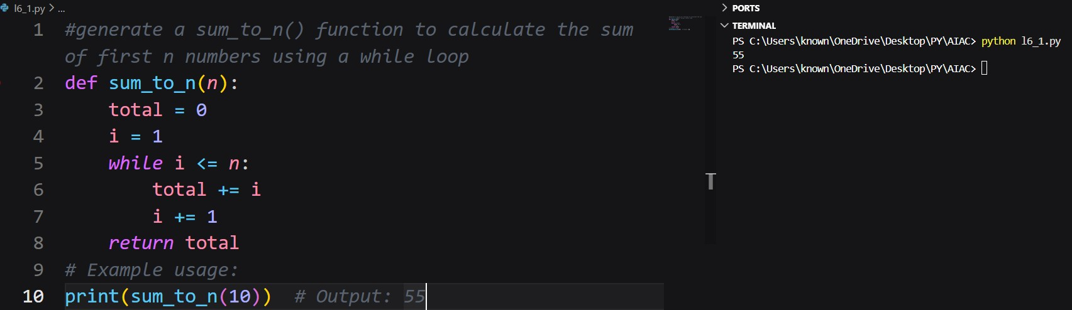
Explanation:
The while-loop version produces the same output as the for-loop version. While loops require manual control of the counter variable, making the for loop slightly cleaner and more readable for fixed iterations.

Task 5: Classes (Bank Account Class) Prompt:
Generate a Bank Account class with methods such as deposit(), withdraw(),and check_balance() with meaningful comments.
Code & Output:
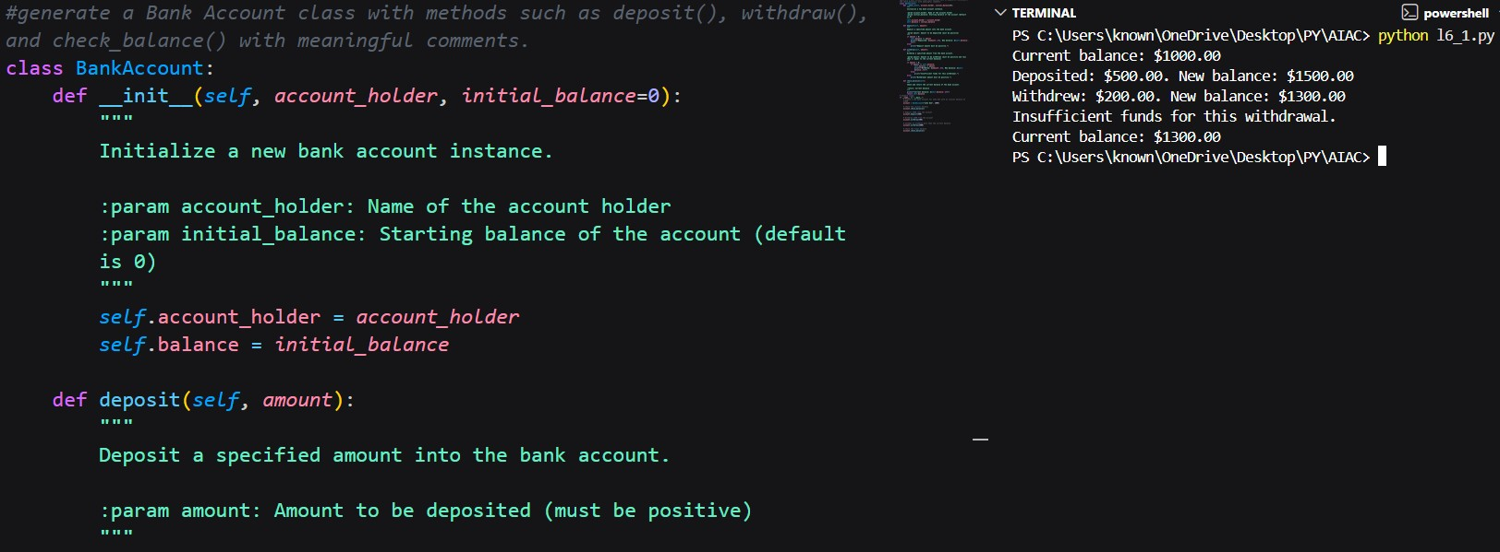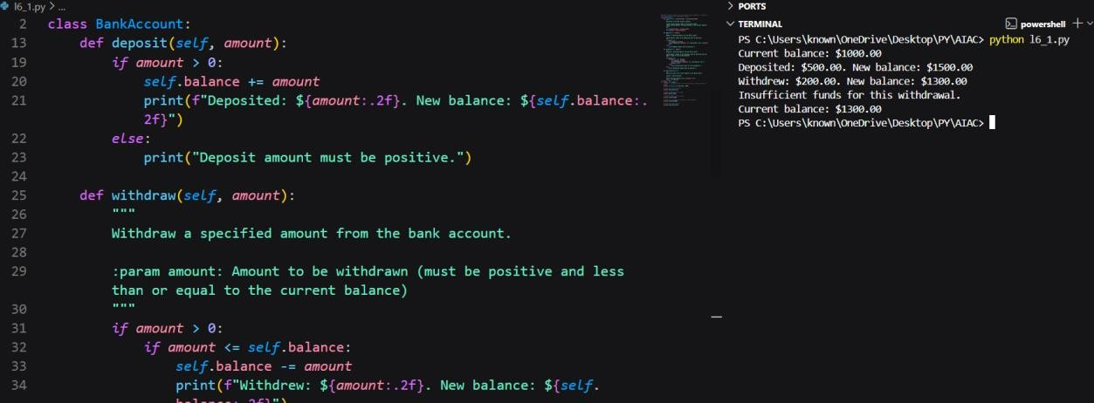
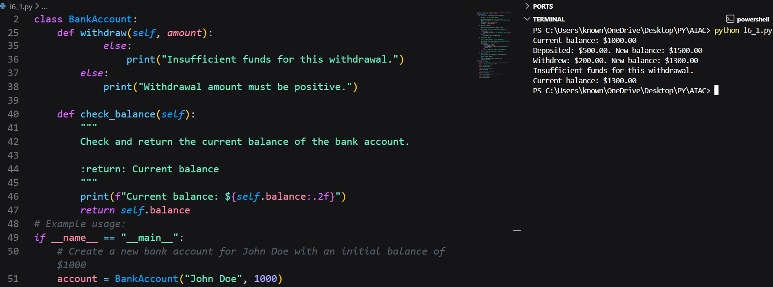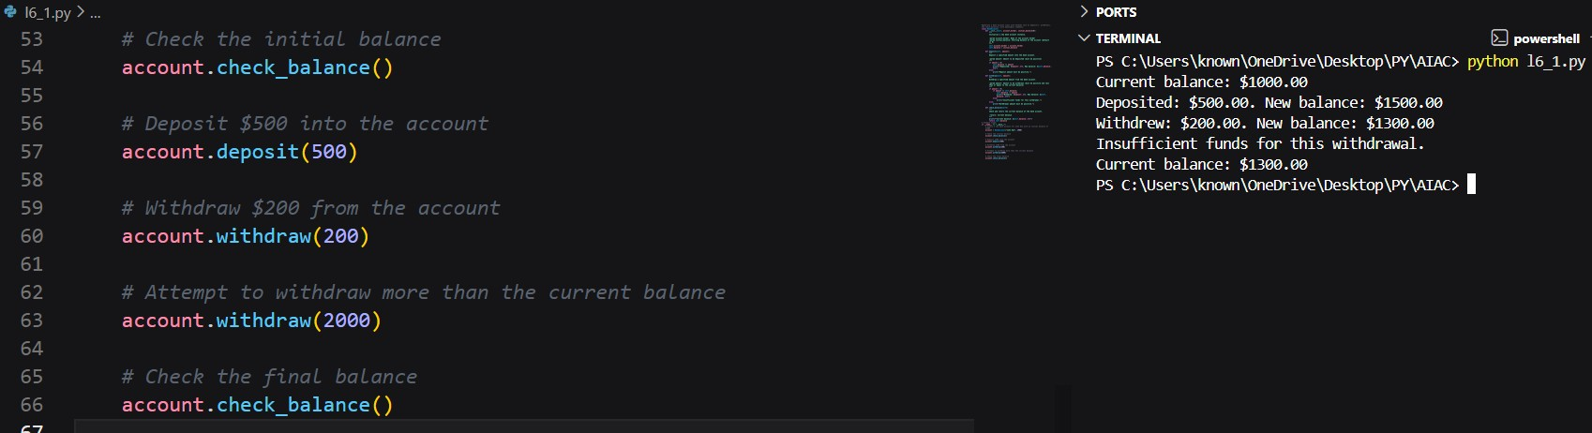
Explanation:
The AI-generated Bank Account class demonstrates effective use of object-oriented programming. The constructor initializes the balance, and the methods allow depositing, withdrawing, and checking the balance. Conditional logic prevents withdrawal when the balance is insufficient. The code is clear, logically sound, and easy to extend, making it suitable for a basic banking application.

