AI Assisted Coding
Assignment 9.3
Name: V Ajay Kumar
Hall ticket no: 2303A51268
Batch no: 19
Task 1: Basic Docstring Generation
Prompt:
Write a Python function that returns the sum of even numbers and the sum of odd numbers in a given list.
Add a Google Style docstring manually and then generate a docstring using AI assistance for the same function.
Code & Output:
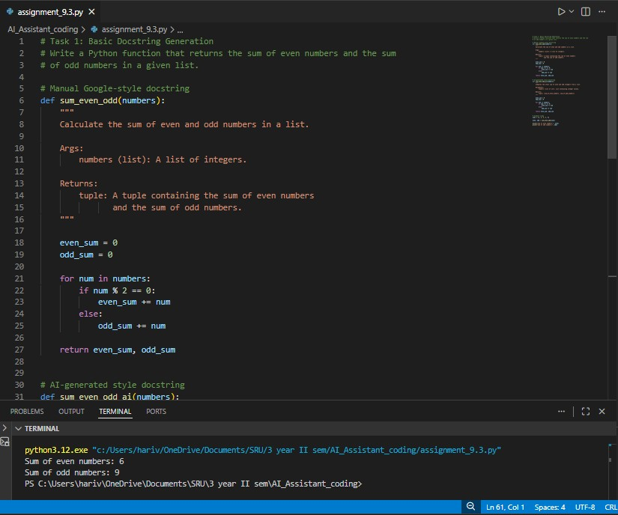
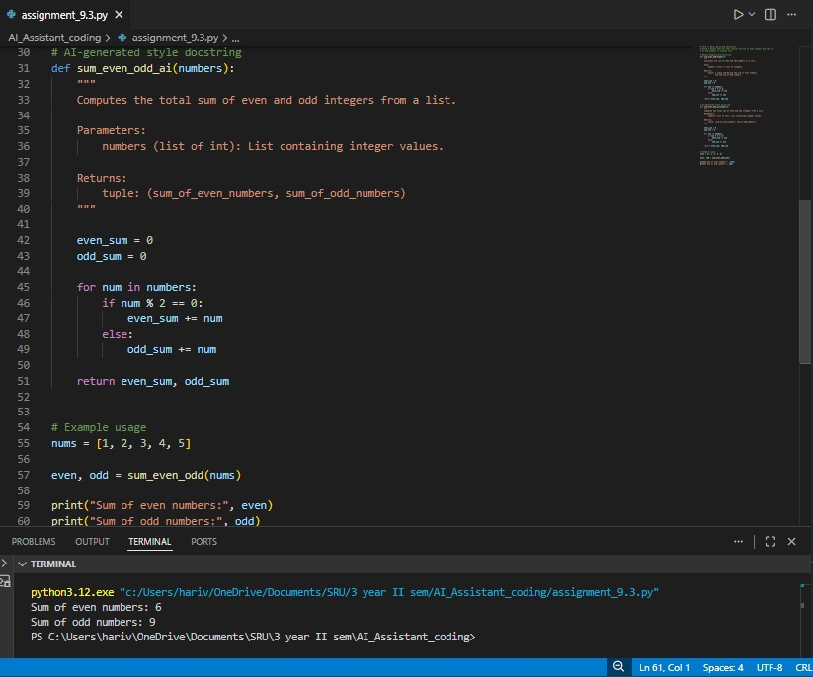
Explanation:
The manual docstring gives a clear and detailed explanation of the function’s purpose and return value. The AI-generated version is shorter and accurate but less descriptive. This comparison shows that AI can create correct documentation, yet human refinement is needed to make it more complete and clear.
Task 2: Automatic Inline Comments Prompt:
Generate a Python class named sru_student with attributes name, roll_no, and hostel_status, and methods fee_update() and display_details(). Add inline comments automatically.
Code & Output:
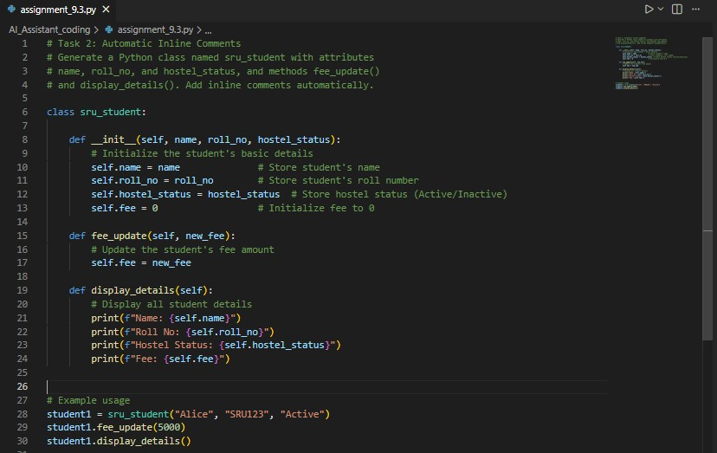
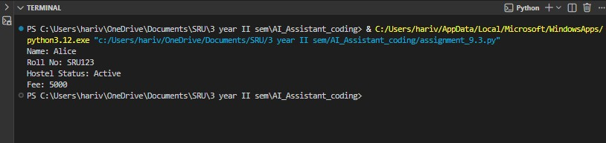
Explanation:
Manual comments are clear, specific, and reflect the developer’s intent. AIgenerated comments are accurate but tend to be more general and sometimes explain obvious code lines. This shows that while AI can speed up documentation, human review is important to ensure the comments are meaningful and not repetitive.

Task 3: Module-Level and Function-Level Documentation
Prompt:
Generate a Python calculator module with functions add, subtract, multiply, and divide. Add NumPy-style docstrings manually and then generate module-level and functionlevel documentation using AI assistance.
Code & Output:
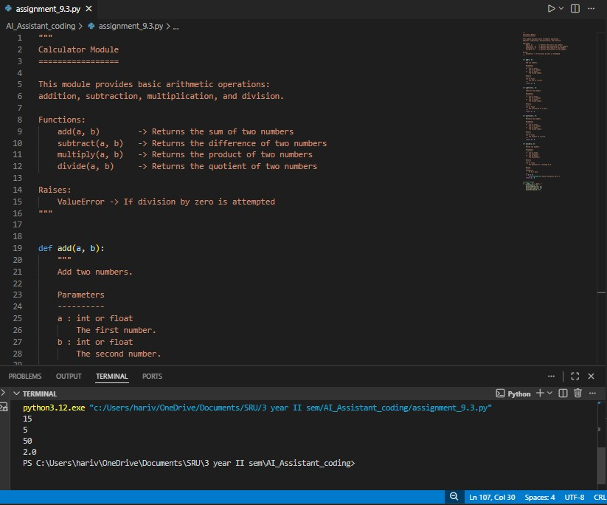
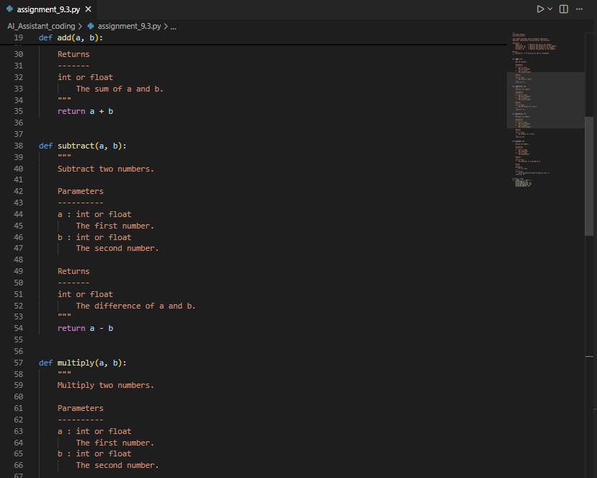

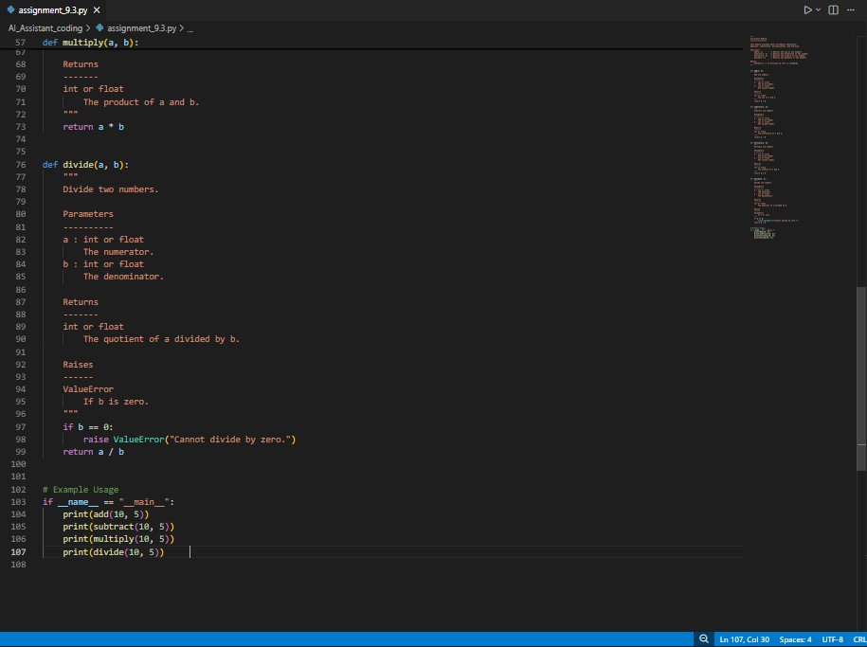
Explanation:
Manual NumPy-style docstrings follow a well-structured scientific format with clear sections for parameters and return values. The AI-generated version is concise and useful for general overviews but does not provide detailed parameter-level explanations. While AI is strong at summarizing, manual documentation offers better technical depth and clarity.

