AI Assisted Coding
Assignment 1.5
Name: V.AjayKumar
Hall ticket no: 2303A51268
Batch no: 19
Task 1:
Prompt:
Generate string reversal without using functions Code& Output:
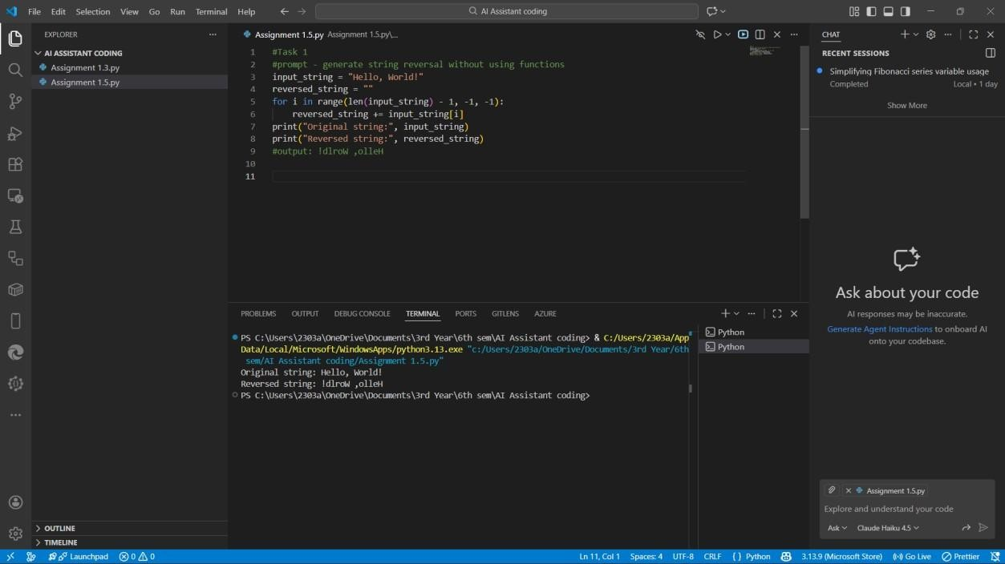
Explanation:
This task reverses a string without using any predefined functions.
The program reads the string from the end and moves backward to the beginning.
Each character is added to a new variable to form the reversed string.
This method relies only on loops and indexing.
It shows how characters are accessed inside a string.
The logic works for strings of any size.

Task 2: Prompt:
improve the code Code& Output:
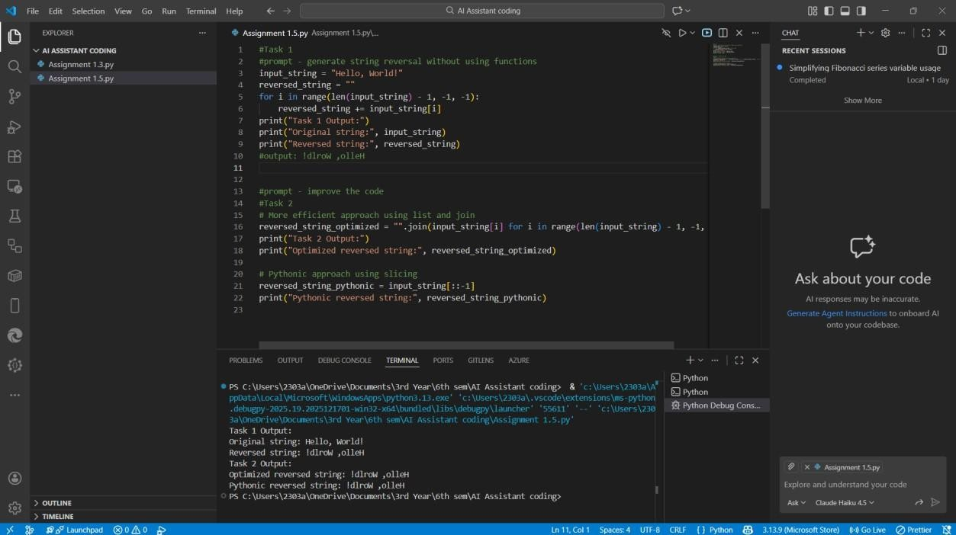
Explanation:
This task improves the earlier code by making it simpler and more organized.
Extra steps are removed so the program runs more smoothly.
The loop is written in a more efficient way.
Clear variable names help in understanding the logic better.
Even though the output stays the same, the code quality is higher.
This reflects better programming practice.
Task 3:
Prompt:
Generate the string reversal using functions
Code& Output:
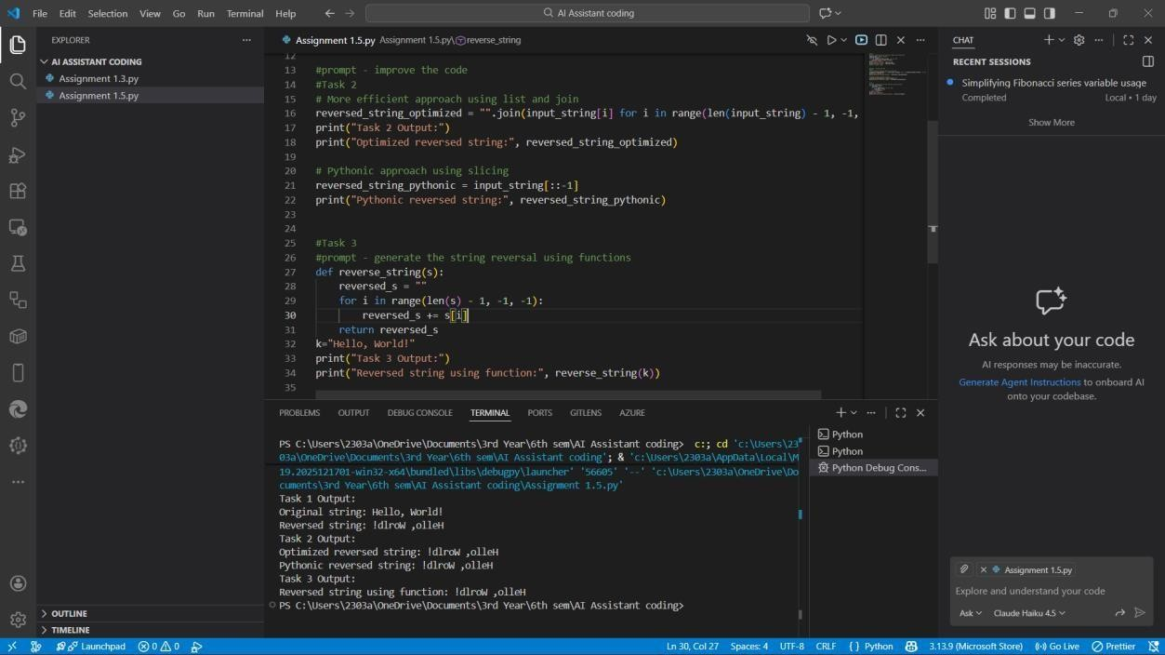
Explanation:
This task performs string reversal using a function.
The main reversal logic is written inside a separate block of code.
This allows the same function to be reused when needed.
It keeps the main program short and clean.
Functions help in managing large programs easily.
This structure is widely used in real software development.

Task 4: Prompt:
compare the code of task 1 and task 3 and print the comparison in a tabular format
Code:
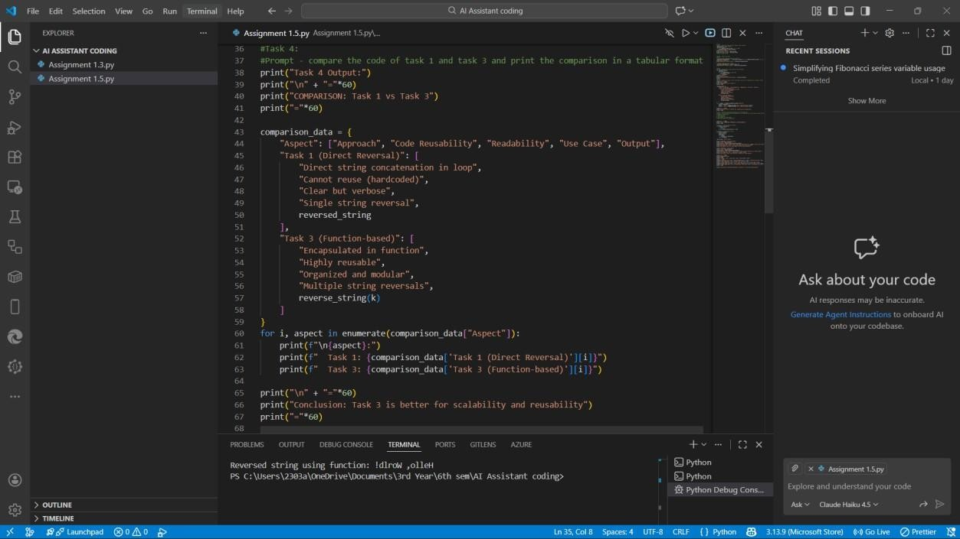
Output :
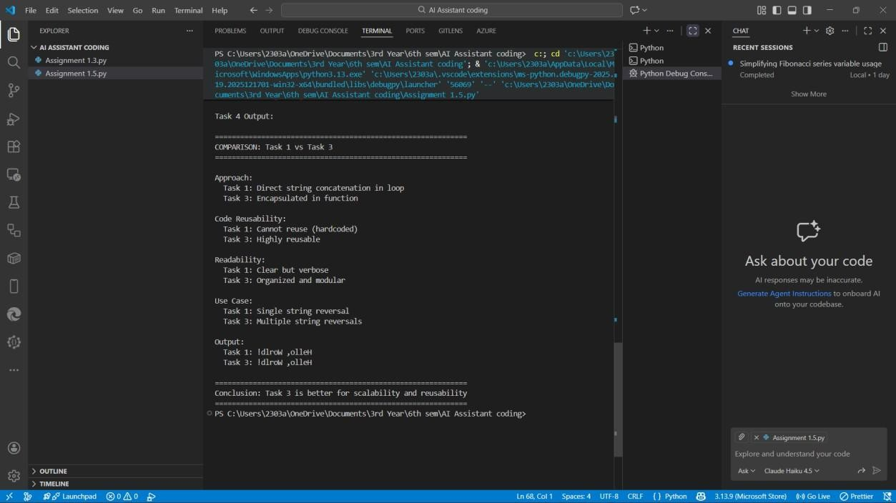
Explanation:
This task compares the programs from Task 1 and Task 3.
The comparison is displayed in a table for easy understanding.
It shows differences in how the code is written and organized.
One method uses direct logic, while the other uses a function.
This explains why functions are better for structured programs.
The table makes the comparison clear and readable.
Task 5: Prompt:
use Different Algorithmic Approaches to String Reversal and the output should contain as Two correct implementations
# Comparison discussing:
# Execution flow
# Time complexity
# Performance for large inputs # When each approach is appropriate
Code:

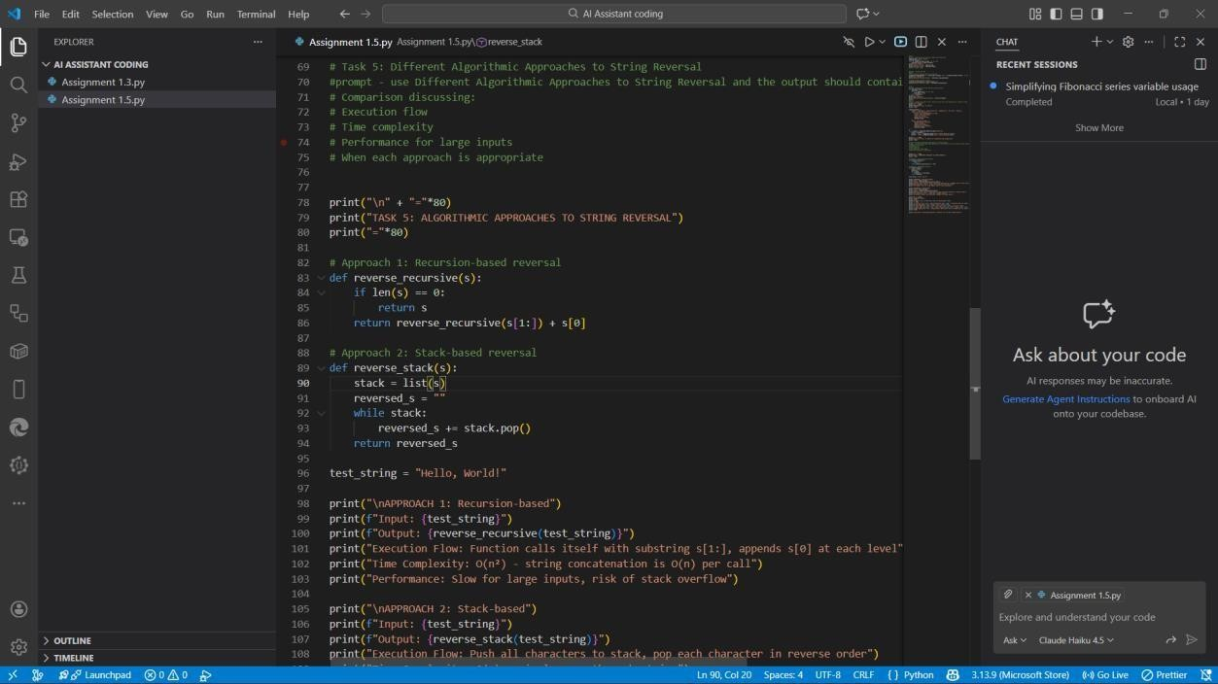
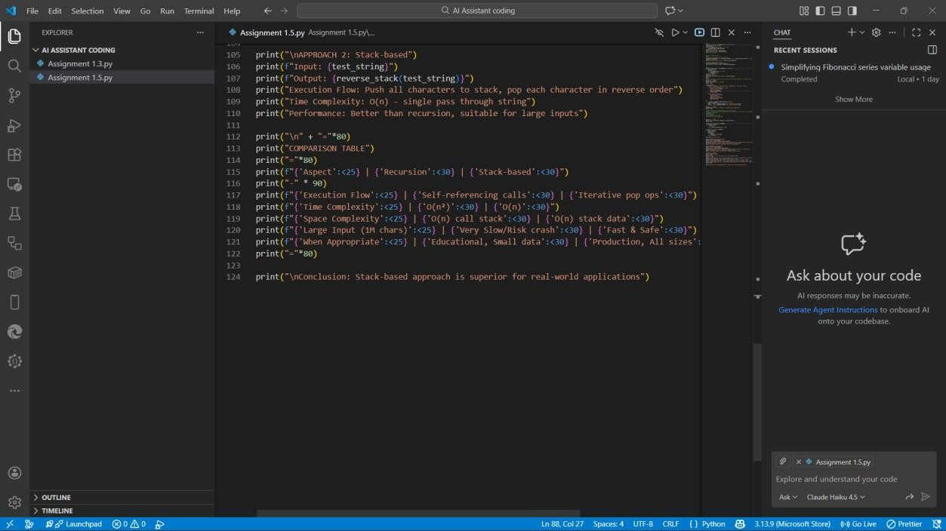
Output :
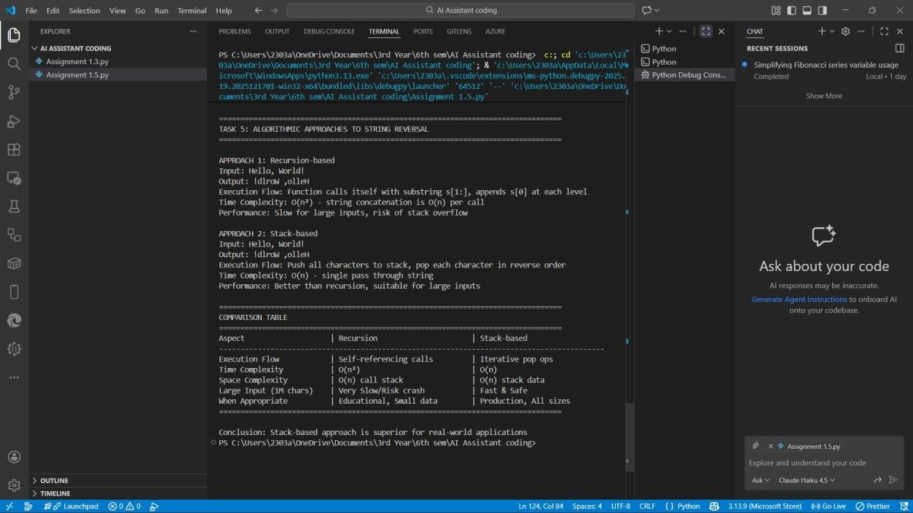
Explanation:
This task applies two different techniques to reverse a string.
Both methods produce the same correct result.
The steps of execution vary between the two approaches.
Each method takes time based on the length of the string.
Some approaches are better when working with large inputs.
The comparison helps decide which method is more suitable.

