Assignment-8.3

Test-Driven Development with AI – Generating and Working with TestCases

Name: V.Ajay kumar
Hall ticket no: 2303A51268
Batch no: 19

Task 1: Email Validation using TDD Prompt:
Generate Python unittest test cases for validating email formats based on the following rules:
- Must contain @ and .
- Must not start or end with special characters
- Must not contain multiple @ symbols Code & Output:
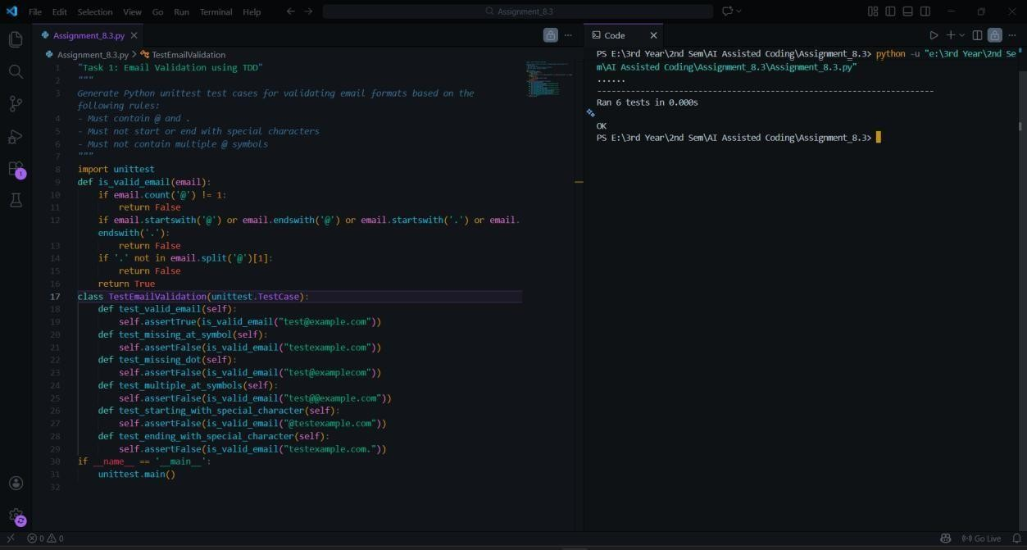
Explanation:
In this task, AI first generated test cases covering both valid and invalid email formats. The implementation was then written to satisfy all test conditions. The function checks for the presence of “@” and “.”, prevents multiple “@” symbols, and ensures the email does not start or end with special characters. By following the TDD approach, correctness was validated through successful test execution.

Task 2: Grade Assignment using Loops
Prompt:
Generate unittest test cases for a function assign_grade(score) with boundary and invalid inputs.
Code & Output:
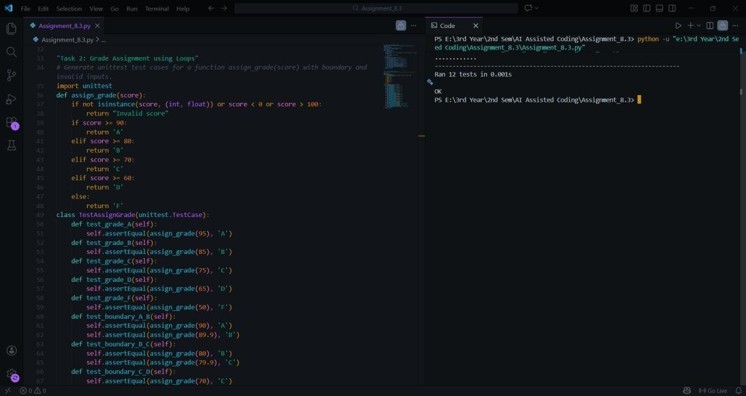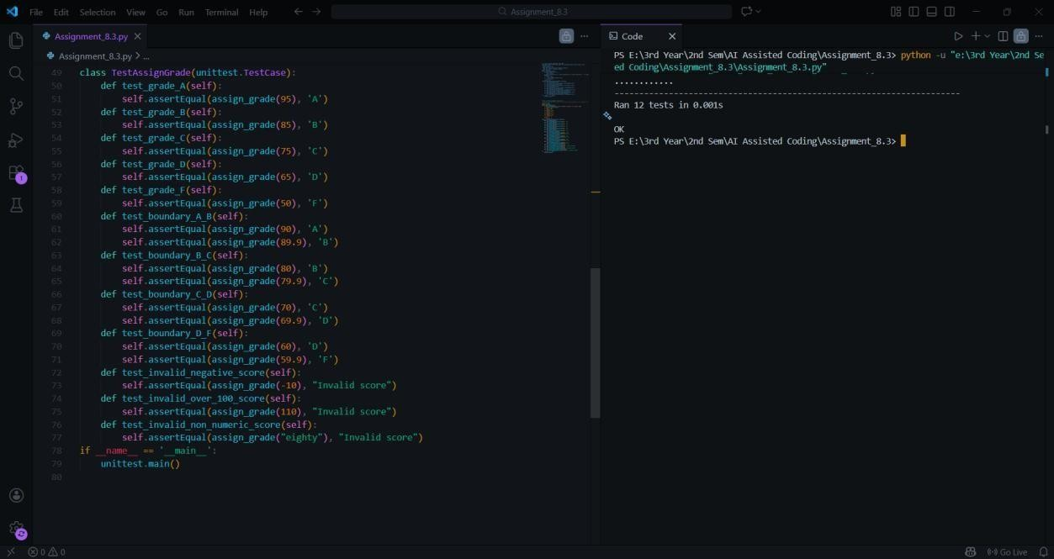
Explanation:
AI-generated tests included normal ranges, boundary values, and invalid inputs. The implementation ensures proper grade assignment using conditional logic. It also validates input type and range, preventing incorrect values from producing misleading grades. All test cases pass successfully, confirming correctness.

Task 3: Sentence Palindrome Checker
Prompt:
Generate unittest test cases for checking whether a sentence is a palindrome while ignoring case, spaces, and punctuation.
Code & Output:
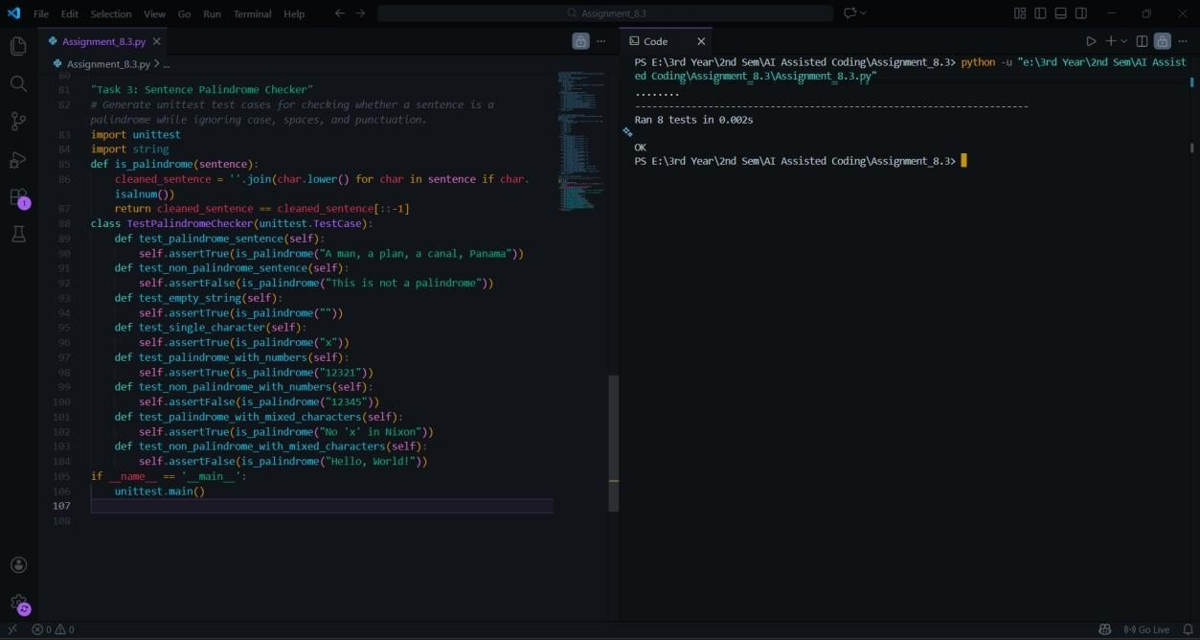
Explanation:
The AI-generated tests check both palindromic and non-palindromic sentences. The implementation removes spaces and punctuation using regular expressions and converts text to lowercase. The cleaned string is compared with its reverse. This ensures accurate palindrome detection regardless of formatting.

Task 4: ShoppingCart Class Prompt:
Generate unittest test cases for a ShoppingCart class with add_item, remove_item, and total_cost methods.
Code & Output:
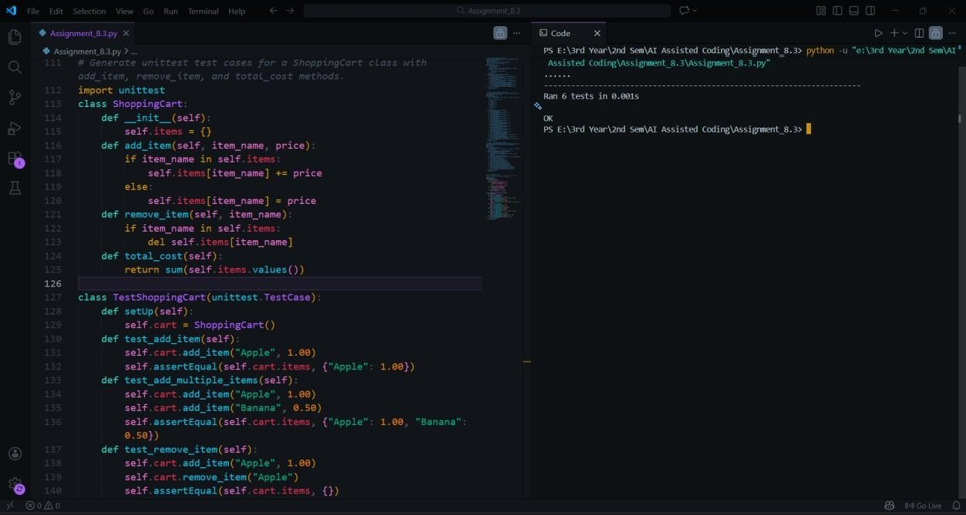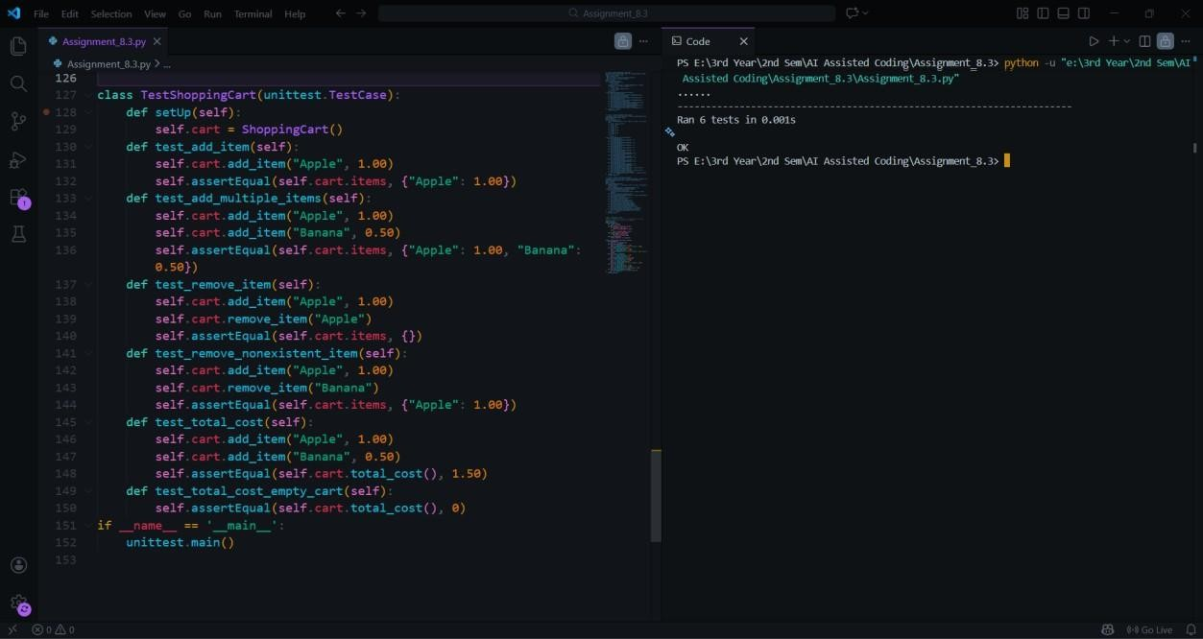
Explanation:
The AI-generated test cases validate item addition, removal, and total cost calculation. The class uses a dictionary to store items and prices. Methods correctly update the cart state, and the total cost is computed using the sum of values. The implementation passes all generated tests, confirming reliability.

Task 5: Date Format Conversion Prompt:
Generate unittest test cases for converting date format from YYYY-MM-DD to DD-MM-YYYY.
Code & Output:
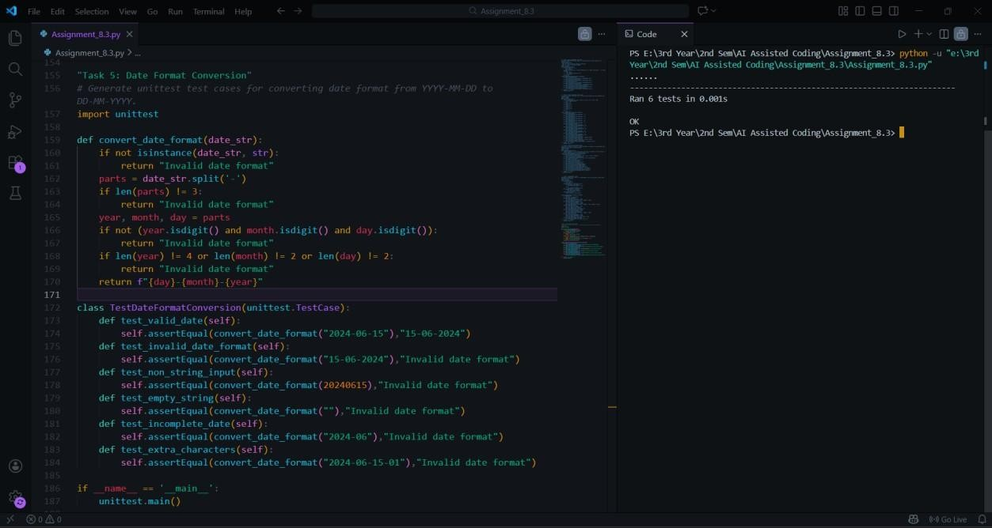
Explanation:
The AI-generated tests verify both valid and invalid date inputs. The implementation splits the input string and rearranges the components into the required format. Error handling ensures that incorrectly formatted inputs return an appropriate message. All test cases pass successfully.

Final Conclusion:
This lab demonstrates the effectiveness of Test-Driven Development using AI. By generating test cases first, developers can ensure correctness, reliability, and validation before implementation. AI accelerates test creation, but human review remains essential for designing robust and meaningful test coverage.

