AI Assisted Coding

Assignment 11.3

Name: V.AJAY KUMAR
Hall ticket no: 2303A51268
Batch no: 19
Task 1: Smart Contact Manager (Arrays & Linked Lists) Prompt:
Generate Python code to implement a Contact Manager system using:
- Array (Python list)
- Linked List
The system must support:

• Add contact
- Search contact
- Delete contact
Use meaningful class names, proper methods, and include comments.
Code & Output (Arrays):
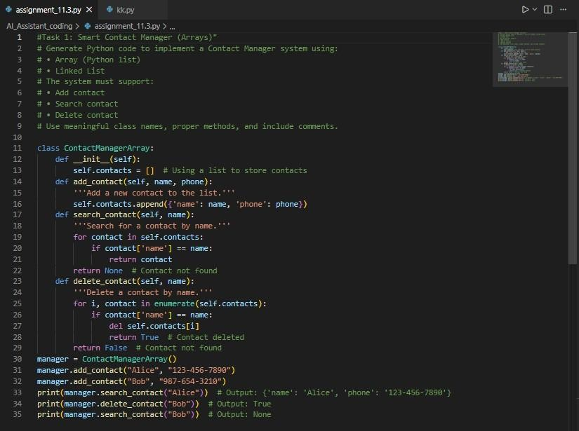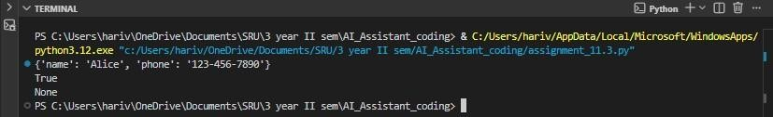
Explanation(Arrays):
This implementation uses a Python list to store contact dictionaries. Adding contacts is efficient (O(1) average). Searching and deletion require linear traversal (O(n)). The array approach is simple and easy to implement but less efficient for frequent deletions in large datasets.
Code & Output (Linked-Lists):
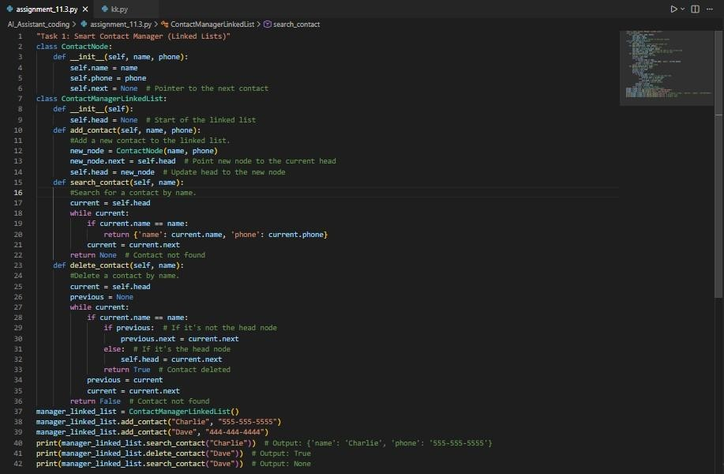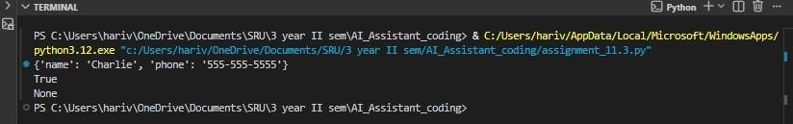
Explanation (Linked-Lists):
The linked list implementation allows dynamic memory allocation. Insertion at the beginning is O(1). Searching and deletion are O(n). Unlike arrays, linked lists avoid shifting elements during deletion. However, they require extra memory for pointers and are slightly more complex to implement.

Comparision (Arrays VS Linked-Lists):
- Insertion Efficiency: Linked List (O(1) at head) is better than array when frequent insertions occur.
- Deletion Efficiency: Linked List avoids shifting elements.
- Search Efficiency: Both require O(n).
- Memory Usage: Array is more memory-efficient.
Task 2: Library Book Search System (Queue & Priority Queue) Prompt:
Generate Python code to implement:
- A Queue (FIFO)
- A Priority Queue prioritizing faculty requests over student requests
Include enqueue and dequeue methods.
Code & Output (Queue):
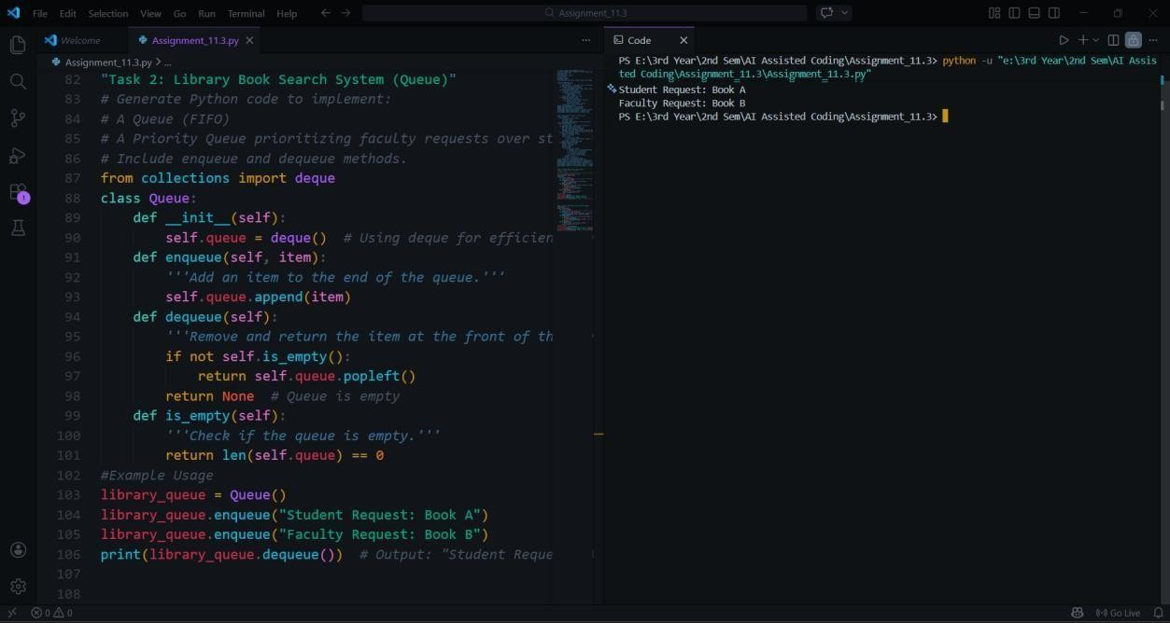
Explanation(Queue):
The queue follows FIFO (First In, First Out). Requests are processed in the order they arrive. This is suitable for standard book request management.
Code & Output (Priority Queue):
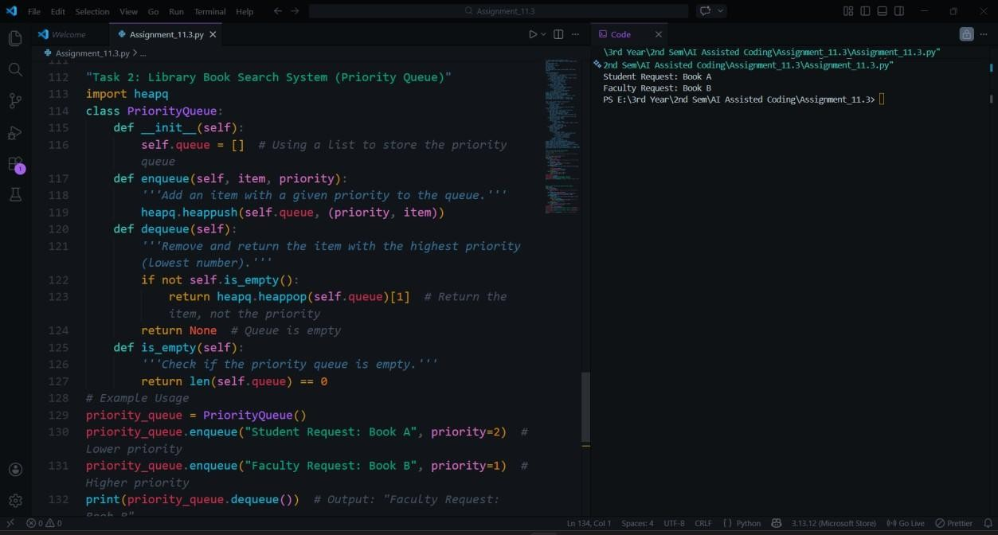
Explanation (Priority Queue):
The priority queue uses a heap. Faculty requests are assigned higher priority (lower numeric value). This ensures faculty members are served before students.

Task 3: Emergency Help Desk (Stack) Prompt:
Generate Python code to implement a Stack for managing support tickets with push, pop, peek, is_empty methods.
Code & Output:
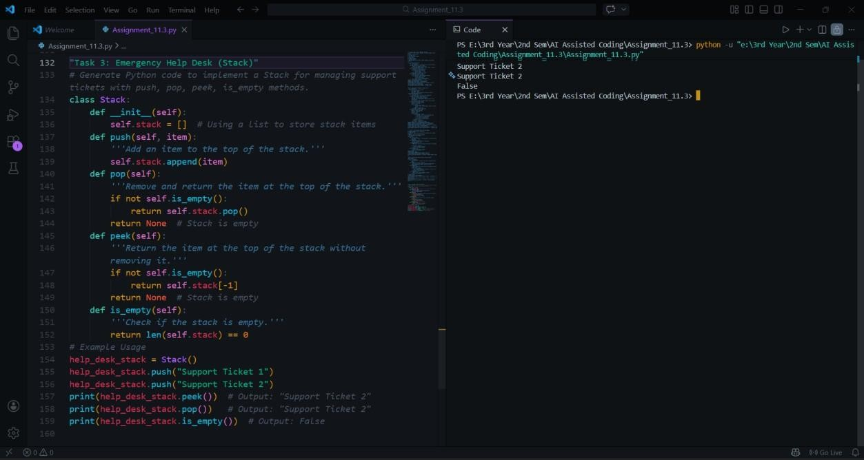
Explanation:
The stack manages support tickets using LIFO order, where the most recent ticket is resolved first. Push, pop, and peek operations demonstrate escalation handling effectively. This structure is suitable for urgent issue resolution workflows. AI assistance helped design stack methods and improve operational clarity.

Task 4: Hash Table Prompt:
Generate a Python HashTable class with insert, search, and delete methods using collision handling through chaining.
Code & Output:
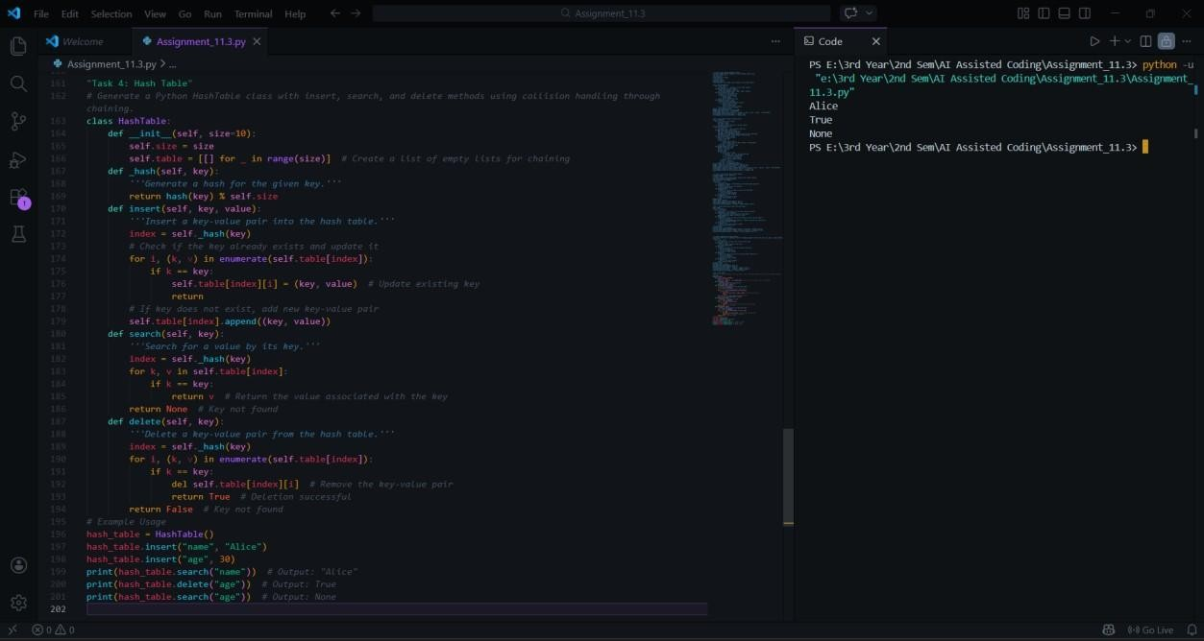
Explanation:
The hash table stores data using a hashing function to determine storage index. Collision handling is done using chaining, allowing multiple elements per bucket. This ensures efficient average-time operations. AI helped generate structured bucket management logic.

Task 5: Real-Time Application Challenge Prompt:
Design a Campus Resource Management feature and implement one selected feature using an appropriate data structure.
Code & Output:
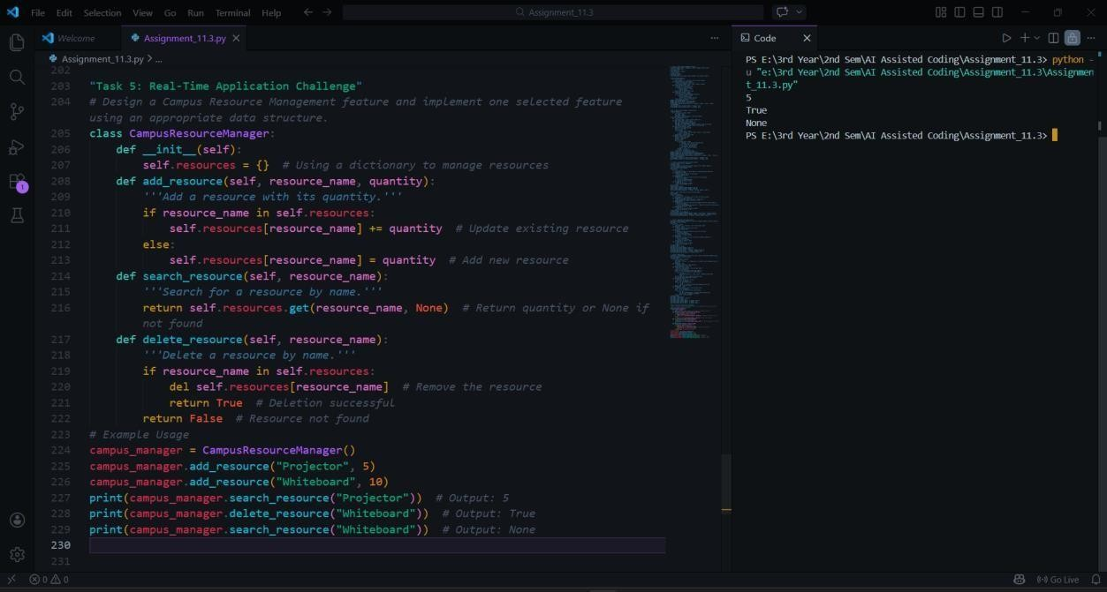
Explanation:
The cafeteria system uses a queue to maintain FIFO order of service. Customers are served in the order they arrive, ensuring fairness. This data structure matches real-world queue behavior. AI assistance helped implement and structure the queue methods efficiently.

