**Treeleaf AI Challenge 2020**

Liveness detection is a challenging task given the number of different scenarios live HD fake video, lightning conditions and deep fakes. This liveness detection uses the mtcnn to detect the face and then after extracting the face , it uses the same frame to classify whether the face is live or not. Further, the eyes are extracted from the face and are checked if the eyes are closed and as per the competition guidelines , they are marked non-live if both the eyes are found to be closed.

**Running the model:**

To run the model ,clone the code from the github. To install the required libraries . The required libraries are listed in the requirement.txt file. To install all the requirements you can simply type the following code in terminal of your IDE.

|  |
| --- |
| Pip install -r requirements.txt |

For easier running of the model and proper evaluation I have written some use friendly command line interface. You can read the help file by running:

|  |
| --- |
| python main.py -h |

|  |
| --- |
| Treeleaf Liveness Detection  optional arguments:  -h, --help show this help message and exit  -f {True,False}, --showFps {True,False}  Choose weather to show the FPS or not  -v {0,1,2}, --videoSource {0,1,2}  Choose the video source to start the liveness detection  0: For the primary webcam  1: For the secondary webcam  2:To select the file from computer  -p VIDEOPATH, --videoPath  VIDEOPATH path to the video// only works if the   -s {1,2,3,4,5}, --stride {1,2,3,4,5}  Increase the FPS by striding  -c {True,False}, --saveVideo {True,False}  Set true to save the output video |
|  |

All the arguments are optional so if you want to run the model through the webcam with the basic setting you can simply run

|  |
| --- |
| python main.py |

To show the fps you can run the main.py as

|  |
| --- |
| python main.py -f True |

You can also use multiple settings from the given argument. Note that the **stride** argument used for increasing the fps may decrease the accuracy of bounding box.The algorithm used is a strided modification of MTCNN in which face detection is performed on only every N frames, and applied to all frames. For example, with a batch of 9 frames, we could pass frames 0, 3, and 6 to MTCNN. Then, the bounding boxes (and potentially landmarks) returned for frame 0 would be naively applied to frames 1 and 2. Similarly, the detections for frame 3 are applied to frames 4 and 5, and the detections for frames 6 are applied to frames 7 and 8.

Also note that this model is made to freeze till the face is detected in the given video frame , as was instructed to ignore the non face object.

Please choose the command line interface as per your need.

For training the model different datasets are used. These datasets are basically used to extract the face or eyes which is the subject of our interest. These datasets are publicly available for download. For ROSE- youtu dataset you have to send an email and they provide you the access after a day or two.

**The datasets used for the liveness detection are:**

1)[ROSE-Youtu Face Liveness Detection Dataset](http://rose1.ntu.edu.sg/datasets/faceLivenessDetection.asp)

2)[Closed Eyes In The Wild (CEW) Dataset](http://parnec.nuaa.edu.cn/_upload/tpl/02/db/731/template731/pages/xtan/ClosedEyeDatabases.html)

3)Personal Dataset(for improvisation as the Rose-youtu dataset only contained people of chinese origin)

1)[ROSE-Youtu Face Liveness Detection Dataset](http://rose1.ntu.edu.sg/datasets/faceLivenessDetection.asp)

The ROSE-Youtu Face Liveness Detection Database (ROSE-Youtu) consists of 4225 videos with 25 subjects in total (3350 videos with 20 subjects publically available with 5.45GB in size).For each subject, there are 150-200 video clips with the average duration around 10 seconds. Five mobile phones were used to collect the database: (a) Hasee smart-phone (with resolution of 640 * 480), (b) Huawei Smart-phone (with resolution of 640 * 480), (c) iPad 4 (with resolution of 640 * 480), (d) iPhone 5s (with resolution of 1280 * 720) and (e) ZTE smart-phone (with resolution of 1280 * 720). All face videos are captured by a front-facing camera. The standoff distance between face and camera is about 30-50 cm.For genuine face video, normally there are 25 videos (5 devices with 5 scenes). The scene covers 5 different illumination conditions in office environment. If the client wears eye-glasses, there will be another 25 videos.

Three spoofing attack types including printed paper attack, video replay attack, and masking attack. For printed paper attack, face image with still printed paper and quivering printed paper (A4 size) are used. For video replay attack, we display a face video on Lenovo LCD screen and Mac screen. For masking attack, masks with and without cropping are considered.

These videos are recorded from a total of 20 persons in MP4 format. The naming template of each mp4 is L_S_D_x_E_p_N (seven sections connected with ‘_’). Each section is introduced as follows:

1. The first section ‘L’ could by any one of the follow 9 strings:

1) G - ‘G’ indicates a genuine person.

2) Ps - ‘Ps’ indicates a still printed paper.

3) Pq - ‘Pq’ indicates a quivering printed paper.

4) Vl - ‘Vl’ indicates a video which records a lenovo LCD display.

5) Vm - ‘Vm’ indicates a video which records a Mac LCD display.

6) Mc - ‘Mc’ indicates a paper mask with two eyes and mouth cropped out.

7) Mf - ‘Mf’ indicates a paper mask without cropping.

8) Mu - ‘Mu’ indicates a paper mask with the upper part cut in the middle.

9) Ml - ‘Ml’ indicates a paper mask with the lower part cut in the middle.

2. The second section ‘S’ could be any one of the follow 2 strings:

1) T - ‘T’ indicates the subject is speaking when recording.

2) NT - ‘NT’ indicates the subject is not speaking when recording.

3) The third section ‘D’ indicates the devices recording the videos, and it could be any one of the follow 5 strings:

1) HS - ‘HS’ indicate the video is recorded by a Hasee smart-phone.

2) HW - ‘HW’ indicate the video is recorded by a Huawei smart-phone.

3) IP - ‘IP’ indicate the video is recorded by an Ipad.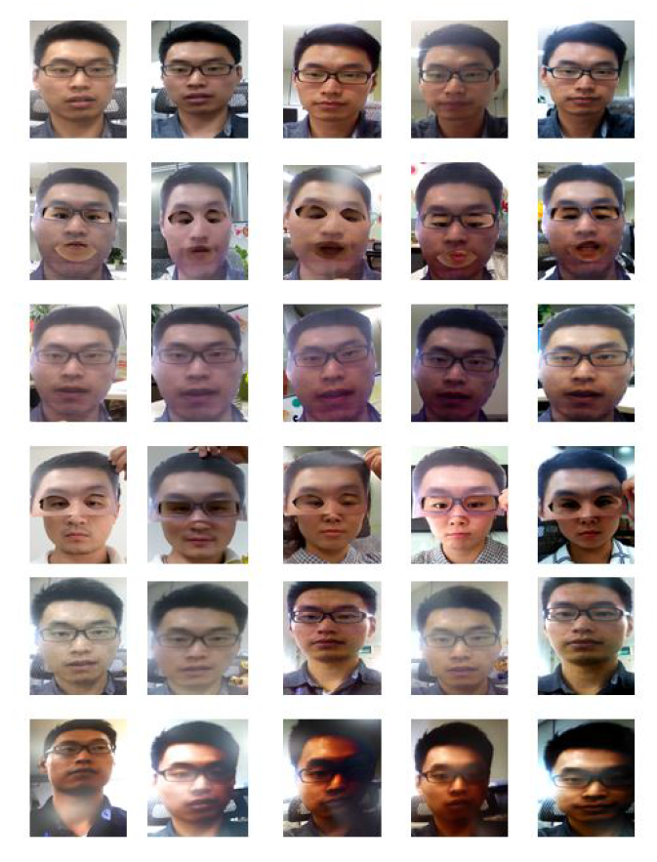

4) 5s - ‘5s’ indicate the video is recorded by an Iphone 5s.

5) ZTE - ‘ZTE ’indicate the video is recorded by a ZTE smart-phone.

4．The fourth section ‘X’ indicates whether the subject is wearing eyeglasses, and it could be any one of the follow 2 strings:

1) g - ‘g’ indicates the subjects is wearing glasses.

2) wg - ‘wg’ indicates the subjects is not wearing glasses.

5．The fifth section ‘E’ indicates the background environment when the video is recorded. This section is reserved and has not been set yet.

6．The section ‘p’ indicates the person ID.

7．The last section ‘N’ indicate the file index number.

2)[Closed Eyes In The Wild (CEW) Dataset](http://parnec.nuaa.edu.cn/_upload/tpl/02/db/731/template731/pages/xtan/ClosedEyeDatabases.html)

Eye closeness detection is a challenging task in the unconstrained real-world application scenario which is full of challenging variations caused by individual difference and kinds of environment changes including lighting, blur, occlusion, and disguise. To investigate the performance of eye closeness detection in these conditions, we collected a dataset for eye closeness detection in the Wild. In particular, this dataset contains 2423 subjects, among which 1192 subjects with both eyes closed are collected directly from Internet, and 1231 subjects with eyes open are selected from the Labeled Face in the Wild (LFW [2]) database. Eye patches are collected based on the coarse face region and eye position automatically and respectively estimated by the face detector[3] and eye localization[4]. We first resize the cropped coarse faces to the size 100×100 (pixels) and then extract eye patches of 24×24 centered at the localized eye position. Illustration of faces images in this dataset can be seen in Figure 1.

3)Personal dataset :

Video of around 20 people is taken for an average of 10 sec . For each person there are 3 videos , one when the eyes are closed , eyes open and the video of them in mobile or the printed photo. Then the faces and eyes are extracted from the video using the MTCNN.

I have shared the zip file containing all the extracted faces from all these [dataset](https://drive.google.com/file/d/1eSh399jNkTCqggIkzM3HC2XWnZc8ZcM6/view?usp=sharing) .