1.Write a python code to create a list that stores names of employees, display the first item, last item in the list and Print

1. Length of the list
2. Type of the list

Code:

employee=["Ajay","Sanjay","Rahul","Keerthana"]

print("First item",employee[0])

print("Lat item",employee[-1])

print("Length of the list",len(employee))

print("Type of the list",type(employee))

Output:

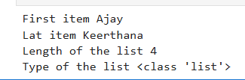

2.Give an example to describe the difference between list, dictionary and tuples

**List**

A list is an ordered collection that is mutable (can be changed). It allows duplicate elements.

Code:

fruits = ["apple", "banana", "cherry"]

fruits.append("orange")

print(fruits)

Output:



**Tuple**

A tuple is an ordered collection that is immutable (cannot be changed). It also allows duplicate elements.

Code:

coordinates = (10, 20, 30)

coordinates[0] = 15

print(coordinates)

Output:

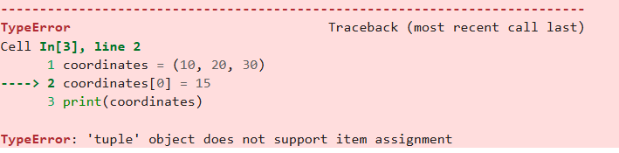

**Dictionary**

A dictionary is an unordered collection of key-value pairs. It is mutable, but keys must be unique.

Code:

person = {"name": "Alice", "age": 25, "city": "New York"}

person["age"] = 26

person["country"] = "USA"

print(person)

Output:



3.Write a python program to accept a number and to identify whether digit 9 is present or not. If 9 is present print the place value and face value

Code:

n=int(input("Enter a number"))

n_str=str(n)

l=len(n_str)

found=False

for i,digit in enumerate(n_str):

if digit=='9':

v=10**(l-i-1)

print("The digit 9 is present at place value",v)

found=True

break

if(found==False):

print("9 is not found")

Output:



4.Write a simple program to illustrate the usage of various operators

a=int(input("Enter first number :"))

b=int(input("Enter second number :"))

print("Using Arithmetic Operators ")

print("Addition :",a+b)

print("Subtraction :",a-b)

print("Multiplication :",a*b)

print("Division :",a/b)

print("--------------------")

print("Using Relational Operators ")

print("a>b :",a>b)

print("a<b :",a<b)

print("a>=b :",a>=b)

print("a<=b :",a<=b)

print("--------------------")

print("Using Logical Operators ")

print("a and b :",a and b)

print("a or b :",a or b)

print("a not b :",not b)

Output:

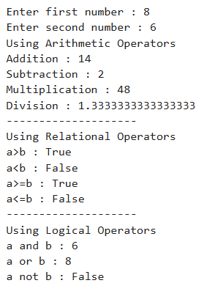

5.Write a python code that prints the number of ways a robot can take steps to climb a n-stair case(Assume that a robot can take step at a one or two step at a time)

Code:

def steps(num):

# Base cases

if num == 0:

return 1

if num < 0:

return 0

return steps(num - 1) + steps(num - 2)

num = int(input("Enter the number of steps: "))

res = steps(num)

print("Number of ways is:", res)

Output:



6. Create a multi-dimensional list and also display the elements  
Code:

x=[]

row=int(input("enter the number of rows"))

col=int(input("enter the number of columns"))

for i in range(row):

for j in range(col):

ans=int(input("enter the value"))

x.append(ans)

print(x)

Output:

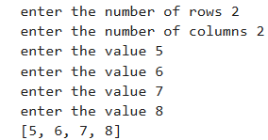

7.Write a python program to print the patterns given

a.Code:

r=int(input("enter the number of rows"))

for i in range(1,r+1,1):

if(i%2!=0):

print(" ** ")

else:

print("******")  
Output:

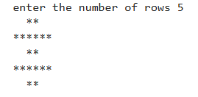

b.code:

r=int(input("enter the number of rows"))

for i in range(r,0,-1):

print(" "*(r-i),end="")

print("*"*(2*i-1))  
  
Output:

