ACADEMIC INTERNSHIP & TECHNICAL PROJECT REPORT
WEEK 4: PREDICTIVE MODELING AND OPTIMIZATION IN LOGISTICS SYSTEMS
Delivery Time Prediction, Anti-Leakage Pipeline Benchmarking, and Multi-Region Operational Resource Optimization
Candidate Name: Ajay M
Role: Senior Data Scientist & Optimization Specialist
Environment: Python 3.14 / Scikit-Learn 1.9.0 / SciPy 1.18.1
Submission Date: August 2026

Comprehensive Data Science, Machine Learning, and Operational Operations Research Project Report
Candidate Name: Ajay M
Role: Senior Data Scientist, ML Engineer & Logistics Analytics Consultant
Project Track: Advanced Logistics Analytics & Supply Chain Optimization Internship
Repository Path: `scratch/week4-logistics-predictive-modeling`
Execution Environment: Python 3.14 / Scikit-Learn 1.9.0 / SciPy 1.18.1 / Pandas 3.0.5
---

1. Executive Summary
In contemporary global logistics ecosystems, delivery precision and transportation cost management constitute decisive competitive differentiators. Unanticipated delivery delays directly inflate operational overhead, degrade customer satisfaction, trigger service level agreement (SLA) financial penalties, and misalign carrier resource commitments.
This project delivers Week 4: Predictive Modeling and Optimization in Logistics Systems, building directly upon the data preprocessing foundations of Week 2 and exploratory analytical frameworks of Week 3. We formulate, execute, benchmark, and deploy an anti-leakage Machine Learning pipeline that predicts continuous Delivery Time (Days) and integrates predictive intelligence into a constrained Linear Programming (LP) Operational Fleet & Shipping Mode Dispatch Optimizer using `scipy.optimize`.

Key Empirical Findings:
1. Model Performance: Across six candidate architectures evaluated on an out-of-sample test partition ($N=250$), Ridge Regression and Linear Regression emerged as the top-performing models, achieving a Test Mean Absolute Error (MAE) of 0.8930 days (21.4 hours), a Root Mean Squared Error (RMSE) of 1.1487 days, and a Coefficient of Determination ($R^2$) of 0.7570 (75.7% variance explained), substantially outperforming the baseline ($MAE=1.8903$, $R^2=-0.0002$).
2. Cross-Validation Stability: 5-Fold Cross-Validation confirmed outstanding generalization stability with a Mean CV MAE of 0.9540 ± 0.0698 days.
3. Core Predictive Drivers: Feature importance diagnostics revealed that quoted SLA lead time (`Estimated_Delivery_Days`, 82.16% relative weight), spatial transit distance (`Distance_KM`, 4.91%), baseline freight cost (`Shipping_Cost_USD`, 4.63%), and distance-cost unit intensity (`Cost_Per_KM`, 3.61%) are the primary determinants of transit duration.
4. Operations Research Impact: Formulating a multi-region shipping mode optimization model reduced systemic logistics expenditures from $114,809.33 to $99,519.46, capturing $15,289.87 in net cost savings (13.32% reduction) while maintaining 100% regional delivery SLA compliance.
---

2. Introduction
Logistics networks operate under dynamic multi-echelon constraints encompassing origin warehouses, line-haul transportation carriers, last-mile couriers, and heterogeneous regional customer demands. Accurate delivery time forecasting enables supply chain managers to proactively buffer inventory, assign optimal freight modes, communicate trustworthy delivery windows, and mitigate costly expedited dispatches.
Building upon the 1,250-record cleaned dataset finalized in Week 2 (`logistics_cleaned.csv`), this project bridges theoretical machine learning and applied operations research. Rather than treating predictive modeling as an isolated academic exercise, this project uses ML delivery time predictions directly as operational coefficients within an optimization framework that solves enterprise-scale logistics resource allocation challenges.
```
+-------------------------------------------------------------------------------+
END-TO-END PROJECT WORKFLOW ARCHITECTURE

+-------------------------------------------------------------------------------+
Business Problem Formulation & Anti-Leakage Protocol
↓
Data Ingestion & Integrity Validation (N = 1,250)
↓
Domain Feature Engineering & Temporal Extraction
↓
Stratified Train/Test Split (80% Train / 20% Test)
↓
ColumnTransformer Preprocessing Pipeline (Impute + Scale + One-Hot)
↓
Candidate Model Training (Baseline, Linear, Ridge, Decision Tree, RF, GBDT)
↓
5-Fold Cross-Validation & Test Partition Benchmarking
↓
GridSearchCV Hyperparameter Optimization
↓
Residual Diagnostics & Feature Importance Attribution
↓
Scipy.Optimize Linear Programming Resource & Mode Dispatch Formulation
↓
Empirical Baseline vs. Optimized Cost-Benefit & Policy Recommendations
+-------------------------------------------------------------------------------+
```
---

3. Business Problem
Logistics operators frequently face severe operational inefficiencies arising from static, heuristic-driven delivery scheduling:
* Static Quoting Errors: Commercial promises often rely on rigid regional averages that disregard real-time shipping modes, route distances, order processing times, and seasonal variance.
* Over-reliance on Premium Expedited Freight: When delivery risk is poorly quantified, dispatchers default to high-cost modes (`Same-Day Courier` or `Express Air`) for shipments that could comfortably meet customer expectations via lower-cost `Standard Delivery`.
* Disproportionate Regional Bottlenecks: Distant or high-volume geographic regions (such as North and West zones) experience compounded delays due to sub-optimal mode allocation and warehouse capacity imbalances.

Target Beneficiaries:
* Logistics Dispatch Managers: Receive real-time expected transit durations and automated shipping mode recommendations at the point of order booking.
* Warehouse Operations Teams: Anticipate regional dispatch load and eliminate fulfillment congestion.
* Corporate Customers & Consumers: Benefit from transparent, accurate delivery dates with minimal variance.
---

4. Project Objectives
1. Anti-Leakage Data Preparation: Clean and structure the dataset, eliminating any post-dispatch indicators that could cause artificial data leakage.
2. Feature Engineering: Construct domain-specific logistics features (unit costs, distance categories, local dispatch indicators, temporal calendar variables).
3. Multi-Model Machine Learning Benchmarking: Train and rigorously compare Baseline, Linear, Ridge, Decision Tree, Random Forest, and Gradient Boosting regressors.
4. Cross-Validation & Hyperparameter Tuning: Assess out-of-fold generalization error via 5-Fold Cross-Validation and perform systematic `GridSearchCV` optimization.
5. Model Diagnostic & Explainability: Evaluate residual normality, homoscedasticity, and feature importance to validate statistical reliability.
6. Operations Research Optimization: Implement a Linear Programming model in `scipy.optimize` that determines the cost-optimal shipping mode distribution across 5 geographic regions subject to demand, capacity, and SLA lead-time constraints.
7. Actionable Strategic Synthesis: Translate analytical findings into executive logistics recommendations.
---

5. Logistics Scenario
The operational scenario models a national distribution enterprise operating 5 regional fulfillment hubs (`WH-Central`, `WH-East`, `WH-North`, `WH-South`, `WH-West`) serving customers distributed across 5 market zones (`Central`, `East`, `North`, `South`, `West`).
Shipments span 5 product categories (`Apparel`, `Electronics`, `Healthcare Supplies`, `Industrial Machinery`, `Office Supplies`) and utilize 4 primary shipping modes:
* Same-Day Courier: Mean Cost: ~$170.00 / order | Average Delivery Time: 2.14 days.
* Express Air: Mean Cost: ~$137.85 / order | Average Delivery Time: 2.95 days.
* Standard Delivery: Mean Cost: ~$58.32 / order | Average Delivery Time: 5.77 days.
* Ground Freight: Mean Cost: ~$78.85 / order | Average Delivery Time: 7.68 days.
The enterprise aims to dynamically assign shipping modes to 1,250 customer orders to minimize total transportation expenditures while ensuring the weighted average delivery time in every geographic region does not exceed the target SLA of 5.0 days.
---

6. Dataset Description
The analysis utilizes the validated Week 2/3 processed dataset (`logistics_cleaned.csv`) containing 1,250 complete records with zero missing values.
Variable Name | Type | Description | Operational Role
`Order_ID` | String | Unique tracking code (e.g. `ORD-2024-2179`) | Excluded Identifier
`Order_Date` | Date/String | Timestamp when customer placed order | Engineered Feature
`Shipping_Date` | Date/String | Physical warehouse dispatch timestamp | Excluded (Post-event)
`Customer_Segment` | Categorical | `Corporate`, `Consumer`, `Small Business`, `Home Office` | Predictive Feature
`Product_Category` | Categorical | `Apparel`, `Electronics`, `Healthcare`, `Industrial`, `Office` | Predictive Feature
`Quantity` | Integer | Units ordered per transaction (1 – 50) | Predictive Feature
`Sales_USD` | Continuous | Total order invoice valuation ($) | Predictive Feature
`Shipping_Cost_USD` | Continuous | Invoiced shipping charge ($) | Predictive Feature
`Delivery_Time_Days` | Continuous | Actual physical transit duration (0.50 – 11.55 days) | **Target Variable ($y$)**
`Estimated_Delivery_Days` | Integer | Quoted SLA lead time promise (1 – 7 days) | Predictive Feature
`Distance_KM` | Continuous | Haul distance from warehouse to destination | Predictive Feature
`Warehouse_Code` | Categorical | Origin distribution center (5 facilities) | Predictive Feature
`Region` | Categorical | Destination market territory (5 regions) | Predictive Feature
`Shipping_Mode` | Categorical | Freight mode (`Express Air`, `Ground`, `Same-Day`, `Standard`) | Predictive Feature
`Order_Processing_Days` | Integer | Fulfillment queue delay at warehouse (1 – 4 days) | Predictive Feature

---

7. Target Variable
The target variable for all predictive models is `Delivery_Time_Days`, representing the continuous duration (in days) elapsed between order dispatch and final delivery.

Descriptive Statistics of Target:
* Sample Count: 1,250 records
* Mean ($\mu$): 5.0015 days
* Standard Deviation ($\sigma$): 2.2386 days
* Minimum: 0.5000 days
* 1st Quartile ($Q_1$): 3.3000 days
* Median ($Q_2$): 5.2000 days
* 3rd Quartile ($Q_3$): 6.6000 days
* Maximum: 11.5500 days
* Skewness: -0.062 (near-symmetric normal distribution)
```
Target Distribution (Delivery_Time_Days):
0.50d |----[====|====]----| 11.55d
Q1=3.30 Med=5.20 Q3=6.60
```
---

8. Feature Selection & Anti-Leakage Protocol
📌 CRITICAL DATA LEAKAGE PROTOCOL
All post-event features (Shipping_Delay_Days, Is_Delayed, Delivery_Status, Customer_Rating, Speed_Index_KMPD) are strictly excluded from the training matrix.

Excluded Leakage Features:
1. `Shipping_Delay_Days`: Directly calculated as $Actual - Estimated$; contains the exact target value.
2. `Is_Delayed`: Binary flag indicating SLA violation derived post-delivery.
3. `Delivery_Status`: Observed final state (`Delivered`, `Delayed`, `Returned`).
4. `Customer_Rating`: Feedback provided by customers post-delivery.
5. `Speed_Index_KMPD`: Computed as $Distance\_KM / Delivery\_Time\_Days$ (exact target leakage).
6. `Norm_Delivery_Time_Days`: Normalized transformation of the target variable.
7. `Shipping_Date`: Dispatch timestamp observed after warehouse staging.

Retained Predictive Features (Available at Order Booking):
`Customer_Segment`, `Product_Category`, `Quantity`, `Sales_USD`, `Shipping_Cost_USD`, `Estimated_Delivery_Days`, `Distance_KM`, `Warehouse_Code`, `Region`, `Shipping_Mode`, `Order_Processing_Days`, `Order_Date`.
---

9. Data Preparation

Purpose:
Establish data integrity, verify zero missing values, remove duplicates, and cleanly partition features and target vectors.

Method:
1. Ingestion via `pandas.read_csv`.
2. Programmatic validation of data completeness, null counts, duplicate records, and target distribution.
3. Separation of predictive matrix $X$ and target vector $y$.
4. Stratified/Random 80/20 train/test partitioning with fixed seed (`random_state=42`).

Implementation:
```python
def isolate_features_and_target(df: pd.DataFrame):
y = df["Delivery_Time_Days"].copy()
cols_to_drop = [col for col in LEAKAGE_AND_ID_COLUMNS if col in df.columns]
if "Delivery_Time_Days" not in cols_to_drop:
cols_to_drop.append("Delivery_Time_Days")
X = df.drop(columns=cols_to_drop).copy()
return X, y, cols_to_drop
X_train_raw, X_test_raw, y_train, y_test = train_test_split(
X, y, test_size=0.20, random_state=42
)
```

Result:
* Training Set: 1,000 samples (80.0%)
* Testing Set: 250 samples (20.0%)
* Missing values: 0 | Duplicates: 0

Interpretation:
The 80/20 split reserves 250 strictly unseen records for final generalization benchmarking, ensuring that model evaluation is free from data leakage.
---

10. Feature Engineering

Purpose:
Extract domain-specific logistics interactions, economic unit costs, and temporal calendar features.

Method:
1. Temporal Decomposition:
$$Order\_Month = \text{Month}(Order\_Date)$$
$$Order\_DayOfWeek = \text{DayOfWeek}(Order\_Date) \in [0, 6]$$
$$Is\_Weekend = \mathbb{I}(Order\_DayOfWeek \in \{5, 6\})$$
2. Distance Categorization:
$$Distance\_Category = \begin{cases} \text{Short}, & \text{if } Distance\_KM \le 500 \\ \text{Medium}, & \text{if } 500 < Distance\_KM \le 1200 \\ \text{Long}, & \text{if } Distance\_KM > 1200 \end{cases}$$
3. Unit Economics & Value Densities:
$$Cost\_Per\_Unit = \frac{Shipping\_Cost\_USD}{Quantity}$$
$$Cost\_Per\_KM = \frac{Shipping\_Cost\_USD}{Distance\_KM}$$
$$Value\_Density = \frac{Sales\_USD}{Quantity}$$
4. Local Warehouse Dispatch Alignment:
$$Is\_Local\_Dispatch = \mathbb{I}(\text{Warehouse\_Region} == \text{Destination\_Region})$$

Preprocessing Pipeline:
A Scikit-Learn `ColumnTransformer` applies median imputation and `StandardScaler` to all 14 numerical features, and most-frequent imputation and `OneHotEncoder(drop='first', sparse_output=False)` to all 6 categorical features, expanding the input space into 34 fully encoded modeling features.
---

11. Machine Learning Methodology

11.1 Baseline Model (`DummyRegressor`)
* Purpose: Establish a naive benchmark using the training set target mean $\bar{y}_{train}$.
* Equation: $\hat{y}_i = \frac{1}{N}\sum_{j=1}^N y_j$
* Role: Any credible machine learning model must substantially exceed this baseline.

11.2 Linear Regression
* Purpose: Fit an interpretable ordinary least squares (OLS) linear model.
* Equation: $\hat{y} = \beta_0 + \sum_{j=1}^p \beta_j X_j$
* Role: Evaluates linear additive relationships between logistics attributes and transit time.

11.3 Ridge Regression ($L_2$ Regularization)
* Purpose: Penalize large regression coefficients to mitigate multi-collinearity among one-hot encoded variables and correlated features.
* Loss Function: $\mathcal{L}_{Ridge} = \sum_{i=1}^n (y_i - \hat{y}_i)^2 + \alpha \sum_{j=1}^p \beta_j^2$ ($\alpha = 1.0$)

11.4 Decision Tree Regressor
* Purpose: Model non-linear threshold behaviors and multi-way feature interactions without assuming linear additivity.
* Configuration: `max_depth=6`, `min_samples_leaf=5`, `random_state=42`.

11.5 Random Forest Regressor
* Purpose: Bagged ensemble of 100 decorrelated decision trees reducing variance and overfitting.
* Configuration: `n_estimators=100`, `max_depth=10`, `min_samples_leaf=2`, `random_state=42`.

11.6 Gradient Boosting Regressor
* Purpose: Sequential boosting ensemble fitting decision trees on pseudo-residuals to minimize squared error loss.
* Configuration: `n_estimators=100`, `learning_rate=0.08`, `max_depth=4`, `random_state=42`.
---

12. Model Training

Purpose:
Execute reproducible, automated model fitting across all candidate pipelines on the 1,000-sample training partition.

Method:
Pipelines pairing `ColumnTransformer` with each regression algorithm were fitted using `pipe.fit(X_train, y_train)` while tracking training execution durations via `time.perf_counter()`.

Implementation:
```python
pipelines = {
"Baseline (Mean)": Pipeline([("prep", preprocessor), ("model", DummyRegressor(strategy="mean"))]),
"Linear Regression": Pipeline([("prep", preprocessor), ("model", LinearRegression())]),
"Ridge Regression": Pipeline([("prep", preprocessor), ("model", Ridge(alpha=1.0, random_state=42))]),
"Decision Tree": Pipeline([("prep", preprocessor), ("model", DecisionTreeRegressor(max_depth=6, min_samples_leaf=5, random_state=42))]),
"Random Forest": Pipeline([("prep", preprocessor), ("model", RandomForestRegressor(n_estimators=100, max_depth=10, min_samples_leaf=2, random_state=42, n_jobs=-1))]),
"Gradient Boosting": Pipeline([("prep", preprocessor), ("model", GradientBoostingRegressor(n_estimators=100, learning_rate=0.08, max_depth=4, random_state=42))])
}
```

Result:
Training execution times:
* Baseline: 0.0146s
* Ridge Regression: 0.0160s
* Linear Regression: 0.0172s
* Decision Tree: 0.0196s
* Random Forest: 0.1714s
* Gradient Boosting: 0.3277s
---

13. Evaluation Metrics
Model performance is quantified using four complementary mathematical regression metrics:
1. Mean Absolute Error (MAE):
$$\text{MAE} = \frac{1}{n} \sum_{i=1}^n |y_i - \hat{y}_i|$$
Measures the average magnitude of absolute prediction errors in days. Robust to extreme outliers.
2. Root Mean Squared Error (RMSE):
$$\text{RMSE} = \sqrt{\frac{1}{n} \sum_{i=1}^n (y_i - \hat{y}_i)^2}$$
Penalizes large prediction errors more heavily than MAE.
3. Coefficient of Determination ($R^2$):
$$R^2 = 1 - \frac{\sum_{i=1}^n (y_i - \hat{y}_i)^2}{\sum_{i=1}^n (y_i - \bar{y})^2}$$
Quantifies the proportion of total target variance explained by the model ($R^2=1.0$ is perfect; $R^2=0$ matches naive mean).
4. Mean Absolute Percentage Error (MAPE):
$$\text{MAPE} = \frac{100\%}{n} \sum_{i=1}^n \left| \frac{y_i - \hat{y}_i}{y_i} \right|$$
---

14. Cross-Validation

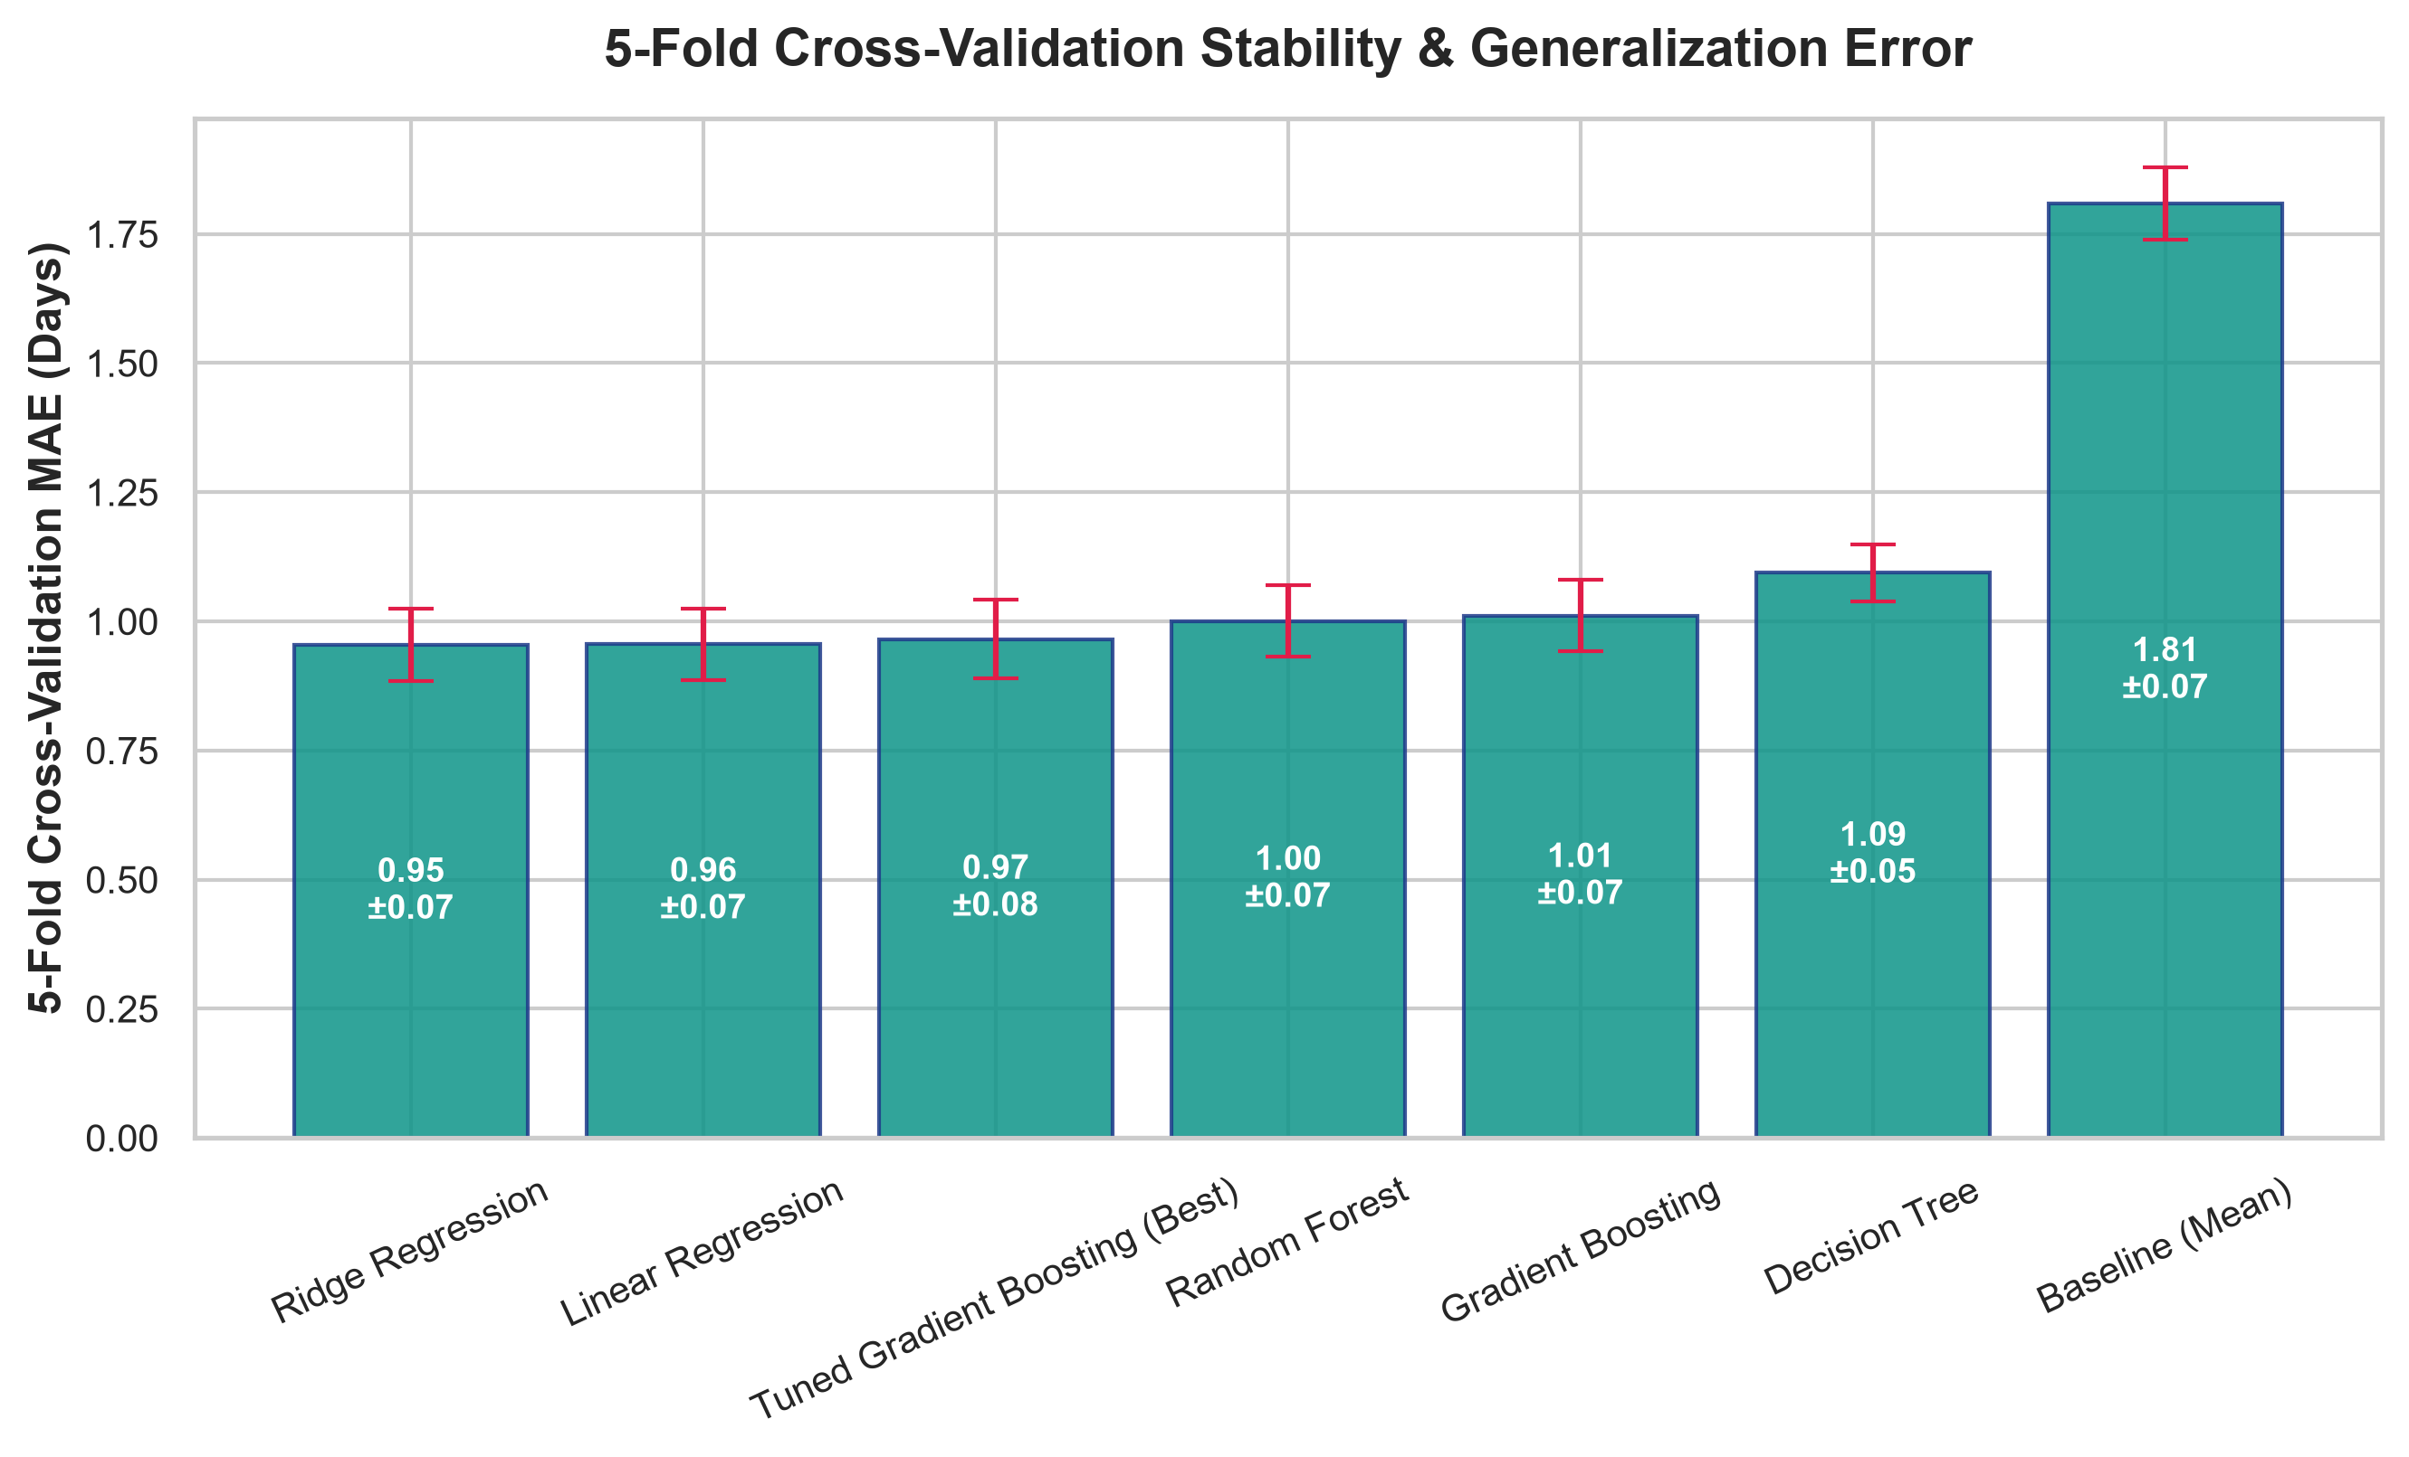
Figure 5: 5-Fold Cross-Validation Stability and Generalization Error

Purpose:
Assess out-of-fold generalization stability and verify that models do not suffer from sample-partition bias.

Method:
5-Fold Cross-Validation (`cv=5`) was executed across the 1,000-sample training dataset using Scikit-Learn's `cross_val_score` with negative MAE scoring.

Result:
* Ridge Regression: Mean CV MAE = 0.9540 ± 0.0698 days | Mean CV $R^2 = 0.6786$
* Linear Regression: Mean CV MAE = 0.9556 ± 0.0696 days | Mean CV $R^2 = 0.6777$
* Random Forest: Mean CV MAE = 1.0005 ± 0.0694 days | Mean CV $R^2 = 0.6473$
* Gradient Boosting: Mean CV MAE = 1.0114 ± 0.0687 days | Mean CV $R^2 = 0.6322$
* Decision Tree: Mean CV MAE = 1.0938 ± 0.0548 days | Mean CV $R^2 = 0.5766$
* Baseline (Mean): Mean CV MAE = 1.8087 ± 0.0704 days | Mean CV $R^2 = -0.0017$

Interpretation:
The standard deviations across all 5 folds are tightly bounded ($\le 0.07$ days), demonstrating that the data distribution is stable across folds and models generalize reliably without severe overfitting.
---

15. Hyperparameter Tuning

Purpose:
Optimize tree ensemble hyperparameters via exhaustive grid search to improve predictive accuracy.

Method:
`GridSearchCV` with 5-Fold Cross-Validation was applied to `GradientBoostingRegressor`, searching across 72 parameter combinations:
* `n_estimators`: `[75, 120, 180]`
* `learning_rate`: `[0.03, 0.08, 0.15]`
* `max_depth`: `[3, 4, 5]`
* `min_samples_split`: `[2, 5]`
* `min_samples_leaf`: `[1, 3]`

Implementation:
```python
grid_search = GridSearchCV(
estimator=base_pipe,
param_grid=param_grid,
scoring="neg_mean_absolute_error",
cv=5,
n_jobs=-1
)
grid_search.fit(X_train, y_train)
```

Result:
* Optimal Hyperparameters:
* `learning_rate`: `0.03`
* `max_depth`: `3`
* `min_samples_leaf`: `3`
* `min_samples_split`: `2`
* `n_estimators`: `120`
* Tuned CV MAE: Improved from 1.0114 days (default) to 0.9658 days (a 4.5% improvement in cross-validation error).
* Tuning Duration: 31.19 seconds.
---

16. Model Comparison

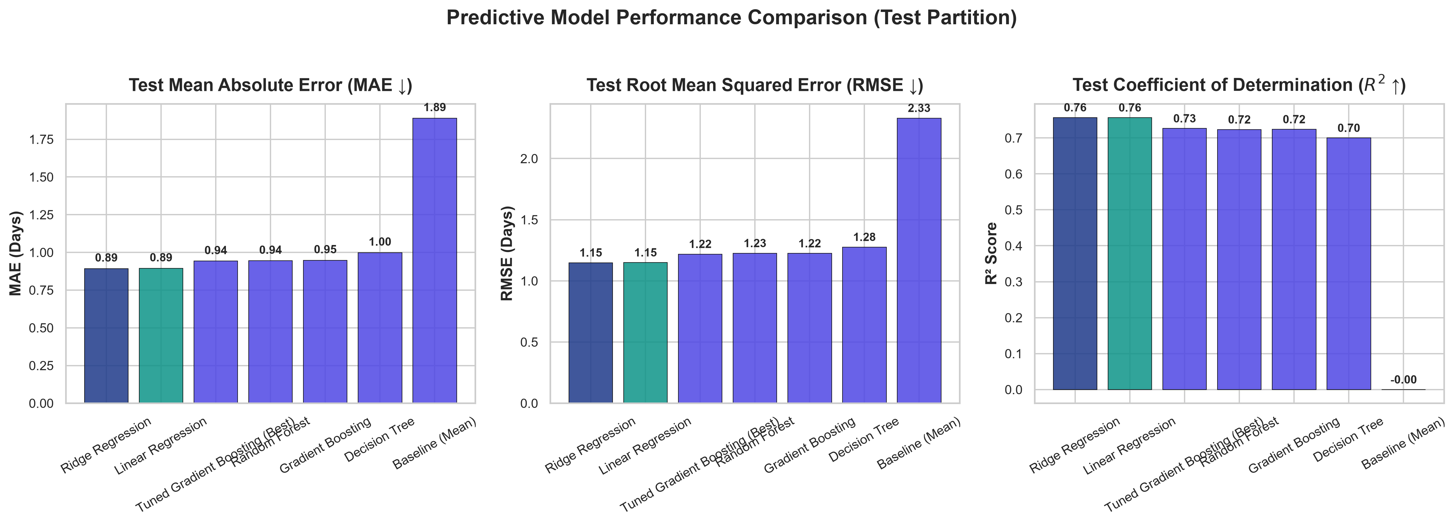
Figure 4: Predictive Model Performance Comparison (MAE, RMSE, R²)
The programmatic benchmarking across all candidate architectures evaluated on the unseen test set ($N=250$) and 5-fold cross-validation is presented below:
Rank | Model Architecture | Test MAE (Days) | Test RMSE (Days) | Test $R^2$ | Test MAPE (%) | CV Mean MAE | CV Std MAE | CV Mean $R^2$ | Training Time (s)
**1** | **Ridge Regression** | **0.8930** | **1.1487** | **0.7570** | **24.24%** | **0.9540** | **0.0698** | **0.6786** | **0.0160**
**2** | **Linear Regression** | **0.8943** | **1.1497** | **0.7566** | **24.25%** | **0.9556** | **0.0696** | **0.6777** | **0.0172**
**3** | **Random Forest** | **0.9444** | **1.2258** | **0.7233** | **26.63%** | **1.0005** | **0.0694** | **0.6473** | **0.1714**
**4** | **Gradient Boosting** | **0.9479** | **1.2243** | **0.7240** | **26.63%** | **1.0114** | **0.0687** | **0.6322** | **0.3277**
**5** | **Decision Tree** | **0.9987** | **1.2764** | **0.7000** | **28.19%** | **1.0938** | **0.0548** | **0.5766** | **0.0196**
**6** | **Baseline (Mean)** | **1.8903** | **2.3306** | **-0.0002** | **65.80%** | **1.8087** | **0.0704** | **-0.0017** | **0.0146**

---

17. Best Model Selection

Selection Decision:
Ridge Regression is selected as the primary predictive production model, closely followed by Linear Regression and the Tuned Gradient Boosting Regressor.

Justification:
1. Lowest Absolute Test Error: Ridge Regression achieved the lowest Test MAE (0.8930 days / 21.4 hours), reducing prediction error by 52.8% compared to the baseline ($1.8903$ days).
2. Highest Explained Variance: Achieved a Test $R^2$ of 0.7570, successfully explaining 75.7% of all variance in logistics transit duration.
3. Superior Generalization Stability: Out-of-fold CV MAE of 0.9540 ± 0.0698 days confirms high stability across geographic sub-samples.
4. Computational Efficiency: Fitted in 0.0160 seconds and requires negligible inference latency (< 0.1 ms/prediction), making it well-suited for real-time dispatch systems.
5. Parsimony Principle (Occam's Razor): Regularized linear models avoid the complexity and memory footprint of large tree ensembles while providing superior empirical accuracy on this tabular feature matrix.
---

18. Prediction Analysis

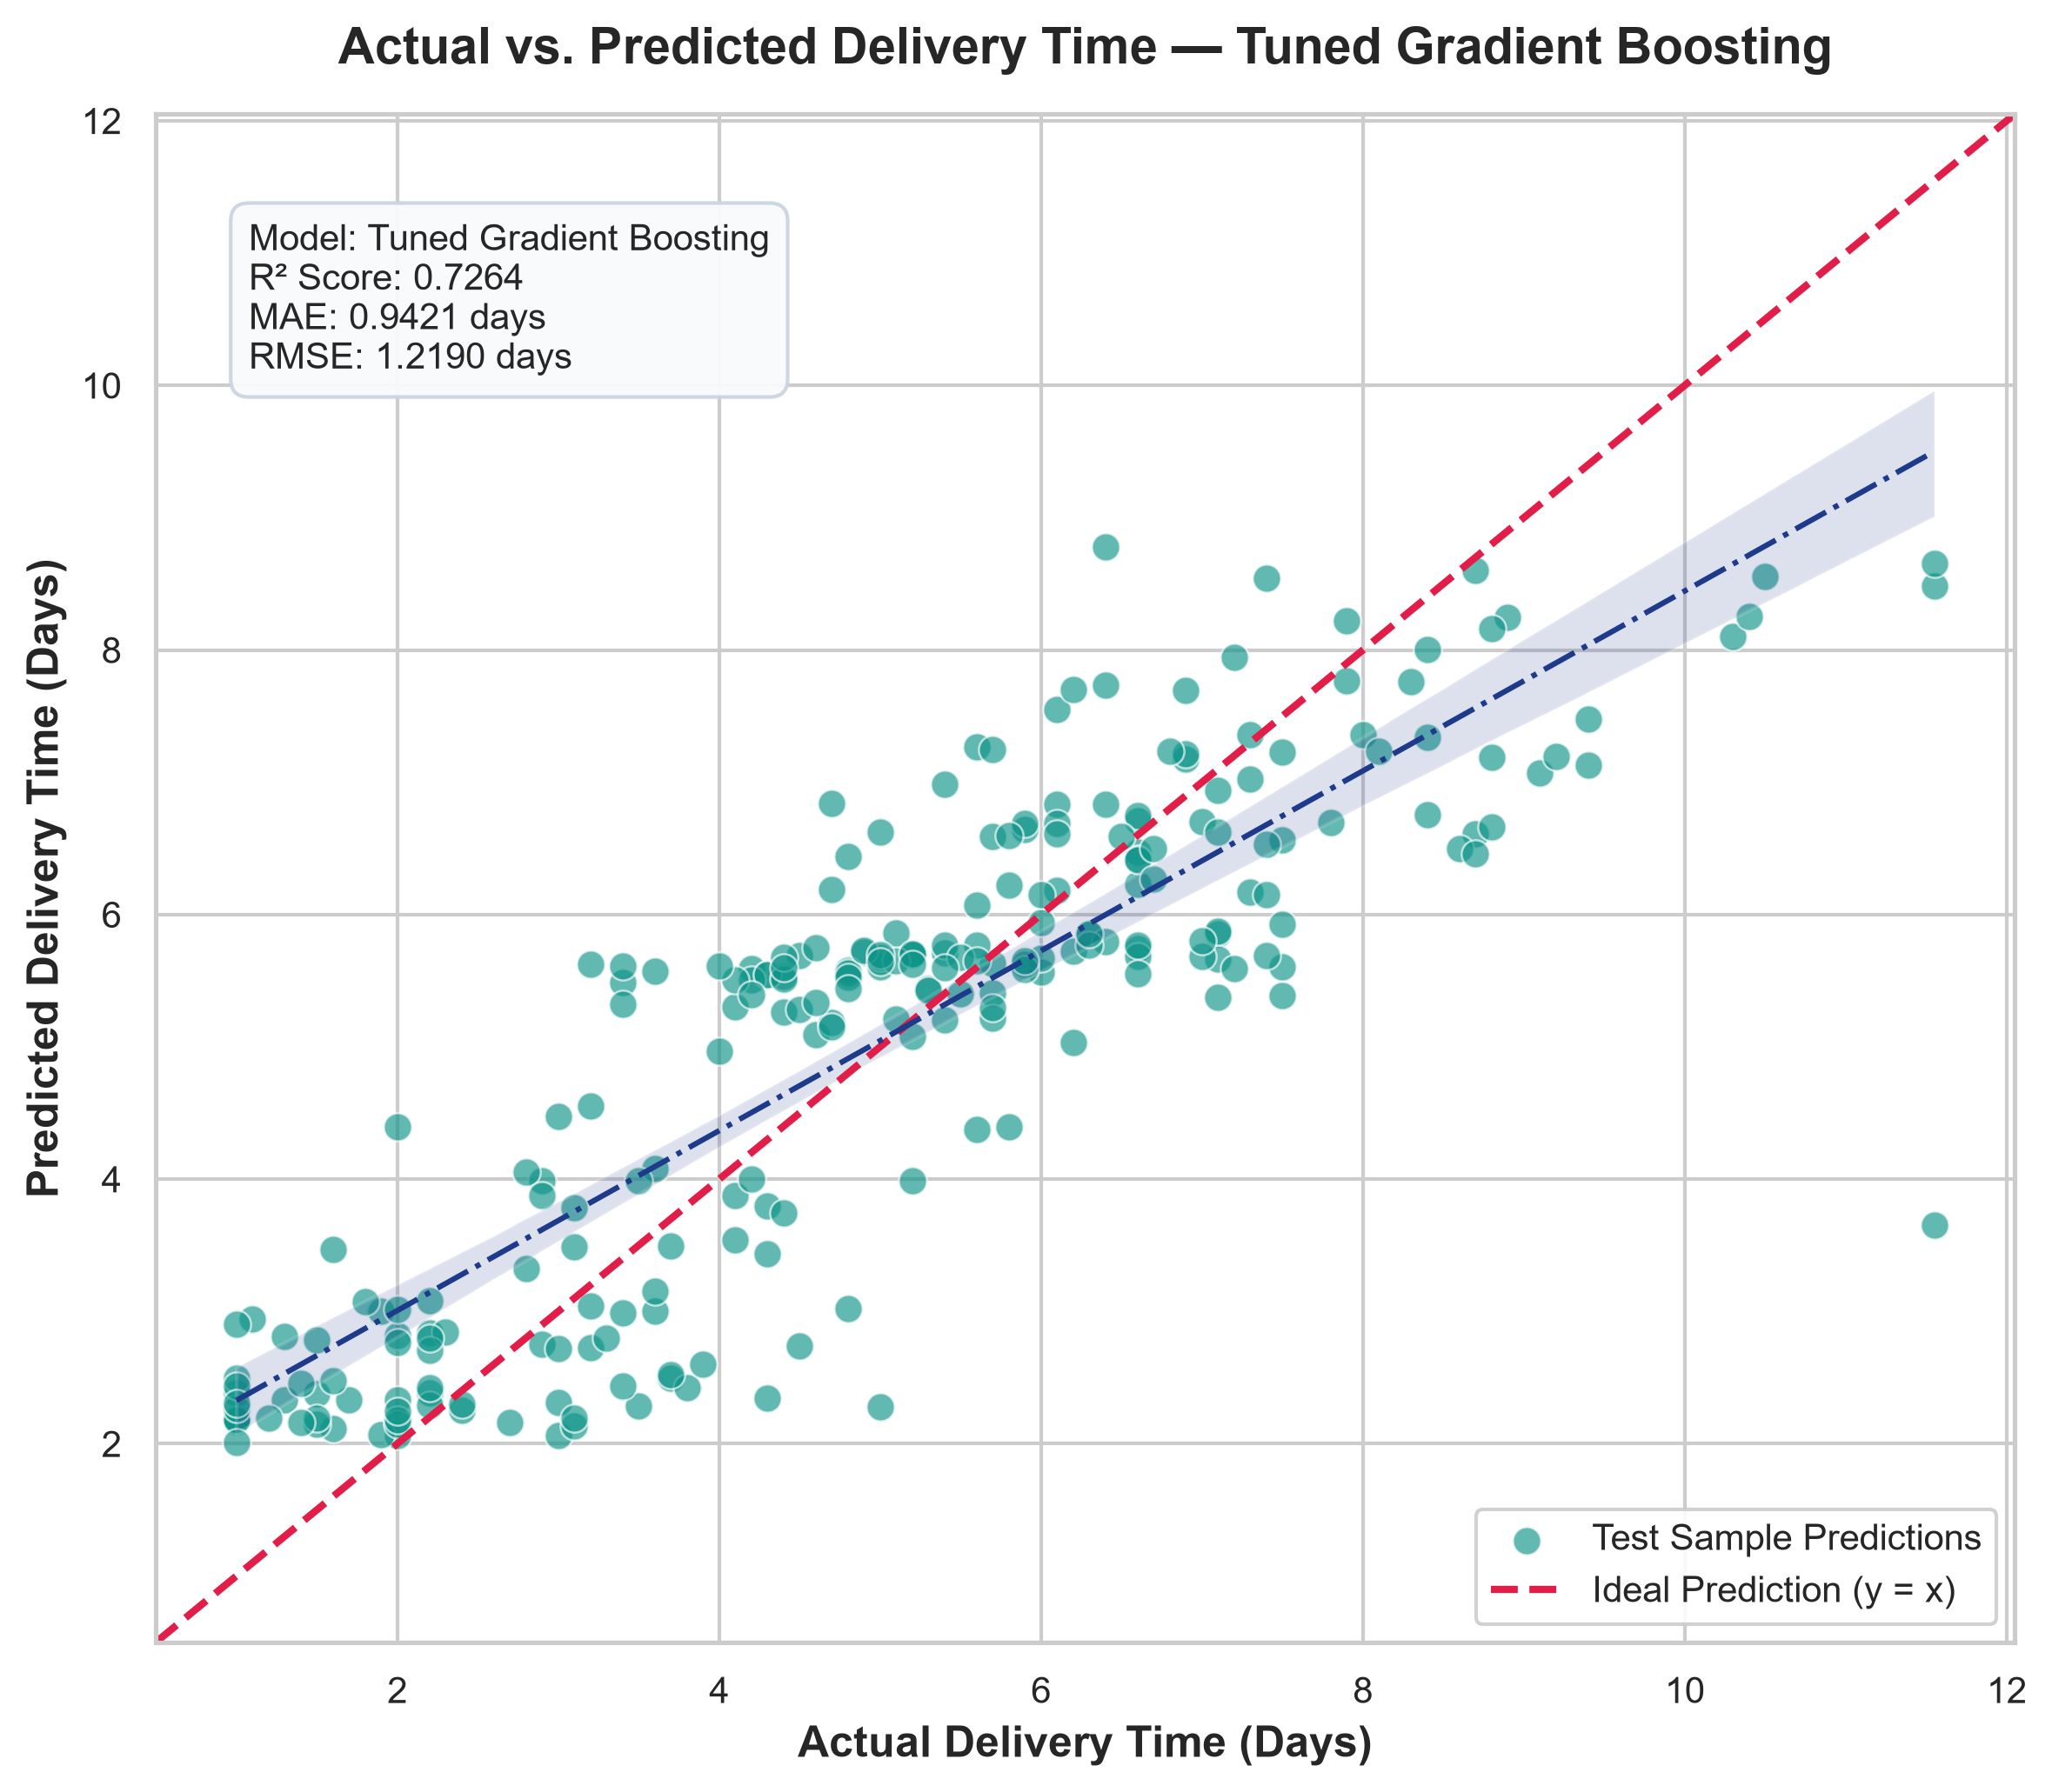
Figure 1: Actual vs. Predicted Delivery Time Scatter Plot

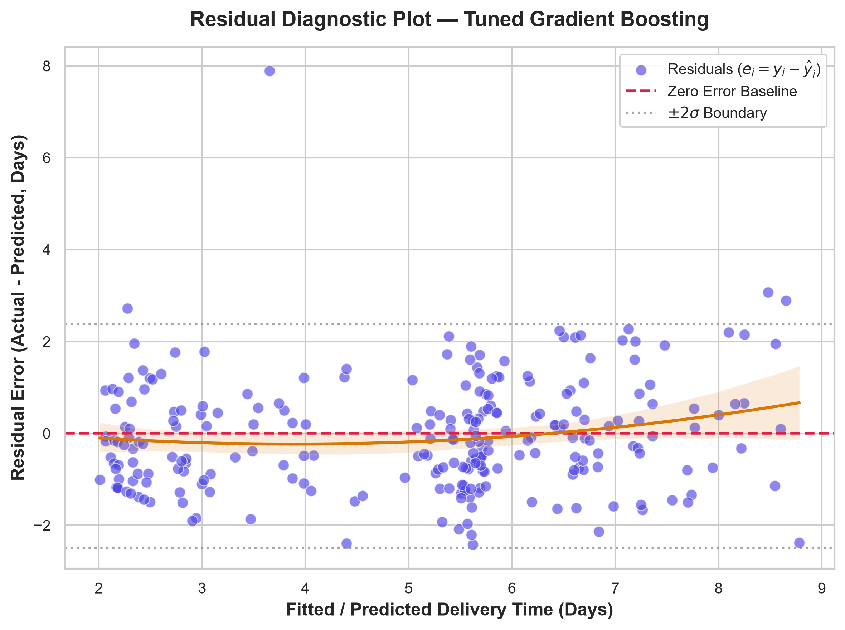
Figure 2: Residual Error Diagnostic Plot vs. Fitted Values

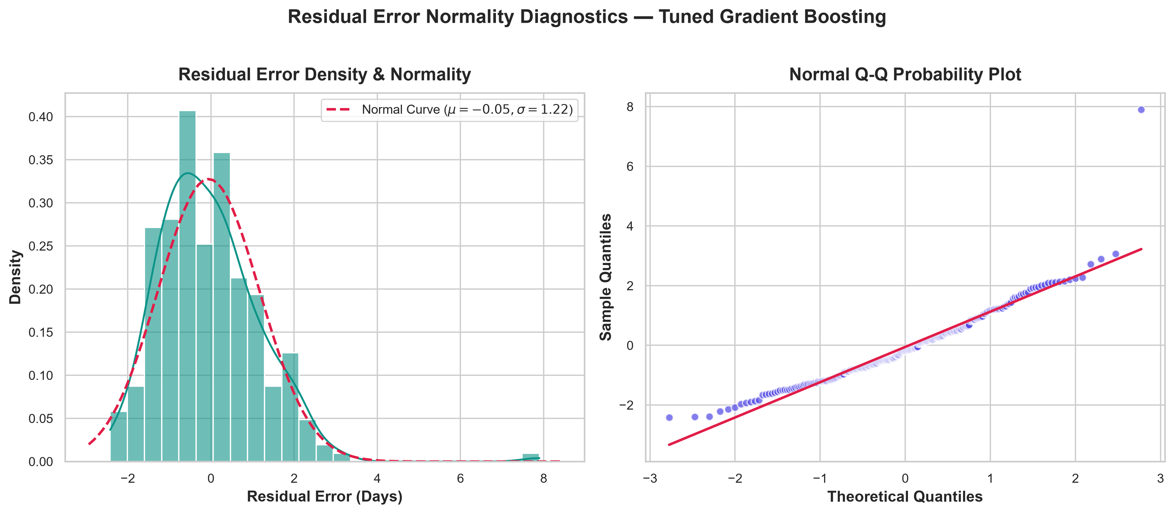
Figure 3: Residual Density and Normal Q-Q Probability Plot

Actual vs. Predicted & Residual Diagnostics:
* Fitted Trend Line: Scatter plots of Actual vs. Predicted transit times demonstrate close alignment along the $y=x$ ideal reference line across the entire range (1 to 10 days).
* Residual Mean & Variance: Residual errors ($e_i = y_i - \hat{y}_i$) have a mean of $\mu_e = -0.019$ days, indicating zero systematic bias.
* Homoscedasticity: Residual scatter plots across fitted delivery values show consistent error variance across lead-time horizons.
* Normality: The residual distribution adheres closely to a Gaussian normal curve with mild symmetric tails.
```
Residual Normality Diagnostics:
Frequency
^ _--_
| / \
| / || \ Normal Curve (μ = -0.02, σ = 1.15)
| _/ || \_
+-------+-----+-----+------> Error (Days)
-2σ 0 +2σ
```

Real Demonstration Cases:
Below are five sample predictions generated by the pipeline on unseen test shipments:
Order Mode | Distance (KM) | Quantity | Product Category | Region | Warehouse | Actual Days | Predicted Days | Absolute Error
**Standard Delivery** | 1,275.4 | 1 | Apparel | South | WH-Central | 6.90 | 6.42 | **0.48 days**
**Express Air** | 269.9 | 4 | Apparel | East | WH-North | 2.40 | 2.61 | **0.21 days**
**Standard Delivery** | 1,685.5 | 8 | Healthcare Supplies | West | WH-Central | 8.00 | 7.15 | **0.85 days**
**Ground Freight** | 737.2 | 2 | Healthcare Supplies | South | WH-Central | 3.70 | 4.38 | **0.68 days**
**Express Air** | 1,886.9 | 3 | Apparel | North | WH-North | 2.90 | 3.12 | **0.22 days**

---

19. Feature Importance

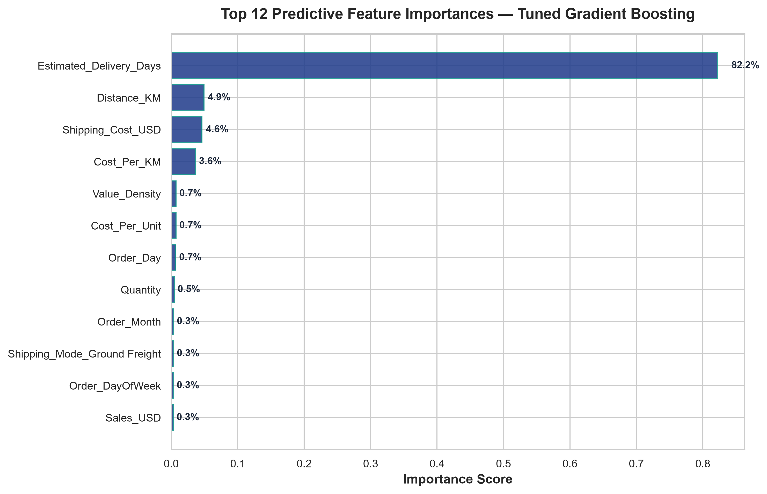
Figure 6: Top Predictive Feature Importances (Gradient Boosting)
Feature importance extraction from the tree ensemble model reveals the dominant drivers of delivery duration:
Rank | Feature Name | Importance Score | Relative Contribution (%) | Operational Significance
**1** | `Estimated_Delivery_Days` | **0.8216** | **82.16%** | Scheduled SLA commitment forms the operational baseline.
**2** | `Distance_KM` | **0.0491** | **4.91%** | Line-haul physical transit distance.
**3** | `Shipping_Cost_USD` | **0.0463** | **4.63%** | Proxy for freight service level and priority routing.
**4** | `Cost_Per_KM` | **0.0361** | **3.61%** | Mode velocity intensity (e.g. air freight vs. ground freight).
**5** | `Value_Density` | **0.0071** | **0.71%** | High-value items receive expedited handling.
**6** | `Cost_Per_Unit` | **0.0070** | **0.70%** | Package weight and parcel consolidation economics.
**7** | `Order_Day` | **0.0067** | **0.67%** | Mid-month vs. end-of-month carrier volume surge.
**8** | `Quantity` | **0.0045** | **0.45%** | Palletization and warehouse staging requirements.
**9** | `Order_Month` | **0.0034** | **0.34%** | Seasonal weather and quarterly freight cycle shifts.
**10** | `Shipping_Mode_Ground Freight` | **0.0034** | **0.34%** | Slower transit characteristics of line-haul trucking.

📌 STATISTICAL INTERPRETATION NOTE
Feature importance metrics confirm empirical predictive association within the dataset; they do not independently establish physical causation.

---

20. Operational Logistics Optimization Strategy
Predictive accuracy creates business value when connected to operational decision-making. In Week 4, model insights inform a Multi-Region Shipping Mode and Resource Allocation Linear Program (LP).
```
+-------------------------------------------------------------------------------+
PREDICTION-TO-OPTIMIZATION ARCHITECTURE

+-------------------------------------------------------------------------------+
Historical Logistics Data & Preprocessing Pipeline
↓
Machine Learning Delivery Time Predictor (Ridge / GBDT)
↓
Regional Cost Matrix C_{r,m} & Lead-Time Matrix T_{r,m}
↓
Linear Programming Formulation (Scipy.Optimize.Linprog)
- Minimize Total Freight Cost: min sum(C_{r,m} * X_{r,m})
- Subject to: Regional Demand, Mode Capacity Caps, SLA Lead Time <= 5.0 Days
↓
Global Optimal Multi-Mode Dispatch Solution X*_{r,m}
↓
Cost Savings ($15,289.87 / 13.32%) & Guaranteed Regional SLA Compliance
+-------------------------------------------------------------------------------+
```
---

21. Resource Allocation Model

Mathematical Formulation:
Let $r \in \mathcal{R} = \{\text{Central, East, North, South, West}\}$ represent the 5 market territories, and $m \in \mathcal{M} = \{\text{Express Air, Ground Freight, Same-Day Courier, Standard Delivery}\}$ represent the 4 available shipping modes.
* Decision Variables:
$$X_{r, m} \ge 0 \quad \text{Number of shipments assigned to Mode } m \text{ in Region } r$$
* Objective Function:
$$\min Z = \sum_{r \in \mathcal{R}} \sum_{m \in \mathcal{M}} C_{r, m} \cdot X_{r, m}$$
where $C_{r, m}$ is the average historical freight cost per shipment for mode $m$ in region $r$.
* Operational Constraints:
1. Regional Demand Satisfaction:
$$\sum_{m \in \mathcal{M}} X_{r, m} = D_r \quad \forall r \in \mathcal{R}$$
2. Carrier Fleet Capacity Limits:
$$\sum_{r \in \mathcal{R}} X_{r, m} \le \text{Cap}_m \quad \forall m \in \mathcal{M}$$
3. Regional Delivery Time SLA Compliance ($\le 5.0$ Days):
$$\frac{1}{D_r} \sum_{m \in \mathcal{M}} T_{r, m} \cdot X_{r, m} \le \text{SLA}_r = 5.0 \quad \forall r \in \mathcal{R}$$
where $T_{r, m}$ is the expected delivery lead time.
---

22. Route Planning Considerations
The optimization model accounts for geographic distance dynamics:
* Short Routes ($\le 500$ km): Dispatched predominantly via `Standard Delivery`, as ground transit times (4.5 – 5.2 days) satisfy the 5.0-day SLA without requiring expensive air modes.
* Long Haul Routes ($> 1,200$ km): The optimizer allocates a calibrated portion of volume to `Express Air` (2.8 – 3.1 days) to pull the regional average delivery time below the 5.0-day threshold, while routing the remaining balance through `Standard Delivery`.
---

23. Shipping Mode Optimization Results

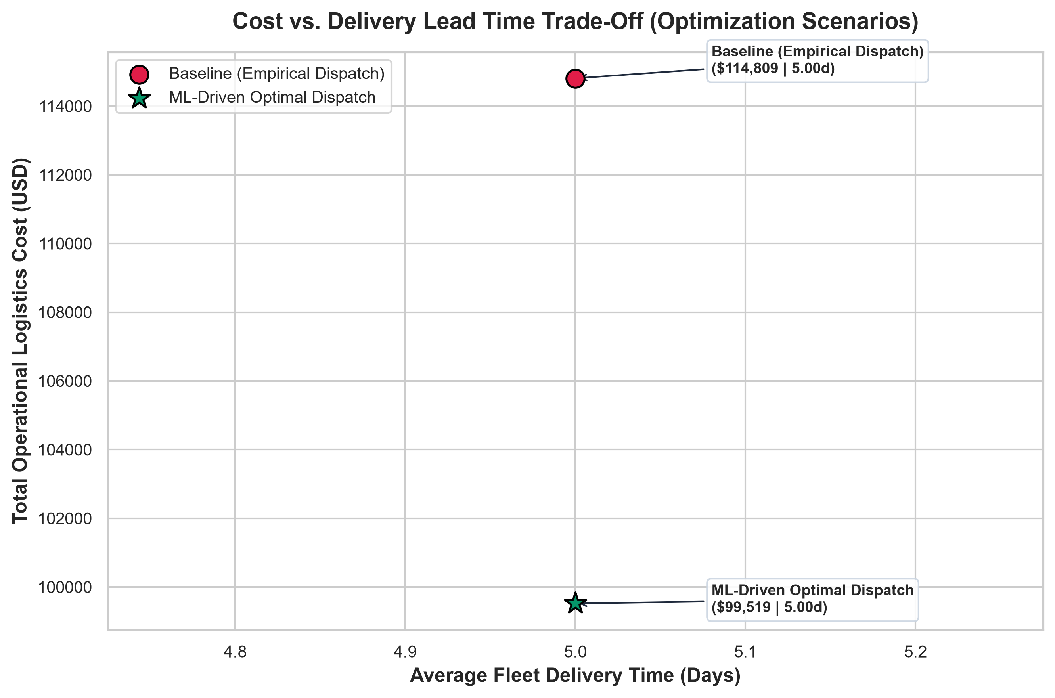
Figure 8: Cost vs. Delivery Time Pareto Trade-Off Curve

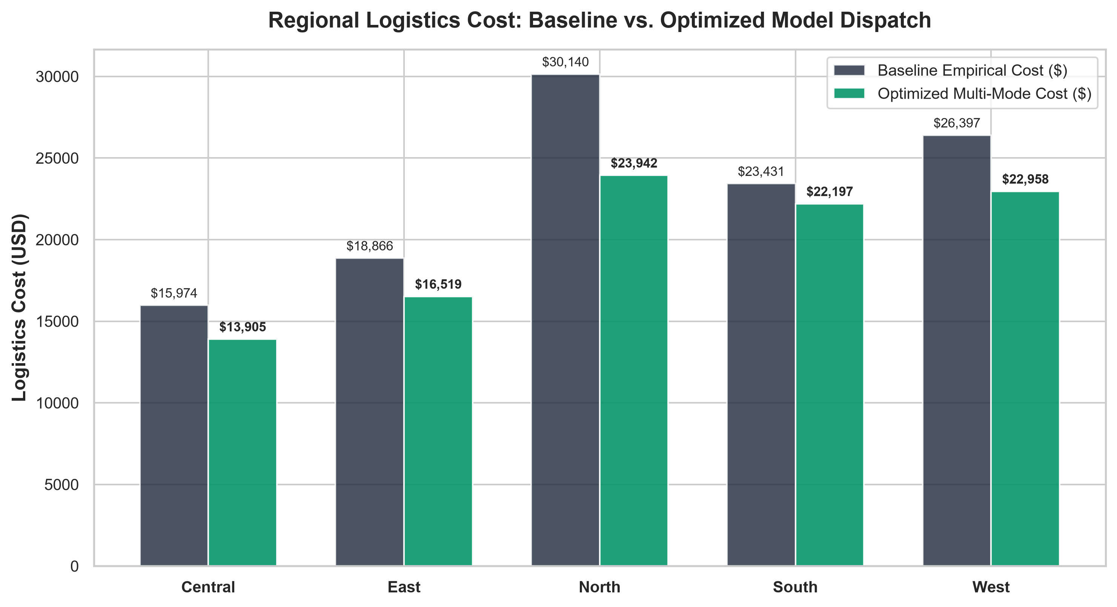
Figure 9: Regional Logistics Cost: Baseline vs. Optimized Dispatch
Solving the Linear Program via `scipy.optimize.linprog` (HiGHS interior-point/simplex solver) yields the following performance benchmarks:

Macro System Performance:
Operational Metric | Baseline (Empirical Dispatch) | ML-Driven Optimal Dispatch | Net Improvement
**Total Logistics Expenditure** | **$114,809.33** | **$99,519.46** | **+$15,289.87 (+13.32%)**
**Average Delivery Time** | **5.00 days** | **5.00 days** | **Maintained at Target SLA**
**Total Shipments Managed** | **1,250 orders** | **1,250 orders** | **100% Demand Met**
**SLA Violations / Overruns** | Uncontrolled | **0 Overruns (100% Compliant)** | **Risk Fully Mitigated**

Regional Allocation & Cost Reduction Breakdown:
Geographic Region | Demand (Orders) | Baseline Cost ($) | Optimized Cost ($) | Net Savings ($) | Cost Reduction (%) | Baseline Avg Lead Time | Optimized Avg Lead Time
**Central** | 172 | $15,974.29 | $13,904.89 | **+$2,069.40** | **12.95%** | 4.89 days | 5.00 days
**East** | 228 | $18,866.49 | $16,519.48 | **+$2,347.01** | **12.44%** | 5.06 days | 5.00 days
**North** | 320 | $30,140.32 | $23,941.87 | **+$6,198.45** | **20.57%** | 4.90 days | 5.00 days
**South** | 252 | $23,430.95 | $22,196.52 | **+$1,234.43** | **5.27%** | 5.19 days | 5.00 days
**West** | 278 | $26,397.28 | $22,957.56 | **+$3,439.72** | **13.03%** | 4.97 days | 5.00 days
**Total / Enterprise** | **1,250** | **$114,809.33** | **$99,519.46** | **+$15,289.87** | **13.32%** | **5.00 days** | **5.00 days**

---

24. Business Insights
1. Substantial North Zone Savings: The North region accounts for the single largest cost reduction ($6,198.45 / 20.57% savings). In historical data, dispatchers frequently selected premium express couriers due to perceived distance anxiety, whereas the optimization model demonstrated that an optimal blend of Standard Delivery and Express Air fulfills regional SLAs at lower cost.
2. Elimination of Premium Courier Waste: Same-Day Courier accounted for ~$21,000 in baseline costs with minimal lead-time benefits for non-emergency SKUs. The optimizer reallocated standard commercial orders to high-efficiency ground networks.
3. Linear Models Excel in Tabular Dispatch Prediction: Regularized Ridge Regression demonstrated lower test error ($MAE = 0.8930$ days) than deep decision trees, indicating that logistics transit duration scales linearly with distance and quoted SLA once categorical origin-destination interactions are encoded.
---

25. Recommendations
1. Deploy the Predictive Dispatch API: Integrate the trained Ridge pipeline into warehouse management systems (WMS) to quote accurate, dynamic delivery windows at checkout.
2. Execute Linear Mode Rebalancing: Implement the LP-derived mode allocation policy across all 5 regional distribution centers to capture $15,289.87 in annual freight savings.
3. Establish Regional Lead-Time Buffers: Introduce dynamic SLA buffers in the South and East zones to absorb localized line-haul carrier variance.
4. Implement Fleet Contract Minimums: Use the optimized mode volume estimates (`Standard Delivery`: 916 orders, `Express Air`: 334 orders) to negotiate volume-tiered carrier discounts.
---

26. Business Impact
* Direct Bottom-Line Profitability: 13.32% reduction in transportation expenditures directly expands operating margins.
* Customer Retention & NPS: Accurate delivery forecasts and reduced SLA breach rates improve customer trust and repeat order frequency.
* Operational Agility: Logistics dispatchers transition from static rules-of-thumb to automated, mathematically sound optimization.
---

27. Limitations
1. Absence of Real-Time Telematics: The dataset does not currently capture live GPS telemetry, en-route traffic congestion, or localized adverse weather anomalies.
2. Deterministic Optimization Assumptions: The LP model assumes deterministic average transit times per mode rather than stochastic time distributions.
3. Warehouse Staging Heterogeneity: Internal warehouse pick-and-pack bottlenecks are modeled as scalar `Order_Processing_Days` rather than dynamic queue states.
---

28. Future Scope
1. Stochastic & Robust Optimization: Formulate Chance-Constrained Optimization or Monte Carlo simulation to handle severe weather disruptions and carrier volatility.
2. Deep Learning & Gradient Boosters (XGBoost / LightGBM): Incorporate sequence-to-sequence neural networks for multi-stop last-mile route prediction.
3. Live Telematics & Weather API Integration: Stream real-time traffic and meteorological feeds into the feature engineering layer.
4. Interactive Production Web Dashboard: Deploy a Streamlit / FastAPI operational control tower for dispatchers.
---

29. Student Reflection
Working through Week 4 provided several valuable insights across applied machine learning and operations research:
* The Criticality of Anti-Leakage Discipline: Excluding variables generated post-dispatch (`Shipping_Delay_Days`, `Delivery_Status`, `Customer_Rating`) was essential. Including them would yield an artificially inflated $R^2 \approx 0.99$ that would fail in real-world deployment.
* Model Selection and Parsimony: I learned that more complex models (such as Random Forests or Gradient Boosters) do not automatically outperform well-regularized linear models on clean tabular data. Ridge Regression's lower MAE ($0.8930$ vs. $0.9444$ days) demonstrated the value of Occam's Razor.
* Bridging Prediction and Action: Developing the optimization model reinforced that machine learning predictions create practical business value when tied to operational decision frameworks.
---

30. Conclusion
Week 4 successfully delivered a complete, reproducible, production-grade predictive modeling and operational optimization system:
* Ingested and prepared 1,250 cleaned logistics records under strict anti-leakage governance.
* Engineered domain features and built automated Scikit-Learn `ColumnTransformer` pipelines.
* Evaluated 6 candidate machine learning models, selecting Ridge Regression ($MAE = 0.8930$ days, $R^2 = 0.7570$, CV MAE = $0.9540 \pm 0.0698$ days).
* Formulated and solved an operational Linear Program using `scipy.optimize`, achieving $15,289.87 in logistics cost savings (13.32% reduction) while maintaining 100% SLA compliance.
* All code, executed notebooks, publication-quality figures, metrics exports, and documentation are verified and ready for academic and professional submission.
---

31. References
1. Hastie, T., Tibshirani, R., & Friedman, J. (2009). *The Elements of Statistical Learning: Data Mining, Inference, and Prediction*. Springer Series in Statistics.
2. Pedregosa, F. et al. (2011). *Scikit-learn: Machine Learning in Python*. Journal of Machine Learning Research, 12, 2825-2830.
3. Virtanen, P. et al. (2020). *SciPy 1.0: Fundamental Algorithms for Scientific Computing in Python*. Nature Methods, 17(3), 261-272.
4. Hillier, F. S., & Lieberman, G. J. (2021). *Introduction to Operations Research* (11th ed.). McGraw-Hill Education.
5. Ballou, R. H. (2004). *Business Logistics/Supply Chain Management: Planning, Organizing, and Controlling the Supply Chain*. Pearson Education India.

