Microservices Design Pattern

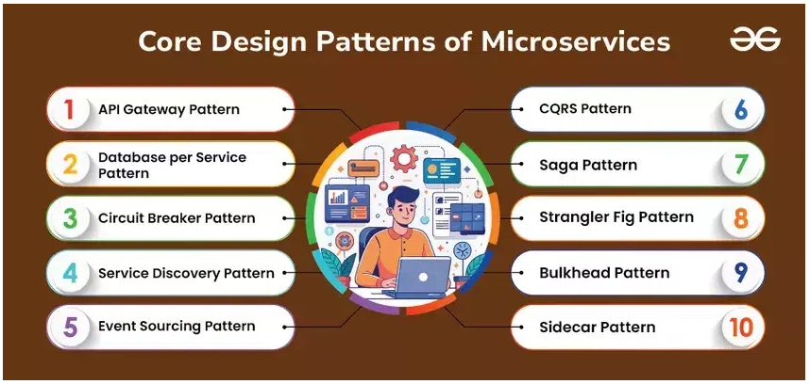

1. API Gateway pattern: