Key microservices solutions:

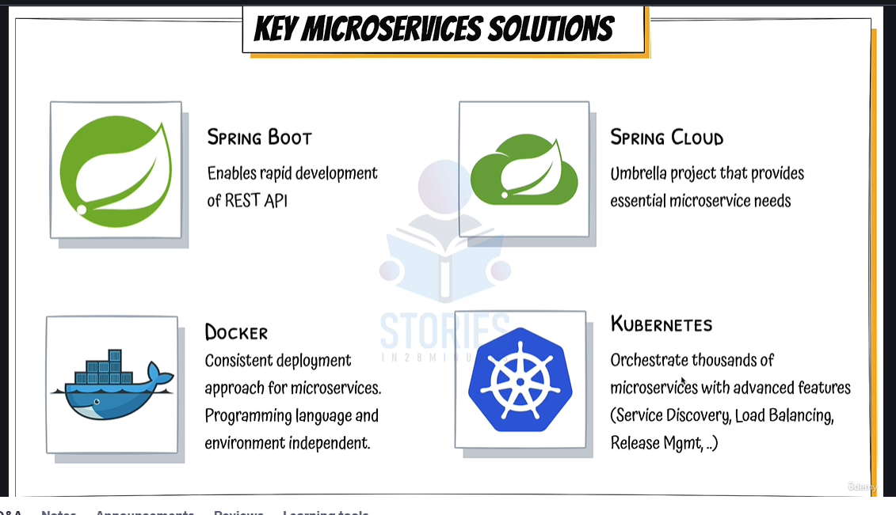

Spring cloud is an umbrella of solutions used for microservices:

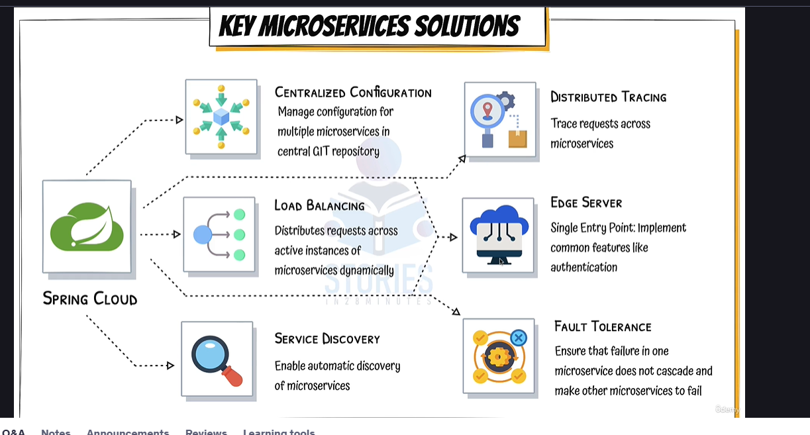

Centralized configurations:

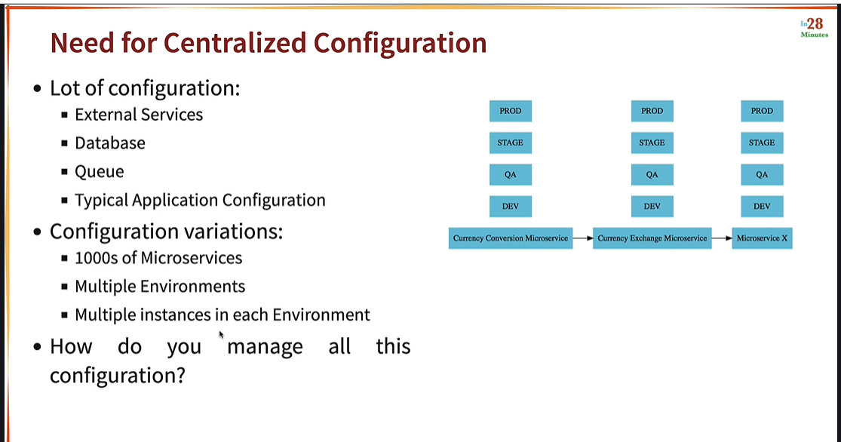

Ports configuration for examples:

**1. Limits Microservice**  
Ports: **8080, 8081**, etc.

**2. Spring Cloud Config Server**  
Port: **8888**

**3. Currency Exchange Microservice**  
Ports: **8000, 8001, 8002**, etc.

**4. Currency Conversion Microservice**  
Ports: **8100, 8101, 8102**, etc.

**5. Netflix Eureka Naming Server**  
Port: **8761**

**6. API Gateway**  
Port: **8765**

**7. Zipkin Distributed Tracing Server**  
Port: **9411**

Currency exchange service:

<http://localhost:8000/currency-exchange/from/USD/to/INR>

Currency conversion service:

<http://localhost:8100/currency-conversion/from/USD/to/INR/quantity/10>