**INFO6205: Program Structure and Algorithms**

**Assignment 3 – UNION FIND**

**By**

**Ajay Mohandas**

**NEU ID: 001426741**

Contents

Observation 1

Analysis 1

Conclusion 1

Screenshots 2

UF_HWQUPC.java 2

UF_HWQUPC_Test.java 2

# Observation

1. From the graph we are having X and Y columns with number of site and number of connections respectively.
2. As number is sites are increasing the number of connections required to reduce the number of components to 1 is also increasing gradually

# Analysis

For our analysis we can take one example from the spreadsheet to calculate the relation between number of site and number of connection.

Number of site(n) = 100

Taking natural logarithm of n we get 4.6051

Multiply the result with n/2, we get

230.25 which is close to what we achieve which is 248.

Please find the graphical representation of the X and Y data in UnionFind.xlsx

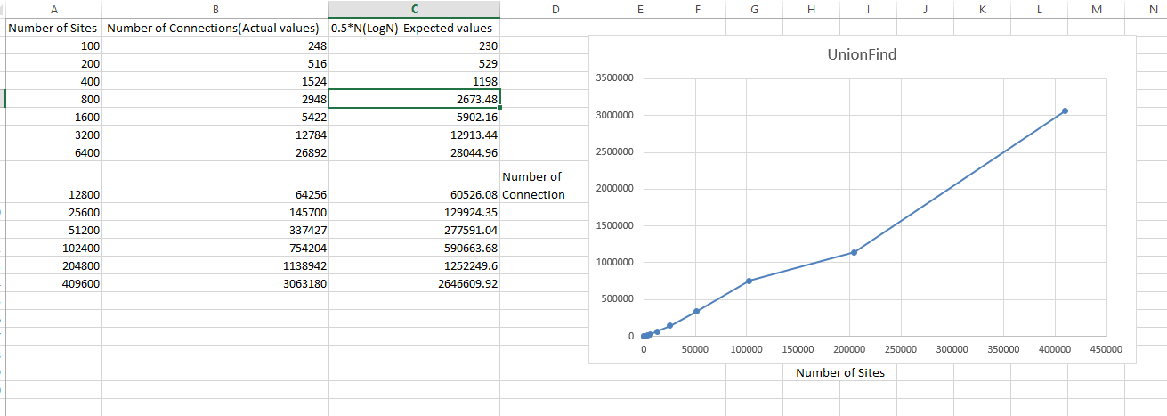

# Conclusion

As per our analysis, we can conclude that number of pairs generated to accomplish this (i.e. to reduce the number of components from n to 1) is **0.5n * ln(n)** .

# Screenshots

## UF_HWQUPC.java

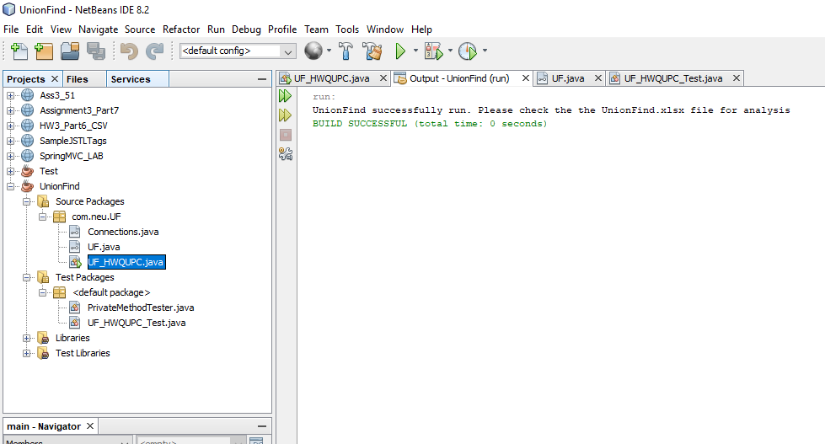

## UF_HWQUPC_Test.java

