Please find screenshot of the output of the application.

When first string is 1.0 and second is 1.0.0

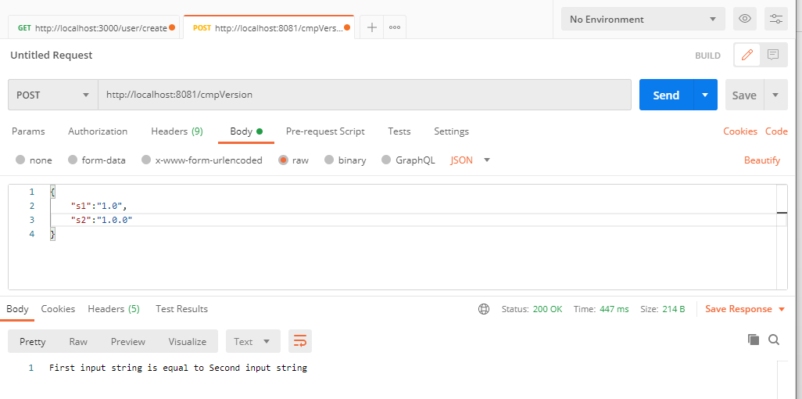

When first string is 1.0 and second is empty

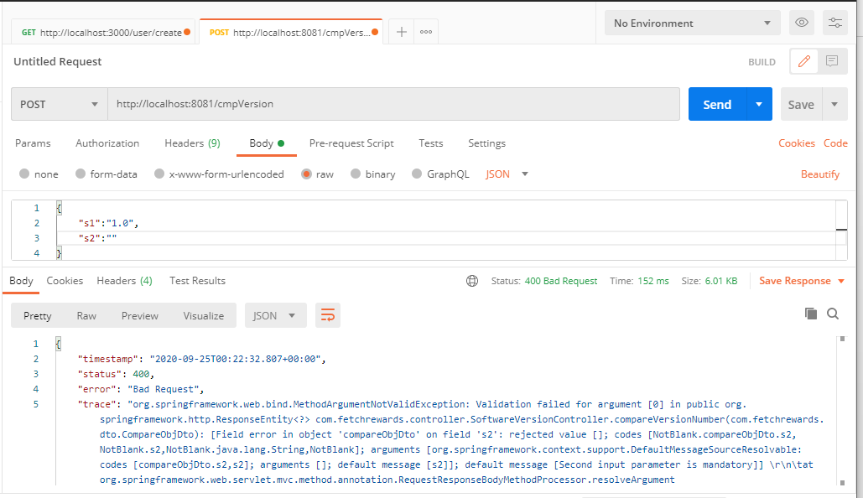

When first string is 2.12 and second is 2.0

