MT Alchemy
NET4207 · Group Project · Flutter + Firebase
COMPLETE PROJECT DOCUMENTATION

MT Alchemy: a human-centred learning and people-development platform
This document describes each page and role of the site, and how it is built, secured, tested and deployed.
Live site | https://ajaynagarajan2005.github.io/mt-alchemy/
Virtual tour | https://ajaynagarajan2005.github.io/mt-alchemy/tour
Source code | https://github.com/ajaynagarajan2005/mt-alchemy
Backend | Firebase project mt-alchemy-net4207: Authentication, Cloud Firestore (asia-southeast1)
Founders | AJAY A.N · MAAHIR FAHEEM · TANUJ SAKTHI KUMAR
Version / date | 1.0 · October 2026

Contents
- Overview
- Information architecture
- System architecture
- Page-by-page guide
  - 4.1 Public website · 4.2 Course player · 4.3 Learner portal · 4.4 Employer portal · 4.5 Trainer portal · 4.6 Super admin portal
- The five user journeys
- Data and security
- Design system, imagery and motion
- Media: videos, virtual tour and QR code
- Quality and verification
- Deployment and operations
- Limitations and future work
- Appendices: demo accounts, route table, credits, glossary

1. Overview
MT Alchemy is a People Development Consultancy specialising in Emotional Intelligence, Leadership Development, Team Engagement and Workplace Well-being. Its tagline is "We don't just run activities. We shift mindsets, behaviours, and team culture." The platform turns visitors into enquiries, learners and corporate clients.

Four modules in one application

Corporate website
A single landing page whose menu glides to About, Services, Upskilling, Store, Insights and Contact. It adds founders, impact stories, an EQ self-assessment, a "For organisations" enquiry and a cartoon virtual tour reached by QR code.

Learning management system
A course catalogue filtered by each learner's pathway (career stage and interests), purchase and enrolment, a modular player (video, PDF, reading, quiz), progress tracking, and certificates with a public verification link.

E-commerce store
Digital products download after payment; physical products ship with a tracked Processing, Shipped, Delivered timeline. One checkout handles products, courses and employer seats. Payments run in test mode.

Role-based portals
Five roles (Guest, Individual, Employer, Trainer, Super Admin), each with its own navigation, notifications and permissions enforced by database security rules.

The project in numbers
5  user roles | 5  user journeys | 12  courses | 6  products
22  Firestore collections | 47  routes | 125  Dart files | 24k  lines of Dart
56  automated tests | 39  live security checks | 30  photographs | 6  videos

How the platform meets the Employer Project brief
Brief requirement | Where it is delivered
Five core journeys (A to E) | Journey A learning to certificate; B digital product to download; C physical product to delivery; D employer seats, assignment and progress; E corporate enquiry to customised programme. See chapter 5.
Five roles with authentication | Guest, Individual, Employer, Trainer, Super Admin. Firebase Authentication plus role-based redirects in the app and security rules in the database.
CRUD for courses, products and users | Courses (trainer and admin, with lessons and quizzes), products (admin), users (admin: create, change role, disable, delete), plus articles, impact stories, founders, employees and assignments.
Course player: video, PDF, quiz, progress, Previous / Mark complete / Next | Modular player with a progress percentage, per-lesson views, quiz scoring (70% pass mark) and persisted progress.
Responsive on web, tablet and mobile | Three breakpoints (600 px and 1024 px), fluid gutters, drawers below 1024 px. Verified at 1440 px and 375 px.
Backend: Firebase (Auth, Firestore, Storage) or Supabase | Authentication and Firestore are used. Storage is not used (see chapter 11); files are served from the site itself.
Provider / Riverpod / Bloc | Provider with one ChangeNotifier store per domain.
README, ER diagram, maintenance guide | README.md, docs/ER_DIAGRAM.md, docs/MAINTENANCE.md, and this document.
Innovation | EQ self-assessment with course recommendation, employer analytics charts, Impact Stories carousel, learning pathways, admin free-access tools, public certificate verification, dark mode, cartoon virtual tour with QR code.
Scaffold, Container, Form (prototype brief) | Two Scaffolds (public AppShell, portal PortalShell) with AppBars; Containers for cards, padding, decoration and grouping; ten Forms with required-field validation. Code is annotated with SCAFFOLD:, CONTAINER ( and FORM: comments.

2. Information architecture
The site has one public area and four signed-in portals. The menu (About, Services, Upskilling, Store, Insights, Contact) is available everywhere; on the home page, each item glides to its section of the landing page, and from any other page it opens the full page.
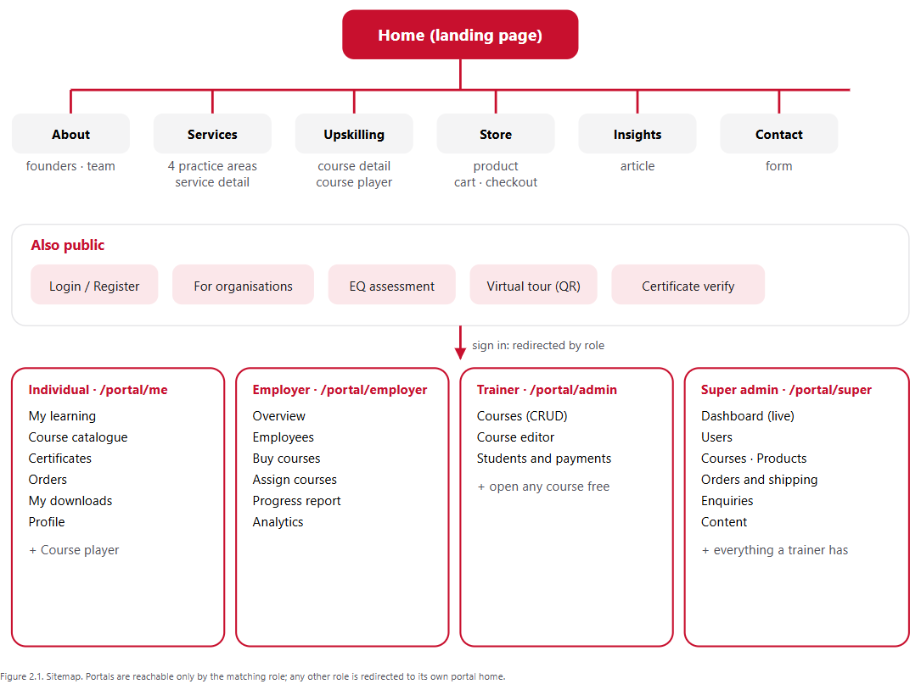

3. System architecture
The application is a single Flutter codebase that talks directly to Firebase. There is no custom server: business rules run in the client stores, and Firestore security rules decide who may read or write each document. Everything is delivered as a static web app (GitHub Pages) that connects to Firebase over HTTPS.
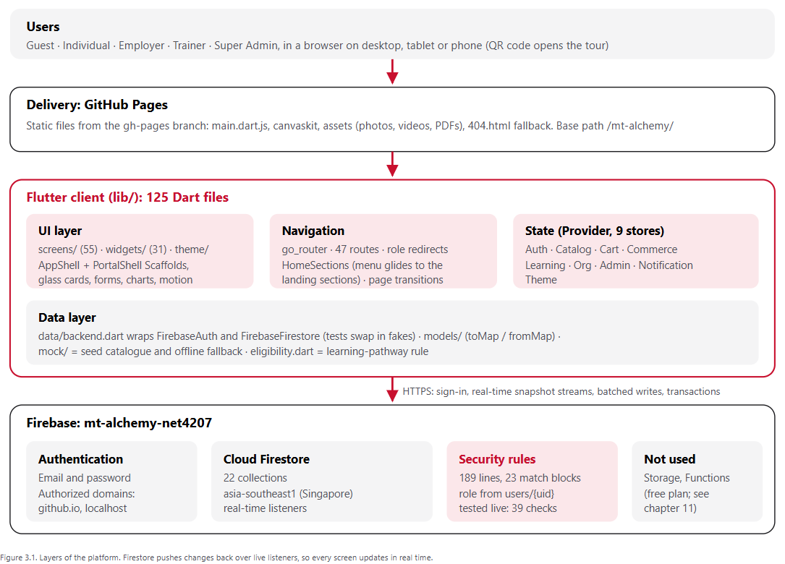

Technology
Area | Choice | Why
UI framework | Flutter 3.47 (Dart 3.13), Material 3 with a custom theme | One codebase for web, Android and iOS, with built-in animation support.
Navigation | go_router 18 | Declarative routes, clean URLs, redirect guards per role.
State | provider with ChangeNotifier stores | Brief-approved; simple and testable.
Auth and data | firebase_auth, cloud_firestore | Managed sign-in and a real-time database with declarative security rules.
Charts | fl_chart | Employer analytics (donut, bars, line).
Media | video_player, flutter_3d_controller, flutter_animate | Looping films, a 3D crystal, staggered reveals.
Utilities | qr_flutter, file_picker, image, url_launcher, intl, google_fonts, hugeicons | QR code, founder photo upload and resize, downloads, formatting, typography, icons.
Video production | Remotion (React) renders to H.264 | Programmatic, repeatable films: landing loop, brand film, cartoon tour.
Hosting | GitHub Pages (static) + Firebase (backend) | Free tier; the web app needs no server.

Code structure
Folder | What lives there
lib/data/ | backend.dart (Firebase access, friendly error messages), models/ (Course with lessons and quiz questions, Product, AppUser, Organisation, Employee, Article, Review, Founder, CartItem), mock/ (seed catalogue), eligibility.dart
lib/state/ | Nine ChangeNotifier stores. Each subscribes to the signed-in user's Firestore queries and exposes getters plus async actions that return an error message or null.
lib/router/ | routes.dart (every path), app_router.dart (shell routes, role guards, fade transitions), home_sections.dart (landing anchors)
lib/screens/ | 55 files: public pages, learn/ (player and lessons), portal/ (learner, employer, trainer, super admin), tour/, certificate/, assessment/
lib/widgets/ | 31 reusable widgets: GlassPanel, AlchemyButton, AnimatedCard, CardImage, CourseThumb, Reveal, TiltCard, ReviewsSection, PathwayFields, the two layout shells, the notification bell
lib/theme/ | Colour, typography, spacing, radius and motion tokens for light and dark
test/ | 13 test files on a fake Firestore and mock Auth (helpers/fake_backend.dart)
tools/ | seed/ (seed.mjs, verify.mjs), export_seed.dart, make_pdfs.py, serve_web.mjs, deploy_pages.sh
video/ | Remotion project: HeroLoop, ServicesLoop, BrandIntro, SiteTour
web/, assets/ | HTML shell and downloads (web/downloads/*.pdf); 30 photographs, 6 videos, a 3D model, textures

How data flows
- On sign-in, AuthStore (which listens to Firebase Auth) streams users/{uid} (role, organisation, pathway) and their organisation document.
- The other stores listen to AuthStore. When the uid changes they cancel their old listeners and subscribe to that user's data, for example enrolments where userId == uid.
- Screens watch the stores and rebuild automatically. CatalogStore starts with the bundled catalogue so pages paint instantly and work offline; Firestore then replaces it live.
- Checkout, assignment and enrolment use batched writes, and the stock decrement uses a transaction. Lesson progress updates optimistically, so the interface responds before the server confirms.
- Actions return a readable message, such as "That email and password do not match an account.", instead of throwing.

Routing and role guards
Public pages share AppShell: one Scaffold with a glass AppBar and an end drawer below 1024 px. Signed-in pages share PortalShell: a second Scaffold with its own AppBar, a side rail (drawer on small screens), the notification bell, a theme toggle and one scroll area with a visible scrollbar. All portal pages are flat sibling routes, because nested child routes would stack a page underneath that Flutter never lays out.
Role | Home after sign-in | Guard
Guest | public site | Portal paths and /learn redirect to /login?from=…, and return afterwards.
Individual | /portal/me | May open only /portal/me/*.
Employer | /portal/employer | May open only /portal/employer/*.
Trainer | /portal/admin | May open only /portal/admin/*.
Super admin | /portal/super | May open /portal/super/* and the trainer's course editor and students pages.

The router waits for Firebase to restore the session before deciding, so a signed-in user is never bounced to the login screen on refresh.

Theme switching
Colour tokens are static getters on the active palette. When the brightness changes, every element is marked for rebuild so each widget re-reads the tokens, without recreating the tree; the current page, scroll position and widget state survive. The toggle reads the live brightness at press time, so it always flips.

Build and delivery pipeline
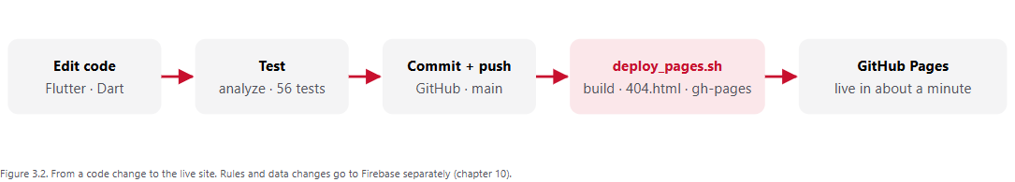

4. Page-by-page guide
Screenshots were taken from the published site at 1440 px, signed in as the role that owns each page.

4.1 Public website
Open to everyone. The home page is one long landing page; its menu items glide to the matching section.

1. Home: landing hero
/ Access: Everyone
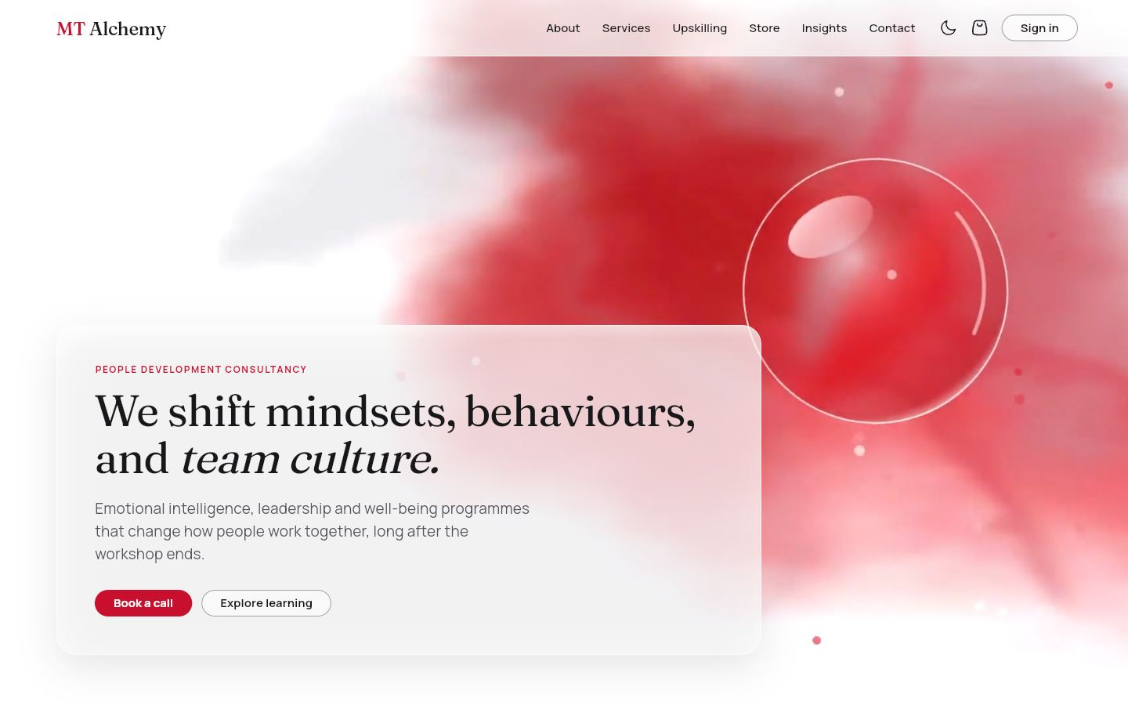
A looping ink-in-water film with a floating glass crystal sits behind glass copy: "We shift mindsets, behaviours, and team culture", and two calls to action.
DATA
None (static hero).
WHAT YOU CAN DO
- Book a call, Explore learning
- Menu and theme toggle
- Cart badge shows the item count

2. Home: services
/ (section) Access: Everyone
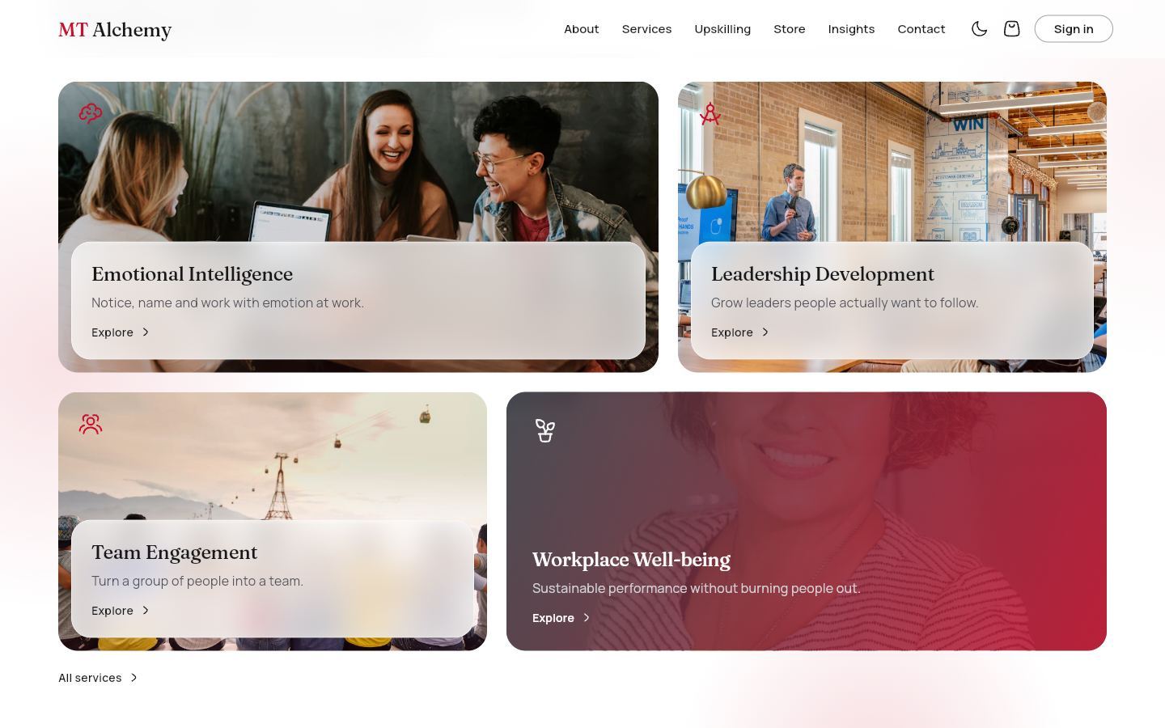
The hero zooms into four photo cards, one per practice area, with a 3D tilt on hover.
DATA
Services (bundled).
WHAT YOU CAN DO
- Open a service
- All services link
- Menu "Services" glides here

3. Home: about
/ (section) Access: Everyone
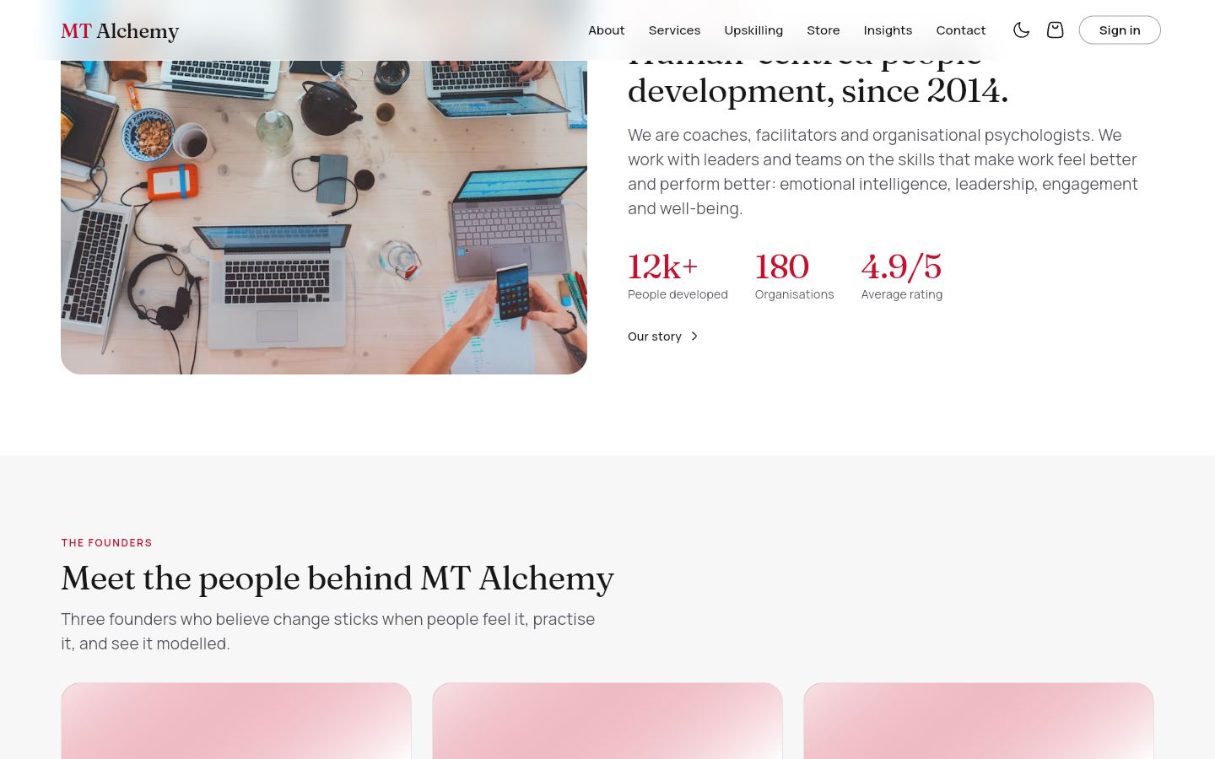
Who we are: a team photograph, a short introduction and three key numbers. The founders section begins underneath.
DATA
None (static content).
WHAT YOU CAN DO
- Our story link
- Menu "About" glides here

4. Home: founders and manifesto
/ (section) Access: Everyone
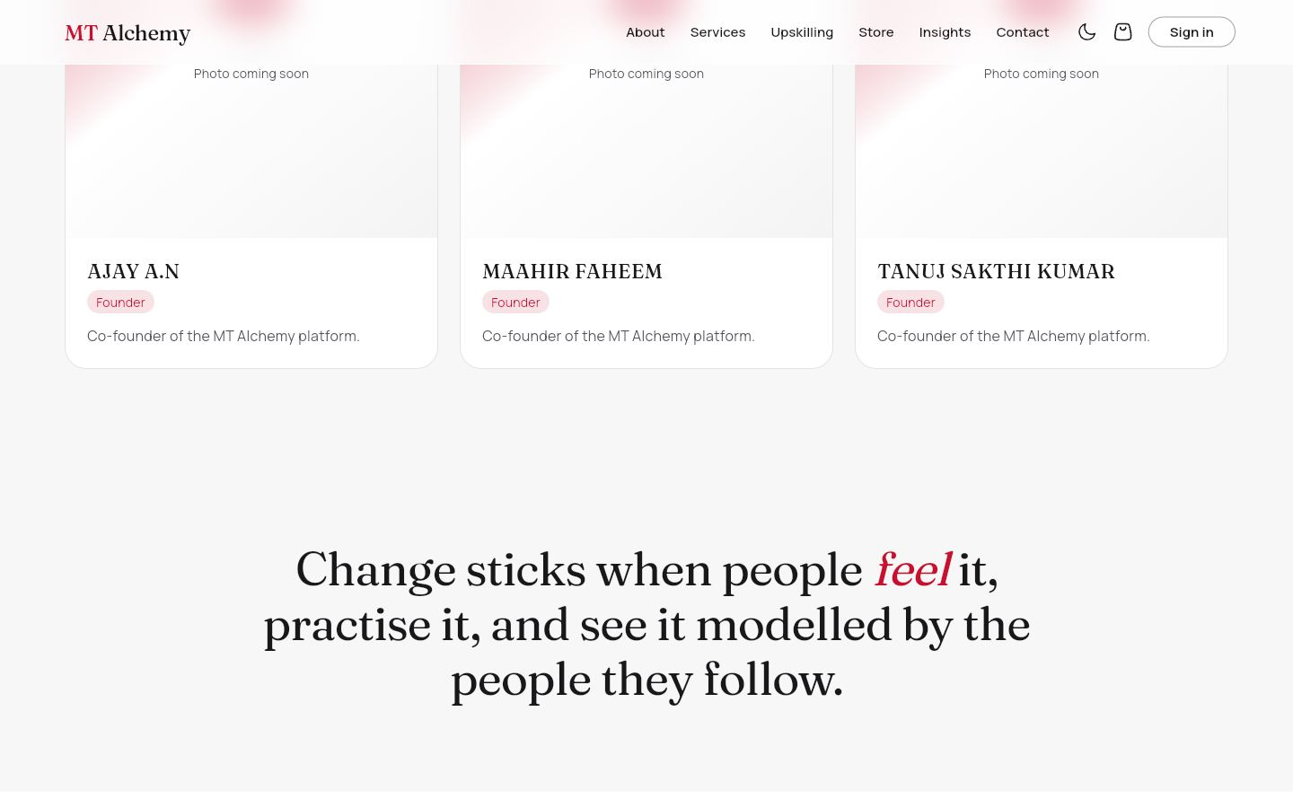
Three animated founder cards (AJAY A.N, MAAHIR FAHEEM, TANUJ SAKTHI KUMAR) with a photo slot each, followed by the statement of belief. A placeholder with initials shows until a photo is added.
DATA
founders (live).
WHAT YOU CAN DO
- Hover: the card lifts
- Super admin: Upload or Change photo, Edit details

5. Home: courses and impact stories
/ (section) Access: Everyone
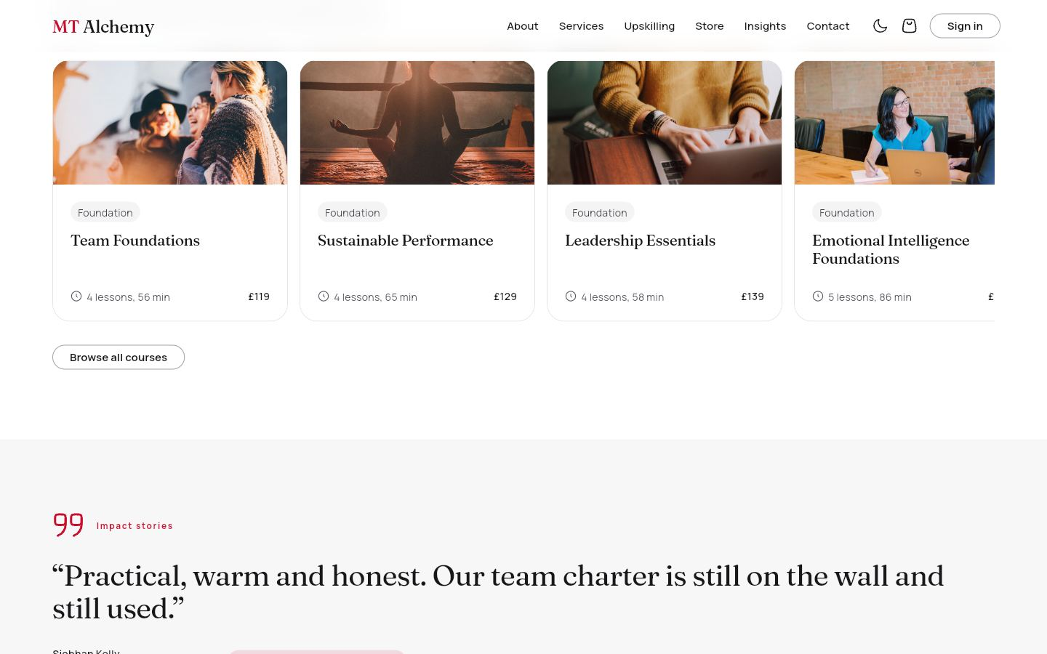
A snapping carousel of featured courses with photos, then client quotes with a headline result that rotate every seven seconds, with dots to jump between stories.
DATA
courses (published only), impactStories (live).
WHAT YOU CAN DO
- Open a course
- Browse all courses
- Jump to a story
- No auto-rotation under reduced motion

6. Home: store and insights
/ (section) Access: Everyone
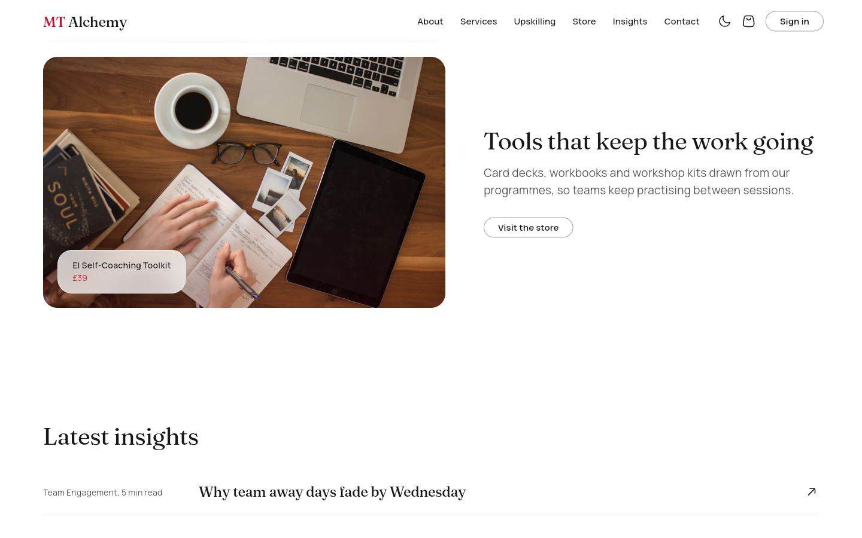
A featured product from the live catalogue and the three latest articles as editorial rows.
DATA
products, articles (live).
WHAT YOU CAN DO
- Visit the store
- Open an article

7. Home: contact and call to action
/ (section) Access: Everyone
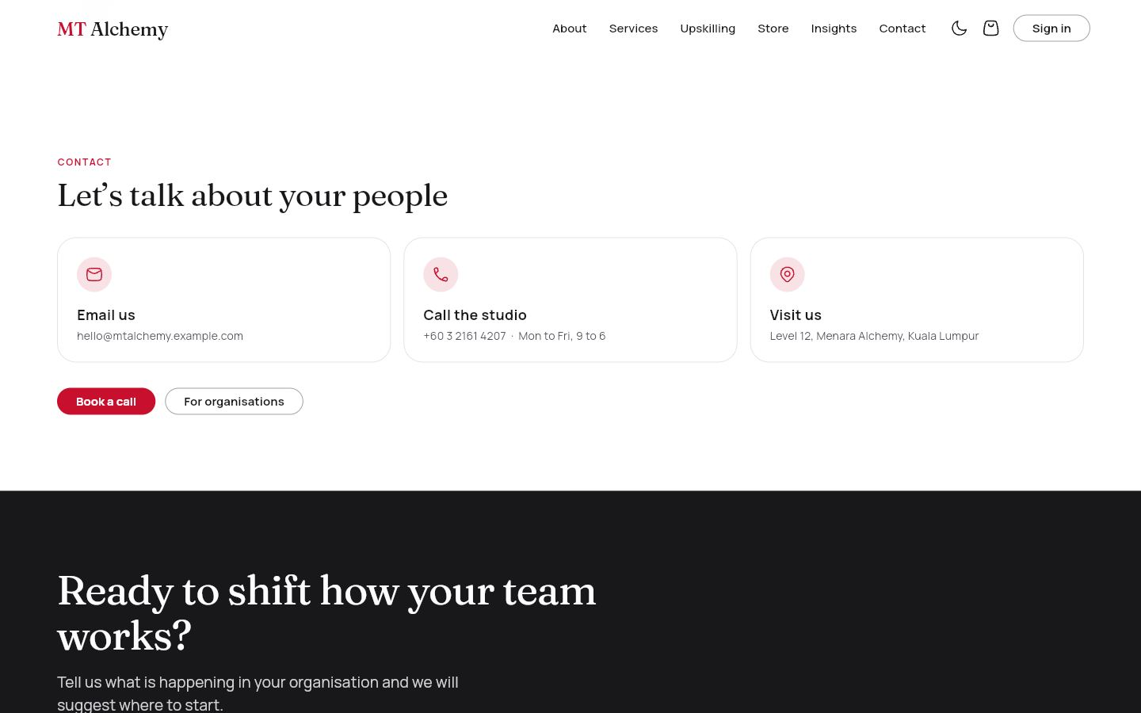
Three animated contact cards and a closing band inviting organisations to design a programme.
DATA
None.
WHAT YOU CAN DO
- Book a call
- For organisations
- Register your organisation

8. Home: virtual tour QR
/ (final section) Access: Everyone
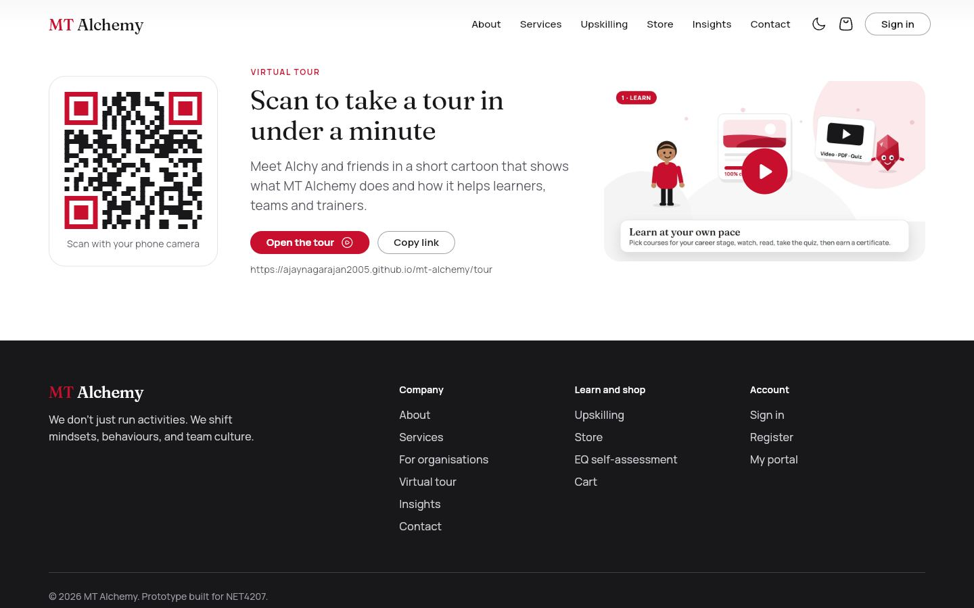
The last section: a QR code that opens the cartoon tour, with the address, copy and open buttons, and a clickable preview of the film.
DATA
None. The address is computed from the host.
WHAT YOU CAN DO
- Scan or open the tour
- Copy link

9. About
/about Access: Everyone
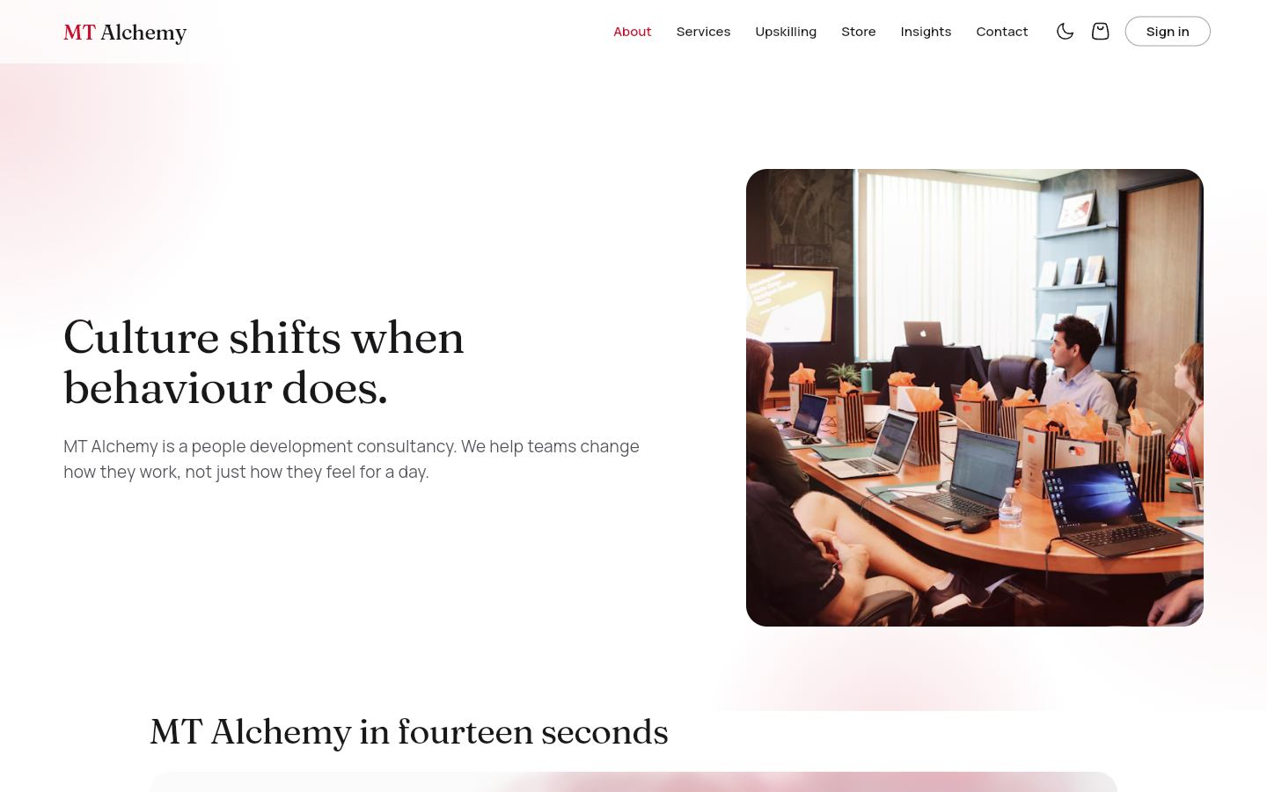
The story of MT Alchemy: hero, the brand film, guiding principles, the founders and the team.
DATA
founders (live).
WHAT YOU CAN DO
- Play the brand film
- Read the principles
- Book a call

10. Services
/services Access: Everyone
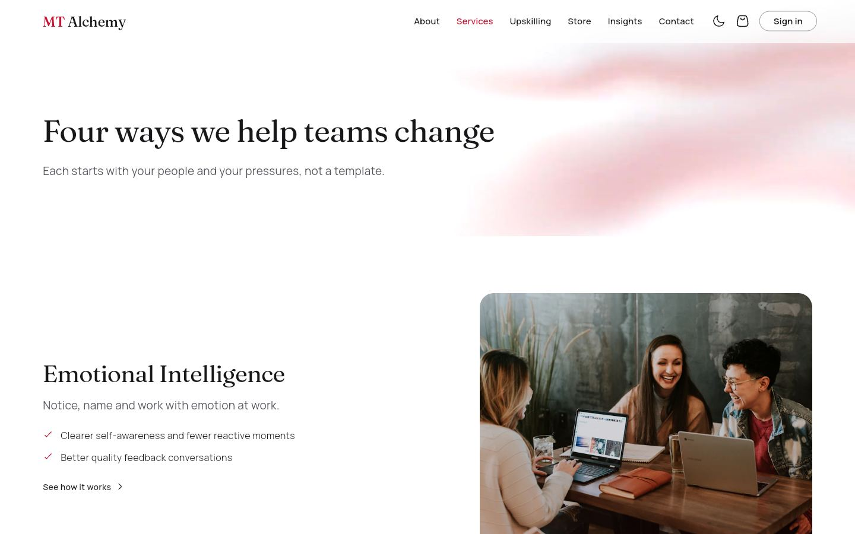
The four practice areas: Emotional Intelligence, Leadership Development, Team Engagement and Workplace Well-being, each with a photograph and a one-line promise.
DATA
Services (bundled).
WHAT YOU CAN DO
- Open a service

11. Service detail
/services/:slug Access: Everyone
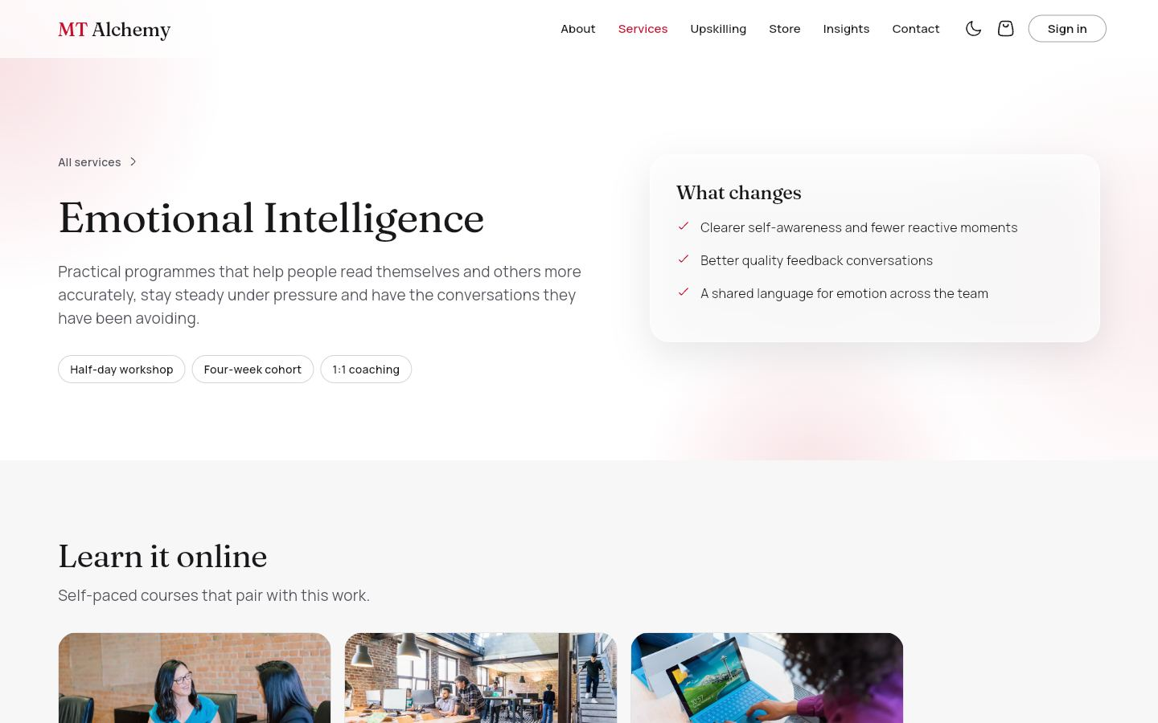
One practice area in depth: summary, what changes, formats, related self-paced courses and a client quote.
DATA
courses, impactStories (live).
WHAT YOU CAN DO
- Open a related course
- Book a call

12. Upskilling (course library)
/upskilling Access: Everyone
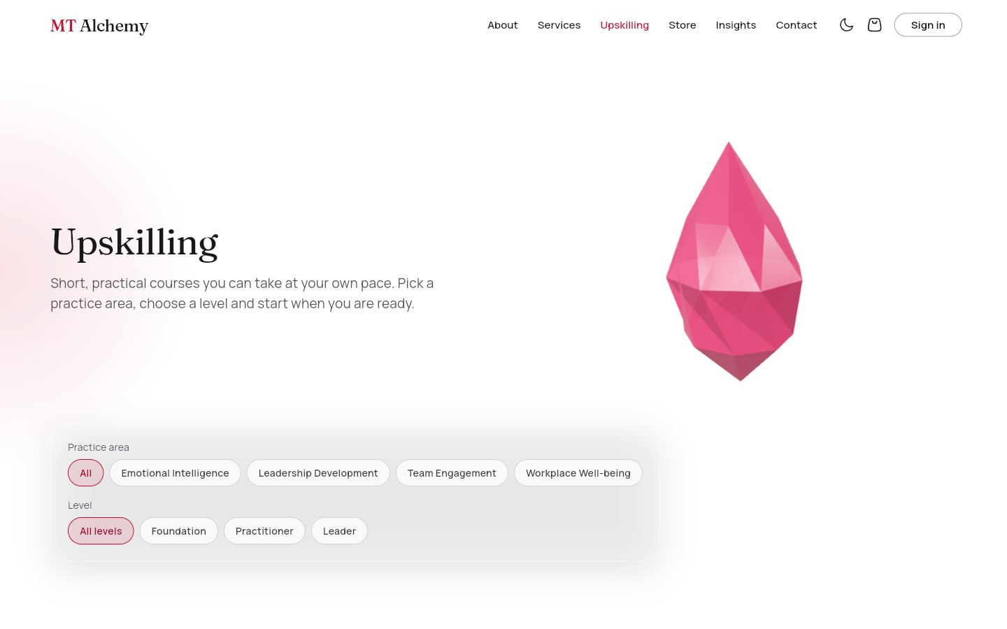
The public course library with level and practice-area filters and photo cards that lift and zoom on hover.
DATA
courses (live).
WHAT YOU CAN DO
- Filter by level or area
- Open a course

13. Course detail
/upskilling/:id Access: Everyone (actions depend on role)
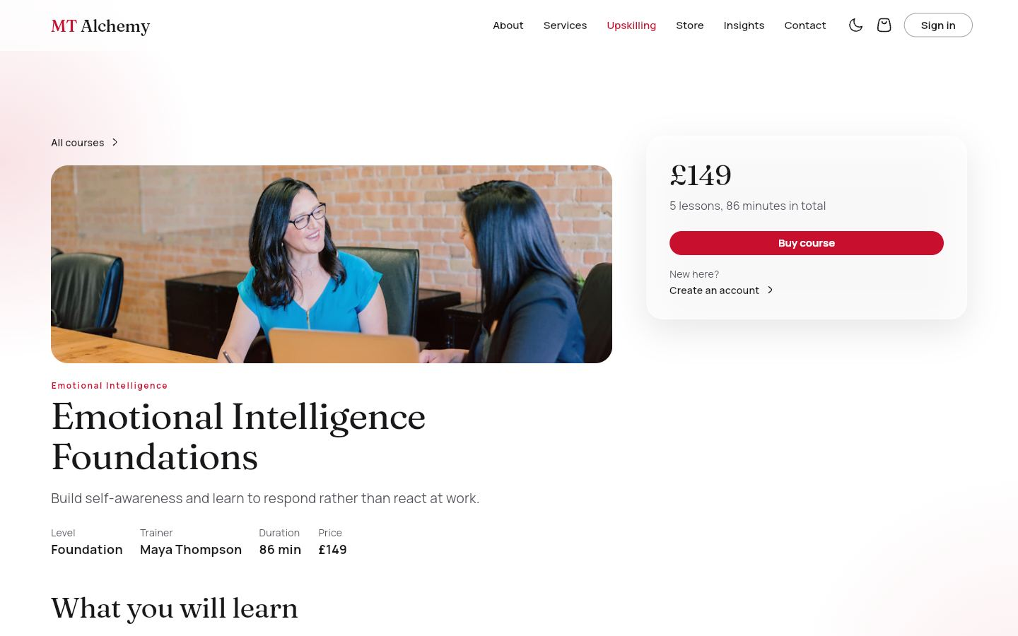
Photo header, what you will learn, lessons (type and duration), reviews and a summary panel whose button depends on who is looking.
DATA
courses, reviews, enrolments, assignments.
WHAT YOU CAN DO
- Guest: sign in or create account
- Learner: Buy course (if in pathway) or See courses in your pathway
- Employee: Start assigned course
- Employer: buy seats
- Staff: Open free, Students, Edit
- Learners post reviews

14. Store
/store Access: Everyone
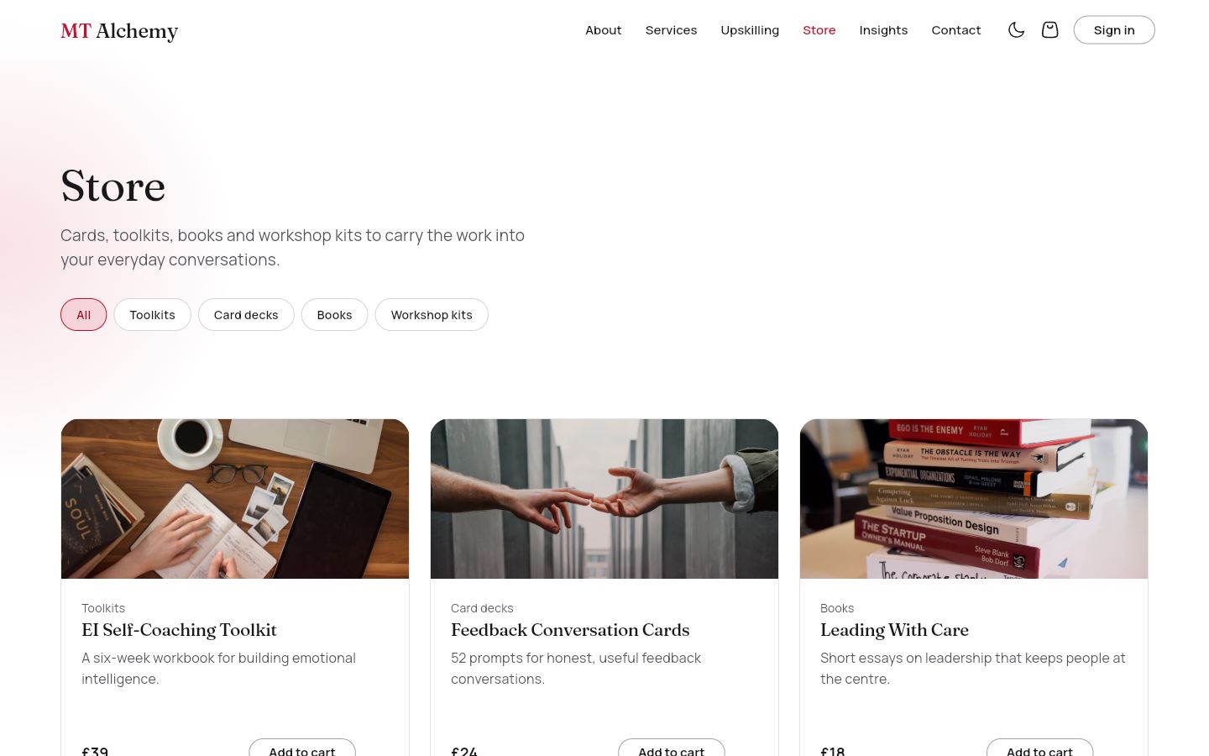
Toolkits, card decks, books and workshop kits with a category filter and photo cards.
DATA
products (live).
WHAT YOU CAN DO
- Filter by category
- Open a product
- Add to cart

15. Product
/store/:id Access: Everyone
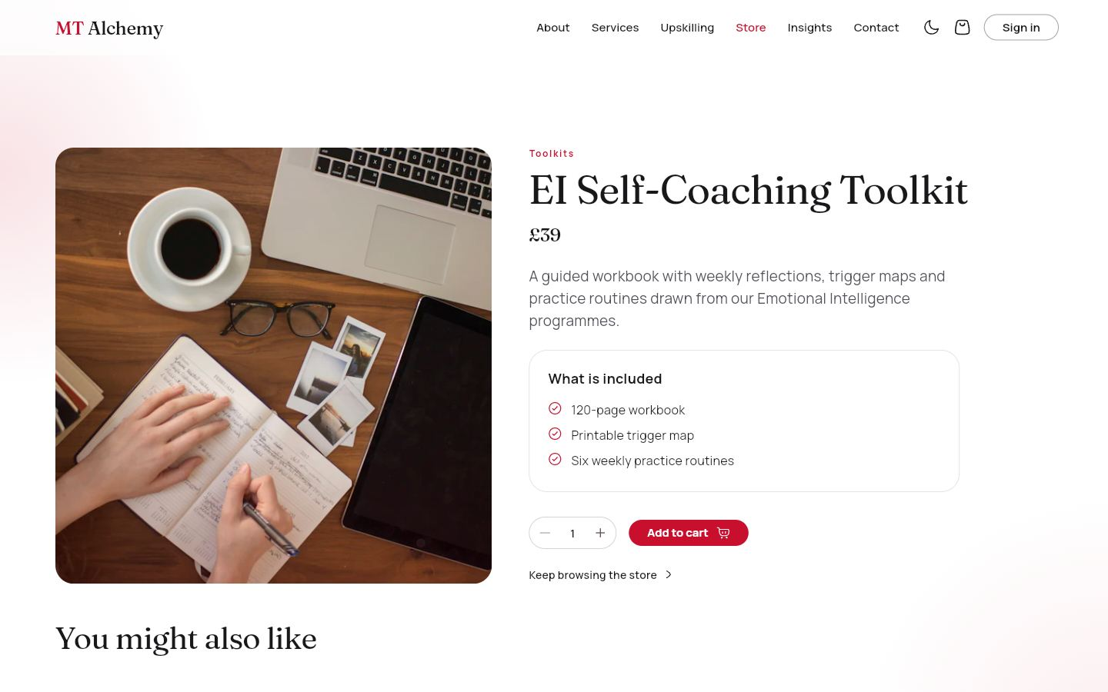
Product photo, description, what is included, price, digital or shipped, reviews and related products.
DATA
products, reviews.
WHAT YOU CAN DO
- Add to cart
- Quantity
- Read reviews

16. Cart
/cart Access: Everyone
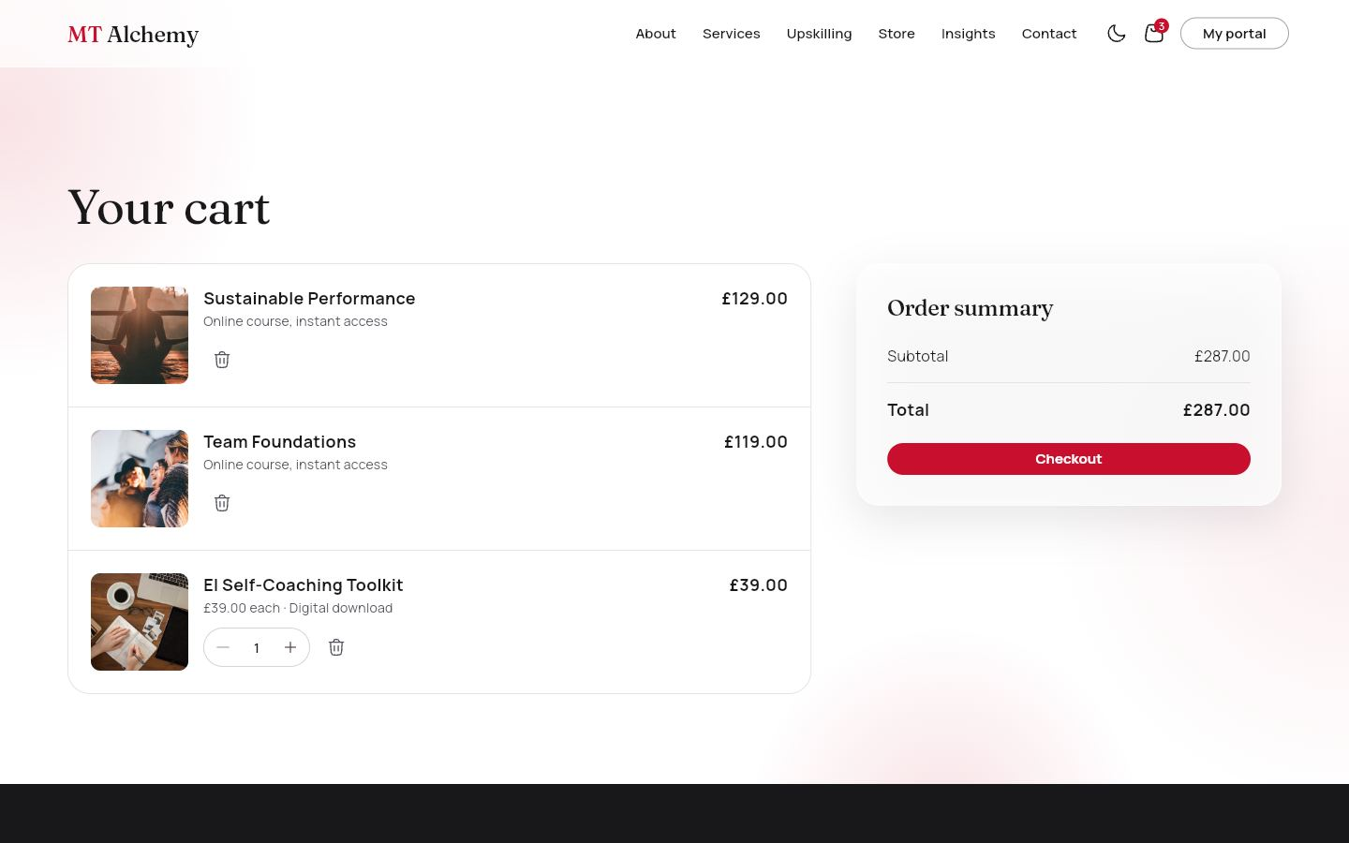
Mixed lines (products, a course, employer seats) with quantity steppers, remove, totals and a free-delivery nudge. A guest cart is merged into the saved cart on sign-in.
DATA
carts/{uid} when signed in.
WHAT YOU CAN DO
- Change quantity
- Remove
- Go to checkout

17. Checkout
/checkout Access: Signed in
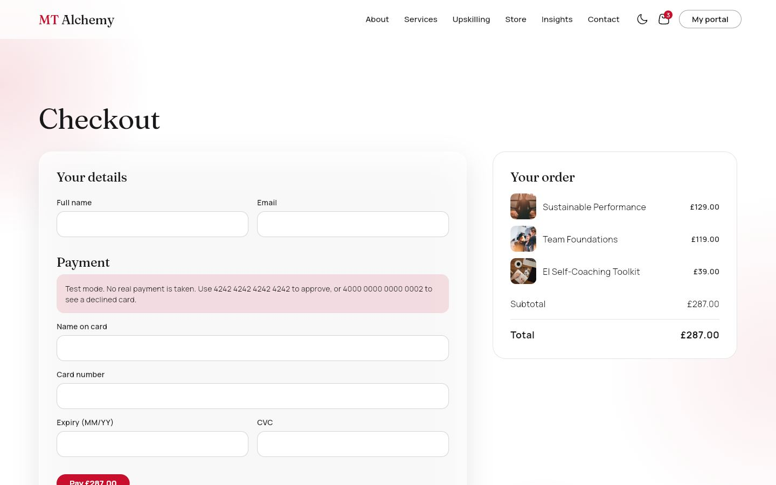
Details, a delivery address only when something ships, and a test-mode card form. The confirmation page (/checkout/success) offers the next step: Start learning, Assign your seats, My downloads or Track my order.
DATA
orders, payments, shipping, downloads, enrolments, organizations (seats), products (stock).
WHAT YOU CAN DO
- Pay (validated card number, expiry, CVC)
- Declined test card shows an error

18. Insights
/insights Access: Everyone
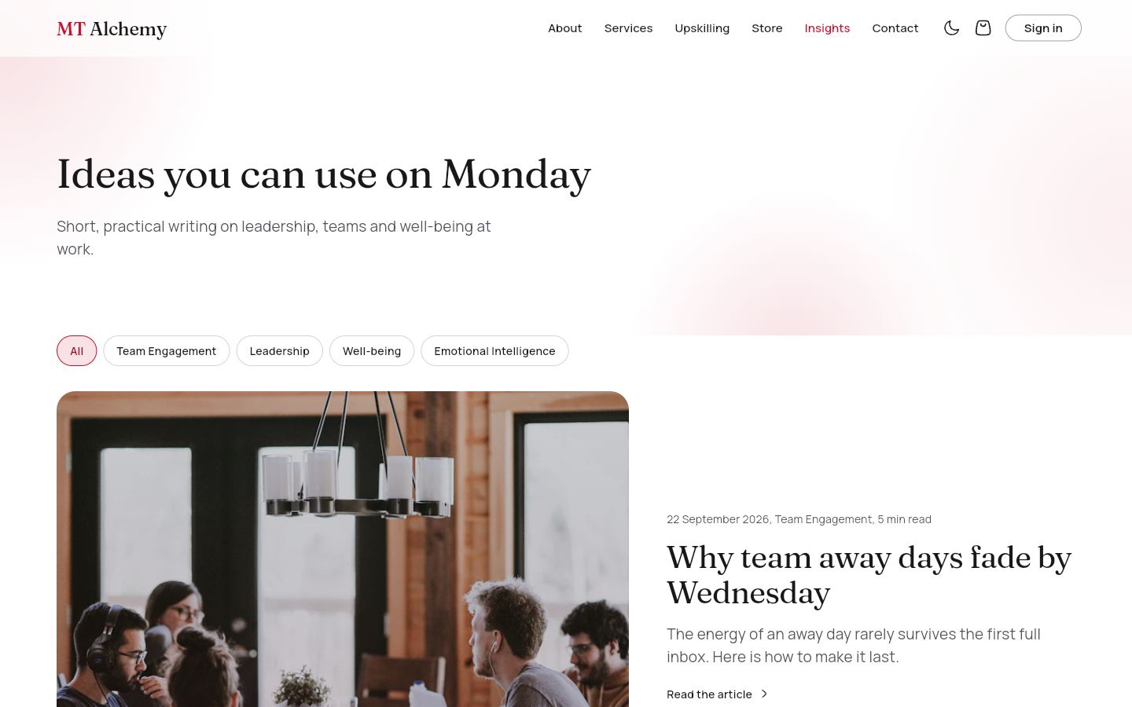
Short practical articles with a category filter and a featured story.
DATA
articles (live).
WHAT YOU CAN DO
- Filter by category
- Open an article

19. Article
/insights/:slug Access: Everyone
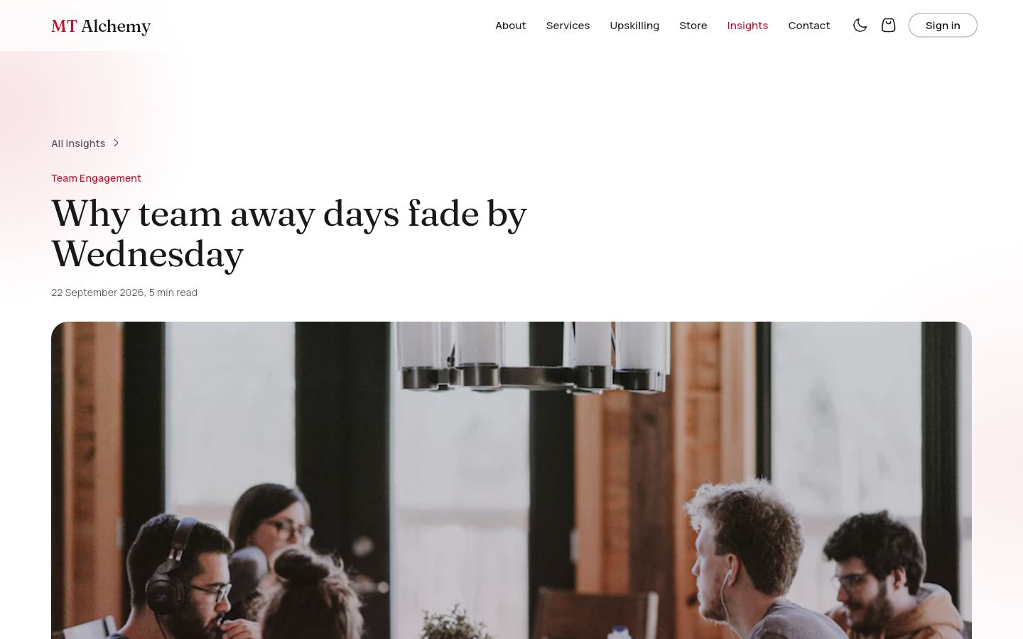
A full article with a photo header, reading time and related articles.
DATA
articles.
WHAT YOU CAN DO
- Read
- Open a related article

20. Contact
/contact Access: Everyone
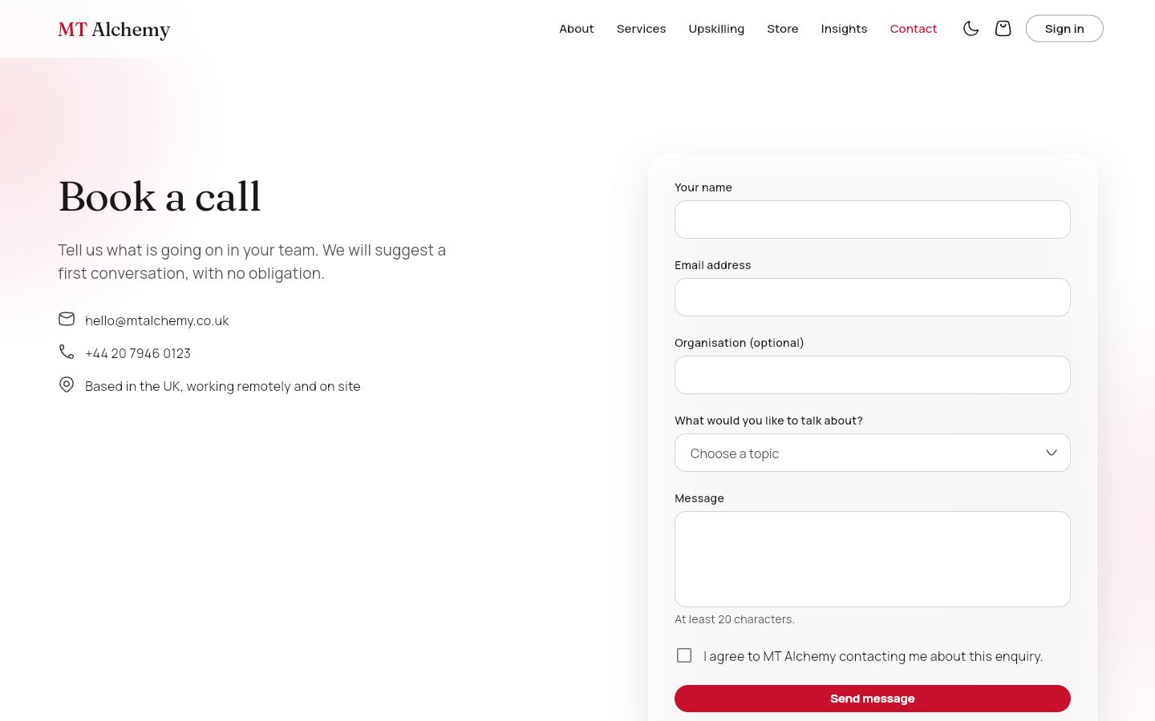
A form (name, email, topic, message, consent) with validation that saves to Firestore and shows a success state.
DATA
contactMessages (write).
WHAT YOU CAN DO
- Send a message
- Send another

21. Sign in
/login Access: Guests
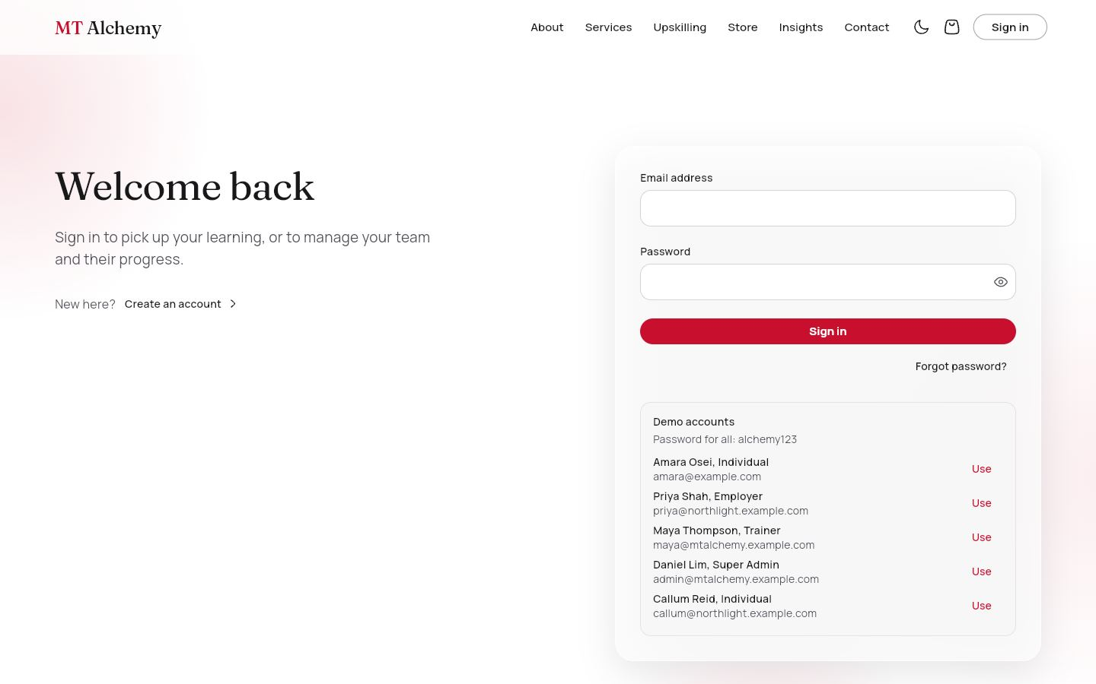
Email and password with validation, "Forgot password?" (sends a Firebase reset email) and one-tap demo accounts.
DATA
Firebase Auth; users.
WHAT YOU CAN DO
- Sign in and land on your portal
- Reset password
- Use a demo account

22. Register: individual
/register Access: Guests
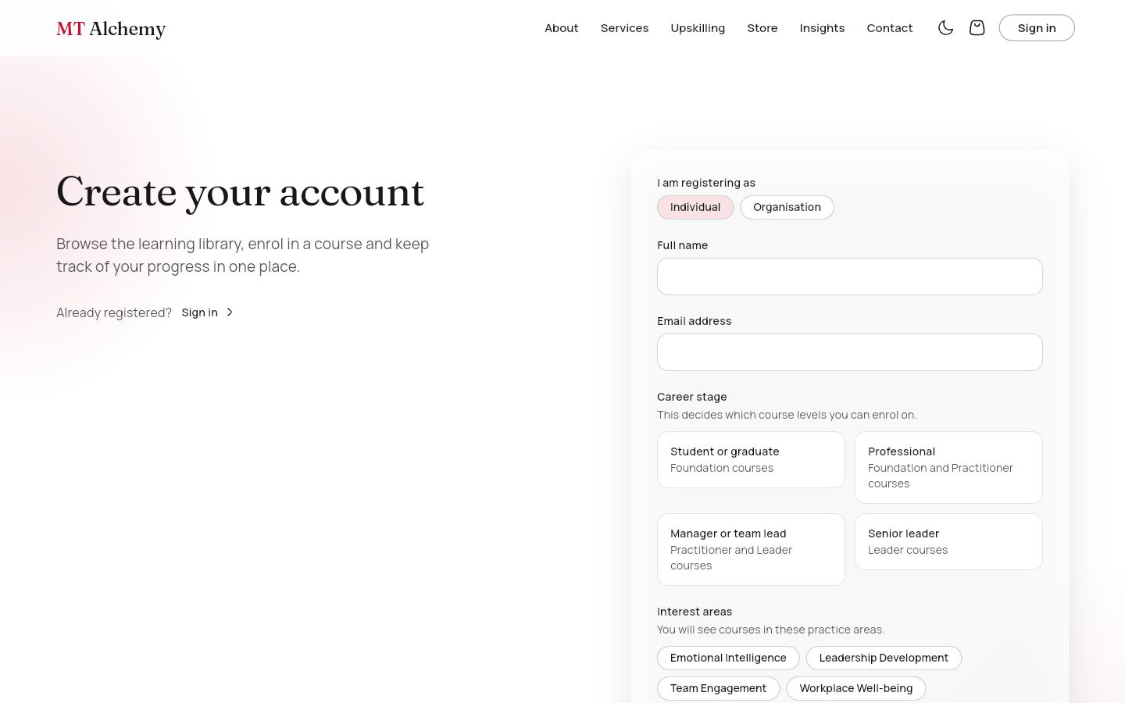
Name, email, password, gender (radio), country (dropdown), hobbies (checkboxes) and the learning pathway: career stage plus interest areas, all validated.
DATA
users (create).
WHAT YOU CAN DO
- Create account, then go to the course catalogue

23. Register: organisation
/register?type=organisation Access: Guests
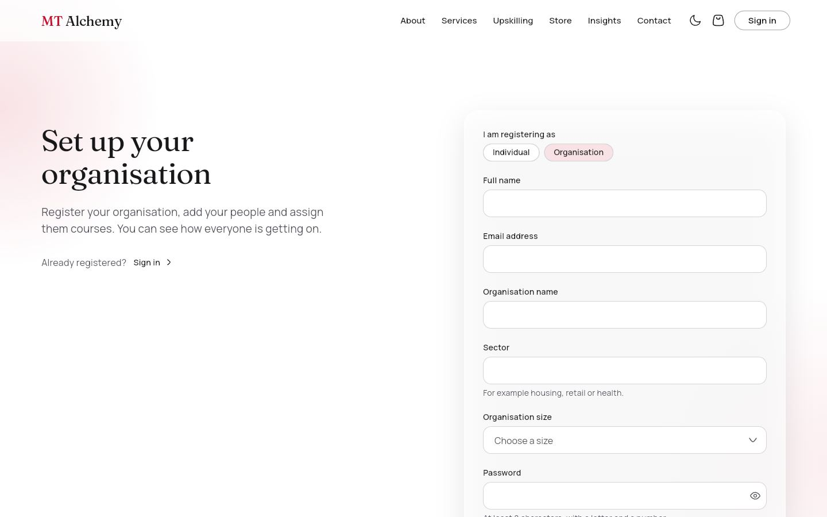
Journey D starts here: organisation name, sector and size, plus the employer's own login.
DATA
users, organizations (create).
WHAT YOU CAN DO
- Register, then go to the employer portal

24. For organisations (Journey E)
/organisations Access: Everyone
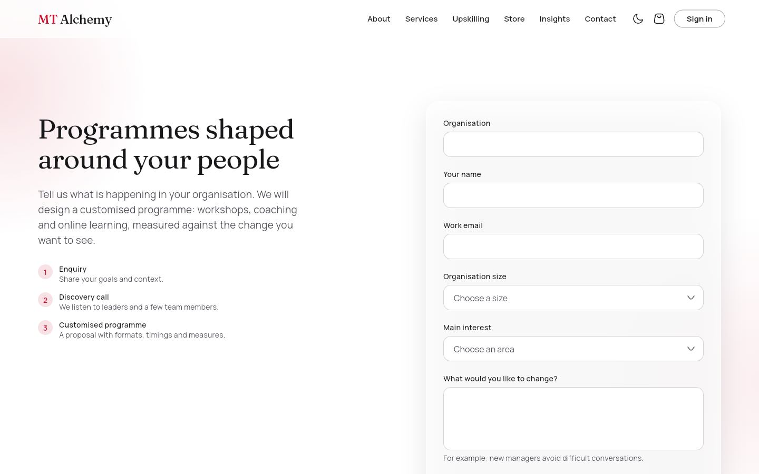
A corporate enquiry form with a three-step explanation: enquiry, discovery call, customised programme.
DATA
enquiries (create).
WHAT YOU CAN DO
- Send enquiry
- Then register the organisation

25. EQ self-assessment
/eq-assessment Access: Everyone (results saved if signed in)
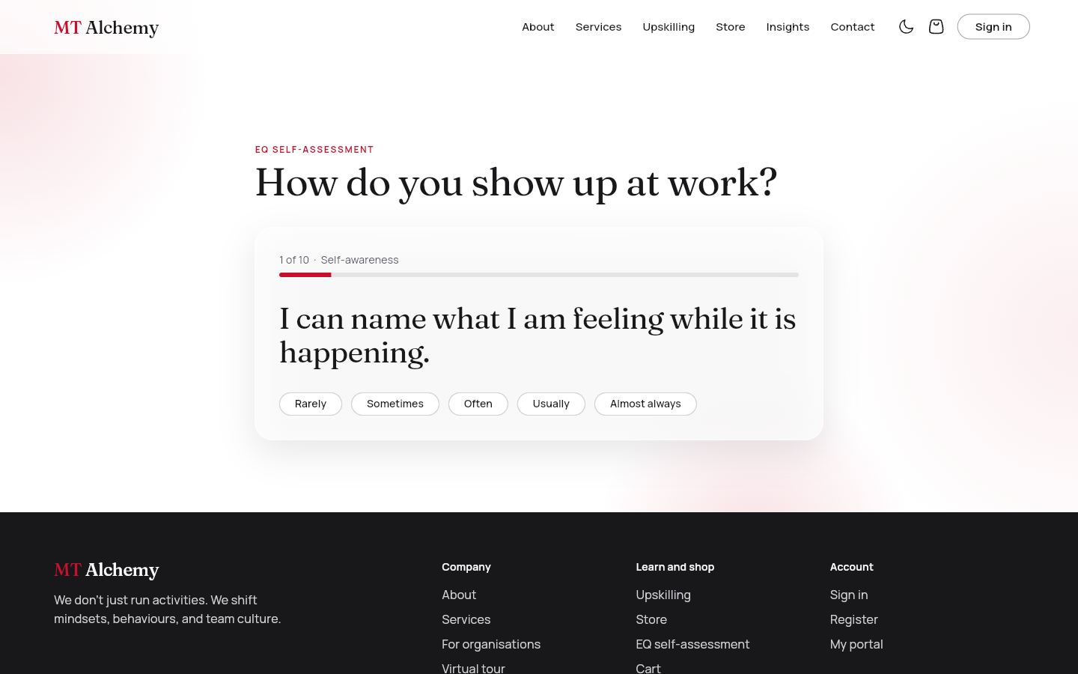
Ten statements across five emotional-intelligence areas, one at a time. The result shows animated bars, a strength, a growth edge and a recommended course.
DATA
assessments (write when signed in).
WHAT YOU CAN DO
- Answer, go back, retake
- View the recommended course

26. Virtual tour
/tour Access: Everyone
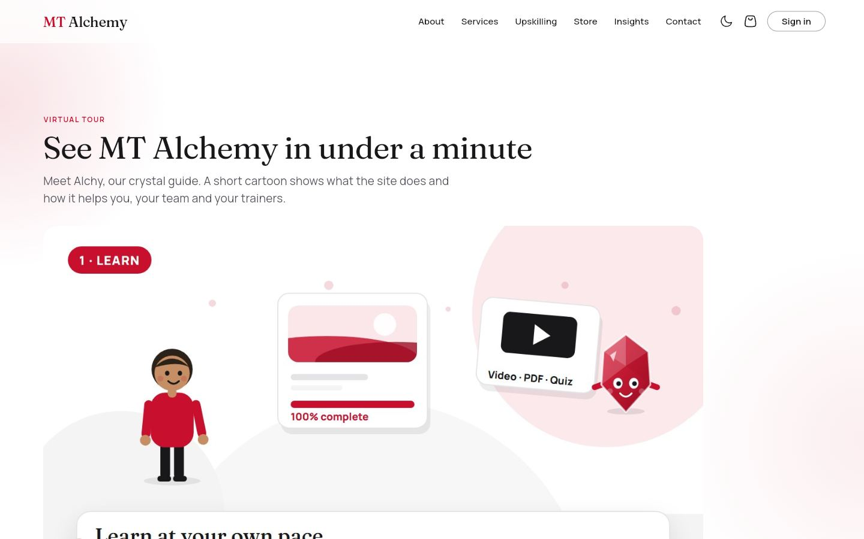
The page the QR code opens: the cartoon explainer film, then six "Try it yourself" cards linking to learning, shop, teams, trainers, the EQ check and insights.
DATA
None.
WHAT YOU CAN DO
- Play the film
- Open any part of the site
- Create a free account

27. Certificate
/certificates/:code Access: Everyone (public by design)
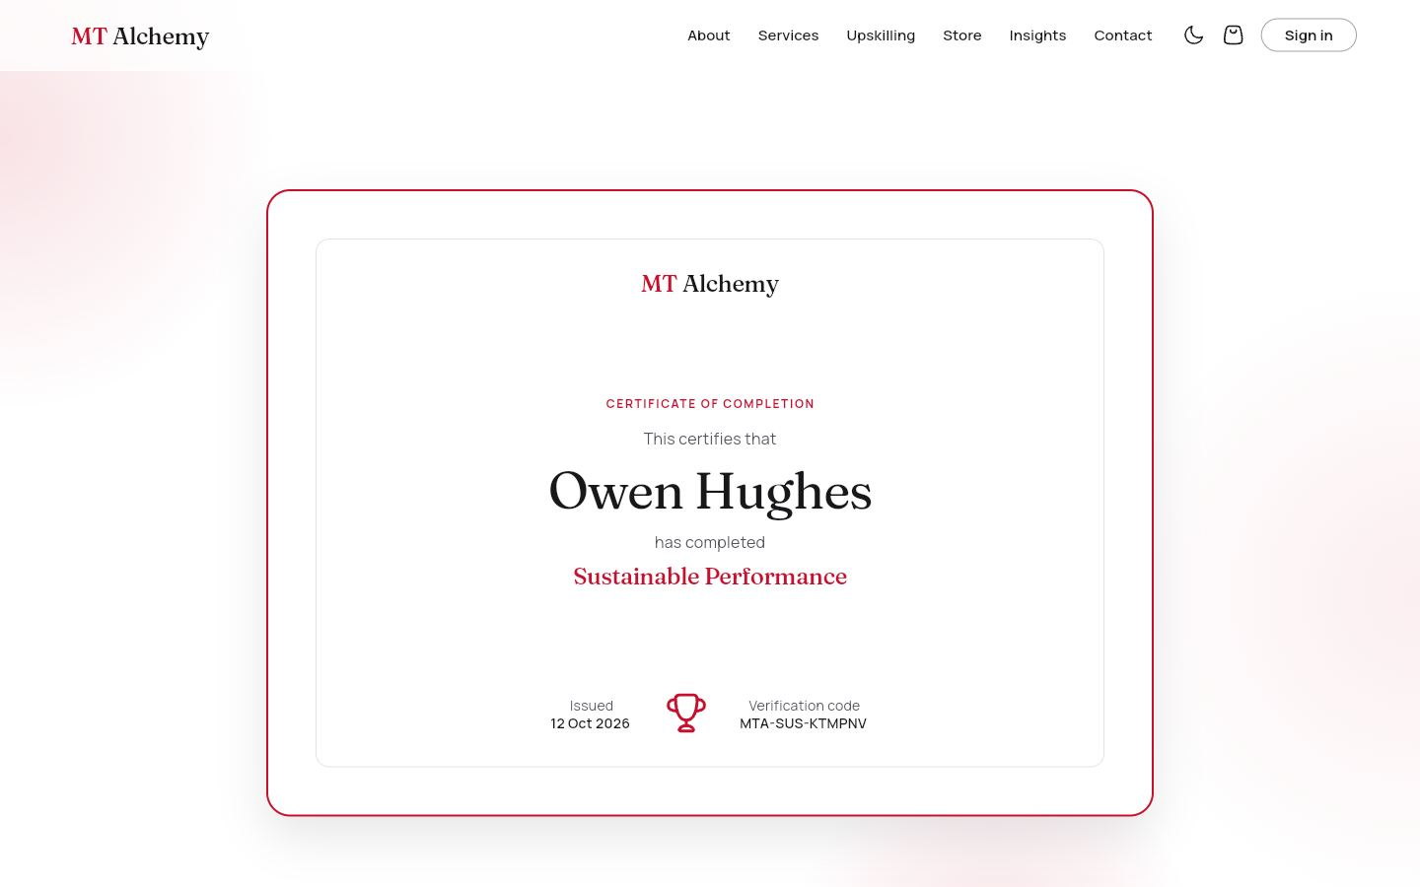
A certificate page with the learner's name, course, issue date and verification code. Anyone with the link can verify it, and an unknown code shows "Certificate not found".
DATA
certificates (public read).
WHAT YOU CAN DO
- Share the link
- Verify a code

4.2 Course player
Signed-in learners open the courses they own. Staff can open any course free.

28. Course player: video lesson
/learn/:id Access: Enrolled learners; staff (free preview)
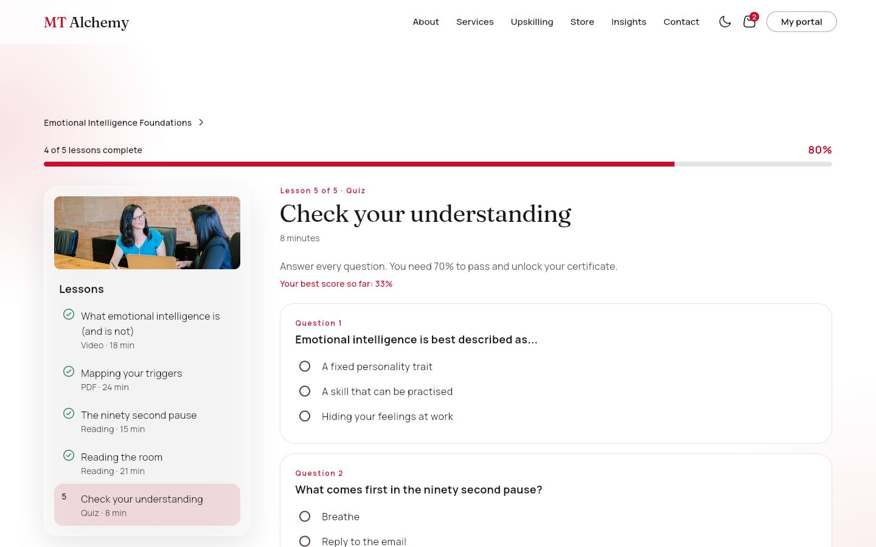
A progress bar with a percentage, a lesson list with a photo banner and a type and duration for each lesson, and the lesson view. Video lessons use the film player; PDF lessons open the workbook; readings show the text.
DATA
courses, enrolments, certificates.
WHAT YOU CAN DO
- Previous, Mark as complete, Next
- Progress is saved to Firestore
- Finishing creates the certificate

29. Course player: quiz lesson
/learn/:id Access: Enrolled learners; staff (free preview)
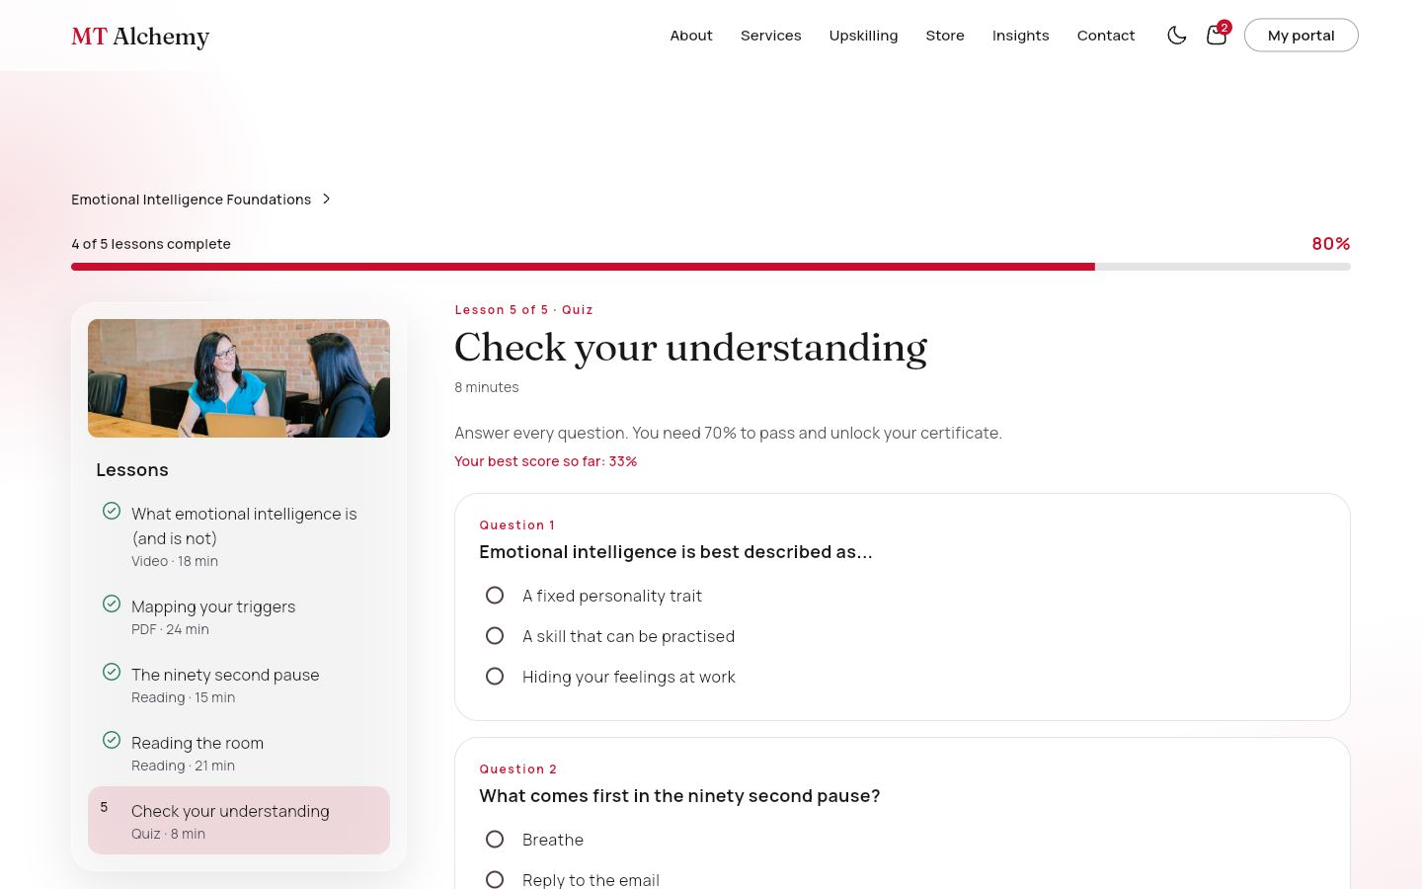
One choice per question. Submitting shows which answers were right; 70% passes and completes the lesson, otherwise "Try again".
DATA
enrolments.quizScores.
WHAT YOU CAN DO
- Answer all questions
- Submit
- Retry until passed

30. Admin preview
/learn/:id Access: Trainer, super admin
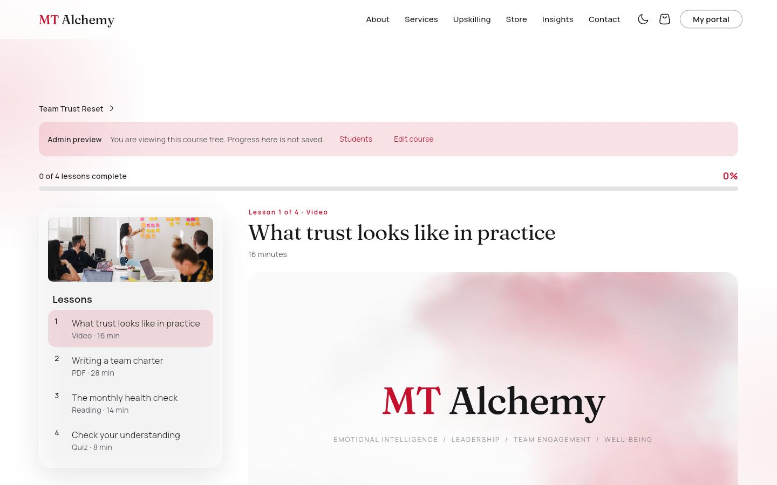
Staff open any course free. A banner says "You are viewing this course free. Progress here is not saved" and offers Students and Edit course.
DATA
courses.
WHAT YOU CAN DO
- Try every lesson
- Jump to Students or the editor

4.3 Learner portal
For individuals. Side navigation: My learning, Course catalogue, Certificates, Orders, My downloads, Profile. The top bar has a notification bell, a theme toggle and sign out.

31. My learning
/portal/me Access: Individual
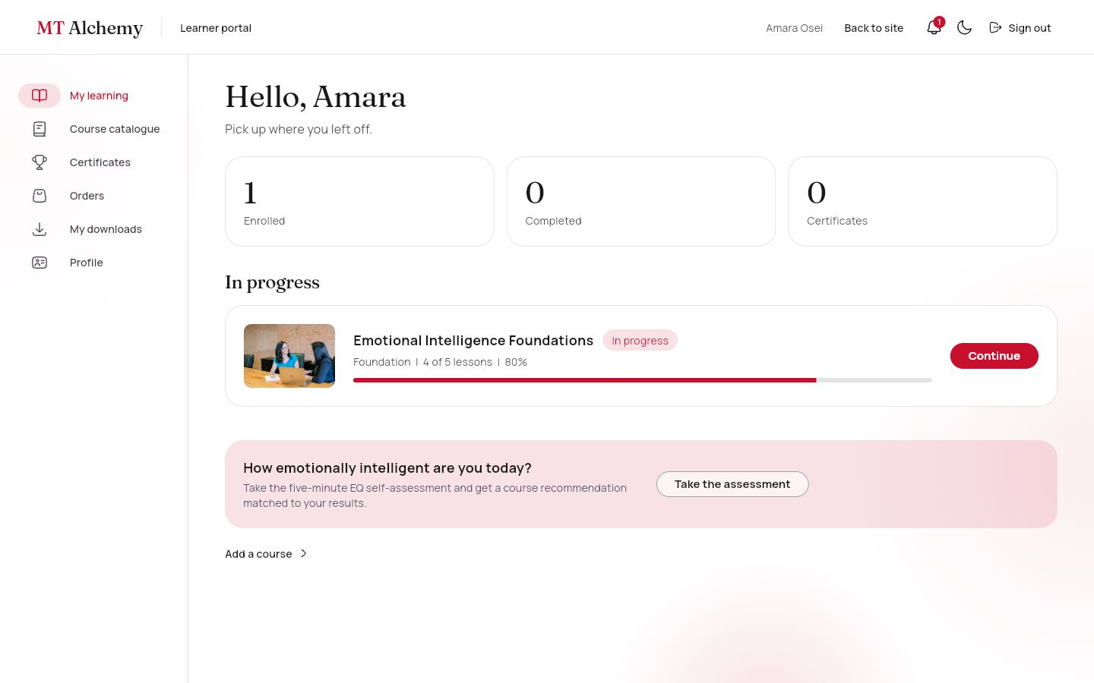
Totals for enrolled, completed and certificates; courses assigned by an employer; courses in progress with a photo and progress bar; completed courses; and a prompt to take the EQ check.
DATA
enrolments, assignments, certificates, courses.
WHAT YOU CAN DO
- Continue or Review a course
- Start an assigned course
- Add a course

32. Course catalogue ("Add a course")
/portal/me/courses Access: Individual
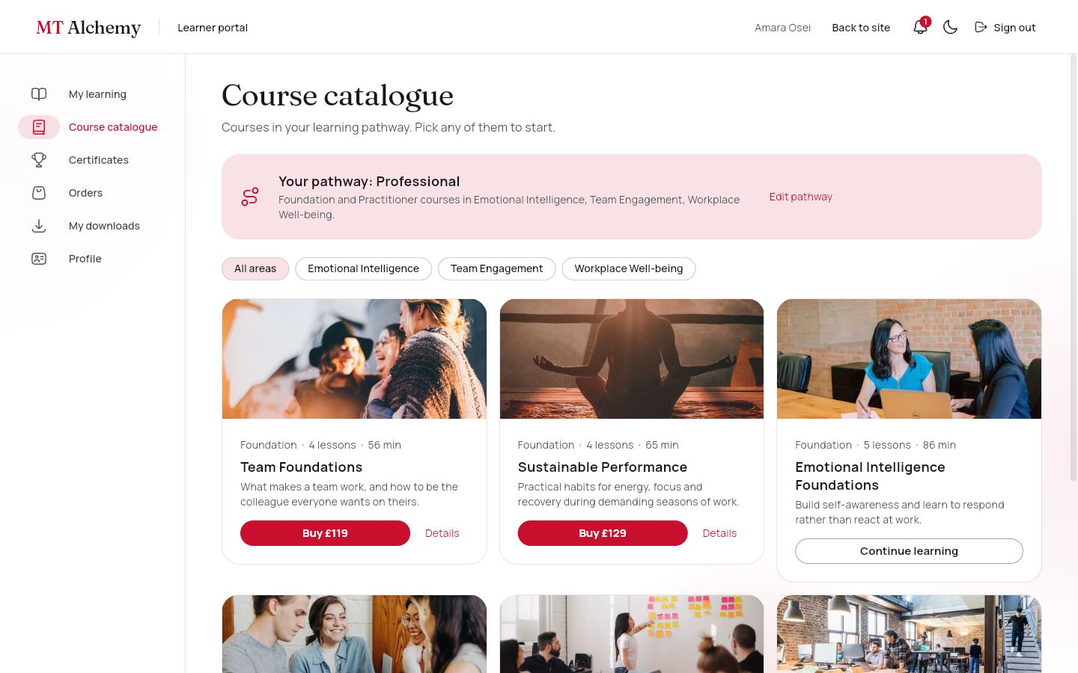
Only courses in the learner's pathway, with a banner showing the pathway and area chips. Courses outside it are listed as locked with the reason.
DATA
courses, users.pathway.
WHAT YOU CAN DO
- Buy a course
- Details
- Edit pathway
- Show locked courses

33. Certificates
/portal/me/certificates Access: Individual
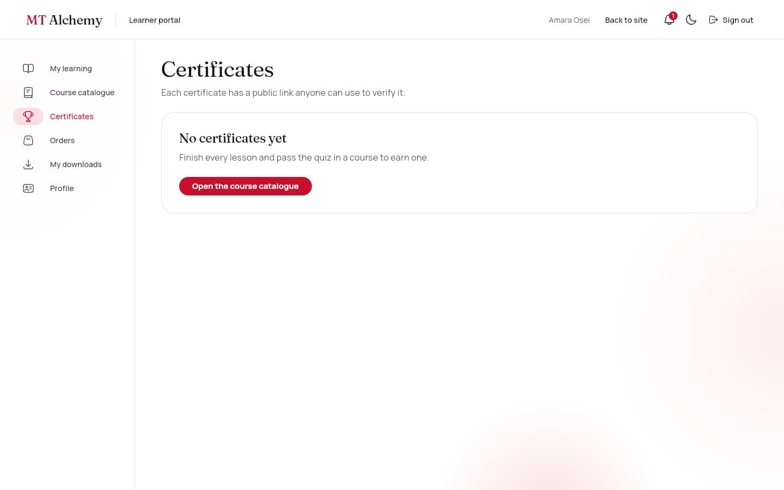
Every earned certificate with its course photo and code.
DATA
certificates.
WHAT YOU CAN DO
- View a certificate

34. Orders
/portal/me/orders Access: Individual
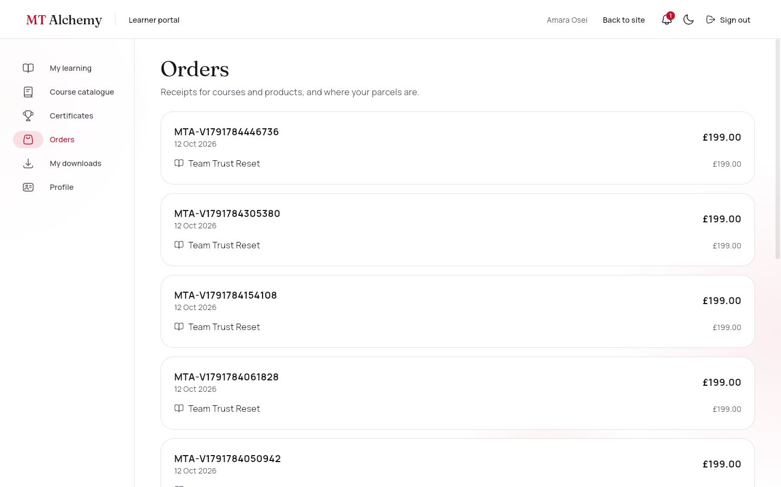
Receipts for courses and products. Physical orders show a Processing, Shipped, Delivered timeline with the tracking number.
DATA
orders, shipping.
WHAT YOU CAN DO
- See delivery progress

35. My downloads
/portal/me/downloads Access: Individual
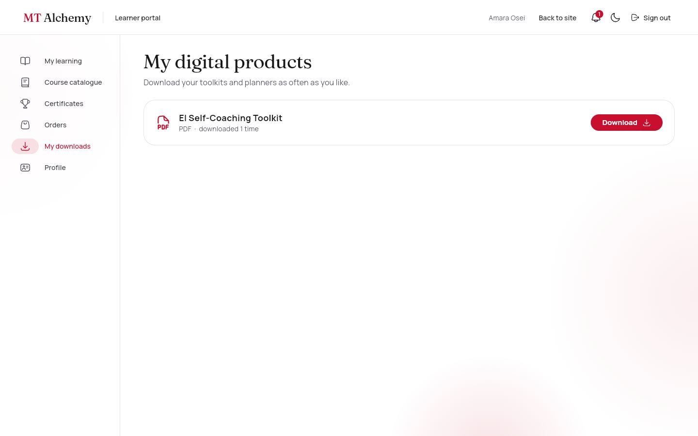
Digital products the learner owns, with a download count.
DATA
downloads.
WHAT YOU CAN DO
- Download (the count goes up)

36. Profile
/portal/me/profile Access: Individual
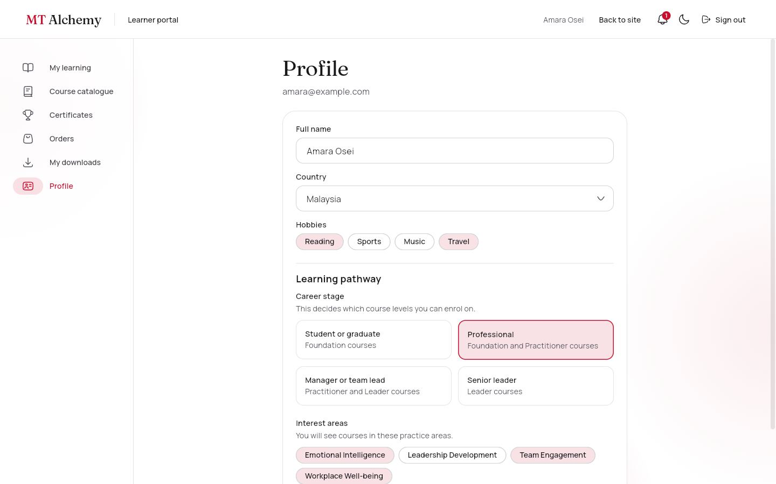
Edit name, country and hobbies.
DATA
users.
WHAT YOU CAN DO
- Save profile

37. Profile: learning pathway
/portal/me/profile Access: Individual
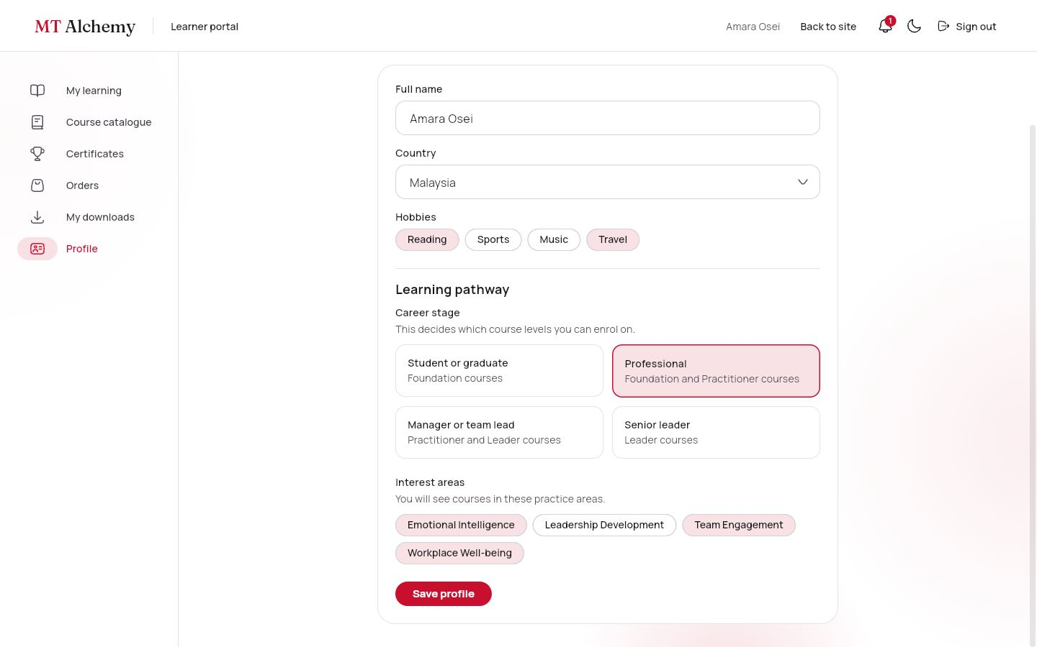
The same pathway control used at registration; changing it changes which courses are open.
DATA
users.careerStage, interests.
WHAT YOU CAN DO
- Choose a career stage
- Choose interest areas
- Save

4.4 Employer portal
For organisations (Journey D). Side navigation: Overview, Employees, Buy courses, Assign courses, Progress report, Analytics.

38. Overview
/portal/employer Access: Employer
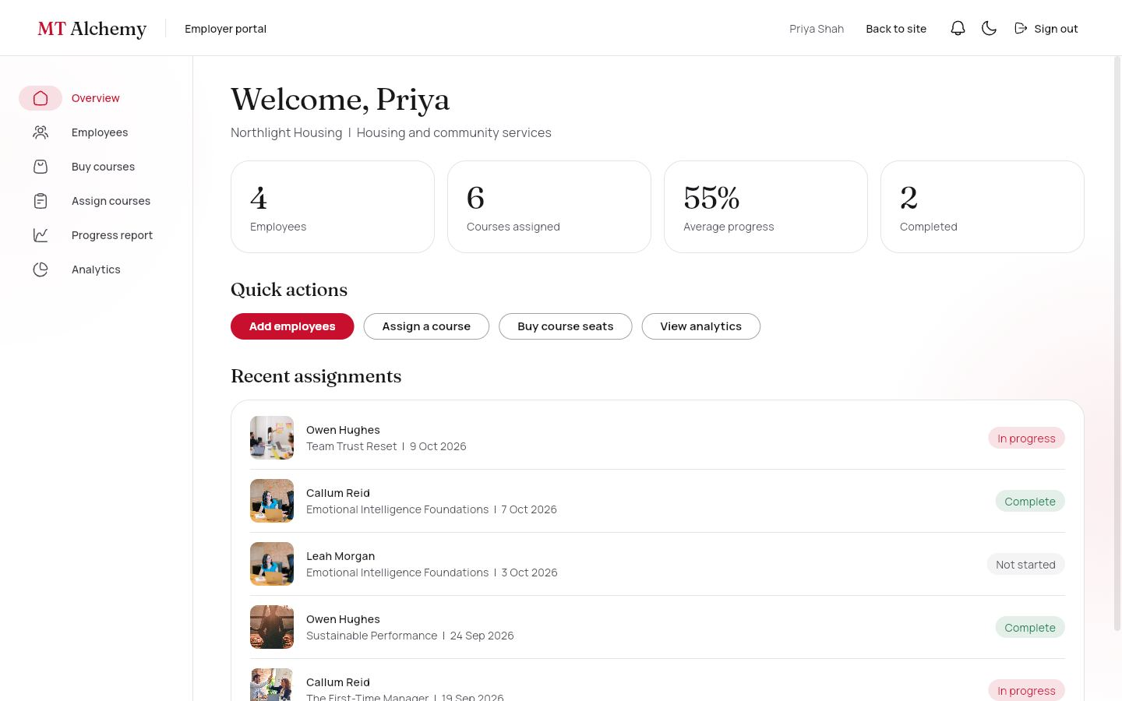
Employees, courses assigned, average progress and completions, quick actions, and the five most recent assignments with course photos.
DATA
employees, assignments, enrolments.
WHAT YOU CAN DO
- Add employees
- Assign a course
- Buy course seats
- View analytics

39. Employees
/portal/employer/employees Access: Employer
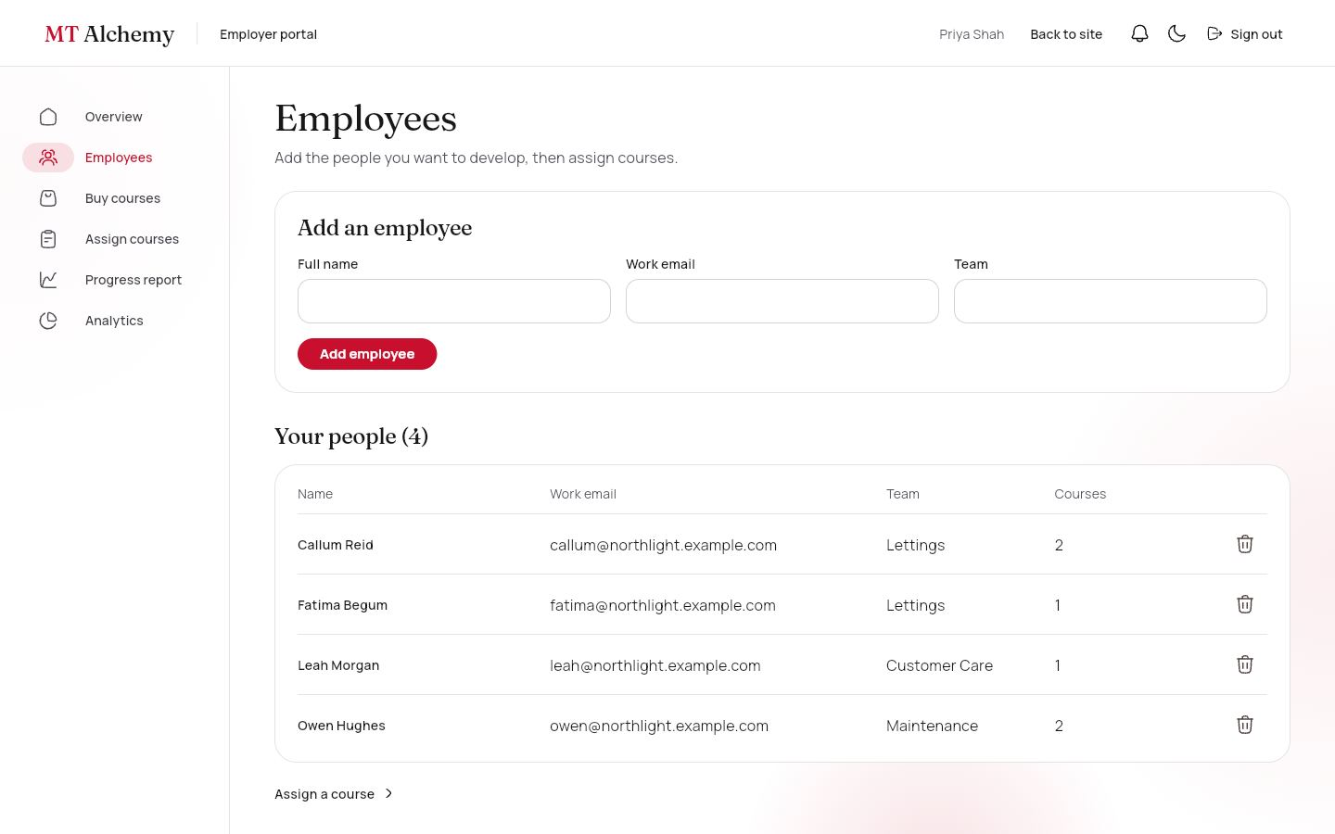
A form to add people (name, email, team) and the list with their number of courses. People join the organisation automatically when they register with that email.
DATA
employees.
WHAT YOU CAN DO
- Add
- Remove (with confirmation)

40. Buy courses
/portal/employer/courses Access: Employer
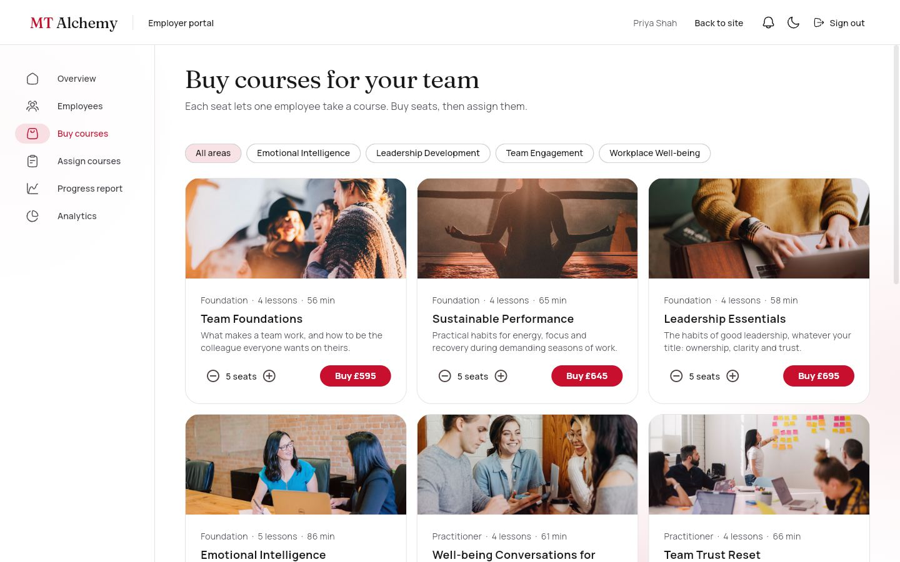
Every course as a photo card with a seat stepper and a Buy button that goes to checkout. Shows how many seats are unassigned.
DATA
courses, organizations.seats.
WHAT YOU CAN DO
- Choose seats
- Buy

41. Assign courses
/portal/employer/assign Access: Employer
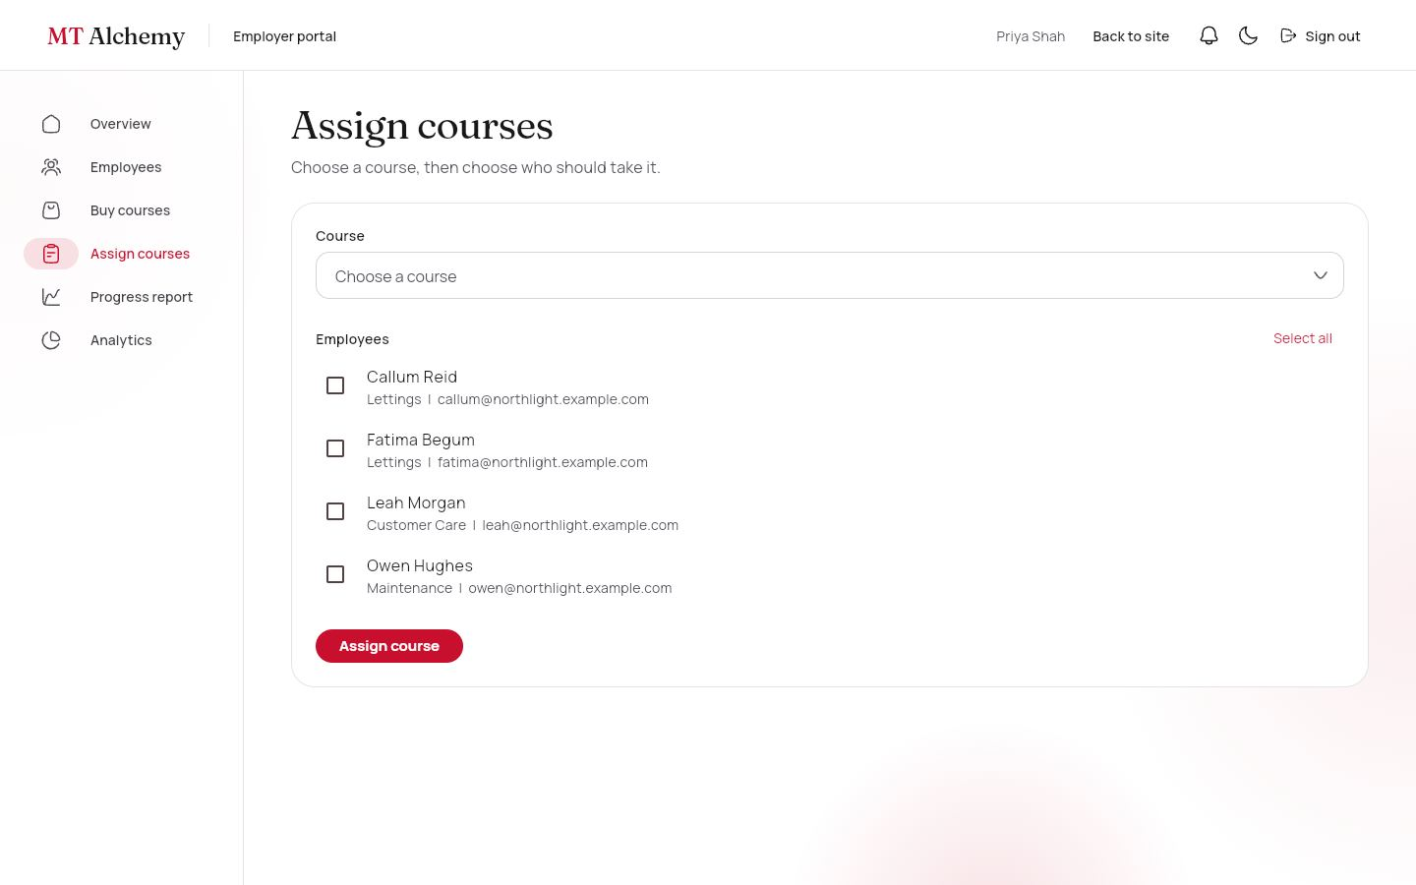
Choose a course, tick the people, assign. Shows the seats left and refuses if there are not enough, with a Buy seats shortcut.
DATA
assignments, organizations.seats.
WHAT YOU CAN DO
- Select all
- Assign
- Buy seats

42. Progress report
/portal/employer/progress Access: Employer
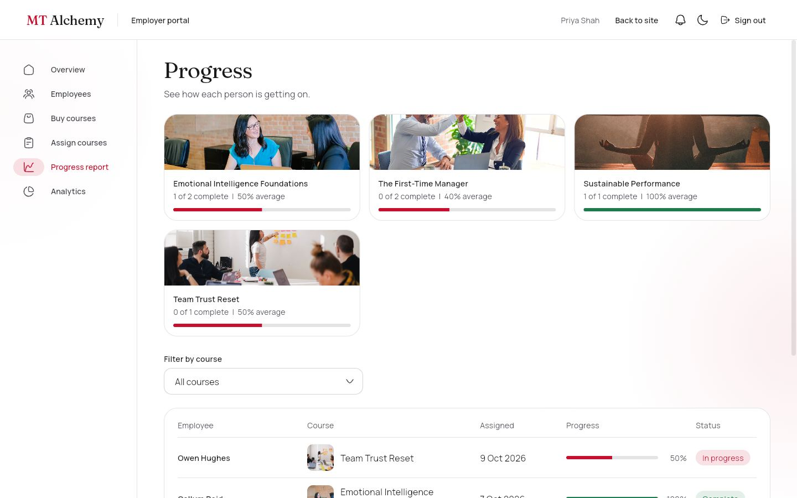
A photo summary card per course, then a filterable table of each person, course, date, progress bar and status.
DATA
assignments, enrolments (live).
WHAT YOU CAN DO
- Filter by course

43. Analytics
/portal/employer/reports Access: Employer
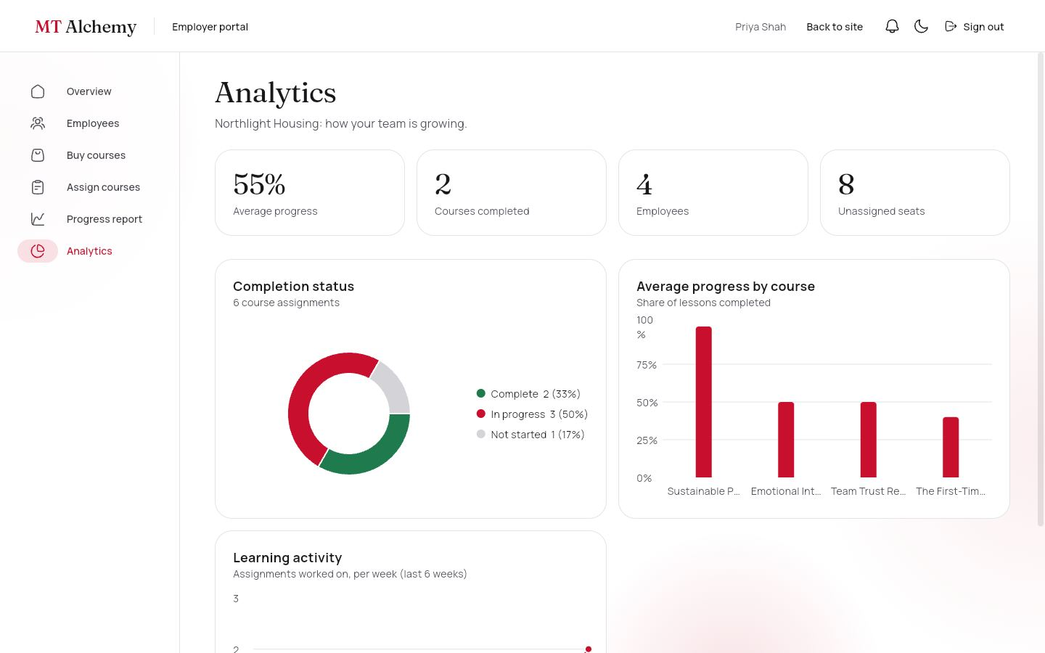
A completion donut, average progress by course (bars) and weekly learning activity (line), with hover details and a legend with counts.
DATA
assignments, enrolments.
WHAT YOU CAN DO
- Hover for values

4.5 Trainer portal
For trainers, who author and look after courses. Super admins use the same screens.

44. Courses
/portal/admin Access: Trainer · Super admin
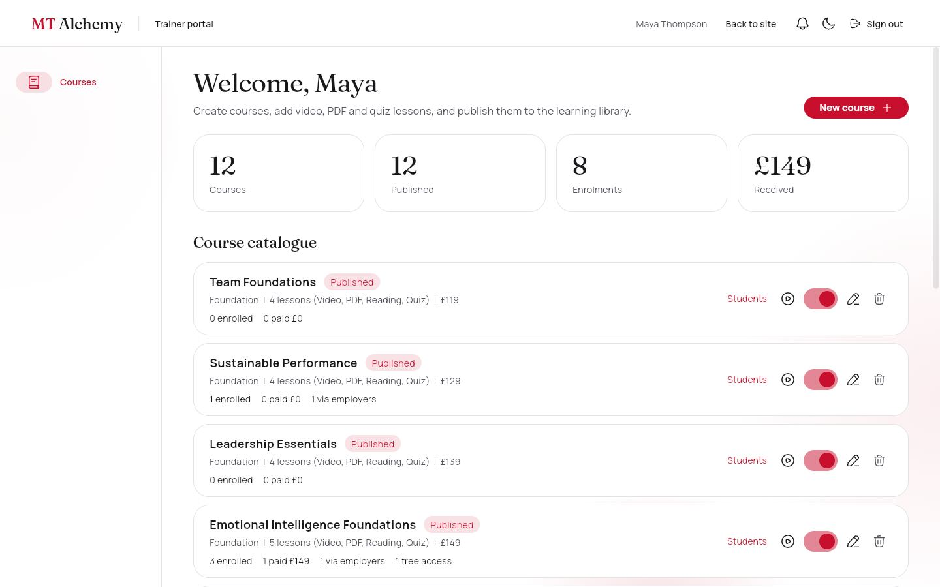
The whole catalogue with totals (courses, published, enrolments, amount received) and a row per course showing enrolled, paid with amount, employer seats and free access.
DATA
courses, enrolments (live).
WHAT YOU CAN DO
- Students
- Open free (play icon)
- Publish or unpublish
- Edit
- Delete
- New course

45. Course editor
/portal/admin/courses/:id Access: Trainer · Super admin
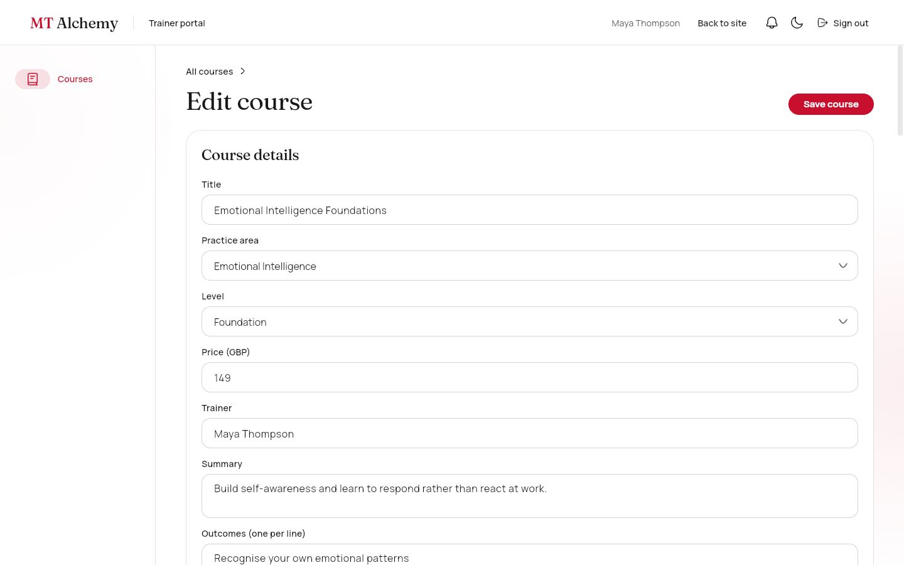
Create or edit a course: title, area, level, price, trainer, summary, outcomes, published switch, and any number of lessons (video, PDF, reading, quiz with questions and a correct answer), reorderable.
DATA
courses.
WHAT YOU CAN DO
- Add lessons by type
- Move up, remove
- Save

46. Students and payments
/portal/admin/courses/:id/students Access: Trainer · Super admin
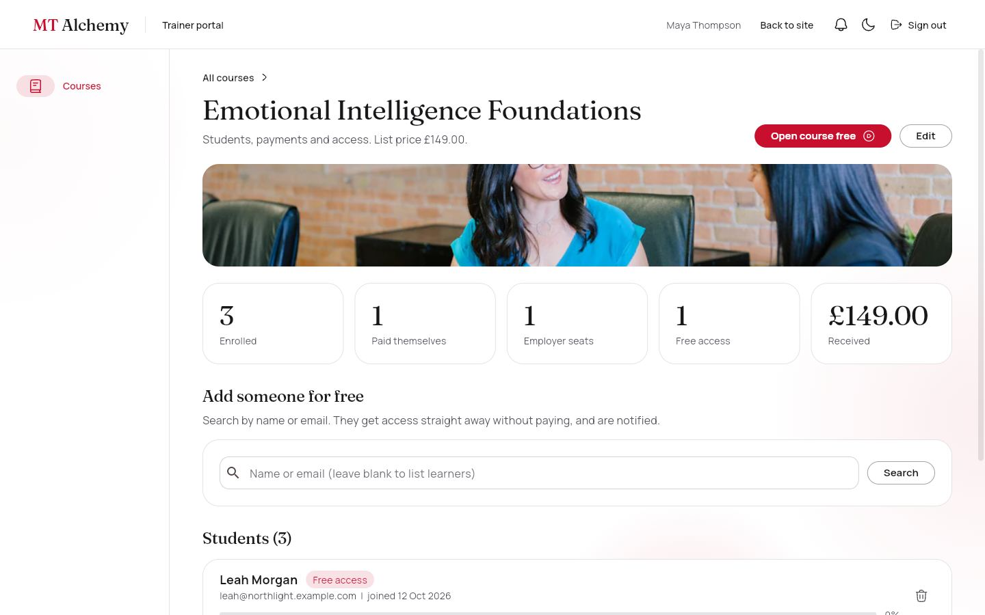
Counts for enrolled, paid, employer seats, free access and amount received. Search any learner and give free access, or remove a student. Each row shows how they joined (Paid £149, Employer seat, Free access), their email, join date and progress.
DATA
enrolments (live), users, notifications.
WHAT YOU CAN DO
- Search and Give free access
- Remove from course
- Open course free

4.6 Super admin portal
For the platform owner. Side navigation: Dashboard, Users, Courses, Products, Orders and shipping, Enquiries, Content.

47. Dashboard
/portal/super Access: Super admin
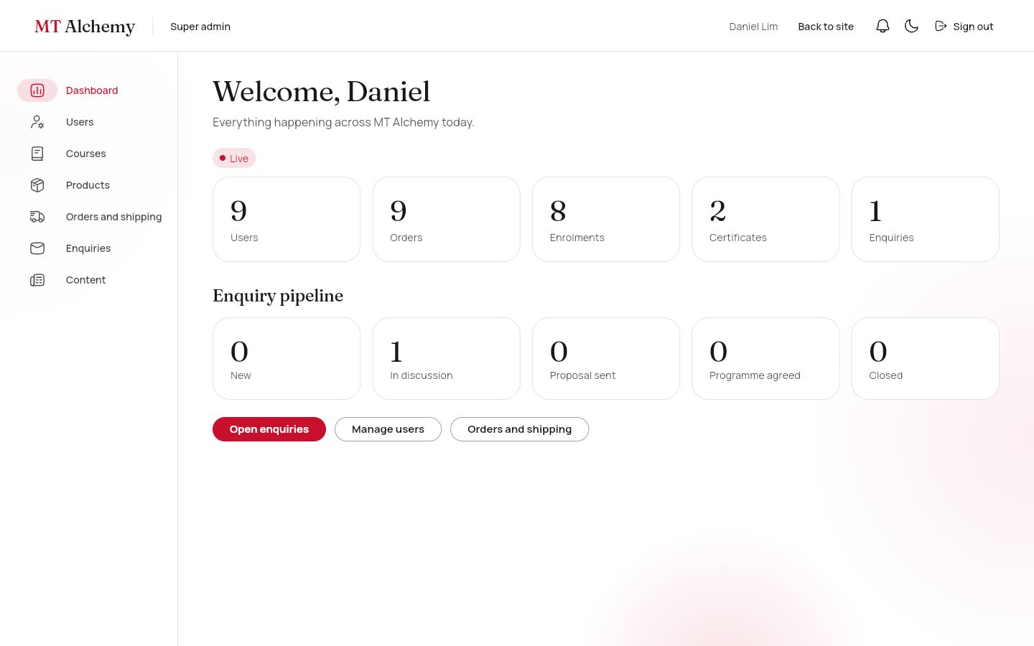
Live totals for users, orders, enrolments, certificates and enquiries (with a pulsing Live badge), and the enquiry pipeline by status.
DATA
Snapshot listeners on five collections.
WHAT YOU CAN DO
- Open enquiries, users, orders

48. Users
/portal/super/users Access: Super admin
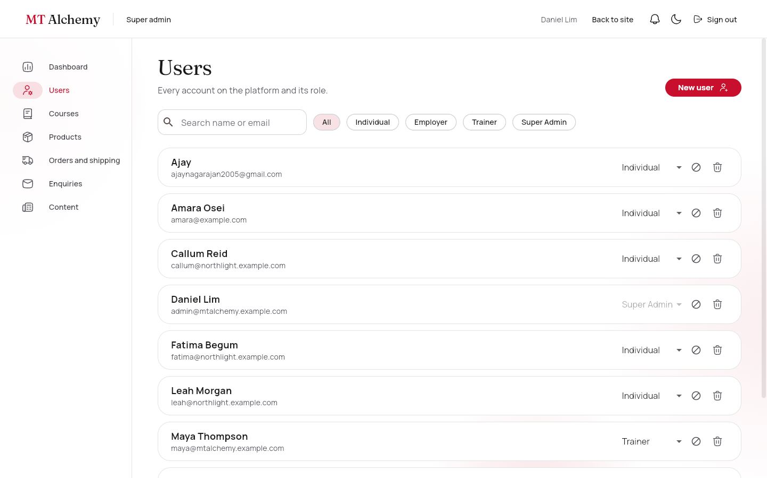
Every account with search and a role filter. Change a role, disable or enable, delete a profile, or create an account for anyone (using a second Firebase app so the admin stays signed in).
DATA
users.
WHAT YOU CAN DO
- Change role
- Disable
- Delete
- New user

49. Courses
/portal/super/courses Access: Super admin
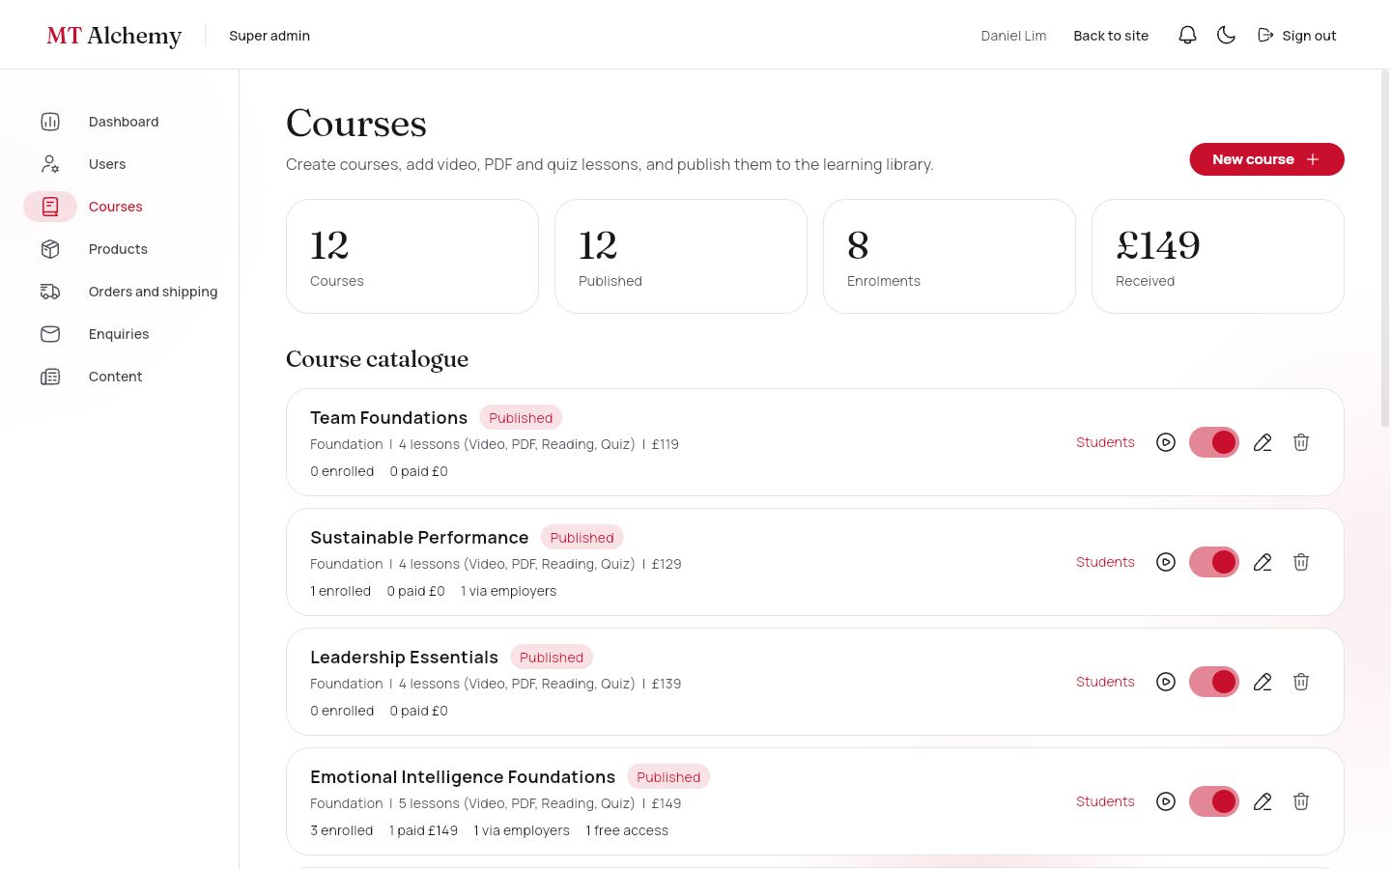
The same course management as the trainer portal, inside the super admin navigation.
DATA
courses, enrolments.
WHAT YOU CAN DO
- As the trainer portal

50. Products
/portal/super/products Access: Super admin
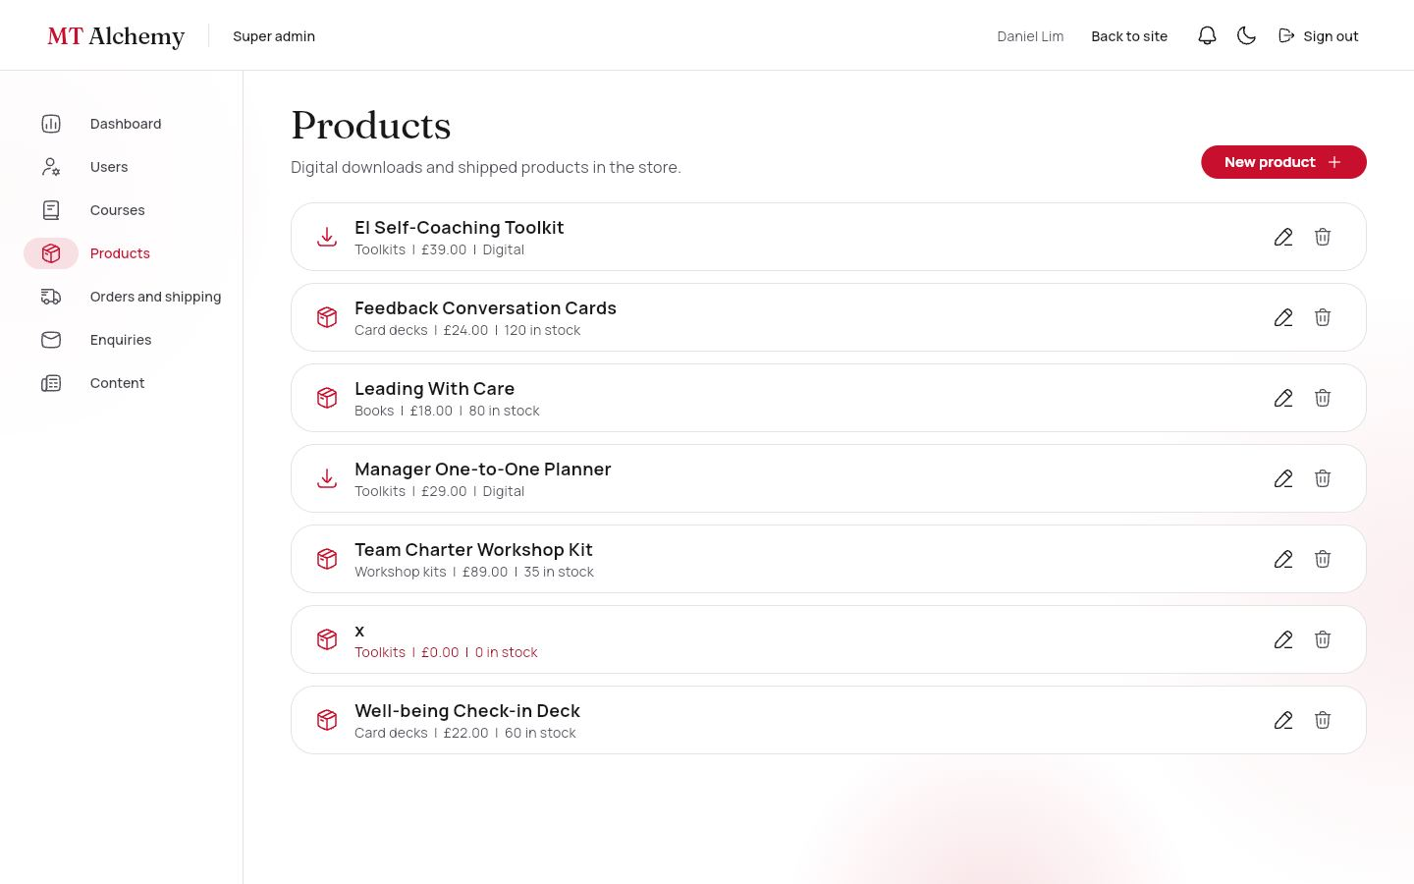
Digital and shipped products with category, price and stock (low stock shows in red).
DATA
products.
WHAT YOU CAN DO
- Edit
- Delete
- New product

51. Product editor
/portal/super/products/:id Access: Super admin
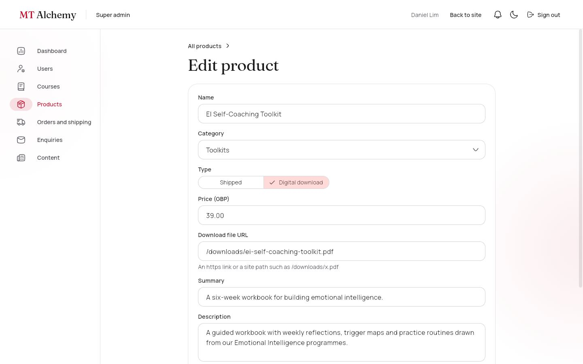
Name, category, type (Shipped or Digital download), price, stock or download file, summary, description and details.
DATA
products.
WHAT YOU CAN DO
- Save

52. Orders and shipping
/portal/super/orders Access: Super admin
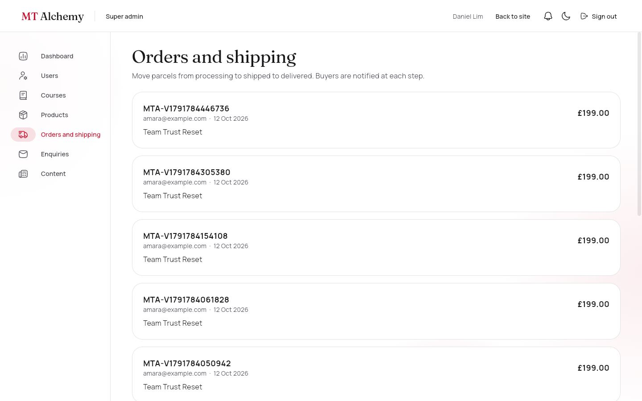
Every order with items, the delivery address and the delivery timeline. One button moves a parcel to the next status and notifies the buyer.
DATA
orders, shipping, notifications.
WHAT YOU CAN DO
- Mark as shipped
- Mark as delivered

53. Enquiries (Journey E)
/portal/super/enquiries Access: Super admin
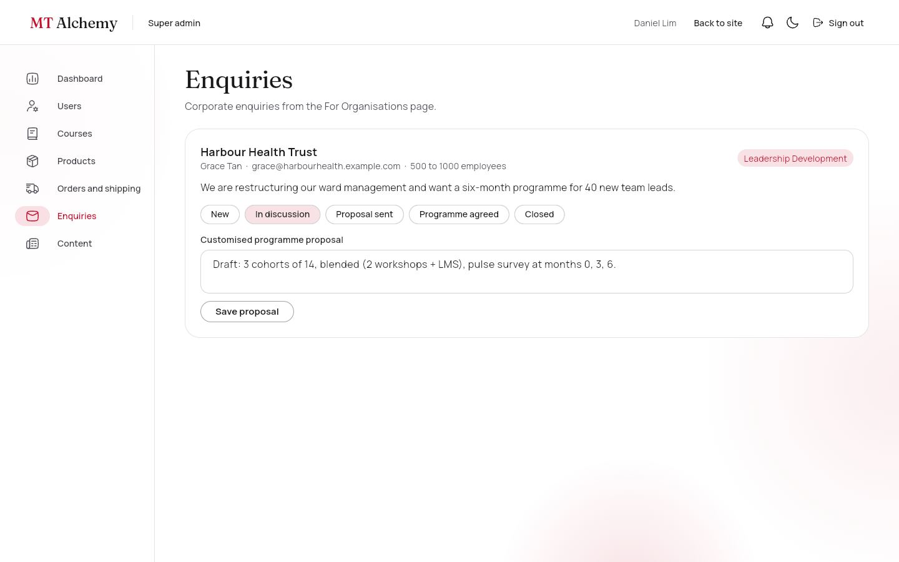
Corporate enquiries with a status pipeline (New, In discussion, Proposal sent, Programme agreed, Closed) and a field for the customised programme proposal.
DATA
enquiries.
WHAT YOU CAN DO
- Change status
- Save proposal

54. Content
/portal/super/content Access: Super admin
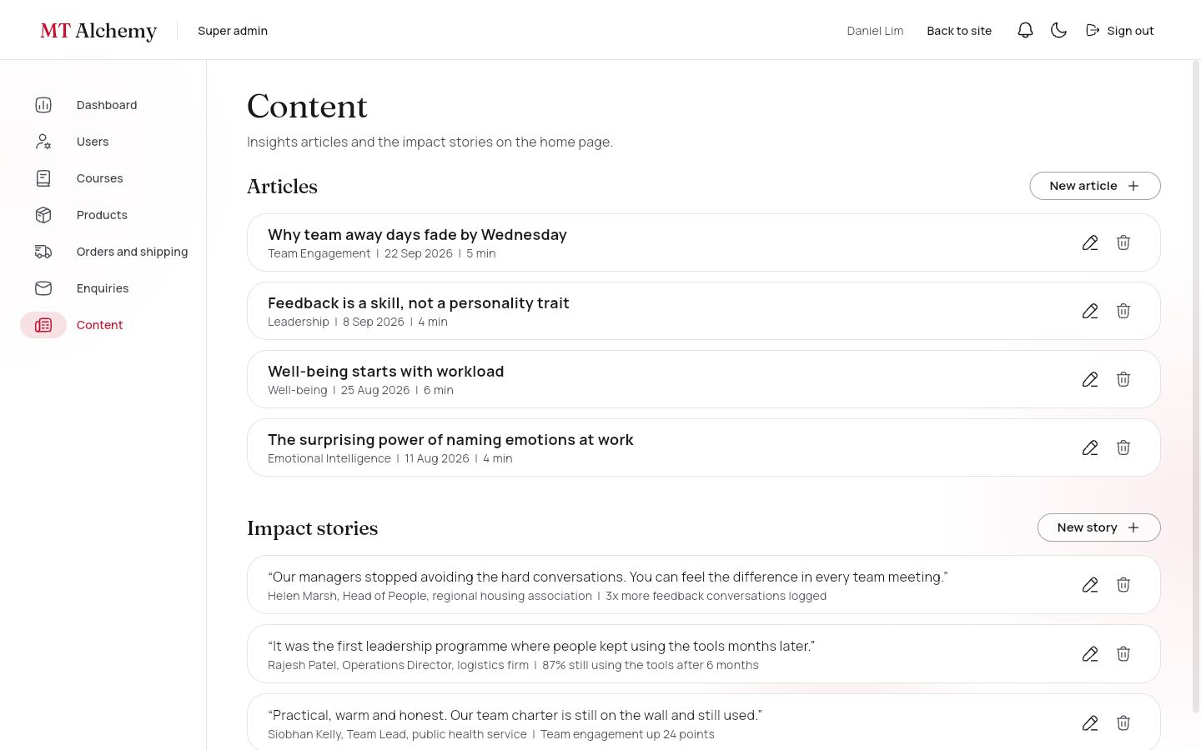
Create, edit and delete Insights articles and Impact Stories.
DATA
articles, impactStories.
WHAT YOU CAN DO
- New article, New story
- Edit, Delete

5. The five user journeys

A · Individual learning
- Register: choose a career stage and interest areas (/register).
- The course catalogue shows only courses that match both (/portal/me/courses).
- Buy the course, then pay at checkout (test card 4242 4242 4242 4242).
- An enrolment is created from the paid order; the dashboard shows progress.
- Open the course: watch the video, read the PDF, Mark complete, Next.
- Pass the quiz (70% or more) to complete the course and receive a certificate with a public verification link.

B · Digital product
- Store, then the EI Self-Coaching Toolkit.
- Add to cart, then checkout (no delivery address, no shipping).
- A payment record is created in test mode.
- My digital products, then Download. The count is tracked.

C · Physical product
- Store, then Cart (delivery is free from £50 of shipped goods).
- Enter a delivery address at checkout and pay.
- Stock is reduced in a transaction; a shipment is created as Processing.
- The super admin marks it Shipped (with a tracking number), then Delivered; the buyer is notified each time.

D · Employer
- Register an organisation (/register?type=organisation).
- Add employees; they join automatically when they register with that email.
- Buy courses: choose the number of seats and pay.
- Assign courses to people; each assignment uses a seat.
- Watch the progress report and the analytics charts update live.

E · Corporate enquiry
- Open "For organisations" from the landing page or footer.
- Submit the enquiry (saved to Firestore).
- The super admin inbox tracks it: New, In discussion, Proposal sent, Programme agreed, Closed.
- The admin writes the customised programme proposal.

Staff: free access
- A trainer or admin opens any course free (admin preview, nothing is saved).
- Courses, then Students shows enrolled, paid, employer seats and free access.
- Search a learner and give free access, or remove someone. A removed payer is not refunded automatically.

6. Data and security

Collections (22)
Each entity is a top-level collection. Lessons and quiz questions are embedded in the course document so the player loads in one read; order items are embedded in the order.
Collection | Key fields | Written by
users | name, email, role, orgId, careerStage, interests[], gender, country, hobbies[], disabled | The person at registration (individual or employer only); super admin
organizations | name, sector, size, ownerId, seats {courseId: n} | Employer
employees · assignments | orgId, name, email, team · employeeEmail, courseId | Employer
courses | title, level, serviceSlug, price, imageUrl, published, modules[] {type, mediaUrl, quiz[]} | Trainer, super admin
enrolments | userId, courseId, source (purchase, assignment, granted), amountPaid, orderId or assignmentId, completedModuleIds[], quizScores, progress, status | Learner (needs a paid order or an assignment); staff for free access
certificates | code, userId, courseId, userName, courseTitle, issuedAt (public read) | Learner, only when the enrolment is complete
products · productCategories | type (digital or physical), stock, fileUrl, imageUrl, price | Super admin (checkout may only reduce stock)
carts · orders · payments | items · status, totals, orgId · amount, last4, gateway "test-mode" | The buyer
shipping · downloads | status, tracking, history[] · url, downloadCount | Buyer creates; super admin advances shipping
articles · impactStories · founders | body[] · quote, metric · name, role, bio, imageUrl | Staff · super admin · super admin
reviews | targetId, userId, rating 1 to 5, comment | Signed-in learners
enquiries · contactMessages | organisation, interest, status, proposal · message | Anyone (guests too); the super admin manages them
notifications · assessments | userId, title, link, read · EQ scores | Staff and employers · the learner

Relationships
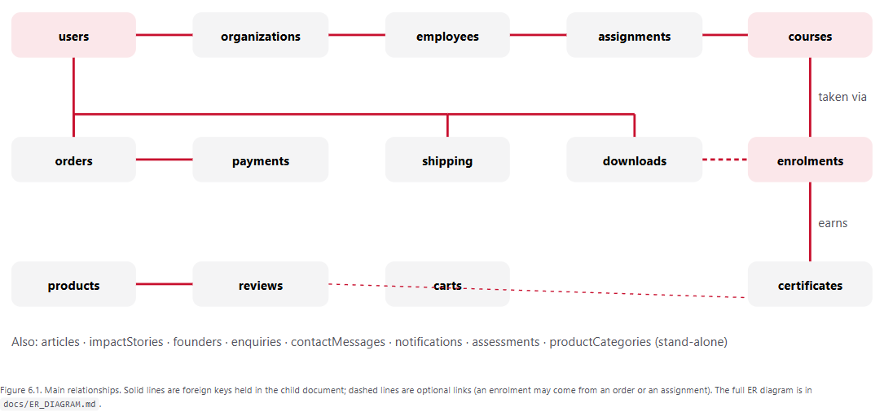

Access rules (from firestore.rules)
Collection | Guest | Individual | Employer | Trainer | Super admin
courses | read published | read published | read published | full CRUD | full CRUD
products, articles, stories, founders, reviews | read | read; write own reviews | read | read; articles CRUD | full
users | none | own profile (no role change) | own profile | read all | full
organizations, employees, assignments | none | own assignments | own organisation only | read | full
enrolments | none | own (needs paid order or assignment) | own organisation's | read; grant and remove free access | full
orders, payments, shipping, downloads | none | own | own organisation's orders | none | full; advances shipping
enquiries | create only | create only | create only | none | read and update

The live verification script checks each of these: users cannot change their own role; self-registration can only create individual or employer accounts; an enrolment needs a paid order or an assignment; a certificate can be created only when the enrolment is complete; employers cannot touch another organisation's data; draft courses are hidden from everyone except staff; buyers cannot mark their own parcel delivered.

Business rules
Rule | Behaviour
Learning pathway | A course is open to a learner only if its level suits their career stage and its practice area is one of their interests. Student: Foundation. Professional: Foundation and Practitioner. Manager: Practitioner and Leader. Senior leader: Leader. Other courses stay visible but locked, with the reason. Employer assignments and staff are not restricted.
Pricing and shipping | Prices in GBP. Delivery is £4.95, free from £50 of shipped goods. Digital products and courses never ship.
Seats | An employer buys seats per course (stored on the organisation). Assigning a course uses one seat per person; the assignment is refused when seats run out.
Progress and certificates | Progress is lessons completed divided by lessons. Quizzes pass at 70% and complete their lesson. Completing every lesson creates the certificate, whose code is built from the first three letters of the course id and the start of the learner id.
Payments | Simulated gateway in test mode. A card number starting 4000 0000 0000 0002 is declined; any other valid test number is approved. Only the last four digits are stored.
Free access | Staff can create an enrolment with source "granted"; it needs no order and no seat.
Offline fallback | If Firestore is unreachable the bundled catalogue keeps pages working.

7. Design system, imagery and motion

Colour
Pure white (#FFFFFF), a neutral zinc "ash" scale (#F4F4F5 to #18181B) and Crimson Red (#C8102E) as the single accent for calls to action, active states, progress and focus. Grey-to-red gradients appear only at moments of change: a passed quiz, a completed order, a finished course. There is no grain texture and no grey haze. A full dark palette mirrors the light one.

Glassmorphism
A shared GlassPanel (backdrop blur, translucent fill, hairline border) is used on the navigation, hero copy, summaries and forms. Few panels per screen, never nested, with a solid fallback for high contrast.

Typography
Fraunces (serif) for headings and Manrope for body text, on a scale that runs from display down to small and label sizes.

Imagery
Thirty free-licence photographs (Unsplash, converted to WebP) appear on every course, product, service and article card. Courses and products store an imageUrl that admins can change; the seeded red ink artwork is the fallback. Founder portraits are uploaded from the site.

Motion
- Landing film with a floating glass crystal and parallax particles
- Staggered reveals on scroll
- Every card: hover lift, soft red shadow, photo zoom, press feedback
- 3D tilt on service cards
- Fade-and-lift page transitions
- Smooth glide from menu to landing section
- Animated EQ result bars, rotating impact stories
- All of it respects the reduced-motion setting

Accessibility
Icon buttons have semantic labels, form errors are announced through live regions, focus outlines are visible, the tour film has captions, and the chart legends spell out their counts.
Light theme
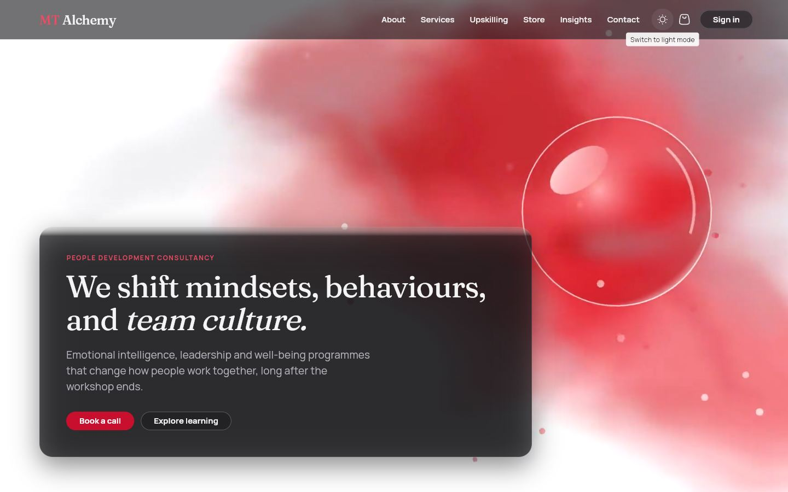
Dark theme
Photo service cards

Responsive behaviour
Size | Width | Layout
Compact | under 600 px | Single column, full-width buttons, banner photos on cards, drawers for navigation.
Medium | 600 to 1023 px | Two columns, drawers for navigation.
Expanded | 1024 px and up | Side rails, three or four columns, fluid gutters (5% of the width, 48 to 120 px).

8. Media pipeline: videos, virtual tour and QR code
All videos are made with Remotion, which renders React components to H.264 files, so any film can be regenerated from code.
Film | Used on | Notes
hero_loop (+ dark) | Landing hero | Ink blooming through water, a floating glass crystal, parallax particles, a slow camera drift. An 8 second loop that repeats without a visible cut, under 1 MB.
services_loop (+ dark) | Services header | Quiet ink loop.
brand_intro | About page, lesson video | Brand film with the wordmark and four practice areas.
site_tour | Virtual tour | 42 seconds, 1280×720, no sound, with captions. Seven scenes: welcome, learn, shop, teams, trainers and admins, EQ check, call to action. Characters and the faceted-crystal mascot Alchy are drawn in SVG, so no outside artwork is involved.

The virtual tour page (/tour): the cartoon film, then one card per part of the site to try.

The QR code
The last section of the landing page shows a QR code that opens the tour. It encodes the site's own address, taken from the browser plus the build's base path, so it is correct on whatever host the site is published to. On a computer's localhost the page warns that the code only opens locally; on the live site it scans from any phone. The same section has an "Open the tour" button and a "Copy link" button.
QR section at the end of the landing page, with a preview of the film.

9. Quality and verification
Check | Result
flutter analyze | No issues.
flutter test | 56 tests on a fake Firestore and mock Auth: cart rules; checkout writes (order, payment, shipping, download, enrolment, stock) and declined cards; shipping state changes with notifications; enrolment from an order and from an assignment; quiz pass and fail; certificate issue and verification; employer seats, assignments, progress and weekly activity; staff free access, removal and revenue totals; founders and photos; theme toggle; validators; portal scrolling; screen layout.
npm run verify (live Firebase) | 39 of 39 checks pass. It signs in as each role over REST, performs each journey's writes, and confirms forbidden writes are refused, such as a learner promoting themselves, enrolling without paying, or giving themselves free access.
Visual checks | Browser screenshots at 1440 px and 375 px, light and dark; the live GitHub Pages site was checked including a deep link and a real sign-in.
Performance | Videos under 1.5 MB each; photographs 25 to 170 KB (WebP).

Firestore rule changes take a few minutes to reach every server. A verification run started during that window briefly saw the temporary open seed rules. The seed and maintenance notes now say to wait about three minutes before verifying, and the verification script deletes the records it creates.

10. Deployment and operations
Task | How
Run locally | flutter pub get then flutter run -d chrome
Publish the site | Commit, then bash tools/deploy_pages.sh. It builds with the /mt-alchemy/ base path, copies index.html to 404.html (so deep links such as /portal load), adds .nojekyll and pushes the gh-pages branch.
Change rules or indexes | Edit firestore.rules or firestore.indexes.json, then firebase deploy --only firestore, wait three minutes, then npm run verify.
Reset demo data | cd tools/seed && npm run seed (exports the catalogue, opens the temporary seed rules, writes 71 documents, redeploys the real rules).
Re-render a video | cd video && npm run render:tour (or render:all).
Authorized domains | The Firebase Authentication allow-list contains localhost, *.firebaseapp.com, *.web.app and ajaynagarajan2005.github.io. Add any new domain under Authentication, Settings.
Day-to-day content | Trainer portal (courses), Super admin (users, products, orders, enquiries, content), landing page founder cards (photo upload for the super admin).

Troubleshooting
Symptom | Likely cause and fix
"You do not have permission to do that." | A security rule refused the write. Check the role in users/{uid} and reproduce it in verify.mjs.
Catalogue shows but never updates | Firestore unreachable; the app falls back to the bundled catalogue. Look for "Could not reach Cloud Firestore" in the console.
"requires an index" | A new compound query. Follow the link in the error or add it to firestore.indexes.json.
Portal is empty after login | The profile document is missing. Re-run the seed or create users/{uid} with a role.
QR code opens a blank or wrong address | The build was made without SITE_BASE; rebuild with deploy_pages.sh.

11. Limitations and future work
Area | Current state and the next step
Payments | Simulated in test mode, with no real charge. Next: a payment provider (Stripe or similar) with a server-side webhook, which needs Cloud Functions.
File storage | Firebase Storage needs the paid plan, so PDFs and downloads are served from the site's own /downloads folder, and founder photos are stored in Firestore as small JPEGs. Next: Storage for lesson videos, PDFs and photos.
Email | Password-reset email is sent by Firebase. Order receipts, employee invitations and enquiry replies are not emailed; people see them in the app (notification bell). Next: transactional email.
Certificates | Viewable and verifiable by link; no PDF download button yet.
Refunds | Removing a paying student does not refund them; an admin must handle that with the payment provider.
Devices | Verified in desktop and phone-sized browsers. Native Android and iOS builds use the same code but were not tested on devices.
Browser window fit | One report of the page not filling the window edge to edge on a particular display was not reproduced and remains open.
Hosting deep links | GitHub Pages returns HTTP 404 for deep links before the app loads (the app then renders normally). Firebase Hosting would return 200.
EQ self-assessment | An engagement tool with ten statements across five areas, not a validated psychometric instrument.
Hero video | An AI-generated landing clip was deferred; the Remotion films are used instead.

12. Appendices

A. Demo accounts
Password for every account: alchemy123. The login page also lists them.
Role | Email | What to try
Individual | amara@example.com | Course in progress, a shipped order, a digital download, pathway: Professional with three interest areas
Employee (individual) | callum@northlight.example.com | Courses assigned by an employer, pathway: Manager
Employer | priya@northlight.example.com | Employees, seats, assignments, progress, analytics
Trainer | maya@mtalchemy.example.com | Course CRUD, open courses free, students and free access
Super admin | admin@mtalchemy.example.com | Full access: users, products, orders, enquiries, content, founders' photos

Test card for checkout: 4242 4242 4242 4242 (approved) or 4000 0000 0000 0002 (declined); any future expiry and any 3-digit CVC.

B. Route table
Route | Screen | Access
/ | Landing page | Public
/about · /services · /services/:slug | About; services; service detail | Public
/upskilling · /upskilling/:id | Course catalogue; course detail | Public
/learn/:id | Course player | Signed in
/store · /store/:id | Store; product | Public
/cart · /checkout · /checkout/success | Cart; checkout; confirmation | Cart public; checkout signed in
/insights · /insights/:slug | Articles | Public
/contact · /organisations | Contact form; corporate enquiry | Public
/eq-assessment · /tour · /certificates/:code | EQ check; virtual tour; certificate | Public
/login · /register | Sign in; register (individual or organisation) | Public
/portal/me and /courses /certificates /orders /downloads /profile | Learner portal | Individual
/portal/employer and /employees /courses /assign /progress /reports | Employer portal | Employer
/portal/admin, /portal/admin/courses/:id, …/students | Trainer courses; editor; students | Trainer, super admin
/portal/super and /users /courses /products /products/:id /orders /enquiries /content | Super admin portal | Super admin

C. Credits and licences
- Photographs: free-licence images from Unsplash (people, workshops, well-being, books, teams), converted to WebP. The Unsplash licence permits this use without attribution.
- Fonts: Fraunces and Manrope (SIL Open Font Licence) via Google Fonts.
- Icons: HugeIcons (stroke rounded set).
- Cartoon characters and mascot: original artwork drawn for this project.
- Packages: Flutter, go_router, provider, Firebase plugins, fl_chart, qr_flutter, video_player, file_picker, image, flutter_animate, Remotion and their dependencies, each under its own open-source licence.

D. Glossary
Pathway | A learner's career stage plus interest areas; decides which courses they can buy.
Seat | One employee's place on a course, bought by an employer and used when assigning.
Free access (granted) | An enrolment created by staff with no payment.
Admin preview | Staff opening a course without enrolling; nothing is saved.
Alchy | The crystal mascot who narrates the virtual tour.
Seed | The script that fills Firebase with demo accounts and content.
Test mode | Payments are simulated; no real card is charged.

