MT Alchemy
NET4207 · Group Project · Flutter + Firebase
PROJECT DOCUMENTATION

MT Alchemy: a human-centred learning and people-development platform
The pages, roles, architecture, security, testing and deployment of the MT Alchemy site.
Live site | https://ajaynagarajan2005.github.io/mt-alchemy/
Virtual tour | https://ajaynagarajan2005.github.io/mt-alchemy/tour
Source code | https://github.com/ajaynagarajan2005/mt-alchemy
Backend | Firebase project mt-alchemy-net4207: Authentication, Cloud Firestore (asia-southeast1)
Students | AJAY A N (I26043131) · TANUJ SAKTHI KUMAR (I26043130) · MAAHIR FAHEEM (I26043132)
Founders | AJAY A.N · MAAHIR FAHEEM · TANUJ SAKTHI KUMAR
Version / date | 1.0 · October 2026

Contents
1. Overview
2. Information architecture
3. System architecture
4. Page-by-page guide
5. The five user journeys
6. Data and security
7. Design system, imagery and motion
8. Videos, virtual tour and QR code
9. Quality and verification
10. Deployment and operations
11. Limitations and future work
12. Appendices

1. Overview
MT Alchemy is a People Development Consultancy specialising in Emotional Intelligence, Leadership Development, Team Engagement and Workplace Well-being. Its tagline is "We don't just run activities. We shift mindsets, behaviours, and team culture." The platform turns visitors into enquiries, learners and corporate clients, and has four modules.

Corporate website
One landing page whose menu glides to About, Services, Upskilling, Store, Insights and Contact. It also has founders, impact stories, an EQ self-assessment, a "For organisations" enquiry and a cartoon virtual tour reached by QR code.

Learning management system
A course catalogue filtered by each learner's pathway (career stage and interests), purchase and enrolment, a modular player (video, PDF, reading, quiz), progress tracking, and certificates with a public verification link.

E-commerce store
Digital products download after payment; physical products ship with a Processing, Shipped, Delivered timeline. One checkout handles products, courses and employer seats. Payments run in test mode.

Role-based portals
Five roles (Guest, Individual, Employer, Trainer, Super Admin), each with its own navigation, notifications and permissions enforced by database security rules.
5  user roles | 5  user journeys | 12  courses | 6  products
22  Firestore collections | 47  routes | 125  Dart files | 24k  lines of Dart
56  automated tests | 39  live security checks | 30  photographs | 6  videos

How the platform meets the Employer Project brief
Brief requirement | Where it is delivered
Five core journeys (A to E) | A learning to certificate; B digital product to download; C physical product to delivery; D employer seats, assignment and progress; E corporate enquiry to customised programme (chapter 5).
Five roles with authentication | Guest, Individual, Employer, Trainer, Super Admin. Firebase Authentication, role-based redirects in the app and security rules in the database.
CRUD for courses, products and users | Courses (trainer and admin, with lessons and quizzes), products (admin), users (admin: create, change role, disable, delete), plus articles, impact stories, founders, employees and assignments.
Course player | Progress percentage, per-lesson views for video, PDF and quiz (70% pass mark), Previous / Mark complete / Next, and saved progress.
Responsive on web, tablet and mobile | Breakpoints at 600 px and 1024 px, fluid gutters, drawers below 1024 px. Checked at 1440 px and 375 px.
Backend and state | Firebase Authentication and Firestore (Storage is not used, see chapter 11). Provider with one ChangeNotifier store per domain.
README, ER diagram, maintenance guide | README.md, docs/ER_DIAGRAM.md, docs/MAINTENANCE.md and this document.
Innovation | EQ self-assessment with course recommendation, employer analytics charts, impact stories carousel, learning pathways, admin free-access tools, public certificate verification, dark mode, cartoon virtual tour with QR code.
Scaffold, Container, Form | Two Scaffolds (public AppShell, portal PortalShell) with AppBars; Containers for cards, padding, decoration and grouping; ten Forms with required-field validation. The code is annotated with SCAFFOLD:, CONTAINER ( and FORM: comments.

2. Information architecture
The site has one public area and four signed-in portals. The menu is available everywhere. On the home page each item glides to its section of the landing page; from any other page it opens the full page.
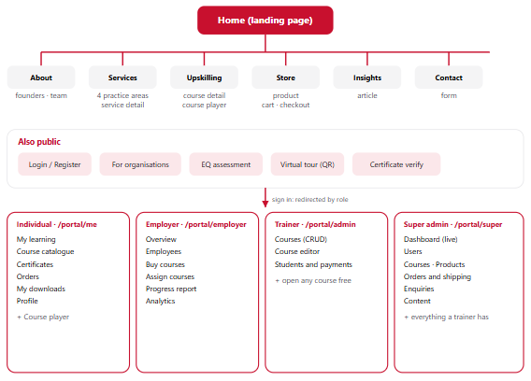
Figure 2.1. Sitemap. Portals are open only to the matching role; any other role is redirected to its own portal home.

3. System architecture
The application is one Flutter codebase that talks directly to Firebase. There is no custom server: business rules run in the client stores, and Firestore security rules decide who may read or write each document. The web app is a static site on GitHub Pages that connects to Firebase over HTTPS.
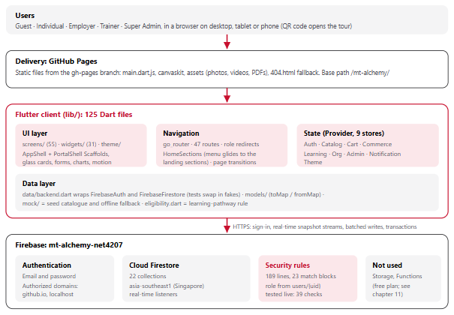
Figure 3.1. Layers of the platform. Firestore pushes changes back over live listeners, so every screen updates in real time.

Technology
Area | Choice | Reason
UI | Flutter 3.47 (Dart 3.13), Material 3 with a custom theme | One codebase for web, Android and iOS.
Navigation | go_router 18 | Declarative routes, clean URLs, role redirects.
State | provider with ChangeNotifier stores | Allowed by the brief; simple and testable.
Auth and data | firebase_auth, cloud_firestore | Managed sign-in and a real-time database with declarative rules.
Charts, media | fl_chart, video_player, flutter_3d_controller, flutter_animate | Employer analytics, looping films, a 3D crystal, staggered reveals.
Utilities | qr_flutter, file_picker, image, url_launcher, intl, google_fonts, hugeicons | QR code, founder photo upload and resize, downloads, formatting, type, icons.
Video | Remotion (React) to H.264 | Repeatable films: landing loop, brand film, cartoon tour.
Hosting | GitHub Pages and Firebase | Free tier; the web app needs no server.

Code structure
Folder | Contents
lib/data/ | backend.dart (Firebase access, friendly error messages), models/, mock/ (seed catalogue and offline fallback), eligibility.dart (pathway rule)
lib/state/ | Nine ChangeNotifier stores (Auth, Catalog, Cart, Commerce, Learning, Org, Admin, Notification, Theme). Each subscribes to the signed-in user's Firestore queries and exposes getters and async actions that return an error message or null.
lib/router/ | routes.dart (every path), app_router.dart (shell routes, role guards, fade transitions), home_sections.dart (landing anchors)
lib/screens/ | 55 files: public pages, learn/, portal/ (learner, employer, trainer, super admin), tour/, certificate/, assessment/
lib/widgets/ | 31 reusable widgets, including GlassPanel, AlchemyButton, AnimatedCard, CardImage, Reveal, TiltCard, PathwayFields and the two layout shells
test/, tools/ | 13 test files on a fake Firestore and mock Auth; tools/seed/ (seed.mjs, verify.mjs), deploy_pages.sh, serve_web.mjs
video/, web/, assets/ | Remotion project (HeroLoop, ServicesLoop, BrandIntro, SiteTour); HTML shell and downloads; 30 photographs, 6 videos, a 3D model, textures

How data flows
- On sign-in, AuthStore (listening to Firebase Auth) streams users/{uid} (role, organisation, pathway) and the organisation document.
- The other stores listen to AuthStore. When the uid changes they cancel their listeners and subscribe to that user's data, for example enrolments where userId == uid.
- Screens watch the stores and rebuild automatically. CatalogStore starts with the bundled catalogue so pages paint instantly and work offline; Firestore then replaces it live.
- Checkout, assignment and enrolment use batched writes, and the stock decrement uses a transaction. Lesson progress updates optimistically.
- Actions return a readable message, such as "That email and password do not match an account.", instead of throwing.

Routing, role guards and theme
Public pages share AppShell: one Scaffold with a glass AppBar and an end drawer below 1024 px. Signed-in pages share PortalShell: a second Scaffold with its own AppBar, a side rail (a drawer on small screens), the notification bell, a theme toggle and one scroll area. Portal pages are flat sibling routes, because nested child routes would stack a page that Flutter never lays out. The router waits for Firebase to restore the session before deciding, so a signed-in user is not sent to the login screen on refresh.
Role | Home after sign-in | Guard
Guest | public site | Portal paths and /learn redirect to /login?from=… and return afterwards.
Individual | /portal/me | May open only /portal/me/*.
Employer | /portal/employer | May open only /portal/employer/*.
Trainer | /portal/admin | May open only /portal/admin/*.
Super admin | /portal/super | May open /portal/super/* and the trainer's course editor and students pages.

Colour tokens are static getters on the active palette. When the brightness changes, every element is marked for rebuild so each widget re-reads the tokens; the page, scroll position and widget state survive. The toggle reads the live brightness when pressed, so it always flips.
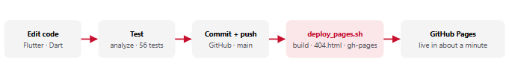
Figure 3.2. From a code change to the live site. Rules and data changes go to Firebase separately (chapter 10).

4. Page-by-page guide
Screenshots are from the published site at 1440 px, signed in as the role that owns each page.

4.1 Public website
Open to everyone. The home page is one long landing page; each menu item glides to the matching section.
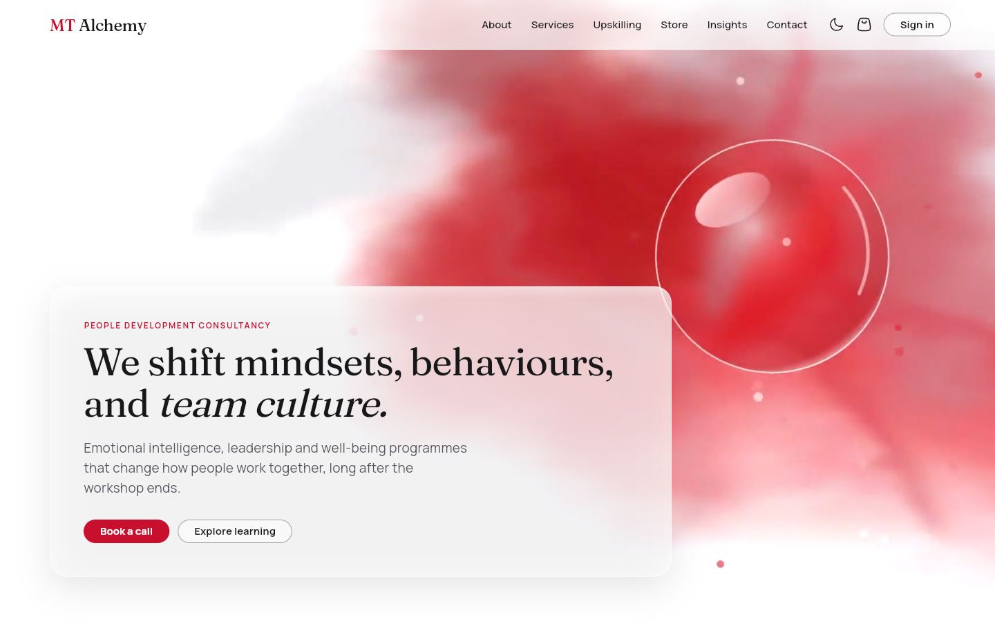  1. Hero | 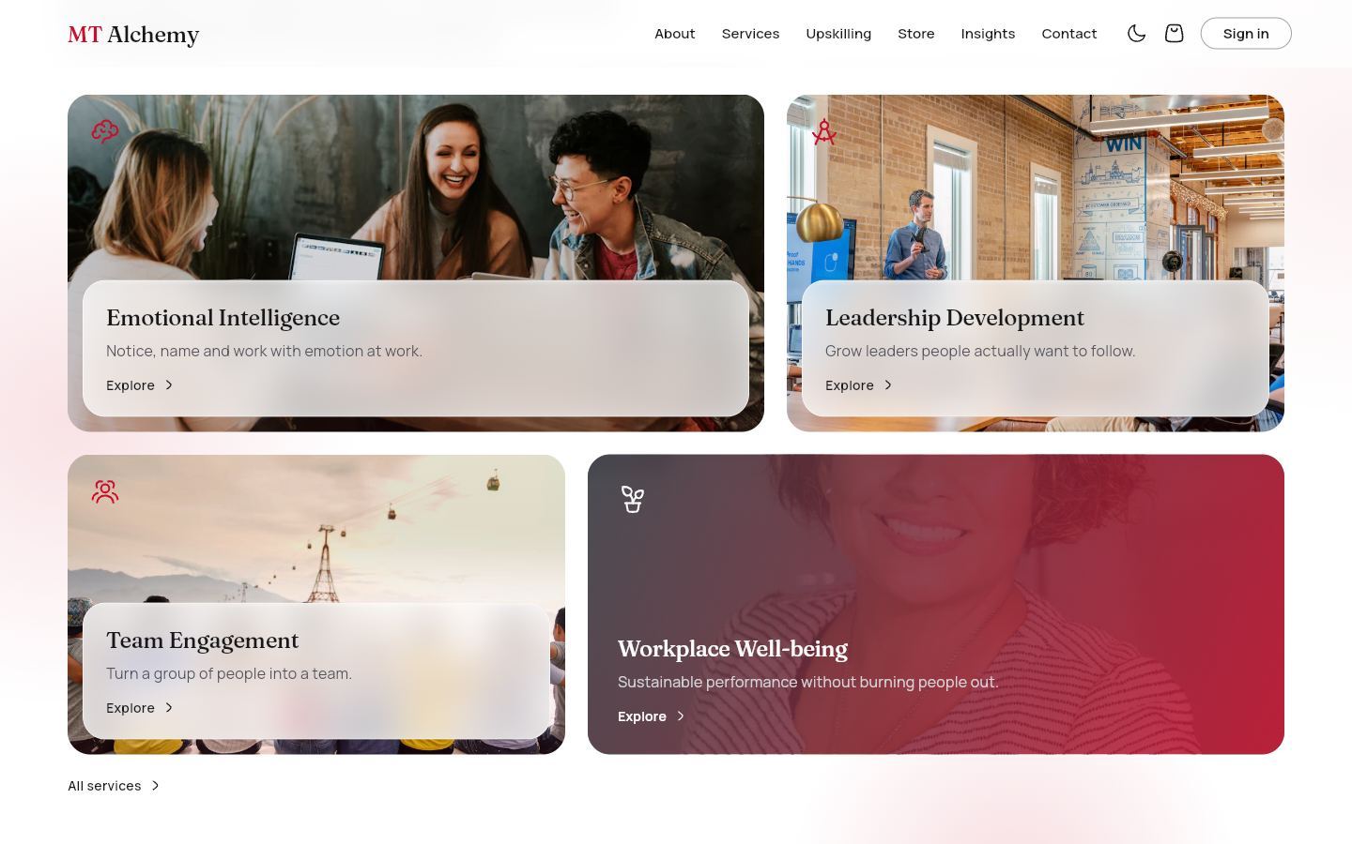  2. Services | 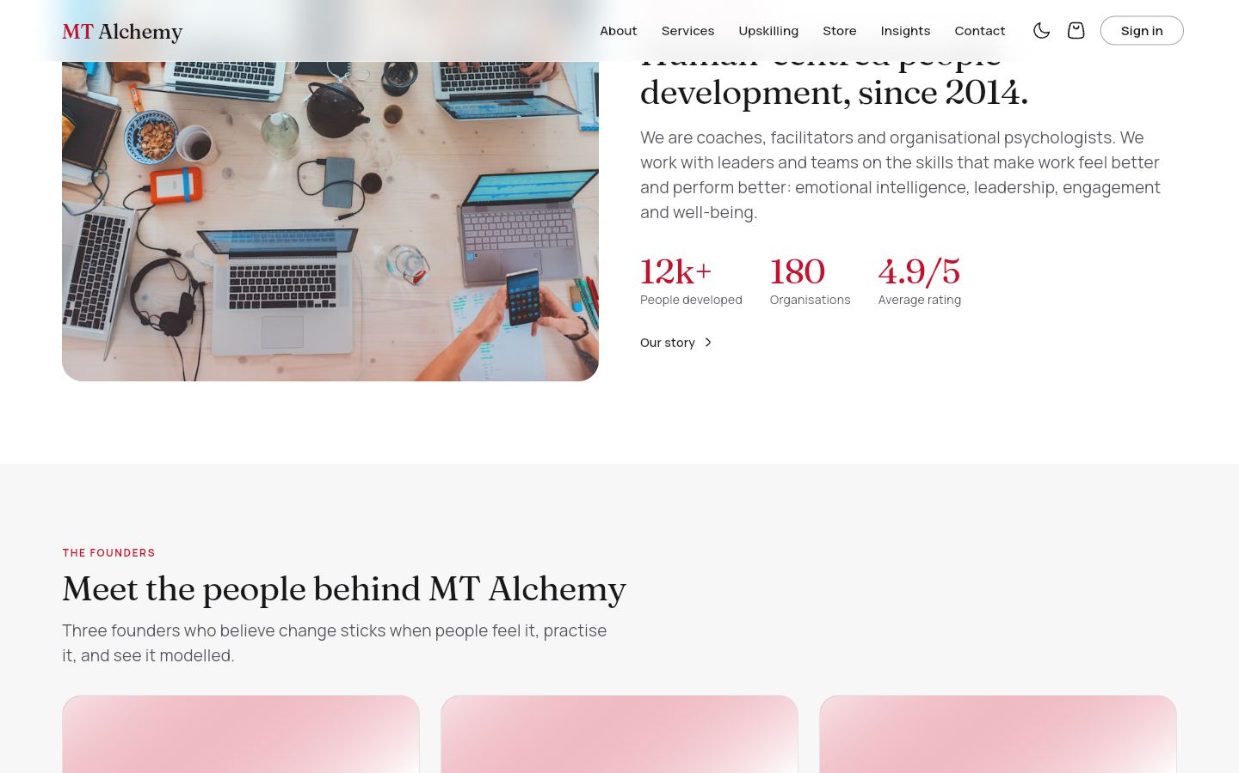  3. About | 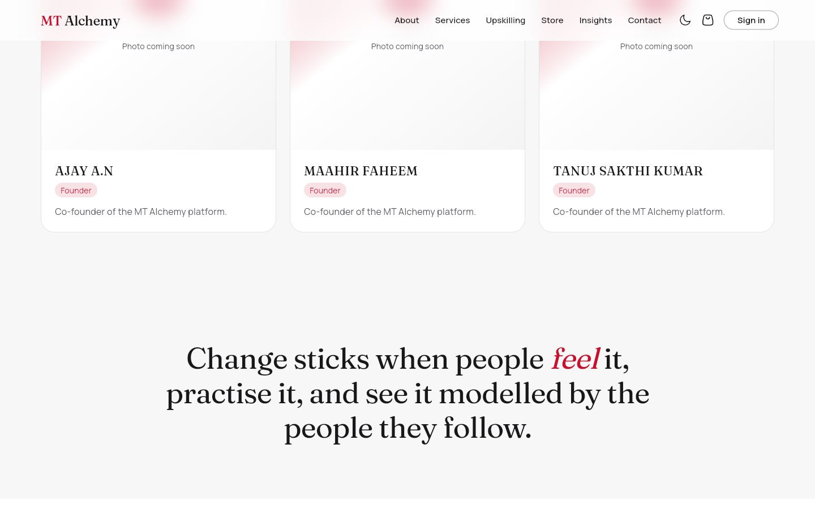  4. Founders and manifesto
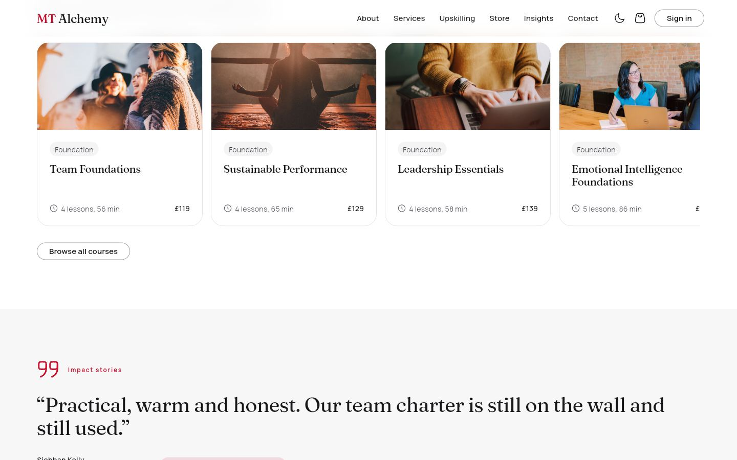  5. Courses and impact stories | 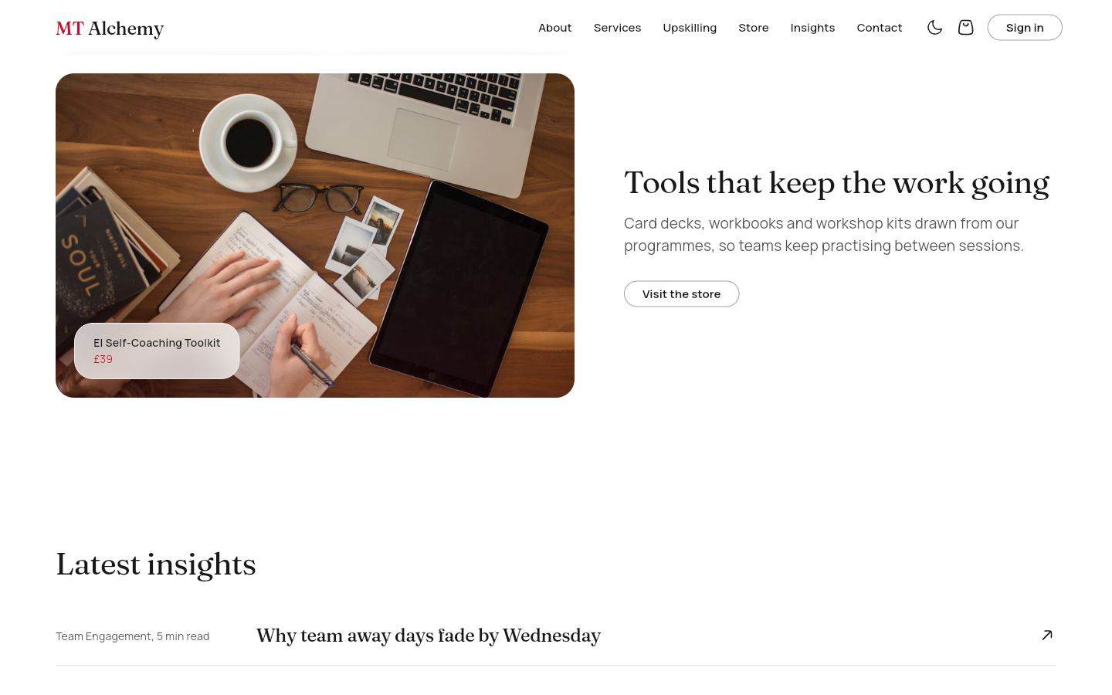  6. Store and insights | 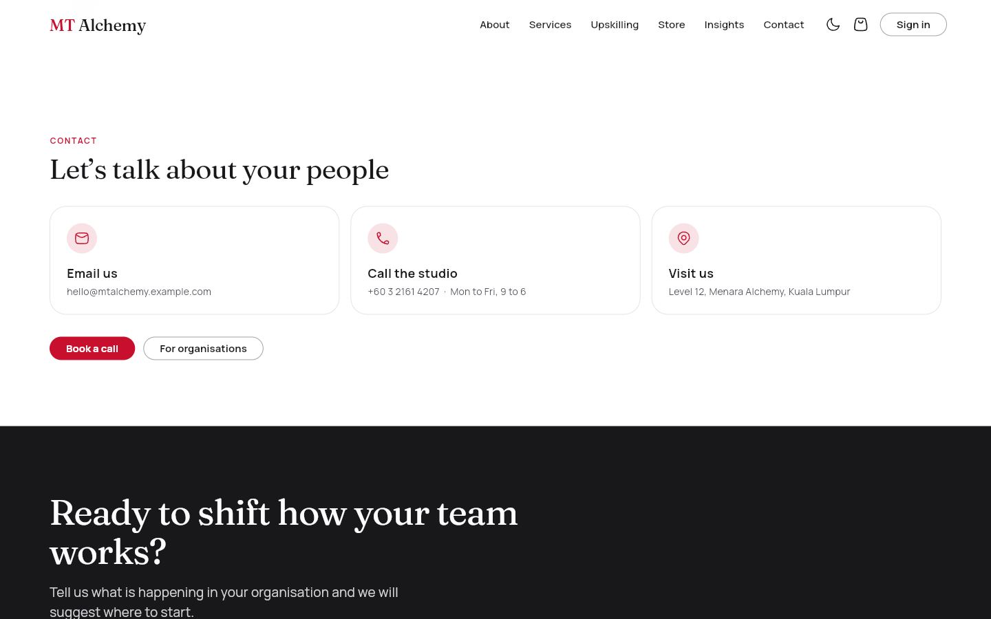  7. Contact and call to action | 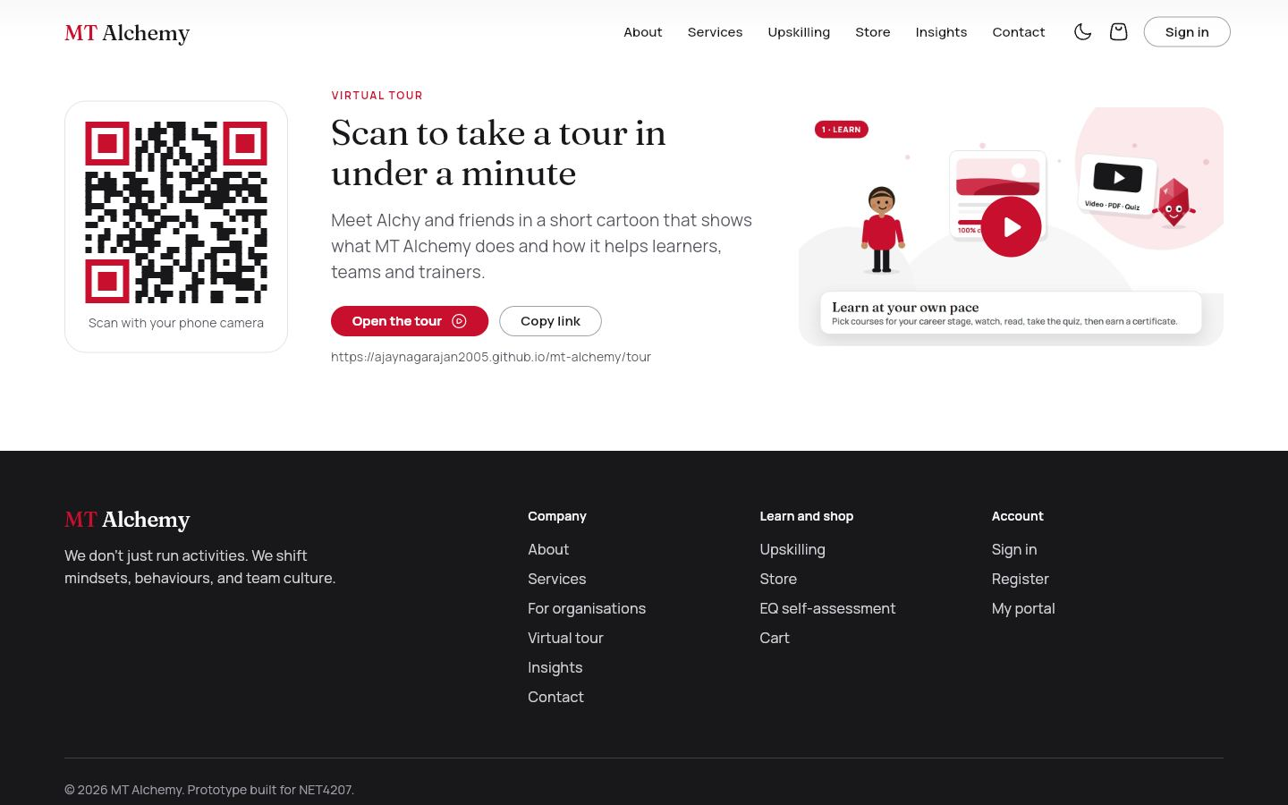  8. Virtual tour QR

The landing page (/) runs through these sections in order. 1: a looping ink-in-water film with a floating glass crystal behind glass copy and two calls to action. 2: four photo cards, one per practice area, with a 3D tilt on hover. 3: a team photograph, a short introduction and three key numbers. 4: three animated founder cards (AJAY A.N, MAAHIR FAHEEM, TANUJ SAKTHI KUMAR), each with a photo slot that shows initials until the super admin uploads a photo, followed by the statement of belief. 5: a snapping carousel of featured courses, then client quotes with a headline result that rotate every seven seconds (no rotation under reduced motion). 6: a featured product and the three latest articles. 7: three contact cards and a closing band inviting organisations to design a programme. 8: the QR code to the tour with the address, copy and open buttons and a clickable preview of the film. The menu items About, Services, Upskilling, Store, Insights and Contact glide to these sections.
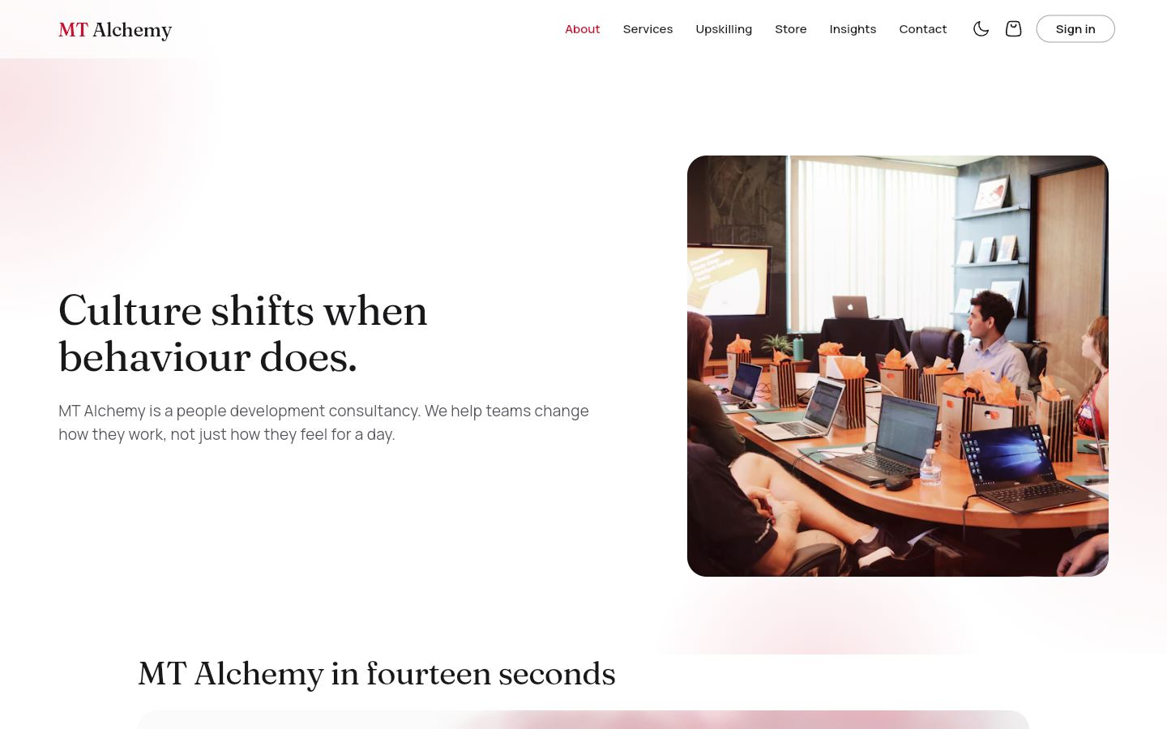 | 1. About  /about Everyone  The story of MT Alchemy: hero, the brand film, guiding principles, the founders and the team.  Data: founders (live). You can: Play the brand film · Read the principles · Book a call.
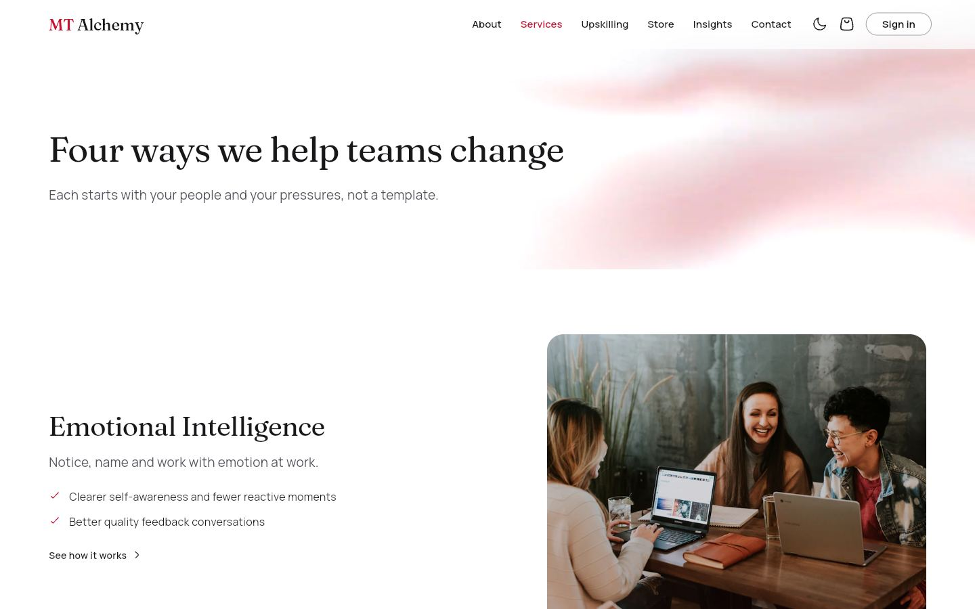 | 2. Services and service detail  /services · /services/:slug Everyone  The four practice areas (Emotional Intelligence, Leadership Development, Team Engagement, Workplace Well-being), each with a photograph and a one-line promise. A detail page covers one area: summary, what changes, formats, related self-paced courses and a client quote.  Data: courses, impactStories (live). You can: Open a service · Open a related course · Book a call.
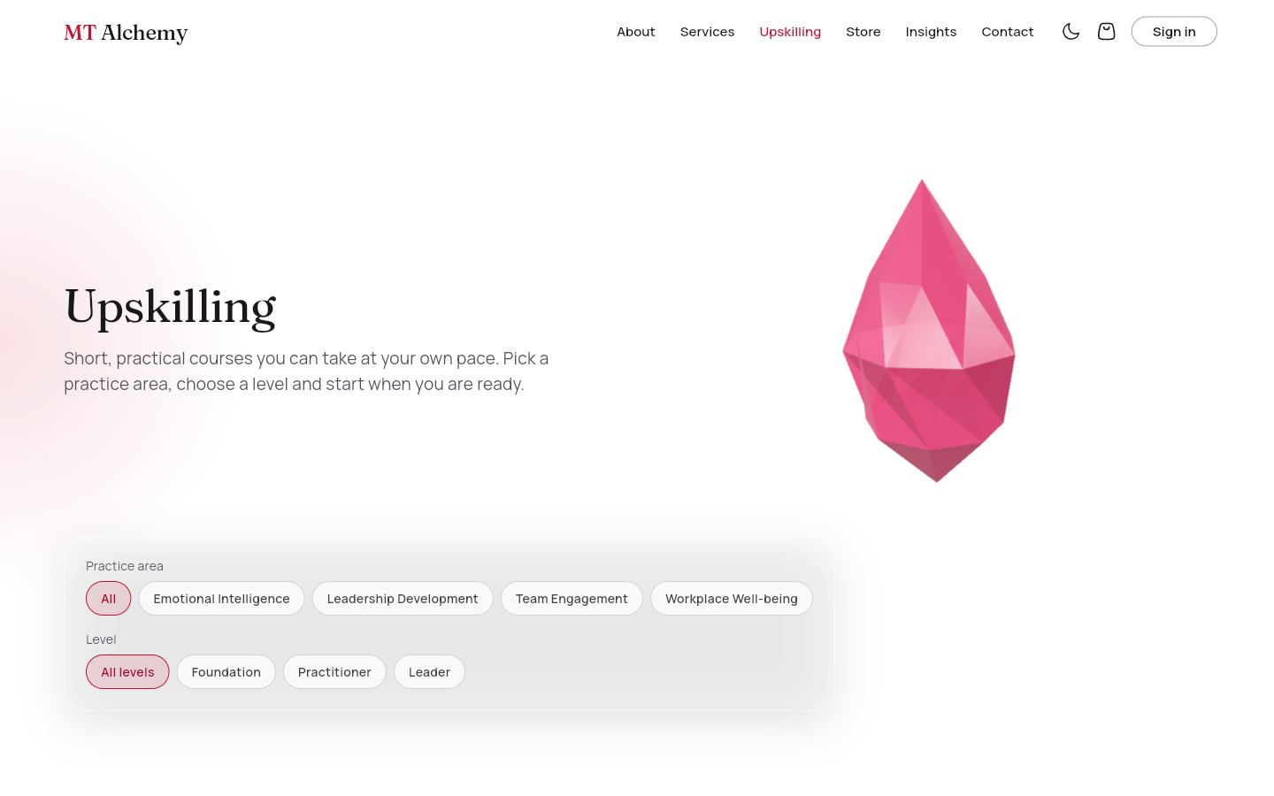 | 3. Upskilling (course library)  /upskilling Everyone  The public course library with level and practice-area filters and photo cards that lift and zoom on hover.  Data: courses (live). You can: Filter by level or area · Open a course.
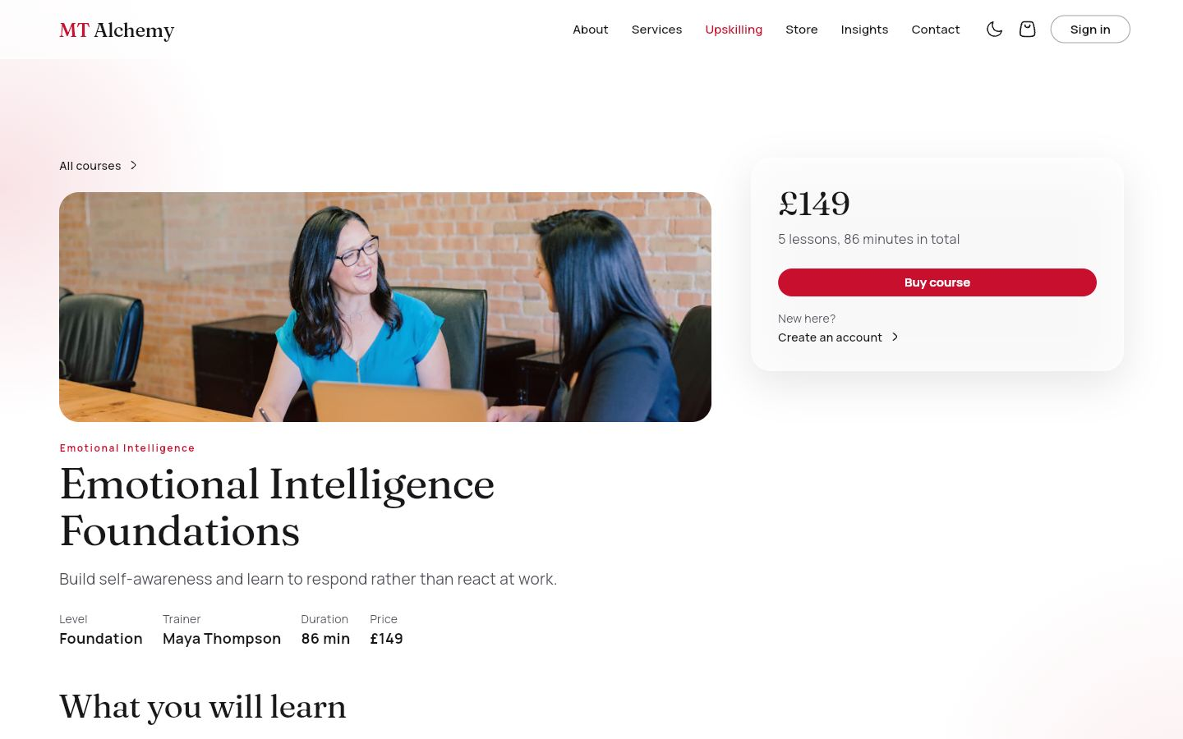 | 4. Course detail  /upskilling/:id Everyone; actions depend on role  Photo header, what you will learn, lessons with type and duration, reviews, and a summary panel whose button depends on who is looking.  Data: courses, reviews, enrolments, assignments. You can: Guest: sign in · Learner: Buy course, or See courses in your pathway · Employee: Start assigned course · Employer: buy seats · Staff: Open free, Students, Edit · Learners post reviews.
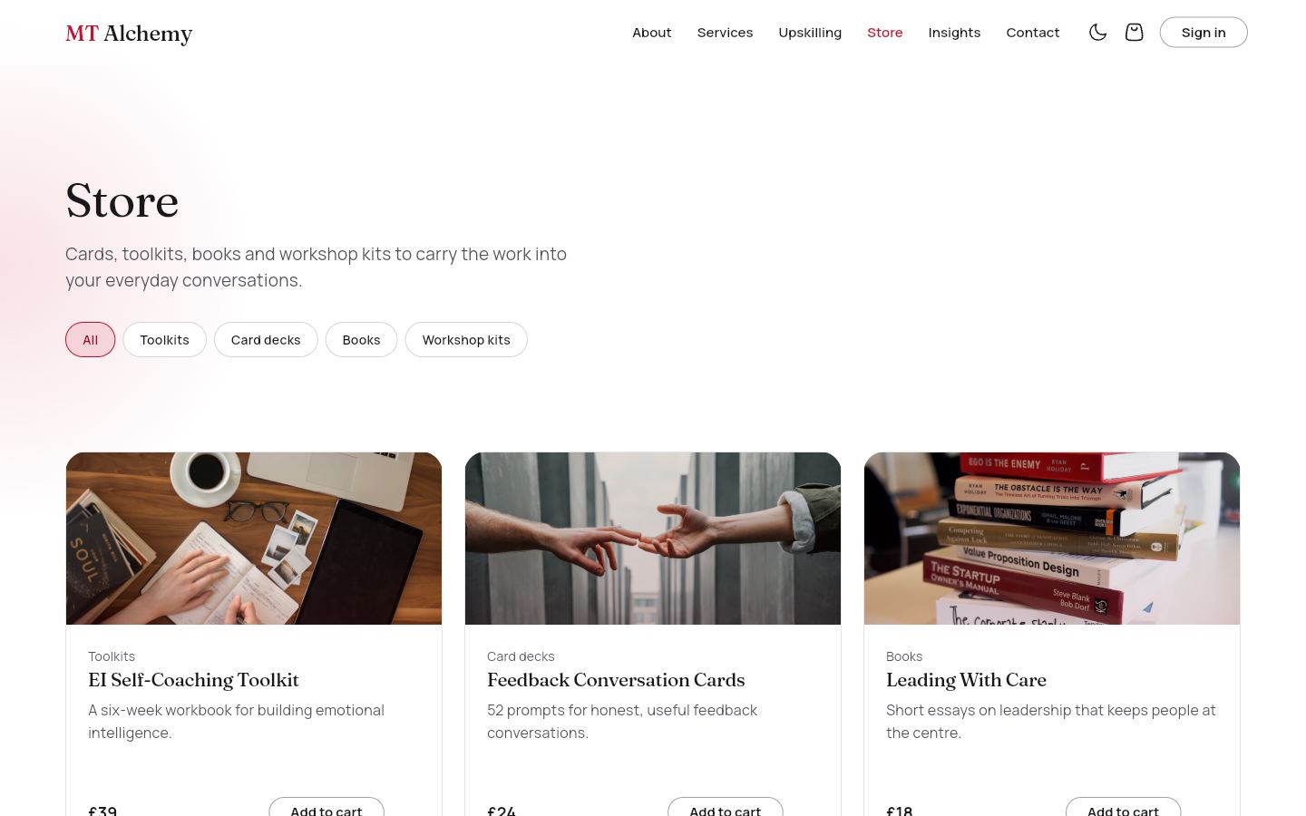 | 5. Store and product  /store · /store/:id Everyone  Toolkits, card decks, books and workshop kits with a category filter and photo cards. A product page adds the description, what is included, price, digital or shipped, reviews and related products.  Data: products, reviews (live). You can: Filter by category · Open a product · Set quantity · Add to cart.
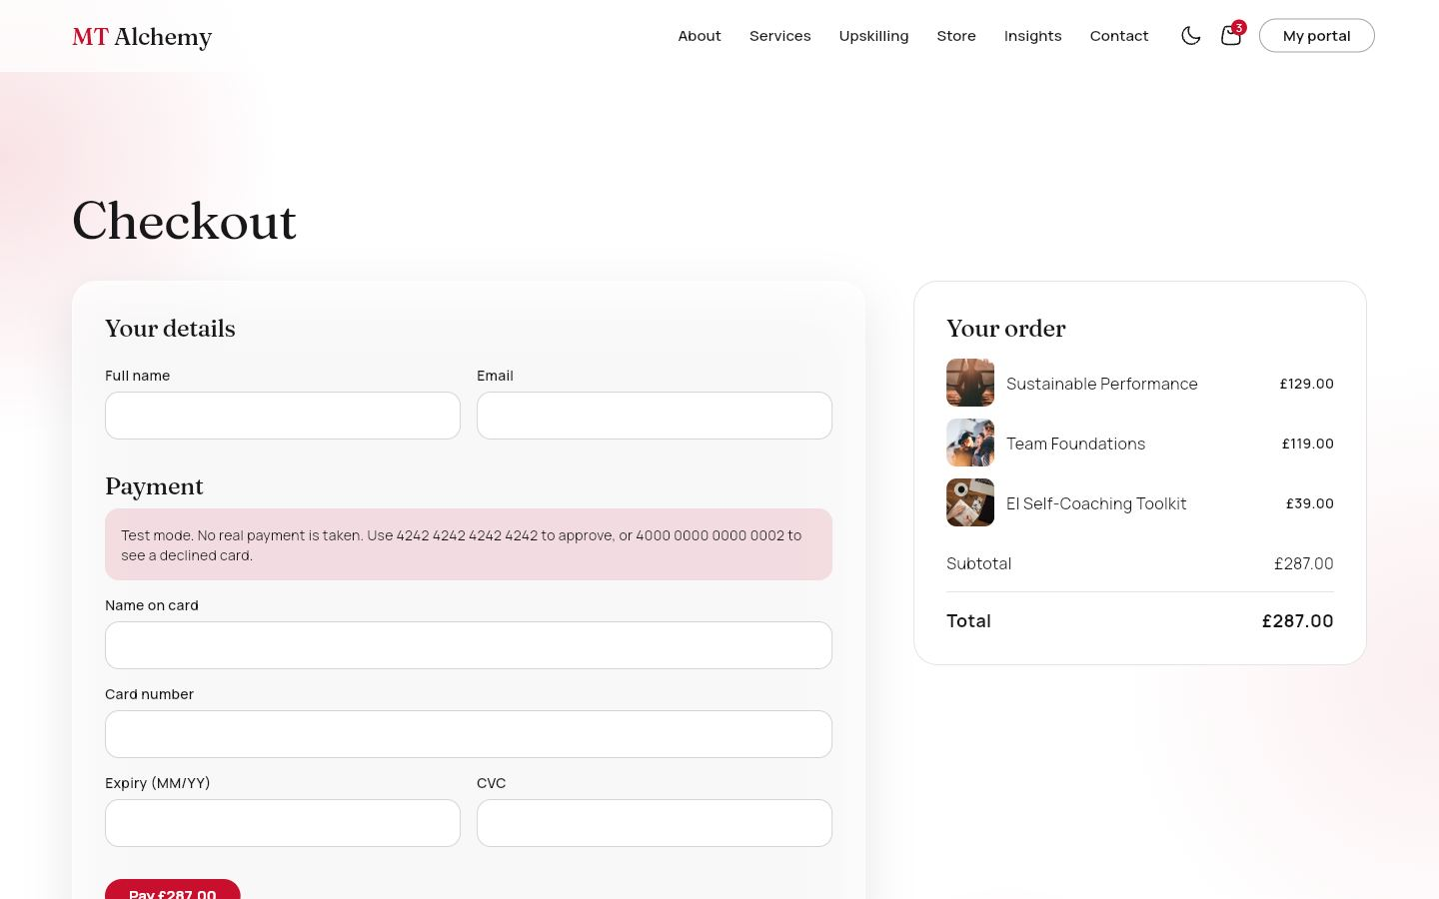 | 6. Cart and checkout  /cart · /checkout · /checkout/success Cart: everyone. Checkout: signed in  The cart mixes products, a course and employer seats, with quantity steppers, totals and a free-delivery nudge. A guest cart merges into the saved cart on sign-in. Checkout asks for details, a delivery address only when something ships, and a test-mode card. The confirmation page offers the next step: Start learning, Assign your seats, My downloads or Track my order.  Data: carts, orders, payments, shipping, downloads, enrolments, organizations (seats), products (stock). You can: Change quantity · Remove · Pay (validated card; the declined test card shows an error).
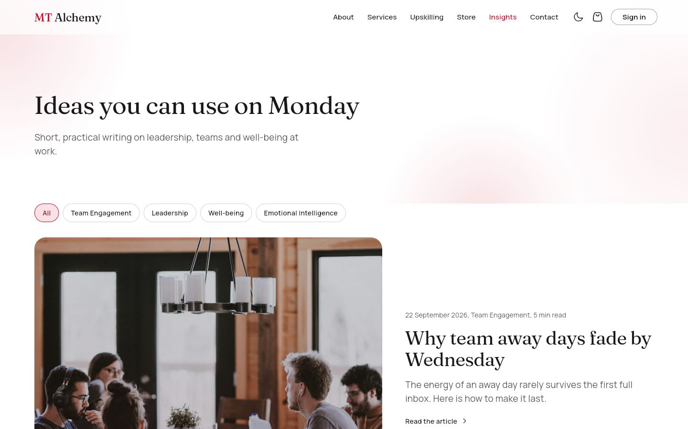 | 7. Insights and article  /insights · /insights/:slug Everyone  Short practical articles with a category filter and a featured story. An article page has a photo header, reading time and related articles.  Data: articles (live). You can: Filter by category · Read · Open a related article.
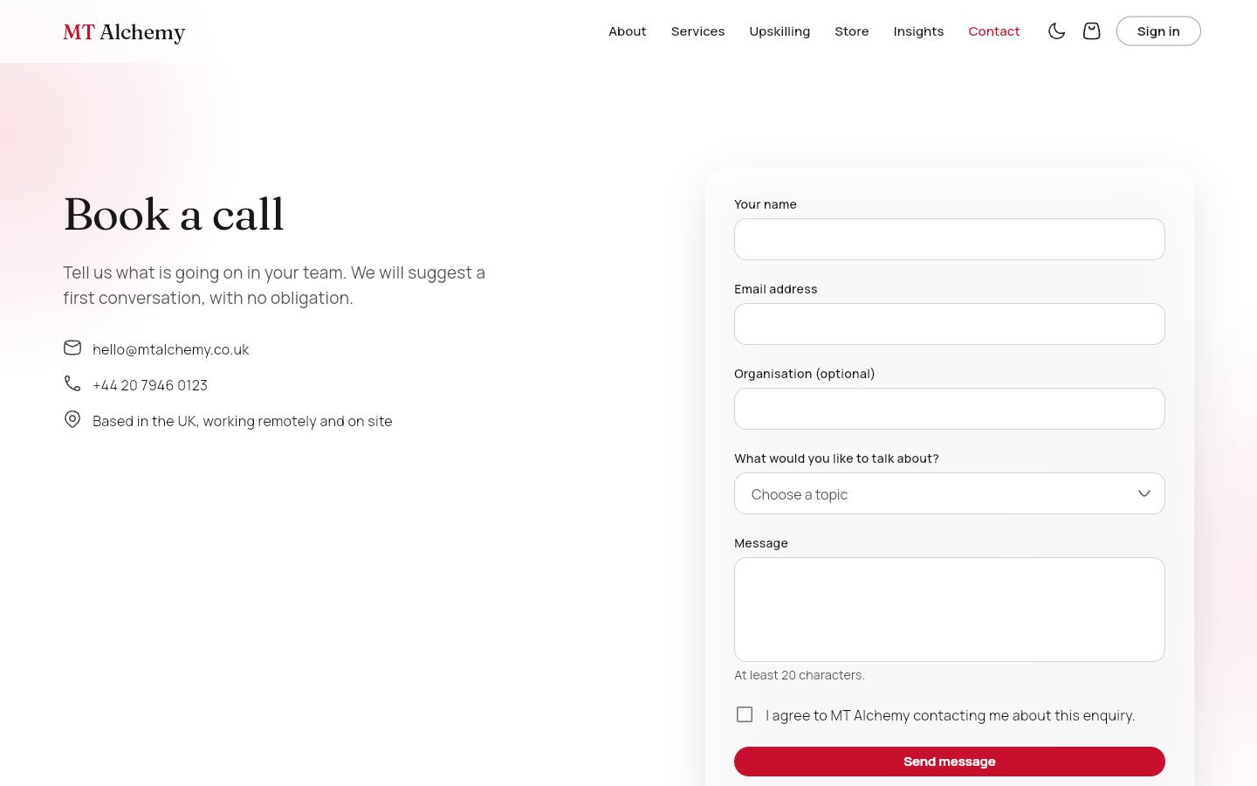 | 8. Contact  /contact Everyone  A form (name, email, topic, message, consent) with validation that saves to Firestore and shows a success state.  Data: contactMessages (write). You can: Send a message · Send another.
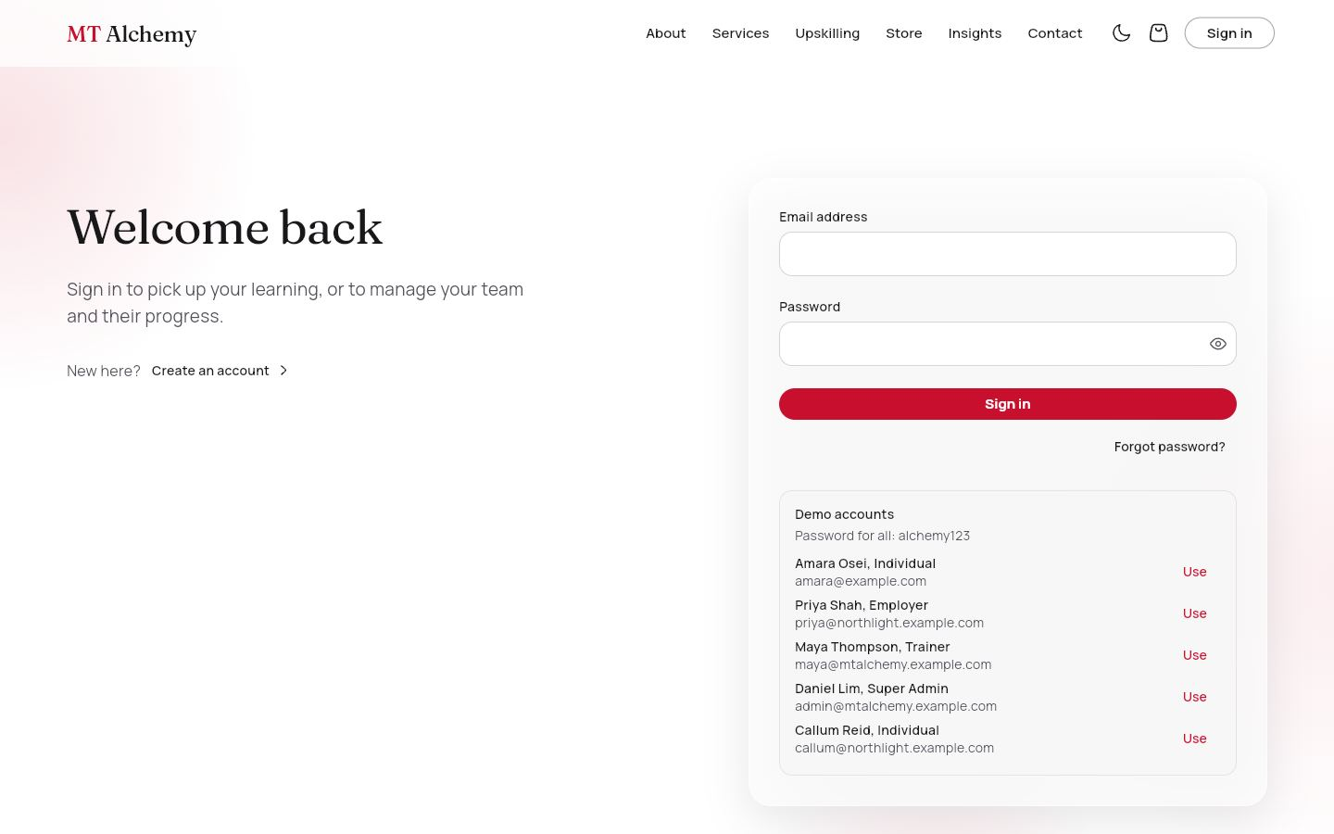 | 9. Sign in  /login Guests  Email and password with validation, "Forgot password?" (sends a Firebase reset email) and one-tap demo accounts.  Data: Firebase Auth, users. You can: Sign in and land on your portal · Reset password · Use a demo account.
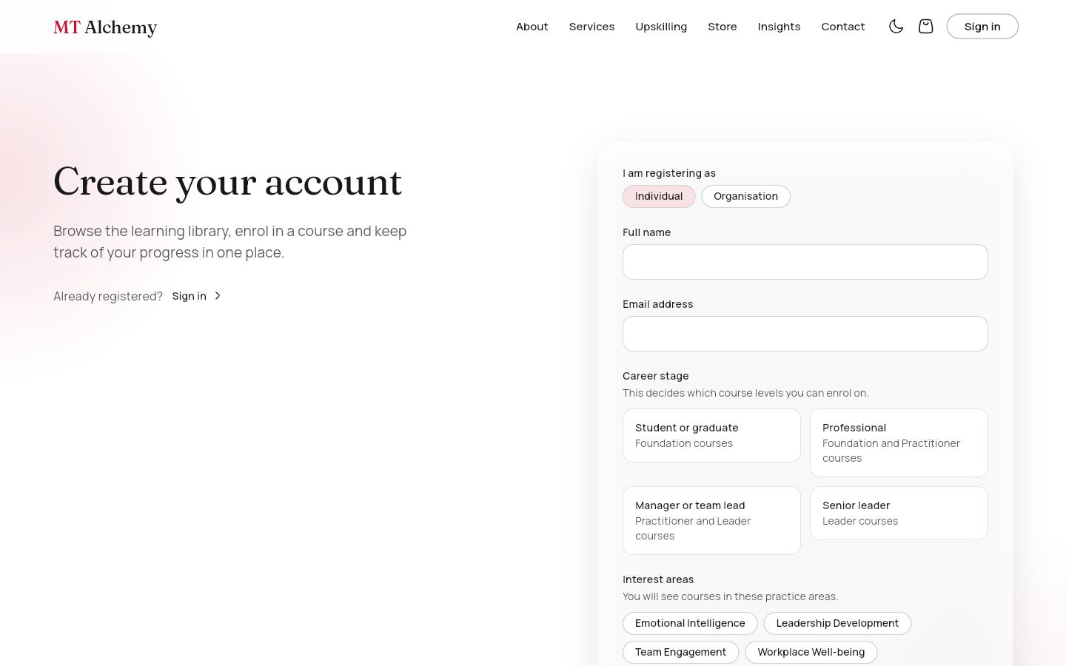 | 10. Register: individual or organisation  /register · /register?type=organisation Guests  Individuals give name, email, password, gender (radio), country (dropdown), hobbies (checkboxes) and a learning pathway: career stage plus interest areas. Journey D starts at the organisation form: organisation name, sector and size, plus the employer's own login.  Data: users, organizations (create). You can: Create account, then go to the course catalogue or the employer portal.
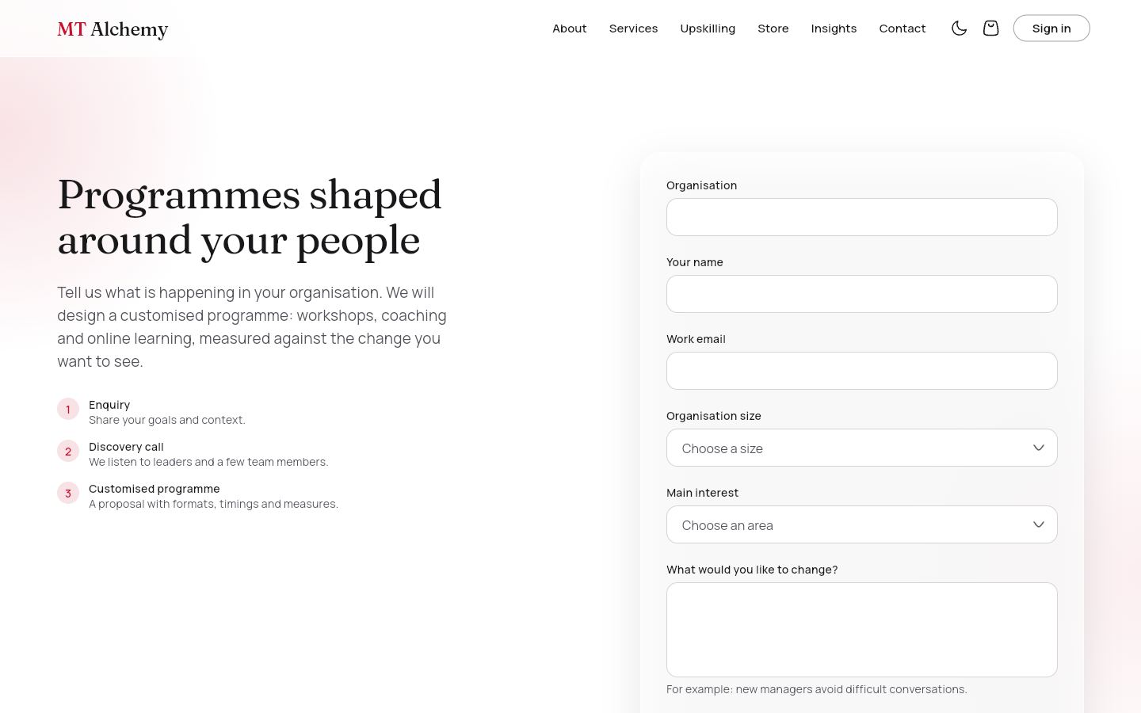 | 11. For organisations (Journey E)  /organisations Everyone  A corporate enquiry form with a three-step explanation: enquiry, discovery call, customised programme.  Data: enquiries (create). You can: Send enquiry · Register the organisation.
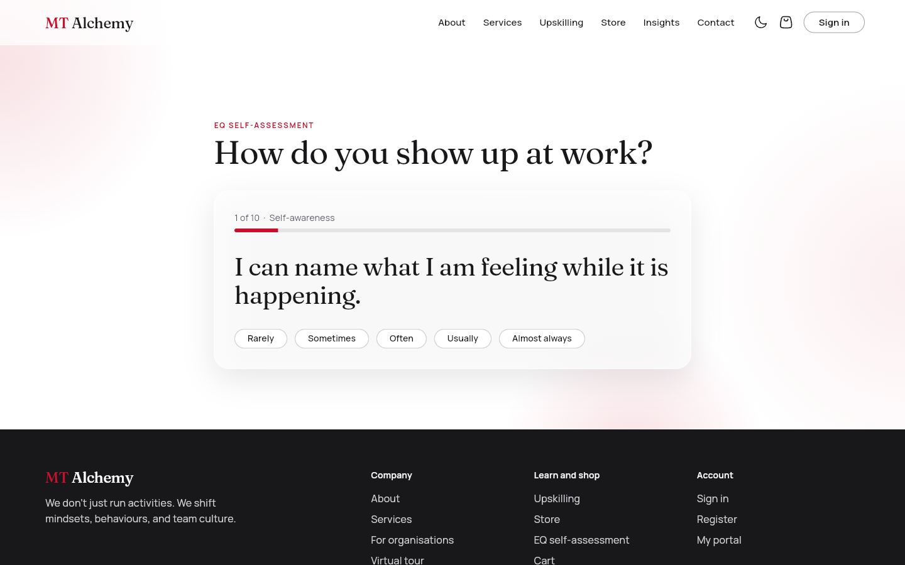 | 12. EQ self-assessment  /eq-assessment Everyone; results saved if signed in  Ten statements across five emotional-intelligence areas, one at a time. The result shows animated bars, a strength, a growth edge and a recommended course.  Data: assessments (write when signed in). You can: Answer, go back, retake · View the recommended course.
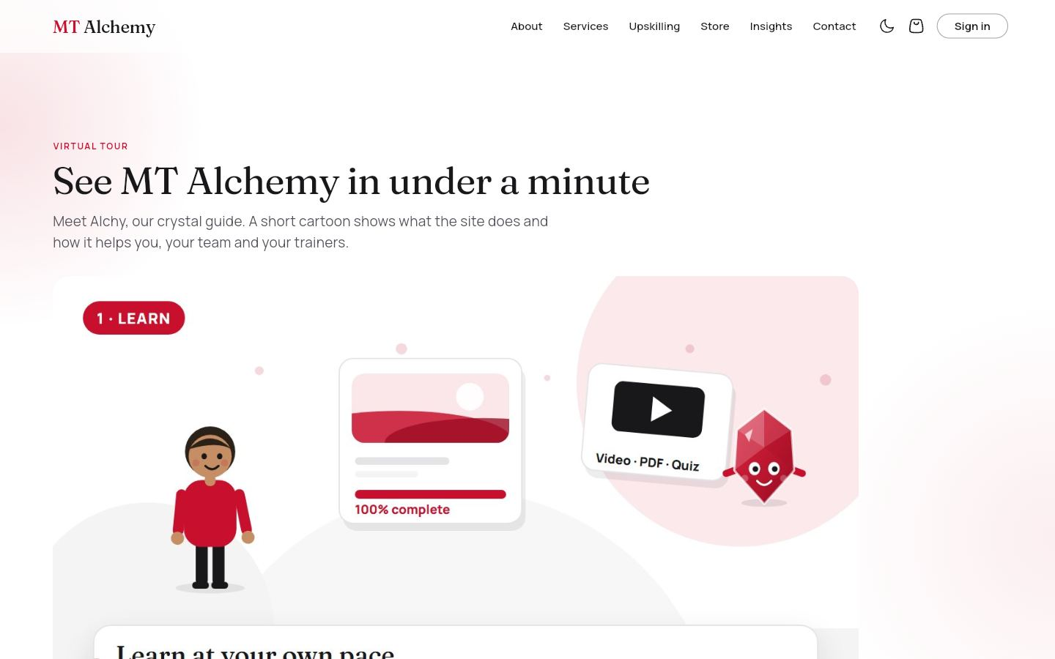 | 13. Virtual tour  /tour Everyone  The page the QR code opens: the cartoon explainer film, then six "Try it yourself" cards linking to learning, shop, teams, trainers, the EQ check and insights.  Data: none. You can: Play the film · Open any part of the site · Create a free account.
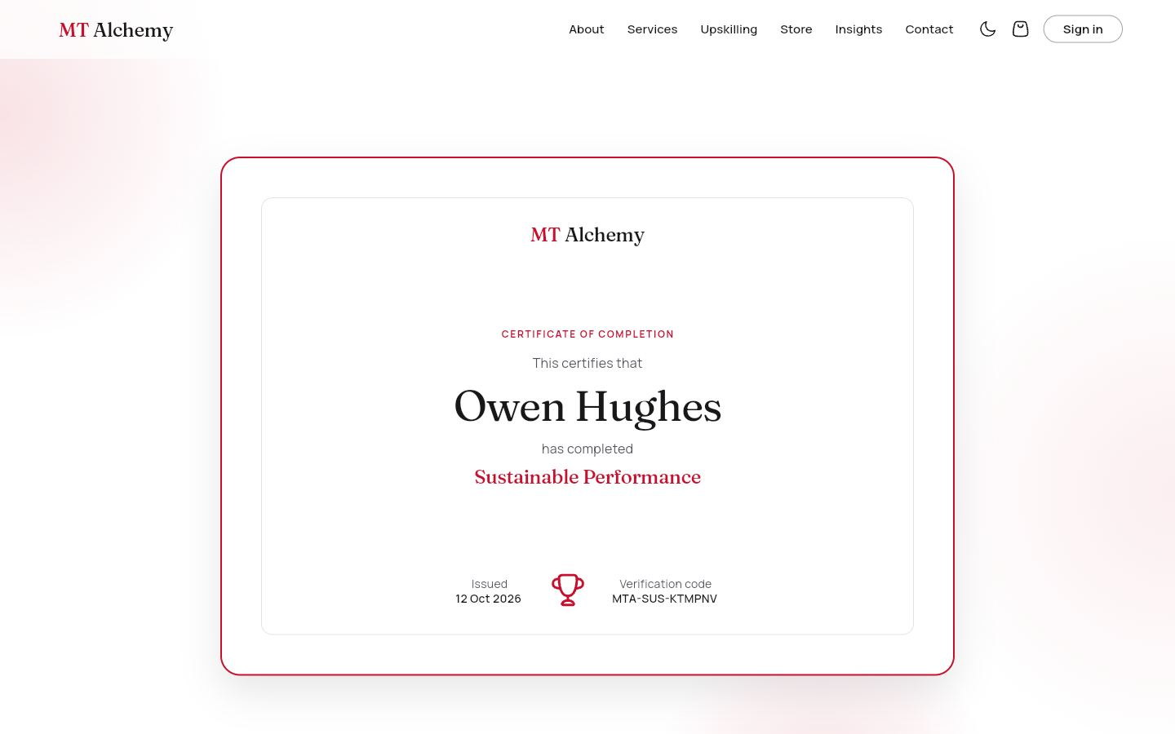 | 14. Certificate  /certificates/:code Everyone (public by design)  The learner's name, course, issue date and verification code. Anyone with the link can verify it, and an unknown code shows "Certificate not found".  Data: certificates (public read). You can: Share the link · Verify a code.

4.2 Course player
Signed-in learners open the courses they own. Staff can open any course free.
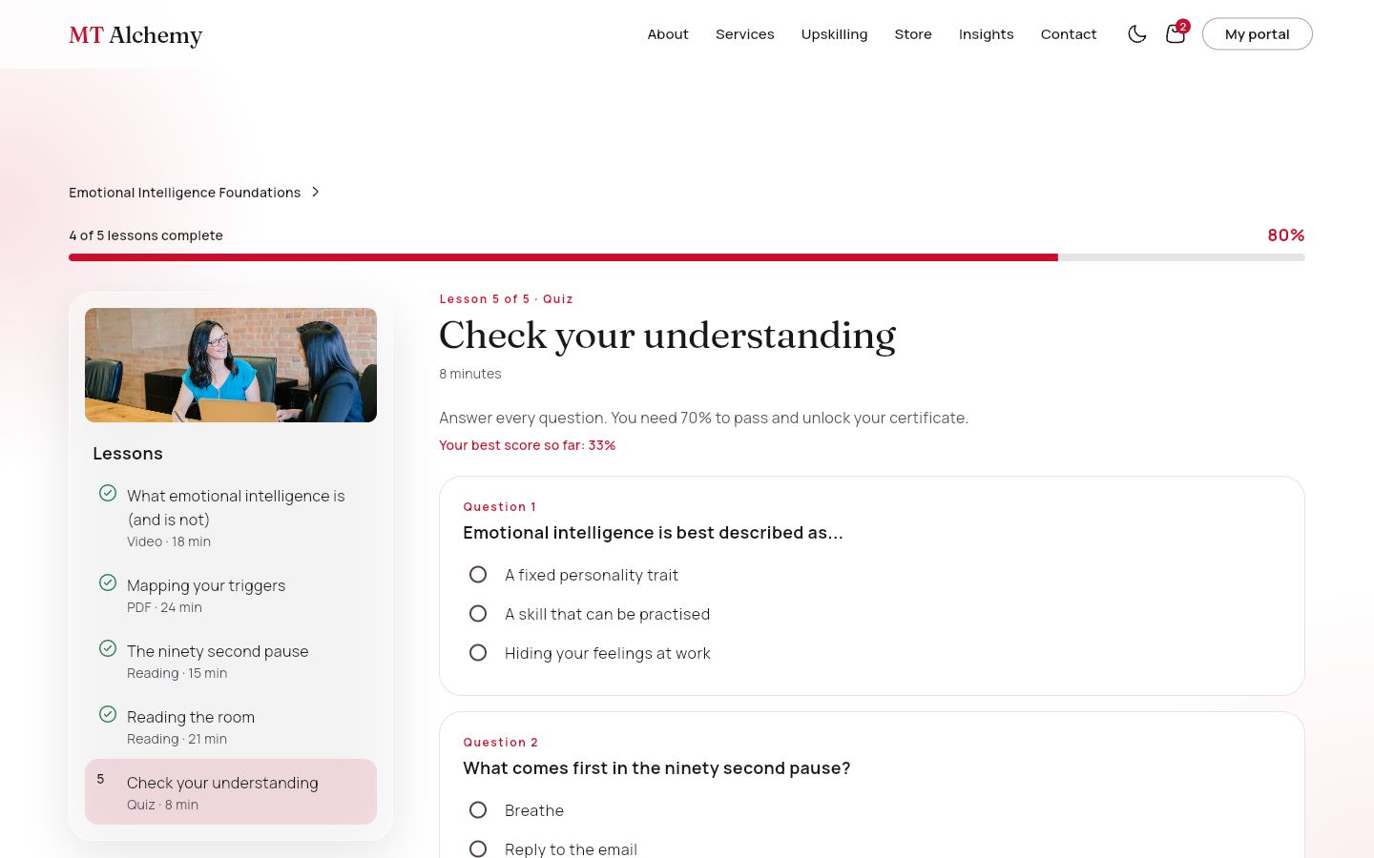 | 15. Video, PDF and reading lessons  /learn/:id Enrolled learners; staff (free preview)  A progress bar with a percentage, a lesson list with a photo banner and a type and duration for each lesson, and the lesson view. Video lessons use the film player, PDF lessons open the workbook and readings show the text.  Data: courses, enrolments, certificates. You can: Previous · Mark as complete · Next. Progress is saved; finishing creates the certificate.
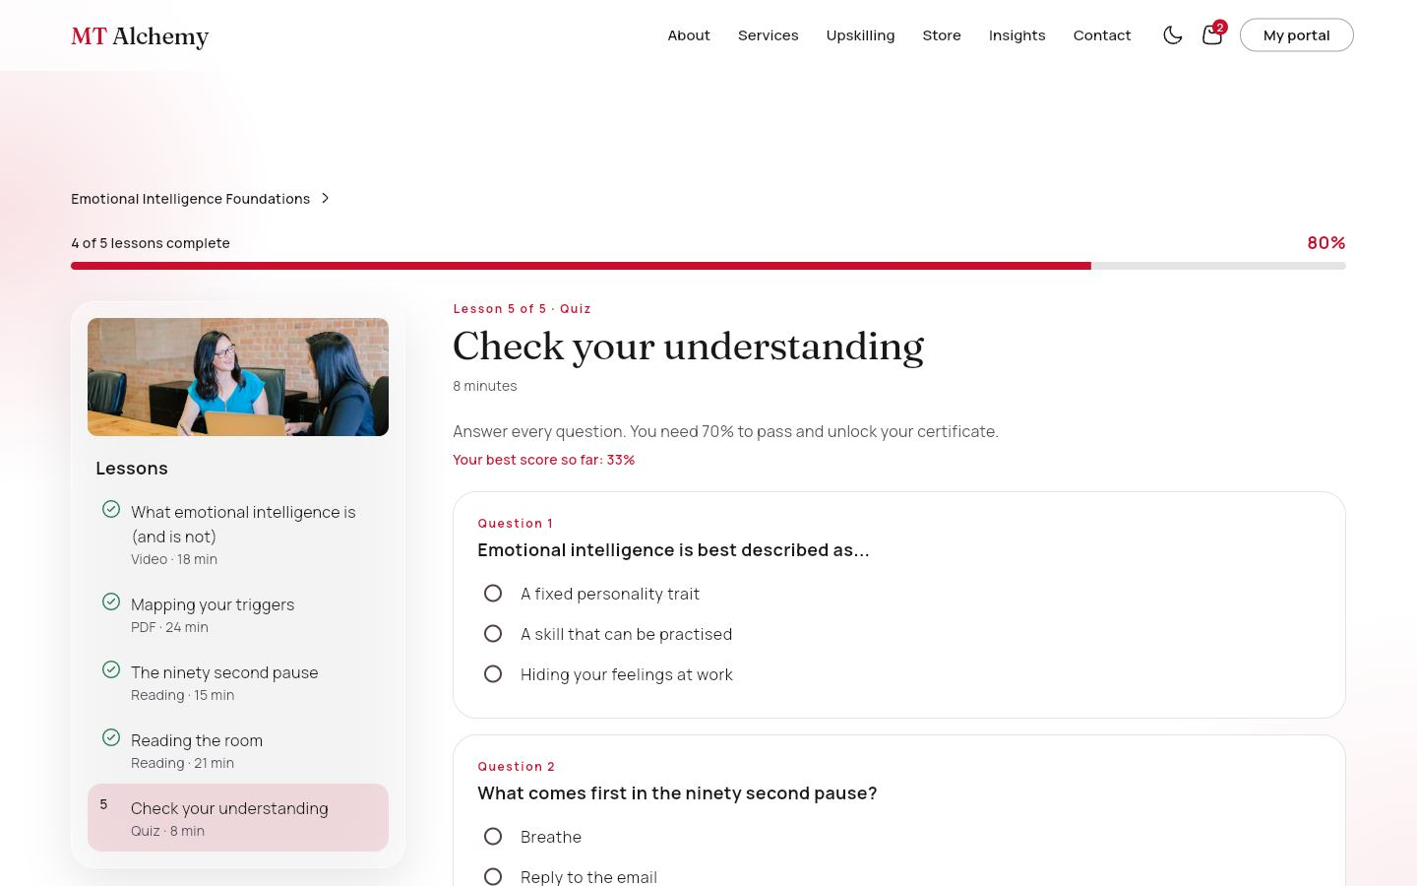 | 16. Quiz lesson  /learn/:id Enrolled learners; staff (free preview)  One choice per question. Submitting shows which answers were right; 70% passes and completes the lesson, otherwise "Try again". When staff open a course, a banner says "You are viewing this course free. Progress here is not saved" and offers Students and Edit course.  Data: enrolments.quizScores. You can: Answer all questions · Submit · Retry until passed.

4.3 Learner portal
For individuals. Side navigation: My learning, Course catalogue, Certificates, Orders, My downloads, Profile. The top bar has the notification bell, a theme toggle and sign out.
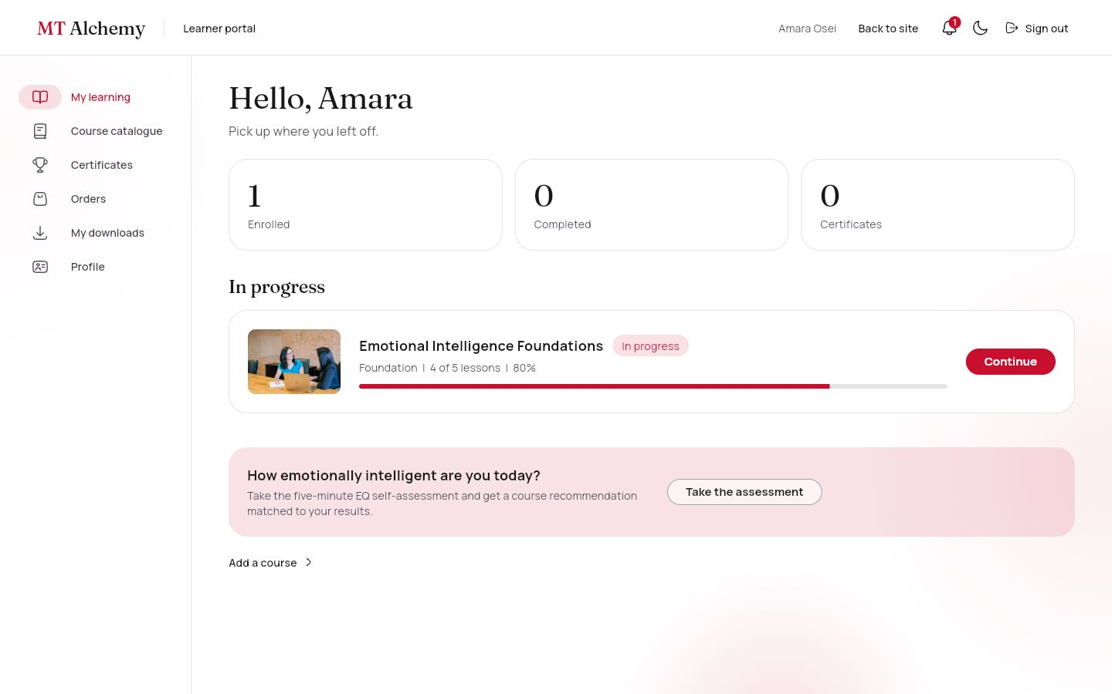 | 17. My learning  /portal/me Individual  Totals for enrolled, completed and certificates; courses assigned by an employer; courses in progress with a photo and progress bar; completed courses; and a prompt to take the EQ check.  Data: enrolments, assignments, certificates, courses. You can: Continue or Review a course · Start an assigned course · Add a course.
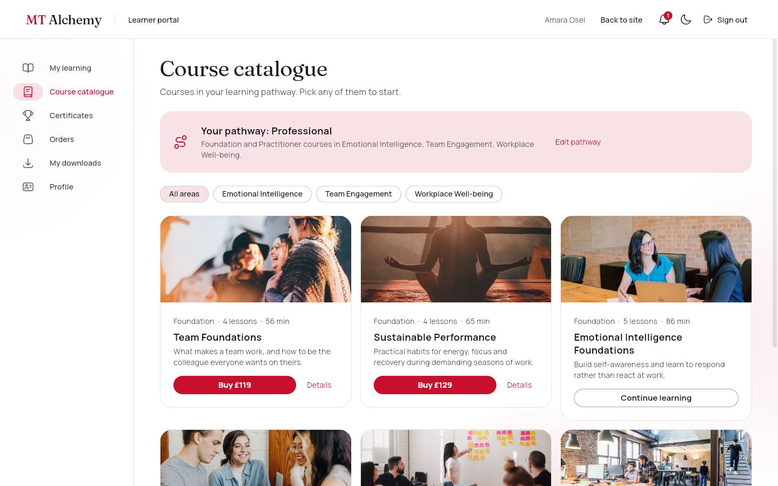 | 18. Course catalogue ("Add a course")  /portal/me/courses Individual  Only courses in the learner's pathway, under a banner showing the pathway and area chips. Courses outside it are listed as locked, with the reason.  Data: courses, users.pathway. You can: Buy a course · Details · Edit pathway · Show locked courses.
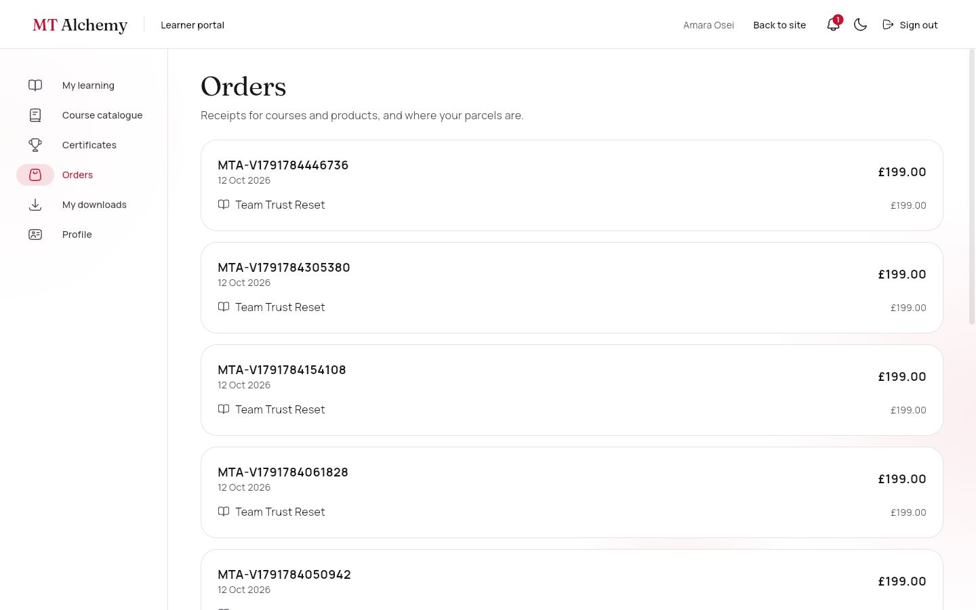 | 19. Certificates, orders and downloads  /portal/me/certificates · /orders · /downloads Individual  Certificates lists every certificate earned, with its course photo and code. Orders holds receipts for courses and products; physical orders show a Processing, Shipped, Delivered timeline with the tracking number. My downloads lists owned digital products with a download count.  Data: certificates, orders, shipping, downloads. You can: View a certificate · See delivery progress · Download (the count goes up).
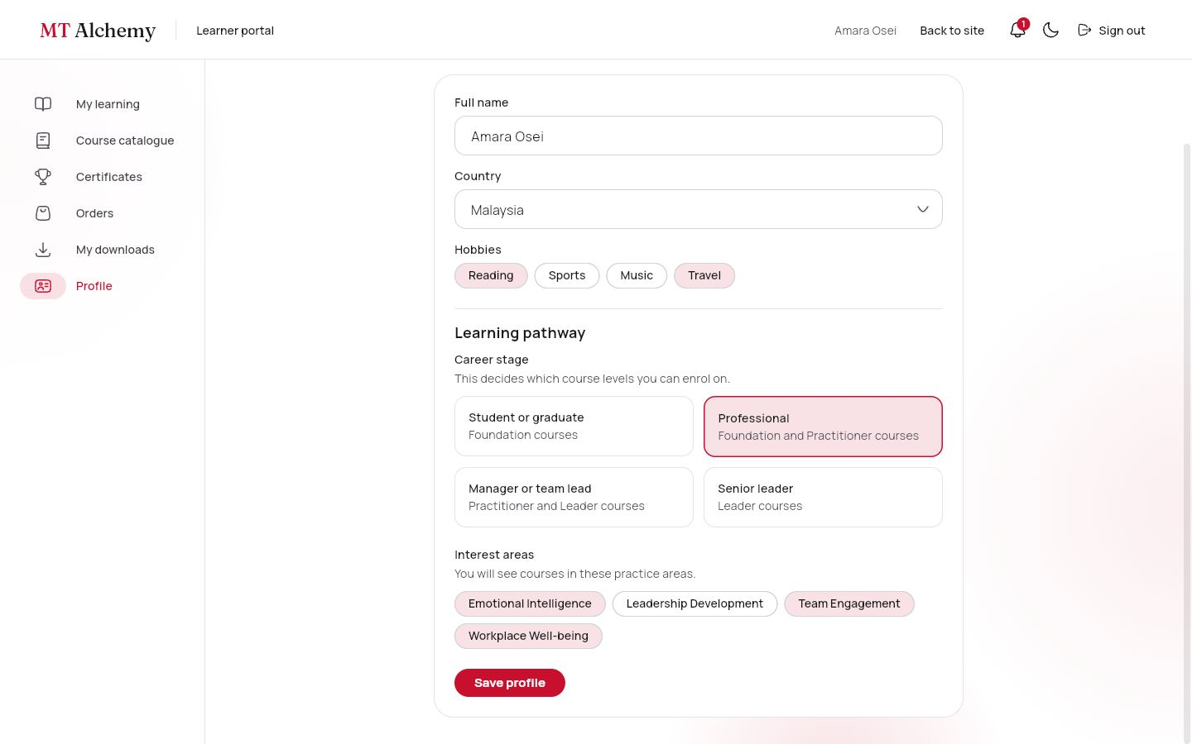 | 20. Profile and learning pathway  /portal/me/profile Individual  Edit name, country and hobbies. The pathway control is the same one used at registration; changing it changes which courses are open.  Data: users (careerStage, interests). You can: Save profile · Choose a career stage and interest areas.

4.4 Employer portal
For organisations (Journey D). Side navigation: Overview, Employees, Buy courses, Assign courses, Progress report, Analytics.
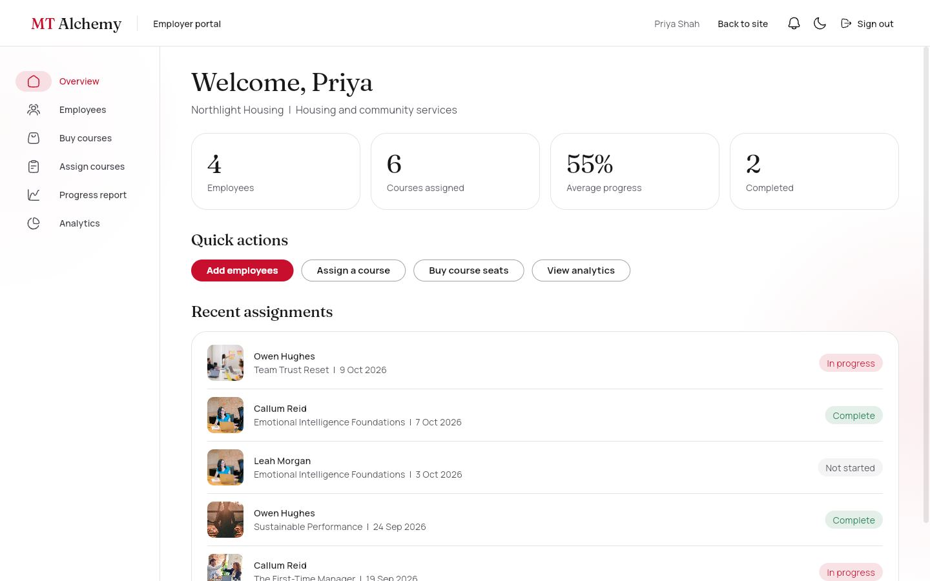 | 21. Overview  /portal/employer Employer  Employees, courses assigned, average progress and completions, quick actions, and the five most recent assignments with course photos.  Data: employees, assignments, enrolments. You can: Add employees · Assign a course · Buy seats · View analytics.
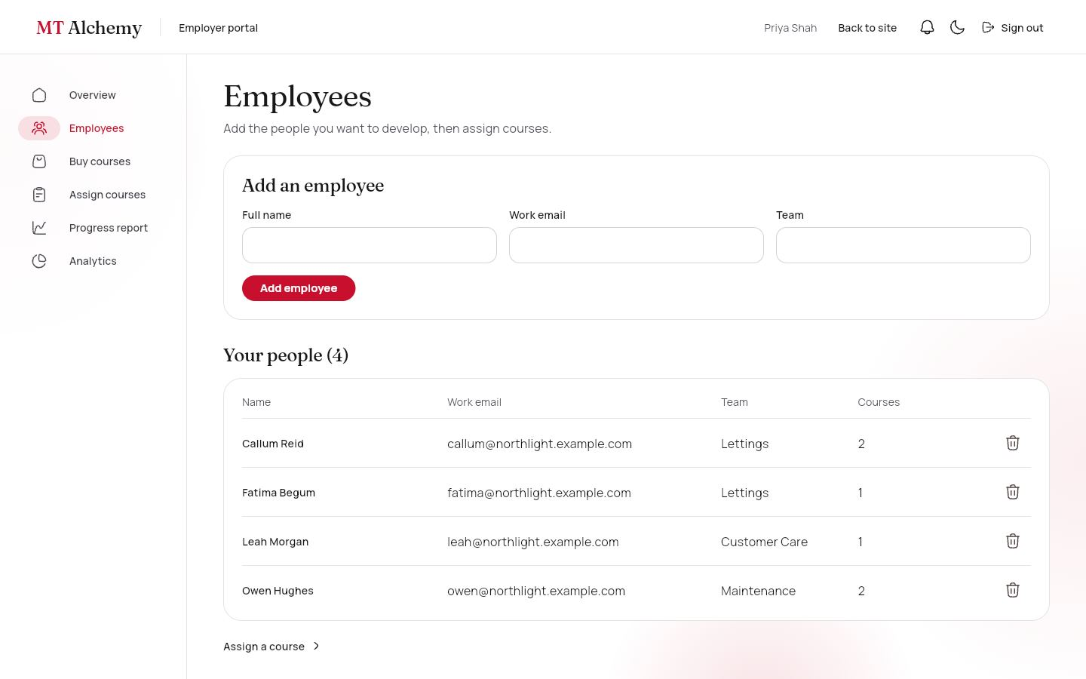 | 22. Employees  /portal/employer/employees Employer  A form to add people (name, email, team) and the list with their number of courses. People join the organisation automatically when they register with that email.  Data: employees. You can: Add · Remove (with confirmation).
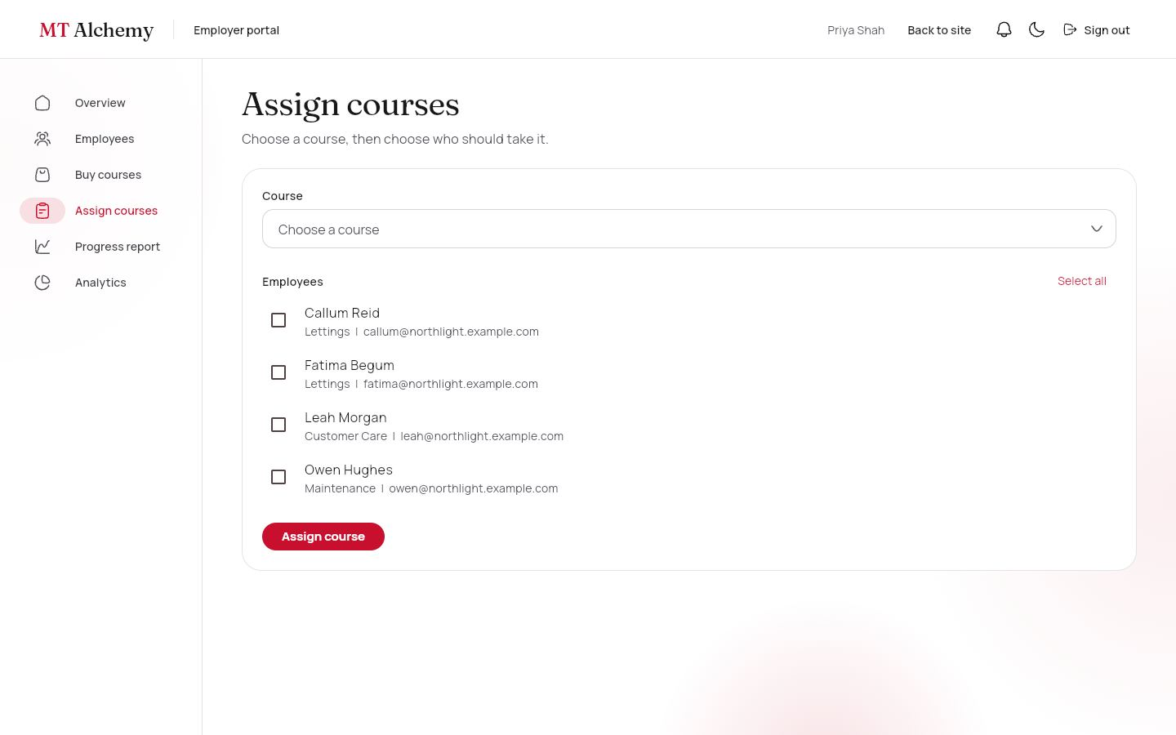 | 23. Buy and assign courses  /portal/employer/courses · /assign Employer  Every course is a photo card with a seat stepper and a Buy button that goes to checkout, with the unassigned seats shown. To assign, choose a course and tick the people; the page shows the seats left and refuses the assignment if there are not enough, with a Buy seats shortcut.  Data: courses, assignments, organizations.seats. You can: Choose seats · Buy · Select all · Assign.
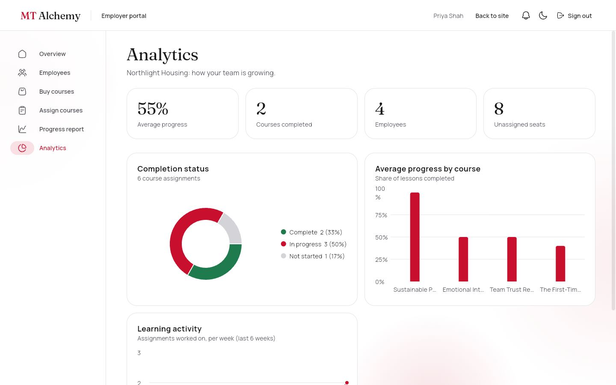 | 24. Progress report and analytics  /portal/employer/progress · /reports Employer  The report has a photo summary card per course and a filterable table of each person, course, date, progress bar and status. Analytics adds a completion donut, average progress by course (bars) and weekly learning activity (line), with hover details and a legend with counts.  Data: assignments, enrolments (live). You can: Filter by course · Hover for values.

4.5 Trainer portal
For trainers, who author and look after courses. Super admins use the same screens.
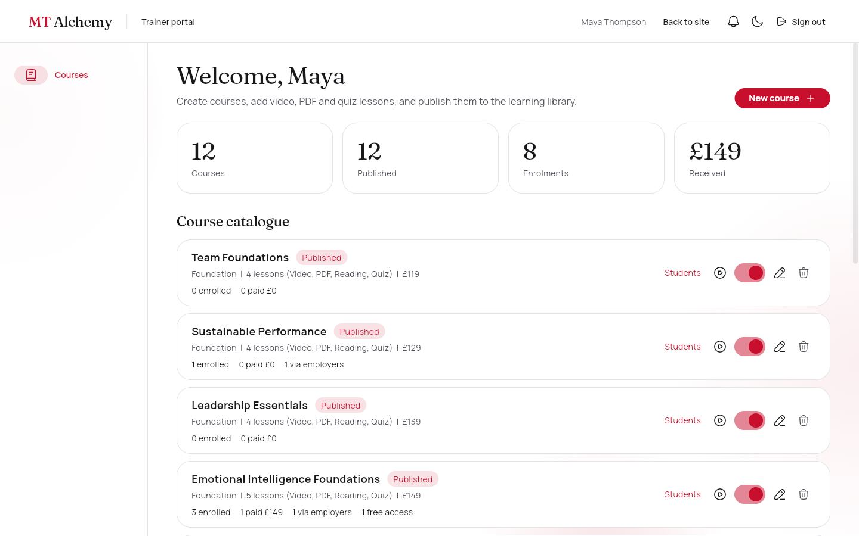 | 25. Courses  /portal/admin Trainer, super admin  The whole catalogue with totals (courses, published, enrolments, amount received) and a row per course showing enrolled, paid with amount, employer seats and free access.  Data: courses, enrolments (live). You can: Students · Open free (play icon) · Publish or unpublish · Edit · Delete · New course.
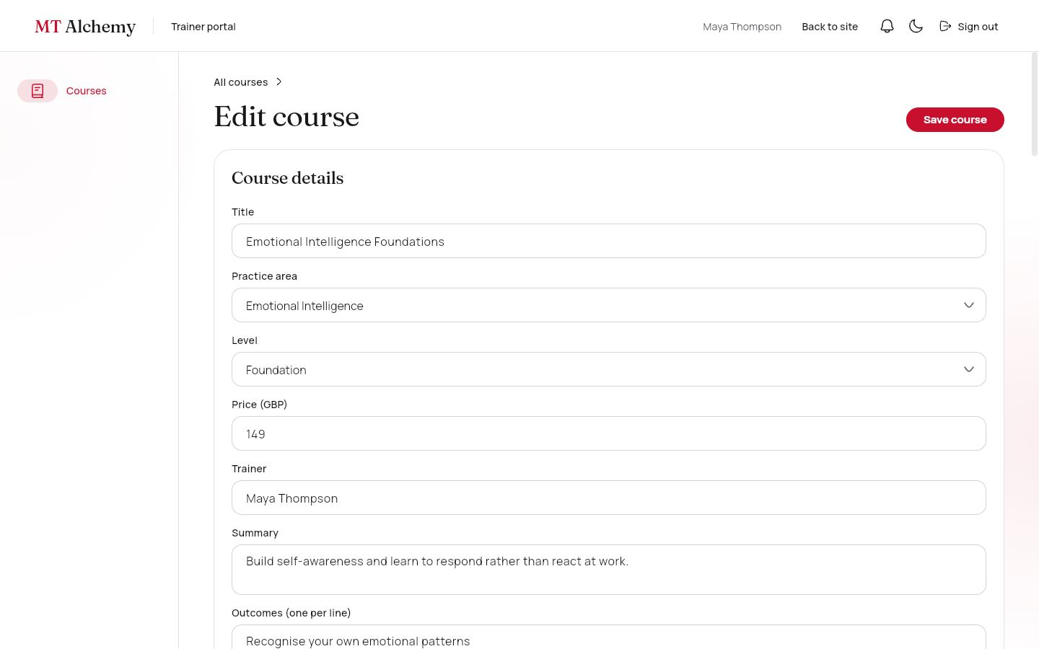 | 26. Course editor  /portal/admin/courses/:id Trainer, super admin  Create or edit a course: title, area, level, price, trainer, summary, outcomes, a published switch, and any number of reorderable lessons (video, PDF, reading, quiz with questions and a correct answer).  Data: courses. You can: Add lessons by type · Move up · Remove · Save.
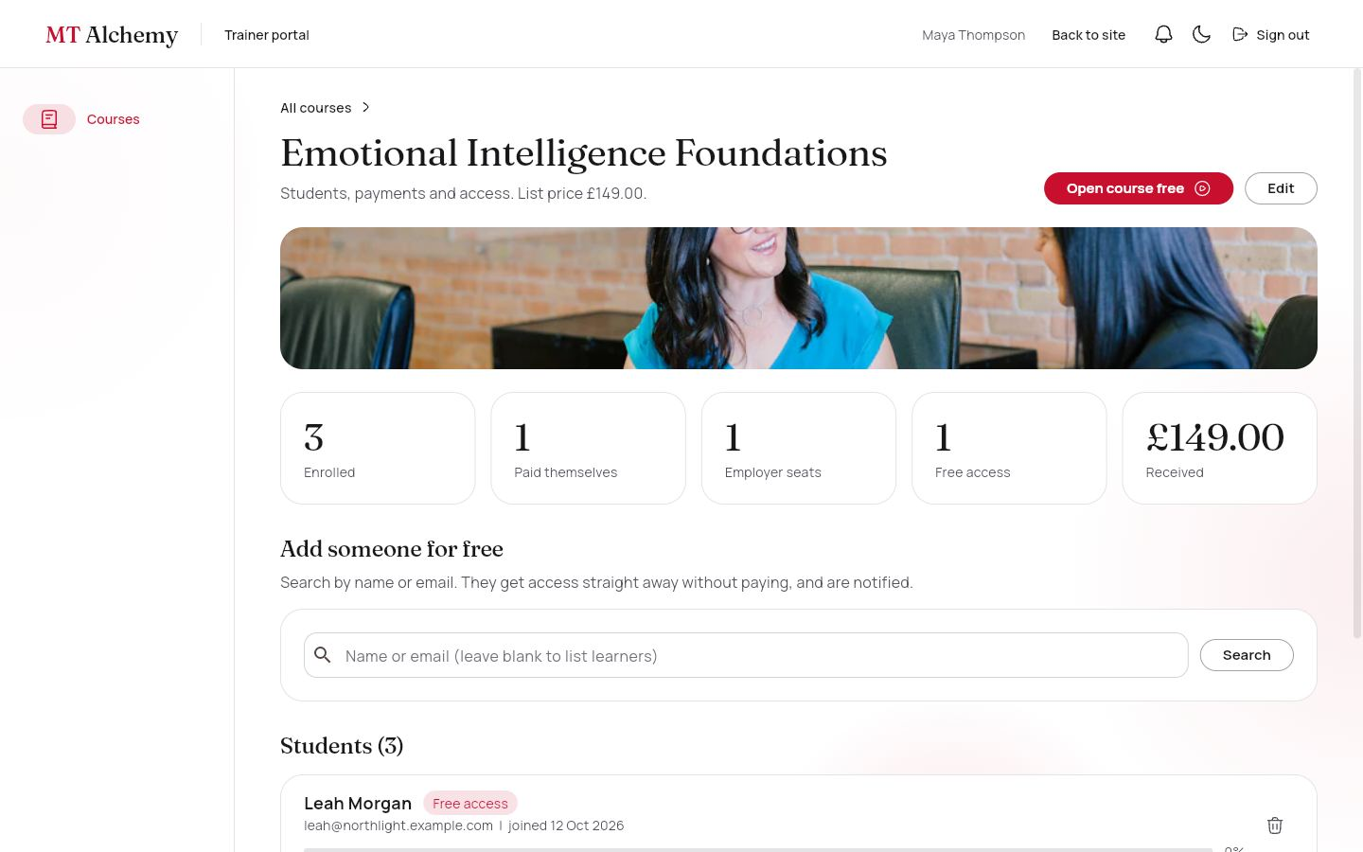 | 27. Students and payments  /portal/admin/courses/:id/students Trainer, super admin  Counts for enrolled, paid, employer seats, free access and amount received. Search any learner to give free access, or remove a student. Each row shows how they joined (Paid £149, Employer seat, Free access), their email, join date and progress.  Data: enrolments (live), users, notifications. You can: Search and Give free access · Remove from course · Open course free.

4.6 Super admin portal
For the platform owner. Side navigation: Dashboard, Users, Courses, Products, Orders and shipping, Enquiries, Content.
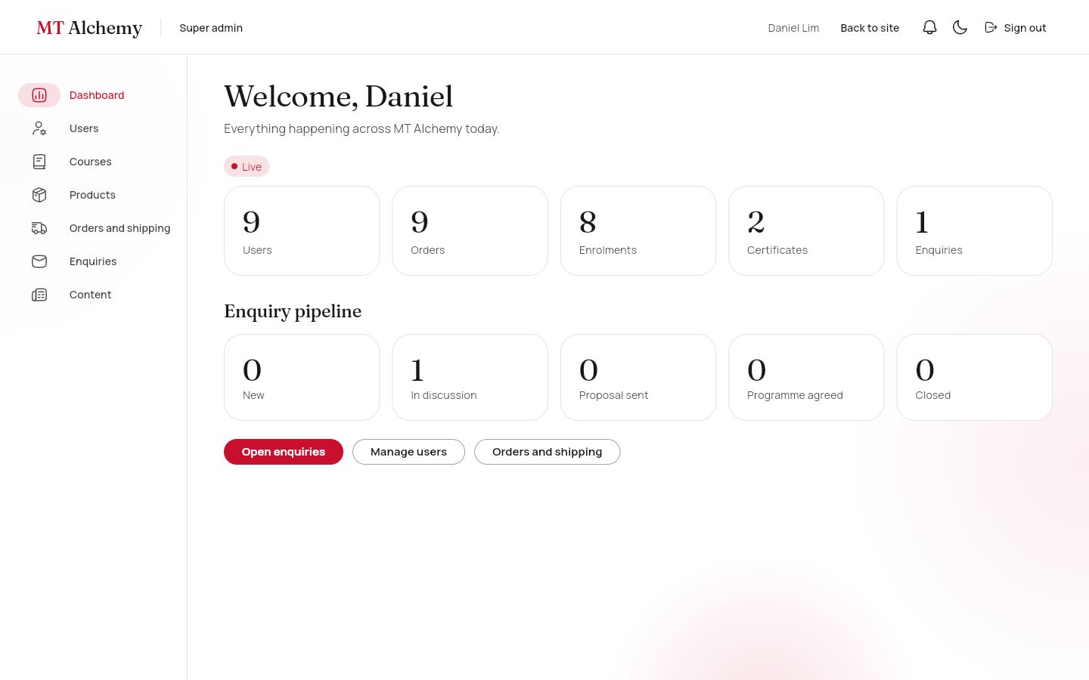 | 28. Dashboard  /portal/super Super admin  Live totals for users, orders, enrolments, certificates and enquiries (with a pulsing Live badge), and the enquiry pipeline by status.  Data: snapshot listeners on five collections. You can: Open enquiries, users, orders.
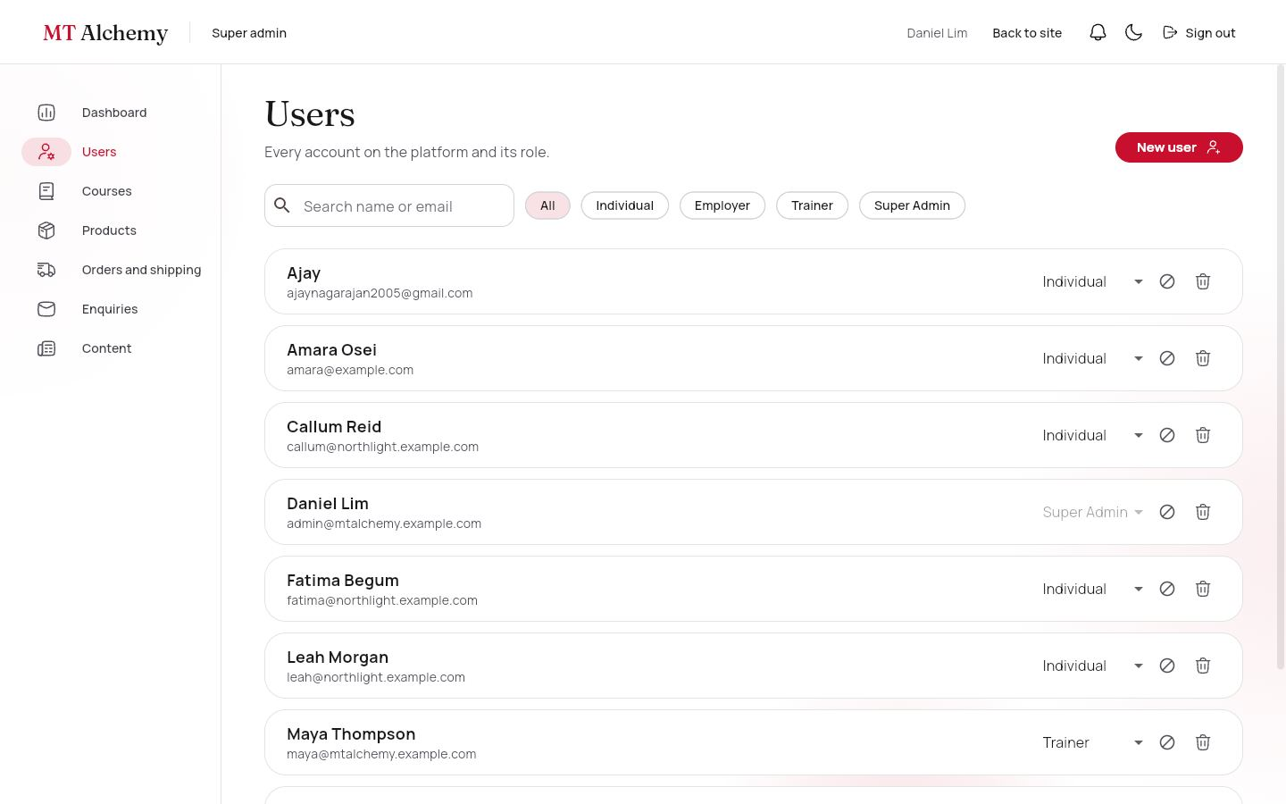 | 29. Users  /portal/super/users Super admin  Every account with search and a role filter. Change a role, disable or enable, delete a profile, or create an account for anyone (through a second Firebase app, so the admin stays signed in).  Data: users. You can: Change role · Disable · Delete · New user.
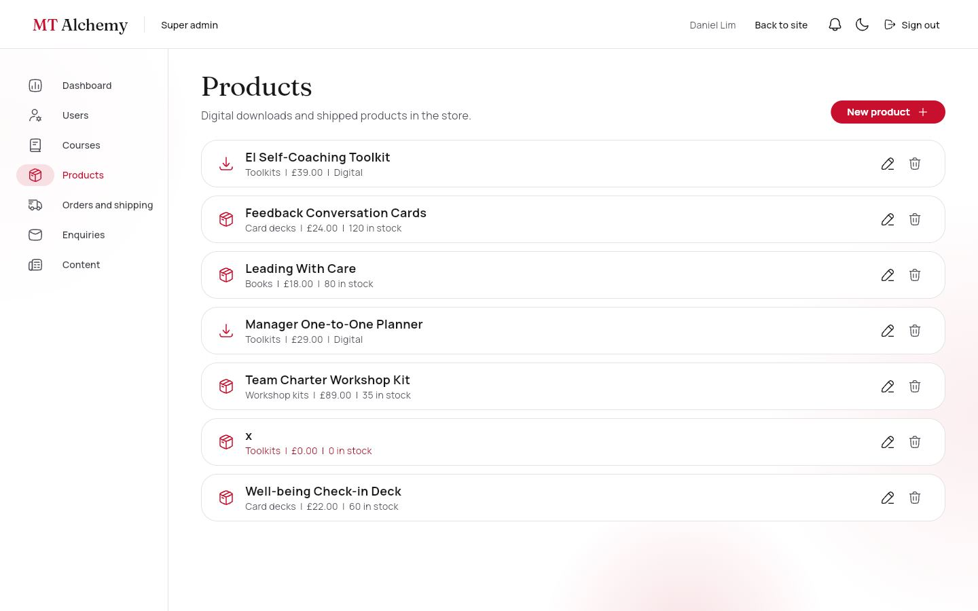 | 30. Courses and products  /portal/super/courses · /products · /products/:id Super admin  Courses use the same management screens as the trainer portal. Products list digital and shipped items with category, price and stock (low stock shows in red). The product editor sets name, category, type (Shipped or Digital download), price, stock or download file, summary, description and details.  Data: courses, enrolments, products. You can: Edit · Delete · New product · Save.
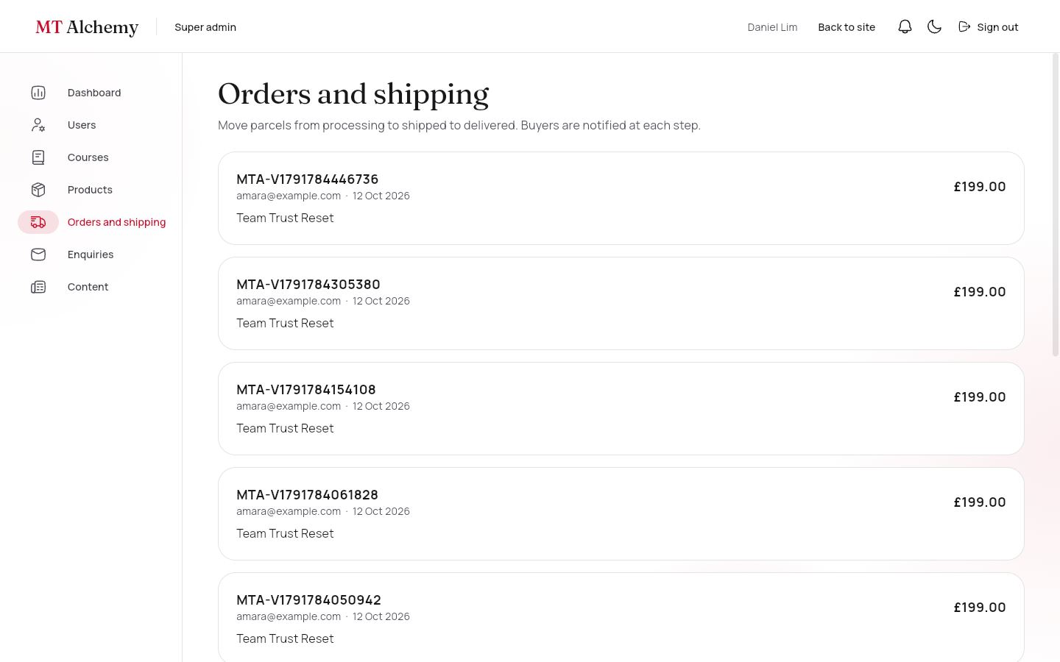 | 31. Orders and shipping  /portal/super/orders Super admin  Every order with items, delivery address and delivery timeline. One button moves a parcel to the next status and notifies the buyer.  Data: orders, shipping, notifications. You can: Mark as shipped · Mark as delivered.
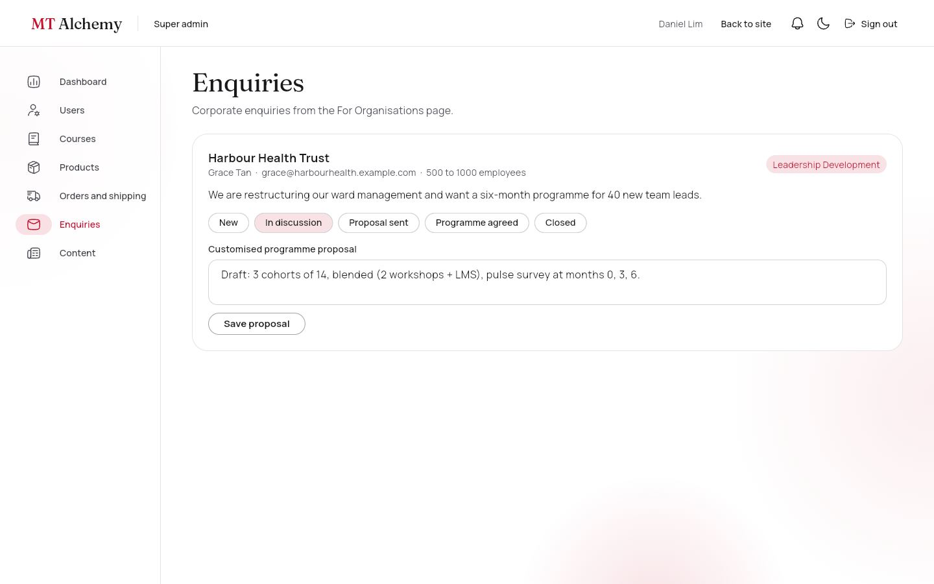 | 32. Enquiries (Journey E)  /portal/super/enquiries Super admin  Corporate enquiries with a status pipeline (New, In discussion, Proposal sent, Programme agreed, Closed) and a field for the customised programme proposal.  Data: enquiries. You can: Change status · Save proposal.
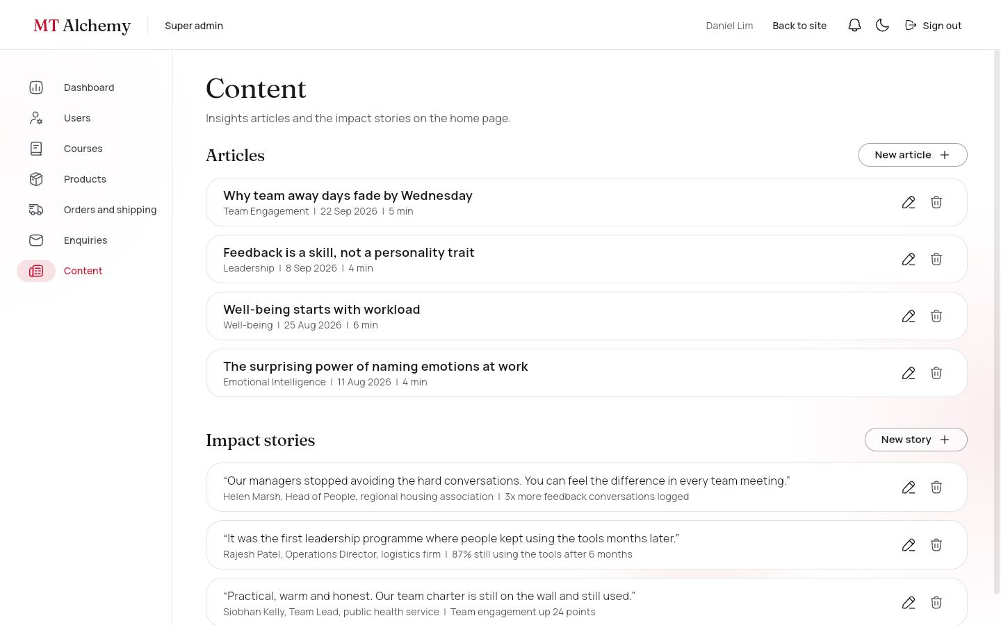 | 33. Content  /portal/super/content Super admin  Create, edit and delete Insights articles and Impact Stories.  Data: articles, impactStories. You can: New article · New story · Edit · Delete.

5. The five user journeys

A · Individual learning
- Register and choose a career stage and interest areas (/register).
- The catalogue shows only courses that match both (/portal/me/courses).
- Buy the course and pay at checkout (test card 4242 4242 4242 4242).
- An enrolment is created from the paid order; the dashboard shows progress.
- Open the course: watch the video, read the PDF, Mark complete, Next.
- Pass the quiz (70% or more) to finish and receive a certificate with a public verification link.

B · Digital product
- Store, then the EI Self-Coaching Toolkit.
- Add to cart and check out (no delivery address, no shipping).
- A payment record is created in test mode.
- My downloads, then Download. The count is tracked.

C · Physical product
- Store, then Cart (delivery is free from £50 of shipped goods).
- Enter a delivery address at checkout and pay.
- Stock is reduced in a transaction and a shipment is created as Processing.
- The super admin marks it Shipped (with a tracking number), then Delivered; the buyer is notified each time.

D · Employer
- Register an organisation (/register?type=organisation).
- Add employees; they join automatically when they register with that email.
- Buy courses: choose the number of seats and pay.
- Assign courses to people; each assignment uses a seat.
- Watch the progress report and analytics update live.

E · Corporate enquiry
- Open "For organisations" from the landing page or footer.
- Submit the enquiry (saved to Firestore).
- The super admin inbox tracks it: New, In discussion, Proposal sent, Programme agreed, Closed.
- The admin writes the customised programme proposal.

Staff free access
- A trainer or admin opens any course free (admin preview, nothing is saved).
- Courses, then Students shows enrolled, paid, employer seats and free access.
- Search a learner to give free access, or remove someone. A removed payer is not refunded automatically.

6. Data and security

Collections (22)
Each entity is a top-level collection. Lessons and quiz questions are embedded in the course document so the player loads in one read; order items are embedded in the order.
Collection | Key fields | Written by
users | name, email, role, orgId, careerStage, interests[], gender, country, hobbies[], disabled | The person at registration (individual or employer only); super admin
organizations | name, sector, size, ownerId, seats {courseId: n} | Employer
employees · assignments | orgId, name, email, team · employeeEmail, courseId | Employer
courses | title, level, serviceSlug, price, imageUrl, published, modules[] {type, mediaUrl, quiz[]} | Trainer, super admin
enrolments | userId, courseId, source (purchase, assignment, granted), amountPaid, completedModuleIds[], quizScores, progress, status | Learner (needs a paid order or an assignment); staff for free access
certificates | code, userId, courseId, userName, courseTitle, issuedAt (public read) | Learner, only when the enrolment is complete
products · productCategories | type (digital or physical), stock, fileUrl, imageUrl, price | Super admin (checkout may only reduce stock)
carts · orders · payments | items · status, totals, orgId · amount, last4, gateway "test-mode" | The buyer
shipping · downloads | status, tracking, history[] · url, downloadCount | Buyer creates; super admin advances shipping
articles · impactStories · founders | body[] · quote, metric · name, role, bio, imageUrl | Staff · super admin · super admin
reviews | targetId, userId, rating 1 to 5, comment | Signed-in learners
enquiries · contactMessages | organisation, interest, status, proposal · message | Anyone, guests included; the super admin manages them
notifications · assessments | userId, title, link, read · EQ scores | Staff and employers · the learner

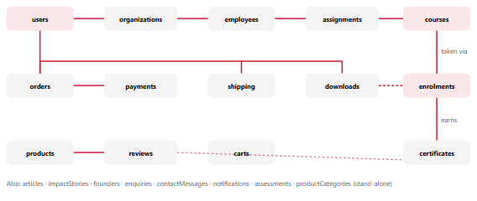
Figure 6.1. Main relationships. Solid lines are foreign keys held in the child document; dashed lines are optional links (an enrolment may come from an order or an assignment). The full ER diagram is in docs/ER_DIAGRAM.md.

Access rules (from firestore.rules)
Collection | Guest | Individual | Employer | Trainer | Super admin
courses | read published | read published | read published | full CRUD | full CRUD
products, articles, stories, founders, reviews | read | read; write own reviews | read | read; articles CRUD | full
users | none | own profile (no role change) | own profile | read all | full
organizations, employees, assignments | none | own assignments | own organisation only | read | full
enrolments | none | own (needs paid order or assignment) | own organisation's | read; grant and remove free access | full
orders, payments, shipping, downloads | none | own | own organisation's orders | none | full; advances shipping
enquiries | create only | create only | create only | none | read and update

The live verification script checks these rules. Users cannot change their own role. Self-registration can only create individual or employer accounts. An enrolment needs a paid order or an assignment. A certificate can be created only when the enrolment is complete. Employers cannot touch another organisation's data, draft courses are hidden from everyone except staff, and buyers cannot mark their own parcel delivered.

Business rules
Rule | Behaviour
Learning pathway | A course is open to a learner only if its level suits their career stage and its practice area is one of their interests. Student: Foundation. Professional: Foundation and Practitioner. Manager: Practitioner and Leader. Senior leader: Leader. Other courses stay visible but locked, with the reason. Employer assignments and staff are not restricted.
Pricing and shipping | Prices in GBP. Delivery is £4.95, free from £50 of shipped goods. Digital products and courses never ship.
Seats | An employer buys seats per course (stored on the organisation). Each assignment uses one seat per person and is refused when seats run out.
Progress and certificates | Progress is lessons completed divided by lessons. Quizzes pass at 70% and complete their lesson. Completing every lesson creates the certificate; its code is built from the first three letters of the course id and the start of the learner id.
Payments | Simulated gateway in test mode. A card number starting 4000 0000 0000 0002 is declined; any other valid test number is approved. Only the last four digits are stored.
Free access | Staff can create an enrolment with source "granted". It needs no order and no seat.
Offline fallback | If Firestore is unreachable, the bundled catalogue keeps pages working.

7. Design system, imagery and motion

Colour
Pure white (#FFFFFF), a neutral zinc "ash" scale (#F4F4F5 to #18181B) and Crimson Red (#C8102E) as the single accent for calls to action, active states, progress and focus. Grey-to-red gradients appear only at moments of change: a passed quiz, a completed order, a finished course. There is no grain texture. A full dark palette mirrors the light one.

Glassmorphism and type
A shared GlassPanel (backdrop blur, translucent fill, hairline border) is used on the navigation, hero copy, summaries and forms, a few per screen and never nested, with a solid fallback for high contrast. Headings use Fraunces and body text uses Manrope.

Imagery
Thirty free-licence Unsplash photographs, converted to WebP, appear on every course, product, service and article card. Courses and products store an imageUrl that admins can change; the seeded red ink artwork is the fallback. Founder portraits are uploaded from the site.

Motion
The landing film has a floating glass crystal and parallax particles. Content reveals in staggered steps on scroll. Every card lifts on hover with a soft red shadow, a photo zoom and press feedback; service cards also tilt in 3D. Pages change with a fade-and-lift transition, the menu glides to its landing section, EQ result bars animate and impact stories rotate. All of it respects the reduced-motion setting.

Accessibility
Icon buttons have semantic labels, form errors are announced through live regions, focus outlines are visible, the tour film has captions and chart legends spell out their counts.
Light theme | 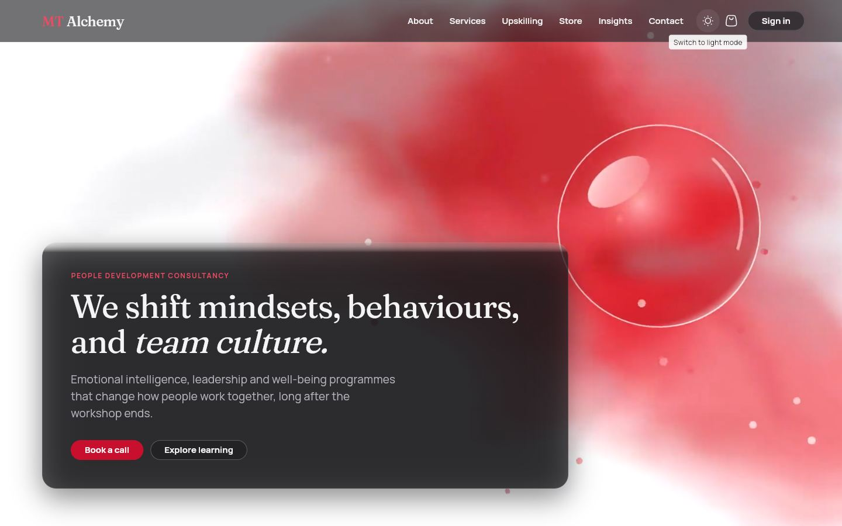  Dark theme | Photo service cards

Size | Width | Layout
Compact | under 600 px | Single column, full-width buttons, banner photos on cards, drawers for navigation.
Medium | 600 to 1023 px | Two columns, drawers for navigation.
Expanded | 1024 px and up | Side rails, three or four columns, fluid gutters (5% of the width, 48 to 120 px).

8. Videos, virtual tour and QR code
All videos are made with Remotion, which renders React components to H.264, so any film can be regenerated from code.
Film | Used on | Notes
hero_loop (+ dark) | Landing hero | Ink blooming through water, a floating glass crystal, parallax particles, a slow camera drift. An 8 second loop without a visible cut, under 1 MB.
services_loop (+ dark) | Services header | Quiet ink loop.
brand_intro | About page, lesson video | Brand film with the wordmark and four practice areas.
site_tour | Virtual tour | 42 seconds, 1280×720, no sound, with captions. Seven scenes: welcome, learn, shop, teams, trainers and admins, EQ check, call to action. The characters and the faceted-crystal mascot Alchy are drawn in SVG, so no outside artwork is involved.

The last section of the landing page shows a QR code that opens the tour. It encodes the site's own address, taken from the browser plus the build's base path, so it is correct on whatever host the site is published to. On localhost the page warns that the code only opens locally; on the live site it scans from any phone. The section also has "Open the tour" and "Copy link" buttons.
The virtual tour page (/tour): the film, then one card per part of the site to try. | The QR section at the end of the landing page, with a preview of the film.

9. Quality and verification
Check | Result
flutter analyze | No issues.
flutter test | 56 tests on a fake Firestore and mock Auth: cart rules; checkout writes (order, payment, shipping, download, enrolment, stock) and declined cards; shipping changes with notifications; enrolment from an order and from an assignment; quiz pass and fail; certificate issue and verification; employer seats, assignments, progress and weekly activity; staff free access, removal and revenue totals; founders and photos; theme toggle; validators; portal scrolling; screen layout.
npm run verify (live Firebase) | 39 of 39 checks pass. It signs in as each role over REST, performs each journey's writes and confirms forbidden writes are refused: a learner promoting themselves, enrolling without paying, or giving themselves free access.
Visual checks | Browser screenshots at 1440 px and 375 px, light and dark. The live GitHub Pages site was checked, including a deep link and a real sign-in.
Performance | Videos under 1.5 MB each; photographs 25 to 170 KB (WebP).

Firestore rule changes take a few minutes to reach every server. A verification run started in that window briefly saw the temporary open seed rules. Wait about three minutes after deploying rules before verifying; the script deletes the records it creates.

10. Deployment and operations
Task | How
Run locally | flutter pub get then flutter run -d chrome
Publish the site | Commit, then bash tools/deploy_pages.sh. It builds with the /mt-alchemy/ base path, copies index.html to 404.html so deep links such as /portal load, adds .nojekyll and pushes the gh-pages branch.
Change rules or indexes | Edit firestore.rules or firestore.indexes.json, run firebase deploy --only firestore, wait three minutes, then npm run verify.
Reset demo data | cd tools/seed && npm run seed. It exports the catalogue, opens the temporary seed rules, writes 71 documents and redeploys the real rules.
Re-render a video | cd video && npm run render:tour (or render:all).
Authorized domains | The Authentication allow-list holds localhost, *.firebaseapp.com, *.web.app and ajaynagarajan2005.github.io. Add any new domain under Authentication, Settings.
Day-to-day content | Trainer portal (courses); super admin (users, products, orders, enquiries, content); founder photo upload on the landing page cards (super admin).

Troubleshooting
Symptom | Likely cause and fix
"You do not have permission to do that." | A security rule refused the write. Check the role in users/{uid} and reproduce the case in verify.mjs.
Catalogue shows but never updates | Firestore is unreachable and the app is using the bundled catalogue. Look for "Could not reach Cloud Firestore" in the console.
"requires an index" | A new compound query. Follow the link in the error or add the index to firestore.indexes.json.
Portal is empty after login | The profile document is missing. Re-run the seed or create users/{uid} with a role.
QR code opens a blank or wrong address | The build was made without SITE_BASE. Rebuild with deploy_pages.sh.

11. Limitations and future work
Area | Current state and next step
Payments | Simulated in test mode with no real charge. Next: a payment provider such as Stripe with a server-side webhook, which needs Cloud Functions.
File storage | Firebase Storage needs the paid plan, so PDFs and downloads are served from the site's own /downloads folder and founder photos are stored in Firestore as small JPEGs. Next: Storage for lesson videos, PDFs and photos.
Email | Firebase sends password-reset email. Order receipts, employee invitations and enquiry replies appear in the app (notification bell) and are not emailed. Next: transactional email.
Certificates | Viewable and verifiable by link; there is no PDF download button yet.
Refunds | Removing a paying student does not refund them. An admin handles that with the payment provider.
Devices | Checked in desktop and phone-sized browsers. Native Android and iOS builds share the code but were not tested on devices.
Browser window fit | One report of the page not filling the window edge to edge on a particular display was not reproduced and remains open.
Hosting deep links | GitHub Pages returns HTTP 404 for deep links before the app loads, then the app renders normally. Firebase Hosting would return 200.
EQ self-assessment | An engagement tool with ten statements across five areas. It is not a validated psychometric instrument.
Hero video | An AI-generated landing clip was deferred; the Remotion films are used.

12. Appendices

A. Demo accounts
The password for every account is alchemy123. The login page also lists them.
Role | Email | What to try
Individual | amara@example.com | Course in progress, a shipped order, a digital download; pathway Professional with three interest areas
Employee | callum@northlight.example.com | Courses assigned by an employer; pathway Manager
Employer | priya@northlight.example.com | Employees, seats, assignments, progress, analytics
Trainer | maya@mtalchemy.example.com | Course CRUD, open courses free, students and free access
Super admin | admin@mtalchemy.example.com | Users, products, orders, enquiries, content, founder photos

Test cards for checkout: 4242 4242 4242 4242 (approved) or 4000 0000 0000 0002 (declined), with any future expiry and any 3-digit CVC.

B. Credits and licences
- Photographs: free-licence Unsplash images converted to WebP; the licence permits this use without attribution.
- Fonts: Fraunces and Manrope (SIL Open Font Licence) via Google Fonts.
- Icons: HugeIcons (stroke rounded set).
- Cartoon characters and mascot: original artwork drawn for this project.
- Packages: Flutter, go_router, provider, the Firebase plugins, fl_chart, qr_flutter, video_player, file_picker, image, flutter_animate and Remotion, each under its own open-source licence.

C. Glossary
- Pathway: a learner's career stage plus interest areas; it decides which courses they can buy.
- Seat: one employee's place on a course, bought by an employer and used on assignment.
- Free access (granted): an enrolment created by staff with no payment.
- Admin preview: staff opening a course without enrolling; nothing is saved.
- Alchy: the crystal mascot who narrates the tour.
- Seed: the script that fills Firebase with demo accounts and content.
- Test mode: payments are simulated and no real card is charged.

