February 25th, 2013

# REP ALERT Handheld Reference Thermometers and Super-Thermometers Trade-In Promotion

**Promise to end customer**Trade in your old thermometer and save 20% on a new 1523/1524 Reference Thermometer or a new 1594A/1595A Super-Thermometer

**Time frame**March 1st – June 30th, 2014

**How the program works**

* Check the trade-in list for which products this program applies.
* Trade-in discount for the customer is 20%.  
  Fluke Calibration funds 15%. The distributor needs to fund 5% of its own margin.
* Place your purchase order for the selected trade-in instrument with the words “THERMOMETER_TRADE-IN”
* Apply your PO value as follows:  
  (Euro list) **X** ( trade-in discount of 20%) **X** (standard resell discount minus 5%)
* Complete the Trade-In Form.
* Send Trade-In Form together with your order to Fluke
* Return trade-in unit together with a copy of the Trade-In Form within 8 weeks after delivery of the new unit. (See paragraph how to return your trade-in.)

**Trade-in list**

|  |  |
| --- | --- |
| **Trade in this old product** | **Receive 20% off the purchase price of this new product** |
| 1521 Thermometer | 1523 or 1524 Reference Thermometer |
| 1522 Thermometer | 1523 or 1524 Reference Thermometer |
| 1575A Super-Thermometer | 1594A or 1595A Super-Thermometer |
| 1590 Super-Thermometer | 1594A or 1595A Super-Thermometer |

rade ine of these: For a new one of these: Discount %

Be aware, the older 1521/1522 handheld thermometer and 1575A/1590 Super-Thermometer models **become obsolete at the end of February 2014.**  After that date, calibration services will still be offered for these products, but parts will no longer be available to repair them. There will never be a better time to replace those old products with new, improved models – at a savings of 20%.

**Promotion rules**

* Trade-in can be claimed on purchases between March 1st and June 30th, 2014
* This trade-in offer is only valid for products listed on the trade-in list.
* A trade-in will only be considered for each ***equivalent***  product. The decision whether a trade-in product qualifies is up to the discretion of Fluke.
* By submitting your PO for this program you promise to return the trade-in instrument within 8 weeks upon delivery of the new instrument. A trade-in unit not returned within 8 weeks may give Fluke the right to claim back the trade-in discount.
* Products that are traded in must be in working condition.
* This offer is for trade-in transactions only and no cash returns will be made.
* This offer cannot be combined with any other discount.
* This offer is only valid for purchases in Europe (excl. CIS).
* Fluke reserves the right to change or withdraw the Fluke Calibration Trade In program at any time, without any prior notice.

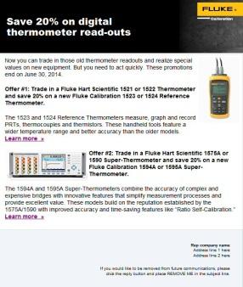

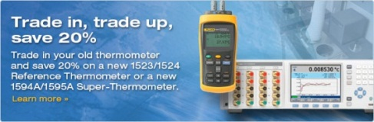**Promotion tools**

* Html mailer in eng, ger, fre, spa
* 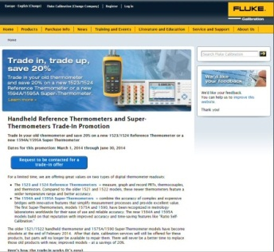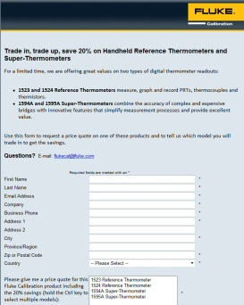Web banners, web page and trade-in form on Fluke Calibration website in eng, ger, fre, spa:   
  [www.flukecal.eu/thermometer-trade-in](http://www.flukecal.eu/thermometer-trade-in)  
  [www.flukecal.de/node/67183](http://www.flukecal.de/node/67183)  
  [www.flukecal.fr/node/67185](http://www.flukecal.fr/node/67185)  
  [www.flukecal.es/node/67186](http://www.flukecal.es/node/67186)

**How to return your trade-in unit**

Return the trade-in unit together with a copy of the trade-in form within 8 weeks after delivery of the new unit to:

Fluke Europe B.V.  
Science Park Eindhoven 5110  
5692 EC Son  
the Netherlands   
Att.: Mr. Peter de Jonge

**Trade-in promo is valid for purchases between March 1st and June 30th, 2014**