Google resources hirarchy

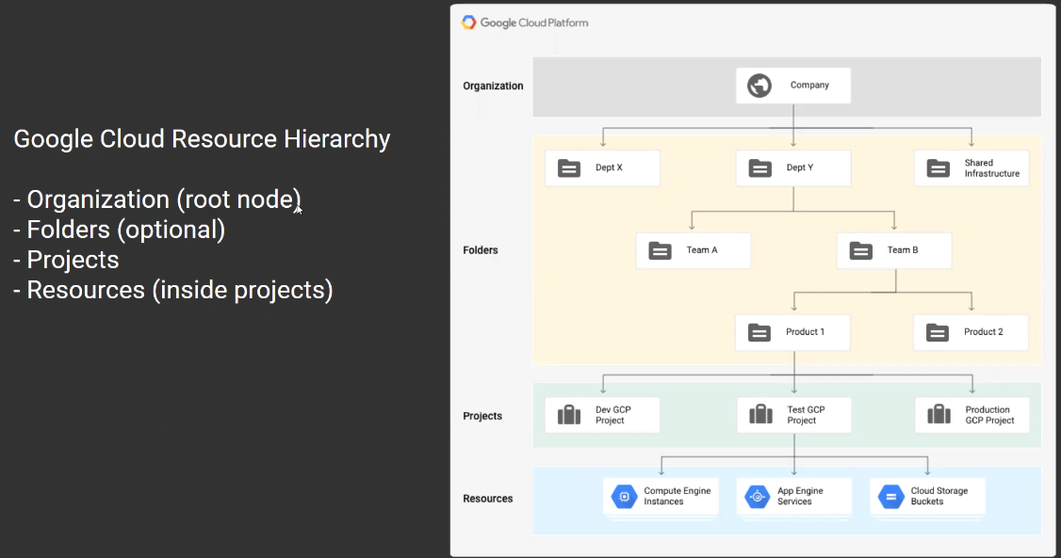

Register company as organization

Permissions are inherited to its next level, if we apply permissions to top level inherited to next level

Organization accounts are not applied to gmail accounts

Google gmail accounts

Google organization registered accounts

For google organization setup need registered company website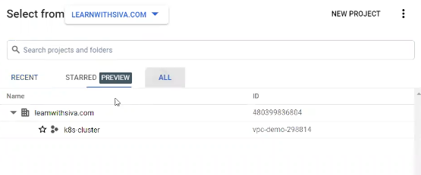

Folders are used to isolate the environment, to organize the resources and not mandatory

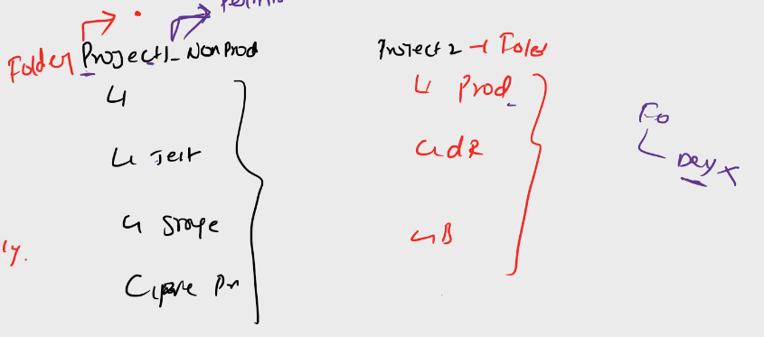

We can move project between folders, once applied permissions to projects, if we move projects to other folders permissions wont apply and need to provide permissions again

We need to troubleshoot the permissions related issues

Projects are the core google organizational component in the google cloud platform

Projects to maintain resources, using projects we can budget, billing for the used resources

We can analysis resource utilization and optimization to manage budgets



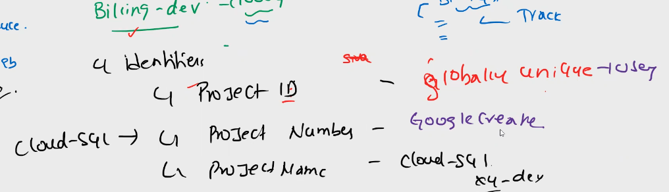

Whle creating project we need to consider 3 identifiers

1. Project ID
2. Prject Number
3. Project Name

Project names are globally unique, google assigns random ids if we don’t git any name

Google creates project number which can not be changed once created

Gmail google cloud accounts

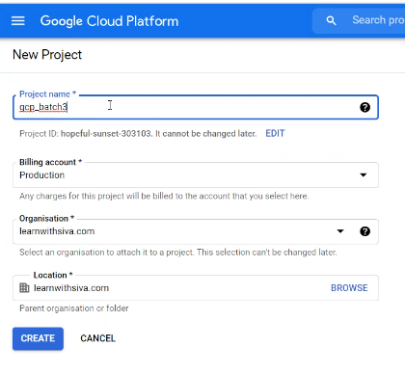

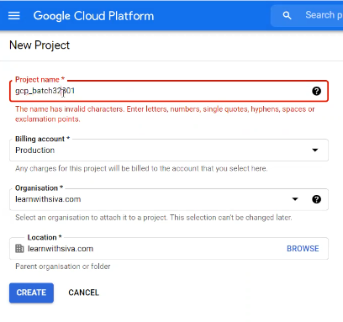

Can not accept symbols

Limitations for gmail registered google cloud accounts

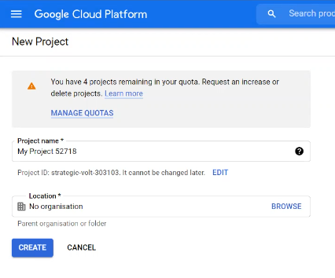

We can create only 5 projects, if we need more need to request google support for additional resources

Organization google account

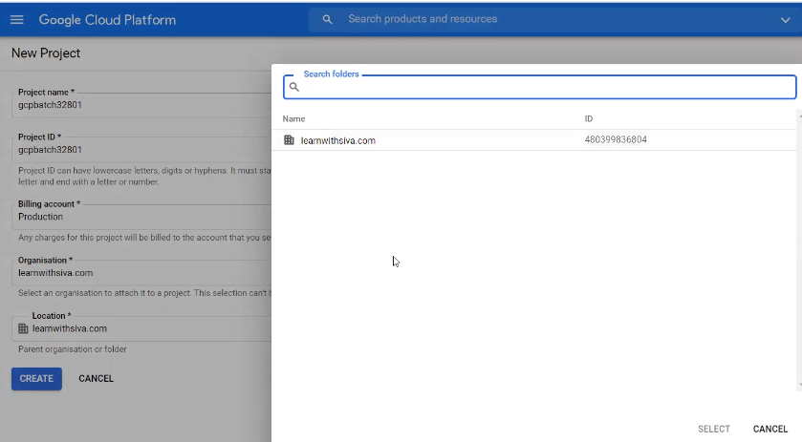

Organization registered google cloud accounts

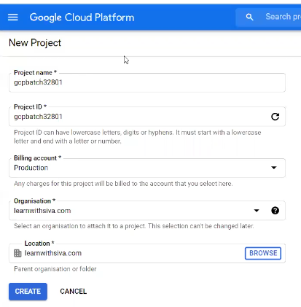

To link billing account to projects

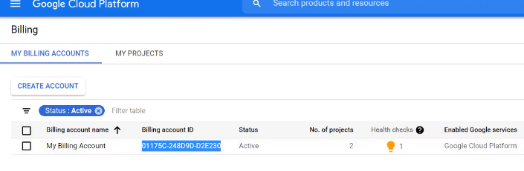

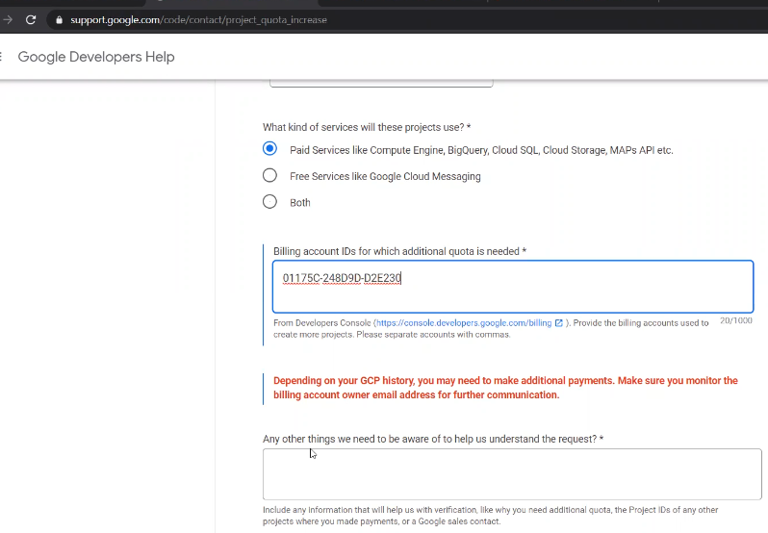

Assigning projects to billing accounts

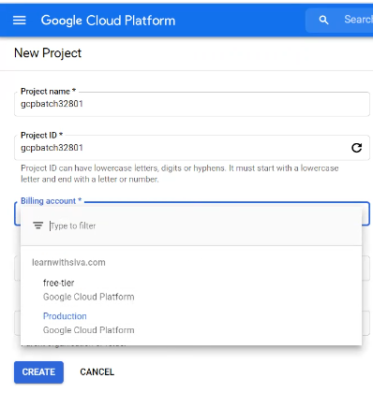

Project numbers are used for API access and integrations

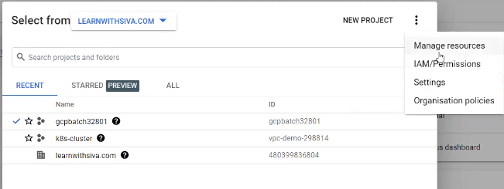

We can delete the Projects using manage resources option

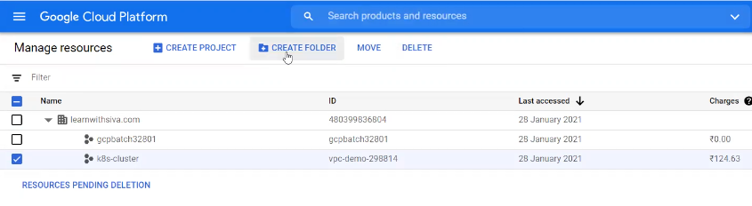

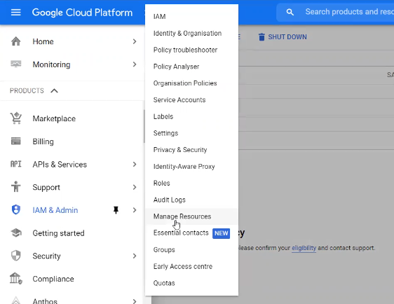

We can chanve project name, can not change project id and project number

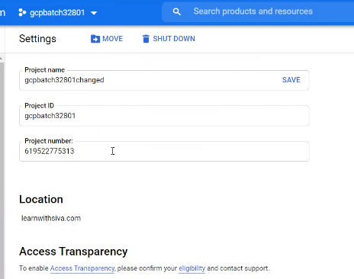

Bydefault no projects are associated to billing account if we are using gmail accounts

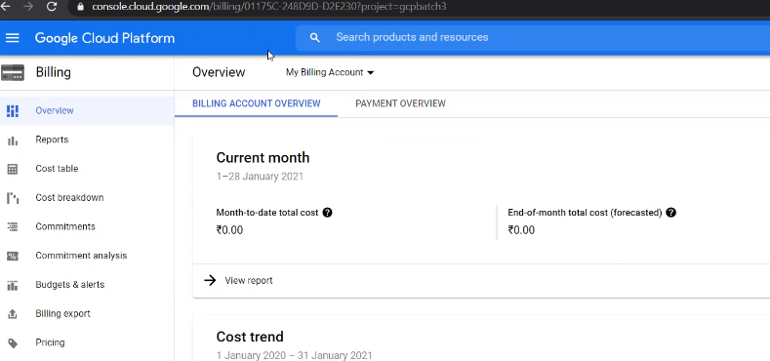

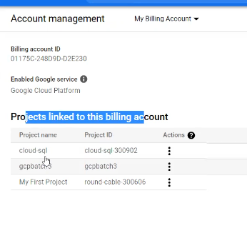

Creating new billing account

