**Abstract**

**PlayHere** is the learning and practicing platform where you can learn or practice multiple-choice questions by playing quizzes, and it helps all types of students who want to learn or practice for any entrance exam. It also improves your knowledge by allowing you to practice on this platform multiple times.

**Introduction**

**PlayHere** is one of the best Learning and Practicing platform.

Here you can practice multiple-choice questions for different types of entrance exams like GATE, UPSC, BPSC, CPT, NEET, JEE and Technical Interview Questions.

Here you can practice questions by playing games.

### Technology Survey

**Python**

Python is a popular programming language. It was created by Guido van Rossum, and released in 1991.

It is used for:

* web development (server-side),
* software development,
* mathematics,
* system scripting.

**Framework Used**

**Django**

Django was design and developed by Lawrence journal world in 2003 and publicly released under BSD license in July 2005. Currently, DSF (Django Software Foundation) maintains its development and release cycle.

* Rapid Development
* Secure
* Fully loaded
* Open Source

**Pillow**

The Python Pillow library is **a fork of an older library called PIL**. PIL stands for Python Imaging Library, and it's the original library that enabled Python to deal with images. PIL was discontinued in 2011 and only supports Python 2.

**Pandas**

**Pandas is a Python library for data analysis**. Started by Wes McKinney in 2008 out of a need for a powerful and flexible quantitative analysis tool, pandas has grown into one of the most popular Python libraries. It has an extremely active community of contributors.

**SQLlite**

SQLite is a C-language library that implements a [small](https://sqlite.org/footprint.html), [fast](https://sqlite.org/fasterthanfs.html), [self-contained](https://sqlite.org/selfcontained.html), [high-reliability](https://sqlite.org/hirely.html), [full-featured](https://sqlite.org/fullsql.html), SQL database engine. SQLite is the [most used](https://sqlite.org/mostdeployed.html) database engine in the world. SQLite is built into all mobile phones and most computers and comes bundled inside countless other applic ations that people use every day.

**Analysis and Modeling**

Analysis

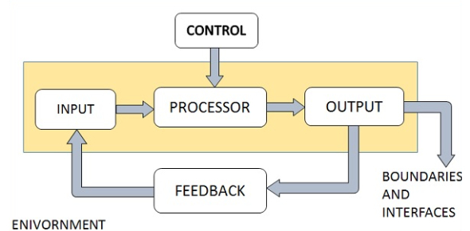

**UML Modeling**

**Data Flow Diagram**

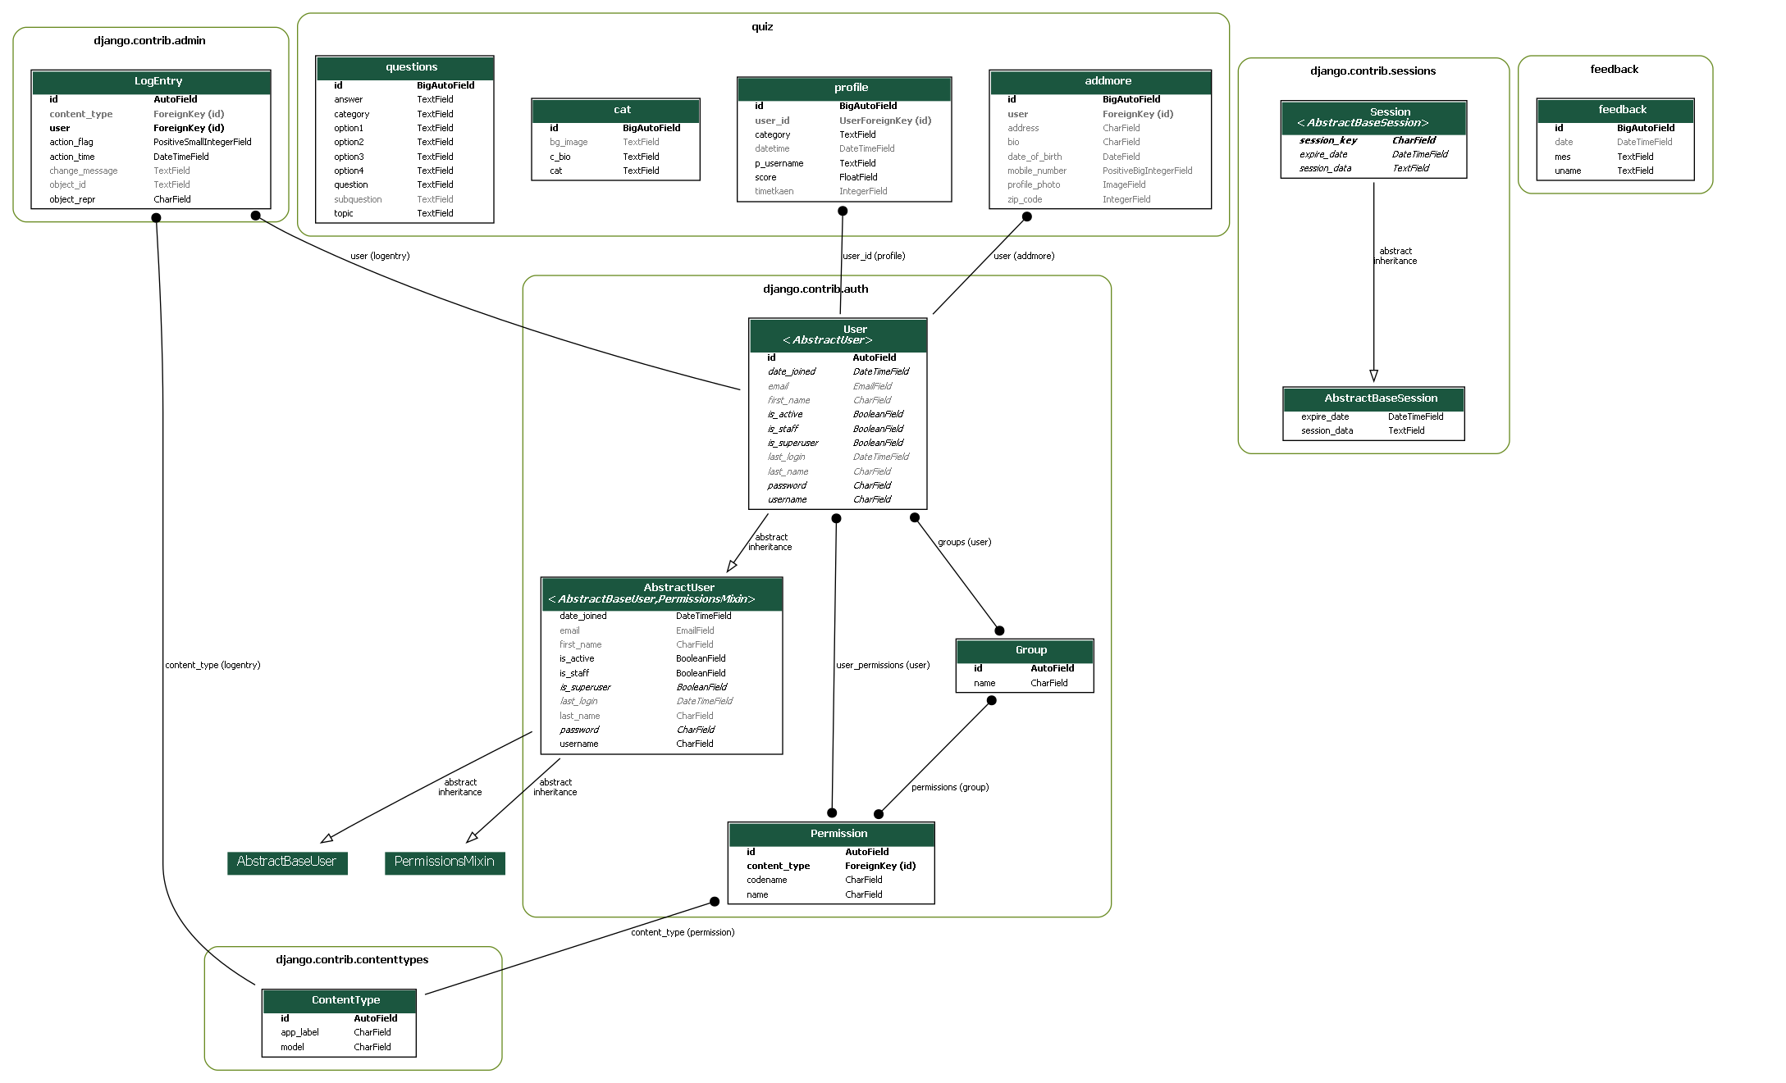

**System Requirement**

**Hardware**

* 2 GB RAM
* 5 GB free disk space
* Intel-3 or above

**Operating System Requirement**

* Windows 7 or above
* Mac OS X 10.11 or higher, 64-bit
* Linux: RHEL 6/7, 64-bit (almost all libraries also work in Ubantu)
* x86 64-bit CPU (Intel/ AMD architecture

**Software**

* VS Code, PyCharm or another IDE
* Internet Browser like Chrome, internet-explorer, etc

### References

### Book

### Programming and problem solving with PYTHON (Ashok Namdev Kamthane, Amit Ashok Kamthane )

### URL

* <https://stackoverflow.com/>
* <https://www.w3schools.com/>
* <https://docs.djangoproject.com/>
* <https://giphy.com/>
* django-extensions.readthedocs.io