**INTRODUCTION**

The project intends to make the management of records easier — via a mobile phone application.

The application is called “ApplicationDB” and it primarily targets educational institutions.

The app provides full CRUD functionality so that the user can create, view (read), update or delete a record.

The application is very user friendly, and provides a clean user interface for faster interaction. There are four buttons (one for each of create, read, update, delete functionalities).

To create a new record, the user is required to fill three columns — enrolment number, name, and phone number. The unique identifier for each record is enrolment number (or ID). Hence, only this enrolment number is required to delete an entry from the database.

Even though the focus was on the educational institutions, the app can easily find its use in plenty of industries and organisations where maintenance of records has to be done.

***Project Goal:***  
The goal of the project was provide a user friendly solution for managing records, which can be accessed very easily. The web application ‘AdmissionDB’ provides a very simple user interface which can be operated by anyone.

***Project Objectives:***  
The objective of the project was to simplify the maintenance of large records in organisations/corporations, mainly educational institutions. Learning was also a very big objective of this project. The overall project was very insightful. One of the main challenges was to choose the correct platform so that it can be accessible by everyone. I learnt how to integrate SQLite database with C#, make user friendly layouts, etc.

***Project Scope:***  
Even though the focus was on the educational institutions, the app can easily find its use in plenty of industries and organisations where maintenance of records has to be done. For example, the same application can be transformed for the use of small scale business owners who need to have one-click access to their employee database.

**TECHNOLOGIES USED**

The project was created using Visual Studio. The primary language used is C#, the other two are CSHTML and SQLite.

The application has been developed for Web platforms, using the popular open source C# framework (ASP.NET).

CSHTML provides the layout, views or the front-end of the application. At the same time, SQLite (local database system) has been used as database.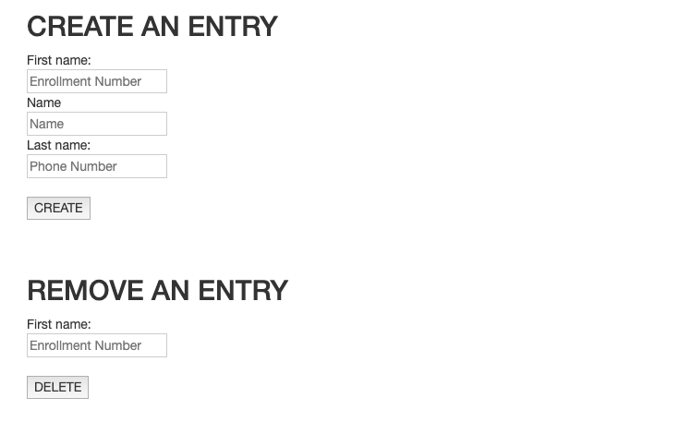

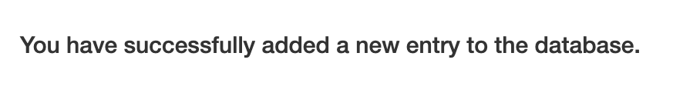

**HOW TO USE**

1. Create an entry:  
   Fill out the details (enrollment ID, name, phone number) in the ‘CREATE AN ENTRY’ section, and click “CREATE”.
2. Delete an entry:  
   Choose the profile that has to be deleted. Fill out the text box with enrolment ID under “DELETE AN ENTRY” section, and click the button. The profile associated with the given enrolment ID will be deleted.
3. Read data  
   Press the upper most link called “Access the database”. A new page will be launched with all the records available in the database.