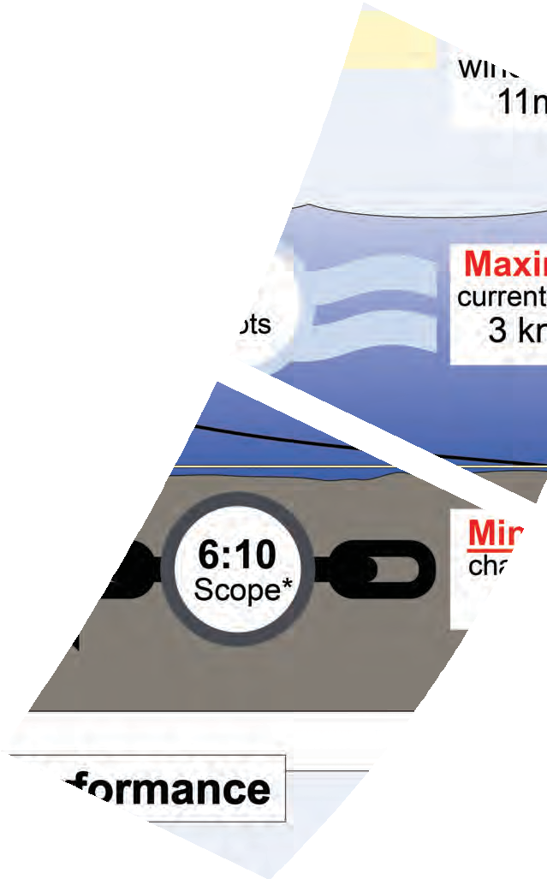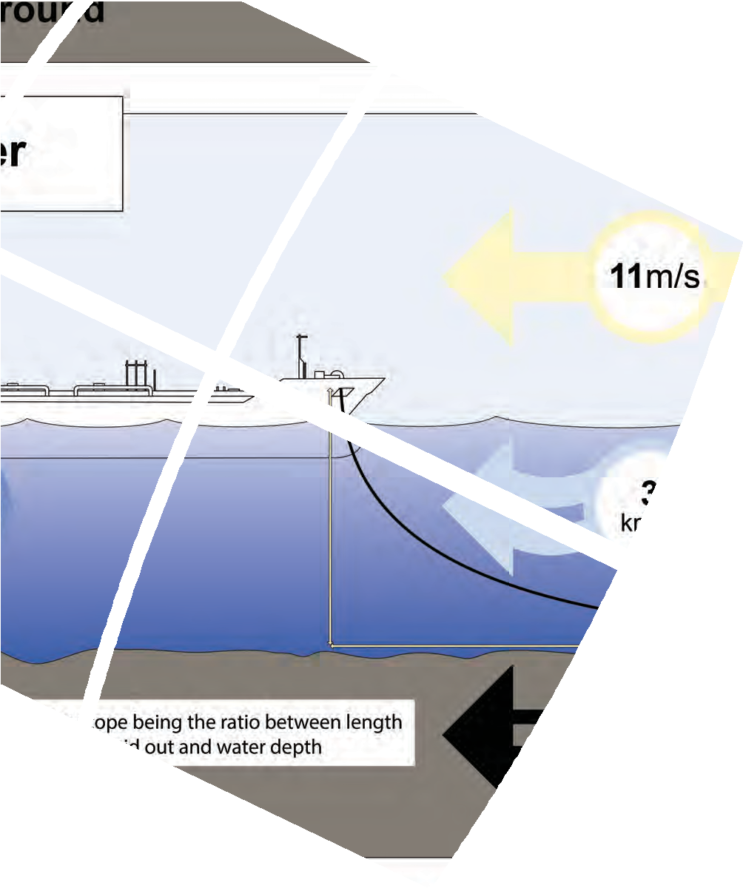

**9**

**Anchoring Guidelines: A Risk-Based Approach**

**Anchoring Guidelines: A Risk-Based Approach**

**© INTERTANKO 2019**

**All rights reserved**

Whilst every effort has been made to ensure that the information contained in this publication is correct, neither the authors nor INTERTANKO can accept any responsibility for any errors or omissions or any consequences resulting therefrom.

No reliance should be placed on the information or advice contained in this publication without independent verification. All rights reserved.

Distribution or reproduction of this publication is strictly prohibited unless prior authorisation has been granted by INTERTANKO.

V1. March 2019

# Contents

Introduction 5

Scope of the guidelines 5

Introduction 5

Objective 6

Part One – A Risk-Based Approach 7

Introduction to a risk-based approach 7

TMSA 3 7

The bow tie approach 9

Operational phases and fault categories 9

Risk index and risk ranking 10

Part Two: Anchoring Guidelines 11

Design and building of the ship and the anchoring equipment layout 12

General 12

Design criteria to be used 12

CCTV monitoring system 12

Compliance with Panama, OCIMF Requirements/Recommendations 12

Anchoring mock-up tests at Yard 12

Operating in ice conditions 13

Distance of anchor to side shell 13

Windlass/Anchor winch 14

Windlass general 14

Grease nipples 14

The brake drum 14

Anchor winch brakes 15

Windlass brake lining wear monitoring device 15

Cable tension monitoring system 15

Chain 16

Chain General 16

Chain counters 16

Chain Stopper 16

Anchor Washing 16

Bitter end 17

Chain lockers 17

Maintenance 17

Maintenance, testing and routine inspections 17

Anchoring operation 18

Planning of the anchoring operation 18

Anchoring, an introduction 19

Anchoring 21

Special conditions 21

Deep water anchoring 22

Anchoring handling operations in adverse weather conditions 22

Anchoring in piracy-prone areas 22

Emergency Anchoring 23

Approaching SBM and oil fields 23

Conventional buoy moorings (CBM) 23

At anchor 23

Use of ECDIS wile at anchor 24

Anchoring for layup or extended periods: 24

Anchoring operations and their impact to environment 24

Heaving up the anchor 25

Recovery of Anchor / Preventing Anchor loss 25

Part Three – The Human Element 26

Technical skills and behaviour 26

Intertanko Competency Management Guidance (ICMG) 26

Training 26

Basic competency for anchoring operations 26

Soft Skills and Behaviour 27

Human factor considerations relating to anchoring (Human Performance) 28

Live anchoring audits: 29

Appendices

Appendix 1 – Lessons learned in anchor handling operations 32

Introduction 32

Common cause of anchor loss 32

Common technical failures 33

Human factor 34

Appendix 2 – Worked example on risk-based approach – bow tie technique 35

Operational Phases

Operational/human error 35

Technical failure 35

External factors 36

Managerial/organisational issues 36

Appendix 3 – Worked example on risk-based approach – Hazid technique 42

Appendix 4 – General Guidelines on Anchoring equipment inspection and maintenance 47

Technical suggestions and considerations 47

Chain stoppers adjusting plates 47

Windlass with high pressure hydraulic motors 49

Appendix 5 – Templates 52

Template for training requirements

Appendix 6 – Personnel engagement for anchoring operation 54

Foreword

# Foreword

Anchoring is a common and vital operation on any ship. However, it has been widely felt that anchoring equipment designs have not kept up with the evolving industry demand for anchoring ships in deeper and more exposed anchorages. When identifying the challenges associated with anchoring procedures, there was an evident need to review the minimum required construction standards of the windlasses, as vessels are currently anchoring at depths above their lifting capacity.

Mitigating the safety risks associated with anchoring operations is paramount in an industry that has been striving to eliminate personnel injuries, prevent harm to the environment and limit damage to equipment.

This publication highlights the key concerns and technical recommendations across a range of topics including the design of hydraulic systems, an area vulnerable to failures that have led to serious injuries. By identifying the challenges associated with current standards and systems, this publication complements existing technical recommendations and guidance relating to the operation and maintenance of anchoring equipment.

Although the guidelines are primarily targeted at ship operators, they also offer a valuable insight to anyone involved in the design, operation and maintenance of anchoring systems, providing further understanding and awareness of equipment limitations through a risk-management approach.

This document also focuses on human factor considerations and, in line with TMSA recommendations, provides risk-based guidance for the training and auditing of crew members involved in anchoring, while also offering best-practice procedures through the risk assessment process.

I would like to thank the INTERTANKO Secretariat and Working Group members for their dedication and contribution to this publication and for providing their essential input and expertise in relation to safer anchoring operations.

.

### Capt. Pantelis Patsoulis – Euronav

**Chairman of the INTERTANKO Nautical Sub-Committee**

Introduction

# Introduction

### Scope of the guidelines

The scope of these guidelines is to cover:

* A guide for ship designers and shipyards on anchoring equipment
* Generic operational guidelines, including emergency procedures
* Maintenance and technical aspects on anchoring equipment
* Human element aspects and training of crew for anchoring

The guidelines also cover the sections on anchoring as laid out in the Oil Companies International Marine Forum (OCIMF) Tanker Management and Self-Assessment Programme 3 (TMSA3) (OCIMF, 2017) and when so deemed appropriate, go beyond TMSA3.

TMSA3 is not laid out to be prescriptive, and these guidelines should not be read as being prescriptive either. While the target audience of these guidelines contains ship managers, operators and ship builders, these guidelines may also be useful in assisting ship owners, managers, operators and training centres to promote safe anchoring operations on board.

### Introduction

Over the past century, the anchoring of ships has seen considerable changes due to the growing demand of products and maritime trade, which in turn has led to an increase of vessel size and expansion of commercial anchorage areas.

Anchoring incidents are associated with equipment failure, personnel injuries and in extreme cases loss of life, where the root causes have been identified to be mainly related to poor seamanship, lack of planning and mishandling of equipment.

Taking into consideration the deeper waters and exposed locations where ships are expected to anchor, there is an apparent need for re-evaluating the risk and current equipment design parameters.

In accordance with The International Association of Classification Societies (IACS) in Unified Requirements (UR) the anchoring equipment design is intended for “a ship within a harbour or sheltered area” and “not designed to hold a ship off fully exposed coasts in rough weather”.

To further complicate matters, at present, the windlass minimum design load lift for vessels without a Deep Water Anchoring (DWA) notation is three shackles (82.5 metres) and the weight of the anchor, when it is hanging vertically (IACS). The fact that the equipment has not kept up with the development and mass increases of the loaded vessels can be commonly experienced in deep water anchorages (such as in Fujairah). Therefore, examining the day-to-day challenges and in view of the recent accidents related to anchoring equipment, design and construction as well as the testing and approval procedures should be re-evaluated to reach more stringent industry performance standards.

INTERTANKO BUNKER COMPLIANCE CLAUSE for Time Charterparties – General Provisions

It is important to point out that this document is intended as guidance only and does not need to be strictly implemented or followed. The guidelines can be used to ‘pick and choose’ according to what is relevant to the reader and the ships operated, trading patterns, etc.

### Risk-based approach

In line with TMSA recommendations, these guidelines provide a risk-based approach to anchoring. The first part of this publication will discuss fundamental risk assessment principles in relation to anchoring.

### Objective

The overall objective of this document is to establish industry best practice that will enhance safety for anchoring in the industry.

Introduction to a risk-based approach

# Part One: A Risk-Based Approach

### Introduction to a risk-based approach

Work on these guidelines began in the wake of several incidents and accidents that occurred on-board ships. This section will list some of the outcomes of the accidents and incidents and trace them back using the fault categories for the various operational phases. The result will be action items and areas of improvement for a ship operator to consider when making decisions relating to procedures, training and human factors, maintenance, and new building contracts, etc, to minimise the risks associated with anchoring.

The Standard Club, in its *ANCHORING – Special Edition* (Standard Club, 2008), described a number of catastrophic outcomes of anchoring incidents. The Standard Club had seen 40 incidents over two and half years where anchoring was a major contributing cause, including:

* 15 lost anchors
* 8 collisions while at anchor – dragging anchor or another vessel dragging anchor and colliding
* 4 groundings because of being at anchor
* 5 piracy attacks whilst at anchor
* 6 anchor chains fouled, 3 with other vessels at anchor
* 1 pollution incident
* 1 total loss /grounding

This ten-year-old report is supported by recent reports from INTERTANKO Members on anchoring; DNV GL, Gard and The Swedish Club (DNV GL, Gard and The Swedish Club, 2016) had very similar findings in their reports on anchoring. The above list can therefore be used as a basis for a list of catastrophic outcomes of anchoring incidents. The list is not exhaustive and should not be taken as a definitive list to be used in all risk assessments on anchoring. The lessons learned in anchor-handling operations from the number of accidents within the industry are summarised in Appendix 1, which can be referred to for further explanation. This includes special focus on the most common causes of anchor loss and failures, common technical failures and human factor considerations.

The TMSA recommendation to have “procedures developed by the company following risk assessments” is a sound approach. This section covers the risk assessment from a high level and the thought process that generally goes in to all risk identification. All companies have their own way of carrying out risk management, this section does not imply or suggest that companies should change how they carry out risk assessments.

According to the International Maritime Organization (IMO), risk is the *“combination of the frequency and the severity of the consequence”*, it links the likelihood of occurrence and the probability of severity of the consequences.

### TMSA3

Element 6 of TMSA3 describes how operators should establish planning and operational procedures for mooring and anchoring operations, and ensure that these procedures are effectively implemented.

Details on anchoring can be found in 6A.1.1 and 6A.2.2.

TMSA 3 – 6A.1.1 lists the following to be included in the procedures:

* Roles and responsibilities.
* Planning including toolbox talk.
* Requirements for risk assessments.
* Mooring arrangements and layout.
* Anchoring methods.
* Use of main engine (and thrusters if fitted).
* Ensure protection of personnel and safe operation of equipment.

TMSA 3 – 6A.2.2 goes further and lists procedures for anchoring operations that will be developed following risk assessments. These should address:

* Methods of anchoring.
* Equipment design limitations and characteristics.
* Emergency anchoring.
* Anchor watches, including actions to be taken when dragging or at onset of bad weather.
* Emergency departure from an anchorage.

To identify the existing preventive and mitigating safety barriers, as well as risk control measures, a ‘bow tie’ approach could be adopted. The bow tie illustrates the functions of various barriers in relation to an anchoring incident. The schematic Figure 1 opposite illustrates possible causal chains leading to anchor incidents and the escalation of the consequences into the final outcome in terms of fatalities, injuries, damage and impact.

The Bow tie approach

### The bow tie approach

The bow tie approach may not be used in Member companies where other methods are more common.

However, to explain the thought process that should go into all risk assessments, the bow tie approach is usually a good visual presentation. The bow tie approach as illustrated below shows a causal chain of incidents and the various controls and barriers to be identified.



**Human Error**

**Fatalities**

**Technical Failure**

**Injuries**

**External Factors**

**Anchoring Incident**

**Losses**

**Organisational**

**Pollution**

**PREVENTATIVE SAFETY**

**SAFETY BARRIERS**

**SAFETY BARRIERS**

**SAFETY**

**ESCALATION CONTROLS**

**MITIGATION OF**

**Operation**

**Causes**

**Accident Event**

**Emergency**

**Final Consequences**



**PREVENT DETECT RESTORE**

**DETECT CONTROL MITIGATE**

**Deviation from normal operation**

**CAUSAL CHAIN**

**The consequences of the incident**

### Figure 1: The bow tie approach

The causal chain to follow involves a systematic discussion of initial failure events, causes and preventive safety barriers at various levels before an anchoring incident occurs. After that, follow-up with the barriers to detect, control and mitigate the consequences of the incident. At this stage, possible gaps or weak barriers may be identified and the need and possibilities for additional safety barriers may be found.

The green side of the bow tie can be further elaborated into a fault tree. The red side can also be further elaborated by an event tree analysis and allows quantitative estimations of final consequences.

The outcome could lead to new or updated procedures, design criteria, training procedures, etc. Appendix 2 provides further explanation and a case study example.

*Operational phases and fault categories*

The risk assessment process can also be divided into “operational” phases and “fault categories” (ref Fig 1 horizontal dotted arrows).

An example of operational phases for anchoring involves:

* Design and building of the ship and the anchoring equipment layout.
* Maintenance.
* Planning of the anchoring operation.
* Anchor operations: o Anchoring
  + At anchor
  + Heaving up the anchor.

In addition to these operational phases, a number of general fault categories could be listed and addressed specifically for each operational phase. Discussions on potential basic faults in these categories could serve as a checklist that all hazards have been identified.

*“Human error” (Operational):*

It is well established that human error is a known root cause of anchoring incidents. Operational errors due to lack of training, lack of safety awareness, human fatigue or complacency are commonly reported in accident/ incident investigations.

*“Technical failure”:*

Exploding hydraulic pumps or brake failure in critical situations may lead to damage potentially involving groundings or injuries. The industry has seen failing designs to be the root cause of several incidents.

*“External factors”:*

These include:

* Extreme and unpredicted weather.
* Acts of third party ships or vehicles operating near the location of the anchoring operations (sabotage and acts of war are, however, not addressed here).

*Organisational issues (Managerial)*

Managerial and organisational issues and potential hazards may be related to economic constraints, commercial pressure or stress, leading to under manning, delay of heaving anchor during bad weather, lack of maintenance and low competence, non-compliance with safety regulations and vetting policies on the ship, etc.

*Risk index and risk ranking*

Taking the above into account, there are several ways to make a hazard identification and subsequently a risk ranking exercise, but this is beyond the scope of these guidelines. However, Appendix 2 “Worked example on risk-based approach” and Appendix 3 “Hazid technique” include examples of risk assessments. These are for demonstration purposes only and each company is encouraged to use its own methodology for applying a risk-based approach when carrying out risk assessments.

These guidelines will look at incidents as set out above and put them into the bow tie approach to find potential causes, barriers, and ways to mitigate the consequences.

Within a company, where more specific facts are known, correct barriers, and procedures can be formed by using a Hazid approach and following a risk ranking exercise. Appendix 3 “Worked example on risk-based approach” provides further explanation in these areas.

Design and building of the ship and the anchoring equipment layout

# Part Two: Anchoring Guidelines

### Design and building of the ship and the anchoring equipment layout

This section is intended as a guide for ship owners who order new ships.

The suggestions below are not intended as a form of industry best practice, but more as a list for the ship- owner to bear in mind as part of a risk-based approach when evaluating the ship’s anchoring design and equipment layout.

The final list could be longer or shorter than that laid out here. It’s noteworthy that additional features to anchoring equipment could increase the safe operability of the systems but their maintenance and repair could increase the operational expenses of a vessel.

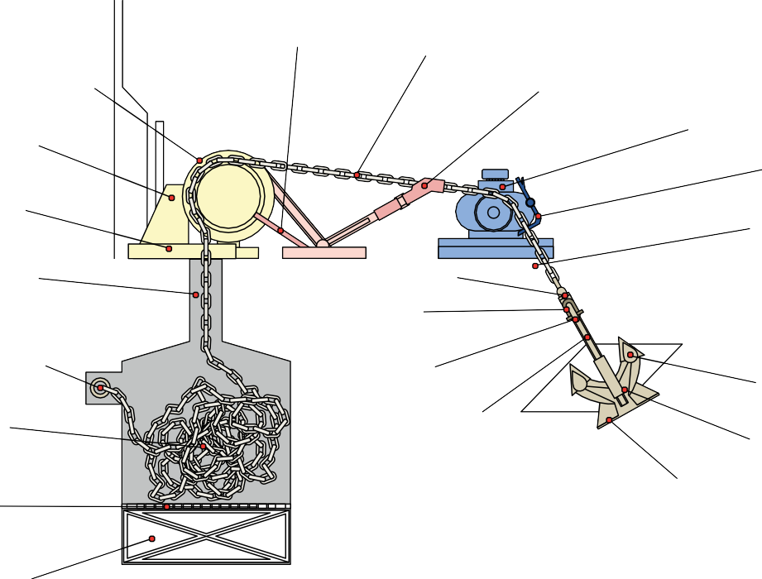

Stripper Bar

Chain Cable

Chain Lifter (Gypsy)

Alternative Means for Anchor Lashing

Chain Stopper

Windlass

Anchor Lashing

Windlass Bed

Hawse Pipe

Spurling Pipe

Swivel

'D' Shackle

Bitter End

Anchor Shackle

Anchor Fluke

Anchor Shank

Chain Locker

Bolster

Anchor Crown

Perforated Grating

Bilge Well

### Figure 2 Glossary

*General*

*Design criteria to be used*

IACS requirements state: “The equipment is therefore not designed to hold a ship off fully exposed coasts in rough weather or to stop a ship which is moving or drifting. In this condition the loads on the anchoring equipment increase to such a degree that its components may be damaged or lost owing to the high energy forces generated, particularly in large ships.”

Recommendation:

Evaluate the possible need for increasing the anchoring equipment strength beyond minimum IACS class requirements, especially if you will be anchoring in deep waters or exposed areas in high wind speeds.

*CCTV monitoring system*

The fitting of closed circuit television (CCTV) monitoring on forecastle is now affordable and will give a clear picture of what is happening on the forecastle. The camera is fitted at high elevation on the mast to cover the full area of the forecastle.

Recommendation:

The owners should consider fitting CCTV systems which will give live information to the Master to allow a good assessment of mooring and anchoring operations. This will also enhance the security surveillance on the forecastle deck through remote anti-piracy watch from the bridge. CCTV cameras should be easily accessible for maintenance and function for rotation to stow in shelter position when not required.

*Compliance with Panama, OCIMF Requirements/Recommendations*

The design of anchoring and mooring system to be in compliance with the latest Panama and OCIMF requirements and guidance.

Recommendation:

Special attention should be paid to the *OCIMF Anchoring Systems and Procedures* (OCIMF, 2010). While the latest *Mooring Equipment Guideline v4* (OCIMF, 2018) is included in the documents that the construction of the vessels should comply with.

*Anchoring mock-up tests at Yard*

The flukes of the anchor should firmly attach the bolster at a minimum of two points. This will prevent the anchor from moving. The correct position of the anchor during heaving and stowing is essential as well. The two aforementioned conditions should be verified during the design stage and the performance of a mock-up test will assist to verify a well-operating design.

Recommendation:

The mock-up test should be carried out before the approval of “Arrangement of Anchor Handling” drawing. The presence of a buyer representative during the mock-up test may be substituted by a video showing the results of such a test.

Distance of anchor to side shell

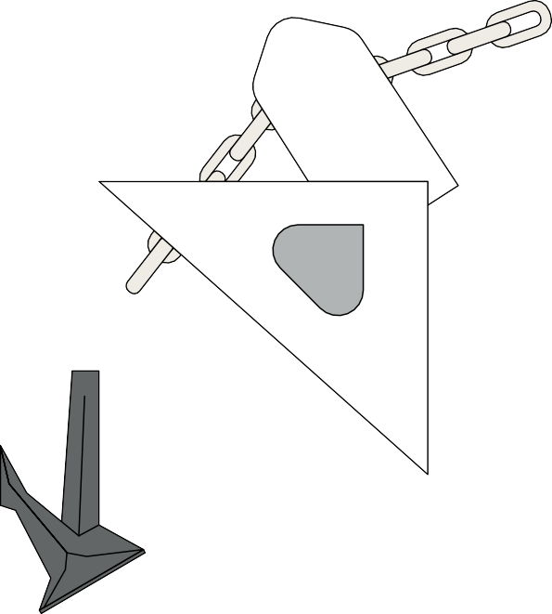

### Figure 3 Mock up test

*Operating in ice conditions*

Attention to special requirements (regarding materials and or type) when operating in extreme sub-zero weather conditions.

Recommendation:

* The lubrication oil used should be suitable for low temperatures
* The power pack should be equipped with a heater for the lubrication oil to be kept warm.
* Vessels likely to encounter freezing spray conditions at sea must have a means of clearing ice from Anchor hawse pipes and windlasses before arriving at the pilot station.

*Distance of anchor to side shell*

The distance between side shell and anchor during heaving operation should be carefully considered.

Recommendation:

Minimum distance of anchor to side shell during heave up or let go is to be considered at design/construction stage, to avoid impact damages on the side shell. Side shell scantlings’ to be reinforced and minimum distance to be increased.

*Windlass/Anchor winch Windlass general* Recommendation:

The following should be considered as part of a newbuilding specification:

* Equipment should be designed to meet the loads that it will be exposed to (as an example, will the ship anchor beyond 82.5 metres depth?) and ensuring that windlass motors do not get overloaded.
* Foundation of the Windlass should be strong enough to withstand the static and dynamic loads during heave up and let go. Analytical methods are to be considered to assess the design.
* It has been observed that the bushes/shafts in the way of drums suffer higher levels of corrosion than the bushes/shafts in way of pedestals. A design that provides a more effective greasing should be applied. Installation of roller bearings instead of plain bushes could be a solution.
* There are designs where the pedestals are welded directly to the upper deck. Such a design is much simpler its maintenance is easier (no bolts, difficult to access points). In such a case, the journals should be of split type.
* For electrically driven windlass smooth operation during anchorage, a variable frequency drive motor and relevant supportive electrical installation should be considered.
* For high-pressure hydraulically driven windlass protection of the hydraulic motor during anchoring operation, interlock to low speed running needs to be considered.
* Windlass hydraulic motors should be designed so as not to suffer catastrophic failure in case of overload or reverse running. A protection cover on the motor should be considered to reduce the risk of flying debris and injury to the operator should the motor not be fully protected.

*Grease nipples*

The greasing of the moving parts of windlasses and mooring winches is of high importance. So grease nipples should be installed on all necessary parts.

Recommendation:

Some shipyards use grease nipples of JIS design. Bayonet (ball type) type should be considered for more effective greasing. It is good practice to highlight with contrasting paint the location of the grease nipples in order to easily identify them all during routine maintenance.

*The brake drum*

If the brake drum/disc surface is made of mild steel it will corrode faster. The rate of corrosion is faster when the brake is applied for long voyages and exposed to shipping sea sprays. The salt water will get absorbed in the brake band material and will cause faster corrosion of mild steel surfaces. The resulting corroded mild steel surface will cause the brake lining to wear out quickly and the uneven drum surface leads to a significant reduction in the brake’s holding power due to corrosion. On larger vessels, a manually-operated brake handle wheel takes a long time to rotate for application of the efficient brake force and sometimes the cable may not be stopped effectively in time and an entire cable is lost from the bitter end.

Recommendation:

Consideration should be given to using stainless steel for all brake surfaces which will provide a smooth, clean and corrosion-free braking surface (OCIMF 2010b). This will also assist the effective transfer of the heat released while applying the brake. The stainless-steel surface should be clad welded to the base material for disc brake surfaces or the brake pads.

Cable tension monitoring system

The use of hydraulically assisted fail-safe brakes or torque-controlled brakes are preferable for larger chain sizes, for example from 70-80nmm and above (OCIMF 2010b). This should be incorporated with spring application and hydraulic release for swift and easier operation.

Furthermore, the provision of remotely operated controls should be considered for the protection of the operator.

*Anchor winch brakes*

Today, many anchor winches brakes are hydraulic. In such cases there should be clear instructions on how to operate the anchor winch brakes manually or in cases of complete blackout.

Recommendation:

All anchor winch brakes should be operable in cases of a complete blackout. Manufacturers should provide clear instructions on how to do this and crew should be trained accordingly.

If hydraulic brakes are installed it is advisable that a dedicated feed pump supplying the oil to the brakes is installed. This pump should be connected to the emergency switchboard.

*Windlass brake lining wear monitoring device*

It is essential that the brake lining is in good condition for the effective operation of the brakes. Reduced thickness of the brake lining could result in inadequate braking force.

Recommendation:

A feature indicating the minimum acceptable brake lining thickness could provide warning that it is time for the brake lining to be changed. The brake lining is attached to the brake band with bronze flat head bolts. These bolts should be well embedded in the brake lining more than the minimum thickness of the brake lining so that the bolts do not touch the brake drum.

*Cable tension monitoring system*

Calculating the various external forces on the anchor system such as wind, current and wave, with their combinations is difficult. A remote monitoring system could provide a great benefit here, such as the use of a load monitoring device comprising “load cells” fitted in the way of windlass brake or in chain stopper for the real time measurement of mooring load on the chain. The system also includes wireless, intrinsically safe, portable monitors that can alarm at high loadings.

Recommendation:

The owners should consider fitting load cells to measure these forces in real time. The data from this cell will provide early warning to the officer on watch (OOW) of forces approaching the design limits of the anchoring system.

The power supply of such systems should be connected to the emergency switchboard.

Note: Different systems exist, including those measuring tension (load) on the break and those that measure on the stopper. Chain stoppers with load cells are used at the offshore industry and it is a mature technology. However, such a system will be useless if the chain load is not on the chain stopper and it is on the windlass brake. Care should be taken when choosing a system for this reason and the right procedures should be in place for the chosen system.

*Chain*

*Chain General*

Recommendation:

The following should be part of a newbuilding specification.

* A swivel piece at the extreme outboard end of each chain cable
* Chain cable marking; for the easy identification of the number of shackles released in the water, adequate number of stainless steel bands to be applied on the chain link.
* It is good practice for the stainless steel band not to touch the material of the chain directly in order to avoid galvanic corrosion.

*Chain counters*

Chain counters help the anchor party to measure the dropped shackles easily, while avoiding close contact with the cable. During anchoring operations, the dust from the spurling pipe makes it difficult for the anchor party to observe and measure the cable visually. It is observed that the anchor marking does not last for very long.

Recommendation:

Chain length counters should be fitted on the cable. The mechanical type is for local reading only. Electrical markers can be fitted with local and remote reading on bridge, providing real-time information to the bridge team and allowing safer control and better efficiency.

Note: The readings will not be accurate and may lead to incorrect decisions if maintenance and calibration is not carried out in a timely manner. The chain counter system disadvantages and lessons learnt should be taken into account before taking the decision to install them.

*Chain Stopper*

The existing design of chain stoppers can provide adequate protection from losing the chain cable when the vessel is anchored but not during heaving; therefore fail safe chain stoppers should be considered. The design of chain stoppers should take into account the aging of the chain cable (including elongation) so the position of the toggle should be adjustable. The position and the height of the chain stoppers should be carefully chosen so that the chain is always aligned between the windlass gipsy wheel and hawser pipe.

Recommendation:

Chain Stopper with adjusting sims plates, to adjust the position of the stopper bar for ensuring good contact with the chain shackle.

It is advisable that the chain stopper is initially tack welded and a test is carried out in the presence of the buyer representative confirming that the wheel of the chain stopper is properly aligned to the chain when heaving or lowering – only then should the chain stopper be fully welded.

*Anchor Washing*

It is good practice to keep your anchor chain as clean as possible. Mud will not accumulate within the chain locker when the chain is clean and moreover the wear of the chain will be reduced. Further to this there is a USCG 33 regulation CFR 151-2050 that in Section (e) states: *“Rinse anchors and anchor chains when the anchor is retrieved to remove organisms and sediments at their places of origin.”*

Recommendation:

For enhancing cleaning, four nozzles of adequate design /angle should be installed in each hawse pipe. It is good practice for the nozzles to be installed in two levels.

Maintenance, testing and routine inspections

*Bitter end*

The bitter end should have been designed to keep the end part of the chain in position. It is not designed to keep the end part of the chain when the chain has been accidentally deployed in speeds higher than normal. Such condition could cause damage to the chain locker structure. The securing pin should be designed with a weak point (IACS rules require it to be >15% and < 30% of cable MBL) so that when forces higher than the structure strength are exercised, the pin breaks, preventing further damage to the steel construction.

Recommendation:

A quick-release ability should be considered, combined with, during drawing approval, that the securing pin has been designed with a weak point. It is at the operator’s discretion to choose what is preferable, the loss of an anchor or damage to the steel structure of chain lockers, most probably accompanied also by a loss of anchor.

*Chain lockers*

There are chain locker designs short in height but broader in width which, in combination with chain stowage angle, do not allow the self-stowage of the chain unless the crew guide the chain through a manhole.

Recommendation:

Chain lockers should be of suitable design to self-stow the full length of chain properly during heaving up. The bilges of the chain lockers should have adequate height for easy access during cleaning.

Moreover, the effectiveness of the drainage system should be demonstrated.

### Maintenance

This section is intended as a guide for ship owners on maintenance. The following suggestions are not intended as a form of industry best practice, but more as a list for the ship owner to bear in mind as part of risk-based approach when evaluating things such as cargo, crewing, trading area, size of ship, life expectancy, etc, to develop a planned or condition maintenance system. The final list can be much longer or shorter than what is laid out here.

*Maintenance, testing and routine inspections*

The detailed instructions of maintenance, testing and routine inspections of anchoring equipment should be given in the company’s safety management system (SMS) and/or planned maintenance system (Ref: TMSA 6A.2.1) after taking into account all of the manufacturer’s recommendations. The maintenance of the equipment should also be in line with the maker’s latest circulars, industry or Class guidance and local regulations where the ship is trading.

In planning for maintenance and spare parts to be kept onboard, *Safety Critical Equipment and Spare Parts Guidance* (OCIMF, 2018) should be taken into account when planning for maintenance of anchoring equipment. A further useful source is the Anchoring Systems and Procedures contain a section on maintenance (OCIMF, 2010)

A general guideline for maintenance and inspection of the anchoring equipment is located in Appendix 4 “General Guideline on Anchoring equipment inspection and maintenance”, however it is important that as a minimum each maker’s maintenance guidelines should be followed. Appendix 4 includes a matrix on suggested maintenance

### Anchoring operation

This section covers operational challenges where known issues have been found among INTERTANKO Members.

For complete anchoring guidelines, suggested references include the *Anchoring Systems and Procedures* (OCIMF, 2010), the *Estimating Environmental Loads on Anchoring Systems* (OCIMF, 2010) or refer to the reference section below. A large amount of information is available on anchoring operations, including a useful video produced by DNV GL and Gard and The Swedish Club (The Swedish Club, 2016)

*Planning of the anchoring operation*

The most important part of planning an anchoring operation is ensuring that you have collected all available information on the anchorage and the area around it. The most important factors are:

* Meteorological and hydrological predictions including tide
* Shelter provided by the topography
* Traffic/congestion in the area
* Evaluation of depth and bottom conditions
* Identifying landmarks and fixed navigational marks to be used for position fixing
* Refer to relevant *Admiralty Sailing Directions, Guide to Port Entry* or other equivalent publications, largest scale charts and local information available

Effective communication is vital for safe anchoring and must be established and tested with the anchoring party and the bridge before crew members attend the operation forward.

The following information should be shared with the anchoring party before proceeding with anchoring operations:

* Method of approach.
* Which anchor is going to be used.
* Depth of water.
* Final amount of shackles to be deployed.
* Method of anchoring (Let go or Controlled paid out).
* Expected weather conditions including currents.
* Type and condition of holding ground.
* Anchorage expected to be congested or open.
* Own ship’s manoeuvring characteristics.

Anchoring, an introduction

*Use of ECDIS*

The effective use of an Electronic Chart Display and Information System (ECDIS) can contribute to safe navigation during anchoring. Preparations may include:

* Configuring ECDIS beyond the standard display to display other information such as, but not limited to, nature of sea bed, submarine cables, pipelines, foul area or obstructions and contents of cautionary note.
* Prohibited/restricted anchoring area to be effectively identified on electronic navigational chart (ENC).
* The safety swinging circle to be calculated and checked for enough availability of sea room in width and depth. (Safety swinging circle = Length of anchor cable + Length of vessel + Safety margin).
* Drawing of safety swinging circle on ECDIS and manually checking ENC for navigational hazards.

*Anchoring, an introduction*

IACS has unified rules for the design of anchoring equipment. The maximum environmental loads include the following specification unless the vessel has been designed to special requirements:

Sheltered waters:

* Current velocity: max. 2.5m/s
* Wind velocity: max. 25m/s.
* No waves (sheltered waters)

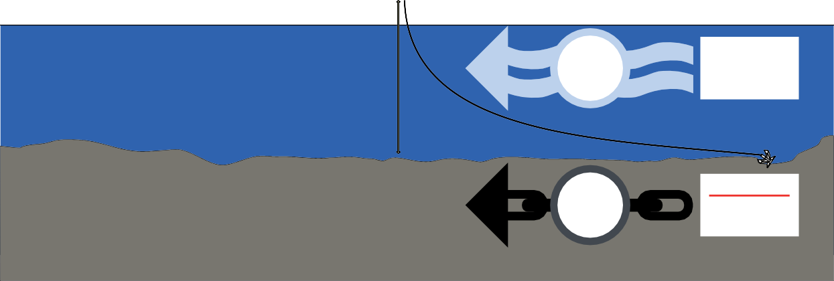

**25**m/s

**4.8**

knots

**Maximum**

current speed

4.8 knots

**6:10**

Scope*

**Minimum** chain scope 6:10

**Good Holding Ground**

**Harboured or**

**Sheltered Areas**

* The scope being the ratio between length of chain paid out and water depth

**Maximum** wind speed 25m/s

### Figure 4: Harboured or Sheltered Areas

In many cases of anchor losses or anchoring incidents, the environmental conditions exceed those stated above. Many anchoring locations are outside sheltered waters, and an equivalent safe ‘environmental envelope’ was found as given by:

Open Water:

* Current velocity: max. 1.5m/s
* Wind velocity: max. 11m/s
* Significant wave height: max. 2m



**11**m/s

**2m**

**3**

knots

**Maximum**

current speed

3 knots

**6:10**

Scope*

**Good Holding Ground**

**Open Water**

* The scope being the ratio between length of chain paid out and water depth

**Minimum** chain scope 6:10

**Maximum**

wave height

**Maximum** wind speed 11m/s

### Figure 5: Open Water

In order to achieve the necessary anchor holding power, it is essential that the anchor chain and the fore-runner remain horizontal on the seabed and that good holding ground is available. The ratio between water depth and the length of the chain – the scope number – is a key factor in ensuring this, and Class guidance is 6 to 10 scopes.

**6:10**

Scope*

**Minimum** chain scope 6:10

* The scope being the ratio between length of chain paid out and water depth

**ound**

### Figure 6: Good Holding Ground

Special conditions

Further, the anchor winch motor is typically designed to lift the anchor and three lengths of chain (82.5m).

According to IACS UR A1: The anchoring equipment is intended for temporary mooring ofa vessel within a harbour ora sheltered area when the vessel is awaiting berth, tide etc.

The equipment is therefore not designed to holda ship off fully exposed coasts in rough weather or stop a ship that is moving or drifting. In this condition the loads on the anchoring equipment increase to sucha degree that its components may be damaged or lost owing to the high energy forces generated, particularly in large ships.



**Anchor Winch Motor Performance**

**Minimum**

**3** Lifting capacity

Lengths 3 lengths

82.5m

The windlass is designed to lift 3 lengths of chain.

ie. 82.5m and the anchor.

### Figure 7: Anchor Winch Motor Performance

*Anchoring*

Below are some rules of thumb that could be implemented in the relevant procedures.

Ensure that the deck officers know the maximum ‘environmental envelope’ the equipment can hold, and make sure that this is reflected in the shipboard anchoring procedures. It is suggested that such key information should be available to the bridge team clearly posted on the bridge as best practice. Anchoring limitations can also be calculated using *Estimating The Environmental Loads On Anchoring System* (OCIMF, 2010) in appendix A (pages 14 & 15).

Appendix 7 of this document provides a poster that can be distributed to ships.

The anchoring position should be approached in a controlled manner. Main engines and steering gear should be tested well in advance prior to approaching the anchorage area.

The anchor party team on forward should be adequately organised including the bridge team for good teamwork between the stations. The planning of anchor watch should be equally incorporated as part of the passage plan. Appendix 6: “The person engagement for anchoring operation” provides an example.

Speed of approach should be closely monitored and controlled. If the approach speed is too fast, or when approaching with a following current, it is difficult to control the vessel, especially if the anchorage is congested. It is essential that prior to anchoring the vessel’s speed over ground is near zero.

Immediately upon anchoring, a fix on the anchor drop position should be made and the ship’s swinging circle ascertained.

Anchor position should be checked at frequent intervals and the distance from other ships or closest danger in the near vicinity should be noted and checked frequently.

*Special conditions*

This section includes the special conditions for anchoring where the risk assessment should be carried out as per guidance given in Part One of this publication.

*Deep water anchoring*

Deep water anchoring is defined here as anchoring in water depths exceeding 82.5 metres. Such anchoring should be avoided as far as practically possible. However, in some trading areas in the worldwide trade of large tankers it is not possible to avoid deep water anchoring.

It must be stressed that anchoring in depths deeper than 82.5 metres goes beyond IACS and most makers’ recommendations for windlasses. However, there are now Class notations for deep water anchoring offered from several ROs.

When anchoring in deep water anchorages, the depth does not allow for the adequate number of shackles to be deployed, resulting in the reduction of the holding power of the anchor. Particular attention should be paid to ensure that the vessel does not drag the anchor.

Anchoring in deep water should be avoided if the following conditions are forecast:

1. Strong wind / current effect
2. High density anchorage or anchorage with restricted area
3. Indistinct depth of water or sea bottom nature

*Anchoring handling operations in adverse weather conditions*

As a basic principle, vessels should not anchor in adverse weather. This means anchoring in conditions above or beyond the limitations as set out in the section *Anchoring, an introduction*.

Heading for open sea or drifting could be a safer option than anchoring, or remaining at anchor before the sea and swell become too high to prevent safe recovery of the anchor. If at anchor already, it is prudent to leave the anchorage area before the weather deteriorates.

However, for those cases where this cannot be avoided:

Avoid excessive tension on an anchor chain cable while making emergency departure from anchorage. Main engines should be used to relieve tension in the anchor chain before ‘heaving in’ as this also helps to prevent an anchor from ‘breaking out’ and dragging while weighing. It is essential that the anchor chain is closely monitored when weighing, and that ‘heaving in’ is stopped as soon as any significant tensioning is observed or any difficulty is experienced. Whenever heaving is stopped due to excessive strain, the primary brakes (usually band brakes) must be immediately applied so as to not overload the motor and input brake.

*In cases of bad weather*

Weighing anchor in bad weather can become a hazardous operation for those on the forecastle. The best indicator of excessive stress is the behaviour of the anchor cable. The anchor party personnel should check the anchor behaviour visually, looking for things such as cable direction, amount of change in the cable catenary (slack) or for unusual effects, such as snatch shocks when the cable tightens.

The Master should consider the impact of dragging anchor and potentially closing in on hazards like pipelines or power cables. The anchor could be slipped when it is suspected fouled with an underwater obstruction in poor weather conditions.

Extra vigilance is required when heaving up the anchor in adverse weather conditions, as catastrophic failures have occurred when recovery attempts have been delayed, combined with failure to use the vessel’s engine movements to relieve the tension from the cable prior to heaving.

At anchor

*Emergency Anchoring*

The anchors should be ready for letting go on arrival and departure port when in anchoring depths as part of contingency planning. Any wire lashings or other securing arrangement if applied should be removed and kept ready in case of emergency except when the vessel is calling terminal as stated in section “Approaching SBM and Oil fields”.

In extremely critical conditions to arrest the movement of the vessel after stopping/reversing the main engine, it is preferable to let go of both anchors simultaneously instead of one.

The anchors of vessels are not designed to stop the vessel and using them to attempt this may result in the loss of anchors and cables with significant impact to ship’s structure, the foundation of the equipment and risk of human injury. This may be acceptable when considering the situation of “take all your way off” in a wider scope while preventing the significant damage to personnel and the environment. Ultimately the anchors should be used on a short stay to slow the vessel down. Both anchors should be used with a short delay in order to triangulate, striving to achieve a ratio 1:3 depth / chain cable.

*Approaching SBM and oil fields*

While the vessel is calling to Single Buoy Mooring (SBM) terminals the restrictions on anchors are very stringent. The anchor and cable are to be secured on the forecastle deck by chain stoppers, devil-claws, anchor lashings and brake while close to the vicinity of oil fields. All precautions should be taken to avoid accidentally letting go of an anchor which may cause damage or the explosion of underwater pipelines.

*Conventional buoy moorings (CBM)*

While the vessel is being moored to CBM, normally it uses one or both anchors and the vessel remains tied on to mooring buoys. The conventional way is to drop the anchor(s) rather than walk back to achieve the desired position of the anchor drop position with respect to the sea bed. In such cases, the necessary control over the cable should be maintained by using windlass brake efficiently.

*At anchor*

At exposed anchorages, weather conditions may deteriorate rapidly, therefore main engines should always be available for use at short notice and weather forecasts and conditions should be continuously monitored.

Masters should also bear in mind that wind forces acting on their ship at anchor in ballast condition may be much larger than the conditions as set out in the section ‘*Anchoring, an introduction’*, above.

These limitations are acting in combination and not as standalone elements, hence calculating the actual limits is even harder. The information paper *Estimating Environmental Loads On Anchoring Systems* (OCIMF, 2010) provides in Appendix A (pages 14 & 15) a calculation sheet to determine whether you should anchor or not, heave the anchor or stay. For an interactive version of this calculation the following link is provided which redirects you to the OCIMF website: https://bit.ly/2VseYzX

Accidents have been known to happen because the Master is tempted or instructed to wait at anchorage and to check on the weather the following morning, despite the received weather forecast predicting worsening conditions.

A few rules of thumb:

1. If a vessel is anchored in an area exposed to weather, it is necessary to have a SMS policy as to when to leave.

BUNKER Part Two: Anchoring Guidelines

1. There should not be commercial pressure on Masters for not leaving the anchorage on safety and security grounds.
2. In making a decision whether to stay or to leave, the Master should also be aware of the limitations of his anchoring equipment.
3. Masters and Officers should have full knowledge of anchoring equipment limitations and sequence of failure through training.

*Use of Chain stoppers at anchorage*

A chain stopper is usually fitted between the windlass and the hawse pipe in order to relieve the windlass of the pull of the anchor cable when the ship is at anchor and is designed to take the dynamic forces imposed on the windlass while at anchor. A chain stopper (if fitted) is designed to be capable of withstanding a force equal to 80% of the chain cable breaking load.

*Use of ECDIS wile at anchor*

* The ECDIS guard rings can provide for additional position monitoring.
* The anchor alarm on ECDIS with safety guard circle would alert the officer if vessels starts dragging.

*Anchoring for layup or extended periods*

When the vessel is expected to remain at anchorage for a long period then this may cause the anchor or its chain to get fouled. There may be a possibility of a knot forming in the chain and this will strongly impact the picking up of anchor at final departure. To avoid this, consideration should be given to alternating the anchors by heaving up anchor and re-anchoring after a set period of time.

*Anchoring operations and their impact to environment*

The discharge from chain locker effluent during anchoring operations causes concern for the transfer of non-indigenous species. However, in such cases the discharge volume is very small and has low potential for causing adverse environmental effects (EPA, 1999).

The anchor chain must be thoroughly washed down when carrying out heaving operations to remove sediment and marine organisms. In addition, chain lockers must be cleaned thoroughly during dry docking to eliminate accumulated sediments and any potential accompanying pollutants.

Recovery of Anchor/Preventing Anchor loss

*Heaving up the anchor*

Careful monitoring of the anchor cable load and lead is important as there will not be any pre-warning of windlass damage if the system is overstressed (unless a cable tension monitor is fitted). Any damage may not be evident until the windlass is next used to heave up the anchor.

Recommendations for heaving up anchor:

* Minimise the tension in the chain and keep the chain as vertical as possible
* In windy weather conditions or strong current, the rudder and engine must be fine-tuned to prevent too high tension in the chain and overload of the windlass motor. This will also prevent dragging of anchor and breaking out the anchor. The heaving up speed is typically nine metres/ min so speed over ground should be less than this ie 0.3 knots. (OCIMF, 2010)
* Close communication between bridge and anchor party on deck is essential
* The anchor party should know the vessel’s windlass capacity to heave up maximum free-hanging shackles
* Vessel to prevent the overloading of high pressure windlasses which can result in their catastrophic failure, the ‘heaving in’ should be stopped as soon as any significant tensioning is observed, or difficulty is experienced.

*Recovery of Anchor/Preventing Anchor loss*

In case the vessel is dragging anchor, keep the ship’s head into the wind and ease the tension on the cable by using the main engine and rudder while heaving up the anchor.

Shifting anchorage or drifting offshore or paying out more cable could be considered depending on the prevailing circumstances. If the weather conditions are likely to deteriorate, it is imperative to heave up and proceed to an open, safe area well in time.

If the vessel is in shallow water and the fully operational windlass is unable to heave up the cable, then the fouling of the anchor should be considered. The vessel can consider steaming around the anchor position or lower and heave the anchor again until it is finally free. In such situations, if there is a suitable work boat available then consideration should be given to using this to help clear the fouled cable.

The last resort is to slip the anchor from the bitter end after tying up an anchor buoy to assist in recovery later utilising external assistance.

Part Three: The Human Element

# Part Three: The Human Element

The crew on board may be competent as per the certificate of competency (CoC), but the practical training of anchoring is very different to the theoretical book knowledge studied in maritime colleges. Training reduces the gap between book knowledge and desired anchoring operation practical skill levels. When training is supported with on-the-job (OTJ) training, the individual is exposed to the anchoring work environment under the guidance and care of an experienced person (the mentor).

The mentor in OTJ training verifies the basic competencies in the job and evaluates the individual for required basic competencies.

### Technical skills and behaviour

In anchoring and all other safety critical operations onboard a tanker, both the technical and non-technical skills are essential.

Technical (hard) skills are knowledge of regulatory, company requirements and the task at hand. The skill is the ability to use the knowledge in the working environment.

Non-technical (soft) skills or behaviours are related to human factors and can be evaluated by observing interactions between team members.

### INTERTANKO Competency Management Guidance (ICMG)

ICMG is scheduled to be launched during 2020 and will cover the skills and knowledge of the crew. This will incorporate the joint initiative between OCIMF and INTERTANKO on soft skill and behaviour called Behavioural Competency Assessment and Verification for Vessel Operators (CAV). The overall aim of CAV is to develop and improve Officers’ non-technical skills for the benefit of each individual and the onboard team. The soft skills assessment should be seen as an opportunity to improve everyone’s behaviour. The associated assessment is part of a continuous improvement process rather than another exam that Officers need to pass. In this way, it differs from technical competency systems such as those in the International Convention on Standards of Training, Certification and Watchkeeping for Seafarers (STCW).

Such structured approach to competence is the foundation for an approach on the human element and thus also for anchoring.

### Training

In terms of specifics for anchoring training, such training should address competencies on the basis of rank and as a minimum should include the following:

* Different anchoring methods with relation to vessel size and available water depths
* Knowledge and understanding of equipment limitations and operating particularities depending on the prevailing weather conditions.

*Basic competency for anchoring operations*

A basic competency assessment and a training scheme should be developed specifically for anchoring as per the sample template for training requirements on anchoring provided in Appendix 5 – “Template for training requirements”.

The anchoring competency should be considered as critical competency for the promotional aspect to each Deck Officer’s rank as per the practical duties included in their capacity in the next promoting rank.

Soft Skills and Behaviour

*Soft Skills and Behaviour*

The OTJ training for anchoring should also focus on behavioural elements.

The scenario mentioned below is a worked example for highlighting the behavioural competencies to be displayed by an Officer in charge of anchoring during anchoring operation.

The following table includes a basic example of competency table for Deck Officer and this can be implemented for each rank as per their job scope and responsibility stated in the company’s SMS.

|  |  |  |
| --- | --- | --- |
| **Phase of the operation** | **Action by the Officer** | **Relevant behavioural**  **competency** |
| **Prior to anchoring** | The Officer discusses the anchoring plan with the Master. He/ she conducts a proper risk assessment prior to commencement of the operations and ensures that all anchoring equipment is in good working order. | Decision-making (risk assessment and option selection) |
|  | The Officer carries out a pre-anchoring tool box meeting with the team. All team members are adequately briefed on the operation. The Officer ensures that the team members are correctly dressed in appropriate personal protective equipment (PPE). | Teamwork (participation, Supporting others) |
|  | The Officer communicates clearly with the team using closed loop communication.  The Officer closely supervises inexperienced team members and ensures that the team members are given additional instruction on the specific equipment used on the vessel. | Communicating and influencing (shared understanding, style of communication, feedback)  Leadership and managerial skills (setting direction) |
| **During anchoring operations** | The focus should be on following the anchoring plan, observing any changes if required, giving instructions and communicating with the bridge using closed loop communication. | Leadership and managerial skills (empowerment, authority and assertiveness, planning and coordination, workload management) |
|  | Before the anchor is ‘walked out’, the Officer checks that there are no small craft or other obstacles under the bow. | Decision-making (problem definition and diagnosis, outcome review) |
|  | The Officer ensures that during anchoring, the anchoring party stands aft of, or at a safe distance from, the windlass/ capstan | Result focus (initiative, determination, flexibility)  Situation awareness (awareness of vessel systems and crew, awareness of external environment) |

### Recommendations:

1. The company should include basic competency training for the anchoring operation for its Officers and rating involved in the operation.
2. The OTJ training should be supported with the theoretical knowledge to develop more skill-oriented techniques to benefit every individual involved in the operation (rank-specific skill training).

### Human factor considerations relating to anchoring (Human Performance)

Many different human factors could be considered when planning and executing anchoring operations. It is important that those involved are aware of these and consider them while developing anchoring plans. One very important issue is that the crew must be completely familiar with the limitations of their vessel’s anchoring equipment.

*Design and layout of Equipment*

The layout of the forecastle area can have a huge effect on human performance during anchoring operations

– obstructions to the line of sight, lighting and background noise all have an effect on communications and teamwork on the forecastle. Added to this are factors such as the ease of operation of equipment, clear labelling, logical human-centred design, perceived safety and reliability of equipment and the number of people required to carry out tasks (such as operating the brake). Even the quality and reliability of radio equipment can have an effect on human performance during anchoring operations. It’s important to note that some design and layout issues are beyond ship owners’ reach. In such cases, ship builders should take this into account when designing anchoring equipment.

The effectiveness of PPE supplied to crew should also be considered; the clarity of goggles, effectiveness of hearing protection and the quality of cold weather gear can all affect performance.

*Cultural Diversity and Communications*

Vessels with multi-national crews might face cultural diversity issues. Language barriers could cause miscommunication and result in anchoring operations going wrong. The use of a working language and standardised phrases will assist in mitigating these issues. These could result in lost anchors, loss of situational awareness as well as putting vessels in dangerous situations if the anchor is not dropped in the planned position. Similar challenges are faced while calling ports and anchorages where the bridge team interacts with others of varied nationalities. Pre-planning, briefings, the use of IMO’s Standard Marine Communication Phrases (SMCP) and an effective Master-Pilot Exchange are effective in overcoming this problem.

*Knowledge, Competency and Training*

A successful anchoring operation relies heavily on the skill of the team on board. The Chief Officer before promotion to Master shall successfully complete practical anchoring under the Master’s supervision. This practice will benefit an individual through the gaining real experience, knowledge and competency for their next potential rank.

*Fatigue and personal factors*

Port / anchorage approaches, river transits and canal transits might require attendance at anchor stations (for emergencies) for extended periods of time. Adverse weather conditions such as extreme heat or cold and ship movement can have a detrimental effect on the crew’s physical and psychological wellbeing, leading to fatigue and a loss of concentration and performance. Often this has been ignored in the anchor planning

process. During such transits, it is recommended that ship staff plan work/rest hours in advance and look at the possibility of rotating crew members at anchor stations.

*Commercial Pressures*

Vessels sometimes come into port limits and drop anchor, even in adverse weather, merely to tender a notice of readiness; there could be real or perceived commercial pressure to do so. Similarly, there might be reluctance to leave an existing anchorage for the fear of the vessel getting “off-hire”. Commercial considerations should not override safety concerns while deciding to drop or heave up anchor.

*Complacency*

It is easy for watch keepers to become relaxed during periods at anchor. Under-stimulation and a perceived low-risk situation can lead to lower levels of alertness. Watch keepers need to remain alert to the possibility of anchor dragging by their own or other vessels in the vicinity, and to other traffic in the area.

On other occasions, despite worsening weather conditions, Masters have displayed a reluctance to leave an anchorage. This is at times driven by a false sense of security by observing other vessels which continue to stay at anchor. A delayed decision to pick up anchor has resulted in numerous damages to anchors, failures of various components of the deck hydraulic machinery and even groundings. Often, by the time a decision has been reached to heave up anchor, weather conditions have deteriorated beyond the operating limits of the anchoring equipment. Ship staff must be completely familiar with the limitations of their vessel’s anchoring equipment.

### Live anchoring audits

It is necessary to check and verify the behaviour of personnel engagement for anchoring operations to identify the deviations from standard practices. The live anchoring audits could be carried out by a competent person such as internal auditor or company’s representative or nominated person by the company.

They should observe the anchoring operation to monitor the performance. The operation on the bridge can also be monitored when an additional auditor is available.

The stages of various operations such as preparation for anchoring, walking back/let go and heaving up anchor can be monitored during the live audit process.

Below are examples of parameters that could be checked during a live audit:

*A: Leadership*

1. Planning and anticipation
2. Delegation of Job
3. Effective monitoring
4. Responsibility and competence
5. Attitude towards safety
6. Implementation of ‘leading by example’
7. Information sharing
8. Information sensing
9. Imparting the training
10. Fatigue management
11. Management of commercial pressure
12. Managing conflicting goals

*B: Anchoring team management:*

1. Effectiveness of team
2. Situational awareness of team
3. Awareness of dangers and hazards
4. Effective inputs by team members
5. Collaboration
6. Alertness, focus on task
7. Dedication to job
8. Creative worry

*C: Equipment and Human Fusion*

1. Handling of alarms, trips and limitation of equipment
2. Chronic unease
3. Operational competency

*D: Human Element*

1. Compliance to no distraction
2. Cultural diversity and effective communication
3. Knowledge, awareness of regulation and compliance
4. Complacency
5. Time management
6. Error tolerance – resilient behaviour

### References

DNV GL, Gard and The Swedish Club. (2016). Anchor loss - technical and operational challenges and recommendations. OSLO: DNV GL, Gard and The Swedish Club.

Retrieved from <http://www.gard.no/Content/22945571/ANCHOR%20LOSS.pdf%20>

GARD P&I. (2010). Limitations of a vessels’ anchoring equipment, Loss Prevention Circular No. 12-10. Oslo: Gard AS.

<http://www.gard.no/Content/8931873/12-10%20Limitations%20of%20vessels%20anchoring%20equipment.pdf>

IACS. (2014). REC 79, Guidance for Anchoring Equipment in Service. London: IACS. Retrieved from <http://www.iacs.org.uk/download/1866>

IACS. (2016). IACS Recommendation 10 on Anchoring, Mooring and Towing Equipment. London: IACS. IACS. (2016). UR A1 Anchoring Equipment. LONDON: IACS.

Retrieved from [www.iacs.org.uk/download/7266](http://www.iacs.org.uk/download/7266)

IACS. (2017). UR A3 Anchor Windlass Design and Testing. LONDON: IACS. Retrieved from [www.iacs.org.uk/download/7093](http://www.iacs.org.uk/download/7093)

OCIMF. (2010). Anchoring Systems and Procedures. London: Witherby Publishing Group Ltd.

OCIMF. (2010). Estimating The Environmental Loads On Anchoring Systems. LONDON: OCIMF. Retrieved from:

[https://www](http://www.OCIMF.org/media/8922/Estimating%20The%20Environmental%20Loads%20On%20Anchoring%20Systems.pdf).OCIMF[.org/media/8922/Estimating%20The%20Environmental%20Loads%20On%20Anchoring%20Systems.pdf](http://www.OCIMF.org/media/8922/Estimating%20The%20Environmental%20Loads%20On%20Anchoring%20Systems.pdf)

OCIMF. (2017). Tanker Management and Self Assessment 3 (TMSA3) A Best Practice Guide. Witherby Publishing Group.

OCIMF. (2018). Mooring Equipment Guideline v4. London: OCIMF.

OCIMF. (2018). Safety Critical Equipment and spare parts Guidance. London: OCIMF. Standard Club. (2008). ANCHORING – Special Edition. Standard Club.

The Swedish Club, D. G. (Director). (2016). Anchor Awareness full video [Motion Picture]. Retrieved from [https://www.swedishclub.com/media_upload/videos/ANCHOR%20A](http://www.swedishclub.com/media_upload/videos/ANCHOR%20AWARENESS%20v.7.mp4)W[ARENESS%20v](http://www.swedishclub.com/media_upload/videos/ANCHOR%20AWARENESS%20v.7.mp4).7.mp4

# Appendices

**Appendix 1 – Lessons learned in anchor handling operations**

### Introduction

This chapter covers a number of anchoring accidents and incidents including the root causes and factors behind these. The below could potentially be used as a part of the risk-based approach by a company in deciding on their approach to anchor equipment and anchoring operations.

### Common cause of anchor loss

Gard has observed the technical reasons behind loss of anchors, and noted the reasons of anchors lost due to breakage of a common chain link, joining shackle, swivel, anchor shackle or crown shackle, and also through breakage of the anchor itself. The consequences include the breaking damage of one or both flukes and, surprisingly, also the solid anchor shank. In addition to reduction by wear and corrosion, one of the common problems of anchor chain is loose or lost studs (Gard News 201, 2011).

The following are common reasons for such losses:

* Problems of anchor chain is loose or lost studs (if a stud is lost, the strength of the link is severely reduced – by up to 30%).
* Lost spile pins (the pin of the anchor D-shackle).
* The conical shape of the spile pin not matching the hole in the shackle parts perfectly (quality at the manufacturers).
* Sealing the hole of the spile pin used not carried out in the shipyard by hammering in a lead pellet with a special tool (sometimes done by pouring melted lead into the hole).
* Repeated hammering or vibrations on board (at sea) may at times loosen the spile pin of the anchor shackle and cause it to fall out.
* If parts of an anchor break, there are good reasons to suspect defects of the cast metal, like inclusions and fissures.
* Dropping of anchor at height at rocky bottom increases the risk for breakage of the anchor’s metal parts.
* Chain link to part under strain long before the anchor shank (a brittle metal structure, caused by insufficient annealing at the makers).
* The manufacturers may have speeded up the production, cut time and temperatures needed for heat treatment (the anchor shank and anchor crown are made of cast steel, which requires a long heat treatment after casting).
* Flaws in heat treatment may not have been discovered by the authorities involved in testing and certification.

Common technical failures

### Common technical failures

The following are common reasons which can result in loss of anchors:

* When the vessel has too much speed during anchoring (excessive speed over the ground).
* When dropping anchor in water that is too deep and when attempting to stop a vessel as a last resort in a black-out situation.
* When dragging
* When clutch disengages accidentally during anchoring operations.
* When anchor is stuck or fouled (*Young Lady*, 2007).
* When the hydraulic motor is engaged and the chain is pulled out by the vessel’s movements.

The other failures include:

* Breakdown of windlass motor (*APL Sydney*, 2008) and the anchor and chain needs to be slipped.
* Improper adjustment of brake or setting or worn brake band linings (full braking force not obtained by tightening the brake spindle alone).
* On large windlasses the screw arrangement at the lower part, to adjust the brake band not done appropriately, resulting in brake pad wear-down.
* On a voyage, if the chain is not properly secured (it has overcome the chain-stopper, the lashing-wire/ tensioning arrangements and the windlass brake, or these have not been correctly engaged). Note: The “chain stopper” should not be considered as the primary securing arrangement.
* The loads in a mooring system are caused by the wind/gale force, waves and current, creating often the adverse issues (*APL Sydney*, 2008), (*Ocean Amber*, 2013).
* Frictional force due to anchor chain touching of ship’s hull (*Ocean Amber*, 2013).
* Over-pressurisation and overspeed operation of windlass causing explosion of motor (*Stellar Voyager*, 2009), (*Young Lady*, 2007), (*APL Sydney*, 2008).
* The anchor fluke may get caught under a rock, or a crevice, or in a wreck or gas pipeline (*Young Lady*, 2007), (*APL Sydney*, 2008) or an abandoned anchor on sea bed (*Ocean Ambe*r, 2013). This happens rarely but, if it does, may result in a bent fluke or breaking of fluke and/or shank. So avoid anchoring on a rocky sea bed, because in addition to being very poor holding ground, there is a risk of damage on recovery.
* The clutch may jump out of engagement. This frequently leads to anchor loss, because the crew are quite unprepared for it, do not get the brake on in time, the cable runs out too fast to arrest and the anchor is eventually lost.
* The depth of water anchored turns out to be too deep for the windlass to recover the anchor and cable.
* Damage to bitter end securing pin housing and bulkhead as a result of using too much cable and /or excess weight on cable (lack of knowledge of number of cables fitted or available to use on the ship).
* Exploded windlass hydraulic motor was not fitted with safety guard (*Ocean Amber*, 2013).

### Human factor

* Lack of detailed passage planning to cover adequate provision for anchoring-related details (*APL Sydney*, 2008).
* Master did not fully assess the weather condition in the anchorage before the onset of worsened weather condition (*Ocean Amber*, 2013).
* When weighing anchor, the main engine and helm were not used to effectively control the ship and prevent its anchor and cable dragging (*APL Sydney*, 2008).
* Use of mobile phone on bridge during the critical operation and distraction to bridge team (*APL Sydney*, 2008).
* Lack of seamanship and inadequate maintenance.
* Lack of familiarisation to anchoring equipment (*APL Sydney*, 2008).
* Lack of knowledge, training and handling skills in the use of anchoring equipment.
* Lack of rest, causing fatigue.
* Cultural diversity in bridge team and lack in usage of common language (*APL Sydney*, 2008).

External factors

# Appendix 2 – Worked example on risk-based approach – bow tie technique

The following is a simplified example of how the bow tie approach could be used.

This worked example is for demonstration purposes only. The guidance has purposely shortened text and the technical details are not complete, but are sufficient for the purposes of an example. It is advised NOT to follow the below in real life scenarios but to follow the company’s own risk assessment tools.

*Case Study: “Hydraulic motor explosion caused serious injuries”*

Members of INTERTANKO have reported that there have been incidents where the hydraulic motor for the anchor windlass have exploded. In some cases, these explosions have caused serious injuries to the crew.

Here we look at how incident that has gone through the whole casual chain to an injury might be catalogued. If this example is put into the fault categories, it may look like this list:

### Operational/human error

* + Fatigue
  + Complacency/ failure to follow procedures
  + Not enough training/not competent (not aware of limitations of anchoring equipment)
  + Roles and responsibilities not clearly defined
  + Communication problem.

### Technical failure

* + Design/manufacturing (specification, lack of safety valves, choice of material etc.)
  + Overload (the hydraulic motor is exposed beyond its operational limit and may be reversed by force effectively making the motor a pump)
  + Lack of maintenance
  + Manoeuvrability of the ship
  + A combination of the above.

### External factors

* + Weather (beyond operational limit of the windlass)
  + A fast change in weather conditions

### Managerial/organisational issues

* + No or inadequate procedures for heaving up anchors
  + Complicated procedures for anchoring
  + Cost saving on maintenance/equipment
  + Inadequate training procedures for crew
  + Wrong specifications of windlass for the trade and ship type
  + International recommendations for windlasses do not cover common situations of anchoring (i.e. beyond 82.5m)

This list covers the green side of the bow tie model for this incident, causes that could have led to the incident. On the red side of the bow tie model, control and barriers for incidents that have happened, there is a similar but shorter list of barriers, or lack of them, that can cause an escalation of the incident to be something more.

As an example, an explosion in a hydraulic motor without a protective cover can cause serious injuries if someone is standing close, in this case, the cover is a barrier for an escalation of the incident.

Using the examples above, a company could then look at each point and see where their procedures should be focused to follow the whole casual chain looking at the fault categories. However, it is not within the scope of this guideline to propose how to implement findings in their operations.

Below is a selection of anchoring incidents that could be used (the yellow part of the bow tie model above). These incidents could be prevented if the right actions and barriers are in place. Likewise, incident escalation is possible if there are no detection and barriers after the incidents have occurred.

* Dragging anchor
* Piracy attack at anchor
* Collision while manoeuvring to/from anchorage
* Fouled anchor/anchor chain
* Exploding anchor windlass.

This section will look at how to prevent incidents in the first place and look at detection measures and barriers to reduce the impact of the consequences of an incident should it occur.

To exemplify this process, the above has been put in the bow tie model in Figure 8 on the page opposite.

Figure 8 looks at the operational phases identified above, identifies the general fault categories there and proposes guidance for the operators.

**Operation**

**Causes**

**Accident event**

**Emergency**

**Final consequences**

**Example Barriers Example Barriers**

**Normal Operation**

* Rested, motivated and well trained crew
* Roles and responsibilities clearly defined
* Design is fit for purpose and trading
* Monitoring weather forecasts, leave anchorage in time
* Maintenance is well planned and performed
* Manoeuvrability of the ship
* Appropriate and easy to understand procedures are in place

**anchoring**

**incidents**

Prevent*

Detect

Restore

Detect**

Control

Mitigate

Dragging anchor Piracy attack at anchor Collision

Fouled anchor

Exploding windlass motor

Safety barriers

Safety barriers

** Good anchor watch to detect dragging

** Explosion protection for windlass

** Engine on stand by

** Good Anti-Piracy watch

**Catastrophic outcome**

Human error

Technical failure

Preventive safety barriers

Externa factors

**Figure 8. Bow-tie model**

Organisational

## Lost anchors

Collisions whilst dragging Groundings

## Anchor chains fouled incl. with other vessels at anchor Pollution incident

Mitigation of consequences

Total loss of ship Loss of life Serious injuries Lost time

## Off hire Etc.

**Deviation from normal operation The consequences of the accident**



Causal chain

Safety barriers

Escalation controls

### Operational Phases

This section will describe causes of accidents and causes of escalation of accidents to become catastrophic events, essentially, this is where barriers that are missing or faulty in the bow tie approach are identified.

Below are listed breaches of:

* + Preventive Safety barriers
  + Detection Safety barriers
  + Restoring Safety barriers
  + Detection of incidents barriers
  + Controlling Safety barriers (escalation controls)
  + Mitigation of consequences barriers.

The list is not intended to cover all safety barriers but aims to cover the whole scope and show the variety of barriers in place and the potential lack of them.

The safety barriers would be the first thing a ship owner addresses to ensure the safe anchoring operation of a ship. The list below may be considered as a starting point in producing a safety barrier list but does not aim at or claim to be complete at all.

*Operational/human error*

* Design and building of the ship and the anchoring equipment layout
* Design specification from owner to ship builder does not meet the requirements of the vessel type and trade
* Lack of understanding from shipbuilders on the operational reality on-board the ship (raised bulwarks introducing slip and trip risk)
* Not using human centred design as a strategy for design of the anchoring and mooring area (line of sight for winch operators to Officer in charge)
* Training of naval architects that design the ship and anchoring layout.

*Maintenance*

* Failure to follow maintenance plan
* Lack of training for involved personnel

*Planning of the anchoring operation*

* Crew not competent – no risk assessment or tool box talk prior to the operation
* Complacency
* Fatigue

*Anchoring*

* Crew not competent
* Complacency
* Fatigue

Maintenance

*At anchor*

* Crew not competent
* Complacency
* Fatigue

*Heaving up the anchor*

* Crew not competent
* Complacency
* Fatigue

*Securing anchors for sea*

* Crew not competent
* Complacency
* Fatigue

*Technical failure*

*Design and building of the ship and the anchoring equipment layout*

* Equipment not designed or purchased to meet the loads it will be exposed to (as an example, will the ship anchor beyond 82.5 metres depth?)
* Ensuring that windlass motors do not get overloaded
* Ensuring that if a windlass or winch motor does get overloaded, that it has a suitable relief system in place and in addition it has built in protection to prevent injury to nearby personnel in the event of overpressure motor explosion.

*Maintenance*

* The equipment is designed to be easily maintained
* Can it be maintained in extreme heat or extreme cold climate?

*Planning of the anchoring operation*

* Failure of windlass

*Anchoring*

* Loss of control of anchor due to windlass brake band failure
* Loss of control of anchoring operation due to main engine failure

*At anchor*

* Loss of anchor due to change in weather conditions

*Heaving up the anchor*

* Protection against exploding windlasses are in place
* Anchor wash is operating

*External factors*

* Design and building of the ship and the anchoring equipment layout
* Equipment designed or purchased to meet the loads it will be exposed to. (As an example, will the ship anchor beyond IACS wind, weather, current and wave limitations?)
* Built for the temperature range the ship will sail in (extreme heat or extreme cold climate?)

*Maintenance*

Does the equipment need maintenance at sea, does the weather make this impossible?

*Planning of the anchoring operation*

* Is there a backup plan for change in weather?
* Is there a backup plan for unexpected heavy traffic in vicinity of anchorage area?

*Anchoring*

* Is there a backup plan for change in weather?

*At anchor*

* Is there a backup plan for change in weather?
* Is there a backup plan if another ship anchors close by and in case of unexpected security concern?

*Heaving up the anchor*

Is there a backup plan for change in weather?

*Managerial/organisational issues*

Design and building of the ship and the anchoring equipment layout

The company has a strategy to specify the environment a ship will operate in when doing newbuilding contracts to ensure the ship is designed and built to safely operate and anchor in conditions it will be exposed to.

The design strategy for anchoring equipment and to mitigate against known technical issues (eg exploding windlass motors)

*Maintenance*

There is a maintenance plan for the specific equipment

*Planning of the anchoring operation*

There are procedures for:

* + Selection of anchoring position
  + Planning including toolbox talk
  + Methods of anchoring
  + Equipment design limitations and characteristics
  + Emergency anchoring
  + Roles and responsibilities
  + Requirements for risk assessments for anchoring
  + Use of main engine (and thrusters if fitted)

*Anchoring*

There are procedures for:

* + Anchoring in extreme depths (beyond 82.5 metres)
  + Anchoring in deep waters
  + Anchoring methods
  + Protection of personnel and safe operation of equipment

Heaving up the anchor

*At anchor*

There are procedures for:

* + Anchor watches, including actions to be taken when dragging or action to be taken when bad weather is expected

*Heaving up the anchor*

There are procedures for:

* + Emergency departure from an anchorage
  + Heaving up anchor in extreme depth
  + Protection of personnel and safe operation of equipment

# Appendix 3 – Worked example on risk-based approach – Hazid technique

42

Anchoring Guidelines: A Risk-Based Approach

This is an example of a more traditional risk-based approach using a Hazid followed up with control measures.

|  |  |  |
| --- | --- | --- |
| **Description of Identified Hazards** | **Possible Consequences** | **Control Measures to Protect: Personnel – Environment – Company – Asset from Harm** |
| Procedures not in place / not following procedures | Personnel injury Equipment damage Oil Pollution Collision / Allision  Grounding | 1. OCIMF “Anchoring System and Procedures for Large Tankers”. 2. SMS procedures and checklists on Anchoring, Anchor Handling and Anchor Watch   5) PPE minimum requirements to be strictly adhered |
| Inadequate planning | Personnel injury Equipment damage Oil Pollution Collision / Allision Grounding | 1. Prior proceeding to anchorage, a plan should be developed by the Master and   communicated effectively to the involved Officers. A Risk Assessment should be prepared prior commencement of the task with all personnel  participating. All available information should be used, included but not limited to: information from the Pilot books, Nautical Chart, the Guide to Port Entry, Port/ Terminal information, weather reports, Navtex etc.   1. The anchor party should have all necessary preparations and tests conducted such as hydraulics on,   anchor lights/shapes prepared, etc. |
| Anchoring in a congested anchorage | Personnel injury Equipment damage Oil Pollution Collision / Allision Grounding | Anchoring in a congested anchorage should be avoided. If, however, anchoring has to be carried out then:   * anchoring position should be selected considering ease of approach and space available * approaching should be carried out with the minimum safe speed and higher Bridge Condition; * ship’s position during approach should be also monitored by visual and Radar * avoid passing close to the bow of another anchored   vessels. |
| Defective anchoring equipment | Personnel Injury Equipment damage Collision / Allision  Grounding | 1. Maintenance and tests to be carried out in accordance to maker’s guidelines and company’s PMS. 2. Pre-arrival and departure checklists to be thoroughly   carried out. |
| Strain / Forces exceeding safe operational limits of the equipment | Windlass / Hydraulic motor failure Personnel injury Equipment damage Collision / Allision Grounding | 1. During Paying-out or heaving in the anchor cable, ship’s speed not to exceed the windlass speed (normally not more than 0.3-0.4kts). 2. Keep a slight slack on the cable as it may be required in order to avoid motor overload, yet to retain control over the bow movement. 3. Responsible Officer to monitor tension / direction of anchor cable and advise Bridge accordingly. 4. Master to make full use of Engine / Rudder, as needed in order to control bow motion / ease the cable tension. 5. Avoid anchoring or staying anchored in rough weather – calculate operational limits based on OCIMF information paper “Estimating The Environmental Loads   On Anchoring Systems”. |

|  |  |  |
| --- | --- | --- |
| Improper windlass operation | Personnel Injury Equipment damage Collision / Allision Grounding | 1. Windlass must not be allowed to operate at a rate in excess of the manufacturers recommendations. 2. Use main engine / rudder to manoeuvre the vessel to relieve tension in the anchor cable before and during ‘heaving up’. 3. Taking into account that movement of the vessel may cause major damage to the vessel’s windlass, the movement of the vessel over the ground must be   accurately monitored (by using also visual observations of landmarks) when the anchor chain is on gear. |
| Inadequate anchor cable monitoring | Personnel injury Equipment damage Oil Pollution Collision / Allision Grounding | 1. Anchor cable should be closely monitored when weighing and windlass operation should be stopped as soon as any significant tensioning is observed or difficulty is experienced. 2. Accurate and frequent information regarding the direction/tension of chain should be relayed to bridge.   Any change should be immediately reported. |
| Adverse weather/sea/ current condition | Personnel injury Equipment damage Oil Pollution Collision / Allision Grounding | 1. The behaviour of the anchor cable is to be verified continuously especially when weather conditions are worsening.   If this happens the stress on the anchor is to be reduced by:   * 1. Using the engines.   2. Using the rudder to attempt to reduce the yawing especially in a current.   Keep the main engine on standby when the weather conditions are expected to be worsening.  During heaving up the anchor, the chain stopper should be ready for engagement at any time.  2) The Master must assess the wind and sea conditions and get the vessel promptly under way whenever necessary. Avoid anchoring or staying anchored in rough weather - calculate operational limits based  on OCIMF information paper “E*stimating The*  *Environmental Loads On Anchoring Systems”.* |
| Rocky / dangerous sea bottom | Equipment damage Personnel injury Collision / Allision Grounding | Anchoring in a rocky seabed should be avoided. If, however, anchoring has to be carried out, extra attention is required to prevent shock loads to the  mooring equipment in case the anchor is snagged in  the sea bottom. |

|  |  |  |
| --- | --- | --- |
| Unable to retrieve the anchor | Equipment damage Personnel injury Delays / commercial impact | If the vessel is in deep water and the windlass is unable to recover the cable, the vessel may be carefully moved towards shallower water using the engines to drag  the anchor and cable along the seabed. The windlass should always be taken out of gear and the chain firmly secured using the chain stopper, before attempting  this manoeuvre to avoid the windlass being damaged personnel should be kept well clear of the chain under tension. Consideration should be given to the nature of the seabed, the position of other anchored ships in near vicinity and the associated ease of dragging the anchor and the possibility of the anchor fouling on underwater obstructions or installations such as pipelines or cables. A solution which might be investigated is to buoy,  slip and abandon the cable, or remain at anchor and  engage the assistance of professional salvers. |
| Weighing anchor in reduced visibility / Congested traffic | Personnel injury Equipment damage Oil Pollution Collision / Allision Grounding | 1. If already at anchorage departure must be carried out only if it is deemed safe to do so. 2. In case of lack of room to manoeuvre, consideration should be given to the following:  * Waiting at anchor for change of tide / current / heading. * Employment of tug(s) for assistance. |
| Slips / Trips / Falls | Personnel injury | Ensure proper housekeeping / No obstructions or loose equipment.  Ensure non-skid areas are in place and properly marked/ highlighted. |
| Dirt/rust particles/debris thrown off, sparks generation/sharp- abrasive objects | Personnel injury Fire | 1. Crewmembers involved in the anchoring operation should, wherever possible, stay in a protected area (preferably aft of the windlass). 2. Personnel wear all required PPE - including safety   glasses. |
| Inadequate supervision / communication | Personnel injury Equipment damage | 1. Anchoring operations shall be planned, co-ordinated and supervised by the Master. 2. A responsible and qualified Officer should be in charge of the anchor party. 3. Efficient communication between the Bridge and the anchoring team should be tested before the operation and a backup system (ie availability of a second UHF, talk-back system) should be ensured. Communications procedures should be familiar to   all personnel that will participate in the task (Working  channels and reporting methods). |
| Darkness/inadequate illumination | Personnel injury Equipment damage | During night time, the forecastle area should be adequately illuminated and flashlights available for the  anchoring team. |

|  |  |  |
| --- | --- | --- |
| Transport of unwanted marine organisms | Transport of unwanted marine organisms | During weighing, the chain itself should be properly cleaned by using the anchor wash system and flexible water hoses, as needed. A thorough wash down to be performed, effectively preventing the transport of  marine organisms between water bodies. |
| High Workload / Fatigue  / Human Error | Personnel injury Equipment damage Property damage | Bridge Watch Level and Anchor Team to be appropriately trained for the task.  ILO/STCW/MLC hours of rest requirements to be  adhered to. |
| Equipment failure (Hydraulic water cooler) | Hydraulic Oil Pollution | Proper check and maintenance of equipment as per vessel’s PMS.  Visual checks of sea water around vessel for any sign of  hydraulic oil sheen / pollution. |
| Brake failure / Uncontrolled release of anchor | Personnel injury Equipment damage Oil Pollution Collision / Allision Grounding | 1. Anchoring equipment to be inspected prior use. 2. Keep stopper secured whenever engaging / disengaging the gear. When engaging, take load on gear, then release brake, then release stopper. When disengaging, secure stopper and carefully take off load from gear and then disengage. 3. Keep ship’s speed to minimum practicable according to circumstances until completely securing anchor by   the means of brake, stopper and lashings. |
| Sparks from friction between cable/windlass | Fire / Explosion if combined with flammable gases | COTs inerted below 5% and under positive but not excessive pressure (400-800mmWG) so as to avoid opening of P/V valves. Condition of P/V valves to be  checked prior anchoring. Mast riser to be shut. |
| Dragging anchor | Personnel injury Equipment damage Oil Pollution Collision / Allision Grounding/ Damage to submerged cable/ pipeline | Plan anchoring. Steer on the wind/current and pay out cable in steps. Pay out and then stop. Wait until cable is moderately tensed and then pay out again. Thus, cable lays evenly on the bottom and piling up is avoided.  Assist with astern eng. order, if need. Take into account depth, bottom quality present and anticipated wx conditions, current, proximity to dangers/other vessels to pay out enough cable.  Responsible Officer to check for signs of dragging anchor (quick slacking/tensing of cable, sound of cable dragging on bottom, steady stern heading). Bridge Team to mark drop. anchor psn. mark & monitor conspicuous objects, draw anchor limit on paper chart/ ECDIS/GPS. Engine Room to be on Stand By. No repairs of critical E/R equipment allowed. DOOW to monitor Wx forecasts and notify Master if weather deteriorates, dragging is suspected, or in any case of doubt. For safety reasons, the main engine should remain at “standby” condition, for at least fifteen (15) minutes after anchoring, in order to be able to immediately  respond, in the case of loss of anchor’s holding. |

|  |  |  |
| --- | --- | --- |
| Anchor stuck at stowage | Personnel injury | Never try to free the anchor by hitting the cable or |
| position | Equipment damage | using any lever. Instead, start the windlass pumps, put |
|  | Oil Pollution | it in gear and walk back the anchor, at least until clear |
|  | Collision / Allision | of the hawse pipe. Apply the brake and disengage gear. |
|  | Grounding | Then, use brake to drop anchor. If walking back does |
|  |  | not clear the anchor in the hawse pipe, secure anchor |
|  |  | using stopper and lashing and try ease the anchor |
|  |  | within the hawse pipe |

Appendix 4 – General Guidelines on Anchoring equipment inspection and maintenance

# Appendix 4 – General Guidelines on Anchoring equipment inspection and maintenance

In a study (DNV GL, Gard and The Swedish Club, 2016) the D-shackle was identified as the single technical component which has the highest failure rate causing anchor losses. Typically, the D-shackle bolt comes loose due to a detached securing pin. The conventional way of assembling the D-shackle is to lock the tapered pin in place by hammering in a lead pellet, a small but essential element in the anchoring equipment. This connection is not easily accessible for inspection. However, special attention should be paid to this detail whenever possible

* when heaving the anchor or when the ship is in port – and, of course, when the ship is in dry-dock.

In a study by West P&I (https://bit.ly/2ImgamH) the following were identified as critical for planned maintenance:

* + Inspection of cable markings, both permanent and painted
  + Brake band thickness and condition of mating surface, brake functionality

– periodically test brake holding capacity

* + Hoist motors to be maintained in accordance with manufacturer’s recommendations
  + Inspection of bitter end and availability of tools for quick release
  + Gypsy for wear down
  + Ranging of cables for inspection at routine dry-docking in line with Class requirements
  + “Walking the anchor” – working shackle removed and refitted at the bitter end during dry-dockings
  + Check wear down of guillotine bar, hinge and securing pin
  + If the devils claw is damaged, replace, do not repair by welding
  + Renew wire lashings periodically when damaged/corroded
  + Renew associated shackles etc. when damaged/corroded

*Technical suggestions and considerations*

This section covers guidance on issues raised by INTERTANKO Members where more detailed technical guidance on the issues is available.

*Chain stoppers adjusting plates*

For the effectiveness of the chain stopper arrangements, instructions should be provided for adjustment (where necessary) of the chain stopper’s adjusting plates. In order for the chain shackle to have an effective contact with the dog plate, the gap between the “dog” and the anchor chain passing underneath should not be excessive (not more than abt. 40 mm).

### Figure 9

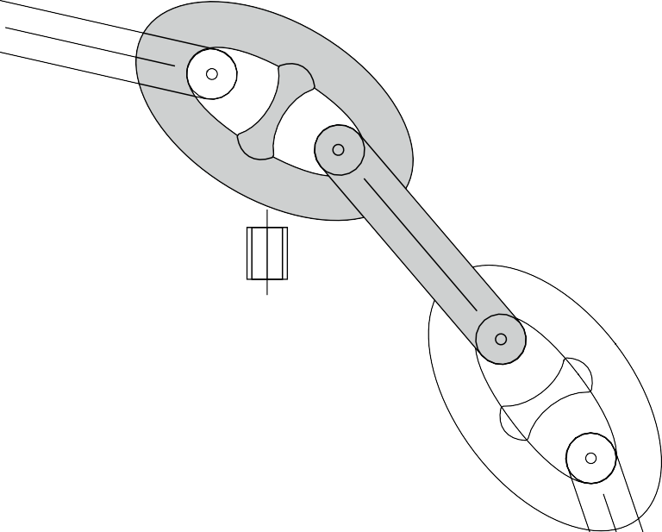

**Figure 10**

Windlass brakes

In case there are no adjusting plates fitted (or due to constructional limitations), an additional plate can be used to minimise and adjust the gap.

*Windlass with high pressure hydraulic motors*

Fatal/serious injuries have occurred over recent years through catastrophic failure (“explosion”) of the hydraulic motor specific windlass fitted with high pressure hydraulic system utilising axial motors that had high gearing and high speed (OCIMF 2010b). Fatal incidents have occurred during anchor heaving operations in adverse weather conditions when the anchor chain has been tensioned beyond the intended safe loading of the windlass resulting in reversing of the motor rotation due to the anchor chain tension (MAIB 2009). It is recommended that hydraulic motors are designed to be safe in such circumstances and protection covers should be fitted where necessary.

Pay attention to:

* + Pressure relief valves
  + Cleanliness of hydraulic oil
  + Corrosion on the housing
  + Protection cover (Refer to the figure below) on motor to be considered to reduce risk for flying debris (*APL Sydney*, 2008).
  + Adequate provision of a remote control stand in a safe position to avoid injuries

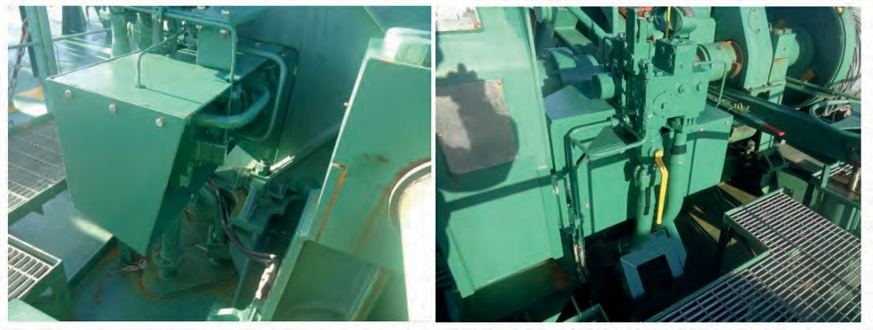

### Figure 11

*Windlass brakes*

* + The windlass brake is essential to control the pay-out of the chain.
  + The conventional design is with brake bands but there are also disc brake systems.
  + Corrosion of the drum and wear of the brake band lining reduce the brake capacity.
  + It is essential that the tension of the brakes is adjusted and liners replaced as per maker’s instructions.
  + Alternate use of port and starboard anchors reduce risk for excessive corrosion / wear on one windlass.

Pay attention to:

* + The lack of ‘Adjustment screw’ for brake band is the most frequent cause of failure in brake system leading to loss of cable and damage to bitter end.
  + The ideal gap for the screw adjustment for brake band support, is 1-2mm.

*Chain cable tensioners*

* + Chain cable tensioners are installed for the purpose of avoiding slamming of the anchor in the hawse pipe.
  + Tensioners of whatever type may be damaged and worn and must not be trusted alone to hold a stowed anchor at sea.
  + Excessive vibrations of the anchors may cause loosening of securing pins in anchor shackles.
  + Broken claws, hooks etc. of cable tensioners should be renewed and not be repaired by welding.

*Bitter end arrangements*

When fitted, bitter end securing arrangements must be maintained in good order to enable releasing the anchor chain with the minimum of involvement by ship’s personnel.

# General Guideline – Anchoring Equipment Inspection Chart



**ROUTINE INSPECTION**

**Anchor & Mooring Windlass**

**MAINTENANCE**

**MAIN SHAFT**

Normally maintenance free.

Listen to transmission for abnormal gear wheel noise.

Listen to bearings for abnormal noise and check for overheating.

**GEARBOX**

**HYDRAULIC/ ELECTRIC MOTOR**

To be greased as per makers recommendations.

To be examined at regular intervals as per makers guidance.

During operation to be rotational free. During operation to be rotational free.

During operation to be rotational free.

**DRUM (STORAGE) DRUM (WORKING)**

**GYPSY WHEEL**

To be inspected for deterioration of material, cracks, deformation. To be inspected for deterioration of material, cracks, deformation.

To be examined for wear at grab points.

**BRAKE BAND**

Adjustment to be carried out at regular intervals.

**CONTROLLERS**

To be regularly checked for deterioration.

Renewal of brake pads to be carried out as per makers recommendations. To be examined at regular intervals as per makers guidance.

Visual inspection prior to commencing operation.

**CLUTCH/ SHIFTING GEAR/ SLIDING CLAW BEARING**

**WINCH FOUNDATION**

To be visually inspected for deterioration of material. Inspect coupling for proper securing.

To be inspected for abnormal noise and overheating.



**Power Pack**

Check for leaking oil.

Check the level of oil inside the tank.

Sampling and analysis to be carried out at consistent intervals.

**HYDRAULIC PUMP HYDRAULIC TANK HYDRAULIC OIL**

**HYDRAULIC OIL FILTERS**

To be internally cleaned and inspected as per makers recommendations.

To be renewed as per makers recommendations.

Visual inspection to assure that there are no weak points.

Check supporting brackets, u-bolts, connection points, valves etc.

**HYDRAULIC HOSES/PIPES**

Check temperature indication.

**HYDRAULIC OIL COOLERS**

Cooler to be cleaned as per makers recommendations.

**Anchor**

Visual inspection during operation. Visual inspection during operation. Visual inspection during operation. Visual inspection during operation.

Visual inspection during operation.

**CROWN PLATE CROWN PIN FLUKES SHANK**

**SHACKLE**

To be examined as per class requirements. To be examined as per class requirements. To be examined as per class requirements. To be examined as per class requirements.

To be examined as per class requirements.

**Chain**

Visual inspection during operation. Visual inspection during operation. Visual inspection during operation.

Inspection for missing/ loose studs, cracks, work out areas and elongation.

**D- SHACKLE ANCHOR SWIVEL KENTER SHACKLE ANCHOR CHAIN**

To be examined as per class requirements. To be examined as per class requirements. To be examined as per class requirements.

Chain to be measured ranged as per class requirements.

**Chain Stopper**

Foundation to be inspected for possible cracks. Check for deterioration of material.

Check pin locking systems that hold tight in position.

**CABLE STOPPER**

**GUARD PIN**

**Chain Locker**

Check tightness and securing bolts are in position.

**CHAIN LOCKER TK**

**CHAIN LOCKER MANHOLE BITTER END**

To be inspected/ cleaned. Normally ona5 year cycle. UTM to be carried out.

To be inspected/ cleaned. Normally ona5 year cycle.

**Anchor Wash**

Fitting, piping system to be examined for deterioration leaks. Fitting, piping system to be examined for deterioration leaks. Pressure to be examined.

**FLEXIBLE PIPING RIGID PIPING**

**WATER WASH SUPPLY PUMP**

Maintenance to be carried out as per makers guidance.

You can download a full-size pdf of this poster from our website: [https://www](http://www.INTERTANKO.com/images/anchoring_guidelines/Anchoring_Equipment_Inspection_Chart.pdf).INTERT[ANKO.com/images/anchoring_guidelines/Anchoring_Equipment_Inspection_Chart.pdf](http://www.INTERTANKO.com/images/anchoring_guidelines/Anchoring_Equipment_Inspection_Chart.pdf)

Appendix 5 – Templates

# Appendix 5 – Templates

### Template for training requirements

The below are example templates as described in section *The Human Element*. For officers:

|  |  |  |  |  |  |
| --- | --- | --- | --- | --- | --- |
| **Sr.** | **Competency for Officers** | **Mtr** | **C/0** | **2/0** | **3/0** |
| **1.** | *To demonstrate a complete accountability of anchoring plan, deployment*  *method, approaches to anchorage, payout /let go and retrieval.* |  |  |  |  |
| **2.** | *To demonstrate a complete understanding of the responsibilities of an*  *Officer-in-charge for the anchor stations (wheelhouse).* |  |  |  |  |
| **3.** | *To demonstrate a complete understanding of the responsibilities of an*  *Officer-in-charge for the anchor stations (forward).* |  |  |  |  |
| **4.** | *Manage the arrival and departure anchoring stations on deck.* |  |  |  |  |
| **5.** | *Assist the Master with the arrival and departure anchoring stations, from*  *the bridge.* |  |  |  |  |
| **6.** | *Plan and Make a safe approach to anchorage considering weather*  *forecasts.* |  |  |  |  |
| **7.** | *Demonstrating efficient use of helm, engine, thrusters, GPS, Doppler, look*  *out, traffic situation, UKC assessment for anchoring & retrieval plan.* |  |  |  |  |
| **8.** | *Prepare and execute an anchoring plan, safely anchor the vessel and*  *subsequently weigh the anchor as per the plan.* |  |  |  |  |
| **9.** | *Efficient communication, report of cable status, team work and clear use of*  *anchoring terminology to avoid confusion.* |  |  |  |  |
| **10.** | *Maker’s instructions in use of anchoring equipment, strength and limitation*  *of equipment.* |  |  |  |  |
| **11.** | *Plan maintenance of anchoring equipment and execution as per time*  *schedule.* |  |  |  |  |

For Ratings at anchor station:

|  |  |  |  |
| --- | --- | --- | --- |
| Sr. | Competency for crew at anchor station | Windlass operator (eg. Bosun) | Assistance To windlass operator  (e.g. AB or OS) |
| 1. | Operation & handling of chain stopper, anchor lashing and  handling of brake. |  |  |
| 2. | Operation of windlass equipment, special power requirement for heaving, limitation of anchoring equipment, bitter end and  emergency let go. |  |  |
| 3. | Cable counting, operation of anchor wash. |  |  |
| 4. | Safety of personnel involved in anchor operation at windlass,  hazards, and PPE to be used. |  |  |

For electrical driven windlass

|  |  |  |  |  |  |  |
| --- | --- | --- | --- | --- | --- | --- |
| Sr. | Competency for Officers | CE | 1AE | C/O | 2/O | ETO |
| 1. | Maker’s instructions in use of electrical driven windlass equipment,  strength and limitation of equipment. |  |  |  |  |  |
| 2. | Efficient communication, team work and clear use of windlass  operational terminology to avoid confusion. |  |  |  |  |  |
| 3. | Maintenance routine which includes checking the lubrication of the sliding parts such as threaded spindles, coupling levers, gear wheels and provided with grease nipples.  To check the Hydraulic drive system of Winch/Windlass. |  |  |  |  |  |
| 4. | Plan maintenance of electrical driven windlass and execution as per time schedule.   * Check for any abnormal noise, vibration and running amp of the motor. * Insulation condition of the power and control cables, check for any chaffing. * Control panel routine of the winch motor, to check the condition of relays, fuse etc. * Meggar test of the motor at regular interval (using Ex Meter) * Checking of the terminals connection tightness and control panel insulation (IP 56), condition of limit switch. |  |  |  |  |  |

The following template table includes examples of OTJ training that could form part of a company’s plan. For Officers:

|  |  |  |  |  |  |
| --- | --- | --- | --- | --- | --- |
| Sr. | On-the-job Training for Officers | Mtr | C/0 | 2/0 | 3/0 |
| 1. | The forces that act on ship while at anchor. |  |  |  |  |
| 2. | Holding power of anchor. |  |  |  |  |
| 3. | Ship’s specific: design, operation and limitations of the mooring equipment. |  |  |  |  |
| 4. | Maker’s instructions (operation of the windlass under normal, emergency  and heavy sea conditions). |  |  |  |  |
| 5. | windlass operator: Practical for normal and at heavy weather operations of  the windlasses. |  |  |  |  |

Anchoring Guidelines: A Risk-Based Approach 53

Appendix 6 – Personnel engagement for anchoring operation

# Appendix 6 – Personnel engagement for anchoring operation

The following is an **example** of a template for manning during anchoring:

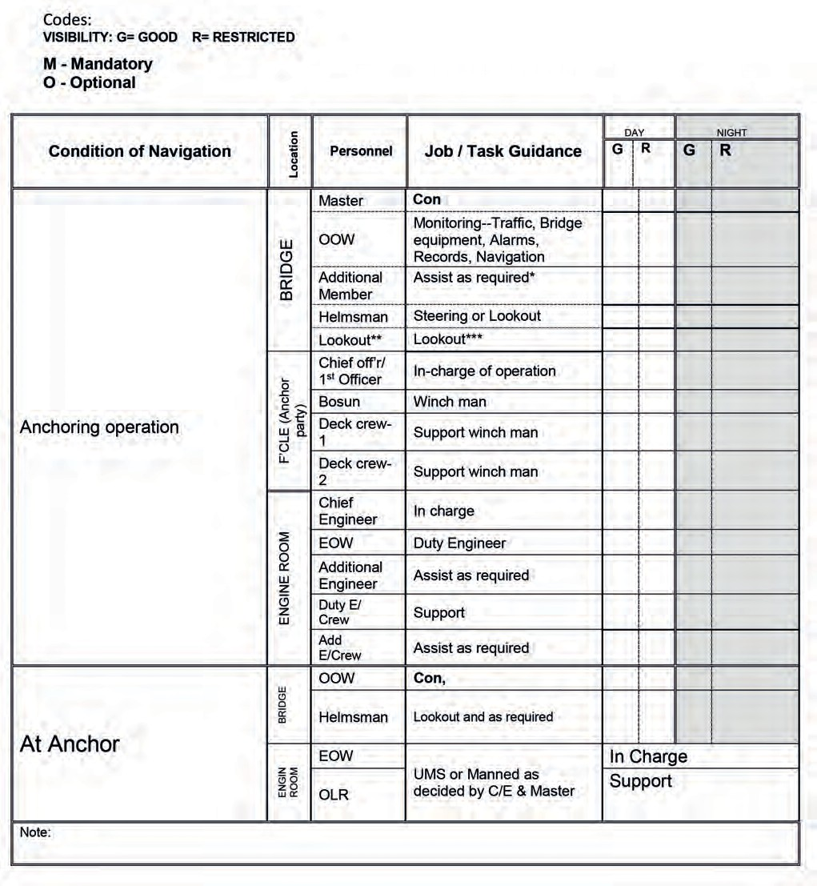

# APPENDIX 7 Poster for bridge

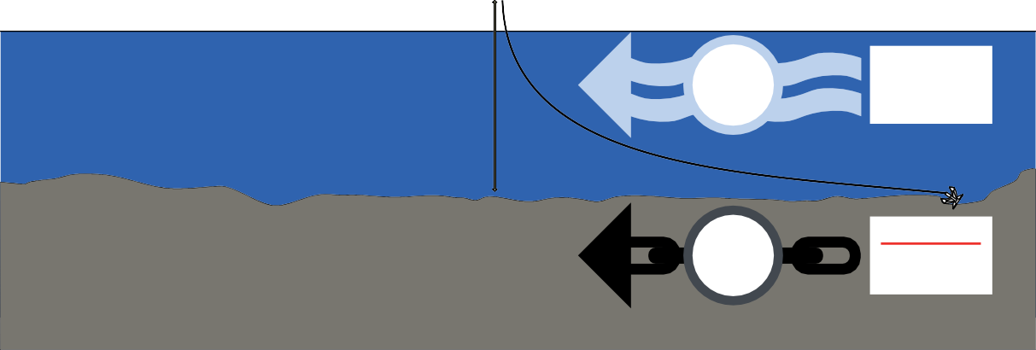

**25**m/s

**4.8**

knots

**Maximum**

current speed

4.8 knots

**6:10**

Scope

**Minimum** chain scope 6:10

**Good Holding Ground**

**Harboured or**

**Sheltered Areas**

* The scope being the ratio between length of chain paid out and water depth

**Maximum** wind speed 25m/s



**11**m/s

**2m**

**3**

knots

**Maximum**

current speed

3 knots

**6:10**

Scope*

**Good Holding Ground**

**Open Water**

* The scope being the ratio between length of chain paid out and water depth

**Minimum** chain scope 6:10

**Maximum**

wave height

**Maximum** wind speed 11m/s

According to IACS UR A1: The anchoring equipment is intended for temporary mooring of a vessel within a harbour or a sheltered area when the vessel is awaiting berth, tide etc.

The equipment is therefore not designed to hold a ship off fully exposed coasts in rough weather or stop a ship that is moving or drifting. In this condition the loads on the anchoring equipment increase to such a degree that its components may be damaged or lost owing to the high energy forces generated, particularly in large ships.



**3**

Lengths

**Min**

Lifting capacity

3 lengths

82.5m

**imum**

**Anchor Winch Motor Performance**

The windlass is designed to lift 3 lengths of chain.

ie. 82.5m and the anchor.

You can download a full-size pdf of this poster from our website: [https://www](http://www.INTERTANKO.com/images/anchoring_guidelines/Anchoring_Poster-for-Bridge.pdf).INTERT[ANKO.com/images/anchoring_guidelines/Anchoring_Poster-for-Bridge.pdf](http://www.INTERTANKO.com/images/anchoring_guidelines/Anchoring_Poster-for-Bridge.pdf)

**INTERTANKO London St Clare House**

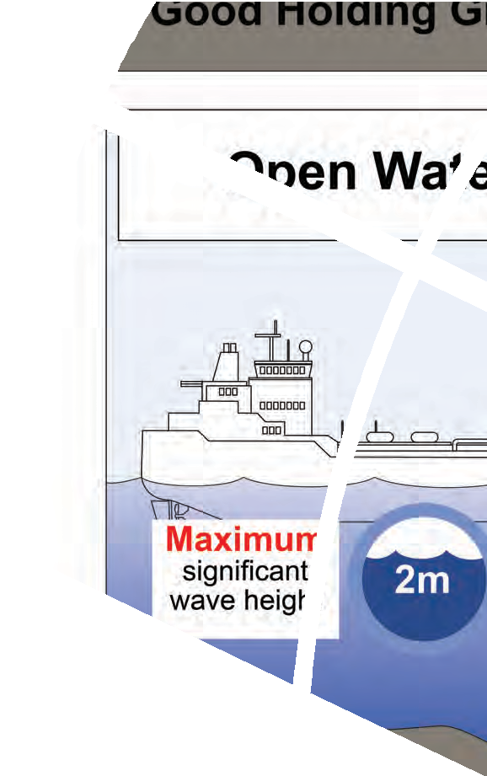

**30-33 Minories London EC3N 1DD United Kingdom**

**Tel: +44 20 7977 7010**

**Fax:+44 20 7977 7011**

[**london@intertanko.com**](mailto:london@intertanko.com)

**INTERTANKO Oslo**

**Nedre Vollgate 4**

**5th ﬂoor**

**PO Box 761 Sentrum N-0106 Oslo Norway**

**Tel: +47 22 12 26 40**

**Fax:+47 22 12 26 41**

[**oslo@intertanko.com**](mailto:oslo@intertanko.com)

**INTERTANKO Asia**

**70 Shenton Way**

**#20-04 Eon Shenton**

**079118**

**Singapore**

**Tel: +65 6333 4007**

**Fax: +65 6333 5004**

[**singapore@intertanko.com**](mailto:singapore@intertanko.com)

**INTERTANKO North America**

**801 North Quincy Street – Suite 200 Arlington, VA 22203**

**USA**

**Tel: +1 703 373 2269**

**Fax:+1 703 841 0389**

[**washington@intertanko.com**](mailto:washington@intertanko.com)

**INTERTANKO Athens Karagiorgi Servias 2 Syntagma**

**Athens 10 562**

**Greece**

**Tel: +30 210 373 1772/1775**

**Fax: +30 210 876 4877**

[**athens@intertanko.com**](mailto:athens@intertanko.com)

**INTERTANKO Brussels Rue du Congrès 37-41 B-1000 Brussels Belgium**

**Tel: +32 2 609 54 40**

**Fax: +32 2 609 54 49**

[**brussels@intertanko.com**](mailto:brussels@intertanko.com)

[**www.intertanko.com**](http://www.intertanko.com/)