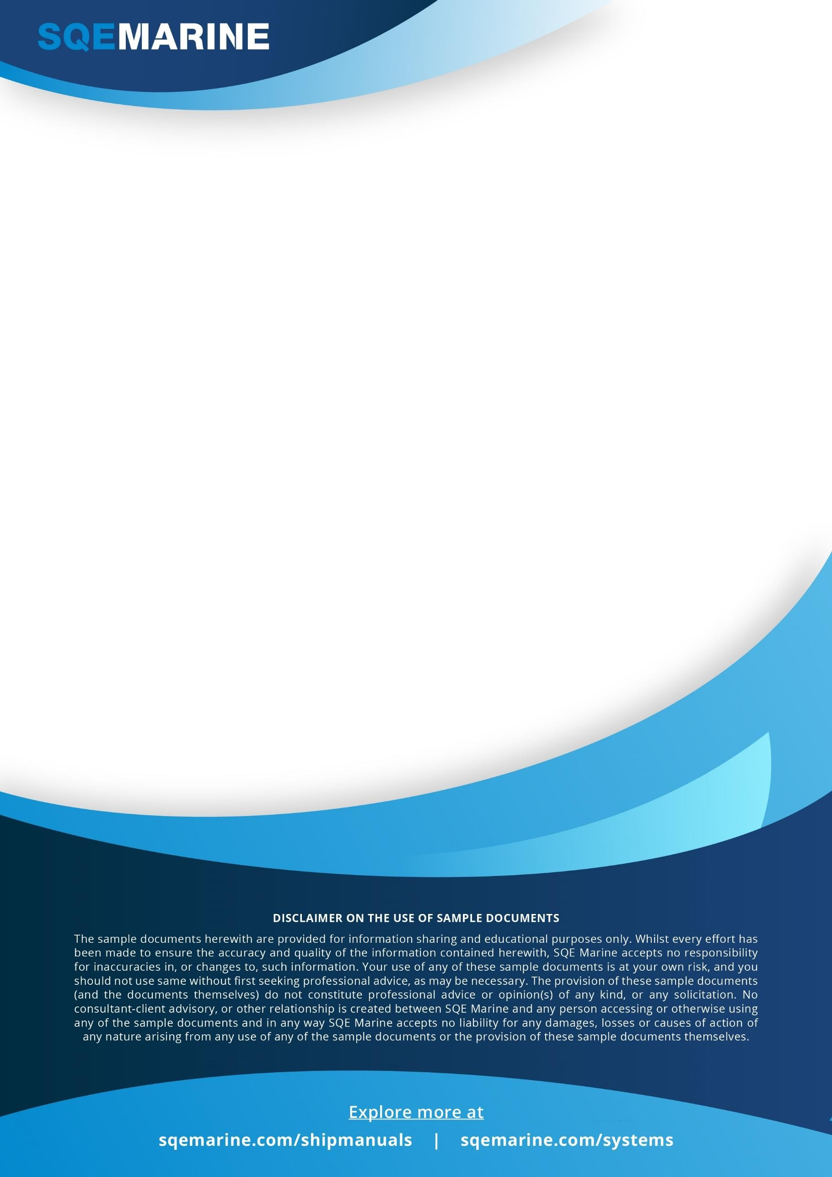

STEERING FAILURE

To be used during steering gear failure incidents. To be kept on the bridge and in the Emergency Steering Gear room.



|  |  |  |  |
| --- | --- | --- | --- |
| **EMERGENCY CHECKLIST**  **Steering Failure** | | | |
| **A.** | **Action** | **Personnel Responsible** | **Completed** |
| 1. | Call Master. | Officer On Duty |  |
| 2. | Disengage autopilot. | Officer On Duty |  |
| 3. | Engage alternate or emergency steering system. | Officer On Duty |  |
| 4. | Advise engineer officer on watch. | Officer On Duty |  |
| 5. | Check positions of vessel in vicinity. | Officer On Duty |  |
| 6. | Maneuver as appropriate and if necessary stop engines. | Master / Officer On Duty |  |
| 7. | Take away off ship is safe to do so. | Master / Officer On Duty |  |
| 8. | If necessary - make appropriate sound signals. | Master |  |
| 9. | Broadcast URGENCY or DISTRESS message, if appropriate. | Master / GMDSS Officer |  |
| 10. | Exhibit NUC shapes/lights/signals as necessary. | Master / Officer On Duty |  |
| 11. | Prepare engine for maneuver. | Master / Officer On Duty |  |
| 12. | Switch on VHF - Channel 16. | Officer On Duty |  |
| 13. | Prepare for anchoring if considered necessary and depth of water is suitable. | Master |  |
| 14. | Fix position of vessel. | Master/ Officer On Duty |  |
| 15. | Check for navigational hazards in vicinity. | Master/ Officer On Duty |  |
| 16. | Modify AIS status. | Master / Ch. Officer |  |
| 17. | Inform VTS or port authority, as appropriate. | Master / Ch. Officer |  |
| 18. | Note time of failure. | Master / Officer On Duty |  |
| 19. | Check cause of failure. | Ch. Engineer |  |
| 20. | Enter facts in log. | Master |  |
| 21. | Report to the Office. | Master |  |
| **B.** | **Other** |  |  |
|  |  |  |  |
|  |  |  |  |
|  |  |  |  |
|  |  |  |  |
|  |  |  |  |
|  |  |  |  |
|  |  |  |  |
|  |  |  |  |
|  |  |  |  |
|  |  |  |  |
|  |  |  |  |
|  |  |  |  |
|  |  |  |  |
|  |  |  |  |

This checklist should be placed in the Bridge and Engine Control Room and followed in case of steering failure.

Page 1 of 1

**Explore more:** [www.sqemarine.com/shipmanuals](http://www.sqemarine.com/shipmanuals) **&** [www.sqemarine.com/systems](http://www.sqemarine.com/systems)