

EMERGENCY TOWING MANUAL

**in accordance with SOLAS Ch.II-1, Reg.3-4**

**SHIP NAME : M/T “RUBY-T”**

**IMO Number : 9457878**

**PORT OF REGISTRY : VALLETTA**

**GROSS TONNAGE : 12.890**

**BUILD YEAR: 2010**

GALATA SHIPPING CO.

Emergency Towing Booklet

**- TABLE OF CONTENTS -**

1. GENERAL DESCRIPTION 3
   1. General 3
   2. Limitation during towing operations 3
   3. Master’s action 4
   4. Safety considerations 4
2. SHIP-SPECIFIC DATA 5
   1. General information 5
   2. Draft and displacement range 5
   3. Anchor, anchor chain and mooring lines 5
   4. Radio equipments 6
   5. Power supply and steering equipments 6
   6. Lifting devices 6
   7. Mooring & Towing fittings on fore mooring deck 7
   8. Mooring & Towing fittings on aft mooring deck 8
3. TOWING PATTERNS 9
   1. General 9
   2. Towing from bow 9
   3. Towing from stern 10
4. ORGANISATION OF TASKS 11
   1. Staffs arrangement & Communications 11
   2. Tasks and equipments 12
5. CURRENT STATUS 13
   1. General 13
   2. Damage and seaworthiness 13
   3. Steering and propulsion 14
   4. Power system 14
6. PROCEDURES FOR CONNECTING TOWING LINES 15
   1. Towing from stern 15
   2. Towing from bow 18

Page 2

Emergency Towing Booklet

# GENERAL DESCRIPTION

* 1. General
     1. This booklet is prepared for use in emergency towing situations in accordance with SOLAS Ch.II-1, Regulation 3-4 and relating MSC.1/Circ.1255.
     2. Following information is included in this booklet.
        1. Drawings of fore and aft deck showing possible emergency towing arrangements
        2. Inventory of equipment on board that can be used for emergency towing
        3. Means and methods of communication
        4. Sample procedures to facilitate the preparation for and conducting of emergency towing
        5. Organization of tasks
        6. Communications plan listing all information that is needed to communicate to the towing ship
     3. A copy of this booklet should be kept at hand by the owners/operators. A copy should be also kept in a common electronic file format, which will allow faster distribution to the concerned parties.
     4. A minimum of three copies should be kept on board and located in following locations.
        1. The bridge
        2. A forecastle space
        3. The Ship’s office or cargo control room
     5. Owners, operators and crew should take into consideration that the nature of an emergency does not allow time for deliberation. Accordingly, the procedures should be practiced beforehand.
     6. Typical procedures for connecting towing lines are introduced in Section 6 of this booklet.
     7. The crew should have good knowledge of equipment stowage location and accessibility. Any identified improvements to stowage arrangements should be implemented.
  2. Limitation during towing operations
     1. Not all ships have the same degree of shipboard equipment, so that there may be limits to possible towing procedures. Nevertheless, the intention of this booklet is to predetermine what can be accomplished.
     2. The towing load should not exceed safety working loads of deck fittings as shown in 2.7 and 2.8 of this booklet. When heavy weather where the towing load increases significantly is forecasted, special considerations are to be paid to towing speed, towing lines arrangement and ship’s stability.
     3. When the angle of tow line around bow or stern chock becomes smaller, the resultant force acting on the chock gets greater. Therefore, tow line’s fleet angle around chocks should be kept greater than generally 135 degrees.

Page 3



* + 1. When the fleet angle is expected to get smaller during turning operation, etc, towing speed should be sufficiently rated down.
    2. Loading points on stand-rollers are so high that great bending moments are generally transferred to the supporting structures. Stand-rollers are not to be used in towing lines arrangement.
  1. Master’s action
     1. The master of ship or ship owner’s representative to recognize that the ship is in distress and may need towing assistance should make the initial notification of the incident to the following parties.
        1. Nearest port states
        2. Flag states
        3. Other relevant parties (Shipper, Insurer, etc.)
     2. The master should fill up tables in Section 5 ‘CURRUENT STATUS’, and prepare to communicate to the towing ship.
     3. All information from Section 1 to Section 5 of this booklet should be delivered to the towing ship.
     4. The master should ensure that towing lines do not come tight until towing lines are made-up to the connection system of towing ship and everyone on deck are noted.
     5. When power system on board is not available or alternative connection procedures are introduced by the towing ship, the master should make a best decision considering ship’s current status in consultation with the towing ship.
     6. When alternative procedures are adopted, any precautions should be well informed to all staffs.
     7. The master should ensure that all survival crafts onboard are ready to employment.
  2. Safety considerations
     1. 1st Officer on mooring deck should be in contact with the Bridge in all times.
     2. Everyone on deck should be equipped with the personnel life saving appliance, and be alert for slips, trips and fall hazards.
     3. All crew should be informed well of the work procedures and tasks.
     4. When the towing line begins strained in tension, all on-deck staffs should be evacuated to the safe location.
     5. It is necessary to grease up continuously in order to prevent wear of ropes in chocks when wire ropes are used as towing lines. Wear-out condition in chocks should be constantly checked.
     6. Whilst engaged in towing operations the minimum number of crew essential to carry out duties, is to be on deck, and never exposed to a rope or wire under tension or load. Wherever possible, a "clear deck" of crew should be in operation whilst towing.

# SHIP-SPECIFIC DATA

### General information

|  |  |  |
| --- | --- | --- |
| 1. **Ship’s name** 2. **Call sign** 3. **Type of ship** |  | **M/T RUBY-T**  **9HA2520 OIL/CHEMICAL TANKER** |
| 1. **IMO number** 2. **Nationality** |  | **9457878**  **MALTA** |
| 6 **Port of registry** |  | **VALLETTA** |
| 7 **Classification** |  | **GERMANISCHER LLOYD** |
| 8 **Classification ID No.** |  | **113852** |
| 9 **Year of built** |  | **2010** |
| 10 **Gross tonnage** |  | **12890** |
|  | **LOA** | **156.70 M** |

#### Principal dimensions

#### LBP 146.90 M

#### Breadth 22.90 M

#### Depth 12.80 M

#### Height of mooring deck at Fore deck 16200 centerline above base line Aft deck 16200

|  |  |  |
| --- | --- | --- |
| 2.2 Draft and displacement range |  | |
|  | Draft [meters] | Displacement [tons] |
| **Summer load condition** | **9800** | **27412** |
| **Lightest sea going condition** | **6060** | **15976** |

### Anchor,anchor chain and mooring lines

|  |  |  |
| --- | --- | --- |
| **Equipment Number** | **Anchor** |  |
| **1932** | **Type** | **HHP** |
| **Mooring lines** | **Weight** | **4500 kg** |
| **Type rope** | **Number** | **2** |
| **Diameter 48 mm** | **Anchor chain** |  |
| **Length 220 m** | **Grade** | **Q3** |
| **Number 18** | **Length** | **577,5** |
| **SWL 430 kN** | **Diameter** | **60 mm** |

### Radio equipments

|  |  |  |  |  |
| --- | --- | --- | --- | --- |
| No. | Equipments | Fitted or | not | Phone No. etc. |
| 1 | VHF radio installation | X Yes | No |  |
| 2 | MF radio installation | X Yes | No |  |
| 3 | MF/HF radio installation | X Yes | No |  |
| 4 | Inmarsat – B | Yes | X No |  |
| 5 | Inmarsat – C | X Yes | No |  |
| 6 | Inmarsat – F | X Yes | No |  |
| 7 | Navtex receiver | X Yes | No |  |
| 8 | 2-way VHF radio telephone (3EA) | X Yes | No |  |
| 9 | Weather facsimile | X Yes | No |  |
| 10 | Maritime telephone | X Yes | No |  |
| 11 |  |  |  |  |
| 12 |  |  |  |  |
| 13 |  |  |  |  |
| 14 |  |  |  |  |

### Power supply and steering equipments

No.

Equipments

Location Particulars

* + 1. Main generator Engine Room 750 kWe 440 V 60 Hz
    2. Em’cy generator Emg. Gen. Room 240 kWe 440 V 60 Hz
    3. Main steering gear pump Str. gear room Leistriz 277,8 l/min@3500 RPM
    4. Em’cy steering gear pump

When all power supplies are halted, steering by a

* + 1. human power is possible?

x Yes No

### Lifting devices

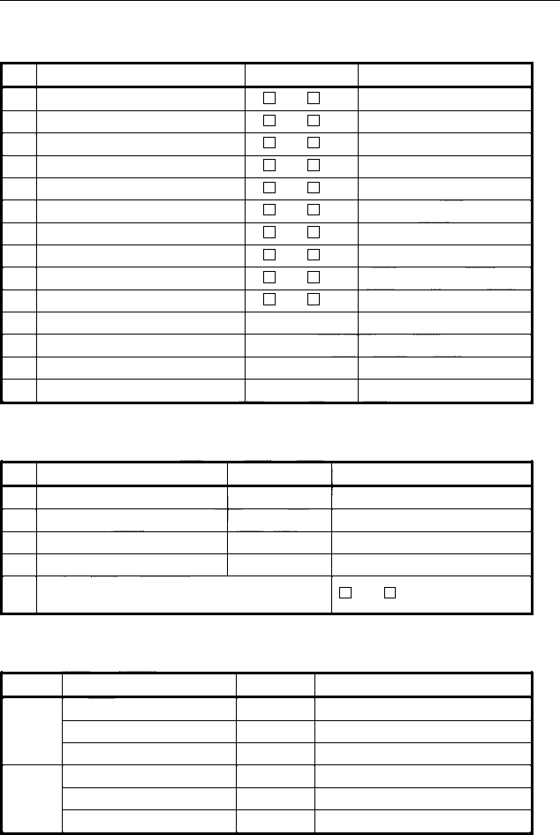

Fore mooring deck

Aft mooring deck

Device

Rope handing davit Portable davit

Provision crane

Fuel oil hose handling davit

SWL [tons]

NA NA

2.0

NA

Location Around rope hatch

-

Aft end of accommodation (P&S) Front end of accommodation (P&S)

### Mooring & Towing fittings on fore mooring deck

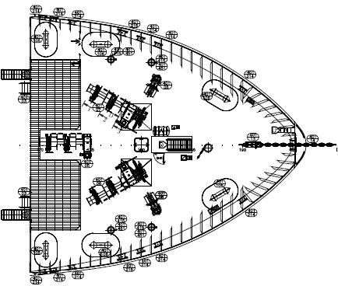

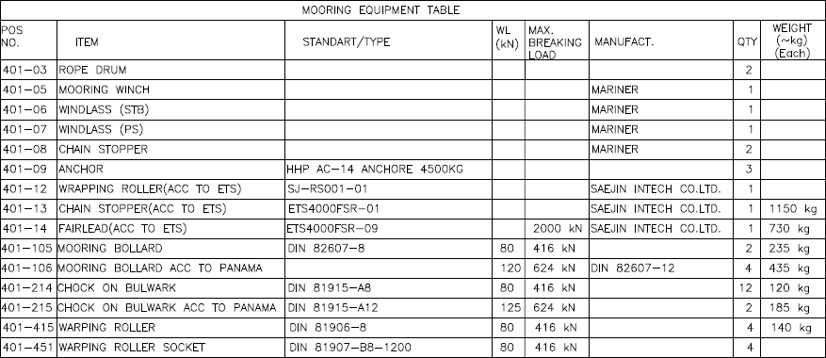

### Mooring & Towing fittings on aft mooring deck

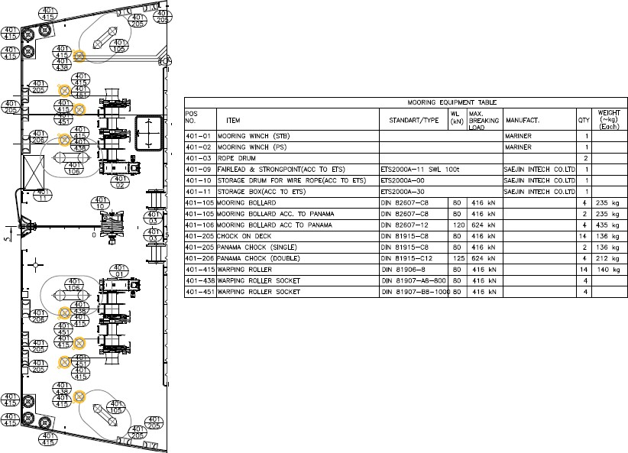

# TOWING PATTERNS

### General

* + 1. The Master of the ship should determine the towing pattern in consultation with the towing company.
    2. The ships should be towed from the bow as far as possible. If it is not possible to tow from the bow for some reasons such as grounding, collision, towing from the stern may be selected as an alternative.
    3. Following circumstances are to be taken into the Master’s account.
       1. Ship’s position
       2. Availability of the propulsion system
       3. Direction and rate of drift
       4. Distance and estimated time to any possible grounding location
       5. Weather and sea conditions
       6. Short-term marine forecast for the area of the incident

### Towing from bow

* + 1. Following figure shows the typical arrangement of tow line connection for towing from bow.

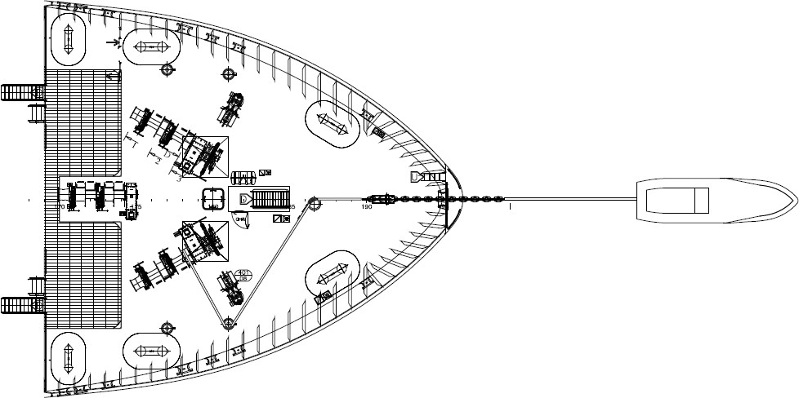

### Towing from stern

* + 1. Following figure shows the typical arrangement of tow line connection for towing from stern.

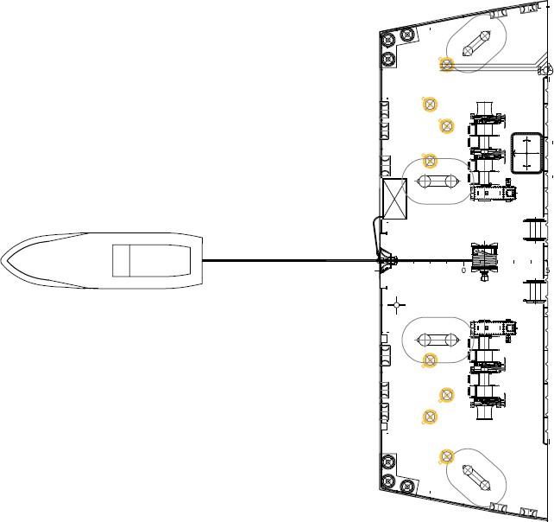

1. **ORGANIZATION OF TASKS**

### Staffs arrangement & Communications

Bridge

Captain

Towing ship

3rd Officer

Quartermaster

ECR

Chief Engineer

Mooring deck

1st Officer (On-deck operations)

Electirician

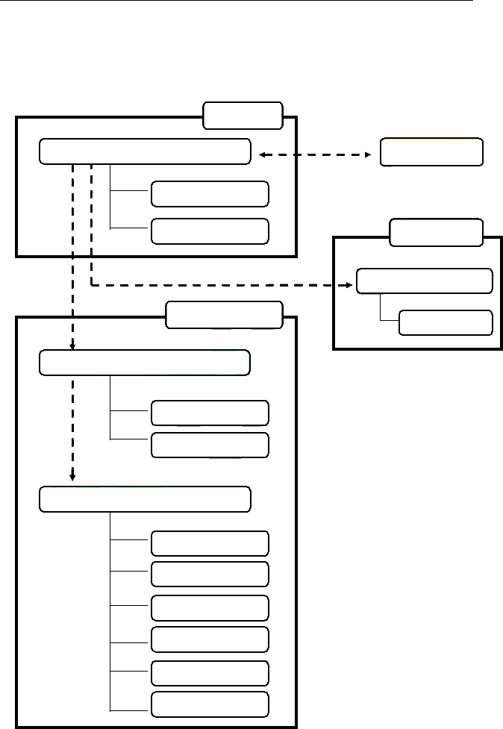

2nd Officer 2nd Engineer

Bosun (Winch & Rope handling)

Deck man A Deck man B

Deck man C

### Tasks and equipments

Task

No. Person

Personnel life saving

Equipments

Portable wireless

On- deck

Posi- tion

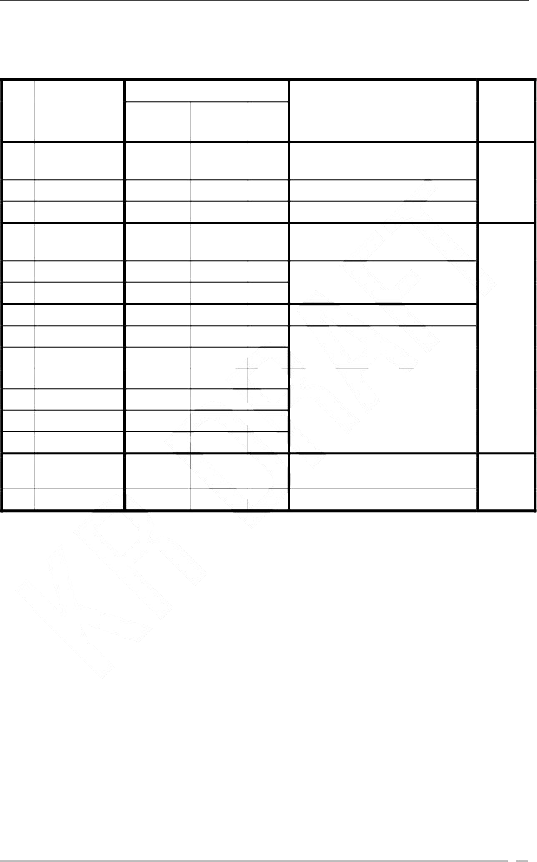Communication with towing ship, Overall responsible person

|  |  |  |  |  |
| --- | --- | --- | --- | --- |
|  | | appliance | radio | tools |
| 1 | Captain |  | O |  |
| 2 | 3rOd fficer |  |  |  |
| 3 | Quartermaster |  |  |  |
| 4 | 1st Officer | O | O |  |
| 5 | 2nd Officer | O | O |  |
| 6 | 2nEd ngineer | O | O |  |
| 7 | Bosun | O | O |  |
| 8 | Deckman A | O |  | O |
| 9 | Deckman B | O |  | O |
| 10 | Deckman C | O |  | O |
| 11 |  |  |  |  |
| 12 |  | O |  | O |
| 13 |  | O |  | O |
| 14 | Chief Engineer |  |  |  |
| 15 | Electrician |  |  |  |

Assistant to Captain Steering

Communication with Bridge, Responsible person on deck

Assistant to 1 Ostfficer

Winch & rope operations Winch handling

Rope handling

Responsible person in engine room

Assistant to Chief Engineer

Bridge

Mooring Deck

ECR

# CURRENT STATUS

### General

No.

Item

Status

1. Present time
2. Current position
3. Cause of towage
4. Weather condition
5. Weather forecast
6. Ship’s drafts
7. Wind velocity and direction

Date/Month/Year

Describe the cause :

Fore :

Velocity [knots]

Aft :

Time

Direction

1. Drifting speed and direction

Speed [knots] Direction

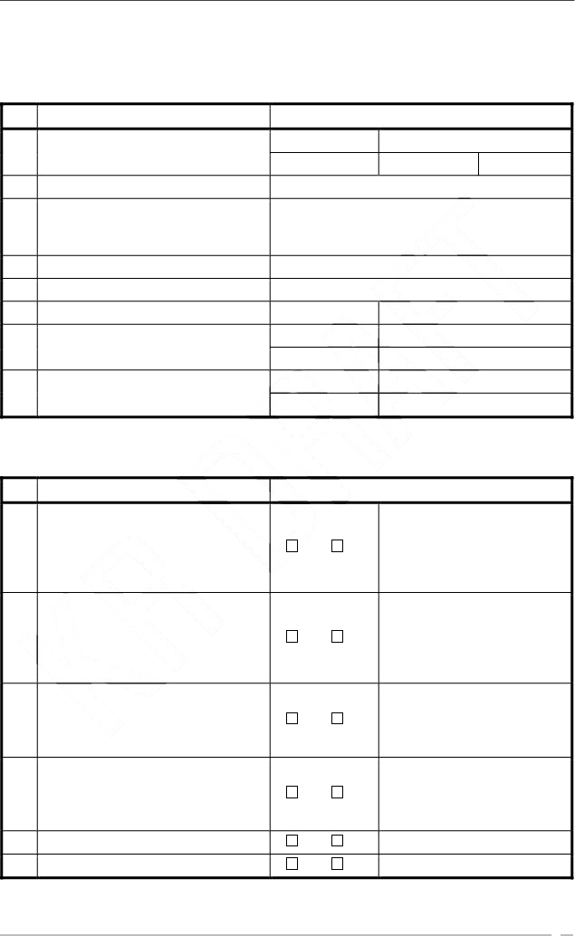

### Damage and seaworthiness

No. Item Status

Describe the status :

1 Flooding or outflow Yes No

|  |  |  |  |
| --- | --- | --- | --- |
| 2 Imminent danger (e.g. grounding) | Yes | No | Describe the danger : |
|  |  |  | Describe the type of cargo : |
| 3 Cargo loaded? | Yes | No |  |
|  |  |  | Describe the status of M/E : |
| 4 Can use the main engine? | Yes | No |  |
| 1. Can control the trim? 2. Is there heeling? | Yes Yes | No No |  |

### Steering and propulsion

No. Item Status

Describe the status :

1. Can use the rudder? Yes No

If the rudder is damaged, what is the

1. current rudder angle and is it possible to return to midship?

Yes No

Describe the status :

Can prevent free rotation of the propeller?

3

Yes No

Describe the status :

### Power system

No. Item Status

Describe the status :

1 Can use power on board? Yes No

Can use the mooring winch for winding the towing line?

2

Yes No

Describe the status :

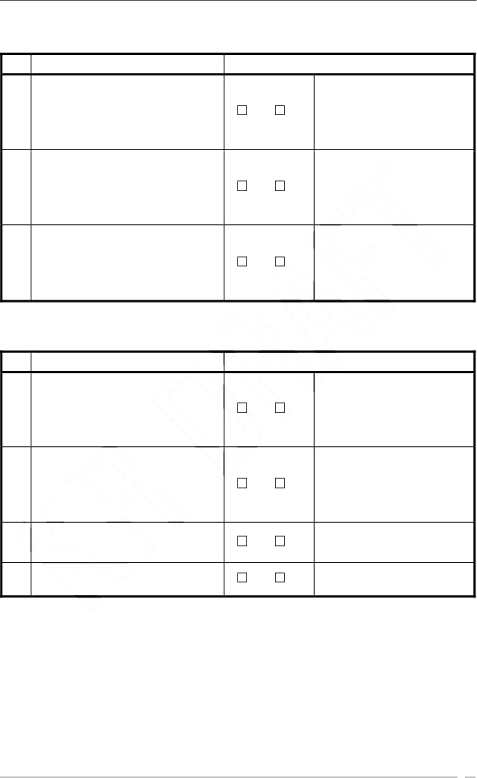Can use deck lighting for the towing

1. line connection?
2. Can use towing side/stern lights?

Yes No

Yes No

# PROCEDURES FOR CONNECTING TOWING LINES

## Towing from stern.

6.1a Deployment procedure of After. No. 1 Stage

For safe operation, follow the procedure below :

1. Go to pick up gear container.
2. Loosen butterfly bolts at pick up gear box and open the box.
3. Connect the end of the messenger rope to C-type socket of the towing pennant with a shackle.
4. The light on the buoy will turn on automatically.

No. 2 Stage

1. Tugboat shell pick up the buoy and the end of the messenger rope.
2. When the messenger rope is being pulled out, the safety clamp on the storage No. 3 Stage
3. C-type socket of the towing pennant is to be fixed on the towing equipment of the tug.
4. Then the towing can be started.

6.1b Retrieval procedure.

1. Remove the cover on the end of the centrifugal brake on the storage drum and install the air motor.
2. Spool the retrieval wire on the smallest storage part of the drum.
3. When the end socket of the wire is resting properly on the drum, guide the towing wire through the split flange to the largest storage side of the drum.

Spool the towing wire on the drum and monitor that correct spooling is obtained. Rinse the towing wire with fresh water while it’s being retrieved.

When spooling, check for damage to the wires. Of any, we strongly recommend to replace the wire with a new one.

1. Retrieve the pick-up gear on deck by hand or by means of wearing head on a

mooring winch. Page 15

## Towing from bow

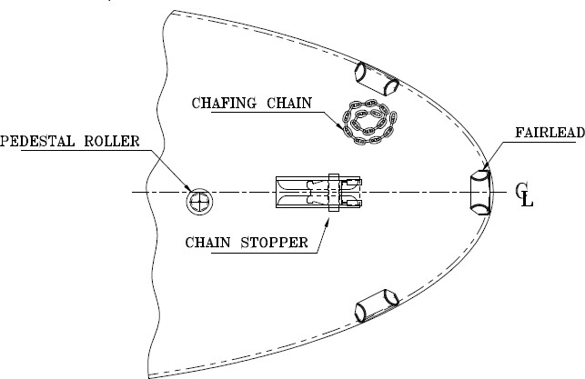

The forward Emergency Towing System consists of the following equipment.

1. Chain stopper
2. Fairlead
3. Pedestal roller
4. Chafing Chain (Location for illustration only)

No. 1 Stage

1. Bring the stored chain to point connectable with towing rope.
2. Throw the sandlead rope of the vessel to the tugboat through the fairlead.
3. Fasten the sandlead rope to the other end of the messenger rope on the tugboat.

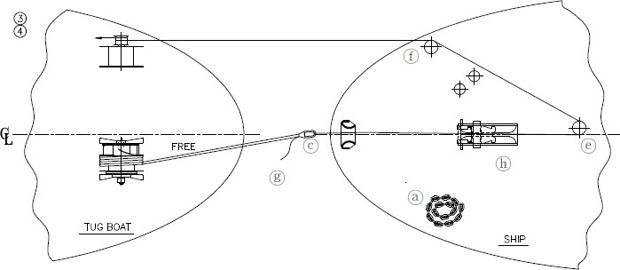

1. Reel the messenger rope on to the warping end of the vessel’s mooring winch by way of the pedestal roller and the fairlead roller .
2. While reeling the messenger rope, pull the towing rope on the vessel where it can be fastened with the stopper rope .

No. 2 Stage

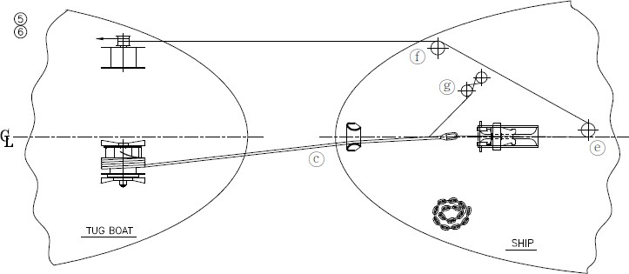

1. Lash the towing with the stopper rope so that towing rope won’t drop loose.
2. Loosen the messenger rope, when the load on the towing rope has moved over to the stopper rope remove the messenger rope.

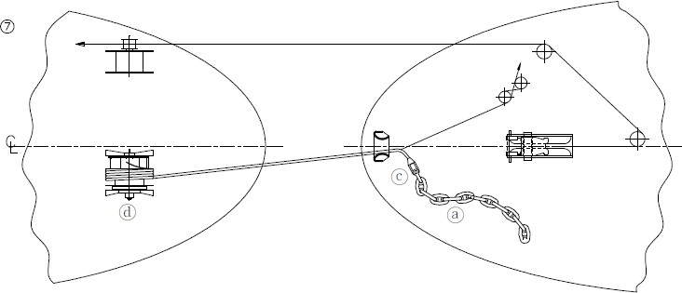

1. Connect to the towing rope with the shackle fitted to the tip of the chain .

### No. 3 Stage

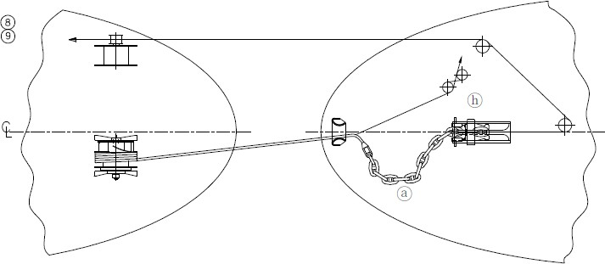

1. While getting the stopper rope loose, run the tugboat’s winch to reel in the towing rope slowly, then let fit the stopper point to the fairlead.
2. Start towing.

Page 18