1. First install node.js from here <https://nodejs.org/en/download/>
2. If some file missing in installatation then search in window (install additional tools for node.js)

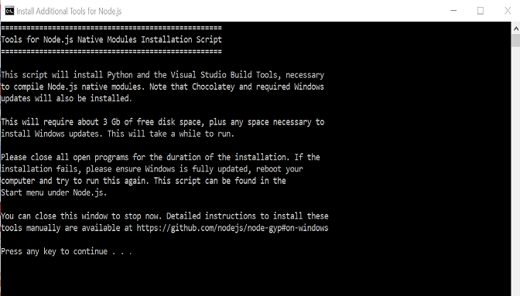

Now you can press any key for continue and it will install all required file automatically

1. Open node.js command prompt
2. Write in node.js command prompt(npm install –g botkit)

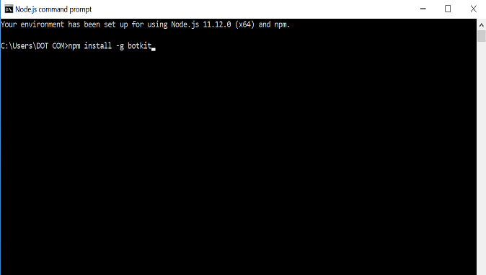

1. Write in node.js command prompt(botkit new --platform web)
2. Then it show a message like name your bot (ex:- my_project)

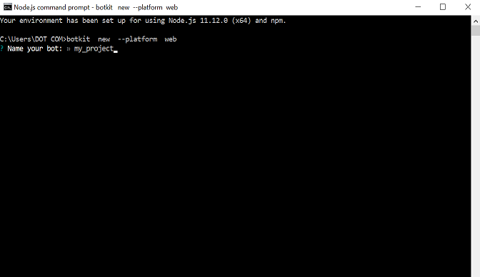

1. Then My_project file saved in your pc contain all folder that are use in your project
2. If it aries some error like

(An error occurred. You may already have that starter kit installed.  
Error:Error: Command failed: git clone <https://github.com/howdyai/botkit-starter-teams.git> mybot&& cd mybot && npm install  
'git' is not recognized as an internal or external command,  
operable program or batch file.) then go to step 4 and continue to 7

1. Then restart your computer
2. Now your installation completed
3. Start node.js command prompt and write(cd my_project && node .)
4. Then it show a message like (I AM ONLINE ! COME TALK TO ME: <HTTP://localhost:3000>)

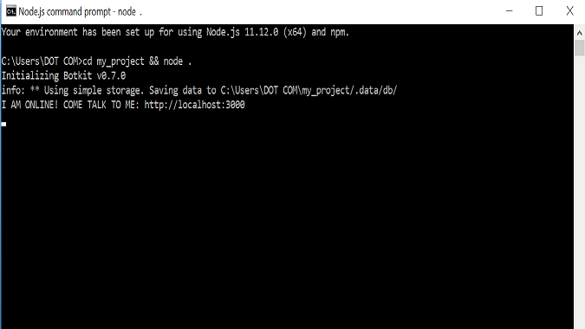

1. Start localhost in your pc
2. Click on Start, Control Panel and select "Programs and Features" category.
3. Open Programs and Features, at the left pane, you will find "Turn Windows Features on or off", click on it.
4. Scroll down to find Internet Information Server (IIS) and enable it to use Localhost functionality on your computer.
5. Open your browser and type localhost:3000
6. Here we can see our chatbot is ready

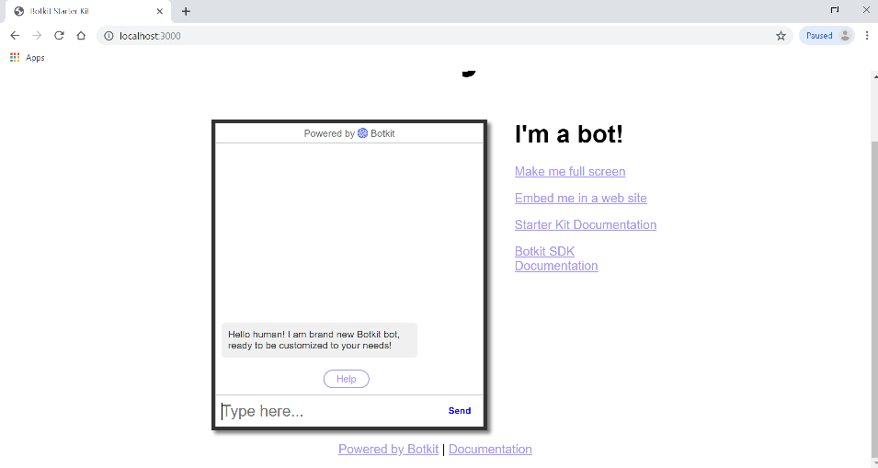

1. Now go to my_project->Skills
2. In this folder contain all .js file are used in our project.
3. _connection_event.js file is used for connection with chatbot server and in this file contain first message of chatbot.
4. the demo_quick_replies.js file show how to use button event in chatbot.

**controller.hears('quick replies','message_received', function(bot, message) {**

**bot.reply(message, {**

**text: 'Look, quick replies!',**

**quick_replies: [**

**{**

**title: 'Hello',**

**payload: 'hello'**

**},**

**]**

**},function() {});**

**});**

In this above code controller.hears() function is used for check receive message

For example if the message received is ‘quick replies’ then it will show a button with

Hello caption and the caption is taken by title property and then payload property is

Used when user click on button then the text in payload property is the next question

For chatbot.all the property are define into quick_replies field.

1. the message_history.js file is use for store the history of user messages.
2. the simple_hears.js file is used to accept message from user and reply to user according to message for example:-

**controller.hears('test','message_received', function(bot, message) {**

**bot.reply(message,'I heard a test');**

**});**

In this above example if message is ‘test’ then it reply to user ‘I heard to test’

1. the super_quit.js is use for quit the chatbot.
2. The unhandled_messages.js is use for if any message that are not define in any file then it handle by this file.
3. Here I used simple_course.js file and this file contain all information about course in our university.

If you want to add your own .js file then follow this steps:-

1. Add this library

module.exports = function(controller) {<describe method and defination>}

1. In above library we can define all method and functionality .

for example:

**module.exports = function(controller) {**

**controller.hears('test','message_received', function(bot, message) {**

**bot.reply(message,'I heard a test');**

**});**

**}**

in this example I used a function that reply ‘I heard a test’ If received message is ‘test’

1. If you want to add an image in chatbot then you need to follow this steps:-

For example:-

**controller.hears('image','message_received', function(bot, message) {**

**bot.reply(message,{**

**text: 'Look, an image!',**

**files: [**

**{**

**url: 'http://www.gujaratvidyapith.org/index_files/GVP-Home_02.jpg',**

**image: true**

**}**

**]**

**});**

In this above example show an image. In this example files field is use for show an image.

First property **url**: is used for take url of image .

(NOTE:-you cannot define your local machine url .you must need to define server url.)

Second property is boolean type so we need to true for show image.

1. If you want to add link in this chatbot then this step are used.

For example:-

**controller.hears('gujarat vidyapith','message_received', function(bot, message) {**

**bot.reply(message,'[Click Here To Gujarat vidyapith Website] (**[**http://www.gujaratvidyapith.org/)**](http://www.gujaratvidyapith.org/))**');**

**});**

1. If you want to add link then you must follow this syntax,

Bot.reply(message,’[write the message that you want to show](write link)’);

In this syntax first you add message keyword and then you need to add a message in square bracket ‘[]’ and this message is show to user and next you need to add link in round bracket’()’ .

1. If many question have same answer then you need to define only one common word in all question

For example :- 1. What is MCA syllabus ,2. What is BA syllabus.

In above ‘**syllabus**’ is common word in both question so we only need to define a question like that:-

**controller.hears('syllabus','message_received', function(bot, message) {**

**bot.reply(message,'[download syllabus](http://www.gujaratvidyapith.org/syllabus.htm)');**

**});**

Here the syllabus is common word so that it reply on both question a same answer.