Group 38

Ajay Patel, 260791038

Raphaël Di Piazza, 260672796

Lara Kollokian, 260806317

Massiva Mahamli, 260806869

April 12th, 2020

**Project Part 3 Submission**

# Question 1

The source code for the function is in the file P3Q1.sql included in this folder as well as in our database. Here are three example outputs for our function:

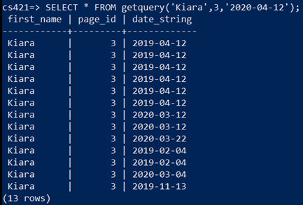

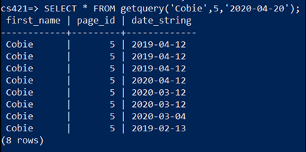

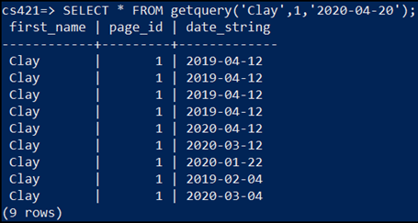

# Question 2

You can view a demo of our application at the following link:

INSERT LINK

There are 6 options in our application:

Option 1: add a new user to the social media platform.

Option 2: view pages where the selected user is an admin.

Option 3: Find users that post frequently to certain pages, and you have the option of promoting them to admin of that page.

Option 4: Get all the events that a user is a part of and you have the added option of adding them to an event with low participation, low participation being events with 0-2 participants.

Option 5: Search all the posts made by a user and display them.

Option 6: Quit, leave the application.

# Question 3

The two indices (plus one bonus) we created are the following.

1st index:

CREATE INDEX accountuser_firstname ON accountuser(first_name);

This creates an index on the table accountuser with the first name being the search key. This index is useful for options 2 and 4 in our application. In both options, we run a query to find all accountuser's with first_name = "name". By having this index, it'll help speed up this query.

2nd index:

CREATE INDEX post_user ON post(email);

This creates an index on the table post with the email being the search key. The email is a foreign key for the account user table. This index is useful for option 5 in our application where we search for the posts made by a user by name. Having an index for the posts made by a specific user would be helpful for this.

3rd index (bonus):

CREATE INDEX event_location_date ON event(location, date);

This creates an index on the table event with the location and date being the search keys. The data entries are first sorted by location, then by date. This index will allow users to browse what events are happening in their location on a said date and it'll make the search more efficient. This would be useful for future features of our application.

# Question 4

Refer to the excel file in this folder called question4.xlsx.

# Question 5

We decided to implement a Java applet GUI instead of a simple terminal application for creativity points.