# MODELING AND SIMULATION

## ASSIGNMENT -2

(1415-MS-09-02)

By,

Pendyala Ajay Chandra 12BCE0296

V Abhishek 12BCE0162

Submitted to,

Prof. Kalyanaraman P,

SCSE

A2+TA2 SLOT

# INTRODUCTION

In this assignment, we extend the concepts of the assignment -1 regarding the queuing system simulation by running the simulation for different parameters of the distribution, for different trials and different time durations and observe the differences or deviations in the performance measures of the queuing system.

# IMPLEMENTATION

1. Firstly, we have assumed that the inter arrival times and the service times are exponentially distributed.
2. Then the program asks for the mean values of the service and the inter arrival times.
3. Then the user gets to choose the method of simulation:
4. Based on number of runs or
5. Based on total time duration
6. The trials case:
7. The user enters the no. of trials and no. of runs in each trial.
8. The total runs can range from few hundreds (500s) to 5000s
9. The performance measures are displayed.
10. The user can also compare these values with the steady state parameters.
11. The total duration to run case:
12. The user enters the total time to run.
13. The performance measures are displayed.

# INPUT AND OUTPUT:

For mean(IAT)=0.4 and mean(ST)=0.6 and then the simulation and the corresponding steady state parameters. TOTAL RUNS=5000, TRAILS=500 AND runs in each trial=10

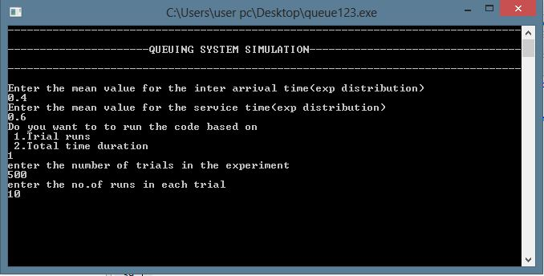

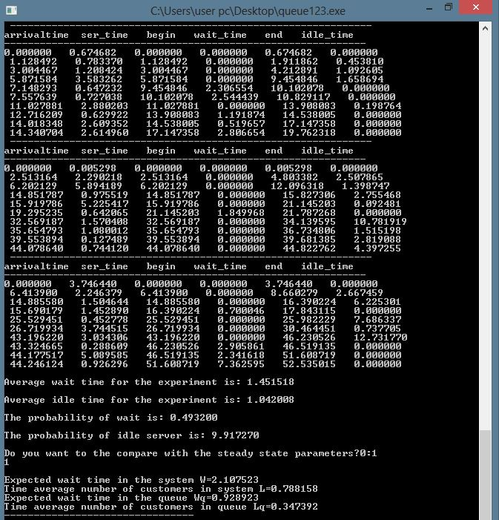

Case2: TOTAL RUNS =5000, TRIALS=1 AND runs in each trial =5000

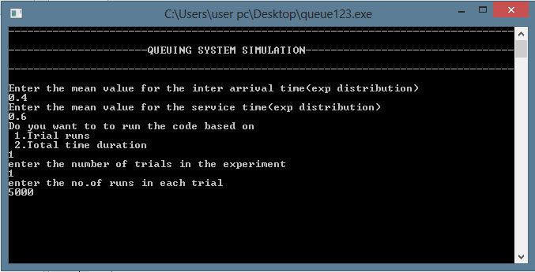

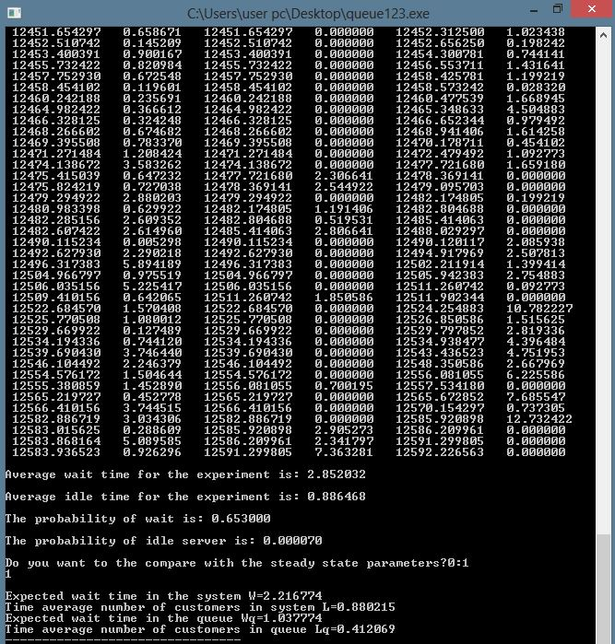

CASE 3: based on total time duration let total time = 5000

