Carolina documentaion
(02-02-2017)

- Next Air ups radio button shows when user is login otherwise by default ground ups.
- Handling fee show on checkout page.
- When the Next day air option should display. This should only be shown if the customer has been selected for approval of tax exempt.
If Yes for Tax exempt account = Shown NDA option on check out
If Yest for Credit/Net30 account = Shown PO field for payment option
- Please see the mockup below:
Note the fields that are side by side like the First Name and Last Name, Email Address and Phone Number and the State and Zip field.
Also can you remove the "Your Order" area?
Also on the Credit Card page can you remove the Invoice field?
Also on the Credit Card page make the page height larger to the second scrollbar doesn't display. https://asset1.basecamp.com/2365261/projects/12565127/attachments/270134042/92f380a0fc5fd0ffc18356afb2726c190010/original/changes%20to%20the%20checkout%20page.png
- Next day Air shows when user login + in wp-admin tax_next_air_exempt “Yes”.
- credit / net 30 type of account click “No” then PO should not show.
- Tax except staus (Tax exempt account) only maintain for tax relaxtion which is reflect on car page and checkout page (Reduce Rate class add for relax the the tax for 0 %)

User: jamtechtest
Pass: Admin@1archanar

Quickbook Integration
…………………………………………………………………………………………

For Quickbook Integration ---
This is the site
https://www.connexforquickbooks.com/home/myconnections
username : kevin@knoxweb.com
password : 1234567

so using this site we have to configure here which is connected to the client desktop software for synchronises orders

Cenpos Payment Gateway
………………………………………………………………………………….

Cenpos payment gateway is a gateway which is integrated custom with woocommece.

In checkout there is credit card payment option name which is cenpos.

So we are showing a checkout cenpos form which are working in api request and response.

So the cenpos form is from plugins/cenpos wordpress 01082014/cenpos.php

Here merchant id is used . so after successful response it comes a page testcenpos.php page which is in themes/client-theme/testcenpos.php.

From which has been redirected to order received page.

This time cenpos test mode is integrated.

The cenpos details are as below

https://www3.cenpos.net/webpay/v7/html5/administration/
https://www3.cenpos.net/vtweb/v6/VirtualTerminalWeb.html
MID: 12725516
DBA: Carolina Motion Control Test
Username: Stevenp
password is #!Osmosis.123!#1

here we can manage by registeting out site and make customised which files should be and which files should n’t be.

Quickbook Integration
…………………………….

Quickbook is used for synchronised order into woocommerce. Client is using desktop enterprise quikbook software which are showing orders into the client software.

So the details are as below

https://www.connexforquickbooks.com/Account/Login?ReturnUrl=%2Fhome%2Fmyconnections

https://www.connexforquickbooks.com/ruleset/insert
username: kevin@knoxweb.com
password: 1234567

For Adding Rule insert
…………………………………………………………………………….

https://www.connexforquickbooks.com/ruleset/insert

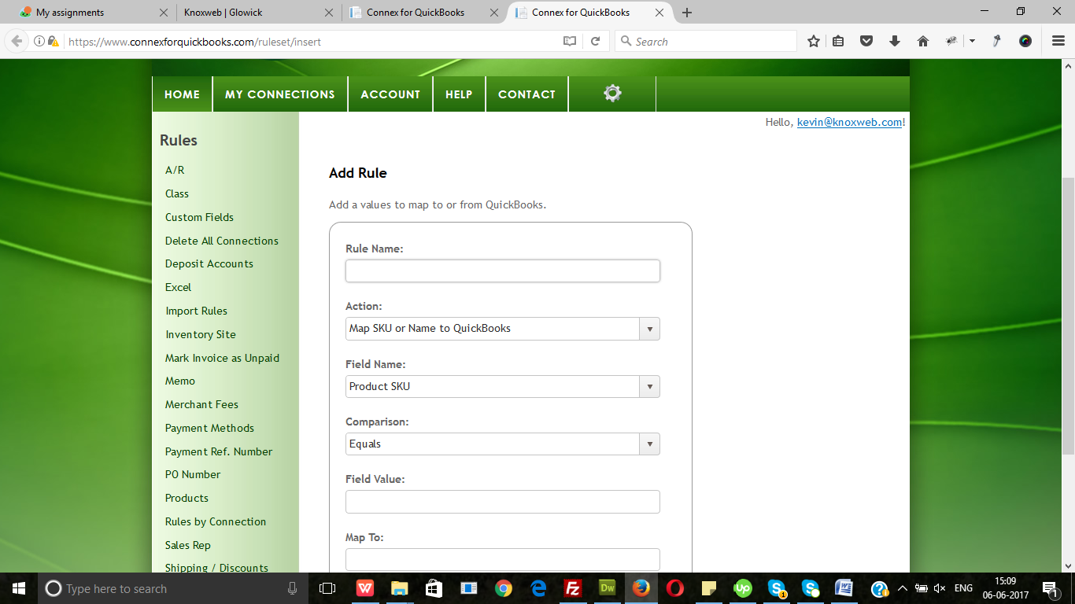

For Mapping field , just add rule name with action

