Make use of flexbox html and css

<!DOCTYPE html>
<html lang="en">
<head>
<meta charset="UTF-8">
<meta name="viewport" content="width=device-width, initial-scale=1.0">
<title>Flexbox Brick Pattern</title>
<link rel="stylesheet" href="style.css">
</head>
<body>

<div class="container">
<div class="row">
<div class="brick" style="flex:1"></div>
<div class="brick" style="flex:11"></div>
</div>

<div class="row">
<div class="brick" style="flex:2"></div>
<div class="brick" style="flex:10"></div>
</div>

<div class="row">
<div class="brick" style="flex:3"></div>
<div class="brick" style="flex:9"></div>
</div>

<div class="row">
<div class="brick" style="flex:4"></div>
<div class="brick" style="flex:8"></div>
</div>

<div class="row">
<div class="brick" style="flex:5"></div>
<div class="brick" style="flex:7"></div>
</div>

<div class="row">
<div class="brick" style="flex:6"></div>
<div class="brick" style="flex:6"></div>
</div>

<div class="row">
<div class="brick" style="flex:7"></div>
<div class="brick" style="flex:5"></div>
</div>

<div class="row">
<div class="brick" style="flex:8"></div>
<div class="brick" style="flex:4"></div>
</div>

<div class="row">
<div class="brick" style="flex:9"></div>
<div class="brick" style="flex:3"></div>
</div>

<div class="row">
<div class="brick" style="flex:10"></div>
<div class="brick" style="flex:2"></div>
</div>

<div class="row">
<div class="brick" style="flex:11"></div>
<div class="brick" style="flex:1"></div>
</div>
</div>

</body>
</html>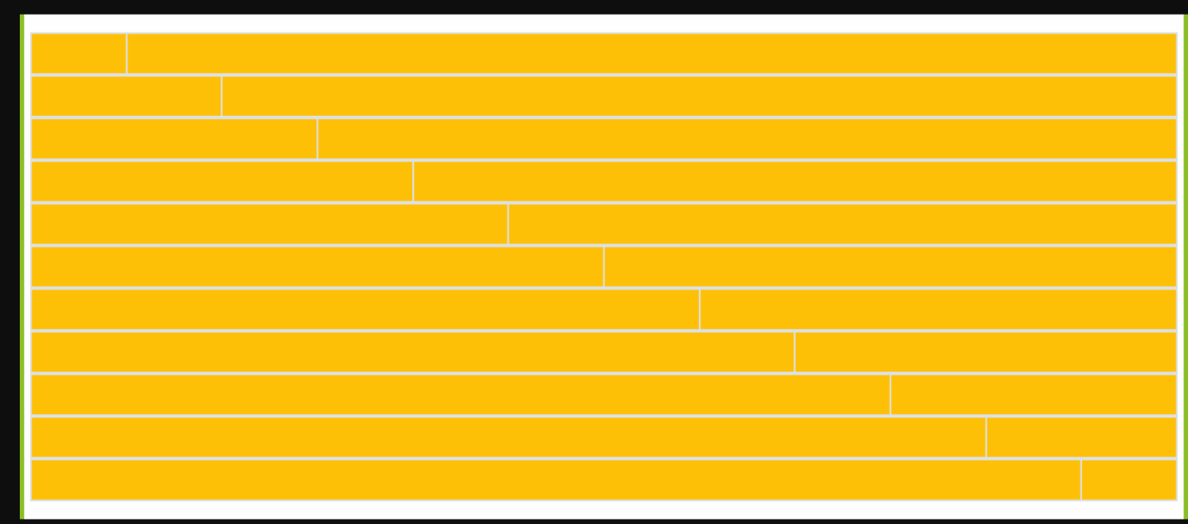

Css
*{
margin:0;
padding:0;
box-sizing:border-box;
}

body{
background:#000;
padding:20px;
}

.container{
background:#ddd;
padding:15px;
border-left:5px solid green;
}

.row{
display:flex;
height:60px;
margin-bottom:4px;
}

.brick{
background:#f5b800;
border:2px solid #eee;
}

