Query 1 -
SELECT d.dept_name,
e.emp_name,
e.salary
FROM employee e
JOIN department d
ON e.dept_id = d.dept_id
WHERE e.salary > (
SELECT AVG(e2.salary)
FROM employee e2
WHERE e2.dept_id = e.dept_id
)
AND e.dept_id IN (
SELECT e3.dept_id
FROM employee e3
GROUP BY e3.dept_id
HAVING COUNT(*) >= 3
);
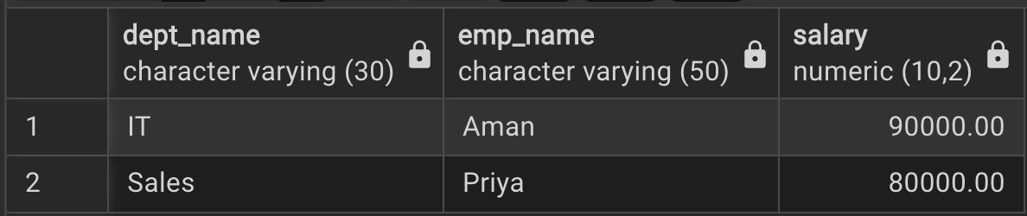

Query 2 -
CREATE OR REPLACE FUNCTION customer_audit_trigger()
RETURNS TRIGGER AS $$
BEGIN
IF TG_OP = 'INSERT' THEN
INSERT INTO customer_audit
(customer_id, customer_name, action, action_time)
VALUES
(NEW.customer_id, NEW.customer_name, 'ADDED', CURRENT_TIMESTAMP);

RETURN NEW;

ELSIF TG_OP = 'DELETE' THEN
INSERT INTO customer_audit
(customer_id, customer_name, action, action_time)
VALUES
(OLD.customer_id, OLD.customer_name, 'REMOVED', CURRENT_TIMESTAMP);

RETURN OLD;
END IF;

RETURN NULL;
END;
$$ LANGUAGE plpgsql;

CREATE TRIGGER customer_audit_trigger
AFTER INSERT OR DELETE ON bank_customer
FOR EACH ROW
EXECUTE FUNCTION customer_audit_trigger();

INSERT INTO bank_customer VALUES
(3, 'Ajay', 500000),
(4, 'Vijay', 7500);
DELETE FROM bank_customer
WHERE customer_id = 1;
