Hostname: f5-qa01 ( 10.1.50.68 )

Version : BIG-IP 11.3.0 Build 3117.0 Hotfix HF5

user : f5-backup

kernel : 2.6.32-220.el6.f5.x86_64

OS : RHEL 6.x

Target : serverworkback01 ( 10.1.50.98 )

SYMPTOM : Create an automatic backup solution and export the backuped up file to another Linux Server

**STEP 1:**

Verify or create the asymmetric keys for the Linux Server.

ssh f5-backup@10.1.50.98

/usr/bin/ssh-keygen -f /export/home/f5-backup/.ssh/id_dsa -q -t dsa -N ""

/usr/bin/ssh-keygen -f /export/home/f5-backup/.ssh/id_rsa -q -t rsa -N ""

cat /export/home/f5-backup/.ssh/id_dsa.pub >> /export/home/f5-backup/.ssh/authorized_keys

cat /export/home/f5-backup/.ssh/id_rsa.pub >> /export/home/f5-backup/.ssh/authorized_keys

**STEP 2:**

Verify or create the asymmetric keys for the BigIP F5 network appliance.

ssh f5-backup@10.1.50.68

mkdir .ssh

/usr/bin/ssh-keygen -f /home/f5-backup/.ssh/id_dsa -q -t dsa -N ""

/usr/bin/ssh-keygen -f /home/f5-backup/.ssh/id_rsa -q -t rsa -N ""

cat /home/f5-backup/.ssh/id_dsa.pub >> /home/f5-backup/.ssh/authorized_keys

cat /home/f5-backup/.ssh/id_rsa.pub >> /home/f5-backup/.ssh/authorized_keys

**STEP 3:**

Exchange the public keys copying into the “authorized_keys” file between Linux && BigIP systems.

cat /export/home/f5-backup/.ssh/authorized_keys

cat /home/f5-backup/.ssh/authorized_keys

**STEP 4:**

Verify or create the directories path to copying the script files into the */opt/scripts* and the backup destination directory */var/local/ucs* in the Linux server.

f5-backup@10.1.50.98 (serverworkback01)

su -

mkdir -p /opt/scripts

chown root:f5-backup /opt/scripts

chmod 770 /opt/scripts

` mkdir -p /var/local/ucs

chown root:f5-backup /var/local/ucs

chmod 770 /var/local/ucs

**STEP 5:**

Verify or create the directory path to copying the script files into the */opt/scripts* for the BigIP F5 network appliance.

f5-backup@10.1.50.68 (ps-f5-qa01)

mkdir -p /opt/scripts

f5backup.pl – Main Script

f5hname.sh – Get the BigIP F5 hostname

f5backup.sh – Save the active configuration

f5archive.sh – Log rotation

chmod 770 *

**STEP 6:**

Verify or create the backup scheduler entry for the BigIP F5 network appliance.

(i.e. crontab –e, OR , /var/spool/cron/f5-backup)

# Backup the f5 User Configuration Set (UCS)

00 03 * * * /opt/scripts/f5backup.pl

**STEP 7:**

Run a manual test to verify the backup process.

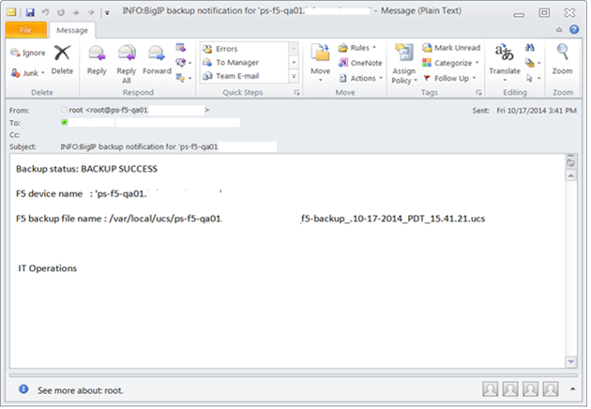

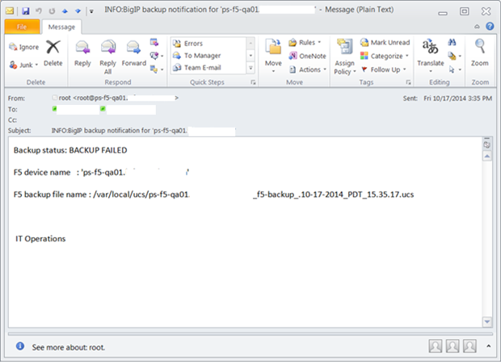

F5

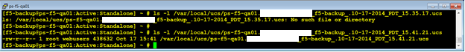

Linux

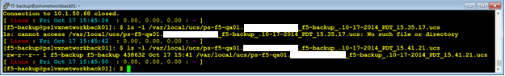

**STEP 8:**

Add/remove e-mail addresses to receive the backup e-mail notification.

**/etc/scripts/f5backup.pl**

#!/usr/bin/perl

use strict;

use warnings;

use Fcntl 'O_RDONLY';

unlink ("/opt/scripts/hname.txt");

system("/opt/scripts/f5hname.sh");

open(DATA,"<","/opt/scripts/hname.txt") or die "Can't open data";

my @hname = <DATA>;

chomp(@hname);

close(DATA);

my $mylbl = '_f5-backup';

my $location = '/var/local/ucs';

my $FileHandle = join("",$hname[0],$mylbl);

&make_unique_file($FileHandle);

my $FHsize = length($FileHandle);

my $FHtrimed = substr($FileHandle,0,$FHsize - 1);

# Creating the current f5backup configuration file

system("/opt/scripts/f5backup.sh '$location/$FHtrimed.ucs'");

# Copying the f5backup configuration out to the main management server

system("scp -pr '$location/$FHtrimed.ucs' f5-backup\@10.1.50.98:'$location'");

# Archiving the f5 backups locally

system("/opt/scripts/f5archive.sh '$location'");

# e-mail

my $to = 'user1@mycompany.com, user2@mycompany.com, user3@mycompany.com';

my $from = 'f5-backup@$hname[0]';

my $subject = "INFO:BigIP backup notification for '$hname[0]'";

open(MAIL, "|/usr/sbin/sendmail -t");

## Mail Header

print MAIL "To: $to\n";

print MAIL "From: $from\n";

print MAIL "Subject: $subject\n\n";

## Mail Body

if (-e "$location/$FHtrimed.ucs") {

print MAIL "F5 Backup status: BACKUP SUCCESS\n\n";

} else {

print MAIL "F5 Backup status: BACKUP FAILED\n\n";

}

print MAIL "F5 device name : '$hname[0]'\n\n";

print MAIL "F5 backup file name : /var/local/ucs/$FHtrimed.ucs\n";

print MAIL "\n \n \n ";

print MAIL "IT Operations\n";

close(MAIL);

exit 0;

sub make_unique_file

{

my ($file, $date) ;

$date = `date '+.%m-%d-%Y_%Z_%H.%M.%S'`;

$_[0] = $_[0] . $date;

}

**/etc/scripts/f5hname.sh**

#!/bin/bash

## Get the F5 hostname

#

# Short hostname

#/usr/bin/tmsh list sys global-settings | grep hostname | awk {'print $2'} | sed -e 's/\(\.\)[^.].*$/\1/' | tr -d '.' > /opt/scripts/hname.txt

#

# Long hostname

/usr/bin/tmsh list sys global-settings | grep hostname | awk {'print $2'} > /opt/scripts/hname.txt

**/etc/scripts/f5backup.sh**

#!/bin/bash

###

## Saving active configuration...

/usr/bin/tmsh save /sys ucs $1

**/etc/scripts/f5archive.sh**

#!/bin/bash

pushd .

cd $1

if [ ! -d $1/archive ]; then

mkdir -p $1/archive

chown f5-backup:webusers $1/archive

fi

# Delete old UCS files by aged criteria every 180 days

/usr/bin/find $1archive/ -name \*.\*.\*.\*\.ucs -mtime +180 -exec rm -f {} \;

# Move the new UCS files by aged criteria every 15 days to archive/ dir

/usr/bin/find $1 -maxdepth 1 -name \*.\*.\*.\*\.ucs -mtime +15 -exec mv {} archive/ \;

popd

exit 0;