* On Registration page change the hand cursor to filed focus.
* After Registration Flash Message is hidden below logo, see attached image.

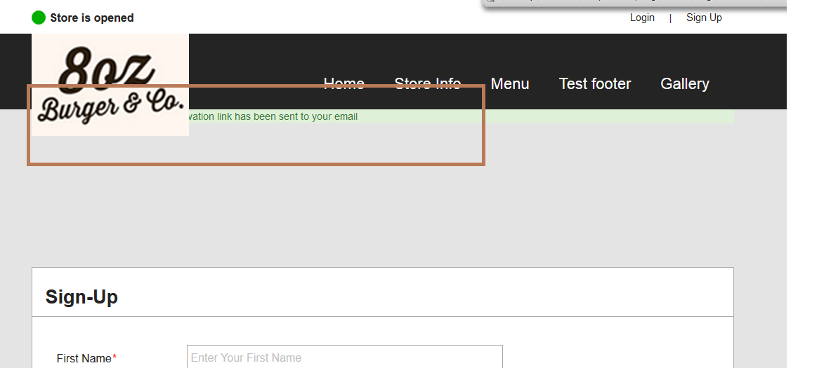

* After Login user should be redirected to Menu and Cart page, currently user remain on same page.
* Agree to our [Terms of Use](javascript:void(0)) & [Privacy Policy](javascript:void(0)) ? page is missing.
* After reset password, I have been redirected to an error page, see attached image.

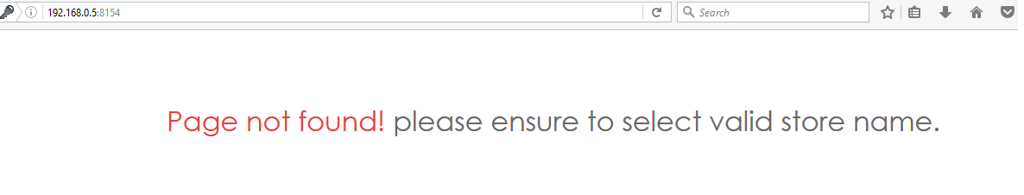- Remember me is not working.

- Top Header Menu should not jump on rollover.

- While Saving the data in database use trim Functions to remove white spaces, see attached image.

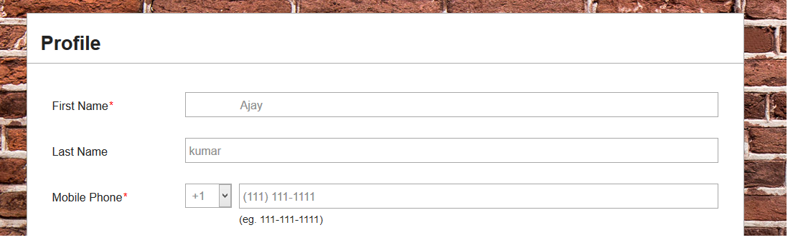

* No Max length applied on add Delivery address section, see below attached image check throughout application.
* In “Add delivery addresses” section add check boxes are not moving correctly on the page.
* While adding office address it redirect me on an error page, however data has been saved in the database, see attached image.

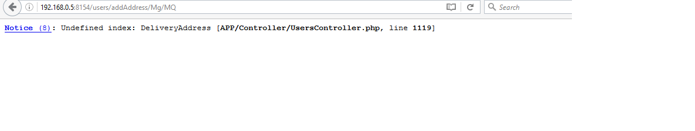

* Do not display previous and next button when data is not available or listed in only one page, see attached image.
* Reorder page is redirecting me on an error page, see attached image. 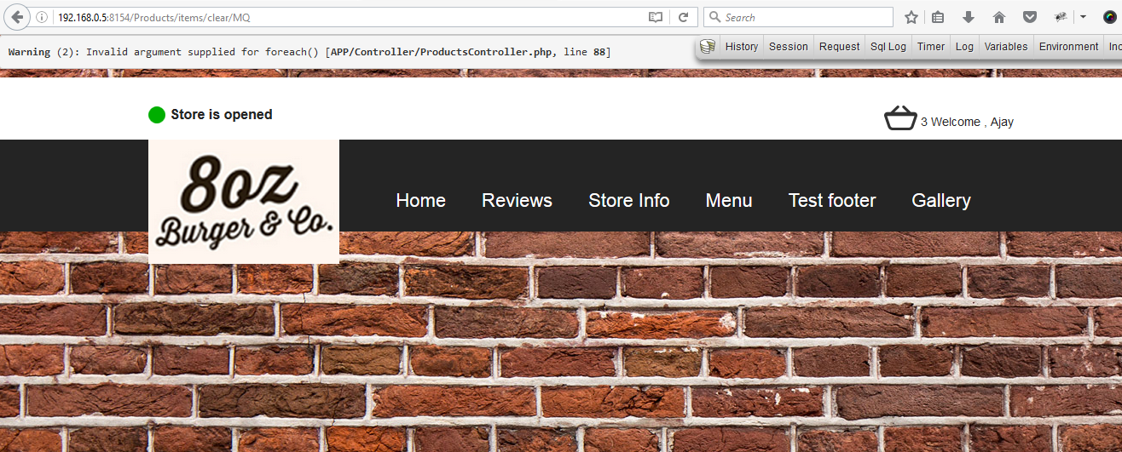
* Top Header Cart Image should be linked to cart detail page.
* Buttons are not consistent throughout the application at some places you have used buttons and at some places you have used only links, please maintain symmetry throughout the application, see attached image for search and clear buttons.
* I added on order in My Favorite order list but it is not listed in “My Favorites” section, however message displayed that order has been added in my favorite list.