Histopathologic Cancer Detection
Using Deep Learning

Title
Histopathologic Cancer Detection Using Deep Learning.

Problem Statement
Develop a deep learning model that accurately classifies histopathology biopsy tissue images as Cancer or No Cancer. The objective is to assist medical professionals by providing fast, reliable, and interpretable predictions on microscopic tissue images from the Kaggle Histopathologic Cancer Detection dataset.

Abstract
This project uses transfer learning with EfficientNetB0 to detect cancer from histopathology tissue images. The model was trained on the Kaggle Histopathologic Cancer Detection dataset after preprocessing and balancing the data. The trained model achieved approximately 86% validation accuracy with strong Precision (0.86), Recall (0.84), and ROC-AUC (0.93).

Introduction
Histopathology is one of the most reliable methods for diagnosing cancer. Examining thousands of biopsy images manually is time-consuming and prone to human error. Deep learning models can automatically learn visual patterns from tissue images and assist pathologists by identifying cancerous regions quickly and consistently.

Technology Used
• Python
• Google Colab
• TensorFlow & Keras
• EfficientNetB0 (Transfer Learning)
• NumPy
• Pandas
• Matplotlib
• Scikit-learn
• Pillow (PIL)
• Kaggle Histopathologic Cancer Detection Dataset

Project Description
The project classifies 96×96 histopathology image patches into Cancer or No Cancer. Images were preprocessed, normalized, and divided into training and validation datasets. A pretrained EfficientNetB0 model was used as the feature extractor, followed by custom dense layers for binary classification. Grad-CAM was used to visualize the regions influencing predictions.

Implementation and Working Logic
1. Download the Kaggle dataset.
2. Read image labels and prepare a balanced dataset.
3. Resize images to 96×96 pixels.
4. Normalize pixel values.
5. Split the dataset into training and validation sets.
6. Build an EfficientNetB0 transfer learning model.
7. Train using Adam optimizer and Binary Crossentropy loss.
8. Evaluate using Accuracy, Precision, Recall, F1-score, and ROC-AUC.
9. Test the model on validation images and unseen images.
10. Visualize important regions using Grad-CAM.

Model Explanation
Input images are passed through the pretrained EfficientNetB0 feature extractor. Global Average Pooling converts extracted features into a feature vector, followed by Dense and Dropout layers. The final Sigmoid layer outputs a probability between 0 and 1. If the probability is greater than 0.5, the image is classified as Cancer; otherwise it is classified as No Cancer.The Models Uses these Technologies for
Technology | Purpose
Google Colab | Used to write and run Python code in the cloud.
Python | Main programming language used for the project.
Pandas | Used to load, clean, and manipulate the dataset.
NumPy | Used for numerical computations and array operations.
Scikit-learn | Used to split the dataset, train the Random Forest model, and evaluate performance.
LabelEncoder | Converts text labels (Low, Medium, High) into numerical values for model training.
Random Forest Classifier | Machine learning algorithm used to predict the cancer level.
Train-Test Split | Divides the dataset into training and testing sets for model evaluation.
Accuracy Score | Measures how accurately the model predicts the cancer level.
Microsoft Excel Dataset | Stores patient information used for training and testing the model.

Result and Screenshot Instructions
Performance:
• Validation Accuracy: ~86%
• Precision: ~0.86
• Recall: ~0.84
• ROC-AUC: ~0.93
Include screenshots of:
1. Training Accuracy/Loss graph.
2. Cancer prediction output.
3. No Cancer prediction output.
4. Grad-CAM heatmap (if available).
The following prediction screenshots are included below.

Conclusion
The proposed deep learning model successfully detects cancer from histopathology images with good accuracy and reliability. EfficientNetB0 transfer learning significantly improves performance while Grad-CAM provides visual interpretability, making the model useful as a decision-support tool for medical professionals.

Prediction Output - Cancer
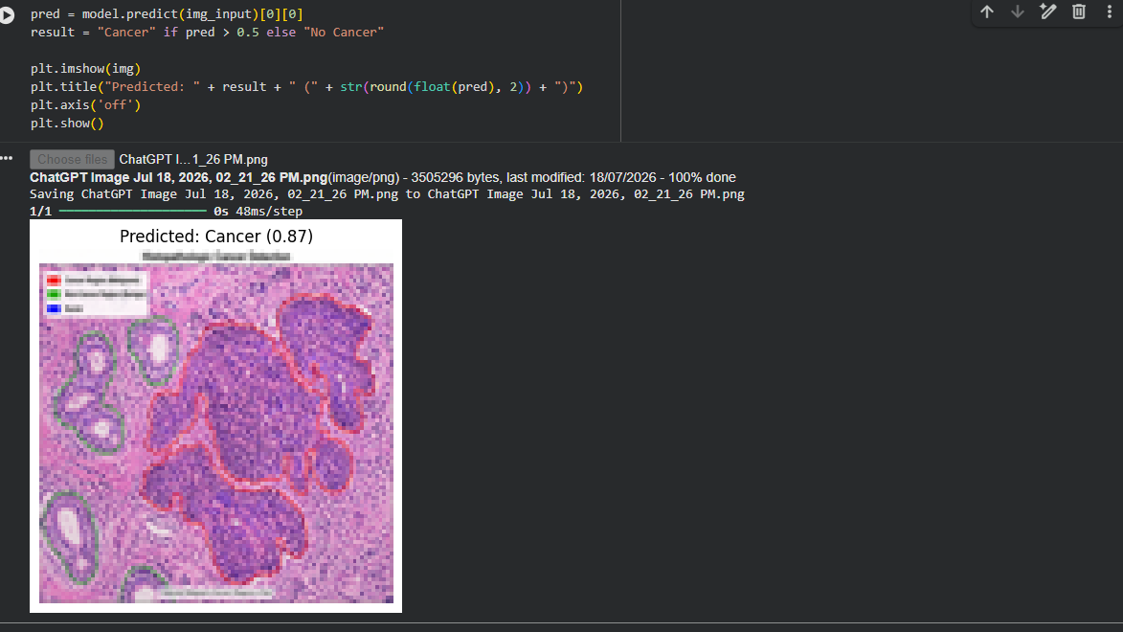

Prediction Output - No Cancer
