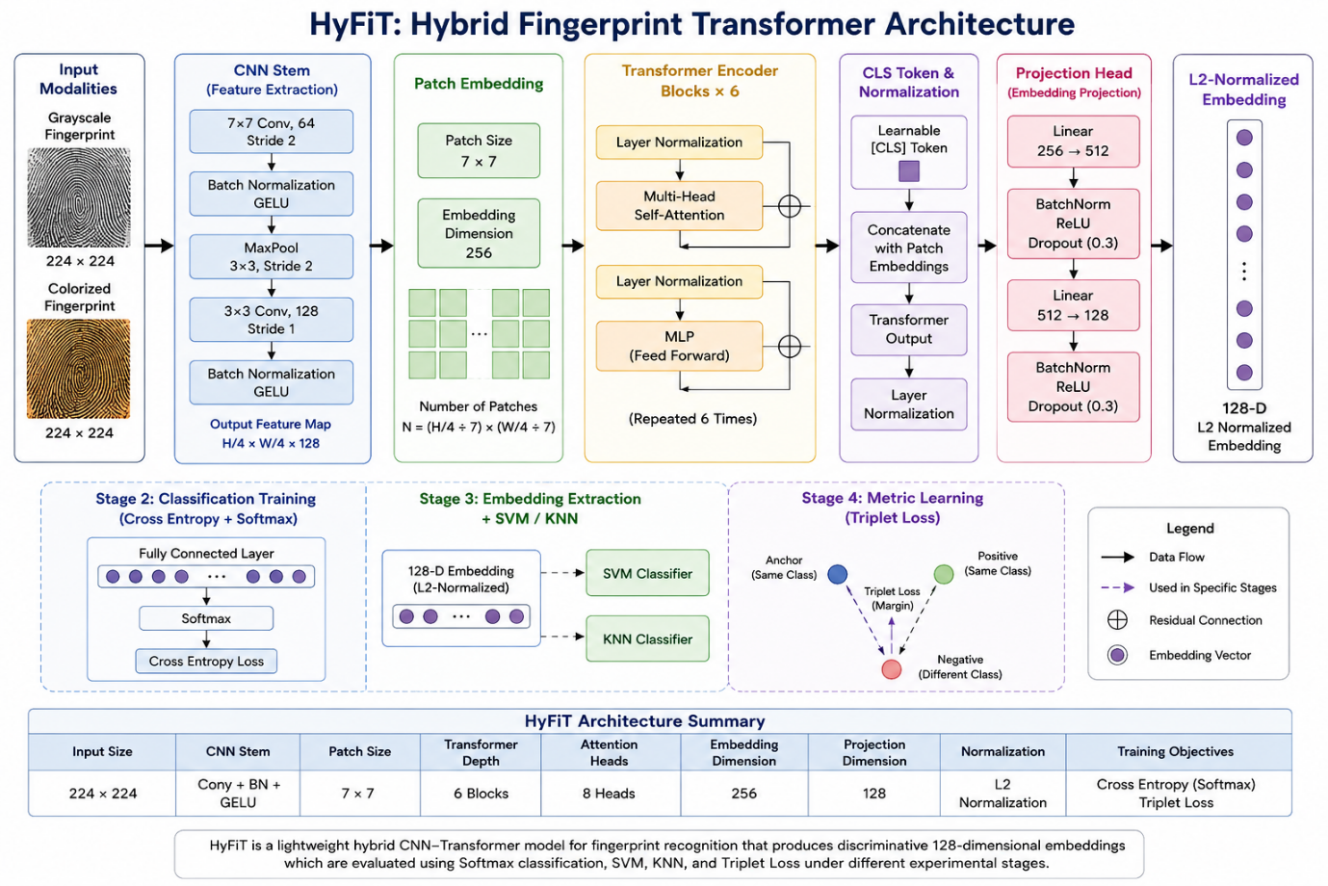
Figure 1. Overall architecture of the proposed HyFiT (Hybrid Fingerprint Transformer) framework, illustrating the lightweight hybrid CNN–Transformer pipeline for fingerprint representation learning, including convolutional feature extraction, transformer-based global contextual modeling, projection head generation, and 128-dimensional L2-normalized embedding formation for classification and verification analysis.

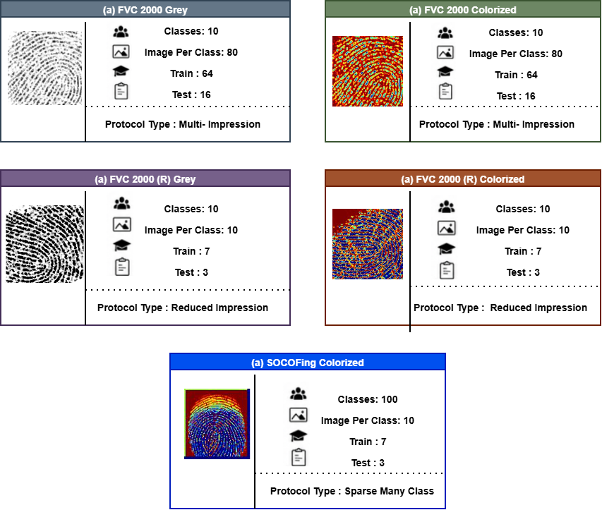
Figure 2. Overview of the fingerprint dataset configurations and protocol structures used in this study, including grayscale and colorized FVC2000 protocols, reduced-impression FVC2000(R) protocols, and the SOCOFing sparse many-class protocol, illustrating differences in impression count, class density, train/test partitioning, and protocol complexity.

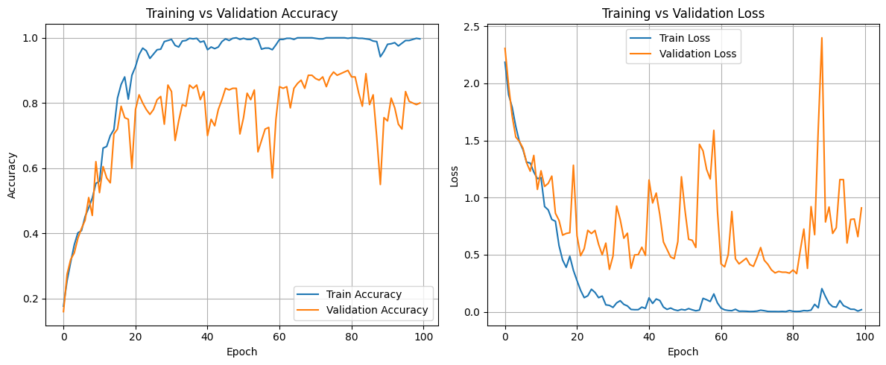
(a) FVC2000 Colorized
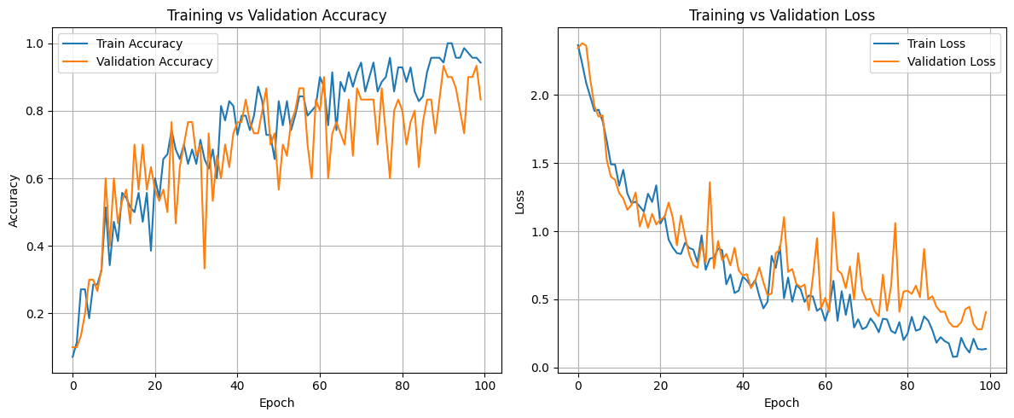
(b) FVC2000(R) Colorized
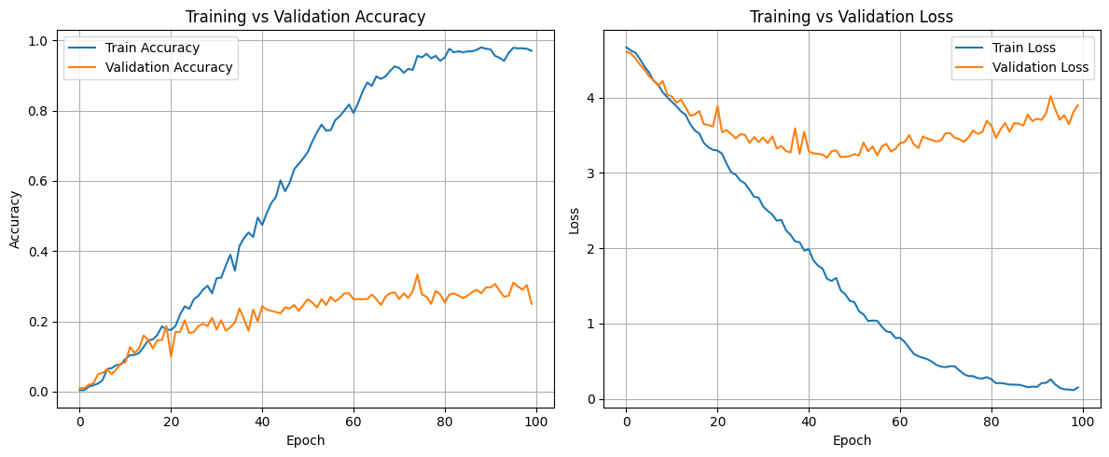
(c) SOCOFing Colorized
Figure 3. Training and validation accuracy and loss convergence curves of the proposed HyFiT + Cross-Entropy + Softmax framework under different fingerprint protocol conditions: (a) FVC2000 Colorized multi-impression protocol, (b) FVC2000(R) Colorized reduced-impression protocol, and (c) SOCOFing Colorized sparse-impression protocol.

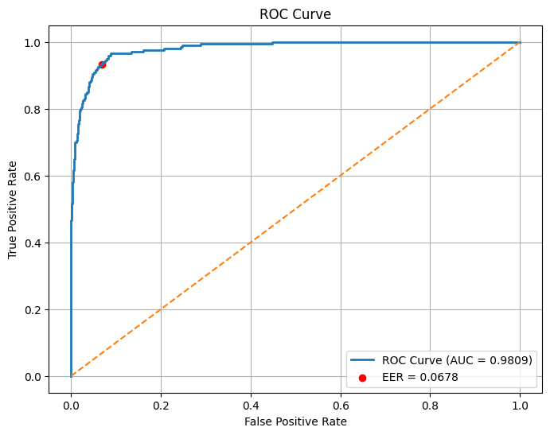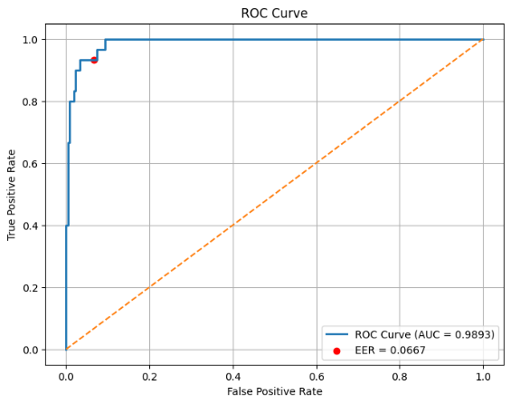
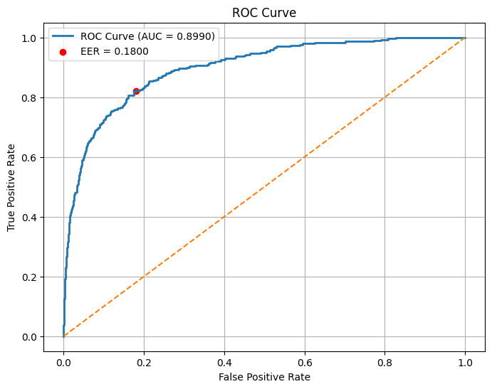
Figure 4. Verification ROC curve comparison of the proposed HyFiT + Cross-Entropy + Softmax framework under different fingerprint protocol conditions: (a) FVC2000 Colorized multi-impression protocol, (b) FVC2000(R) Colorized reduced-impression protocol, and (c) SOCOFing Colorized sparse-impression protocol, illustrating progressive degradation in verification separability under sparse-impression settings.

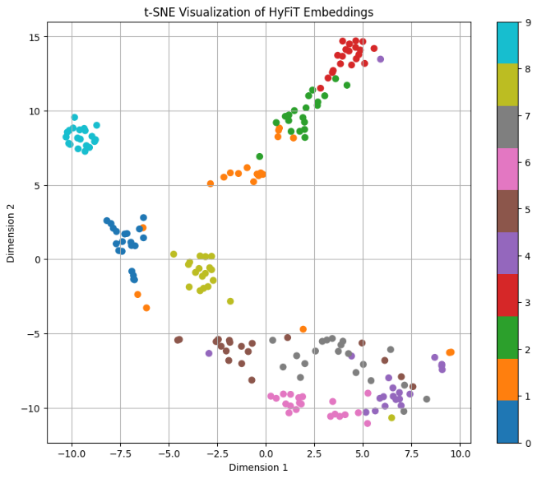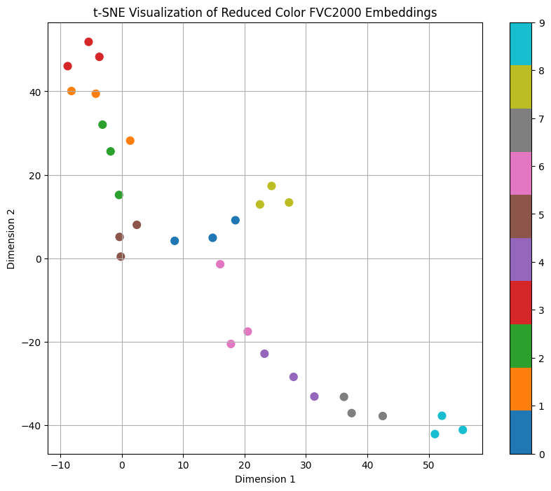
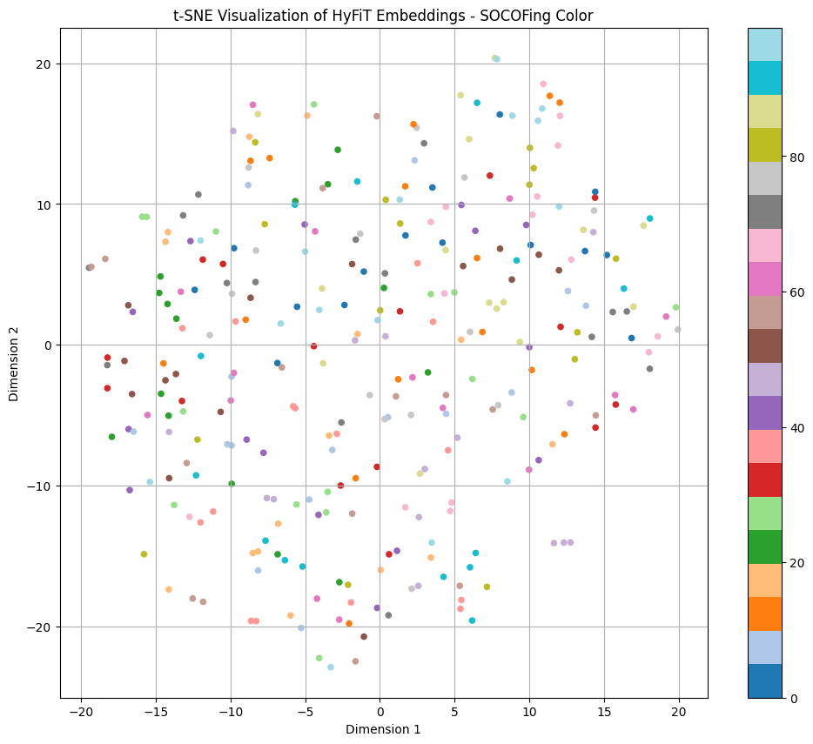
Figure 5. t-SNE visualization of the learned 128-dimensional fingerprint embeddings generated by the proposed HyFiT + Cross-Entropy + Softmax framework under different protocol conditions: (a) FVC2000 Colorized multi-impression protocol showing compact cluster separation, (b) FVC2000(R) Colorized reduced-impression protocol showing partial embedding overlap, and (c) SOCOFing Colorized sparse-impression protocol showing substantial inter-class embedding mixing and reduced geometric separability.

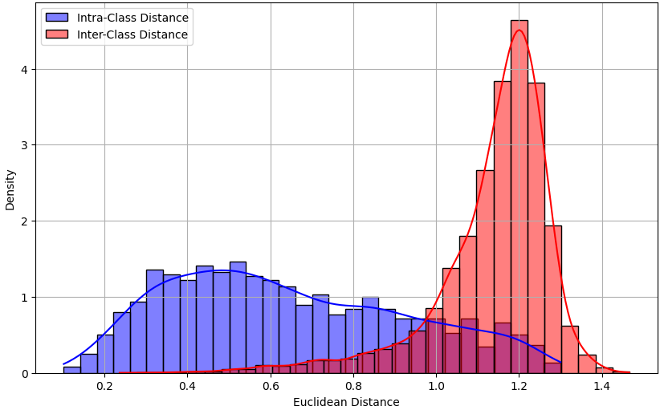
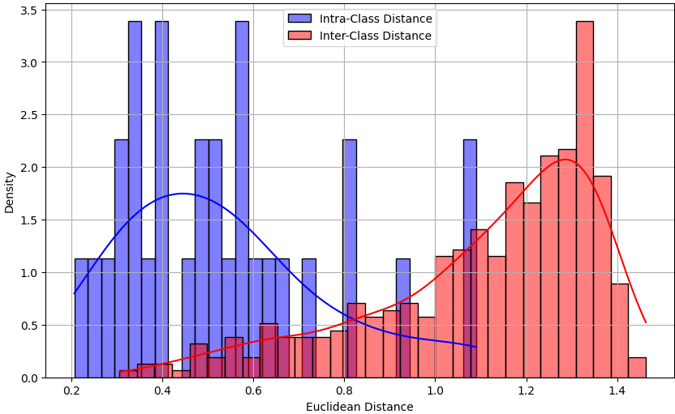
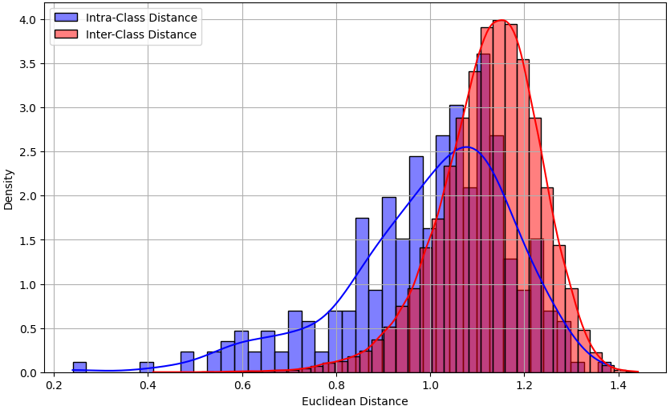
Figure 6. Intra-class and inter-class distance distribution analysis of the learned fingerprint embeddings generated by the proposed HyFiT + Cross-Entropy + Softmax framework under different protocol conditions: (a) FVC2000 Colorized multi-impression protocol showing strong geometric separation, (b) FVC2000(R) Colorized reduced-impression protocol showing partial distribution overlap, and (c) SOCOFing Colorized sparse-impression protocol showing substantial overlap between intra-class and inter-class distance distributions, indicating reduced embedding separability and verification instability.
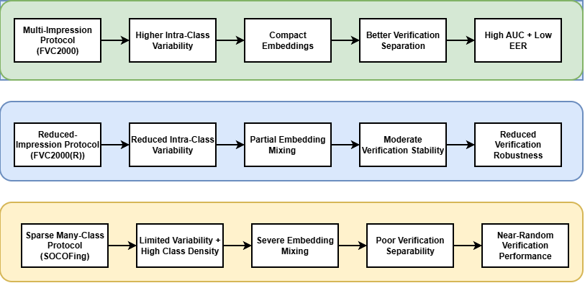
Figure 7. Conceptual summary of protocol-sensitive embedding behavior observed under different fingerprint dataset structures, illustrating the relationship between intra-class variability, embedding compactness, geometric separability, and verification robustness under multi-impression, reduced-impression, and sparse many-class fingerprint recognition protocols.

