ACTIVITY SHEET – 8
Programs Using Interfaces and Packages

Name : Usikala ajay sai
Roll no : CH.AI.U4AID25054

1. OBJECTIVES
By completing this activity, students will be able to:
• Understand the concept of interfaces in Java
• Implement multiple inheritance using interfaces
• Understand the structure and use of packages
• Organize classes using packages
• Design modular and scalable Java applications

2. READING REQUIREMENTS
Oracle Java Tutorials – Interfaces:
https://docs.oracle.com/javase/tutorial/java/IandI/createinterface.html
Oracle Java Tutorials – Packages:
https://docs.oracle.com/javase/tutorial/java/package/index.html

3. ILLUSTRATIVE EXAMPLES
Example 1: Interface Implementation
Code:
interface Animal {
void sound();
}
class Dog implements Animal {
public void sound() {
System.out.println("Dog barks");
}
}
Example 2: Package Usage
Code:
// package mypack;
public class Hello {
public void display() {
System.out.println("Hello from package");
}
}

4. PROGRAMMING / TASK QUESTIONS

A. EASY LEVEL (Conceptual)
1. Create an interface Shape with method area(). Implement it in class Circle.
Hint: Use implements keyword.
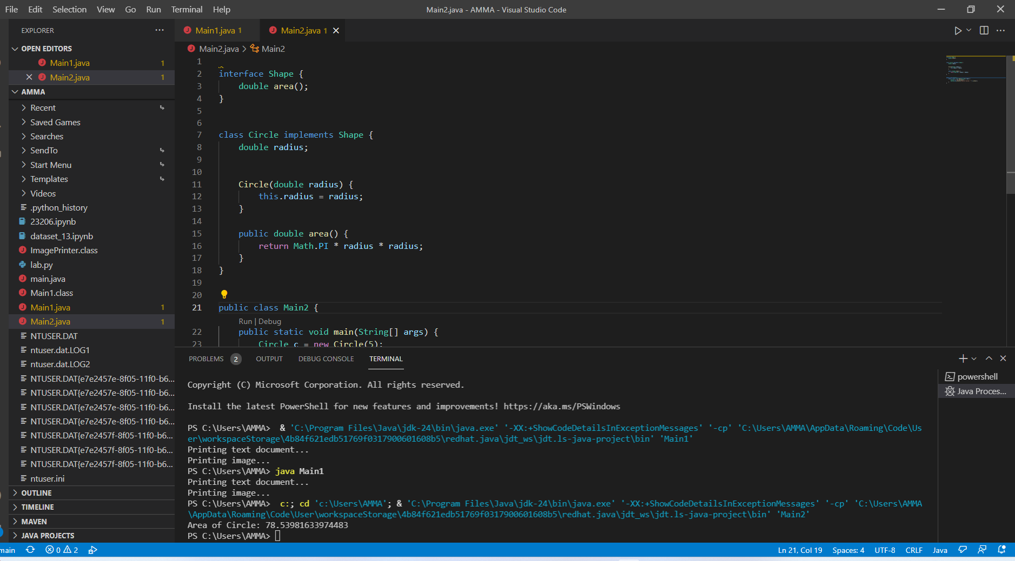
2. Create an interface Printer with method print(). Implement it in two classes TextPrinter and ImagePrinter.
Hint: Multiple classes implementing same interface.
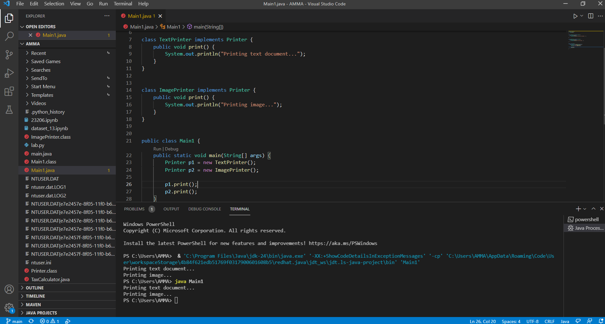
3. Create a simple package and a class inside it. Access the class from another program.
Hint: Use package and import statements.
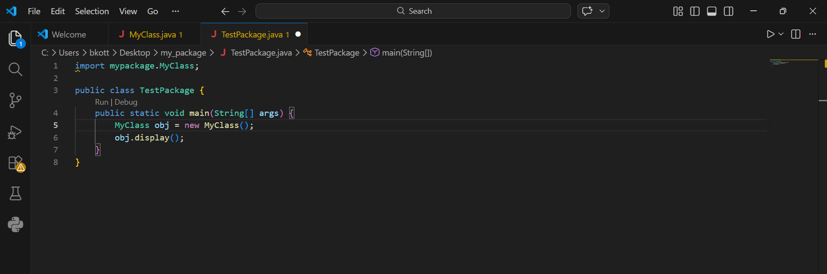output:

B. MEDIUM LEVEL (Problem-Based)
4. A payment system supports multiple payment modes such as CreditCard and UPI. All payment modes follow a common rule processPayment(). Design the system.
Hint: Hint: Use interface for common behavior.
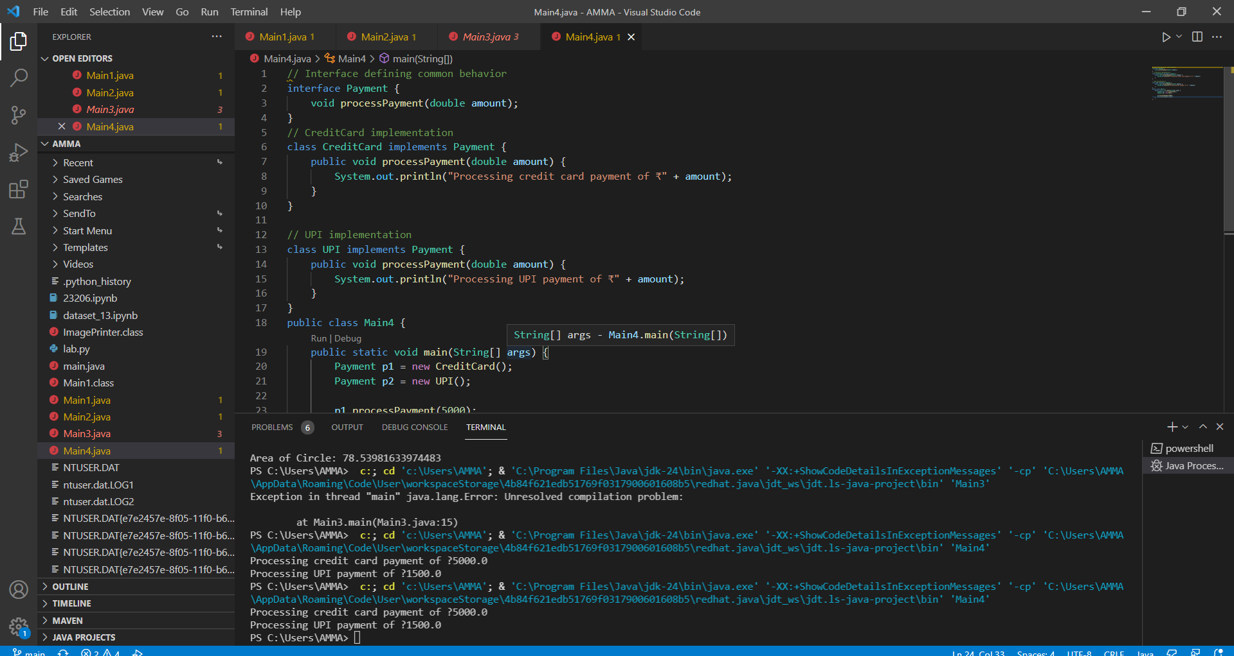
5. A media player supports audio and video playback. Design an interface MediaPlayer with play() method and implement it for AudioPlayer and VideoPlayer.
Hint: Hint: Interface implementation.
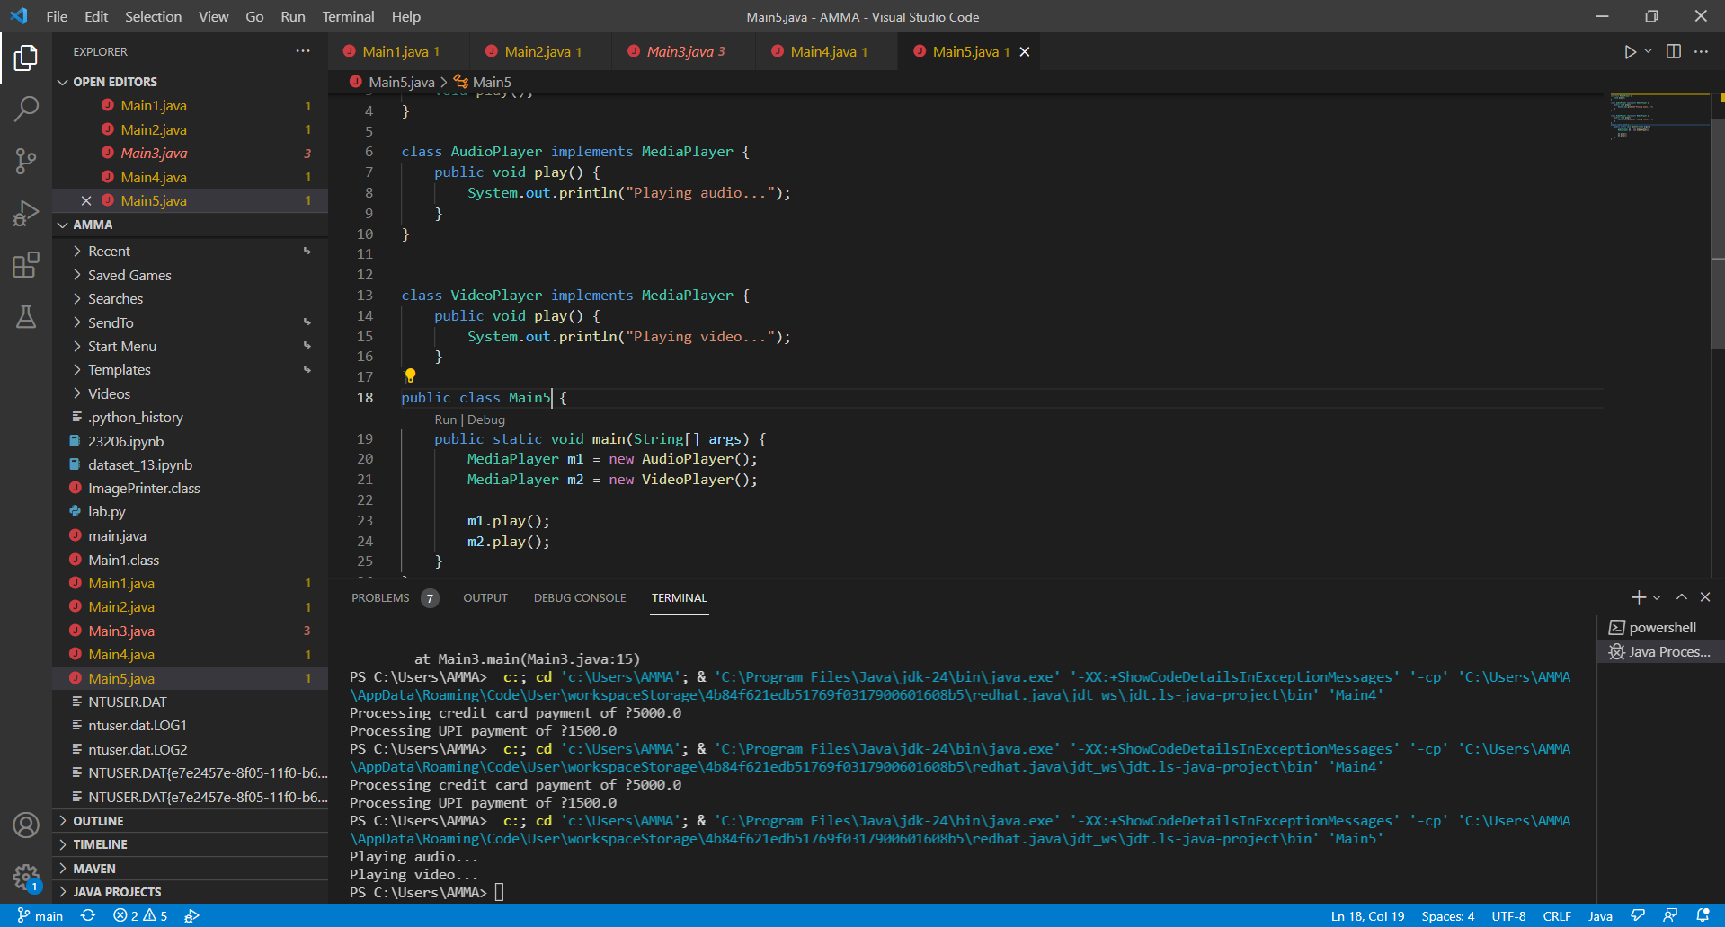
6. Organize a student management system into packages such as student, course, and admin. Demonstrate access between packages.
Hint: Use package structure and import.
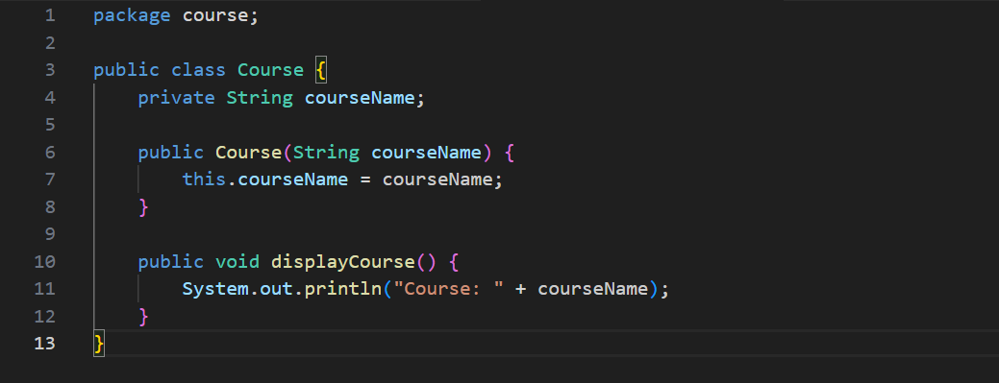

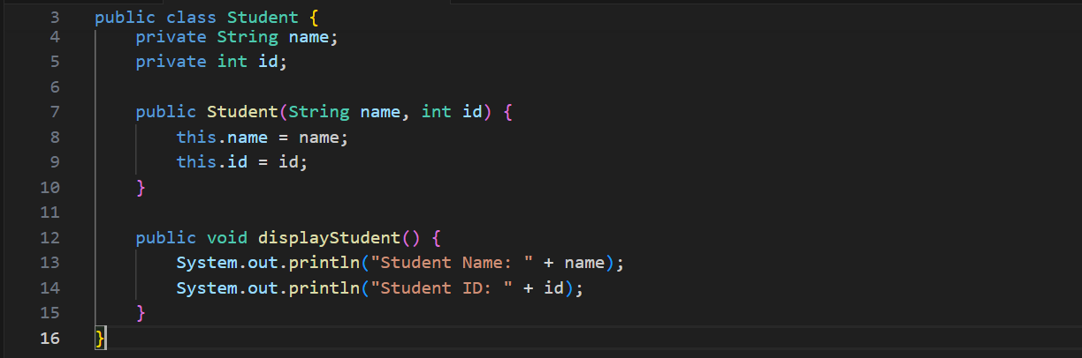
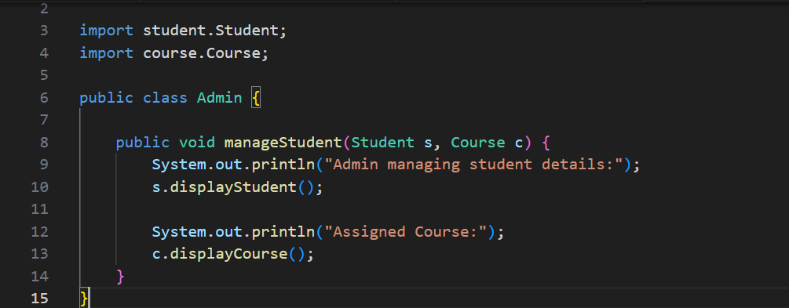

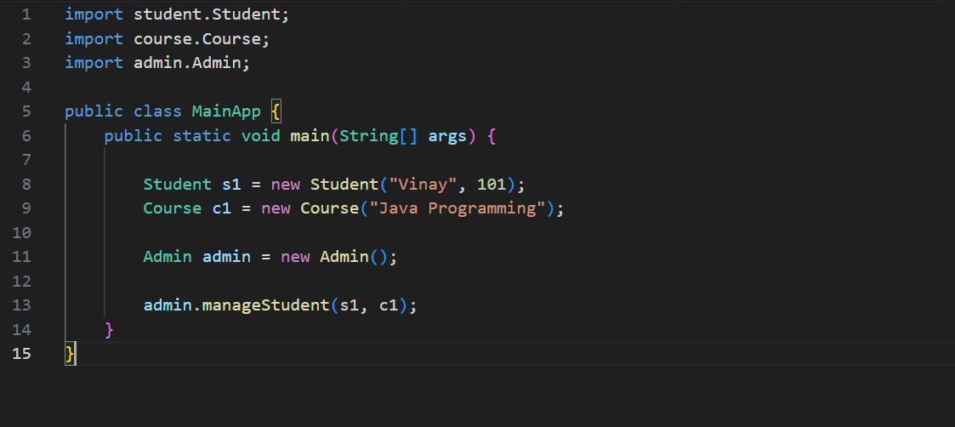Output:

C. HARD LEVEL (Design / Placement-Oriented)
7. Design a system where a device can perform multiple functions like printing and scanning. Use interfaces Printable and Scannable and implement them in a class MultiFunctionDevice.
Hint: Multiple interfaces.
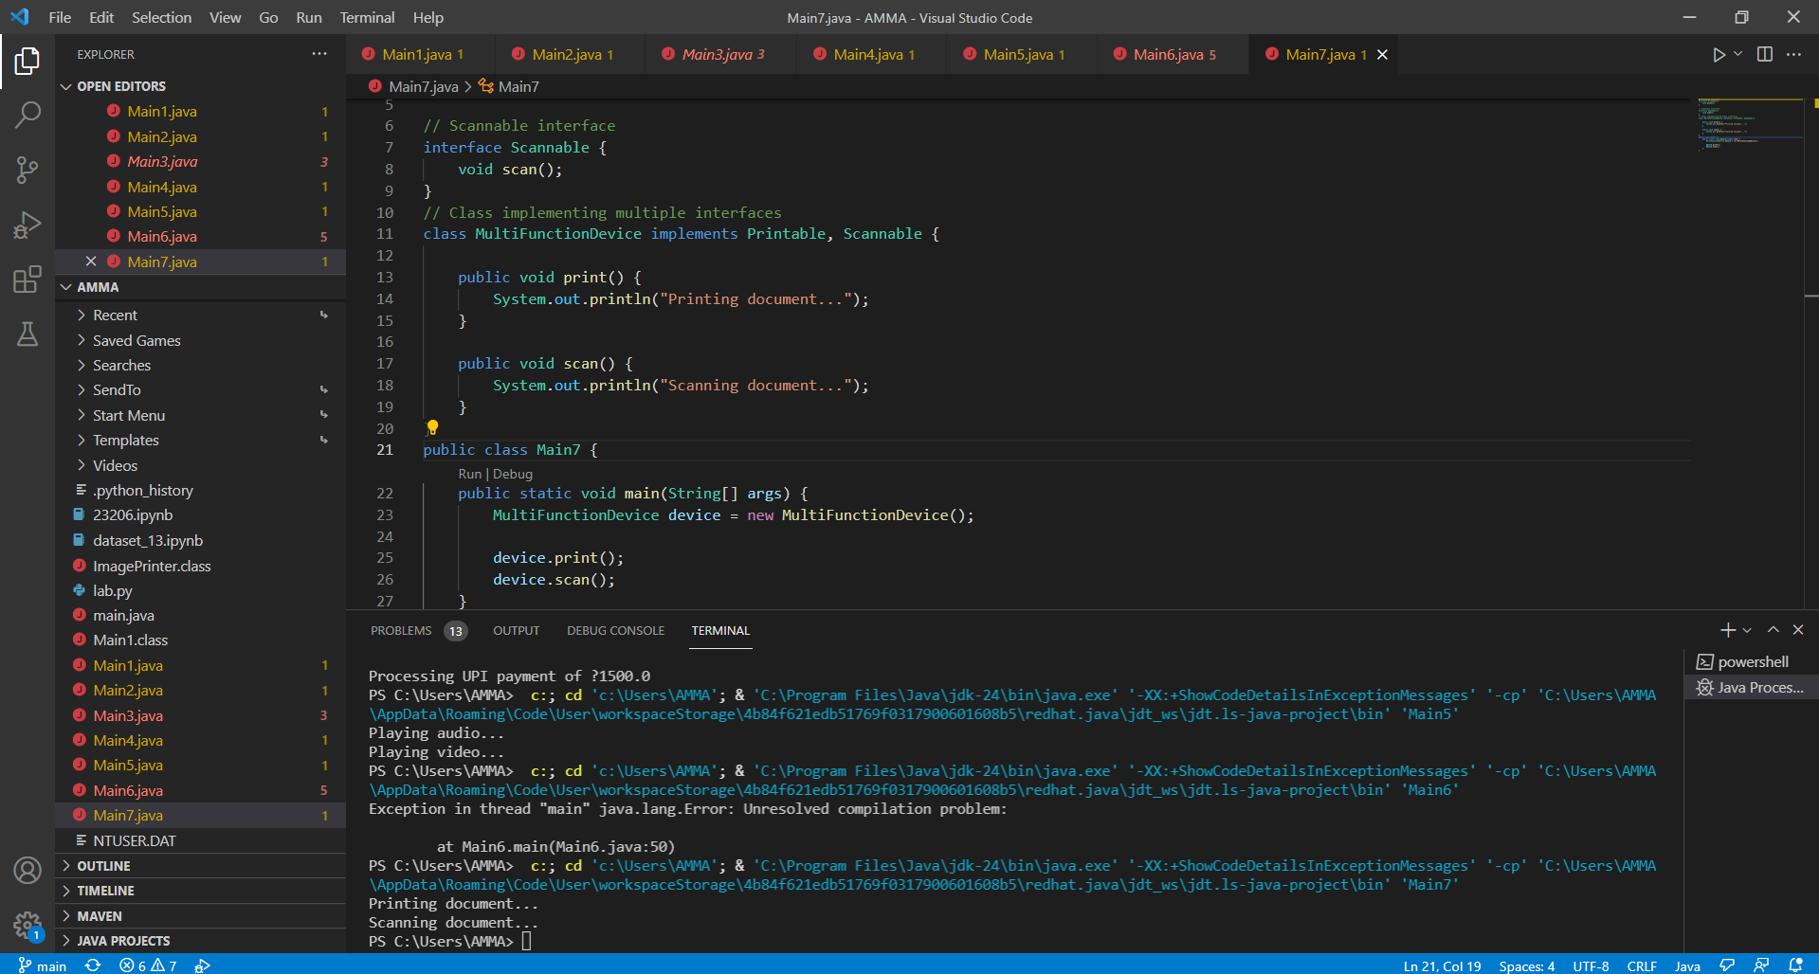
8. A ride service application supports different services such as booking and payment. Separate these behaviors using interfaces and implement them in concrete classes.
Hint: Hint: Use multiple interfaces and modular design.
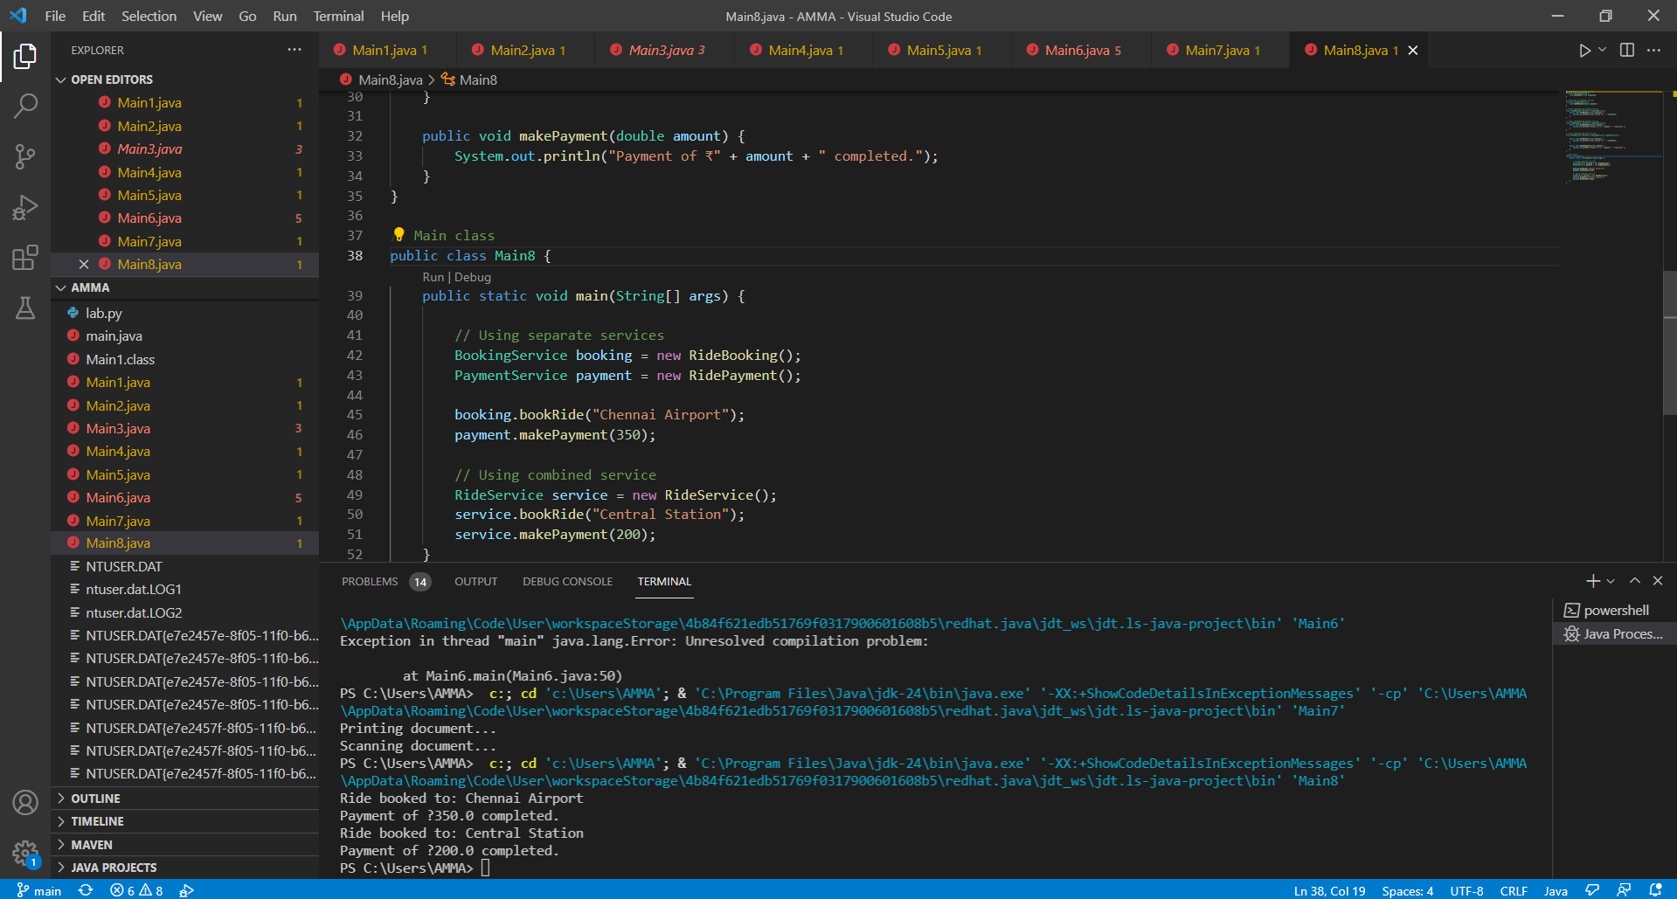
9. Design a modular banking system where different functionalities such as account management, transactions, and reporting are organized into separate packages.
Hint:Package-based modular design.
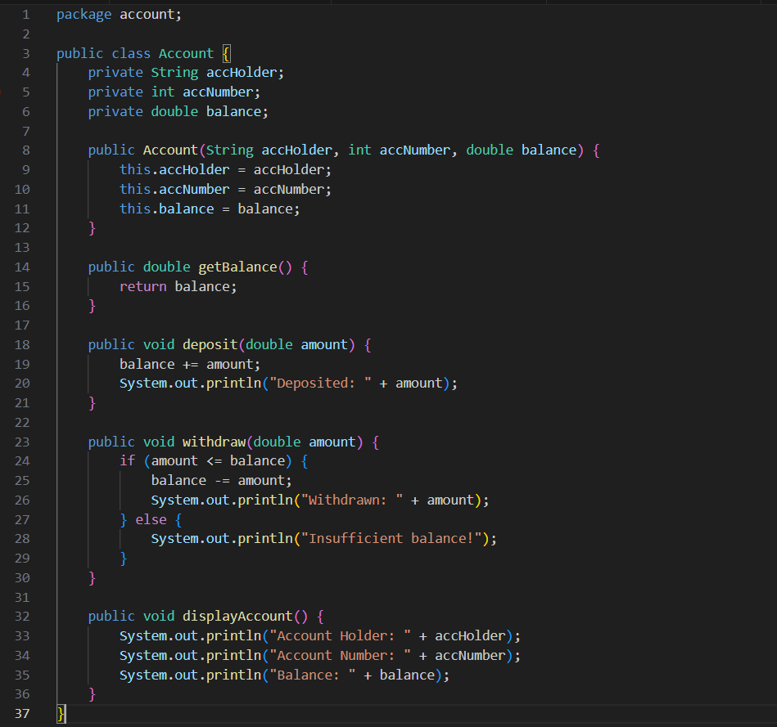
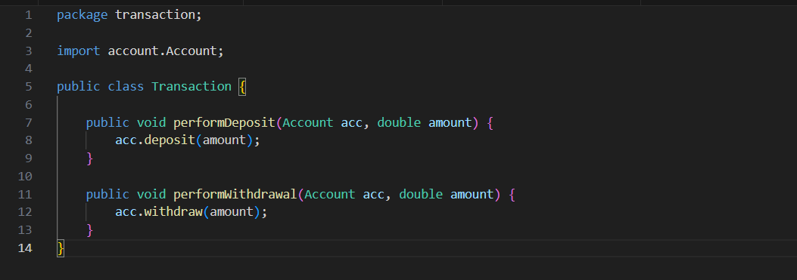

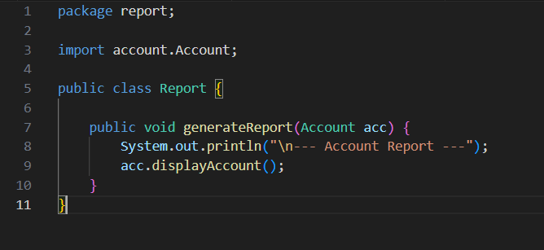
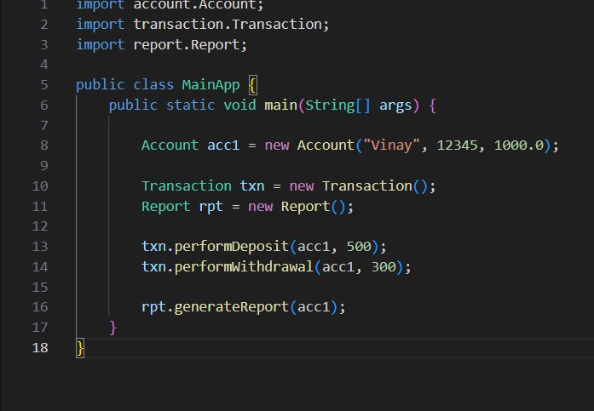10. A smart home system supports devices that can be controlled remotely and monitored. Use interfaces to define behaviors and organize the system into packages.
Hint: Combine interfaces and packages.
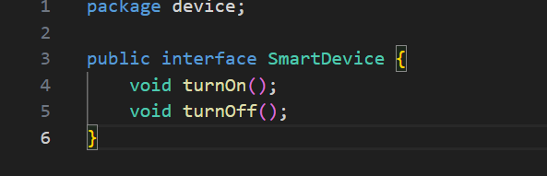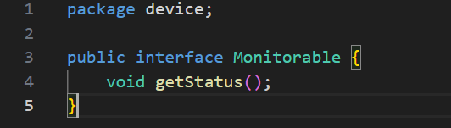

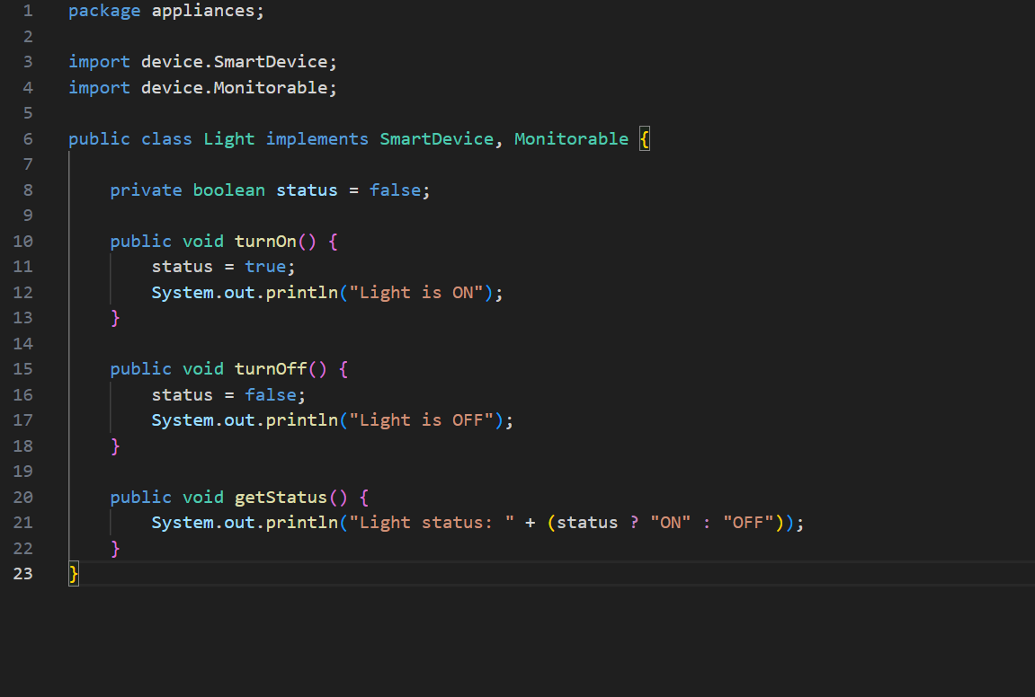

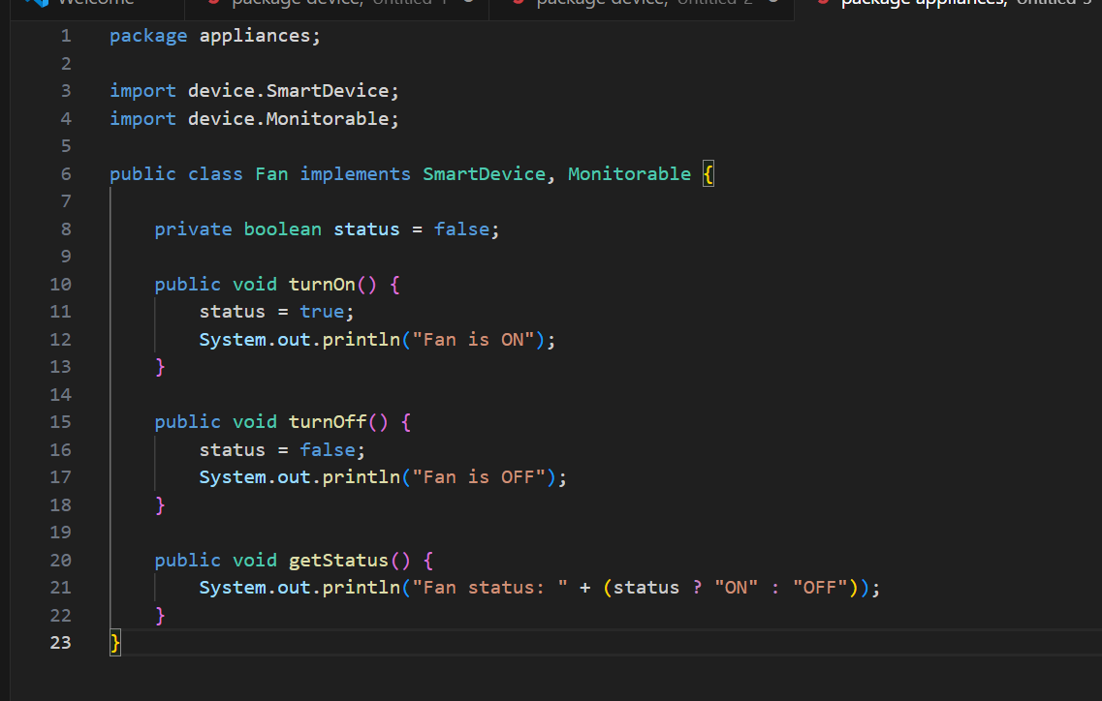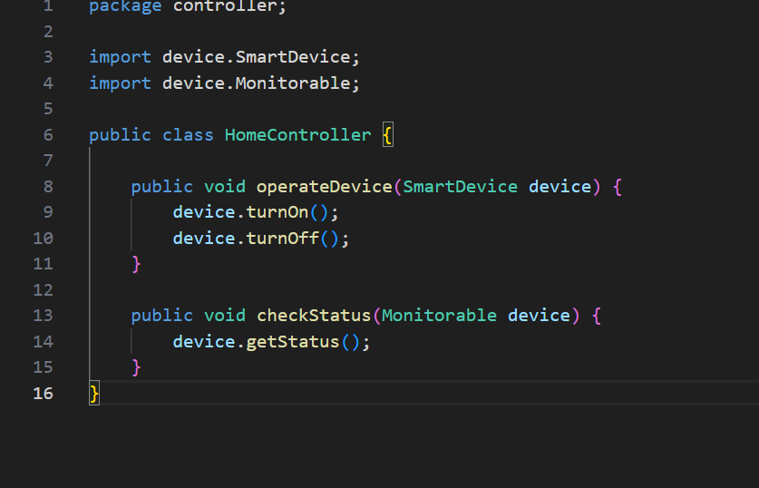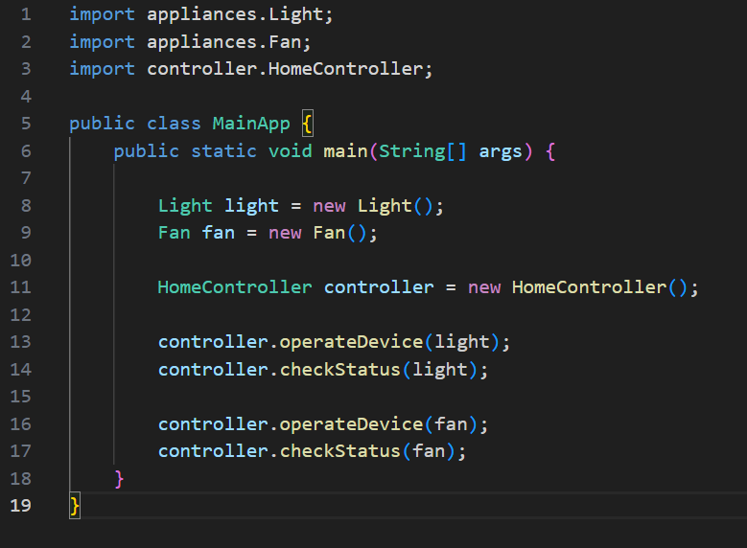5. ASSIGNMENT EVALUATION
0 : Not Done
1 : Incomplete
2 : Late Completion
3 : Needs Improvement
4 : Complete
5 : Well Done

6. VIVA QUESTIONS
1. What is an interface in Java?
2. Can a class implement multiple interfaces?
3. What is the difference between class and interface?
4. What is a package?
5. Why do we use packages?
6. How to import a package?
7. What is modular programming?

