ACTIVITY SHEET – 9
Programs Using try, catch, finally

1. OBJECTIVES
By completing this activity, students will be able to:
• Understand exception handling in Java
• Use try, catch, and finally blocks effectively
• Handle runtime errors gracefully
• Design robust and fault-tolerant programs
• Apply exception handling in real-world scenarios

2. READING REQUIREMENTS
Oracle Java Tutorials – Exceptions:
https://docs.oracle.com/javase/tutorial/essential/exceptions/index.html

3. ILLUSTRATIVE EXAMPLES
Example 1: Basic try-catch
Code:
public class Test {
public static void main(String[] args) {
try {
int a = 10 / 0;
} catch (ArithmeticException e) {
System.out.println("Cannot divide by zero");
}
}
}
Example 2: try-catch-finally
Code:
public class TestFinally {
public static void main(String[] args) {
try {
int arr[] = new int[3];
arr[5] = 10;
} catch (ArrayIndexOutOfBoundsException e) {
System.out.println("Index error");
} finally {
System.out.println("Execution completed");
}
}
}

4. PROGRAMMING / TASK QUESTIONS

A. EASY LEVEL (Conceptual)
1. Write a Java program to handle division by zero using try-catch.
Hint: Use Arithmetic Exception.
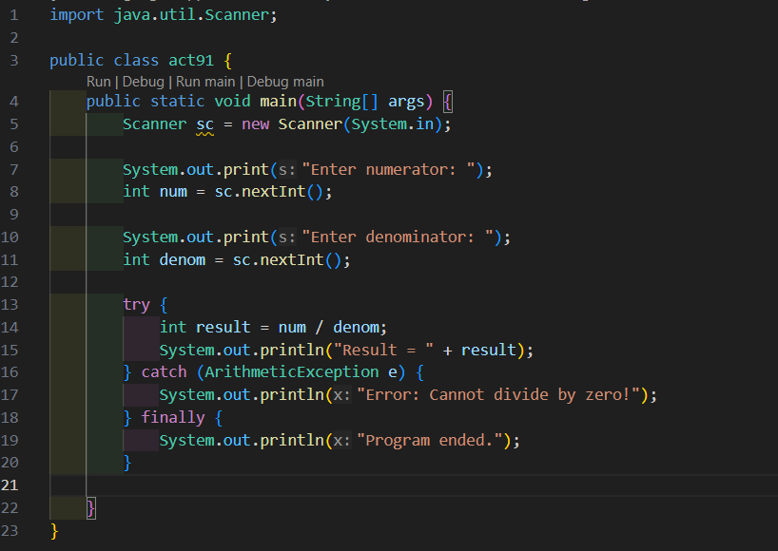
Output:
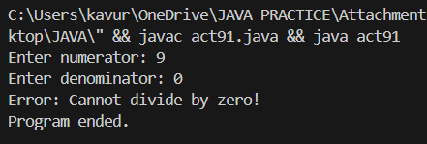

2. Write a program to handle array index out of bounds exception.
Hint: Access invalid index. 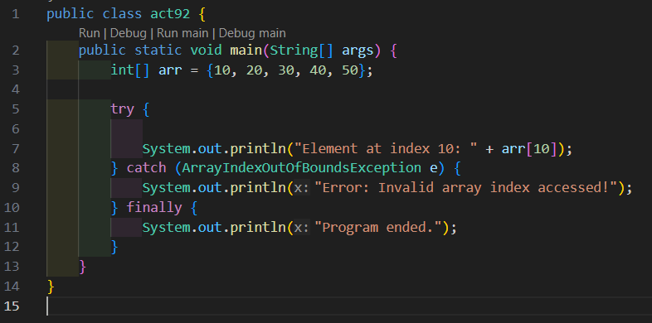
output:
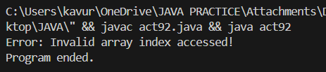
3. Write a program to demonstrate finally block execution.
Hint: finally executes always.
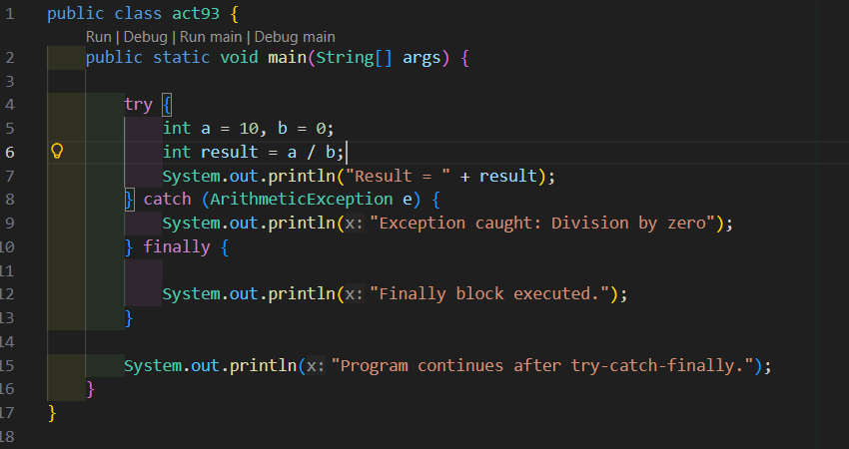
output:
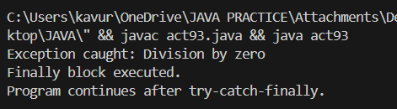

B. MEDIUM LEVEL (Problem-Based)
4. Design a program where user inputs two numbers and performs division. Handle invalid inputs and division errors.
Hint: Use try-catch for multiple exceptions.
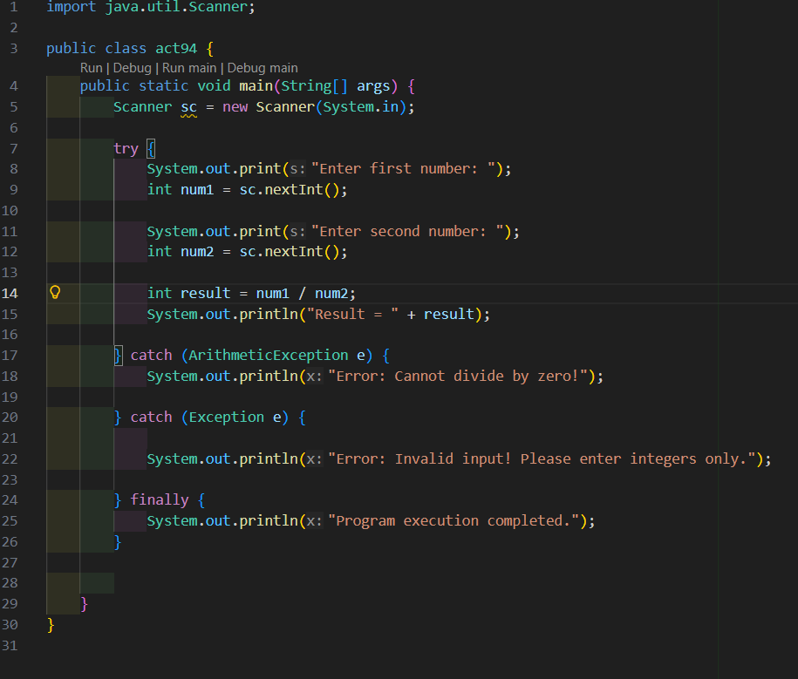
output:
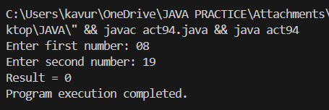
5. A file reading system may encounter errors like file not found or invalid format. Design a program to handle such exceptions gracefully.
Hint: Use multiple catch blocks.
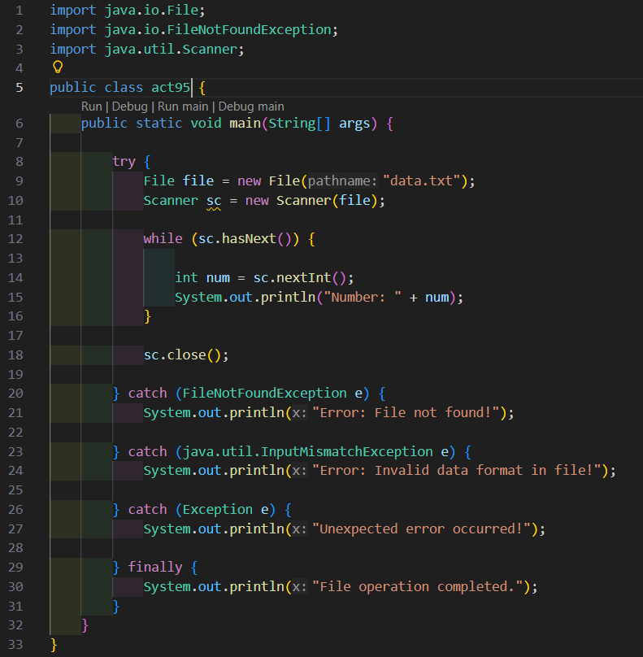
Output:
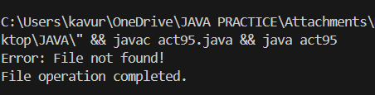
6. Create a banking system where withdrawal may fail due to insufficient balance. Handle this using exception handling.
Hint: Throw and catch exception.
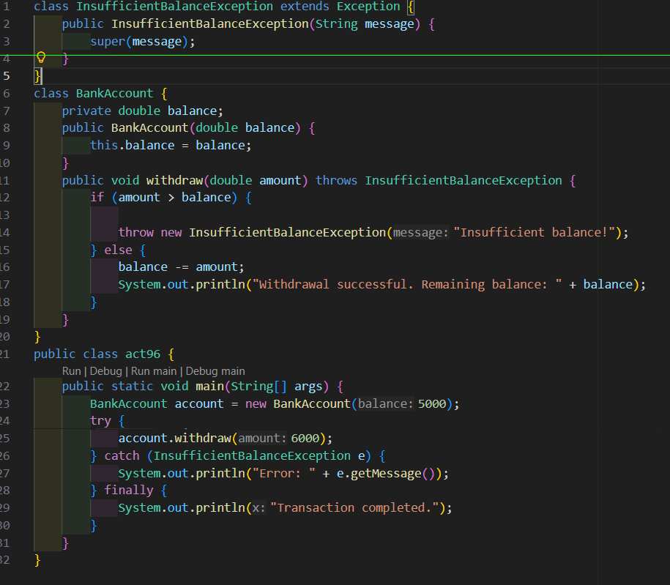
output:
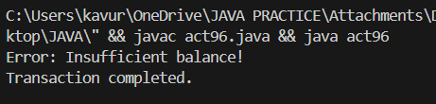

C. HARD LEVEL (Design / Placement-Oriented)
7. Design a login system that validates user credentials. Handle cases such as null input, invalid format, and authentication failure using exceptions.
Hint: Use custom exception handling.
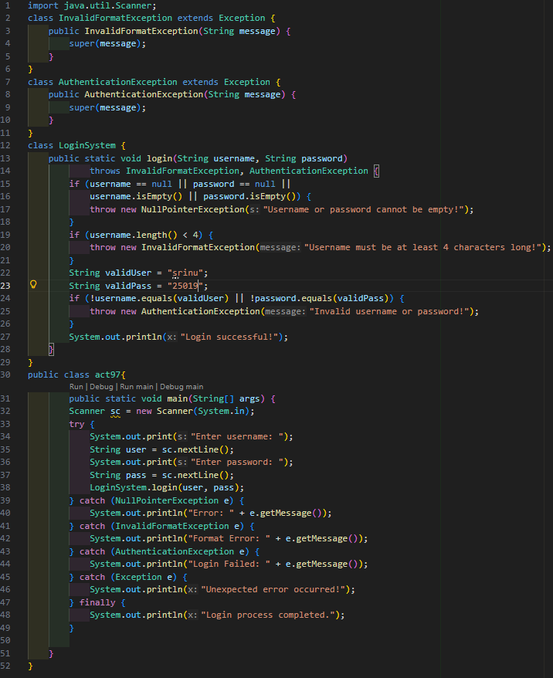
output:
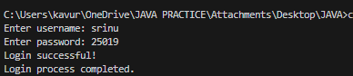
8. Implement a system where multiple operations are performed and ensure resources are always released using finally block.
Hint: finally for cleanup.
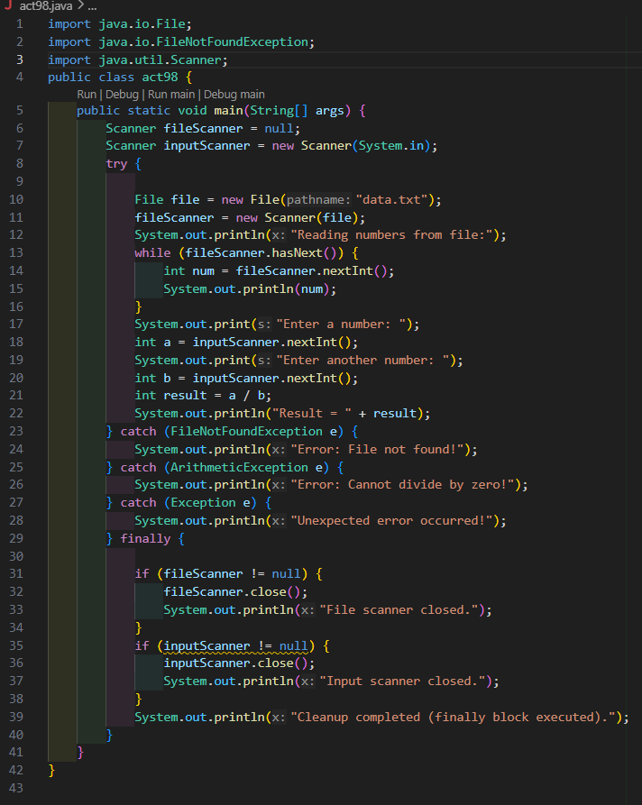
output:
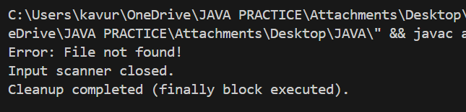
9. Design a program to process a list of numbers where some inputs may be invalid. Continue processing remaining elements even after encountering exceptions.
Hint: Use try-catch inside loop.
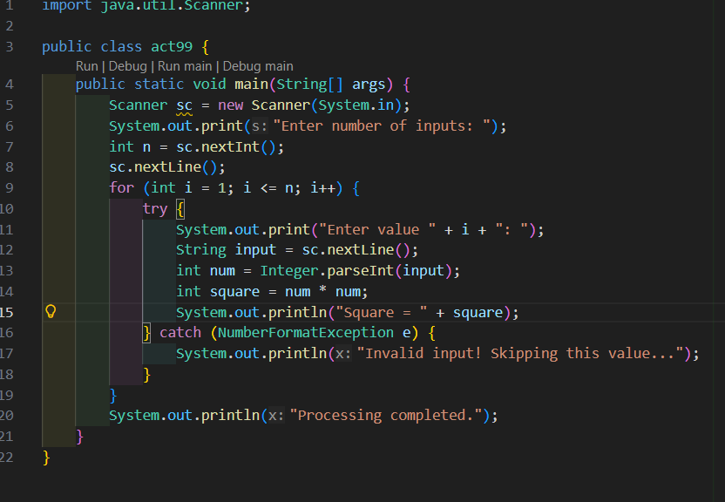
Output:
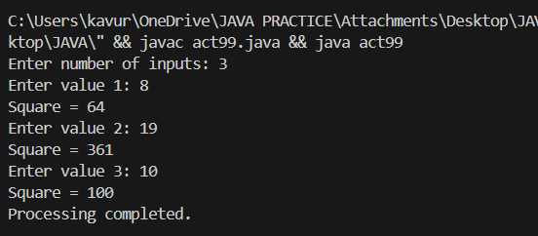
10. Create a program simulating an online transaction system where multiple exceptions can occur. Ensure system stability using structured exception handling.
Hint: Combine try-catch-finally.
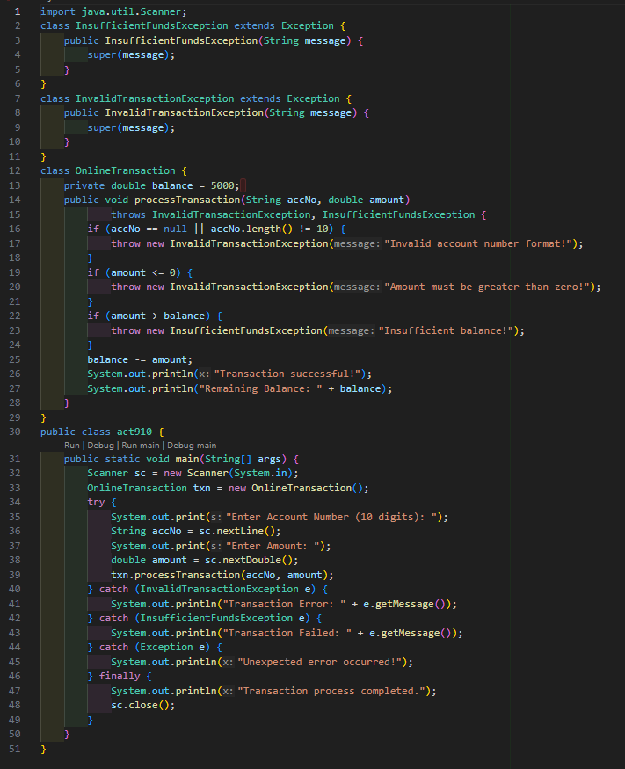
Output:
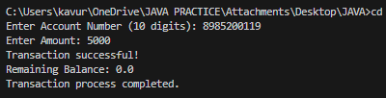

5. ASSIGNMENT EVALUATION
0 : Not Done
1 : Incomplete
2 : Late Completion
3 : Needs Improvement
4 : Complete
5 : Well Done

6. VIVA QUESTIONS
1. What is an exception?
2. What is try-catch block?
3. What is finally block?
4. Difference between checked and unchecked exceptions?
5. Can finally block execute without catch?
6. What happens if exception is not handled?
7. What is custom exception?

