OOPS-Object Oriented
Programming
23AID111
ACTIVITY SHEET – 5
Programs Using Constructors
& Method Overloading
Name : Usikala ajay sai
Roll : CH.AI.U4AID25054
AVV-CHENNAI

1. OBJECTIVES
By completing this activity, students will be able to:
- Understand the concept of constructors in Java
- Differentiate between default and parameterized constructors
- Apply constructor overloading
- Implement method overloading
- Improve object initialization and program design skills

2. READING REQUIREMENTS
Oracle Java Tutorials – Constructors: https://docs.oracle.com/javase/tutorial/java/javaOO/constructors.html
Oracle Java Tutorials – Method Overloading:
https://docs.oracle.com/javase/tutorial/java/javaOO/methods.html

3. ILLUSTRATIVE EXAMPLES Example 1: Constructor and Constructor Overloading
Code:
class Student {
String name; // Instance variable int rollNo; // Instance variable
Student() { // Default Constructor name = "Unknown"; rollNo = 0; }
Student(String n, int r) { // Parameterized Constructor name = n; rollNo = r;
}
void display() {
System.out.println(name + " " + rollNo);
}
} public class TestStudent { public static void main(String[] args) {
Student s1 = new Student(); // Object for default Student s2 = new Student("Anita", 101); // Object for Parameterized s1.display(); s2.display();
}
}

Example 2: Method Overloading
Code:
class Calculator { int add(int a, int b) { return a + b;
}
double add(double a, double b) {
return a + b;
}
}
public class TestCalc { public static void main(String[] args) { Calculator c = new Calculator();
System.out.println(c.add(5, 3));
System.out.println(c.add(2.5, 3.5));
}
}

4. PROGRAMMING / TASK QUESTIONS A. EASY LEVEL
- Create a class Book with title and price. Initialize values using a constructor and display details.
Hint: Use a parameterized constructor.
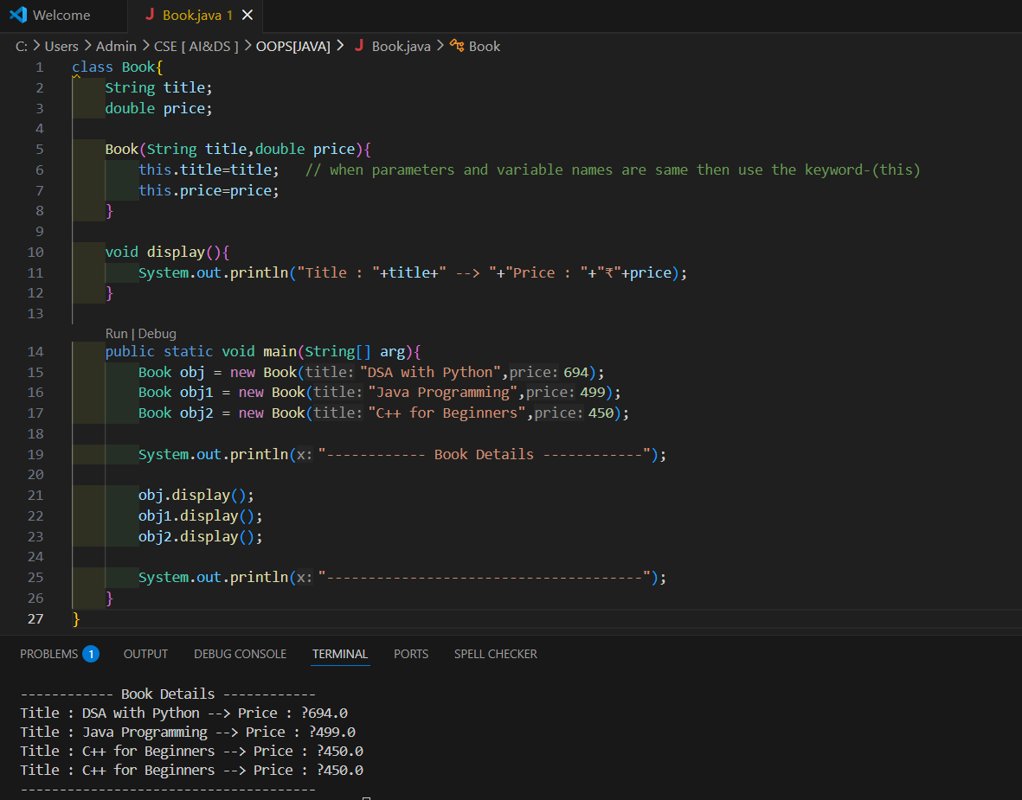
- Create a class Rectangle with length and breadth. Use a constructor to initialize values and calculate area.
Hint: Define constructor and area() method.
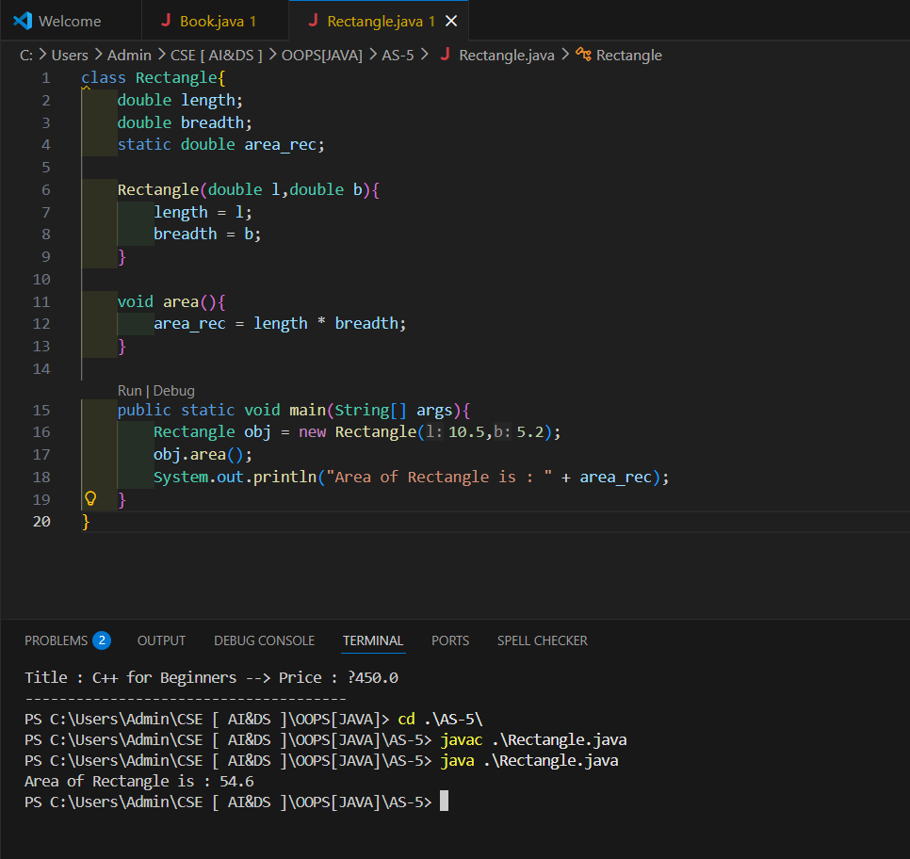
- Create a class Student with default constructor that assigns default values and displays them.
Hint:Use no-argument constructor.
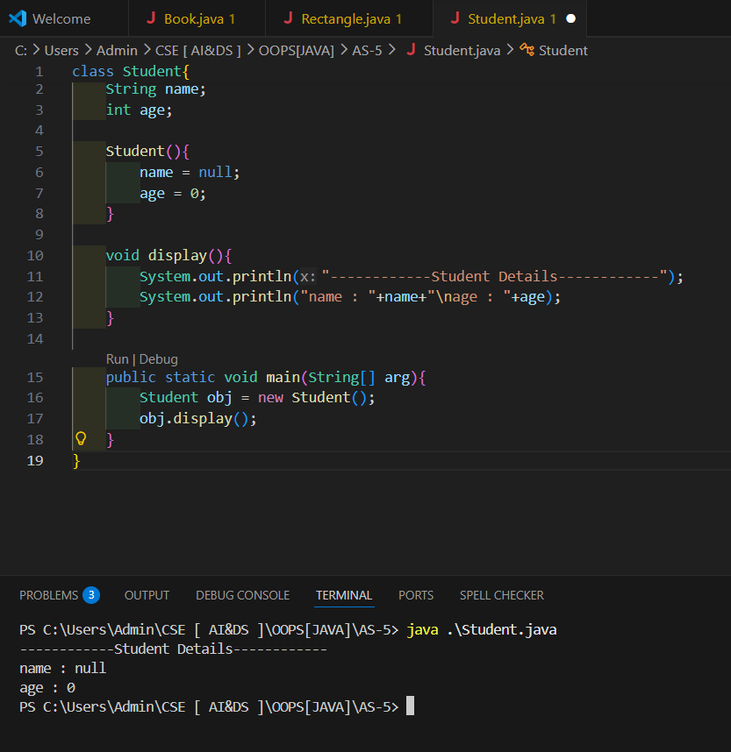

B. MEDIUM LEVEL (Problem-Based)
- A company maintains employee records. Some employees are created with only name, while others are created with name and salary. Design a program to handle both cases.
Hint: Constructor overloading is applicable.
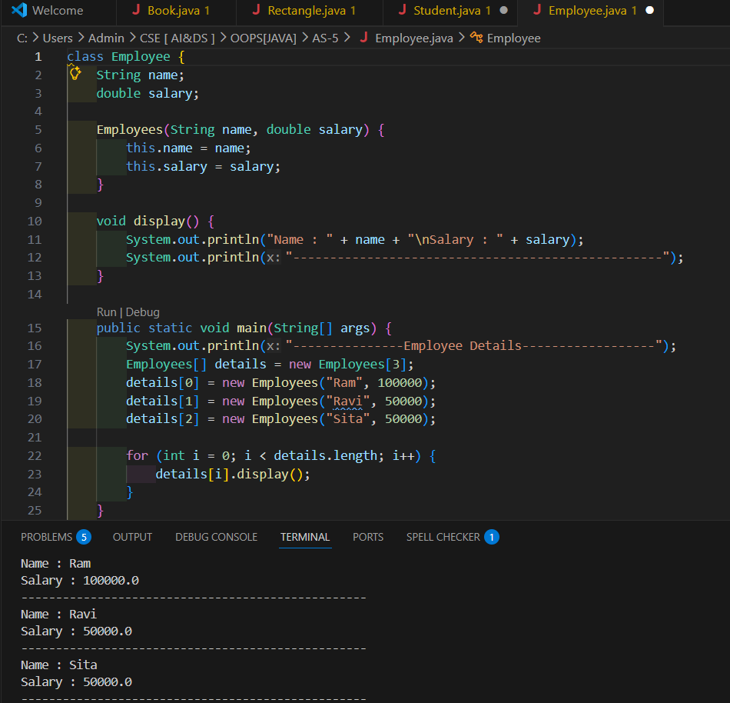
- Design a program where a calculator performs addition for integers and floating-point numbers using same method name. Hint: Method overloading is applicable.
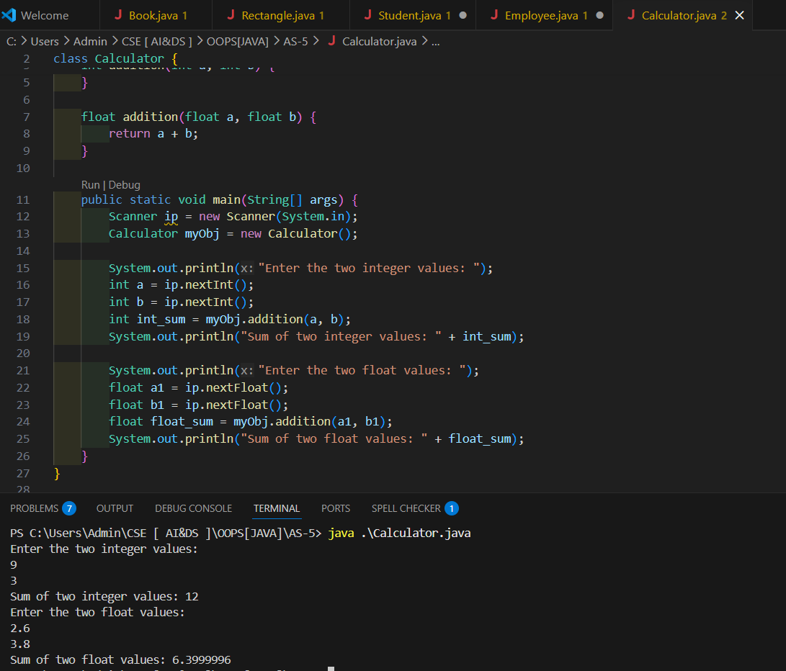
- A mobile phone object can be created with only brand name or with brand name and price. Design a Java program to model this situation.
Hint: Constructor overloading is applicable.
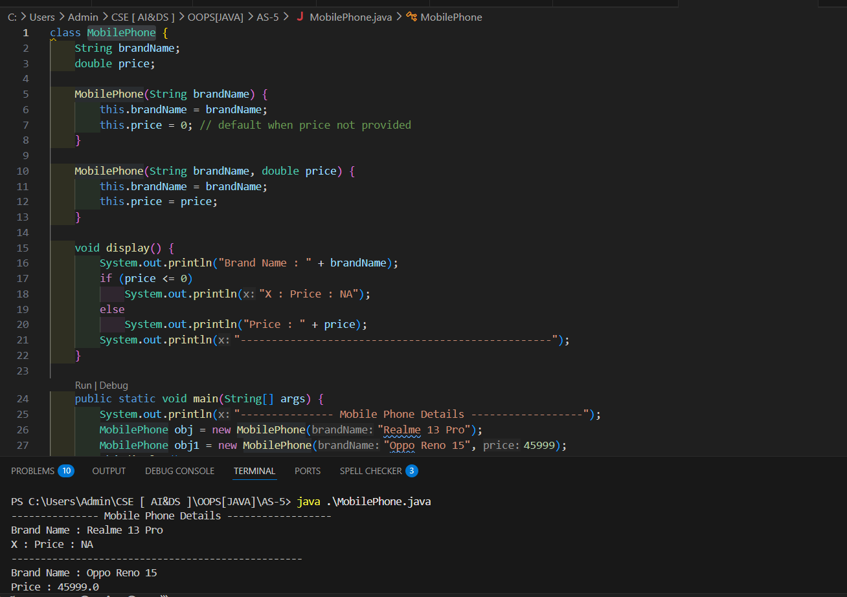

C. HARD LEVEL (Design-Oriented)
- A banking application allows creating an account with account number only, or with account number and initial balance. Design a Java program for this system. Hint: Constructor overloading is applicable.
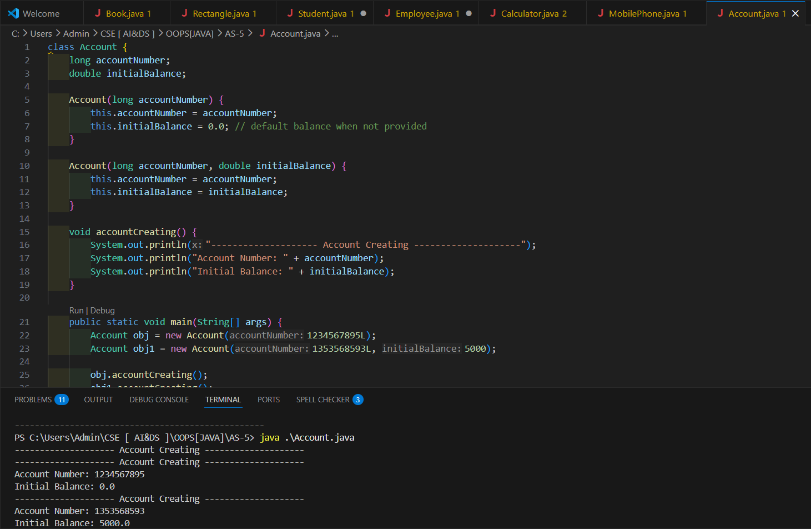
- Design a program to calculate area of shapes where area() method works for circle and rectangle using same method name.
Hint: Method overloading is applicable.
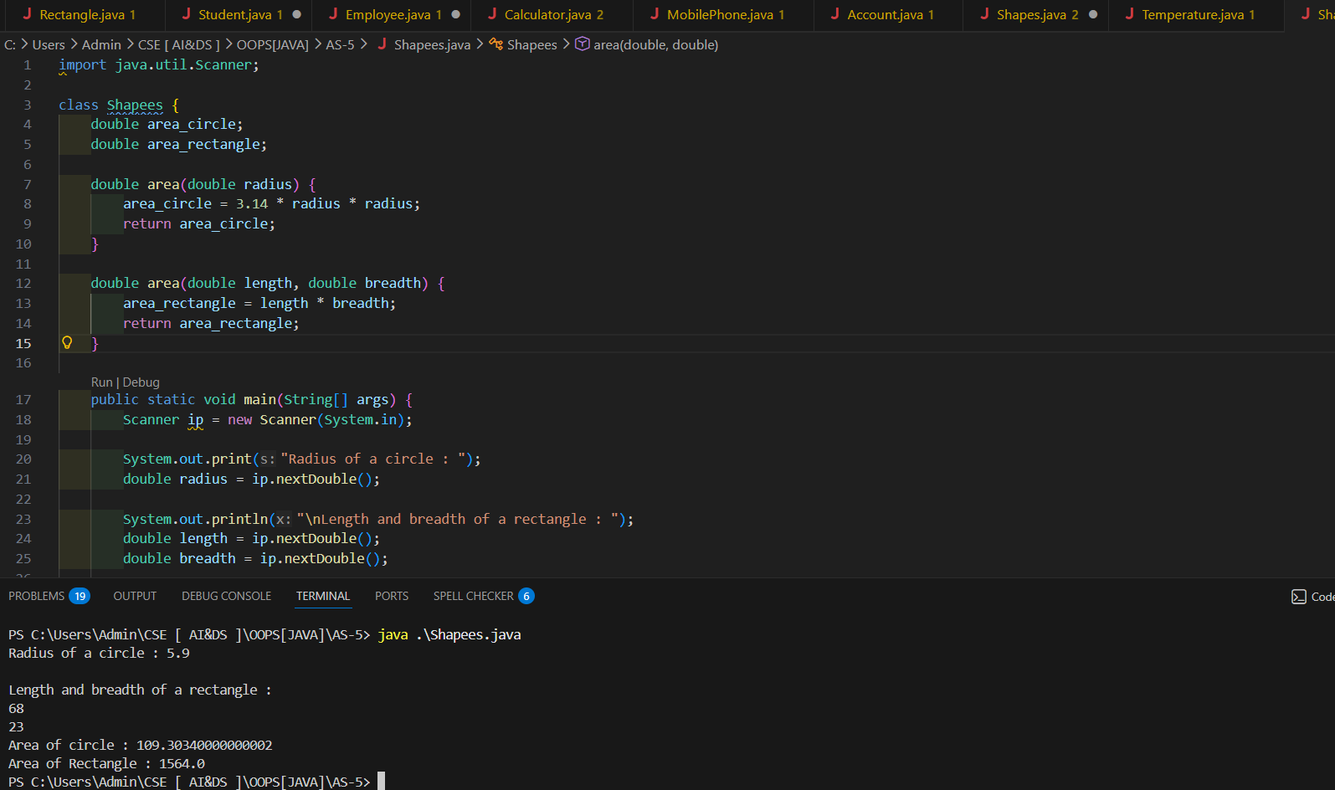
- Create a class Temperature that converts temperature from Celsius to Fahrenheit and Kelvin using overloaded methods.
Hint: Use method overloading with different parameter lists.
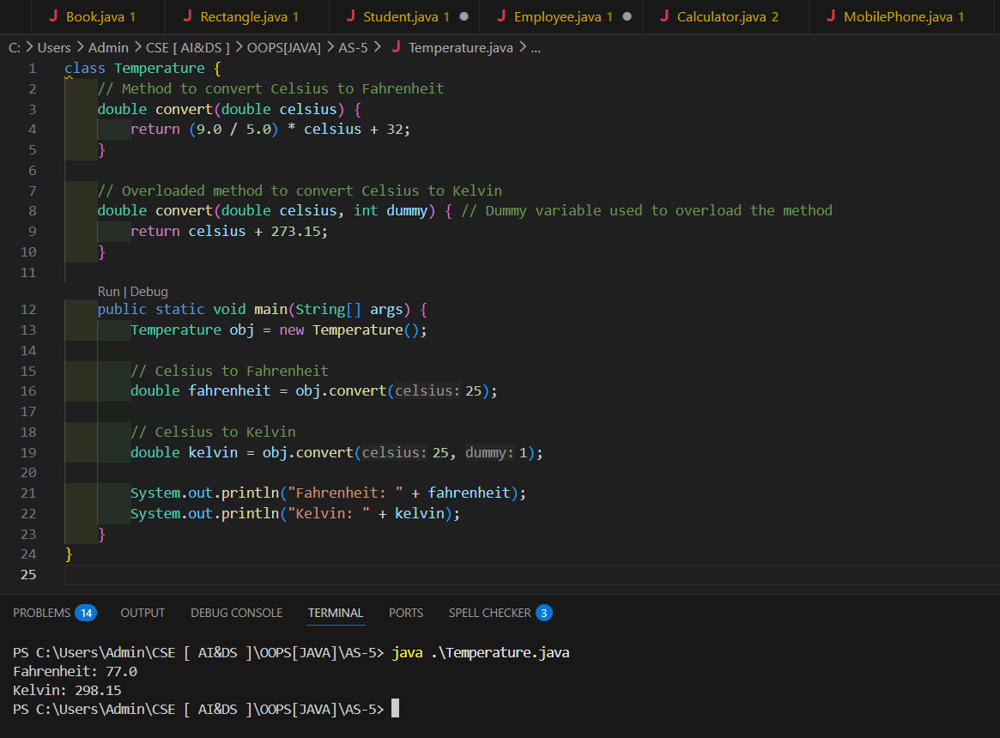

5. ASSIGNMENT EVALUATION
- : Not Done
- : Incomplete
- : Late Completion
- : Needs Improvement
- : Complete
- : Well Done

6. VIVA QUESTIONS
- What is a constructor?
- What is the difference between default and parameterized constructor?
- What is constructor overloading?
- What is method overloading?
- Can constructors have return type?
- When is a constructor called?
- What is the difference between constructor and method?

