OOPS-Object Oriented Programming
23AID111

ACTIVITY SHEET – 6

Programs Using Method Overloading
& Method Overriding

Name : Usikala ajay sai
Roll : CH.AI.U4AID25054
AVV-CHENNAI

ACTIVITY SHEET – 6
Programs Using Method Overloading and Method Overriding

1. OBJECTIVES
By completing this activity, students will be able to:
• Understand compile-time polymorphism using method overloading
• Understand runtime polymorphism using method overriding
• Apply polymorphism to solve logical and industry-oriented problems
• Design reusable object-oriented programs
• Analyze scenarios and identify when overloading or overriding is appropriate

2. READING REQUIREMENTS
Oracle Java Tutorials – Method Overloading:
https://docs.oracle.com/javase/tutorial/java/javaOO/methods.html
Oracle Java Tutorials – Method Overriding:
https://docs.oracle.com/javase/tutorial/java/IandI/override.html

3. ILLUSTRATIVE EXAMPLES
Example 1: Method Overloading
Code:
class Calculator {
int add(int a, int b){
return a + b;
}
int add(int a, int b, int c){
return a + b + c;
}
double add(double a, double b){
return a + b;
}
}
Example 2: Method Overriding
Code:
class Animal{
void sound(){
System.out.println("Animals make sound");
}
}
class Dog extends Animal{
void sound(){
System.out.println("Dog barks");
}
}

4. PROGRAMMING / TASK QUESTIONS

A. EASY LEVEL
1. A printer application needs to display different types of information. Sometimes it prints a number, sometimes a text message, and sometimes both number and text. Design a Java program so the printer performs all these tasks using the same method name.
Hint: Behavior should depend on different parameters.
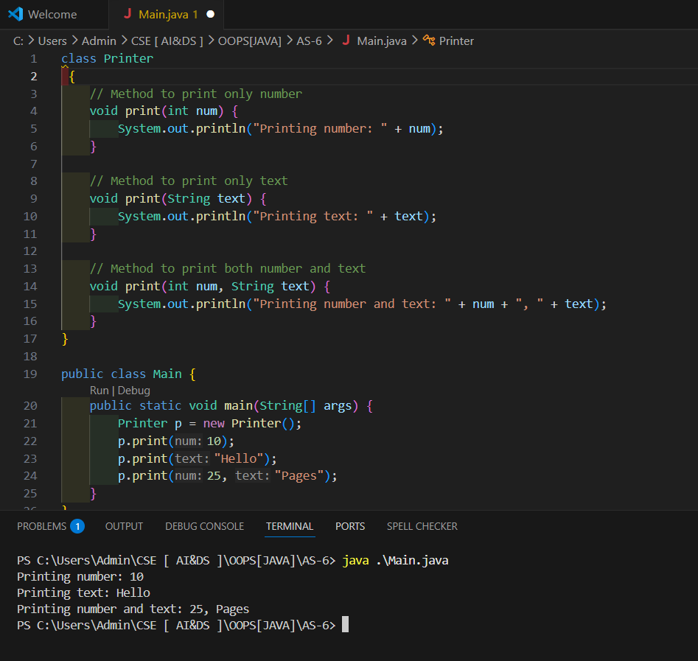

2. A notification system sends alerts to users. A base class Notification sends a general notification, while EmailNotification sends email alerts. Design a program where the notification behavior changes when called from the child class.
Hint: Child class should redefine the method behavior.
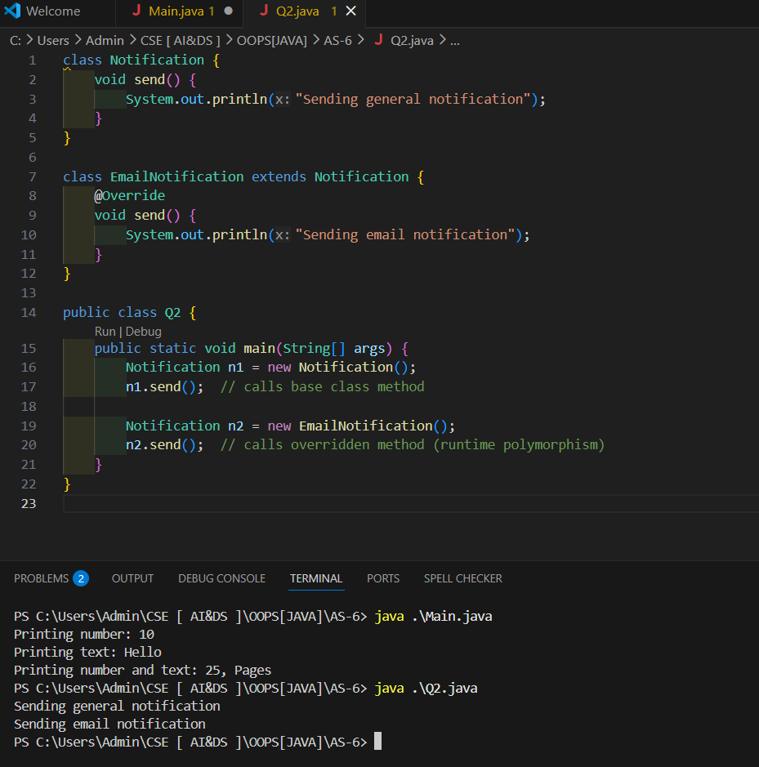
3. A logging system records system events. Sometimes it logs only a message, sometimes message with timestamp, and sometimes message with timestamp and error code. Design a program where the same method name logs all these cases.
Hint: Same method name with different parameter lists.
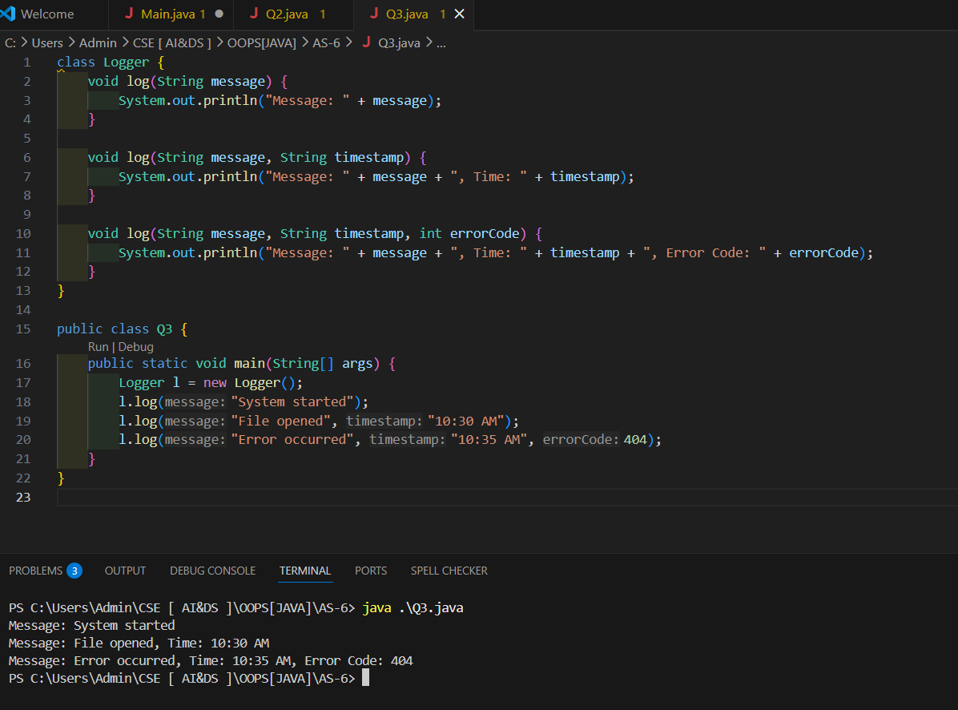

C. MEDIUM LEVEL
4. Given a large integer represented as an integer array digits where each element represents a digit, add one to the integer and return the updated array. (For Practice)
Example: Input: [2,9,9] Output: [3,0,0] 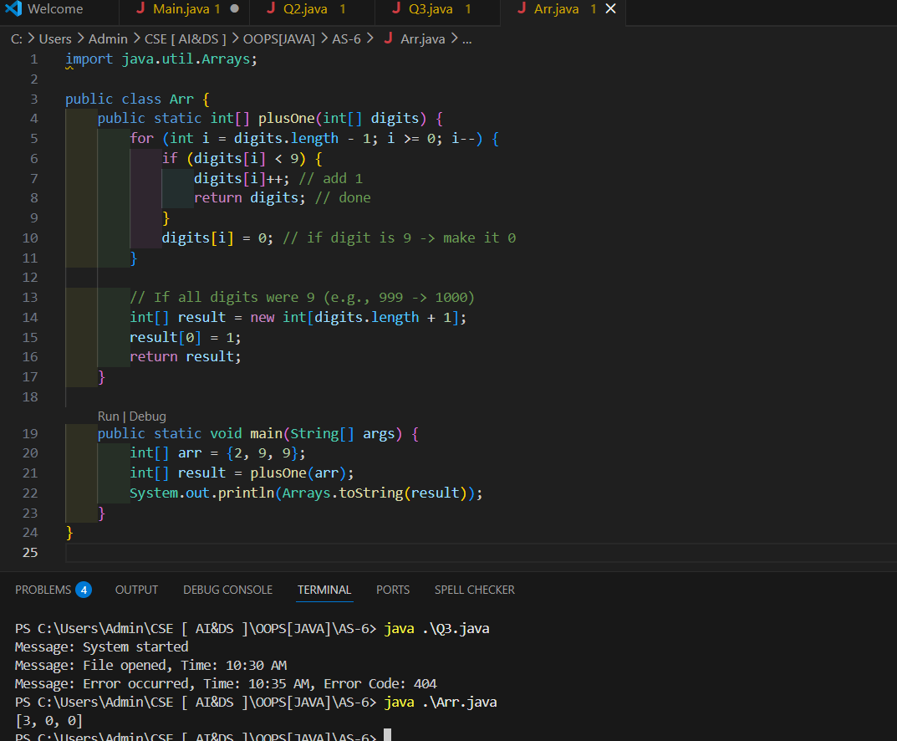

5. Write a Java program to check whether brackets in a string are balanced. The brackets include (), {}, and [].(For Practice)
Example: Input: {[()]} Output: Valid
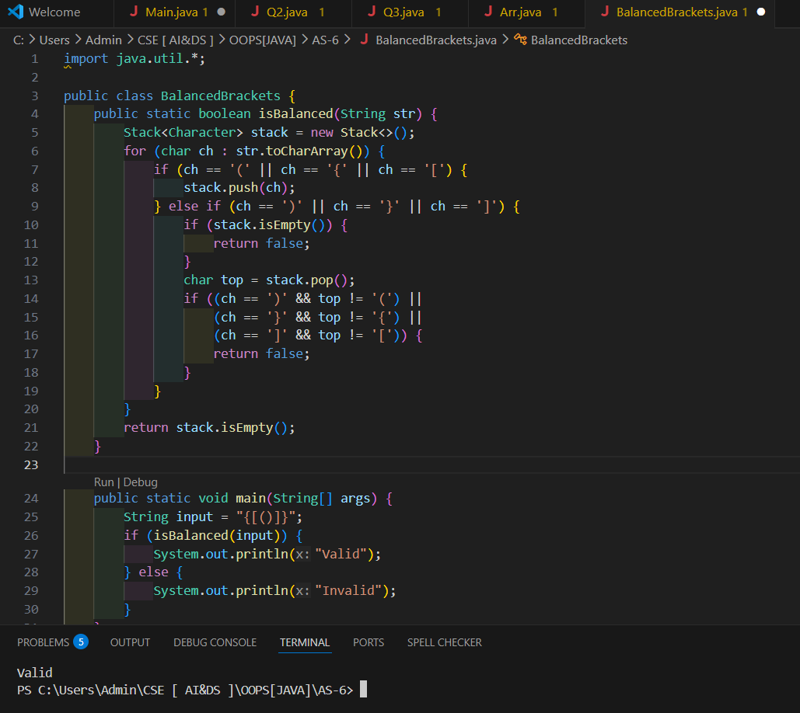
6. A payment system processes payments differently depending on whether the payment is made using cash, card, or UPI. Design a class PaymentProcessor where the same
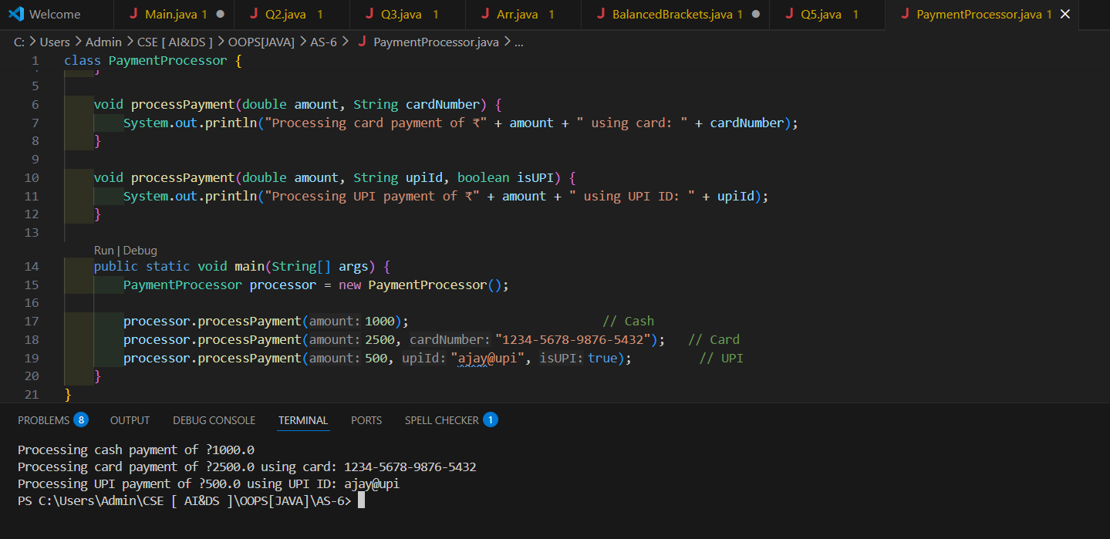 method processPayment() handles different payment inputs.
Hint: Method overloading is applicable.

C. HARD LEVEL (Placement / Design-Oriented)
7. A smart home application controls devices such as Light, Fan, and AirConditioner. All devices inherit from SmartDevice and implement their own version of turnOn(). Design a Java program to simulate this system.
Hint:Method overriding is applicable.
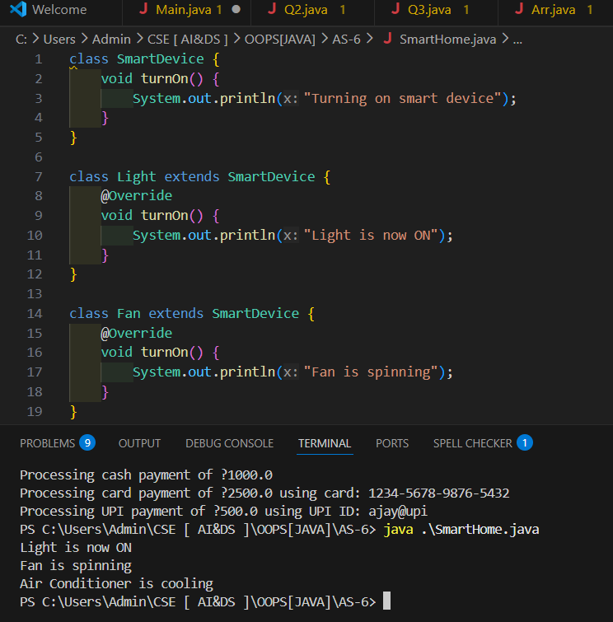
8. An e-commerce platform calculates discounts differently depending on input: price only, price with membership type, and price with membership plus coupon code. Design a class DiscountCalculator that handles all cases.
Hint: Method overloading is applicable.
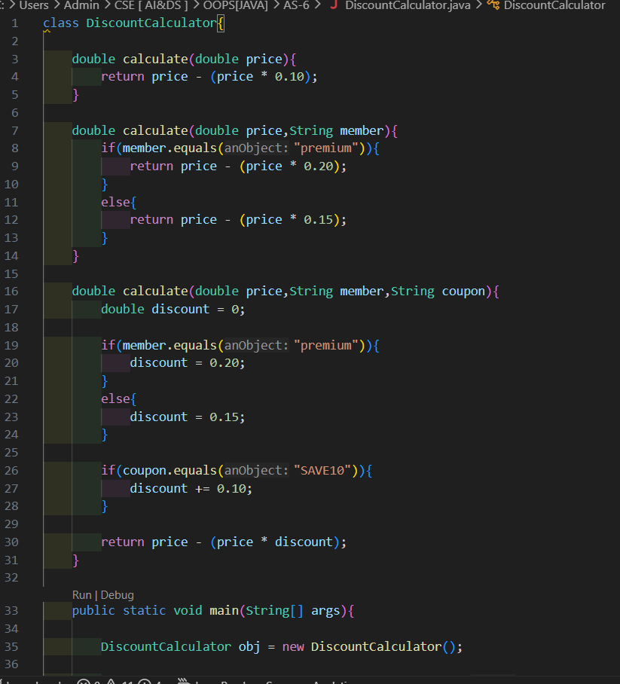
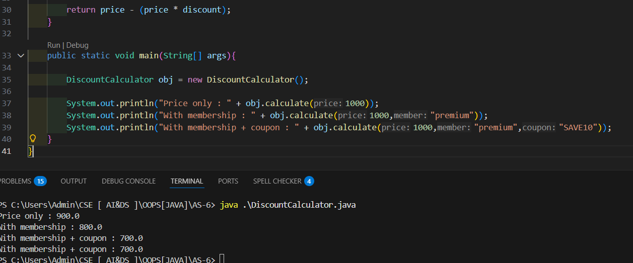

9. A ride-sharing platform supports BikeRide, AutoRide, and CarRide. All inherit from Ride and override calculateFare(distance) with different pricing rules.
Hint: Method overriding is applicable.
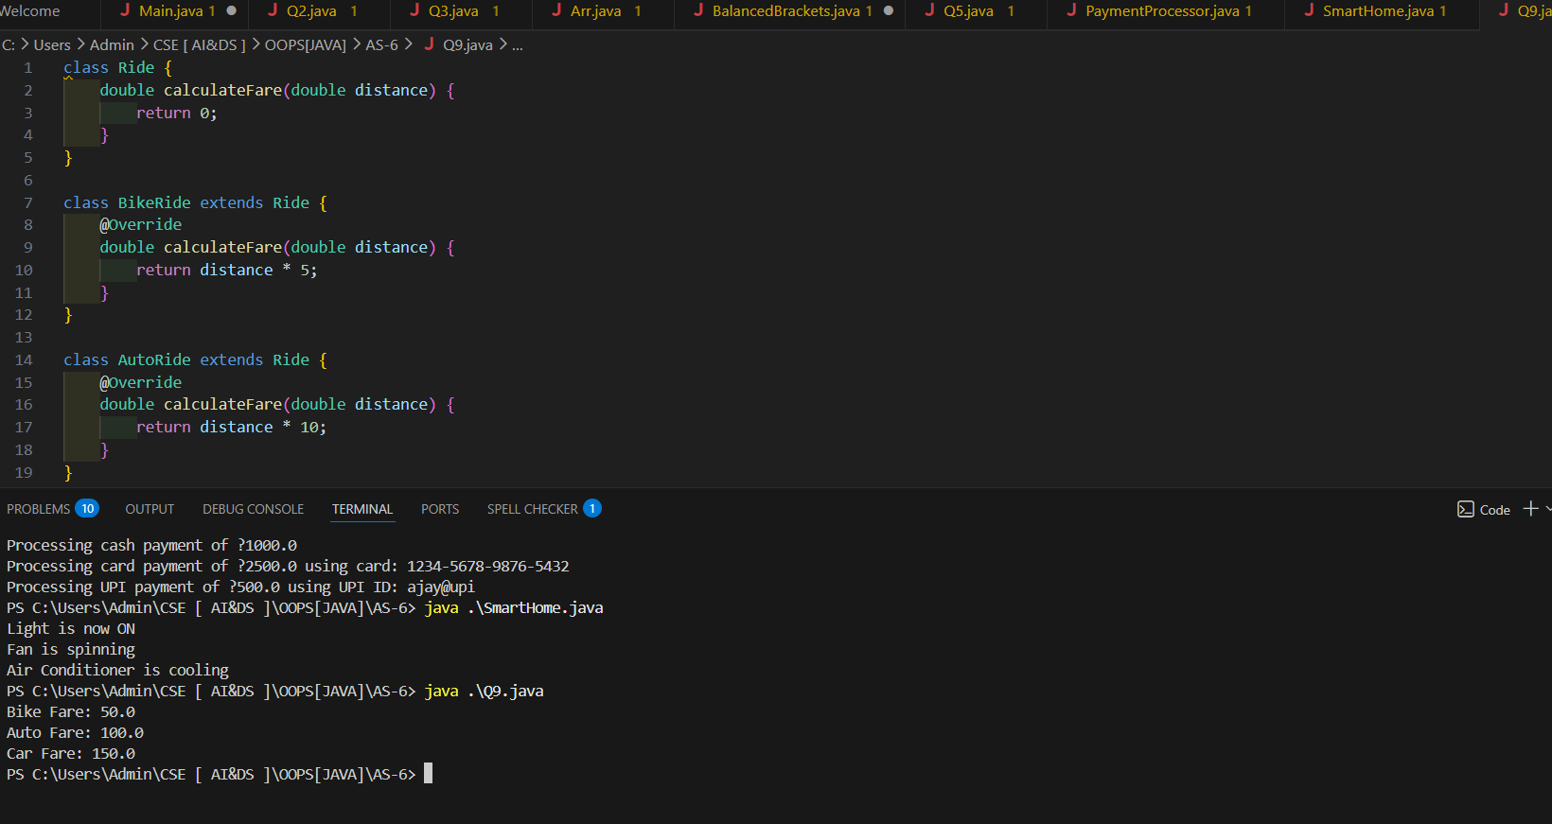

10. Design a flexible search utility where the same method search() can search an integer in an integer array, a string in a string array, and optionally within a given index range.
Hint: Hint: Method overloading is applicable.
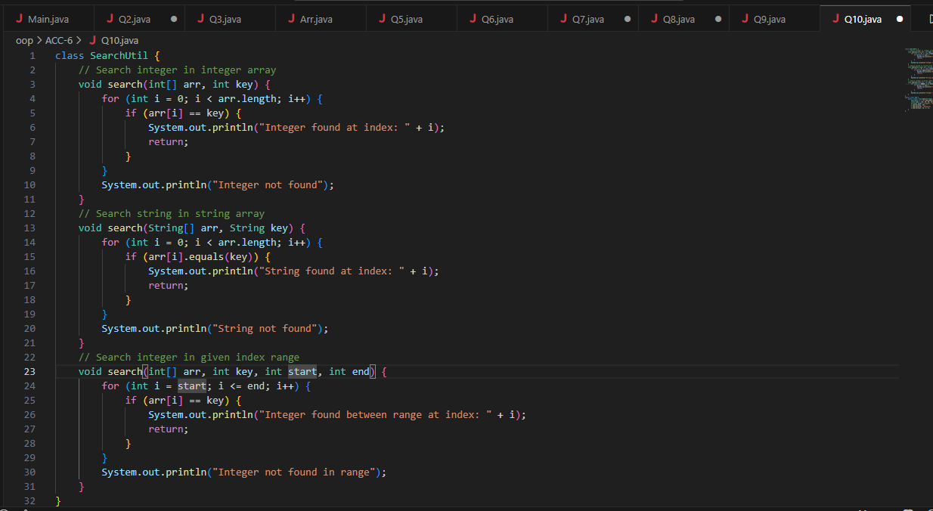
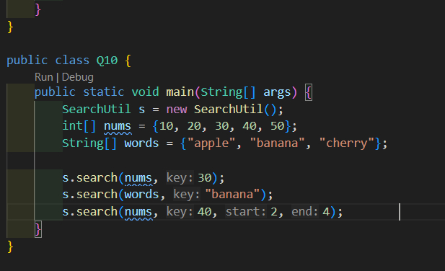

5. ASSIGNMENT EVALUATION
0 : Not Done
1 : Incomplete
2 : Late Completion
3 : Needs Improvement
4 : Complete
5 : Well Done

6. VIVA QUESTIONS
1. What is polymorphism in Java?
2. What is method overloading?
3. What is method overriding?
4. What is the difference between overloading and overriding?
5. Which polymorphism occurs at compile time?
6. Which polymorphism occurs at runtime?
7. Can overloaded methods have different return types?
8. Why is method overriding important in object-oriented design?

