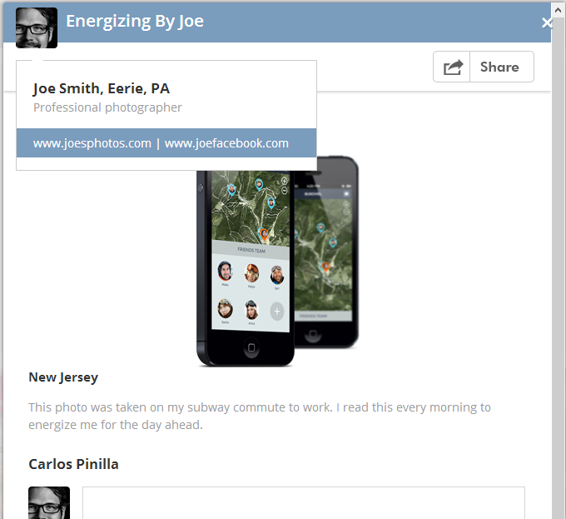

Upload image



Choose background









Option for text alignment. I’d like to give font and size options too but that can wait until after the launch.

We could have 5 or 6 options for backgrounds if the user is entering text only, and an option to upload background image.

Let’s default to gray background with white text should the user not want to choose a background.

A Poem about Energizing.

Energizing is when I feel alive

I feel energized when I drive

I love to get energy from a hike

I feel energized when I’m riding my bike.

I wrote this poem in Central Park on my visit to New York City.