# Designer Overview

We went to a conference and learned how disruptive mobile solutions are going to be to Managed Service Providers like us and because of that we need to add Mobile Management to our portfolio of services. For this, we need to do some minor updates to the site/design. We also added feedbacks for others pages as well.

# Feedback 1 – Menu Bar

Update Menu bar as per the image below. We are going to remove “Analytics” and replace it with “Consulting”.

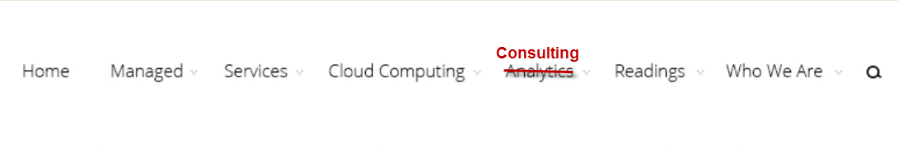

# Feedback 2 – Home Page

The Homepage also needs to be updated to reflect the above change. Where we have Consulting Services we need to replace it with Mobile Management. Please be aware that the Managed Services page needs to reflect this change – Remove Consulting Services and replace it with Mobile Management.

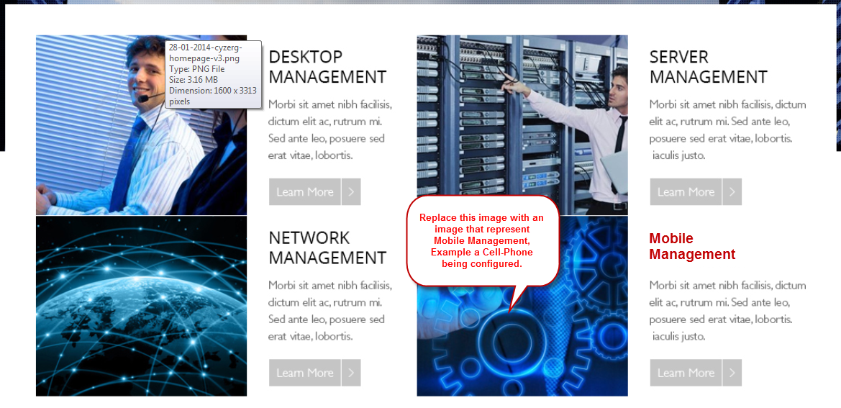

# Feedback 3 – Blogs

The blogs is missing the functionality for people to subscribe to our blogs. If you want you can use something similar or the same design that the Divi blogs have at the bottom. This is a very important component of the blogs as we can collect leads from here and send new articles to our clients as they are post.

# Feedback 4- Contact Us

The Contact Us page is a very important page of the website. The page needs to grab attention as this is the last point whereby a potential client can change his mind and contact us or not. The page needs to be visually perfect, have an image, and two small placeholders for content - text. The following website is an excellent and quick read about designing excellent Contact Us pages.

**Content 1:**

Probably two or three sentences at most, with a seductive statement to get the client to contact us. Probably something like: *“As in life, business achievements always begin with taking the right steps on the path that can take us in the right direction. Contact us and lets us help you”.*

**Content 2:**

Probably one or two sentences to set expectation as to when we will be contacting the client. Probably something like: *“We check our emails every minute and reply even when we are at a romantic dinner. We are obsessed with our clients”*

In the form we need to capture the followings:

* Name
* Email
* Phone Number
* Message

More feedback next page ……

# Feedback 5- Managed Services

The first draft of the Managed Services felt like a page from another website. The only thing that connected was the top and bottom. We don’t want all the pages to be the same (because it becomes boring) but to evolve around the same theme. All the pages of the site need to be visually appealing and well connected with the content (txt). Please refer to the websites that we sent for reference/inspiration - specially the NEST website.

**We also need to add the following content to the Managed Services page:**

Multi-Tier Pricing Support Services

Not every system is equally complex neither every systems has the same strategic importance in your business. We have created a multi-level pricing system so you effectively and efficiently invest in your business.

Level 1: Provides for the basic services needs to get your business up and running and covered with basic support.

Level 2: Provides businesses with more predictable operations and reliability of their systems and services.

Level 3: Provides a fully functional and enterprise level technical operational framework based on an international standard framework to maintain your systems secure and compliant.